JERICHO M. SALAS
INFORMATION TECHNOLOGY STUDENT

CONTACT

Phone:
0997-703-0323

Email Address:
jeysalas05@gmail.com

Address:
San Jose City of San Fernando, Pampanga, Philippines 5000

PROFILE
Motivated IT student and working student since 2021 with hands-on experience in building basic Flask-based web applications and foundational IT/networking tasks. Currently developing a capstone project focused on personality-based pet recommendations to promote responsible pet ownership and help reduce pet abandonment. Seeking an internship to further develop full-stack web development and IT support skills in a real-world environment.

EDUCATION

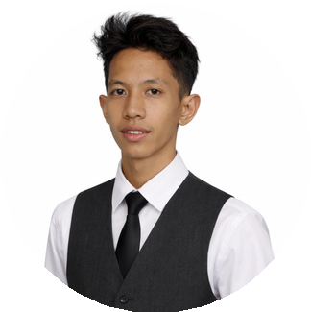


SOFT SKILLS
Time management Teamwork & communication Problem-solving Adaptability / fast learner

TECH SKILLS
Programming & Web Development Python, Flask
HTML, CSS
JavaScript (Vanilla, Alpine.js) Bootstrap, Tailwind CSS
IT Support & Networking
PC assembly & disassembly; basic hardware troubleshooting
OS installation & PC reformatting Basic network configuration (IP setup, folder/network sharing) LAN setup using Ethernet cables; cable crimping
Basic router configuration (Wi-Fi, network settings)
Printer setup and PC-to-printer connection

LANGUAGES
English (Basic) Filipino (Fluent)
Bachelor of Science in Information Technology 2022-Present City College of San Fernando Pampanga | San Fernando, Pampanga Relevant coursework: Web Development,
Networking Fundamentals

PROJECTS

Petsona – Personality-Based Pet Recommendation Web App (Capstone Project)
Developing a web application that recommends suitable pets based on user personality and lifestyle
Designed to promote responsible pet ownership and help reduce pet abandonment
Implementing user input forms, recommendation logic, and responsive UI using Flask
Technologies Used: Python, Flask, HTML, CSS, JavaScript,
Bootstrap/Tailwind — In Progress

RentEase - Rental Listing & Booking Web App (Academic Project)
Built a basic web application that allows tenants to post rental listings and users to apply/book rentals
Implemented listing forms, user views, and a simple booking/application workflow
Gained hands-on experience in basic full-stack web development with Flask
Technologies Used: Python, Flask, HTML, CSS, JavaScript, Bootstrap

WORK EXPERIENCE

Kitchen Staff (Part-time) — Kokoy’s Kitchen Ext. | 2021 – Present
Balanced part-time work with academic responsibilities as a working student
Maintained efficiency and quality in a fast-paced environment Collaborated with team members to meet service standards Demonstrated reliability, time management, and strong work ethic

