**E-Commerce Analysis Report**

* **Customer Data:**
  + 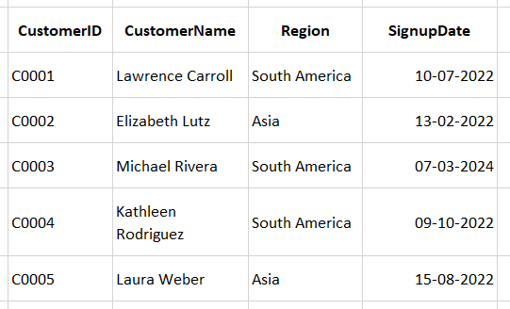**Customer Distribution by Region**: Customers are primarily located in **South America** and **Asia**, indicating a regional focus for the business.
  + **Signup Trends**: Customer signups span from early 2022 to 2024, showing consistent growth in customer base over the years.
  + **Top Customer Names**: Examples include **Lawrence Carroll**, **Elizabeth Lutz**, and **Michael Rivera**, reflecting a diverse customer demographic.
  + **Key Regions for Growth**: **South America** has more frequent customer representation compared to Asia, suggesting it might be a primary market.
  + **Recent Activity**: **Michael Rivera** is the most recent signup, indicating new customer acquisition in March 2024.
* **Product Data:**
  + 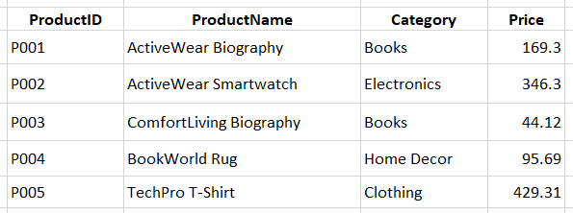**Diverse Product Categories**: Products cover a range of categories including **Books**, **Electronics**, **Home Decor**, and **Clothing**, catering to varied customer preferences.
  + **High-Priced Products**: The **TechPro T-Shirt** is the most expensive item, priced at **$429.31**, indicating a premium clothing option.
  + **Affordable Offerings**: The **ComfortLiving Biography** is the least expensive product, priced at **$44.12**, providing cost-effective choices in the books category.
  + **Electronics Popularity**: The **ActiveWear Smartwatch** stands out in electronics with a price of **$346.30**, signifying potential demand for tech products.
  + **Balanced Pricing**: Products like the **BookWorld Rug** (**$95.69**) and **ActiveWear Biography** (**$169.30**) reflect mid-range pricing in home decor and books, appealing to budget-conscious customers.
* **Transaction Data:**
  + 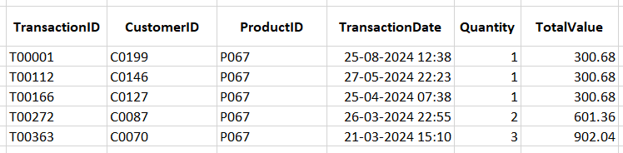**Popular Product**: Product **P067** is consistently purchased in all listed transactions, indicating strong customer demand for this item.
  + **Transaction Patterns**:
    - Transactions show a mix of **single-unit** purchases (e.g., 1 unit for $300.68) and **bulk purchases** (e.g., 3 units for $902.04).
    - Larger purchases lead to proportionally higher total values, with no discounts applied.
  + **Time Distribution**: Transactions occur over five months, from **March to August 2024**, showing periodic purchase activity within this timeframe.
  + **Bulk Purchase Impact**: Customers purchasing **2 or 3 units** contribute significantly to total revenue compared to single-unit purchases.
  + **Pricing Consistency**: The price per unit for Product P067 is **$300.68** across all transactions, reflecting stable pricing strategies.
* 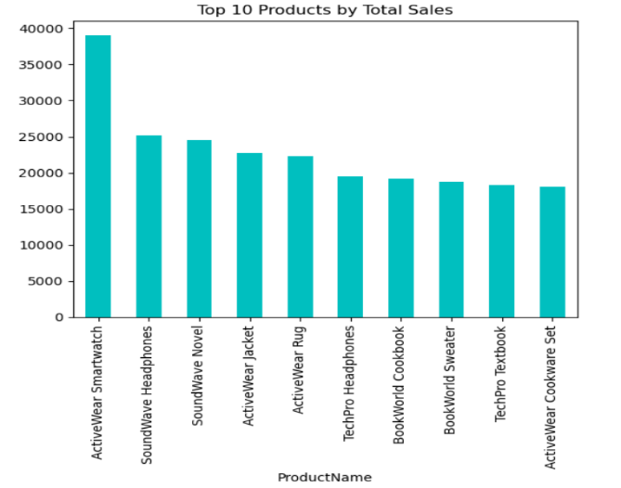**Top 10 Customers by Total Sales:**
  + **Top Spender:** Customer **C0141** leads with sales of **$10,673.87**, well ahead of others.
  + **Moderate Range:** Customers **C0054**, **C0065**, and **C0156** have sales between **$7,600–$8,040**.
  + **Close Figures:** Customers **C0082** to **C0165** have sales ranging from **$6,700–$7,600**.
  + **Key Insight:** These 10 customers significantly impact revenue, suggesting the need for focused retention strategies.
* **Sales Tre nd Over Time:**

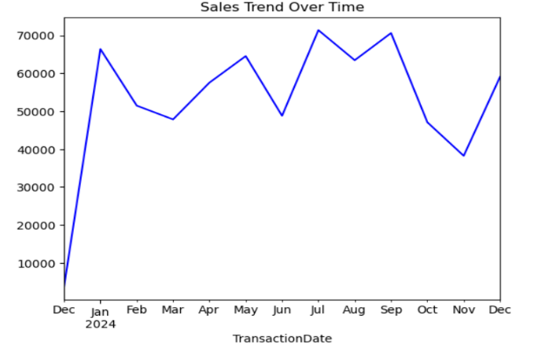Sales peaked in **January 2024**, dropped in **October**, and recovered in **December**. The **ActiveWear Smartwatch** led with sales of **$39,096.97**, followed by **SoundWave Headphones** and **SoundWave Novel**, each exceeding **$24,000**. Among the top 10, the **ActiveWear Cookware Set** ranked lowest at **$18,083.73**.

* 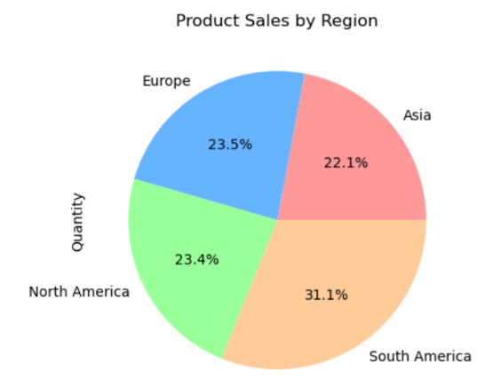**Region Wise Product Sales:**

South America leads in product sales, contributing **31.1%**, followed by Europe and North America, which account for **23.5%** and **23.4%**, respectively. Asia has the smallest share at **22.1%**, suggesting potential growth opportunities. Overall, sales are fairly distributed across regions, reflecting strong global market penetration.

* **Customer Segmentation Report:**

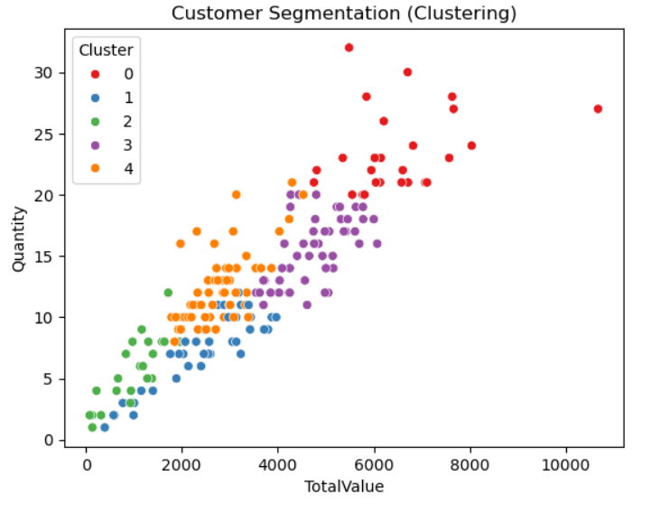The dataset comprises 199 customer records segmented into five clusters (0–4) based on their purchasing behavior. Each cluster represents a group of customers with distinct patterns in total spending (TotalValue) and purchase quantities (Quantity).

* **Cluster 0:** High-value customers with high spending and purchase quantities.
* **Cluster 1:** Moderate spenders with slightly lower quantities.
* **Cluster 2:** Customers with low spending and low purchase quantities.
* **Cluster 3:** Customers with above-average spending and purchase quantities.
* **Cluster 4:** Mid-range customers balancing moderate spending and purchase activity.

This clustering provides actionable insights for businesses to develop targeted strategies. For instance, high-value customers (Cluster 0) can be prioritized for loyalty programs, while low-value customers (Cluster 2) may benefit from promotions or engagement campaigns to encourage higher spending.

* **Customer Similarity Report:**

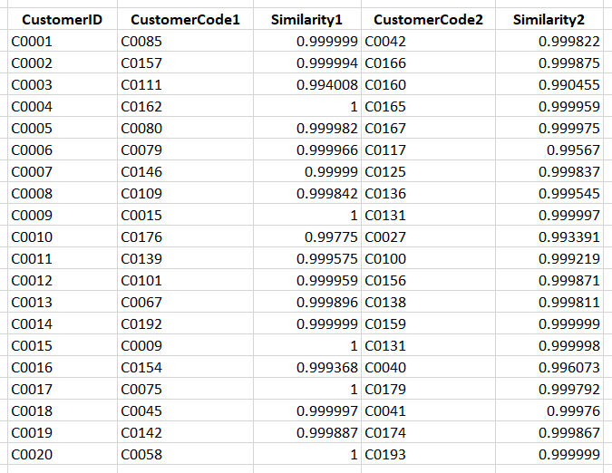

* **High Similarity Scores**: Most customer similarity scores range from 0.9904 to 1.0000, showing strong alignment.
* **Top Matches**: Many pairs, such as C0004-C0162, have perfect similarity (1.0000).
* **Clustering**: Scores are tightly clustered near 1.0000, indicating consistent patterns.
* **Business Use**: Insights can aid in personalized marketing and customer segmentation.