YuvaIntern | Logistics Data Analyst Intern
WEEK 3 REPORT
Data-Driven Logistics Performance Analysis and Delivery Time Optimization Using Python
Advanced Data Analysis and Visualization in Logistics
Prepared by: Saransh Govil
Internship period: 22 October 2026 – 19 November 2026
Dataset note: Simulated educational data; not real company records.

1. Executive Summary
This report outlines EDA on a simulated shipment dataset and includes four charts generated from the supplied CSV. The analysis examines delivery-time distribution, delivery time by zone, distance versus duration, and cost by vehicle type.

2. Dataset and Analytical Questions
The dataset contains 600 synthetic shipment rows. Key questions include: How variable are delivery times? Do average durations differ by zone? Is distance associated with duration? Do average transport costs differ by vehicle type? These are exploratory questions, not causal claims.

3. Descriptive Statistics
Use mean and median to describe typical values, standard deviation and interquartile range to measure variability, and minimum/maximum values to spot possible errors. Grouped summaries should report shipment counts as well as averages so small groups are not overinterpreted. The supplied script prints numeric summaries and correlations when run.

4. Visualizations and Interpretation
Figure 1: Delivery-time histogram. It shows the shape and spread of simulated durations and helps identify skew or unusual observations.
Figure 2: Average delivery time by zone. It supports comparison of service patterns across regions; check each zone's sample size before acting.
Figure 3: Distance versus delivery time scatter plot. It helps assess whether longer routes tend to take more time and highlights exceptions for investigation.
Figure 4: Average cost by vehicle type. It compares simulated mean cost across vehicle categories, but should be interpreted alongside payload capacity, route distance and service requirements.
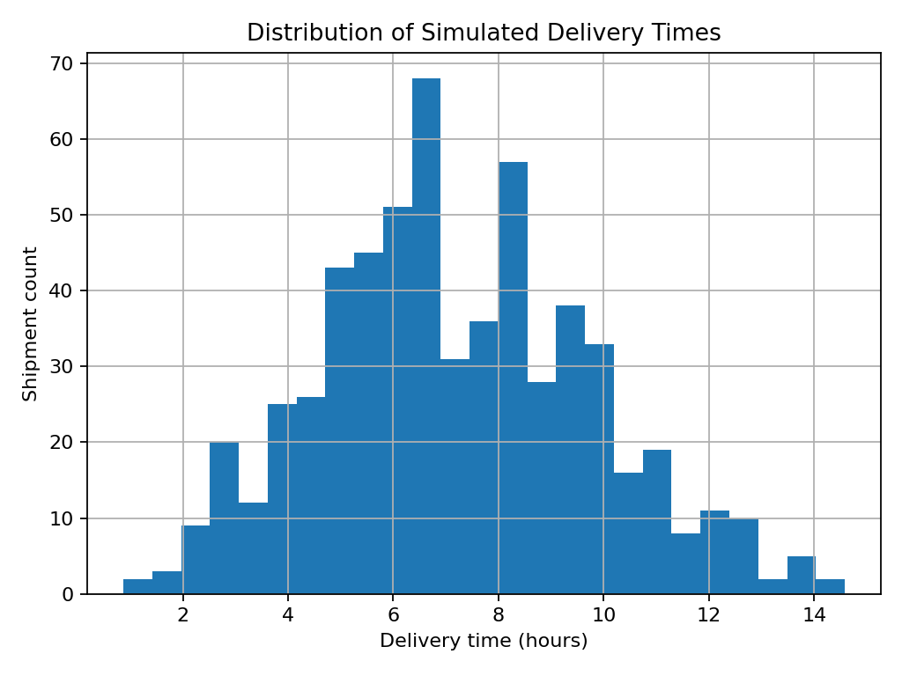
Figure 1. Distribution of simulated delivery times.
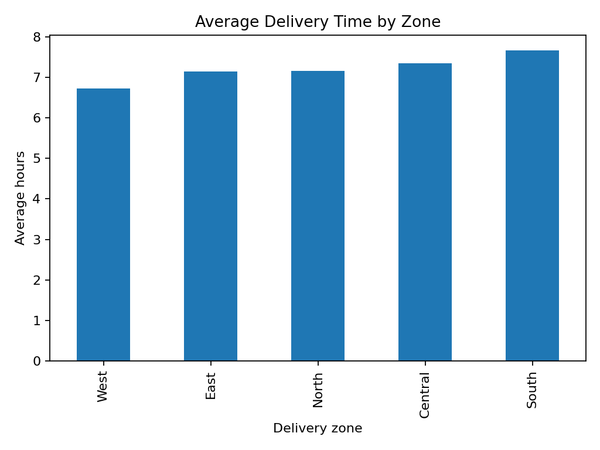
Figure 2. Average simulated delivery time by zone.
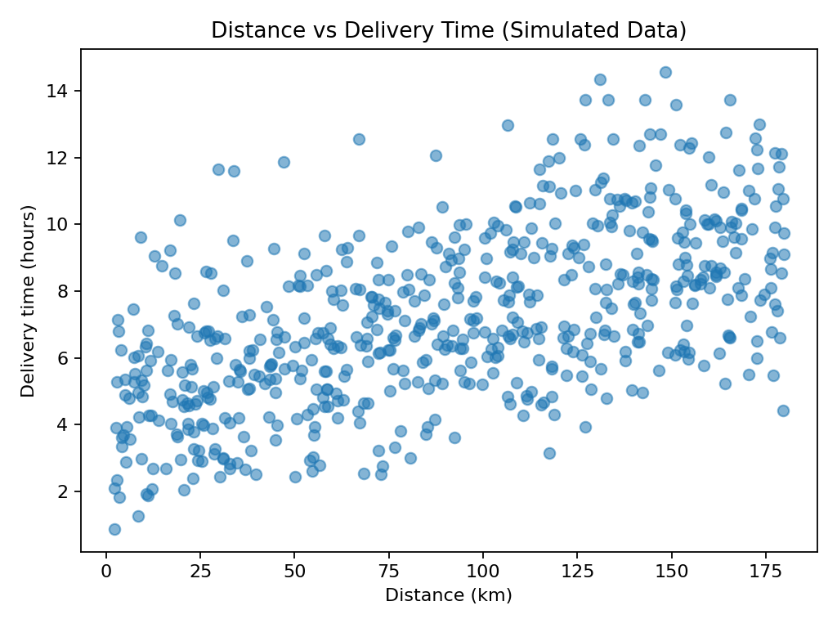
Figure 3. Distance and delivery duration.
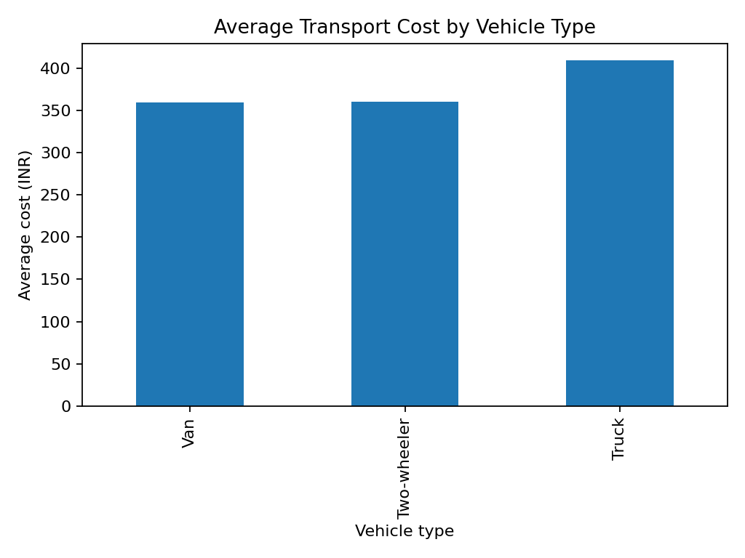
Figure 4. Average simulated transport cost by vehicle type.

5. Statistical Relationships
A correlation matrix can identify linear associations among numeric variables. A positive correlation between distance and delivery time would be operationally plausible, but correlation can be affected by traffic, weather, service priority and the way the synthetic data was generated. Correlation should not be presented as proof that one factor independently causes a delay.

6. Python and Reproducibility
The week3_eda.py script uses pandas for summaries and matplotlib for charts. The image files embedded in this report are generated from the reproducible simulated dataset. Re-run the script to recreate the charts. For real reporting, include a date range, data-source notes, definitions, sample sizes and version information.

7. Actionable Recommendations
Use zone comparisons to decide where to inspect dispatch timing or staffing. Review long-distance exceptions together with traffic and weather. Compare vehicles on cost per parcel, capacity and service constraints rather than average cost alone. Establish a baseline and run a controlled pilot before changing routing or resource allocation.

8. Limitations
All observed patterns are generated from synthetic data and should not be treated as findings about a real company. The report demonstrates a workflow and chart selection. Real conclusions require representative, quality-checked operational records.

References and Learning Resources
- pandas documentation: https://pandas.pydata.org/docs/
- scikit-learn user guide: https://scikit-learn.org/stable/user_guide.html
- Matplotlib documentation: https://matplotlib.org/stable/users/index.html
- Dataset note: synthetic dataset generated for this educational project; no real company data was used.

Submission Description (copy into YuvaIntern form)
This report explores the simulated logistics dataset using descriptive statistics, group comparisons, correlation analysis, and visualizations generated with Python. It outlines the dataset variables and examines delivery duration, shipment distance, parcel weight, transport cost, service priority, traffic, weather, vehicle type, and delivery zone. The report includes visual outputs for delivery-time distribution, average delivery time by zone, the relationship between distance and delivery duration, and average cost by vehicle type. Each chart is selected to answer a practical question: a histogram shows spread and skew, a bar chart compares operational groups, a scatter plot reveals relationships and potential exceptions, and summary statistics quantify central tendency and variability. The accompanying code uses pandas and matplotlib so the analysis can be rerun and audited. Interpretations are framed as patterns to investigate rather than proven causal claims, because the records are simulated and the results cannot establish real-world performance. The report explains how managers could use these views to identify zones for further investigation, check whether long-distance shipments take longer, and compare costs while accounting for vehicle capacity and service requirements. It ends with recommendations for validating these hypotheses on real operational data before making policy or routing changes. The visualizations are accompanied by explanations of what each chart can and cannot establish, helping prevent overconfident conclusions from small or synthetic samples. The report encourages checking group sizes, validating unexpected points, and combining charts with domain knowledge before recommending changes. It also discusses how the same reporting structure could be reused in a real logistics team through regular KPI reviews and documented comparisons over time.

