MICRO PROJECT HANDOUT BATCH(2024-2028) PROJECT BATCH NO:
BLOCKCHAIN-BASED E-TENDER MANAGEMENT SYSTEM
Smart E-Tendering for Secure Bidding, Transparent Allocation & ML Monitoring

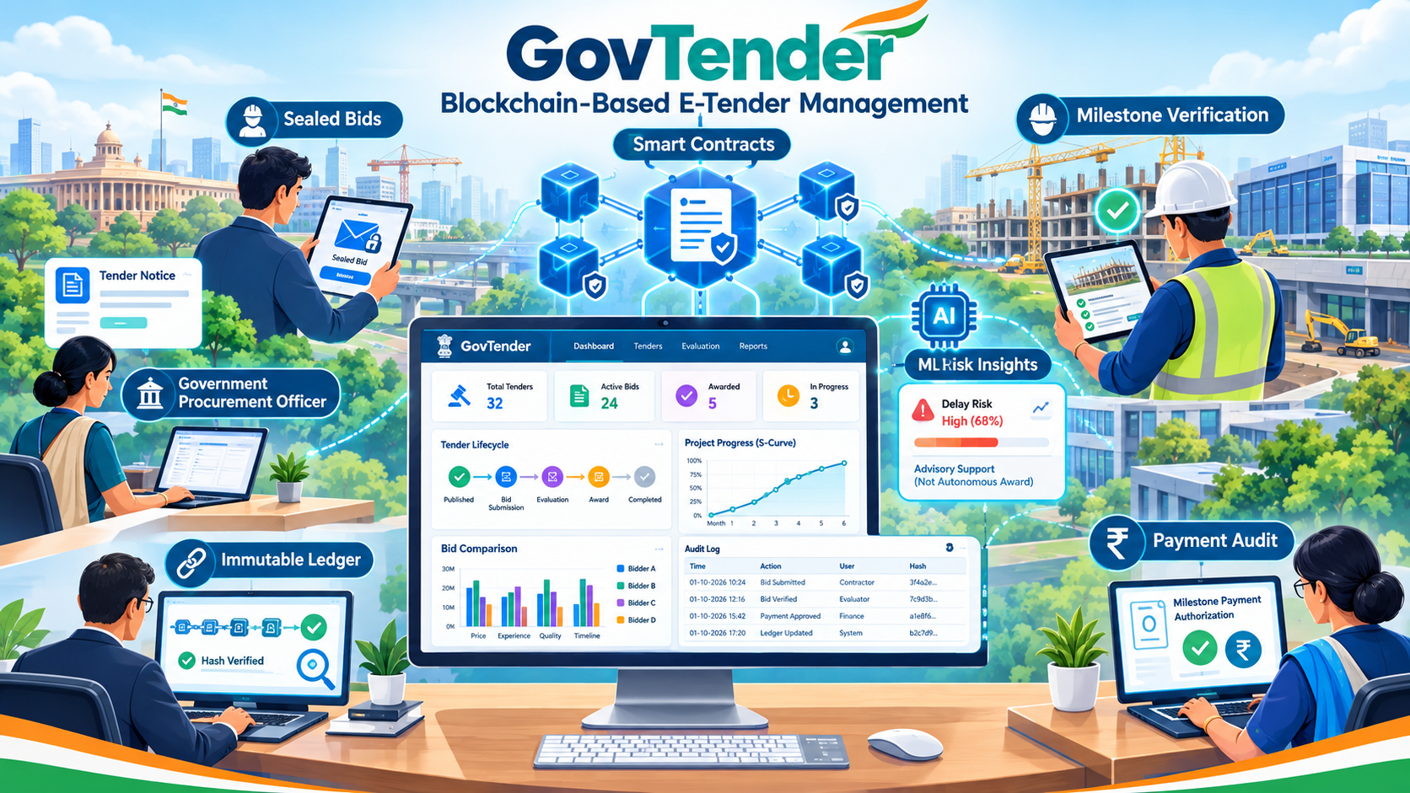



College Vision and Mission

Vision:
To be globally recognized for excellence in quality education, innovation and research for the transformation of lives to serve the society.

Mission:
M1: Quality Education: To provide comprehensive academic system that amalgamates the cutting edge technologies with best practices.
M2: Research and Innovation: To foster value-based research and innovation in collaboration with industries and institutions globally for creating intellectuals with new avenues.
M3: Employability and Entrepreneurship: To inculcate the employability and entrepreneurial skills through value and skill based training.
M4: Ethical Values: To instill deep sense of human values by blending societal righteousness with academic professionalism for the growth of society.

Department Vision and Mission

Vision:
To create a productive learning and research environment for graduates to become highly dynamic, competent, ethically responsible, professionally knowledgeable in the field of computer science and engineering to meet the industrial needs on par with global standards.

Mission:
M1: Quality Education: Empowering the students with the necessary technical skills through quality education to grow professionally.
M2: Innovative Research: Advocating the innovative research ideas by incorporating with industries for developing products and services.
M3: Placement and Entrepreneurship: Advancing the education by strengthening the Industry-academic relationship through hands-on training to seek placement in the top most industries or to develop a start-ups.
M4: Ethics and Social Responsibilities: Stimulating professional behaviour and good ethical values to improve the leadership skills and social responsibilities.



TEAM MEMBERS


PHOTO


PHOTO


RANJANI M
LAKSHMIPRIYA R
SHIYONA THILAK



YUVASRI S

MENTORS


PHOTO

NAME: Mrs. V. INDUMATHY
DESIGNATION: Assistant Professor
QUALIFICATION: SPECIALIZATION: YEARS OF EXPERIENCE:

PROBLEM STATEMENT

The current government e-tendering process faces challenges in ensuring secure bidding,

transparent tender allocation, and effective monitoring of projects after contract award. Limited

integration of tamper-evident records, automated workflows, and predictive analysis can make it

difficult to track procurement activities and project performance

Lack of Transparency in Tender Allocation:
Manual intervention and centralized record management can make it difficult to maintain transparent, traceable and accountable tender allocation processes.
The lack of a tamper-evident audit trail may create challenges in verifying tender-related activities.
This can reduce public trust and make it harder to identify unauthorized changes or irregularities.

Security and Bid Confidentiality:

Risk of unauthorized access, data tampering and premature disclosure of confidential bid

information. Improper handling of sensitive documents may compromise the fairness and

integrity of the bidding process. Secure access control and reliable record management are

essential to protect bid information.

Inefficient Evaluation and Risk Prediction:

Challenges in evaluating contractors based on their experience, financial capability and past performance. Manual evaluation can be time-consuming, making it difficult to assess multiple bids efficiently. Limited predictive analysis can also delay the identification of potential project risks, such as construction delays and cost overruns.

Limited Project Monitoring and Accountability:

Difficulty tracking project milestones, quality inspections, payments and audit records after tender allocation. Lack of integrated monitoring can make it challenging to identify project delays, incomplete work and deviations from planned budgets. This can affect timely decision-making and accountability throughout the project lifecycle.

OUR SOLUTION

RESEARCHIQ

- Blockchain-Based Transparent Tender Allocation:
Uses Hyperledger Fabric and smart contracts to manage tender publication, bidding,
evaluation and allocation. Maintains tamper-evident records of all important tender activities.
Automates predefined rules to reduce manual intervention. Improves transparency,
traceability and accountability in tender allocation.

Secure Bidding and Role-Based Access:
Provides a secure platform for submitting and managing confidential bids. Implements role-
based access control for officers, contractors, evaluators and auditors. Restricts access to
sensitive information based on user responsibilities. Protects bid confidentiality and reduces
the risk of unauthorized access.

ML-Based Risk Prediction:
Uses machine learning to analyze contractor and project-related data. Considers past
delays, cost overruns, experience and project duration. Identifies potential risks that may
affect project completion. Provides risk indicators to support informed decision-making
by officials.

Integrated Project Monitoring and Audit:
Tracks project milestones, construction progress and quality inspections.
Maintains records of payment details and project updates. Uses
blockchain to provide traceable records of important activities. Improves
post-award monitoring, transparency and project accountability.

PROJECT CHALLENGES

Blockchain Integration:
Integrating Hyperledger Fabric with the web application and database requires proper
coordination. Maintaining reliable communication between the blockchain network and
backend is a key challenge.

Data Security and Confidentiality:
Protecting sensitive bid information from unauthorized access and premature disclosure is
essential. Implementing secure storage and role-based access control is necessary.

ML Model Accuracy:
Obtaining reliable historical tender and contractor data can be difficult. Incomplete or
inconsistent data may affect the accuracy of risk predictions.

Smart Contract Development:
Designing and testing smart contracts to handle tender rules, bidding and allocation
requires careful implementation. Errors in contract logic may affect the tender
workflow.

Project Monitoring and Integration:
Integrating milestone tracking, quality inspections, payment records and ML risk predictions
into one platform can be complex. Ensuring accurate and consistent updates throughout the
project lifecycle is another challenge.

TEAM CONTRIBUTIONS
All team members contributed to project planning, literature survey, system architecture, feature
integration, debugging, testing, documentation and final presentation.

RANJANI M — BACKEND & BLOCKCHAIN DEVELOPMENT
- Designed the FastAPI backend for tender registration, bid submission and project monitoring.
- Implemented Hyperledger Fabric integration and smart contract workflows for secure, tamper-evident tender records.
- Developed APIs for tender management, transaction tracking and audit activities.
LAKSHMIPRIYA R — FRONTEND & UI/UX DEVELOPMENT
- Designed and developed the GovTender portal interface, including dashboards, tender listings and role-based views.
- Implemented interactive pages for tender publication, bid submission, milestone tracking and payment monitoring.
- Integrated frontend components with backend APIs for smooth data flow.
SHIYONA THILAK — MACHINE LEARNING & DATA ANALYSIS
- Developed the machine learning pipeline for contractor performance and project risk assessment.
- Prepared and processed datasets using Python, Pandas, NumPy and Scikit-learn.
- Implemented risk prediction for potential project delays, cost overruns and performance
issues.
YUVASRI S — DATABASE, TESTING & INTEGRATION
- Designed and managed the PostgreSQL database for tender, contractor, bid and project records.
- Integrated database operations with backend APIs and supported data validation.
- Performed system testing, debugging and documentation to verify the integration of blockchain,
ML and web modules.

ARCHITECTURE
High-Level System Architecture of ResearchIQ
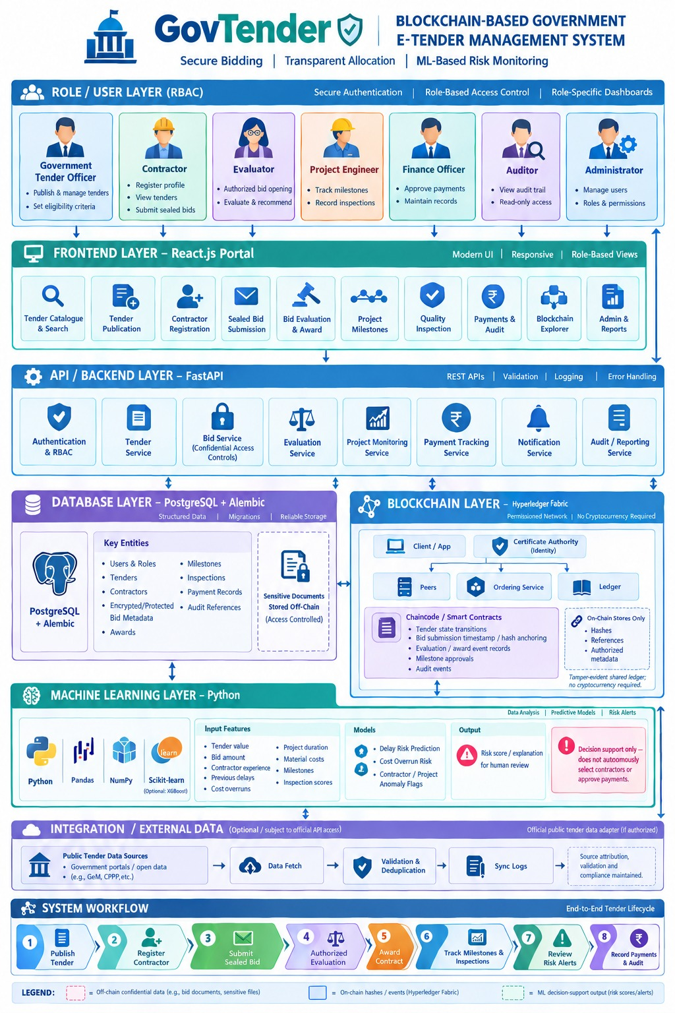


PROGRAMME OUTCOMES (POs)
PO1: Engineering knowledge: Apply the knowledge of mathematics, science, engineering fundamentals, and an engineering specialization to the solution of complex engineering problems.
PO2: Problem analysis: Identify, formulate, research literature, and analyze complex engineering problems reaching substantiated conclusions using first principles of mathematics, natural sciences, and engineering sciences.
PO3: Design/development of solutions: Design solutions for complex engineering problems and design system components or processes that meet the specified needs with appropriate consideration for the public health and safety, and the cultural, societal, and environmental considerations.
PO5: Modern tool usage: Create, select, and apply appropriate techniques, resources, and modern engineering and IT tools including prediction and modeling to complex engineering activities with an understanding of the limitations.
PO6: The engineer and society: Apply reasoning informed by the contextual knowledge to assess societal, health, safety, legal and cultural issues and the consequent responsibilities relevant to the professional engineering practice.
PO9: Individual and team work: Function effectively as an individual, and as a member or leader in diverse teams, and in multidisciplinary settings.

LINK

GITHUB : YOUTUBE : PPT :



