Web Programming

Assignment-1

SOURCE CODE:

<!DOCTYPE html>
<html lang="en">
<head>
<meta charset="UTF-8">
<title>User Interaction Demo App</title>
<meta name="viewport" content="width=device-width, initial-scale=1.0">

<style>
body {
font-family: Arial, sans-serif;
padding: 20px;
}

h1 {
text-transform: uppercase;
font-weight: bold;
}

.container {
width: 250px;
margin: auto;
padding: 15px;
border: 1px solid #ccc;
}

button {
padding: 8px;
margin-top: 8px;
cursor: pointer;
}

button:hover {
background-color: green;
color: white;
}

#box {
border: 1px solid black;
padding: 10px;
margin-top: 10px;
}

.item {
color: red;
}

.flex-center {
display: flex;
justify-content: center;
align-items: center;
height: 100px;
border: 1px dashed gray;
margin-top: 15px;
}

.hidden {
display: none;
}
</style>
</head>

<body>

<h1>User Interaction Demo Application</h1>

<form onsubmit="handleSubmit(event)">
<fieldset>
<legend>User Information</legend>

<label>
Username:
<input type="text" required>
</label>
<br><br>

<label>
Email:
<input type="email">
</label>
<br><br>

<label>
Rating (1–10):
<input type="number" min="1" max="10">
</label>
<br><br>

<label>
<input type="checkbox" required> I agree to terms
</label>
</fieldset>

<br>
<button type="submit">Submit</button>
</form>

<br>

<div class="container">
Centered Content Box
</div>

<div id="box">
This section is styled using ID selector.
</div>

<p class="item">This paragraph is styled using class selector.</p>

<div class="flex-center">
Flexbox Centered Content
</div>

<br>

<label>
Enter your name:
<input type="text" id="name">
</label>
<button onclick="displayName()">Display Name</button>

<p id="output"></p>

<br>

<button onclick="changeBackground()">Change Background to Yellow</button>

<br><br>

<label>
Enter a number:
<input type="number" id="numberCheck">
</label>
<button onclick="checkNumber()">Check</button>

<br><br>

<label>
Add Numbers:
<input type="number" id="num1" placeholder="First">
<input type="number" id="num2" placeholder="Second">
</label>
<button onclick="addNumbers()">Add</button>

<br><br>

<button id="clickBtn" onclick="changeText()">Click Me</button>

<br><br>

Progress:
<progress value="60" max="100"></progress>

<br><br>

<a href="https://example.com" target="_blank">Visit Example Website</a>

<p class="hidden">This text is hidden.</p>

<script>
console.log("Application Loaded on:", new Date());

function handleSubmit(event) {
event.preventDefault();
alert("Form submission prevented for demo purpose.");
}

function displayName() {
const name = document.getElementById("name").value;
document.getElementById("output").innerHTML = name;
}

function changeBackground() {
document.body.style.backgroundColor = "yellow";
}

function checkNumber() {
const num = Number(document.getElementById("numberCheck").value);
if (num > 10) {
alert("Number is greater than 10");
} else {
alert("Number is 10 or less");
}
}

function addNumbers() {
const a = Number(document.getElementById("num1").value);
const b = Number(document.getElementById("num2").value);
const sum = a + b;
alert("Sum = " + sum);
console.log("Sum:", sum);
}

function changeText() {
document.getElementById("clickBtn").innerHTML = "Clicked";
}
</script>

</body>
</html>

OUTPUT:

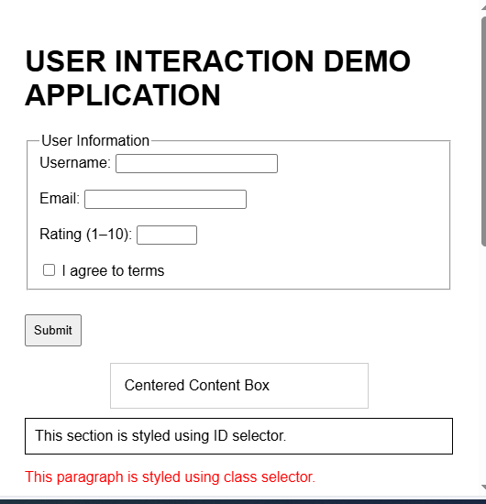

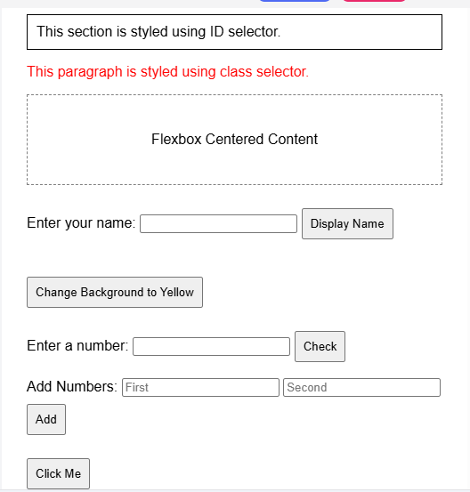

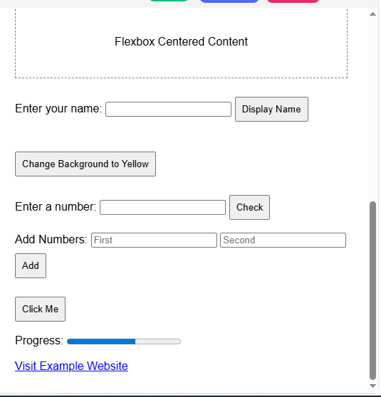

YUVA DHARSHINI.C
CSE-A
2403917710422185

