22CS450-WEB PROGRAMMING

LAB ZERO EXPERIMENT
NAME: YUVA DHARSHINI.C
REG NO: 2403917710422185
SLOT: CSE-IV ’A’

AIM:
To design and develop basic web pages using HTML and CSS by implementing commonly used HTML tags such as text formatting, images, links, lists, tables, semantic elements, multimedia elements, and forms, and to apply basic styling and interactivity for better presentation and usability.
SOFTWARE USED:
- Operating System: Windows / Linux
- Text Editor / IDE: Visual Studio Code (or Notepad++, Sublime Text)
- Web Browser: Google Chrome / Microsoft Edge / Mozilla Firefox
TAG DESCRIPTION:
<html>
Defines the root element of an HTML document. All other HTML elements are written inside this tag.
<head>
Contains meta information about the webpage such as title, character set, and styles.
<title>
Specifies the title of the webpage that appears on the browser tab.
<meta>
Provides metadata such as character encoding and viewport settings.
<style>
Used to write internal CSS for styling the webpage.
<body>
Contains all the visible content of the webpage.

Text & Structure Tags
<h1> to <h6>
Used to define headings. <h1> is the largest heading and <h6> is the smallest.
<p>
Defines a paragraph of text.
<br>
Inserts a line break within text.
<hr>
Creates a horizontal line used to separate content.
<b>
Displays text in bold.
<i>
Displays text in italic style.
<u>
Underlines the text.

List Tags
<ul>
Creates an unordered (bulleted) list.
<ol>
Creates an ordered (numbered) list.
<li>
Defines an item inside a list.

Table Tags
<table>
Used to create a table.
<caption>
Provides a title for the table.
<tr>
Defines a table row.
<th>
Defines a table header cell.
<td>
Defines a table data cell.

Form Tags
<form>
Creates a form to collect user input.
<label>
Defines a label for form input elements.
<input>
Accepts user input. Different types include text, email, password, date, radio, checkbox, file, etc.
<textarea>
Used to accept multi-line text input.
<select>
Creates a drop-down list.
<option>
Defines an option inside a drop-down list.
<optgroup>
Groups related options inside a drop-down list.
<datalist>
Provides a list of predefined options for input fields.
<fieldset>
Groups related form elements together.
<legend>
Provides a caption for a fieldset.
<button>
Creates a clickable button.
<output>
Displays the result of a calculation or user input.

Input Type Attributes (used with <input>)
type
Specifies the type of input such as text, email, password, radio, checkbox, date, time, file, range, color, etc.
required
Makes the input field mandatory.
placeholder
Displays a hint inside the input field.
pattern
Specifies a regular expression that the input value must match.
min, max
Defines minimum and maximum values for number and range inputs.
maxlength
Limits the maximum number of characters.
disabled
Disables the input field so it cannot be edited.

Media & Link Tags
<a>
Creates a hyperlink to another webpage.
<img>
Displays an image on the webpage.
<iframe>
Embeds another webpage inside the current webpage.

Script & Interactive Tags
<script>
Used to write JavaScript code for validation and interaction.
<progress>
Displays progress of a task.

SOURCE CODE:
<!DOCTYPE html>
<html lang="en">
<head>
<meta charset="UTF-8" />
<meta name="viewport" content="width=device-width, initial-scale=1.0" />
<meta name="description" content="Lab 0 - Form Creation Webpage using HTML, CSS and JavaScript validation." />
<title>Lab 0 - Creative Form Creation</title>

<style>
:root {
--bg1: #0b1020;
--bg2: #111a33;
--card: rgba(255,255,255,0.08);
--card2: rgba(255,255,255,0.12);
--text: #eaf0ff;
--muted: rgba(234,240,255,0.75);
--border: rgba(255,255,255,0.18);
--ok: #38d39f;
--bad: #ff5c7a;
--warn: #ffcc66;
}

* { box-sizing: border-box; }
body {
margin: 0;
font-family: system-ui, -apple-system, Segoe UI, Roboto, Arial, sans-serif;
color: var(--text);
background: radial-gradient(1000px 600px at 20% 10%, #2b5cff55, transparent 60%),
radial-gradient(900px 500px at 80% 30%, #ff2e7a44, transparent 55%),
linear-gradient(145deg, var(--bg1), var(--bg2));
min-height: 100vh;
padding: 28px 16px;
}

header {
max-width: 1100px;
margin: 0 auto 18px auto;
padding: 18px 18px 8px;
}
header h1 {
margin: 0 0 6px;
font-size: clamp(1.4rem, 2.2vw, 2.1rem);
letter-spacing: 0.3px;
}
header p { margin: 0; color: var(--muted); }

.grid {
max-width: 1100px;
margin: 0 auto;
display: grid;
grid-template-columns: 1.2fr 0.8fr;
gap: 16px;
}

.card {
background: var(--card);
border: 1px solid var(--border);
border-radius: 18px;
padding: 16px;
backdrop-filter: blur(10px);
box-shadow: 0 18px 60px rgba(0,0,0,0.35);
}

.row {
display: grid;
grid-template-columns: 1fr 1fr;
gap: 12px;
}

fieldset {
border: 1px solid var(--border);
border-radius: 14px;
padding: 14px;
margin: 12px 0;
background: rgba(255,255,255,0.04);
}

legend {
padding: 0 10px;
color: var(--muted);
letter-spacing: 0.2px;
}

label {
display: inline-block;
font-size: 0.92rem;
margin: 0 0 6px;
color: var(--muted);
}

input, select, textarea {
width: 100%;
padding: 10px 10px;
border-radius: 12px;
border: 1px solid var(--border);
background: rgba(10,12,18,0.35);
color: var(--text);
outline: none;
}

input:focus, select:focus, textarea:focus {
border-color: rgba(255,255,255,0.35);
box-shadow: 0 0 0 3px rgba(90,160,255,0.18);
}

textarea { min-height: 92px; resize: vertical; }

.inline {
display: flex;
flex-wrap: wrap;
gap: 10px 14px;
align-items: center;
margin-top: 6px;
}

.inline label { margin: 0; color: var(--text); font-size: 0.95rem; }
.inline input[type="radio"], .inline input[type="checkbox"] { width: auto; }

.hint {
font-size: 0.86rem;
color: var(--muted);
margin: 6px 0 0;
}

.error {
font-size: 0.86rem;
color: var(--bad);
margin-top: 6px;
min-height: 18px;
}

.actions {
display: flex;
flex-wrap: wrap;
gap: 10px;
margin-top: 12px;
}

button, input[type="submit"], input[type="reset"] {
width: auto;
padding: 10px 14px;
border-radius: 12px;
border: 1px solid var(--border);
background: linear-gradient(135deg, rgba(90,160,255,0.35), rgba(255,46,122,0.25));
color: var(--text);
cursor: pointer;
font-weight: 600;
letter-spacing: 0.2px;
}

button:hover, input[type="submit"]:hover, input[type="reset"]:hover {
border-color: rgba(255,255,255,0.35);
}

.ghost {
background: rgba(255,255,255,0.06);
}

.ok {
color: var(--ok);
font-weight: 700;
}

hr {
border: none;
border-top: 1px solid var(--border);
margin: 14px 0;
}

table {
width: 100%;
border-collapse: collapse;
overflow: hidden;
border-radius: 14px;
border: 1px solid var(--border);
background: rgba(255,255,255,0.04);
}
caption {
caption-side: top;
text-align: left;
padding: 10px 6px;
color: var(--muted);
font-weight: 600;
}
th, td {
padding: 10px 10px;
border-bottom: 1px solid rgba(255,255,255,0.10);
vertical-align: top;
}
th { color: var(--muted); width: 36%; }

.badge {
display: inline-block;
padding: 6px 10px;
border: 1px solid var(--border);
border-radius: 999px;
background: rgba(255,255,255,0.06);
color: var(--muted);
font-size: 0.86rem;
margin-right: 6px;
margin-bottom: 6px;
}

.media {
display: flex;
gap: 12px;
align-items: center;
}

.media img {
width: 92px;
height: 92px;
border-radius: 16px;
border: 1px solid var(--border);
background: rgba(255,255,255,0.06);
}

.small {
font-size: 0.88rem;
color: var(--muted);
margin: 6px 0 0;
line-height: 1.4;
}

@media (max-width: 920px) {
.grid { grid-template-columns: 1fr; }
.row { grid-template-columns: 1fr; }
}
</style>
</head>

<body>
<header>
<h1>Lab 0: Creative Form Creation Webpage</h1>
<p>
This page uses <strong>HTML form tags</strong>, <strong>many input types</strong>, <strong>CSS styling</strong>,
and <strong>JavaScript validation</strong> (submit button + error messages).
</p>
</header>

<div class="grid">

<!-- LEFT: FORM -->
<section class="card" id="formSection">
<h2>🌟 Student Profile & Event Registration</h2>
<p class="hint">
Fill all required fields. Use the <span class="ok">Submit</span> button to validate.
</p>

<hr />

<!-- FORM -->
<form id="labForm" action="#" method="post" autocomplete="on" novalidate>
<fieldset>
<legend>Account Details</legend>

<div class="row">
<div>
<label for="username">Username (required, pattern, minlength)</label>
<input
type="text"
id="username"
name="username"
placeholder="Eg: your_name"
required
autofocus
pattern="^[a-zA-Z][a-zA-Z0-9_]{4,14}$"
minlength="5"
maxlength="15"
size="20"
/>
<div class="hint">Pattern: starts with letter, 5–15 chars, letters/numbers/_</div>
<div class="error" id="errUsername"></div>
</div>

<div>
<label for="email">Email (required)</label>
<input
type="email"
id="email"
name="email"
placeholder="Eg: name@gmail.com"
required
/>
<div class="error" id="errEmail"></div>
</div>
</div>

<div class="row">
<div>
<label for="password">Password (required, minlength, pattern)</label>
<input
type="password"
id="password"
name="password"
placeholder="Min 8 chars, 1 letter & 1 number"
required
minlength="8"
maxlength="20"
pattern="^(?=.*[A-Za-z])(?=.*\d).{8,20}$"
/>
<div class="hint">
Strength:
<output id="pwdStrength" name="pwdStrength" for="password">—</output>
</div>
<div class="error" id="errPassword"></div>
</div>

<div>
<label for="phone">Phone (tel, required, pattern)</label>
<input
type="tel"
id="phone"
name="phone"
placeholder="Eg: 9876543210"
required
pattern="^[0-9]{10}$"
maxlength="10"
/>
<div class="error" id="errPhone"></div>
</div>
</div>

<div class="row">
<div>
<label for="website">Website/Portfolio (url)</label>
<input
type="url"
id="website"
name="website"
placeholder="https://example.com"
/>
<div class="error" id="errWebsite"></div>
</div>

<div>
<label for="search">Search Interest (search)</label>
<input
type="search"
id="search"
name="search"
placeholder="Eg: Web Development"
/>
<div class="hint">This is just to show the input type.</div>
</div>
</div>
</fieldset>

<fieldset>
<legend>Personal & Preferences</legend>

<div class="row">
<div>
<label for="dept">Department (select + optgroup + option)</label>
<select id="dept" name="dept" required>
<option value="" disabled selected>Select your department</option>
<optgroup label="Engineering">
<option value="cse">CSE</option>
<option value="ece">ECE</option>
<option value="eee">EEE</option>
</optgroup>
<optgroup label="Science">
<option value="maths">Maths</option>
<option value="physics">Physics</option>
</optgroup>
</select>
<div class="error" id="errDept"></div>
</div>

<div>
<label for="city">City (datalist)</label>
<input list="cityList" id="city" name="city" placeholder="Type or select…" />
<datalist id="cityList">
<option value="Chennai"></option>
<option value="Coimbatore"></option>
<option value="Madurai"></option>
<option value="Trichy"></option>
<option value="Salem"></option>
</datalist>
<div class="hint">Uses &lt;datalist&gt; + &lt;option&gt;.</div>
</div>
</div>

<div class="row">
<div>
<label>Gender (radio)</label>
<div class="inline">
<label><input type="radio" name="gender" value="Female" required /> Female</label>
<label><input type="radio" name="gender" value="Male" /> Male</label>
<label><input type="radio" name="gender" value="Other" /> Other</label>
</div>
<div class="error" id="errGender"></div>
</div>

<div>
<label>Skills (checkbox)</label>
<div class="inline">
<label><input type="checkbox" name="skills" value="HTML" /> HTML</label>
<label><input type="checkbox" name="skills" value="CSS" /> CSS</label>
<label><input type="checkbox" name="skills" value="JavaScript" /> JavaScript</label>
<label><input type="checkbox" name="skills" value="C" /> C</label>
</div>
<p class="hint">At least 1 skill recommended (not required).</p>
</div>
</div>

<div class="row">
<div>
<label for="bio">About You (textarea)</label>
<textarea id="bio" name="bio" placeholder="Write 2–3 lines about yourself…"></textarea>
<div class="hint">Uses &lt;textarea&gt;.</div>
</div>

<div>
<label for="favColor">Favorite Color (color)</label>
<input type="color" id="favColor" name="favColor" value="#5aa0ff" />
<p class="hint">Uses input type="color".</p>

<label for="range">Confidence Level (range + output)</label>
<input type="range" id="range" name="range" min="0" max="10" value="5" />
<p class="hint">Value: <output id="rangeOut" name="rangeOut" for="range">5</output>/10</p>
</div>
</div>
</fieldset>

<fieldset>
<legend>Date & Time Inputs</legend>

<div class="row">
<div>
<label for="date">Date (date)</label>
<input type="date" id="date" name="date" required />
<div class="error" id="errDate"></div>
</div>

<div>
<label for="time">Time (time)</label>
<input type="time" id="time" name="time" required />
<div class="error" id="errTime"></div>
</div>
</div>

<div class="row">
<div>
<label for="dtlocal">DateTime (datetime-local)</label>
<input type="datetime-local" id="dtlocal" name="dtlocal" />
<p class="hint">Shows datetime-local input type.</p>
</div>

<div>
<label for="month">Month (month)</label>
<input type="month" id="month" name="month" />
<p class="hint">Shows month input type.</p>
</div>
</div>

<div class="row">
<div>
<label for="week">Week (week)</label>
<input type="week" id="week" name="week" />
</div>

<div>
<label for="age">Age (number with min/max)</label>
<input type="number" id="age" name="age" min="16" max="60" placeholder="16 to 60" />
<p class="hint">min=16, max=60 example.</p>
</div>
</div>
</fieldset>

<fieldset>
<legend>File Upload & Special Attributes</legend>

<div class="row">
<div>
<label for="photo">Upload Photo (file)</label>
<input type="file" id="photo" name="photo" accept="image/*" />
<p class="hint">Uses input type="file".</p>
</div>

<div>
<label for="disabledDemo">Disabled Field (disabled)</label>
<input type="text" id="disabledDemo" name="disabledDemo" value="This field is disabled" disabled />
<p class="hint">Demonstrates the disabled attribute.</p>
</div>
</div>

<div class="row">
<div>
<label for="code">Student Code (maxlength + placeholder)</label>
<input type="text" id="code" name="code" placeholder="Eg: CSE2026" maxlength="8" />
<p class="hint">maxlength=8 example.</p>
</div>

<div>
<label for="id">College ID (pattern)</label>
<input type="text" id="id" name="id" placeholder="Eg: NC-1234"
pattern="^NC-\d{4}$" />
<p class="hint">Pattern: NC-1234 format.</p>
</div>
</div>
</fieldset>

<fieldset>
<legend>Terms & Submit</legend>

<div class="inline">
<label>
<input type="checkbox" id="terms" name="terms" required />
I agree to the terms (required)
</label>
</div>
<div class="error" id="errTerms"></div>

<div class="actions">
<input type="submit" value="Submit Form ✅" />
<input type="reset" value="Reset ↩" class="ghost" />
<button type="button" id="previewBtn" class="ghost">Preview Data 👀</button>
</div>

<p class="hint">
Submit → triggers JavaScript validation and shows errors.<br />
Reset → clears the form.
</p>
</fieldset>
</form>

<hr />

<!-- EXTRA HTML TAGS DEMO (as actual elements, not just text) -->
<section id="extras">
<h3>Extra HTML Tags Used (Lab Demo)</h3>
<p>
Here are some common tags: <strong>strong</strong>, <em>em</em>, <span class="badge">span</span>, and a line break below.<br />
This line appears after &lt;br&gt;.
</p>

<h4>List Example (ul / ol / li)</h4>
<ul>
<li>Form tags: form, label, input, button</li>
<li>Grouping tags: fieldset, legend</li>
<li>Options: select, optgroup, option, datalist</li>
</ul>

<ol>
<li>Fill the form</li>
<li>Click Submit</li>
<li>Check validation messages</li>
</ol>

<hr />

<h4>Image + Image Map (img + map + area)</h4>
<p class="hint">Click the image sections to jump to parts of this page.</p>

<!-- SVG data URL so it works offline -->
<img
alt="Clickable map demo"
usemap="#labmap"
src="data:image/svg+xml;utf8,
<svg xmlns='http://www.w3.org/2000/svg' width='320' height='180'>
<defs>
<linearGradient id='g' x1='0' x2='1'>
<stop offset='0' stop-color='%235aa0ff'/>
<stop offset='1' stop-color='%23ff2e7a'/>
</linearGradient>
</defs>
<rect width='320' height='180' rx='18' fill='url(%23g)' opacity='0.95'/>
<rect x='14' y='14' width='140' height='70' rx='14' fill='rgba(0,0,0,0.25)'/>
<rect x='166' y='14' width='140' height='70' rx='14' fill='rgba(0,0,0,0.25)'/>
<rect x='14' y='96' width='292' height='70' rx='14' fill='rgba(0,0,0,0.25)'/>
<text x='36' y='56' fill='white' font-size='16' font-family='Arial'>Go to Form</text>
<text x='188' y='56' fill='white' font-size='16' font-family='Arial'>Go to Table</text>
<text x='36' y='138' fill='white' font-size='16' font-family='Arial'>Go to Extras</text>
</svg>"
/>

<map name="labmap" id="labmap">
<area shape="rect" coords="14,14,154,84" href="#formSection" alt="Go to form" />
<area shape="rect" coords="166,14,306,84" href="#previewTable" alt="Go to table" />
<area shape="rect" coords="14,96,306,166" href="#extras" alt="Go to extras" />
</map>
</section>
</section>

<!-- RIGHT: PREVIEW / TABLE / INFO -->
<aside class="card">
<div class="media">
<img
alt="Lab badge"
src="data:image/svg+xml;utf8,
<svg xmlns='http://www.w3.org/2000/svg' width='120' height='120'>
<defs>
<linearGradient id='g' x1='0' x2='1'>
<stop offset='0' stop-color='%235aa0ff'/>
<stop offset='1' stop-color='%23ff2e7a'/>
</linearGradient>
</defs>
<rect width='120' height='120' rx='24' fill='url(%23g)'/>
<text x='22' y='64' fill='white' font-size='26' font-family='Arial' font-weight='700'>LAB</text>
<text x='58' y='92' fill='white' font-size='22' font-family='Arial' font-weight='700'>0</text>
</svg>"
/>
<div>
<h3 style="margin:0;">Preview Panel</h3>
<p class="small" style="margin:6px 0 0;">
Click <strong>Preview Data</strong> to show the entered values in a table.
</p>
</div>
</div>

<hr />

<table id="previewTable">
<caption>Submitted Data (Preview)</caption>
<tbody>
<tr><th>Username</th><td id="pUsername">—</td></tr>
<tr><th>Email</th><td id="pEmail">—</td></tr>
<tr><th>Phone</th><td id="pPhone">—</td></tr>
<tr><th>Department</th><td id="pDept">—</td></tr>
<tr><th>Gender</th><td id="pGender">—</td></tr>
<tr><th>Skills</th><td id="pSkills">—</td></tr>
<tr><th>Favorite Color</th><td id="pColor">—</td></tr>
<tr><th>Confidence</th><td id="pRange">—</td></tr>
<tr><th>Date</th><td id="pDate">—</td></tr>
<tr><th>Time</th><td id="pTime">—</td></tr>
</tbody>
</table>

<hr />

<h4>Quick Notes (for record)</h4>
<p class="small">
✅ Used tags: <strong>form, label, input, button, fieldset, legend, datalist, select, optgroup, option, textarea, output</strong><br />
✅ Used inputs: text, email, password, tel, url, search, date, time, datetime-local, month, week, range, color, file, submit, reset<br />
✅ Used attributes: required, autofocus, placeholder, disabled, size, maxlength, pattern, min, max
</p>

<p class="small">
For deprecated tags (<strong>frameset, frame, noframes</strong>), open the file
<strong>frameset-demo.html</strong> (below).
</p>
</aside>

</div>

<script>
// Get elements
const form = document.getElementById("labForm");

const username = document.getElementById("username");
const email = document.getElementById("email");
const password = document.getElementById("password");
const phone = document.getElementById("phone");
const website = document.getElementById("website");
const dept = document.getElementById("dept");
const date = document.getElementById("date");
const time = document.getElementById("time");
const terms = document.getElementById("terms");

const pwdStrength = document.getElementById("pwdStrength");

const range = document.getElementById("range");
const rangeOut = document.getElementById("rangeOut");

const previewBtn = document.getElementById("previewBtn");

// Update output for range
range.addEventListener("input", () => {
rangeOut.value = range.value;
});

// Password strength (simple)
password.addEventListener("input", () => {
const v = password.value;
let score = 0;
if (v.length >= 8) score++;
if (/[A-Za-z]/.test(v)) score++;
if (/\d/.test(v)) score++;
if (/[^A-Za-z0-9]/.test(v)) score++;

const labels = ["Weak", "Okay", "Good", "Strong", "Very Strong"];
pwdStrength.value = labels[score] || "—";
});

// Helper to set error messages
function setError(id, msg) {
document.getElementById(id).textContent = msg || "";
}

// Get selected gender
function getGender() {
const g = document.querySelector('input[name="gender"]:checked');
return g ? g.value : "";
}

// Get checked skills
function getSkills() {
return Array.from(document.querySelectorAll('input[name="skills"]:checked'))
.map(x => x.value);
}

// Validate URL only if filled
function isValidURL(value) {
if (!value.trim()) return true; // optional
try { new URL(value); return true; } catch { return false; }
}

// Main validation on submit
form.addEventListener("submit", (e) => {
e.preventDefault();

let ok = true;

// Clear previous errors
["errUsername","errEmail","errPassword","errPhone","errWebsite","errDept","errGender","errDate","errTime","errTerms"]
.forEach(id => setError(id, ""));

// Username
if (!username.checkValidity()) {
ok = false;
setError("errUsername", "Enter a valid username (5–15 chars, start with letter, letters/numbers/_).");
}

// Email
if (!email.checkValidity()) {
ok = false;
setError("errEmail", "Enter a valid email address.");
}

// Password
if (!password.checkValidity()) {
ok = false;
setError("errPassword", "Password must be 8–20 chars with at least 1 letter and 1 number.");
}

// Phone
if (!phone.checkValidity()) {
ok = false;
setError("errPhone", "Enter a 10-digit phone number (digits only).");
}

// Website (optional but must be valid if entered)
if (!isValidURL(website.value)) {
ok = false;
setError("errWebsite", "Please enter a valid URL (example: https://site.com).");
}

// Department
if (!dept.value) {
ok = false;
setError("errDept", "Please select your department.");
}

// Gender
if (!getGender()) {
ok = false;
setError("errGender", "Please select gender.");
}

// Date & Time required
if (!date.value) {
ok = false;
setError("errDate", "Please choose a date.");
}
if (!time.value) {
ok = false;
setError("errTime", "Please choose a time.");
}

// Terms
if (!terms.checked) {
ok = false;
setError("errTerms", "You must agree to the terms.");
}

if (ok) {
// If everything is valid, show preview and a success message
previewData();
alert("✅ Form submitted successfully (Lab demo). Data shown in preview table.");
// In real apps, you would submit to server here.
// form.submit();
}
});

// Preview button
previewBtn.addEventListener("click", () => previewData());

function previewData() {
const skills = getSkills();

document.getElementById("pUsername").textContent = username.value || "—";
document.getElementById("pEmail").textContent = email.value || "—";
document.getElementById("pPhone").textContent = phone.value || "—";

const deptText = dept.options[dept.selectedIndex]?.text || "—";
document.getElementById("pDept").textContent = deptText;

document.getElementById("pGender").textContent = getGender() || "—";
document.getElementById("pSkills").textContent = skills.length ? skills.join(", ") : "—";

document.getElementById("pColor").textContent = document.getElementById("favColor").value || "—";
document.getElementById("pRange").textContent = range.value ? range.value + "/10" : "—";

document.getElementById("pDate").textContent = date.value || "—";
document.getElementById("pTime").textContent = time.value || "—";
}
</script>
</body>
</html>

OUTPUT:
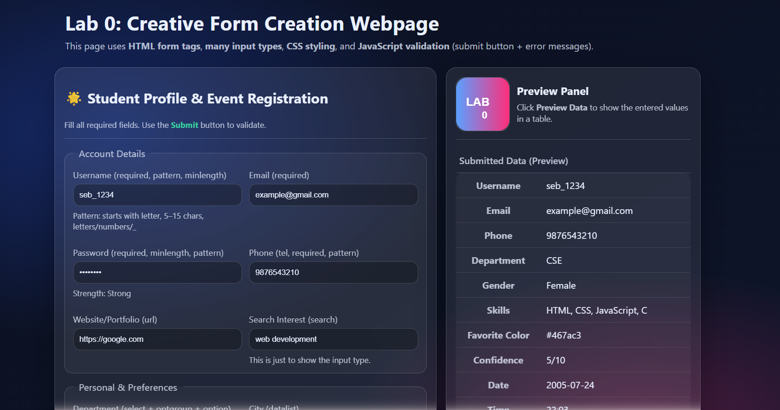

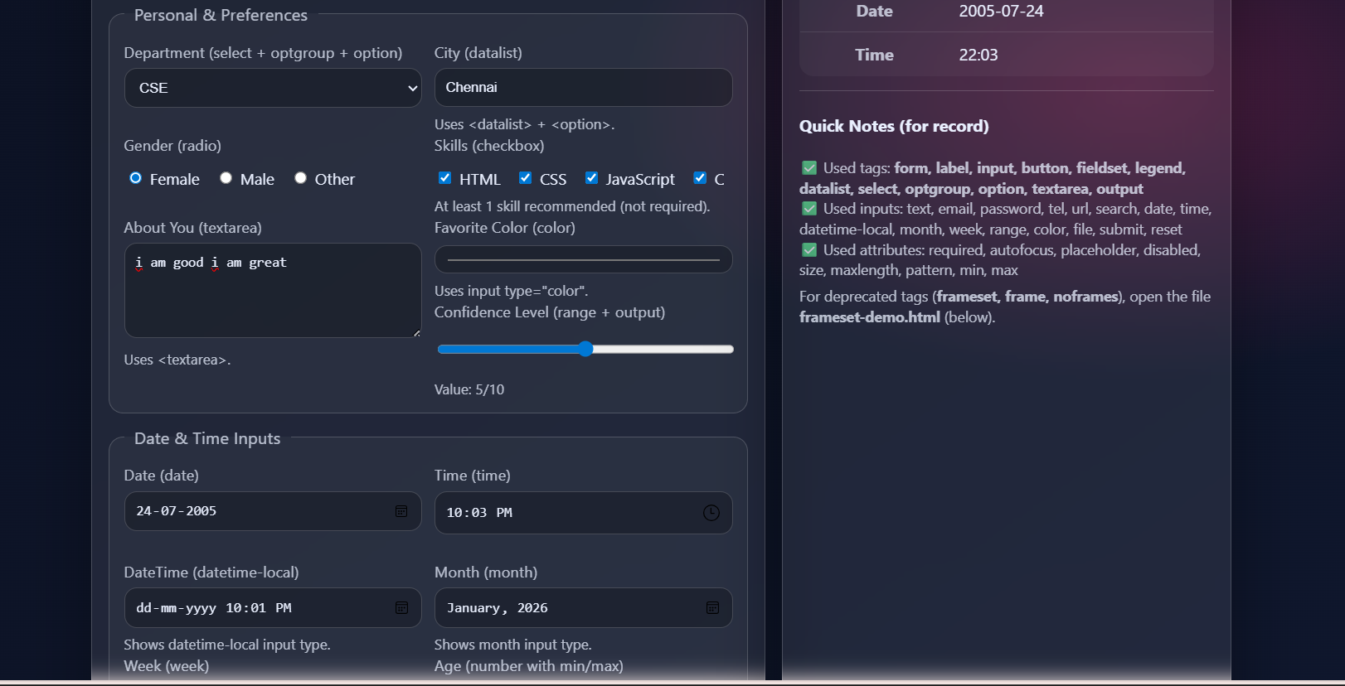

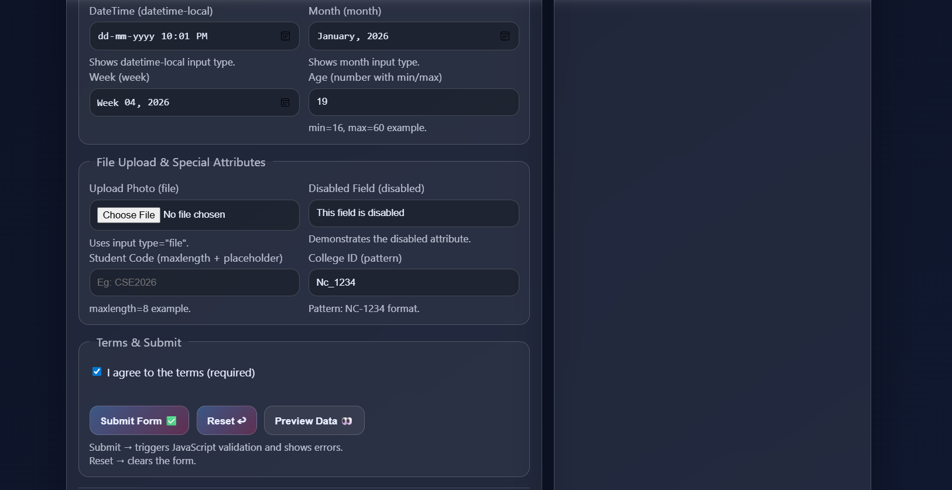

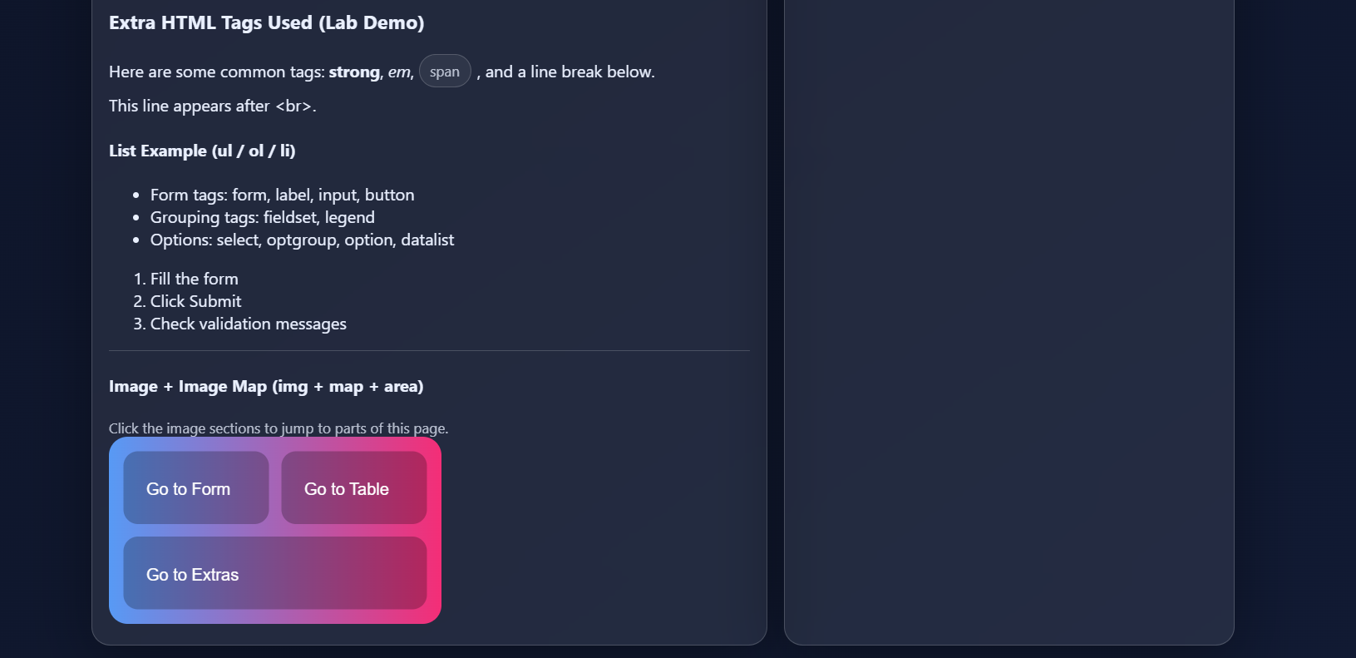

OTHER PROGRAMS:
PROGRAM1:
SOURCE CODE:
<!DOCTYPE html>
<html lang="en">
<head>
<meta charset="UTF-8" />
<meta http-equiv="X-UA-Compatible" content="IE=edge" />
<meta name="viewport" content="width=device-width, initial-scale=1.0" />
<meta name="description" content="Mini college info page using common HTML tags." />
<title>College Info</title>

<style>
body { font-family: Arial, sans-serif; margin: 20px; line-height: 1.5; }
header, footer { padding: 12px; border: 1px solid #ddd; }
nav a { margin-right: 12px; text-decoration: none; }
main { margin-top: 14px; }
.card { border: 1px solid #ddd; padding: 12px; border-radius: 8px; margin-top: 12px; }
table { width: 100%; border-collapse: collapse; margin-top: 10px; }
caption { font-weight: bold; margin-bottom: 6px; }
th, td { border: 1px solid #ccc; padding: 8px; text-align: left; }
tbody tr:nth-child(even) { background: #f7f7f7; }
tbody tr:nth-child(odd) { background: #ffffff; }
.note mark { padding: 0 4px; }
</style>
</head>

<body>
<header>
<h1>Web Programming Lab</h1>
<p class="note">Today’s topic: <mark>HTML tags</mark> + <u>CSS basics</u> + <strike>old mistakes</strike>.</p>

<nav>
<a href="#about">About</a>
<a href="#schedule">Schedule</a>
<a href="#lists">Lists</a>
</nav>
</header>

<main>
<section id="about" class="card">
<h2>About This Page</h2>
<article>
<h3>Why we use semantic tags?</h3>
<p>
<strong>Semantic tags</strong> make the page structure clear.
This sentence uses <b>b</b>, <i>i</i>, <em>em</em> and <span>span</span>.
</p>
<aside>
<p><small>Tip:</small> Put your main content inside <code>&lt;main&gt;</code>.</p>
</aside>
</article>
</section>

<section id="schedule" class="card">
<h2>Lab Schedule</h2>
<p>Next lab on <time datetime="2026-01-06">06 Jan 2026</time>.</p>

<table>
<caption>Weekly Plan</caption>
<thead>
<tr>
<th>Day</th>
<th>Topic</th>
<th>Task</th>
</tr>
</thead>
<tbody>
<tr>
<td rowspan="2">Monday</td>
<td>HTML Basics</td>
<td>Tags practice</td>
</tr>
<tr>
<td>Tables</td>
<td>Create table with <span>caption</span></td>
</tr>
<tr>
<td>Tuesday</td>
<td colspan="2">Forms + Validation (next experiment)</td>
</tr>
</tbody>
</table>
</section>

<section id="lists" class="card">
<h2>Lists</h2>

<h3>Ordered + Nested List</h3>
<ol>
<li>Learn tags</li>
<li>Practice
<ul>
<li>Headings</li>
<li>Tables</li>
<li>Lists</li>
</ul>
</li>
<li>Submit</li>
</ol>

<h3>Description List</h3>
<dl>
<dt>HTML</dt>
<dd>Structure of a webpage</dd>
<dt>CSS</dt>
<dd>Style (color, spacing, borders)</dd>
</dl>
</section>
</main>

<footer>
<p>Made for Lab Practice | <a href="#about">Back to top</a></p>
</footer>
</body>
</html>

OUTPUT:
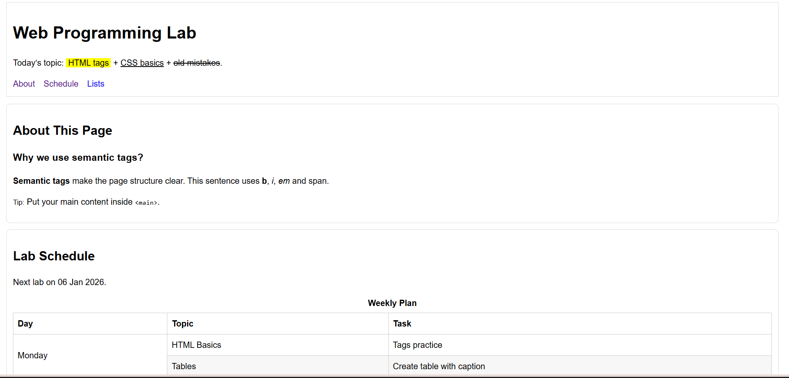
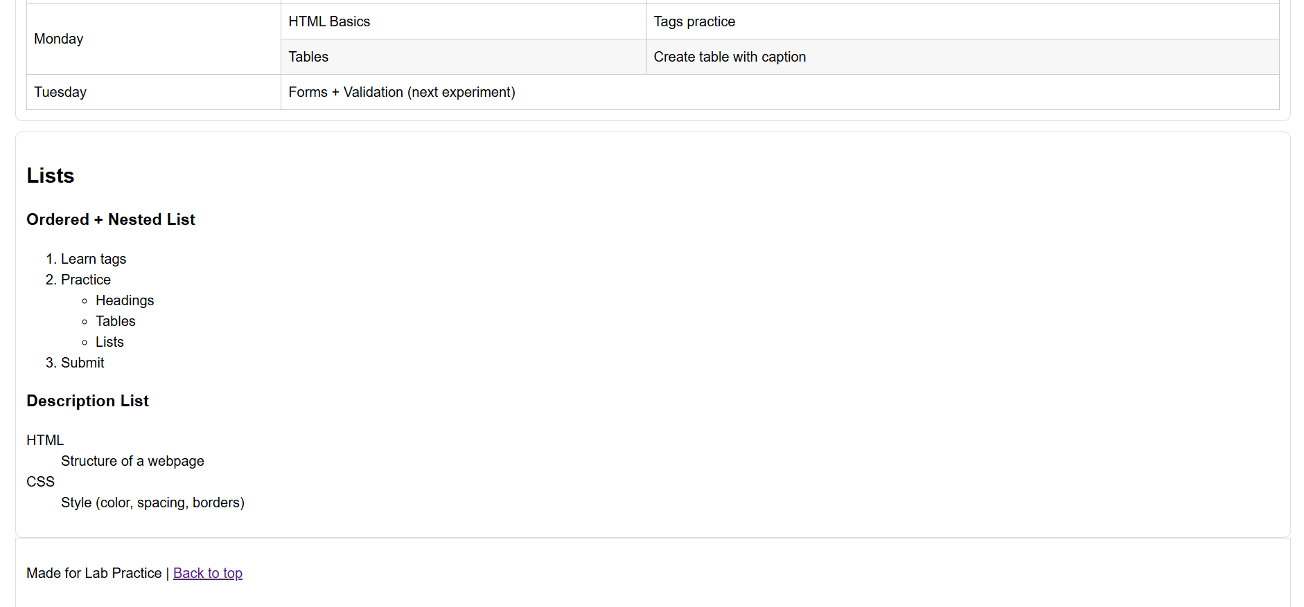

PROGRAM2:
SOURCE CODE:
<!DOCTYPE html>
<html lang="en">
<head>
<meta charset="UTF-8" />
<meta name="viewport" content="width=device-width, initial-scale=1.0" />
<title>Image Map Demo</title>
<style>
body { font-family: Arial, sans-serif; margin: 20px; }
figure { border: 1px solid #ddd; padding: 10px; border-radius: 8px; max-width: 520px; }
figcaption { margin-top: 8px; font-size: 14px; }
.hint { color: #555; }
</style>
</head>
<body>
<header>
<h1>Campus Map (Image Map)</h1>
<p class="hint">Click different regions (rect/circle/poly). Default area links to home.</p>
</header>

<main>
<figure>
<!-- Use any image you like; keep same width/height in your file -->
<img src="campus.png" alt="Campus map demo"
width="500" height="300" usemap="#campusMap" />

<map name="campusMap">
<!-- RECT: x1,y1,x2,y2 -->
<area shape="rect" coords="20,20,170,110" href="library.html" alt="Library" />

<!-- CIRCLE: x,y,r -->
<area shape="circle" coords="320,90,45" href="cafe.html" alt="Cafeteria" />

<!-- POLY: x1,y1,x2,y2,x3,y3... -->
<area shape="poly" coords="250,200,310,160,380,210,330,260" href="lab.html" alt="Computer Lab" />

<!-- DEFAULT -->
<area shape="default" href="index.html" alt="Home" />
</map>

<figcaption>
<strong>Note:</strong> Replace <em>campus.png</em> with your image.
</figcaption>
</figure>

<section>
<h2>Quick Links</h2>
<p>
<a href="index.html">Home</a> |
<a href="library.html">Library</a> |
<a href="lab.html">Lab</a>
</p>
</section>
</main>

<footer>
<p>Image map practice for Lab.</p>
</footer>
</body>
</html>

OUTPUT:
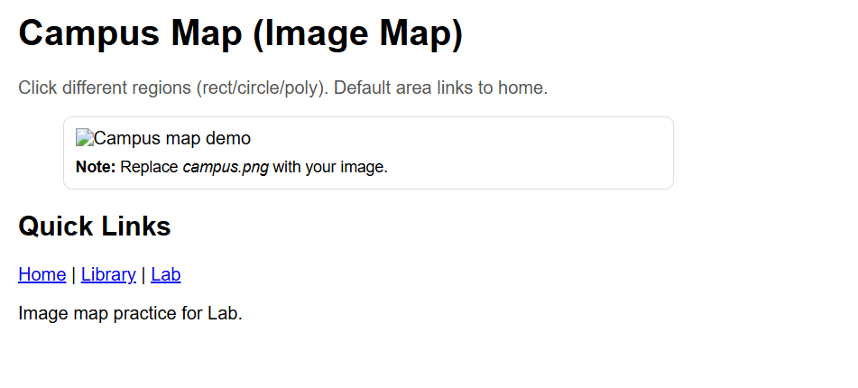
PROGRAM3:
SOURCE CODE:
<!DOCTYPE html>
<html lang="en">
<head>
<meta charset="UTF-8" />
<meta name="viewport" content="width=device-width, initial-scale=1.0" />
<title>Comparison Table</title>
<style>
body { font-family: Arial, sans-serif; margin: 20px; }
.wrap { max-width: 760px; }
table { width: 100%; border-collapse: collapse; }
caption { text-align: left; font-weight: bold; margin: 8px 0; }
th, td { border: 1px solid #bbb; padding: 10px; vertical-align: top; }
tbody tr:nth-child(even) { background: #f4f4f4; }
tbody tr:nth-child(odd) { background: #fff; }
.tag { display: inline-block; padding: 2px 6px; border: 1px solid #aaa; border-radius: 6px; }
</style>
</head>
<body>
<div class="wrap">
<header>
<h1>Device Comparison</h1>
<p>Simple table with <span class="tag">colspan</span> and <span class="tag">rowspan</span>.</p>
</header>

<main>
<table>
<caption>Comparison (Sample)</caption>
<thead>
<tr>
<th>Item</th>
<th>Battery</th>
<th>Performance</th>
<th>Progress</th>
</tr>
</thead>
<tbody>
<tr>
<td rowspan="2"><strong>Laptop A</strong><br><small><time datetime="2026-01-05">Updated: Jan 5</time></small></td>
<td><meter min="0" max="10" value="7">7/10</meter></td>
<td><meter min="0" max="10" value="8">8/10</meter></td>
<td><progress value="60" max="100"></progress> 60%</td>
</tr>
<tr>
<td colspan="3">
Notes: <mark>Good for coding</mark>, supports <u>fast compile</u>.
</td>
</tr>

<tr>
<td><strong>Laptop B</strong></td>
<td><meter min="0" max="10" value="9">9/10</meter></td>
<td><meter min="0" max="10" value="6">6/10</meter></td>
<td><progress value="40" max="100"></progress> 40%</td>
</tr>
</tbody>
</table>

<section>
<h2>Mini Notes</h2>
<p><b>Bold</b>, <i>italic</i>, <em>emphasis</em>, <strong>strong</strong> tags used.</p>
</section>
</main>

<footer>
<p>End of table demo.</p>
</footer>
</div>
</body>
</html>

OUTPUT:
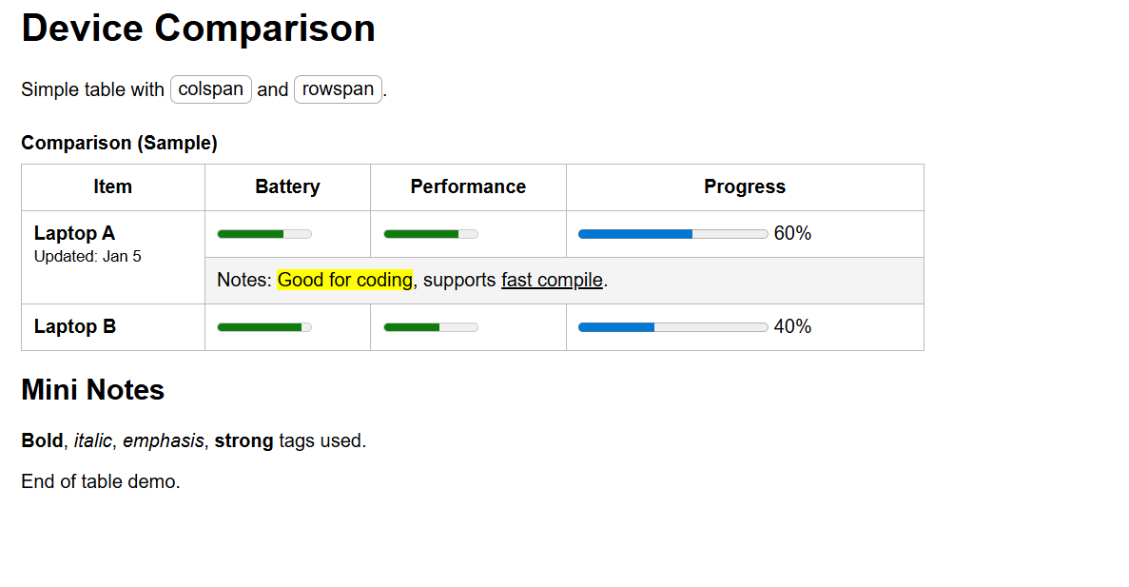
PROGRAM4:
SOURCE CODE:
<!DOCTYPE html>
<html lang="en">
<head>
<meta charset="UTF-8" />
<meta name="viewport" content="width=device-width, initial-scale=1.0" />
<title>FAQ + Dialog</title>
<style>
body { font-family: Arial, sans-serif; margin: 20px; }
.box { border: 1px solid #ddd; padding: 12px; border-radius: 8px; max-width: 700px; }
button { padding: 8px 12px; cursor: pointer; }
dialog { border: 1px solid #aaa; border-radius: 10px; padding: 14px; width: min(520px, 90%); }
</style>
</head>
<body>
<header class="box">
<h1>FAQ (details/summary) + Dialog</h1>
<p>Click the questions and open the dialog for a quick tip.</p>
<button id="openBtn">Open Tip</button>
</header>

<main class="box" style="margin-top:12px;">
<section>
<h2>Common Questions</h2>

<details>
<summary>What is HTML?</summary>
<p>HTML is used to create the structure of webpages.</p>
</details>

<details>
<summary>What is CSS?</summary>
<p>CSS is used to style the webpage (colors, spacing, layout).</p>
</details>

<details>
<summary>What is JS used for?</summary>
<p>JavaScript adds interactivity like popup, validation, dynamic changes.</p>
</details>
</section>

<section>
<h3>Small text break example</h3>
<p>
VeryLongWordWithoutSpace<wbr>BreakHere<wbr>ToFitOnScreen
</p>
</section>
</main>

<dialog id="tipDialog">
<h2>Quick Tip</h2>
<p>Use <mark>semantic tags</mark> like <code>&lt;header&gt;</code>, <code>&lt;main&gt;</code>, <code>&lt;footer&gt;</code>.</p>
<button id="closeBtn">Close</button>
</dialog>

<script>
const d = document.getElementById("tipDialog");
document.getElementById("openBtn").addEventListener("click", () => d.showModal());
document.getElementById("closeBtn").addEventListener("click", () => d.close());
</script>

<footer style="margin-top:12px;">
<p>Dialog + FAQ demo.</p>
</footer>
</body>
</html>

OUTPUT:
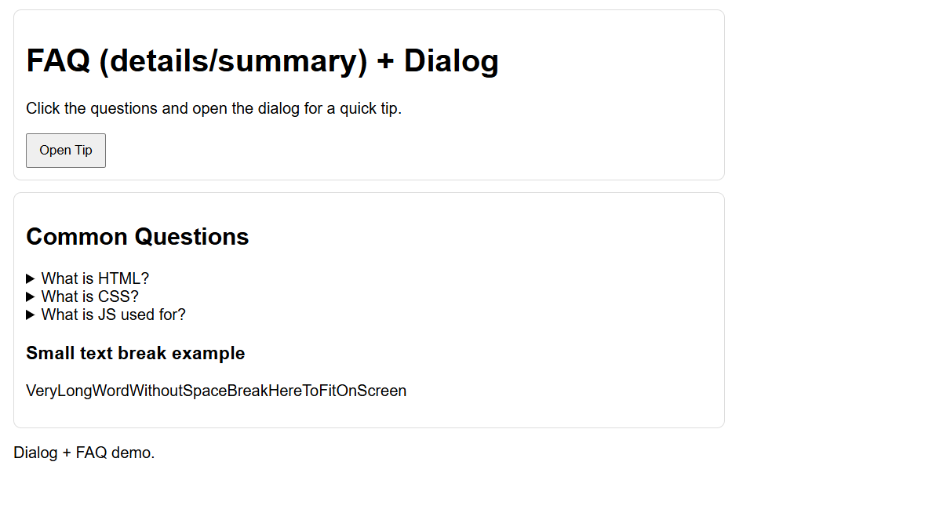
PROGRAM5:
SOURCE CODE:
<!DOCTYPE html>
<html lang="en">
<head>
<meta charset="UTF-8" />
<meta name="viewport" content="width=device-width, initial-scale=1.0" />
<title>Multimedia Page</title>
<style>
body { font-family: Arial, sans-serif; margin: 20px; }
.grid { display: grid; gap: 12px; max-width: 820px; }
.panel { border: 1px solid #ddd; padding: 12px; border-radius: 8px; }
video, audio { width: 100%; height: auto; }
</style>
</head>
<body>
<header class="panel">
<h1>Audio + Video + Ruby + Embed</h1>
<p>
Ruby example:
<ruby>水<rp>(</rp><rt>mizu</rt><rp>)</rp></ruby>
means “water”.
</p>
</header>

<main class="grid">
<section class="panel">
<h2>Audio</h2>
<audio controls>
<source src="sample-audio.mp3" type="audio/mpeg" />
<source src="sample-audio.ogg" type="audio/ogg" />
Your browser does not support audio.
</audio>
<p><small>Use your own file names in the same folder.</small></p>
</section>

<section class="panel">
<h2>Video (with track)</h2>
<video controls poster="poster.jpg">
<source src="sample-video.mp4" type="video/mp4" />
<source src="sample-video.webm" type="video/webm" />
<track src="captions.vtt" kind="subtitles" srclang="en" label="English" default />
Your browser does not support video.
</video>
</section>

<section class="panel">
<h2>Embed Example</h2>
<p>This uses the <code>&lt;embed&gt;</code> tag (PDF/image).</p>
<embed src="sample.pdf" type="application/pdf" width="100%" height="260" />
</section>
</main>

<footer class="panel" style="margin-top:12px;">
<p>Multimedia tags demo done.</p>
</footer>
</body>
</html>

OUTPUT:
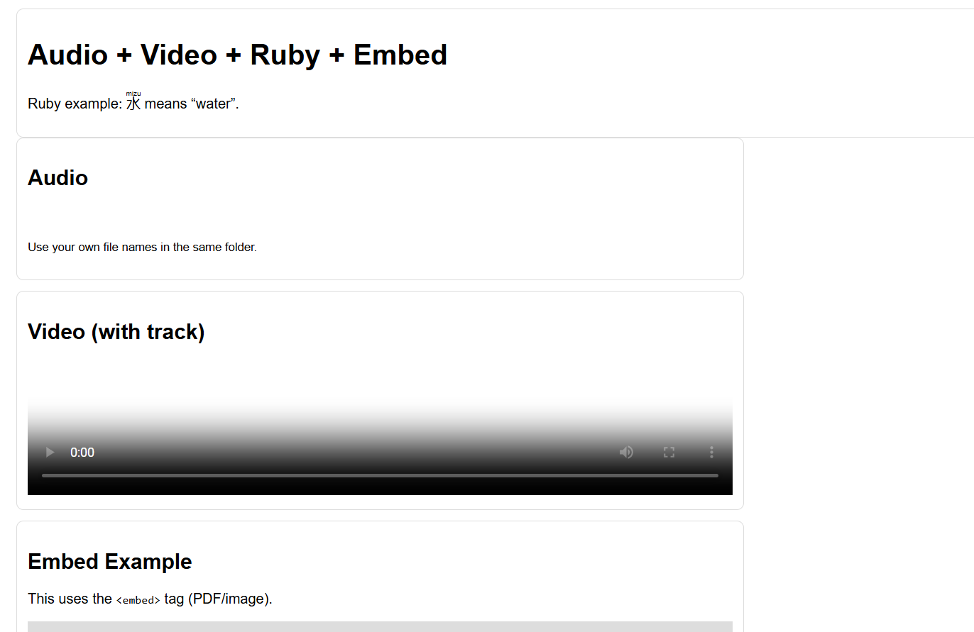
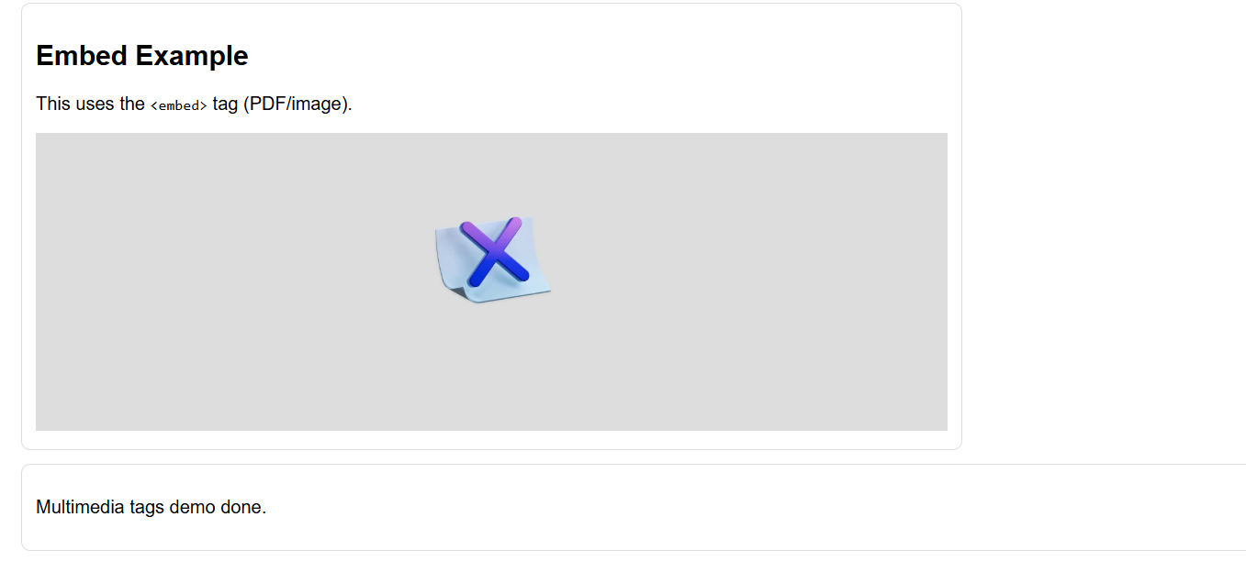
RESULT:
Thus, the required web pages including a form page and other web pages using HTML and CSS (with minimal JavaScript wherever required) were successfully created and executed, and the output was verified in a web browser.

