***DISTANCE MEASUREMENT USING ULTRASONIC SENSOR***

*INTRODUCTION*

*Ultrasonic sensors are useful for measuring distances. Ultrasonic waves are transmitted and whenever these strike an obstacle and return back in the from of an echo. Difference of outgoing sound and returning echo gives us the distance.*

*However, when there are cheap methods available to find a distance like the IR sensor or even a combination of LED’s and LDR would do, but the question is why we use a more expensive sensor. The reason is:-*

* *IR sensors are not accurate*
* *The result varies from object to object*
* *Calibration is required*
* *Works well only for short range.*

*FEATURES*

*This project uses an ultrasonic sensor to indicate the distance of any object from it. Here we have made a setup based on a microcontroller in which real time distance is sensed by an ultrasonic sensor and displays measured distance on an LCD display.*

*4W’S AND 1H*

*Who:*

*Everyone in this world can use.*

*When:*

*Used in longer range.*

*Why:*

*It is used in many applications.*

*What:*

*Gives the accurate measurement from the object.*

*How:*

*This project is based on atmega 328P.**Ultrasonic sensor provides an output signal proportional to distance based on the echo. The sensor here generates a sound vibration in ultrasonic range upon giving a trigger, after that it waits for the sound vibration to return.*

*SWOT ANALYSIS*

*Strength:*

* *Discrete distance of moving objects can be measured.*
* *High accurate within a range.*
* *The range of detection is very large which makes sensor useful in many applications.*
* *Not highly affected by dust, dirt, or high-moisture environments*
* *Not affected by color or transparency of objects*

*Weakness:*

* *Cannot work in a vacuum*
* *Not designed for underwater use*

#### ***Sensing accuracy affected by soft materials***

#### ***Have a limited detection range***

#### ***Sensing accuracy affected by changes in temperature of 5-10 degrees or more.***

*Opportunities:*

*Ultrasonic sensors can measure the distance to a wide range of objects regardless of shape, color or surface texture. They are also able to measure an approaching or receding object. By using “non-contact” ultrasonic sensors, distances can be measured without damage to the object. They’re easy to use and, in many cases, can be used in place of other traditional sensors when the environmental conditions make traditional sensors unusable.*

*Threats:*

* *Wiring*
  + *Power supply voltage*
  + *Load short-circuiting*
* *Incorrect wiring*
  + *Connection without a load*
  + *Operating Environment*

*HIGH LEVEL REQUIREMENTS*

*In the high level requirement, we must have the knowledge of Microcontroller ATmega328*

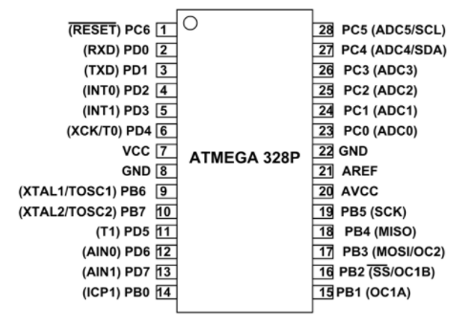

*LOW LEVEL REQUIREMENTS*

*In the low level requirements, we must have some knowledge about ultrasonic sensor for the implementation in the project.*

