ICRES Employee Handbook

Mumbai

1st September 2015

| DOCUMENT CONTROL | | | |
| --- | --- | --- | --- |
| Version | Last Updated | Last Updated by | Description of Change |
| 2 | 31st July’16 | Vijay Rego | Review & additions |
| 3 | 30th June ‘17 | Vijay Rego & Sulata Hosadu | Review & additions |
|  |  |  |  |

|  |  |
| --- | --- |
| DOCUMENT DETAILS | |
| **Created By** | Sushil Sawant |
| **Date of Creation** | 1st September 2015 |
| **Approved By** | Sumeet Sharma |

Table of Contents

Capgemini Offices 3

[Offerings 21](#_Toc513203328)

[Transport services 21](#_Toc513203329)

[Bus / station shuttle services 21](#_Toc513203330)

[Shift cab requests 27](#_Toc513203331)

[Travel Services 30](#_Toc513203332)

[Workplace services 33](#_Toc513203333)

[Helpdesk 33](#_Toc513203334)

[Concierge Services 34](#_Toc513203335)

[Food & beverage services 38](#_Toc513203336)

[Stationery request 50](#_Toc513203337)

[Mail room 51](#_Toc513203338)

[Seat allocation and movement 55](#_Toc513203339)

[Process of seat allocation 55](#_Toc513203340)

[Space management portal 55](#_Toc513203341)

[SPOCs for Mumbai Seat Management & escalation Matrix 57](#_Toc513203342)

[Employee wellness services 58](#_Toc513203343)

[First aid and medical room facility: 58](#_Toc513203344)

[Physical safety & security services 61](#_Toc513203345)

[Issuance of access card and security 61](#_Toc513203346)

[Secure area / ODC awareness 63](#_Toc513203347)

[Vehicle parking 64](#_Toc513203348)

[Physical safety 65](#_Toc513203349)

[SPOCs for escalation 65](#_Toc513203350)

[FAQs 68](#_Toc513203351)

[Transport services 68](#_Toc513203352)

[Workplace services 70](#_Toc513203353)

[Seat allocation and movement 72](#_Toc513203354)

[Physical safety & security services 72](#_Toc513203355)

Capgemini offices

|  |  |
| --- | --- |
| Address:  Mumbai 3 – M3  Plant 6, Godrej & Boyce Compound, Gate No.2, L.B.S. Marg, Phirojshanager, Vikhroli (West), Mumbai - 400079, Maharashtra, India. <Tel:+91.22.6686> 0500  Mumbai 4 – M4  Plant 5, Godrej & Boyce Compound, Gate No.2, L.B.S. Marg, Phirojshanager,  Vikhroli (West), Mumbai - 400079,  Maharashtra, India. <Tel:+91.22.6686> 0500  Brief narration about the location:  The Capgemini leased facility is located in campus of Godrej & Boyce Mfg Co. Ltd. Vikhroli (W). In addition to Capgemini, Accenture, TCS, WNS, Atos are other IT and ITES companies that operate out of this Campus. Located in L.B.S. Marg, the campus is close to Vikhroli, Ghatkopar rail way station and Metro rail station.  How to reach?  From Chhatrapati Shivaji International Airport – The campus is approximately 9 k.m. which takes about 35 min from the airport by car (during non-rush hours). The shortest way to get to the campus is to route from Airport -> Sahara Elevated road -> pass by THE LALIT -> Andheri – Kurla Rd / Mathuradas Vasanji Rd-> pass by woodland-> pass by Maniklal ground->take left to LBS marg->pass by SBI bank on right-> destination is in Godrej & Boyce Compound.  *From* *Vikhroli Railway Station* – The campus is approximately 2 k.m. which takes about 10 mins. from the vikhroli Station by car. The shortest way to get to the campus is to route from Railway Station -> Head towards Pedestrian Overpass ->turns right and becomes P Godrej Marg-> Turn left onto Lal Bahadur Shastri Marg-> pass by petrol pump on left ->pass by Accenture on left-> destination is in Godrej & Boyce Compound. | |
| **From Chhatrapati Shivaji International Airport** | **From Vikhroli Railway Station** |
| From_CSI_Airport_To_Capgemini_India_Pvt_Ltd_Vikhroli | From_Vikhroli_RailwayStation_To_Capgemini_India_Pvt_Ltd_Vikhroli |
|  | |

|  |  |
| --- | --- |
|  |  |
|  |  |
| |  |  | | --- | --- | | \\Mumpkpdt000600\d\scans\Daljeet\SEZInauguration\IMG_7442.JPG  Address  Mumbai – Capgemini Knowledge Park (CKP SEZ)  Capgemini India Pvt. Ltd.  IT3/IT4, Airoli knowledge Park,  Thane Belapur Rd,Airoli,  Navi Mumbai -400708,India.  Phone  + 91 22 7144 4283  Brief narration about the location  The Capgemini owned campus is located at Airoli in 35 acres; 1st phase is operational with 7,200 seats & 5000 seats in 2nd phase already and work in progress to complete by December, 2018 to accommodate 14,000 employees. Campus environment and a township within which includes residential block, customer experience center, pharmacy, cafeterias, food court etc. Situated at Navi Mumbai’s only knowledge corridor; proximity to upcoming International Airport. Well connected to national highways; close to Railway stations & residential complexes with modern amenities, shopping malls with leading brand outlets & theatres; weekend getaway spots are not too far away; another advantage is uninterrupted power & water supply.  How to reach?  Chhatrapati Shivaji International Airport – The office is approximately 24 km which takes about 1 hr. from the airport by car (during non-rush hours). The shortest way to get to the campus is to route from Airport -> Sahar Elevated road -> pass by THE LALIT -> Andheri – Kurla Rd / Mathuradas Vasanji Rd-> pass by woodland-> Pass by Larsen & Toubro (on the right in 1.9 km)-> Turn right towards JVLR-> turn left to merge onto NH 3-> Use the left 3 lanes to take the exit towards Mulund – Airoli Bridge Rd-> Turn right onto Mulund – Airoli Bridge Rd->pass on Octroi toll plaza-> At Airoli Circle, take the 1st exit onto Mugalsan Rd->pass by khoper hospital-> Destination will be on left opposite Gigaplex.  From *Airoli Railway Station* – The office is approximately 2 km which takes about 10 mins. from the Airoli Railway Station by car (during non-rush hours). The shortest way to get to the office is Railway Station -> Head on Thane-Belapur Rd->make U- turn pass by chandani palace-> pass by mind space -> Turn left onto Mugalsan Rd-> Destination will be on left opposite Gigaplex. | | |  | | | **From Chhatrapati Shivaji International Airport** From_CSI_Airport_To_Capgemini_India_Pvt_Ltd_Airoli_Gigaplex |  |     Address:  Mumbai – Airoli Mindspace West  *Blgd No 5,  Plot No. IT5,*  *Gigaplex, Airoli Knowledge  Park,*  *TTC Industrial Area,*  *Airoli, Navi Mumbai 400708 Maharashtra, India*  *Tel : +91 22 6686 0500*  Brief narration about the location  *The Capgemini leased facility is located at Mindspace West (Gigaplex) with 3,650 seats on 8 floors. There are 3 cafeterias, 7 food stalls and 4 break-out areas for recreational activities, ATM, Doctor & dormitory room with 8 beds and 5 relaxation rooms. In addition to Capgemini, IDFC bank, Axis Bank, Accenture, UBS etc are a few companies that operate out of this IT Park. The biggest landmark to reach Gigaplex is the Erstwhile CAPGEMINI campus is across the road.*  How to reach Gigaplex ?  Chhatrapati Shivaji International Airport – The office is approximately 24 km which takes about 1 hr. from the airport by car (during non-rush hours). The shortest way to get to the campus is to route from Airport -> Sahar Elevated road -> pass by THE LALIT -> Andheri – Kurla Rd / Mathuradas Vasanji Rd-> pass by woodland-> Pass by Larsen & Toubro (on the right in 1.9 km)-> Turn right towards JVLR-> turn left to merge onto NH 3-> Use the left 3 lanes to take the exit towards Mulund – Airoli Bridge Rd-> Turn  right onto Mulund – Airoli Bridge Rd->pass on Octroi toll plaza-> At Airoli Circle, take the 1st exit onto Mugalsan Rd->pass by khoper hospital->make U-turn at Gigaplex->Destination will be on left.  From *Airoli Railway Station* – The office is approximately 2 km which takes about 10 mins. from the Airoli Railway Station by car (during non-rush hours). The shortest way to get to the office is Railway Station -> Head on Thane-Belapur Rd->make U- turn pass by chandani palace-> pass by mind space -> Turn left onto Mugalsan Rd-> Destination will be on left   |  |  | | --- | --- | | **From Chhatrapati Shivaji International Airport** | **From Airoli Railway Station** | | From_CSI_Airport_To_Capgemini_India_Pvt_Ltd_Airoli_Gigaplex | From_Airoli_RailwayStation_To_Capgemini_India_Pvt_Ltd_Gigaplex | | |

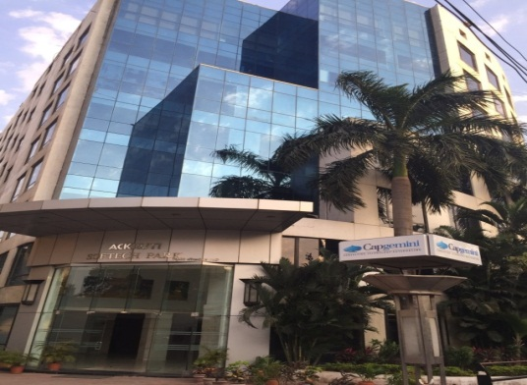

Address:

Ackruti

Ackruti Softtech Park,

MIDC Cross Road No 21,

Andheri (East), Mumbai - 400 093,

Maharashtra, India  
Tel: +91-22-6693-0500/ +91-22-7101-8000

Brief narration about the location:

The Capgemini Ackruti facility is located at Ackruti Softech Park Building on 1st Floor, 4th floor to 7th floor and 8th floor, Address - M.I.D.C. Cross Road No.2, Andheri (East), Mumbai 400 093 In addition to Capgemini, Syformix India Pvt. Ltd. Is the other IT company that operates on the 3rd floor of this building. Ackruti office is located in Andheri (East); close to Seepz (Santa Cruz Export Processing Zone), Andheri Railway station and Metro Rail station, the International Airport and Domestic Airport are at 15 to 20 minutes’ drive.

How to reach?

From Chhatrapati Shivaji International Airport -

From Chhatrapati Shivaji International Airport – Ackruti Softech Park building is approximately 4.3 km which takes about 15 minutes from the airport by car (during non-rush hours). The shortest way to get to the campus is to route from Airport -> Sahara Elevated road -> pass by THE LALIT -> Andheri – Kurla Rd / Marol Fire Brigade, Marol Maroshi Depot/Seven Hills hospital, take the Vijay Nagar Flyover bridge, 1st Left is Ackruti Softech Park (Annex Passport Office)

How to reach ?

From Andheri Railway station -

*From* Andheri *Railway Station* – Ackruti Softech Park is approximately 4 km which takes about 15 mins from the Andheri Station by car. The shortest way to get to Ackruti Softech Park is to route from Railway Station -> Head towards Chakala Church -> turns left and again right and becomes MIDC Central Road-> Reach “C” Cross Road and turn Right onto MIDC Cross Road No.21->pass by BHEL office and take immediate right -> destination is Ackruti Softech Park.

*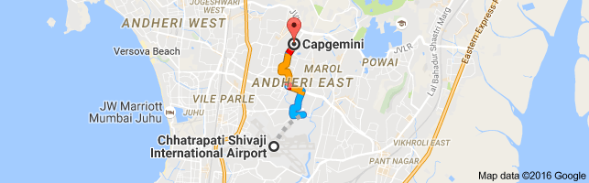* 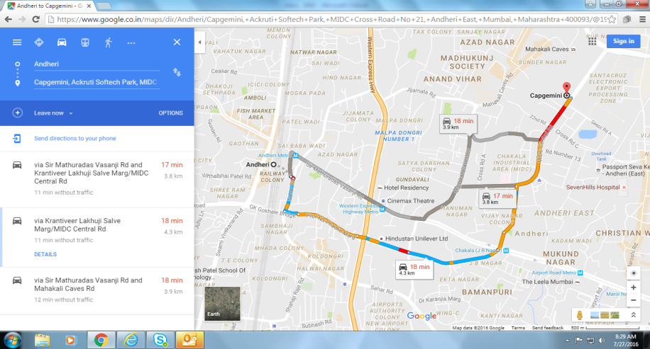

**CAMPUS FACILITIES Offered**:-

1. Departmental Store (CKP STPI)
2. Crèche (CKP STPI)

| **Location** | **Mumbai- Airoli CKP (STPI)** |
| --- | --- |
| **Timings** | 8:00 - 18:30 hrs |
| **Enrollment Criteria** | Age - Three months to Two years (School going children are not admitted) |
| **Contact Person and Number** | Ms Ravinder Kaur- 09819267614 |
| **Fees** | Borne by the organization |
| **Capacity** | Creche is accessible to Capgemini employees on a first-come, first-served basis, and is currently being upgraded to welcome upto 30 children in STPI campus as on June 2018; one more in SEZ is getting ready |
| **Process** | The employee has to meet the Creche Manager and fill the form after understanding all the details. | |

1. Pharmacy (CKP STPI & CKP SEZ)
2. In-house Doctor (CKP STPI & CKP SEZ)
3. Club House (CKP STPI & CKP SEZ)

Gymnasium, Badminton, Table Tennis, Pool Tables, Carom etc

1. ATMs, Banking Zone (CKP STPI & CKP SEZ)
2. Cricket net Practice Pitch & Volleyball court (CKP SEZ)

Offerings

# Transport services

Bus transport facility is on defined routes, for employees with necessary contribution from their salary. Company provides Bus transport facility on defined routes and timings. Details of routes & timings are available in data pub https://bustransport.in.capgemini.com/

Same schedule is also available with respective transport Desk / Coordinators. Transport schedule for Bus routes are prepared & published by ICRES team.

Company Bus Transport follows Main Roads / Highways only and will not detour to any by-lanes. Only employees / contractors are authorized to use the Company transport facility. Employees are expected to use this service to travel to and from Office. Employees need to contribute to avail this facility; process for the same is defined below.

## Bus / station shuttle services

### Bus pass application – How to raise a request

To avail transport facility provided by company, employees should Register themselves on talent page   
<https://groupitcloudapps.in.capgemini.com/bustransport>

### Process of issuance of bus pass

1. Collect your Physical Bus pass from Transport Desk within 2 days of the registration.

2. Your transport deduction shall begin from the date you register in bus pass application, as per the payroll cycle.

3. Transport Fee deduction Cycle is calculated from 16th of the previous month to 15th of the current month (eg.: For month of June deduction will be May 16th to June 15th and for the month of July it will be June 16th to July 15th).

4. We don’t follow prorated bases of deduction, nor do we have temporary bus pass facilities.

5. Bus passes will have to be produced on demand to the designated persons authorised by Capgemini to check the passes.

### Process to De-register the bus pass

Bus pass needs to be handed over to ICRES personnel to complete de-registration process. ***De-registration formality is not complete till the pass is physically handed over to ICRES team member and approved on* Talent page Transport link *,* till *such time deduction will continue***

1. Date of approval by ICRES team shall be considered as date of de-registration.

2. Employees going on-site or on long leave, need to submit their passes to complete the deregistration process and avoid transport fee deduction from salary, failing which deduction would continue and no refund will be granted.

### Loss of bus passes:

Employees need to follow below mentioned steps to get a new Bus Pass

1. Employee needs to inform ICRES team in cases of a loss of the bus pass by email.

2. ICRES team will deactivate the same.

3

. Employees need to reapply for bus pass in bus pass application if he / she want to continue availing the bus facility.

4. Fine of Rs. 100/- will be deducted directly for the loss of bus pass

### Change of route

Routes shall not change once declared, unless it happens due to unavoidable circumstances like statutory requirements

### Cancellation of routes

We would need minimum 25 employees to run a particular route, if the same is not observed over a period of one month, the route will be cancelled with 30 days notice, and communication will be sent to employee registered for the route. Refund of transport fee will be granted for balance days.

### Adding new routes

To add new routes, minimum 25 employees are required from a particular location. Routes will be introduced as per the policy. This will be region based and final call will be taken by city leads.

### Location Limits

|  |  |
| --- | --- |
| **Mumbai** | |
| **Zone** | **Location** |
| Western | upto Borivali / Virar |
| Central | upto Thane/ Ambernath |
| Harbour | up to Vashi / Panvel |
| South | upto Dadar /Tardeo |
| Station Shuttle | Available from nearest Railway Station |

### Inter office Shuttle service timings

Inter office Shuttle transport facility refers to the Bus or other Company vehicle deployed to travel frequently between Capgemini Offices on working days.

Presently Traveler need not contribute to use the inter office shuttle service; any employee required to use the inter-office shuttle facility will have to provide an approval from their respective Project Manager along with a valid justification one day prior to the travel.

Inter office shuttle can only be used to travel in between offices.

In the absence of an approval, the concerned employee will not be allowed to use this facility (exceptions and emergencies will be considered separately).

|  |  |  |
| --- | --- | --- |
| **Shuttle Service between Vikhroli Capgemini to Airoli Capgemini** | | |
| **Shuttle Timings From Mum 3 & 4 to Airoli Office-Gigaplex** | | |
| **Mum III** | **Airoli Office** | **Gigaplex Office** |
| 9:30 AM | 10:05 AM | 10:15 AM |
| 12:00 PM | 12:35 PM | 12:45 PM |
| 2:30 PM | 3:05 PM | 3:15 PM |
| 5:00 PM | 5:35 PM | 5:45 PM |

|  |  |  |
| --- | --- | --- |
| **Shuttle Service between Airoli Capgemini to Vikhroli Capgemini** | | |
| **Shuttle Timings From Gigaplex- Airoli Office to Mum M-3 & M-4** | | |
| **Gigaplex** | **Airoli Office** | **Mum III** |
| 11:00 AM | 11:10 AM | 11:50 AM |
| 1:00 PM | 1:10 PM | 1:50 PM |
| 4:00 PM | 4:10 PM | 4:50 PM |
| 6:30 PM | 6:40 PM | 7:20 PM |
| 8:30 PM | 8:40 PM | 9:20 PM |

### Bus charges / Station shuttle charges: Available on <https://groupitcloudapps.in.capgemini.com/bustransport>

### General guidelines for bus users

* Please be present at the specified boarding time and place.
* All bus users need to carry their bus passes daily.
* Please do not pass any instructions to the drivers, supervisors, etc. but only to the ICRES transport team & your transport committee members of your particular route.
* An Employee is entitled to get themselves dropped at their designated stop only & not at alternate.
* Use designated stops. Family and friends are not permitted in the buses.
* No eatables and beverages to be carried in the vehicle.
* Please note the bus / route no. in which you are commuting.
* Whilst on the bus, conduct yourself in an orderly manner.
* In case of an emergency or a break down, please contact the transport team.

### Penalties

As per the CG transport policy travelling in CG bus, without valid bus pass, a penalty of Rs. 3,000/ per instance will be charged. Hence this amount is levied to you and will be recovered from your salary for the travel cycle as per definition. You must obtain a regular bus pass if you wish to avail the bus transport service in future and avoid any further penalty.

### Bus transport assistance

|  |
| --- |
| **Please call – On Duty Supervisor:** |
| Transport Helpdesk Mumbai +91 9920763294/ STPI Campus- 02271411600/01 |
| Transport Helpdesk Airoli & Gigaplex +91 7506272166 |
| **For complaints / suggestions / Emergency contact:** |
| For Mumbai: [transporthelpdesk-mum.in@capgemini.com](mailto:transporthelpdesk-mum.in@capgemini.com)  For Airoli:transport-airoli.in@capgemini.com  For Gigaplex:transportgigaplex.in@capgemini.com  For STPI Campus Mumbai : transport-Airolickp.in@capgemini.com |

### SPOCs for escalation

|  |  |  |  |  |  |
| --- | --- | --- | --- | --- | --- |
| **Escalation Level** | **Role** | **Name** | **Email ID** | **Extn.** | **Cell No.** |
| **First Level** | Transportation SPOCs | Anil  (Vikhroli) | [transporthelpdesk-mum.in@capgemini.com](mailto:transporthelpdesk-mum.in@capgemini.com) | 2279999 | +91 9920763294 |
| Umesh (Airoli) | [transport-airoli.in@capgemini.com](mailto:transport-airoli.in@capgemini.com)  [transport.mumbai@capgemini.com](mailto:transport.mumbai@igate.com) | 2214005/2214285  022-71411600/  022-71411601 | +91 7506272166 |
| Gigaplex – CG Umesh | [transportgigaplex.in@capgemini.com](mailto:transportgigaplex.in@capgemini.com) | 2214002 / 221422  022-71411600/  022-71411601 | +91 7506272166 |
|  |
|  |
| **Second Level** | Transportation Lead | Suryakant Jagtap (Vikhroli) | [surykant.jagtap@capgemini.com](mailto:surykant.jagtap@capgemini.com) | 2273076 | +91 9619592766 |
| Rishit Shetty (Airoli and Gigaplex) | [rishit.shetty@capgemini.com](mailto:rishit.shetty@capgemini.com) | 2211997 | +91 9820981903 |
| **Third Level** | Transportation Lead Mumbai | Mumbai | [vijay.gadge@capgemini.com](mailto:vijay.gadge@capgemini.com) | 2280603 | +91 9819094876 |
| **Fourth Level** | Transportation COE Deputy Head | CG - Satish Kanojia | [satish.kanojia@capgemini.com](mailto:satish.kanojia@capgemini.com) | 2272837  11589 | +91 9004188884  +91 9819094876 |
| **Fifth Level** | City Service Delivery Head | Sulata Hosadu  Vijay Rego | [sulata.hosadu@capgemini.com](mailto:sulata.hosadu@capgemini.com)  [vijay.rego@capgemini.com](mailto:vijay.rego@capgemini.com) | 2272827  11555 | +91 9820413293  +91 9920141505 |
| **Sixth Level** | Transportation COE Head | Pramod Shetty | [Pramod.shetty@capgemini.com](mailto:Pramod.shetty@capgemini.com) | 6801103 | +91 9845257926 |

## Shift cab requests

Company provides Home drop / pick- up during specified hours as mentioned in the table below.

To avail this facility, employees need to raise a daily/weekly/monthly request through self/project [**https://groupitcloudapps.in.capgemini.com/cabtransport/Home.htm**](https://groupitcloudapps.in.capgemini.com/cabtransport/Home.htm)

These requests should be raised on Friday for service required in following week. i.e. from Monday onwards

Any additional Pickup / Drop request that comes in to the transport should have the following conditions:

Pickup request should be made prior to 24 hrs from the pickup time

Drop request should be made prior to 4 hrs prior to the drop time.

Security escort is provided to any lady employee travelling alone or to be picked up first or to be dropped last during night. (Please do not board the vehicle in absence of security escorts and kindly highlight this immediately on helpline number)

* Timings for usage of Night home drop / Pick Up between 20:00 to 06:00 hrs for female employee only when such employee is staying back for project exigencies and has the manager’s approval for the same..

Cost of security escort service is debited to respective project

There will not be any project specific transport unless approved by BU head and Transport CoE.

|  |  |
| --- | --- |
| **City** | **Operational hours** |
| Mumbai / Airoli / Gigaplex (for All employees) | 23:30 Hrs to 06:30 |
| Winspire Home drops (only for Women Employees) | 20:30 hrs, 21:30 and 22:30 hrs |

### General guidelines for cab users

In case a pickup is not required the same needs to be intimated to transport helpdesk 6 (six) hours prior to start of shift. Transport facility required for any new shift on temporarily basis would require approval from the Operations Head and location head and would require a fortnight’s lead time after approval

All cancellations need to be informed to transport desk a day in advance. In the event, Transport desk does not receive a cancellation then also travel cost will be billed to project even though employee has not shown up.

All complaints to be addressed to transport desk on respective transport ID. or local help line number, avoid discussion with driver.

Employees are requested to fill log sheet completely and sign the same while availing this facility

Other than registered Travelers, no one else is permitted to travel under any circumstances.

In the event, female traveler is the first one to be picked / dropped, in such case Escort will sit **on the front seat** with the driver.

**In the event, radius of the distance between both female or male Traveler residences are within 2 km then female Traveler should be dropped first.**

For door-to-door pickup all Travelers are expected to be ready at least 10 minutes before their expected time of pickup and should wait for the transport. Under no circumstances, Transport can be kept waiting for any Traveler.

**At places (narrow lanes, road work in process, etc) where movement of vehicle is not possible, Traveller will be dropped at their society gate or nearby location or will be escorted (in case of female Traveller). In such situations it is the duty of the female Traveller to provide prior intimation to the Transport Team so that Escort to the gate of residence/ society can be arranged accordingly.**

For any Adhoc / Out of roster requirements requests should be duly approved by process manager / HOD.

It is mandatory that all commuters sign & complete the duty slip provided by the driver with reasons, if any.

Travelers are required to wear seat belts always.

### We are furnishing the list of contacts for Cab Transport Services

|  |
| --- |
| **Please call – On Duty Supervisor:** |
| Transport Helpdesk Mumbai +91 9920763294 |
| Transport Helpdesk Airoli +919920145136 |
| **For complaints / suggestions / Emergency contact:** |
| For Mumbai: [transporthelpdesk-mum.in@capgemini.com](mailto:transporthelpdesk-mum.in@capgemini.com)  For Airoli:transport-airoli.in@capgemini.com  For Gigaplex:transportgigaplex.in@capgemini.com |
|  |

## Travel Services

* Egencia is an application used to making travel bookings for all the business units at Capgemini. The application is used for both domestic as well as international travel.
* **Easy-to-use application:**
* **– Grade A to D:** A familiar booking tool (India Apps Portal > Facilities > Travel > Travel Request Summary), designed specifically for the business traveler. Once the Travel Request is approved, ticket booking can be done by visiting the Capgemini-Egencia website**.**
* **– Grade E & F:** Make your travel reservations by directly visiting Capgemini-Egencia website**.** © 2018 Capgemini. All rights reserved. Cover Title 8
* **Alerts:** The flight status alerts are sent to your registered mobile. So, stay updated with the latest information affecting your business travel, including flight delays and gate changes. Alerts can also be used to inform a colleague or loved ones of your up-to-date arrival timing.
* **Safety:** Using the in-house travel portal and seeking the assistance of the Capgemini travel agent enables your travel manager to notify you of any potential issues and/or locate you in case of an emergency.
* **Easy hotel bookings:** Hotel booking can be made online with egencia tool
* **Helpdesk:** Experienced travel agents will be available 24x7 for your assistance via toll free telephone numbers and over email.
* **– Grade A to D:** 1800-419-9927 or +91-124-6672318
* **– Grade E & F:** 1800-419-9926 or +91-124-6672319
* **– Email id:** [**capgemini@egencia.co.in**](mailto:capgemini@egencia.co.in)
* **For you to use:**
* Read the Profile Updation step-by-step guide and update your profile on the Capgemini-Egencia website.
* **Travel and Expense Reimbursement Policy -** Please refer to the [2018 Capgemini Group Policy.](https://talent.capgemini.com/media_library/Medias/finance_new/Group_Travel_Policy_2018.pdf)

# 

# Workplace services

## Helpdesk

The ICRES Helpdesk provides 24X7 support for all facilities related queries, requests and feedback.

You can register your requests on ICRES Helpdesk through the following channels:

* **Email** – Write to **IN, HelpdeskICRES** OR [helpdeskicres.in@capgemini.com](mailto:helpdeskicres.in@capgemini.com)
* **Web Platform** – Visit our portal at <https://capgeminiicres.ifmapps.com/Account/SingleSignOn>  OR India Talent >> About Us >> Support Fuctions  >> ICRES & Procurement >> ICRES >> ICRES Helpdesk (Right Side Links)
* **Phone** – Please refer to the following table:

|  |  |  |
| --- | --- | --- |
| **New ICRES Helpdesk Number** | **Number** | **Location** |
| **Dial from outside office** | **1800-267-4005** | Bengaluru, Chennai, Gandhinagar, Hyderabad, Kolkata, Mumbai, Noida & Gurugram, Pune. |
| **Dial from Inside office** | **4005** |

|  |  |
| --- | --- |
| You can use the above channels to raise requests related to the following:   * Air Conditioning * Carpentry * Electrical * Plumbing * Repairs & Maintenance * Cleaning & Janitorial Services * Pantry Services * Pest Management * Waste Management * Office Relocations * Landscaping and Indoor Plants |  |

This ICRES helpdesk tool has been launched with the support of our Facility Management vendor partner – Jones Lang LaSalle (JLL).

## Concierge Services

The ICRES Team offers a 24/7 digitized experience for concierge services across all locations through our partner Lesconcierge Services Pvt. Ltd.

A onetime registration is required to be done by all employees to avail these services by logging into [www.lesconcierges.in/capgemini](http://www.lesconcierges.in/capgemini).

Post registration, these concierge services can be availed anytime, through any of the following channels:

* **Phone**: Toll free number – 1800 1037 247/ Landline number – 080 4511 2427
* **Email**: [support@lesconcierges.in](mailto:support@lesconcierges.in)
* **Mobile App**: Google Play Store, Apple iStore and Windows OS
* **Online Chat**: [www.lesconcierges.in/capgemini](http://www.lesconcierges.in/capgemini)

Any complaints /queries on concierge services should be directed to the tools/ link mentioned at the Les Concierge Website - [www.lesconcierges.in/capgemini](http://www.lesconcierges.in/capgemini).

a. Facility Helpdesk system

i. Helpdesk receives and determines the priority of each call received

ii. Selects and confirms response time along with name of responsible person

iii. Keeps requestor informed from time to time about status of call logged.

iv. Notifies the requestor on completion each logged call / user can also track status of his/her call online

v. Provides detailed summary of calls on daily, weekly & monthly basis. The SLA for each call will be tracked as per report forwarded to ICRES representative.

b. Housekeeping services

House Keeping Service at Capgemini is outsourced to an external agency and services expected from them are clearly specified in service level agreement in contract

i. House Keeping Team shall provide daily housekeeping services like:

* Garbage and waste from facilities will be collected and disposed off in a safe and hygienic manner on a daily basis.
* Rest rooms will be cleaned on regular basis
* Spring cleaning / deep cleaning of all areas shall be done on weekly or monthly basis as agreed

c. Clean Desk Policy

i. Clean desk policy is a corporate directive that specifies how employees should leave their working space when they leave the office. It is required that employees clear their desks of all papers at the end of the day. The Policy supports the Information Security Policy available on the Intranet.

ii. Employees before leaving for the day must ensure no company informative documents, personal files or any other confidential / sensitive records are left unattended on their desks or around the work area. This includes files, correspondence, minutes, reports and any other information which could be regarded as confidential or of a sensitive nature. They must ensure that the documents and other records are kept under lock & key.

iii. Any Personal item (i.e. keys, handbags, wallets etc) should be locked away safely in the interest of personal security. It is the responsibility of the owner to ensure all security precautions are taken.

iv. A neat work environment during business hours to be maintained.

v. Non-essential items like idols, decorative table tops should be stored away when not in use.

vi. Employee should refrain from cluttering the work area with post-It or other handwritten notes displaying sensitive information.

vii. Any unattended paper near the printer will be removed at the end of the day.

viii. Eatables are not allowed in the workstation area, all food items should be consumed only in the cafeteria

ix. Thrash if any needs to be dumped in the common bins placed on the floors

d. Decoration Policy

i. For decorating the workstation, employees should take prior approval from the respective Facility incharge

ii. Banners / Posters / Decorations should be displayed in a manner so as not to obstruct the view to signage indicating direction / location of “Exit” and “Fire Extinguishers”.

iii. No decorative material should be pasted on painted walls, ceiling, electrical fixtures or fire sprinklers. Do not use any permanent markers / colours while decorating

iv. Do not use flammable material like cotton, cellophane, streamers especially in close proximity to electrical / electronic equipment.

v. While putting up decoration, appropriate equipment like ladders, floor mats, carpet covers, gloves, etc. should be used to ensure safety of staff and protection of office equipment. Even before doing so, please take ICRES approval.

vi. Do not use double sided tape for pasting on glass walls / doors / windows. This causes permanent damage and has major cost implications for the company.

vii. Do not use pins to stick displays on gypsum walls.

viii. Heavy items like flower pots, etc should not be placed on cube partitions. If these fall, then not only will they damage office equipment but can also cause injury to staff.

ix. Please keep the work area clean after completing with the decorations required

x. No decoration material should affect the normal aisle space and specially those leading to emergency exits.

xi. No proposals for keeping animals / aquariums of any sort can be entertained. This is mandated in view of practical as well as legal implications.

xii. All old displays should be removed upon completion of the event.

xiii. Any display has to have an end date by the specific project / team, after which they it will be removed. However the displays without any such end date specified, will be removed after one month of display.

xiv. No one is allowed to play with colors (Powder / wet) at workplace / on floors / company premise; if anyone found doing so then strict action will be taken through Human Resources.

xv. Decorative lightings are prohibited

xvi. Any damage caused to organisation’s infrastructure, repair cost for the same will be billed to the project.

**Display of Informative Posters / Information Sheets**

1. Banners / Posters / standees can be put up by project team / department only with approval from the ICRES team.

2. Do not stick or paste any posters / adhesives in the meeting rooms / conference / board rooms / cabins etc.

3. Any display of posters / banners / standees etc will need an end date by which it can be removed. In case the projects / departments do not provide the end date, ICRES will remove these in 30 days.

4. All old displays should be removed by concerned Project / Department at end of relevant period, else will be removed by ICRES without intimation.

5. All such information will be displayed in specific areas identified by ICRES. Posters will generally be pasted on glass wall / acrylic wall / notice board; no material will be posted directly on walls, doors or windows as it peels the paint, etc.

6. Any material displayed directly without prior intimation to ICRES will be removed.

7. None of the display material on notice boards or within cubicles should contain confidential business / client information.

**Note**: In any eventuality of office property being damaged due to any such activity being done directly and with or without ICRES consent, the cost of repairs will be charged to the concerned project.

## Food & beverage services

Cafeteria Services are available 24 X 7 except public holiday and weekends (after 11.00 pm basic[[1]](#footnote-1)\* food items will be served). The cafeteria has microwaves to warm up food brought from home. A food-committee which is an employee taskforce, is responsible for the selection and monitoring of the food content and quality. A suggestion / complaint register is placed in the cafeteria where employees can suggest improvements in cafeteria and complaints if any. Employees can also send their feedback/suggestions to the food committee id for Airoli and Vikhroli and will be picked by the committee members and responded to.

**Purpose**

1. The need to have catering guidelines is to ensure smooth and efficient catering services at Capgemini. These guidelines form the basis for assessing the performance of the caterers and services rendered. These guidelines would additionally assist the food committee in planning, deciding and optimising the services of the caterer in terms of variety, quality, hygiene & punctuality.

To ensure this the following broad outlines have been laid:

**Meal Timings**

1. The following meals timing will be maintained for employees:

|  |  |
| --- | --- |
| Breakfast | 08:00 am to 10:30 am |
| Lunch | 12:30 pm to 02:30 pm |
| Snacks | 04.00 pm to 06:30 pm |
| Dinner | 08:30 pm to 10:30 pm |

**Variety**

2. There are chaat, sandwich, cake, pastry & juice counters in some of our cafeterias at negotiated rates. All cafeterias may not necessarily have additional snacks counters.

3. Vending machines for tea, coffee are available in the pantries and without cost.

**Rate**

1. Rates for all types of food items are standard across all our locations within city. There is no subsidy provided on meals and these rates are pre- approved by procurement team. List of items available and the cost is displayed in the cafeteria next to cash counter. Exhaustive menu available with cashier.

**Food arrangement on Week-ends / Public Holidays**

1. All weekend working / holiday food requests will have to be submitted to the Cafeteria by 7 p.m. on previous working day and coupons (receipts) needs to be collected against cash from cafeteria for the same. Employees will have to pay for food and claim it through expense reimbursement system if project approves the cost, no project codes will be accepted by cafe vendor for reimbursement. Employees need to use this coupon to collect the food next day. The coupon can be used as receipt to claim these expenses. All requests received after 7 p.m. cut-off time, may be rejected if the vendor is unable to make provisions for food.

2. If meal request is not provided, caterer would serve a standard limited meal which includes the basic food items – Maggie / Sandwiches / egg bhurji / omelette, etc

3. Meal request sent on Food committee email id will not be attended.

**Organizing small parties**

1.    Employees organising small parties / biryani parties in the cafeteria need to inform the respective ICRES building SPOC of that location through email a day in advance before 5.00pm.

        Contact details of the ICRES building SPOC are as mentioned below. Team will need to arrange disposable leaf/ sugarcane agasse/ aracnut plates/ glasses/ spoons from outside for your event so that other employees do not face issues due to large quantity of crockery being used at a given time

 Kindly note thermocol & plastic plates to be strictly avoided.

2.   Employees to have their team lunch / biryani parties from 12.00 -1.00 pm or after 2.00 pm, to avoid crowding of the cafeteria during peak lunch hours. Also for all such events please arrange for disposal plates / spoons / glasses as mentioned above.

**Cafeteria booking for open house**

1. Cafeteria booking for any events/open house will be done from 3.30pm onwards

Note: None of the food counters will be closed during such session

**Suggestions / Complaints**

1. Suggestions / Complaints are most welcome and the same can be put across to ICRES either by-

a. An e-mail [foodcommittee-vikhroli.in@capgemini.com](mailto:foodcommittee-vikhroli.in@capgemini.com) & [foodcommittee-airoli.in@capgemini.com](mailto:foodcommittee-airoli.in@capgemini.com)

b. Through Feedback register in the cafeteria which is available at the cash counters

c. The suggestions / complaints are checked by food committee / ICRES person of particular location and feedback is provided to the caterer and required necessary actions as required taken.

**Food Committee**

1. Food committee comprises of employees across different locations of the city.

The process to be part of the Food committee is as follows:

a. A mail is sent to the employees requesting nominations.

b. All names are collated and depending on the number of nominations, members are selected from various projects and from different locations and shift timings.

c. Nominated employees are intimated by mail

d. A meeting is arranged to induct the members and thank the existing ones

e. Members are not generally repeated and new members are selected each year, this is not applicable for ICRES members + dietician

f. A new food committee is formed every year by inviting nominations and following the process.

**Role of Food Committee**

1. The Food Committee is responsible for:

a. Check on quality of Food.

b. Address complaints and grievances regarding food and cafeteria, received through e-mails or by checking complaints register kept in the cafeteria.

c. The location Committee member to discuss issues with Caterer.

d. Surprise visit to kitchen twice a year and report to be generated.

e. Selection and termination of caterer is done by the Procurement team but the Food committee will assist in selection and also intimate procurement for issues with vendor and request for change, decision with Procurement

f. Arrange Food Festivals.

g. Review of caterer on regular basis.

2. Actions taken by ICRES after Food committee feedback:

a. The building SPOC of respective location will co-ordinate with caterer on following points as and when required:

i. Complaint and feedback Analysis

ii. Issues regarding Quantity, timings etc.

iii. Enhancement of Food Quality & Food Service

**Food & Water testing**

1. Testing of food and water supplied is carried out every quarter.

**Bottled water Process – except campus**

The company endeavors to provide safe bottled water supply to all associates / visitor / vendor from the license holder / ISI product water supply Company.

1. Bottled water jars are placed across the facility to provide drinking water to employees.

2. Servicing of the water Dispensers is done on a fortnightly basis by the vendor.

3. If there is any request for supply of 250 / 500ml water of sealed bottle in meeting rooms / cafeteria will need to be intimated and same needs to be purchased through café vendor

4. Meeting rooms / conference rooms / cabins are provided with bottled water in jugs. The water jugs and glasses provided are cleaned regularly and water replenished as required.

**Campuses got in-house Water Purification Plant**

**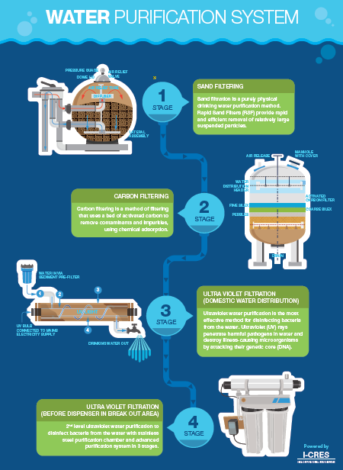**

SPOCs or escalation

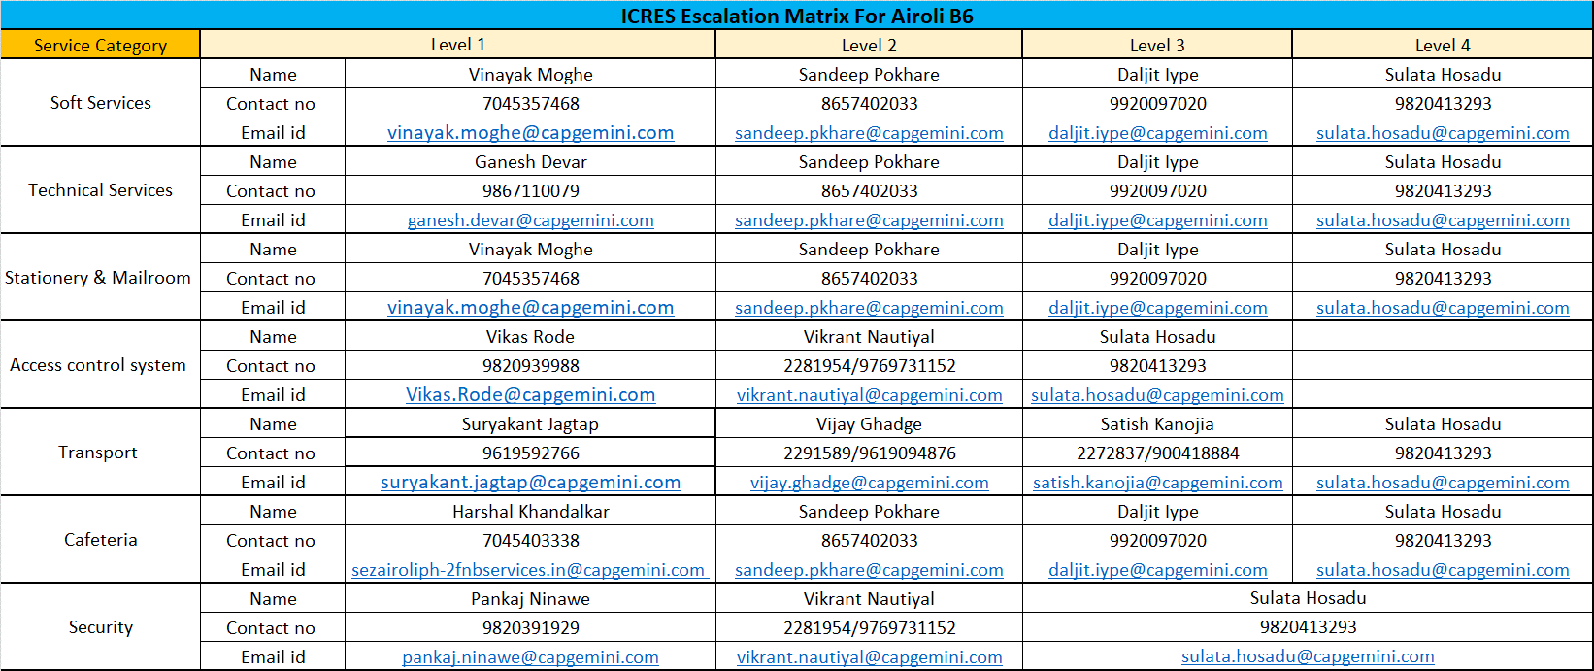

|  |  |  |  |  |
| --- | --- | --- | --- | --- |
| **RES Escalation Matrix For Airoli CKP- STPI** | | | | |
| Service Category | Level 1 | | Level 2 | Level 3 |
| Soft services | Name | Manoranjan Mohanty | Priya Aggarwal | Vijay Rego |
| Contact no | 2291705/ | 9820449844 | 9920141505 |
| Email id | manoranjan.a.mohanty@capgemini.com | [priya.aggarwal@capgemini.com](mailto:priya.aggarwal@capgemini.com) | [vijay.rego@capgemini.com](mailto:vijay.rego@capgemini.com) |
| Technical services | Name | Prashant Naroji | Rammohan Reddy | Vijay Rego |
| Contact no | 8898017110 | 9920873062 | 9920141505 |
| Email id | [prashant.naroji@capgemini.com](mailto:prashant.naroji@capgemini.com) | [rammohan.reddy@capgemini.com](mailto:rammohan.reddy@capgemini.com) | [vijay.rego@capgemini.com](mailto:vijay.rego@capgemini.com) |
| Key Management | Name | Desmond Dantas | Priya Aggarwal | Vijay Rego |
| Contact no | 2291705/9920090392 | 9820449844 | 9920141505 |
| Email id | manoranjan.a.mohanty@capgemini.com | [priya.aggarwal@capgemini.com](mailto:priya.aggarwal@capgemini.com) | [vijay.rego@capgemini.com](mailto:vijay.rego@capgemini.com) |
| Stationery & Mailroom | Name | Karansingh Khadka | Priya Aggarwal | Vijay Rego |
| Contact no | 9820036776 | 9820449844 | 9920141505 |
| Email id | [karansingh.khadka@capgemini.com](mailto:karansingh.khadka@capgemini.com) | [priya.aggarwal@capgemini.com](mailto:priya.aggarwal@capgemini.com) | [vijay.rego@capgemini.com](mailto:vijay.rego@capgemini.com) |
| Access control system | Name | Rajesh Lakhabathini | Vikrant Nautiyal | Vijay Rego |
| Contact no | 2291013/8655434736 | 2281954/9769731152 | 9920141505 |
| Email id | rajesh.lakhabathini@capgemini.com | [nilesh,bhagwat@capgemini.com](mailto:vikrant.nautiyal@capgemini.com) | [vijay.rego@capgemini.com](mailto:vijay.rego@capgemini.com) |
| Transport | Name | Rishit Shetty | Vijay Ghadge | Satish Kanojia |
| Contact no | 2280542/9820981903 | 2291589/9619094876 | 2272837/900418884 |
| Email id | [rishit.shetty@capgemini.com](mailto:rishit.shetty@capgemini.com) | [vijay.ghadge@capgemini.com](mailto:vijay.ghadge@capgemini.com) | [satish.kanojia@capgemini.com](mailto:satish.kanojia@capgemini.com) |
| Cafeteria | Name | Rajesh Patnaik | Priya Aggarwal | Vijay Rego |
| Contact no | 7045403338 | 9820449844 | 9920141505 |
| Email id | [rajesh.b.patnaik@capgemini.com](mailto:rajesh.b.patnaik@capgemini.com) | [priya.aggarwal@capgemini.com](mailto:priya.aggarwal@capgemini.com) | [vijay.rego@capgemini.com](mailto:vijay.rego@capgemini.com) |
| Security | Name | Surendra Singh | Vikrant Nautiyal | Vijay Rego |
| Contact no | 2291706/9594286334 | 2281954/9769731152 | 9920141505 |
| Email id | [surendra.a.singh@capgemini.com](mailto:surendra.a.singh@capgemini.com) | [nilesh,bhagwat@capgemini.com](mailto:vikrant.nautiyal@capgemini.com) | [vijay.rego@capgemini.com](mailto:vijay.rego@capgemini.com) |
|  |  |  |  |  |
| Building ICRES Spocs-IKP | | | | |
| Block | Contact Name | Contact number | Email id | |
| A | Rajesh Chandramore | 9892445608 | [rajesh.chandramore@capgemini.com](mailto:rajesh.chandramore@capgemini.com) | |
| B | Balkrishna Naik | 9833067678 | [balkrishna.naik@capgemini.com](mailto:balkrishna.naik@capgemini.com) | |
| C | Sneha Kale | 9619082043 | [sneha.a.kale@capgemini.com](mailto:sneha.a.kale@capgemini.com) | |
| D | Sandeep Sawant | 9223123452 | [sandeep.a.sawant@capgemini.com](mailto:sandeep.a.sawant@capgemini.com) | |
| E | Karansingh Khadka | 9820036776 | [karansingh.khadka@capgemini.com](mailto:karansingh.khadka@capgemini.com) | |
| TC & ERC | Satyaprakash Pandey | 9819175231 | [satyaprakash.pandey@capgemini.com](mailto:satyaprakash.pandey@capgemini.com) | |

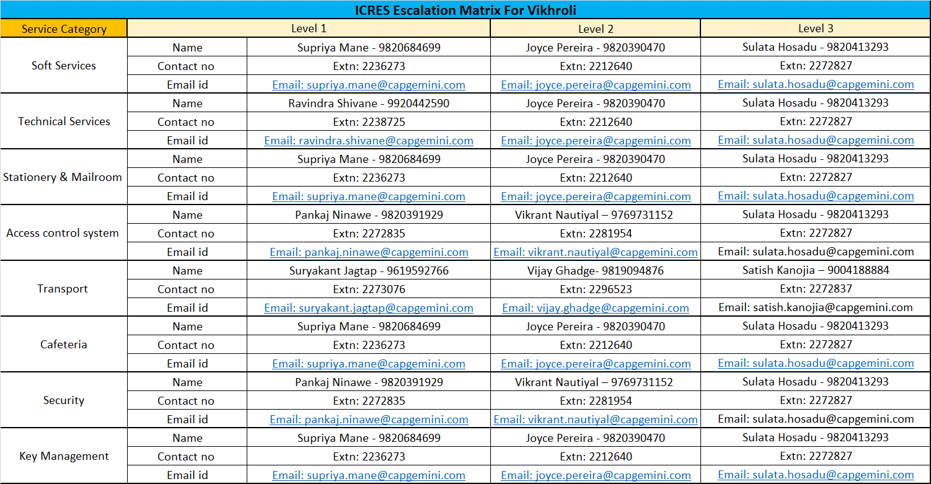



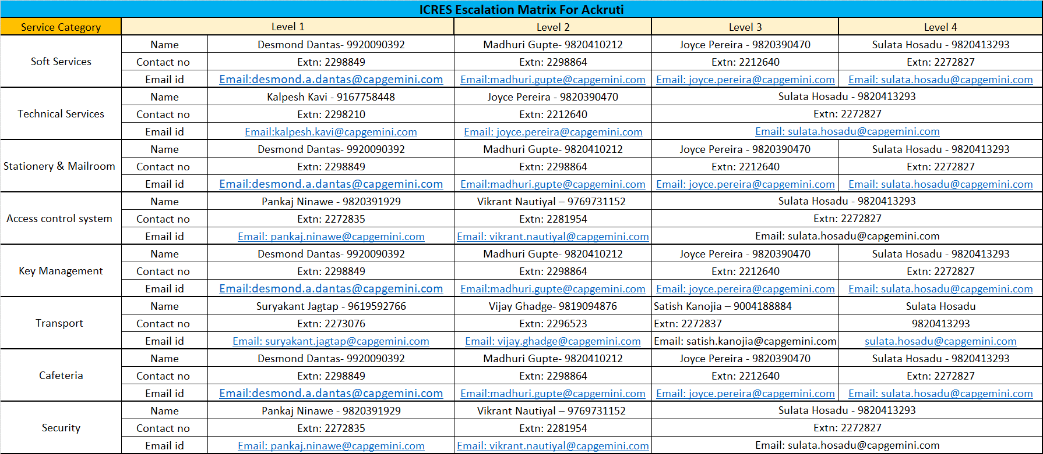

## Stationery request

On line requests to be submitted through the stationery portal on Talent-Useful links- stationery portal

Distribution of stationery is as per defined timings, from 9.30a.m to 1230 p.m and 3.00 p.m to 06.00 p.m

### Visiting Card Request Process

1. Request to be raised through online portal in Talent the stationery portal on Talent-Useful links- stationery portal

2. Company will issue visiting cards only to its bonafide employees.

3. Company follows a standard format for printing of visiting cards. Any deviation to this format needs to be approved by Head-ICRES

4. Visiting Cards will be printed within 15 working days from the date of submission of request form.

5. Employee will be informed through email on receipt of cards and the same should be collected by him / her during stationery room work timings.

6. For Managers and above no approvals required when requesting business cards

7. Employees below managers requesting business cards will need approval from code owners and this will be triggered directly through the system, only after the approvals will the request be processed for printing

### Photocopy Process

1. Photocopier machine is installed at each facility.

2. Photocopying is strictly for official purpose.

3. Employee should mention his / her details in the register maintained near photocopy machine.

4. For photocopy of more than 20 copies, photocopy request form needs to be filled with the approval from the Sr. Manager with the Project Code. The cost is debited to concerned project / department.

5. Photocopy request form is available on the Intranet.

**Photocopy, Spiral Binding & Lamination Request Form**

|  |  |
| --- | --- |
|  |  |

## Mail room

1. Mail room at Capgemini Mumbai offices are outsourced to an external vendor. Function of mail room is to receive and send documents internally (within different locations of Capgemini ACIS India offices) and externally (to Capgemini offices, clients and vendors around the world) through tie-ups with courier companies and only related to official mails and couriers, it does not entertain personal mails and couriers.

**Mail room timings**

|  |  |  |
| --- | --- | --- |
| **M4 office** | Ground floor | 9.00 am – 9.00 pm |
| **Airoli Gigaplex** | 7th floor | 9.00 am – 6.00 pm |
| **Airoli STPI** | Visitors Lounge | 9.00 am – 6.00 pm |
| **Airoli SEZ** | Behind Visitors Lounge | 9.00 am - 6:00 pm |

**Incoming Mail (Letters / Courier)**

1. Mail room boy will collect the courier covers and sign acknowledging the receipt of the courier

2. E-mail notification will be sent to employees to collect their mails from mail room.

3. Mails will be stored for 30 days only.

4. Any unclaimed letter or courier for more than 30 days will be destroyed without further intimation.

5. Mail room will accept documents / letters only. Credit / Debit Cards will not be accepted.

6. Mail room will not be responsible to pay charges of postage.

7. Employees should follow the process while collecting mails from mail room.

**Employee Guidelines**

1. Every new employee should visit mail room at their base location and register by giving details as required for receiving mails.

2. If employee has not registered, mail room will not be responsible for the mails received.

3. All employees should use following format to furnish address to the senders:

a. Full Name of the Recipient (with First and Last names)

b. Name of the project / Department

c. Complete address of the facility

d. Extension number and Mobile number of the recipient

**Internal Office Mail**

1. Internal mail timings are: 9 a.m. to 4 p.m. for same day delivery.

2. Employees should follow the process for sending mails through mail room.

**Outbound Mail**

1. Accepting the mail the timings are: 9 a.m. to 4 p.m.

Only official courier will be accepted by mail room along with ‘Courier Request Form’ (applicable only for domestic and international courier) with project code.

2. For sending CDs / DVDs / Tapes / any other device or packet / parcel, BU Head’s approval is required. Mail room needs declaration letter on company letterhead, invoice copy of the material on company letter head, indemnity letter (in case things are fragile), three copies of Shipper’s Certification for Non- Hazardous Cargo on company letterhead & Gate pass along with the packet / parcel.

3. Mail room will check all parcels and seal the same in front of employee. No packaging will be done by mailrooms

4. Employees are requested to adhere to all rules of the courier companies and cut-off time for handover of outbound mails which is displayed outside the mail room.

5. All mail / packets should be furnished with sender’s name, address / details of addressee, project name & charged code.

6. Courier Request Form, Declaration letter, Invoice Copy, Indemnity letter and Packing List is available on the Datapub-Admin folder.

7. Mail will be handed over to the courier agency and the airway bill receipt is collected from the Vendor. Mail will be tracked and follow up will be done with courier agency in case of a complaint by the employee, if the courier is not being received or in case of urgent official documents.

**List of items not accepted by Courier companies**

a. Electronics Equipment’s such as Laptops, Computer parts, Mobile phones, Toner etc.

b. Sweets & Eatable Articles.

c. Any Petroleum products.

d. House Hold Items.

e. Medicines, Films

**Responsibility**

Any complaints / queries on mail room services to be directed to ICRES Helpdesk or the ICRES facility person.

Company provides facility at central location within premise for inward & outward mails. This facility is available for official mail only. Employees should not make office address as personal address for personal mails. All domestic and international mails should be sent to all official addresses by the authorised courier agency.

**Mail ids:**

Mumbai: [mailroom-mumbai4.in@capgemini.com](mailto:mailroom-mumbai4.in@capgemini.com)

[mailroom-airoli.in@capgemini.com](mailto:mailroom-airoli.in@capgemini.com)

[mailroom-gigaplex.in@capgemini.com](mailto:mailroom-gigaplex.in@capgemini.com)

[mailroom-SEZ.in@capgemini.com](mailto:mailroom-SEZ.in@capgemini.com)

mailroom-STPI.in@capgemini.com

# Seat allocation and movement

## Process of seat allocation

1. Seat request by PM / PMO/RMG/BU SPOC on ATON portal for single / bulk seats (all seat requests are required to be raised on ATON selecting name of employee & project codes)

2. Approval by BU SPOC

3. Seat allocation / Blocking by Space Management Team

## Space management portal

**ATON –Automation Tool for Online Space Management**

ATON is the automated space management tool that is used for seat management.

The system provides a complete mapping and allocation of seats across our facilities along with relevant floor plans and reports. There are in-built features like on screen navigation, that will help you navcapgemini through Capgemini Offices globally, providing information about facilities, available seats etc. It enables you to trigger processes like Seat Assignment, Employee Seat Tagging, Seat Release/ Reclaim, One Step Floor Map view, Forecast Submission, Project Movement etc.

**ATON Detailed Features**

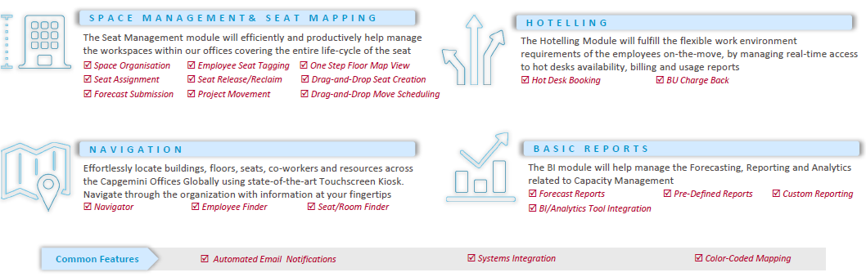

ATON can be accessed through [https://aton.capgemini.com](https://aton.capgemini.com/)

For booking conference / Meeting rooms:

1. Please log on to the online portal mrm.capgemini.com for meeting room / conference room bookings

2. Conference rooms can be booked 10 calendar days in advance and are auto approved

3. Meeting Rooms can be booked 5 calendar days in advance and are auto approved

4. VC room bookings are with ITICS and can be booked using VC rooms can be booked using <https://lvis.capgemini.com>



## SPOCs for Mumbai Seat Management & escalation Matrix

|  |  |  |  |  |
| --- | --- | --- | --- | --- |
| **Role** | **Name** | **Email ID** | **Extn.** | **Cell No.** |
| Space Management and Automation Lead | Santosh Koyande | santosh.koyande@capgemini.com | 2273784 | +91 9769906006 |

|  |  |  |  |  |  |
| --- | --- | --- | --- | --- | --- |
| **Escalation Level** | **Role** | **Name** | **Email ID** | **Extn.** | **Cell No.** |
| **First Level** | Space Management and Automation Lead | Santosh Koyande | [santosh.a.koyande@capgemini.com](mailto:santosh.a.koyande@capgemini.com) | 2273783 | +91 9769906006 |
| **Second Level** | Space Management and Automation Deputy Lead | Priya Aggarwal | [priya.aggarwal@capgemini.com](mailto:priya.aggarwal@capgemini.com) | 2273782 | +91 9820449844 |
| **Third Level** | Space Management and Automation COE Lead | Vijay Chandramoha n | vijay.chandramohan@capgemini.com | 2013427 | +919850976021 |

# Employee wellness services

## First aid and medical room facility:

1. A first aid-box is available at the reception Security desk and is available 24x7.

2. Employees can avail the medicines but will be solely responsible for the consumption and should consult their physician if required.

3. In case of emergency employees need to contact the ICRES representative and the employee will be taken to the nearest hospital. The hospital charges needs to be borne by the employee.

4. A medical room is available at specific locations in Mumbai (M4, Airoli and Airoli Gigaplex, SEZ & STPI)

5. An employee can use the medical room for about an hour. A register is maintained with the security at the main reception and employee needs to make an entry with some contact details and can use the medical room. If the room is occupied for more than an hour, after taking the employees consent, he / she is sent home or shifted to the nearest hospital.

### Medical room and doctor visit:

1. HSE has tied up with a doctor who visits the facilities on certain days and times as planned and already intimated to employees.

2. The doctor is available in the medical rooms on fixed days and timings

        CKP STPI – 9:00 am to 12:00 pm (mon – fri)

        CKP SEZ -  11:00 am to 2:00 pm (mon – fri)

        Airoli Gigaplex – 11:00 to 2:00 pm (mon – fri)

   Paramedic staff is available throughout the day other than doctor timings.

3. Detailed policy with HR

SPOCs for escalation

|  |  |  |  |  |  |
| --- | --- | --- | --- | --- | --- |
| **Escalation Level** | **Role** | **Name** | **Email ID** | **Extn.** | **Cell No.** |
| **First Level** | Facility Manager | Joyce Pereira  (Vikhroli)  Daljit Iype (CKP SEZ)  Raju Nanaware (CKP STPI)  Sarosh Dastoor  (Gigaplex) | [joyce.pereira@capgemini.com](mailto:joyce.pereira@capgemini.com)  [raju.nanaware@capgemini.com](mailto:raju.nanaware@capgemini.com)  [priya.aggarwal@capgemini.com](mailto:priya.aggarwal@capgemini.com)  [Sarosh.dastoor@capgemini.com](mailto:Sarosh.dastoor@capgemini.com) | 2212640  2281921  11518  30487 | +91 9820390470  +91 9920025533  +91 9820449844  +91 9820646339 |
| **Second Level** | City Service Delivery Head – Vikhroli  City Service Delivery Head – Airoli | Sulata Hosadu  Vijay Rego | [sulata.hosadu@capgemini.com](mailto:sulata.hosadu@capgemini.com)  [vijay.rego@capgemini.com](mailto:vijay.rego@capgemini.com) | 2272827  2291555 | +91 98 204 13293  +91 9920141505 |
| **Third Level** | Health and Safety COE Head | Roy, Mrittika | mrittika.roy@capgemini.com |  | +919830184593 |

# Physical safety & security services

## Issuance of access card and security

### Process of getting the access card and SLAs

**ID Card Management**

* On receipt of notification from the HR, employees are issued with employee proximity Photo ID card.
* General Access will be provided as default
* Access to High security zones is provided on separate approval from Account owner / PMO authorized person.
* In case of Loss or Damaged ID Card – Employee notifies security team for Issue of Duplicate ID Card. There is a penalty of Rs 500 in case of Loss of Card.

**Material Management**

* All Capgemini / Contractor material are regulated using Gate pass process & SEZ guidelines (in case offices coming under SEZ zones)

### Do’s and don’ts related to security

**Do’s**

* Employee must display their Capgemini ID card at all times while at work inside the facility.
* All Employees are required to swipe their access card on Entry & Exit
* VMS pass to be created for all visitors (through visitor management portal vms.in.capgemini.com/)
* Visitors will be escorted at all times by host/authorized person
* Get familiar with all emergency exits on floors of work and building safe assembly points
* Wear helmets / seat belts while driving inside campus
* Speed limit is 15km/h inside campus
* All employees are required to lock their drawers when unattended and take care of their personal belongings
* The employee should ensure a “clear desk “policy, leaving no confidential documents on the table.

**Don’t**

* Carry materials like personal laptop, pen drive, CDs, floppy, sharp items such as blades & knifes, liquor etc inside Campus / Restricted areas
* Carry Camera inside the campus
* Tailgate [Please swipe your access cards prior to Entry & Exit]
* Take Photograph using Camera / Camera phone or any Other Gadget inside Restricted / General area
* Over speed vehicles beyond 15 kms
* Do wrong parking , parking in front of emergency exits , utility areas
* Tamper with any security or safety equipment like Manual Call Point, access reader, CCTV camera and should not attempt to access restricted area, which he / she is not entitled.

**Additional Guidelines**

* Vehicles / Bags will be checked on **random basis** having mix of Scanning Machines and Physical checks at entrances.
* For baggage scan, this process will be instituted on the basis of random selection of a colored balls placed at the entrance
* In case the security personnel requests for a bag check, it is mandatory for all employees to abide by it
* For contractual and vendor staff, the bag checks are mandatory
* The scanning machines are being placed at strategic locations for checking the baggage. Physical checks will only be carried out in absence of a scanning machine.

**Advisory for our women colleagues:**

* Women colleagues are advised to use company cab transport, accompanied by a security escort (in case of first pick up or last drop), if they are traveling to / from office during silent hours (20:00 - 06:00 hrs). If a woman colleague is not using the company transport for any reasons or is using a personal transportation, an undertaking to this effect must be provided to the security at the time of exit.
* If you notice anything suspicious within the premises, or sense a threat to your personal safety, please reach out to the Physical Security Command Center by dialing **4001** from office phone, or**1800-267-4001 \*** if dialing from a mobile phone, or from outside Capgemini Office**.**

 Dos:

* Plan work in such a way that travel during silent hours is avoided.
* Always ensure that security escort sits in the front seat of the cab.
* Ensure mobile phones are charged before you leave for or from work.
* Follow the allocated route and stop only at the designated place as per the schedule.
* As far as possible, keep your friends, family, colleagues and manager informed of your travel during silent hours.

Don'ts:

* Don't sleep in the cab and be attentive in case of change in route.
* Do not use common transport facility during silent hours.
* Do not permit any outsider to board the vehicle under any circumstances.
* Avoid conversations which give personal details.

## Secure area / ODC awareness

### Restricted area / Client ODC

* Data Center | Network Room | Communication Rooms | Client ODC are Earmarked as High Security Zones
* Data Center | Server Room are installed with dual authentication access control system
* Access to these areas are only on approval of the owner and is reviewed on monthly basis
* Any access violation in these area are monitored and investigation is carried for breach of security
* Employees need access to restricted areas have to submit Physical access control form signed by their project manager to the security command center for activation of access.

### Fire safety and evacuation procedures

### ERT team

* Each account / floor / module to Nominate min two ERT members to the Security Command Center
* Emergency Response Team is Trained in Basic Fire Fighting / First Aid Training twice a year
* Associates can go through this training link to have a better know how of What to do in case of an emergency [*e-learning module – Basis Fire Fighting*](https://capgemini.sumtotalsystems.com/sumtotal/app/management/LMS_ActDetails.aspx?UserMode=0&ActivityId=91305)
* (<https://capgemini.sumtotalsystems.com/sumtotal/app/management/LMS_ActDetails.aspx?UserMode=0&ActivityId=91305>)
* Associates can also self-nominate for ERT by writing to the Security command center

### Safety signage and safe assemble area (Mock-up drills)

* ERT members are identified and a list of ERT members is also maintained on each floor
* All Fire Doors / Emergency exit doors are marked
* Fire extinguishers are placed at strategic places with visual identification.
* Each module Floor layout is displayed showing emergency exit / safe assembly point
* Safe assembly points are marked in each building
* Evacuation Drills are conducted twice a year

## Vehicle parking

* Vehicle parking space is provided and we follow “First come First” parking policy for all employees. Vehicles blocking other cars or parked in “ no parking area’s “ is strictly forbidden. If parking is full then employees may park their vehicles outside or in our campus premises depending subject to availability. Vehicle will be parked solely at owner’s responsibility & company will not be responsible for any theft or damages.
* Vehicle parking dangler/sticker is mandatory to access entry to Capgemini offices and needs to be submitted back while resigning from the organization; if lost reissue charges will be applicable @ INR 250
* Hemet & Seat belt are compulsory while driving/riding inside campus.
* Overnight parking without prior approval is not allowed.

## Physical safety

### Do’s and don’ts

### Contacts in case of emergency

* In case of an emergency, contact 4001 internally from Capgemini, or 69444001 from anywhere external.

### Off hours Security provisions

* Security Command Center is Operational on 24 x 7 basis and will attend to any requirement. The emergencies are also attended on 4001 (Internally) / Externally **1800-267-4001**.

## SPOCs for escalation

Vikhroli

|  |  |  |  |  |  |
| --- | --- | --- | --- | --- | --- |
| **Escalation Level** | **Role** | **Name** | **Email ID** | **Extn.** | **Cell No.** |
| **First Level** | Security Command Center |  | [Security-commandcenter.in@capgemini.com](mailto:Security-commandcenter.in@capgemini.com) | 4001/ 2262222 | +91 9920122730 |
| **Second Level** | Physical Security – Location SPOC | Pankaj Ninawe  Bala Nair | [Pankaj.ninawe@capgemini.com](mailto:Pankaj.ninawe@capgemini.com)  [Bala.nair@capgemini.com](mailto:Bala.nair@capgemini.com) | 2272835 | +91 9820391929  +91 8879523758 |
| **Third Level** | Physical Security Lead | Nilesh Bhagwat | nilesh.bhagwat@capgemini.com | 2267871 | +91 9833731456 |
| **Fourth Level** | City Service Delivery Head | Sulata Hosadu | [sulata.hosadu@capgemini.com](mailto:sulata.hosadu@capgemini.com) | 2272827 | +91 9820413293 |
| **Fifth Level** | Physical Security COE Lead | Avalluru, Chandra Mohan (ICRES) | [chandra-mohan.avalluru@capgemini.com](mailto:chandra-mohan.avalluru@capgemini.com) | 26031 | +91 9848912586 |

AIROLI

|  |  |  |  |  |  |
| --- | --- | --- | --- | --- | --- |
| **Escalation Level** | **Role** | **Name** | **Email ID** | **Extn.** | **Cell No.** |
| **First Level** | Security Command Center |  | [Security-commandcenter.in@capgemini.com](mailto:Security-commandcenter.in@capgemini.com) | 4001/ 2262222 | +91 9920122730 |
| **Second Level** | Physical Security – Location SPOC | Surendra – CKP STPI  Sandeep Thorat (SEZ) | [Pankaj.ninawe@capgemini.com](mailto:Pankaj.ninawe@capgemini.com)  [Sandeep.thorat@capgemini.com](mailto:Sandeep.thorat@capgemini.com) | 2291706  2280515 | +919594286334  +919819289925 |
| **Third Level** | Physical Security Lead | Nilesh Bhagwat | nilesh.bhagwat@capgemini.com | 2267871 | +91 9833731456 |
| **Fourth Level** | City Service Delivery Head – Airoli | Vijay Rego | [vijay.rego@capgemini.com](mailto:vijay.rego@capgemini.com) | 2291555 | +91 9920141505 |
| **Fifth Level** | Physical Security COE Lead | Avalluru, Chandra Mohan (ICRES) | [chandra-mohan.avalluru@capgemini.com](mailto:chandra-mohan.avalluru@capgemini.com) | 26031 | +91 9848912586 |

FAQs

# Transport services

**Q.** How do I apply for the bus pass?

**Ans**: Associate needs to login into India Intranet->PACE-> Payroll & compensation-> Transport Declaration-> Transport Registration & fill in the details.

**Q.** What will happen after I apply for the application?

**Ans**: Associate will receive a auto generated mail informing the status.

**Q.** How will I get to know when to collect my bus pass?

**Ans**: You will be notified through email about the readiness of bus pass & to collect the same within two working days.

**Q.** What in case if I had applied & need to travel on the same day?

**Ans**: You can take a screen print out of your PACE registrations were your transport details and the route selected is clearly visible. Also take acknowledge of ICRES personnel on printout.

**Q.** How do I cancel the bus pass?

**Ans**: Associate needs to deregister in PACE and submit their bus pass to ICRES personnel at their location.

**Q.** Do I need to submit the bus pass?

**Ans**: Yes, it is **mandatory** to submit the bus pass after associate has deregister in PACE. If the associate fails to submit the bus pass it will considered that the associate is still availing the facility & deductions will be carried out till the date pass is submitted.

**Q.** How will I come to know that cancel application is effected after submission of bus pass?

**Ans**: There will be mail confirmation sent to you after the transport desk administrator has received your bus pass.

**Q.** What is the escalation matrix in case of any queries?

**Ans**: For Mumbai: - Refer page no. 23

**Q.** How do I know the difference for the grid I am traveling?

**Ans**: For ease of identification bus passes will be changed to different color coding as per the location.

|  |  |  |
| --- | --- | --- |
| **City** | **Fees Deducted / Month (INR)** | **Routes Covered** |
| Mumbai | 1700 | Andheri, Dadar, Bandra, Thane, Vashi |
| Mumbai | 1950 | Via JVLR till Borivali |
| Mumbai | 2200 | Virar, Sanpada, Belapur, Bhayander &Panvel |

**Q.** How do I update any details?

**Ans**: For any update in records after the creation of bus pass associate needs to cancel the previous application (cancellation process as described in point No. 5) & apply afresh for the bus pass.

**Q.** What will happen if after updating my records my grid changes?

**Ans**: Associate will be notified of the changes & the applicable amount will be deducted from the associate’s payroll effective that date.

**Q.** What is the basis of distance measurement?

**Ans**: Distance is measured as per the existing bus routes & is originating from Mumbai campus.

**Q.** What if I need to travel for a day?

**Ans**: You have to send a mail to transport desk and take approval.

**Q.** What if somebody is caught without bus pass?

**Ans**: If during bus pass checking, any associate is found traveling without valid bus pass and if he / she has not followed procedure as described above, associate will penalised with penalty amount of  
Rs. 1700/- per instance. If associate wants to avail the service then they need to apply it online through bus PACE application. Repeated offence would be considered as activity against organisation & would be reprimanded as per the company policies.

**Q.** What if the associate’s needs to travel for attending training session at the campus?

**Ans**: Associates need to collect bus pass from Learning & Development team.

**Q.** What in case if the bus pass is lost?

**Ans**: Associate has to first send an email to transport desk to deactivate in PACE under bus pass lost option. And then reapply for a new bus pass.

# ****Workplace services****

**Q.** Whom should I call in case there is an issue with housekeeping?

**Ans**: Call on the ICRES helpdesk & provide details of the issue / request that needs to be serviced.

**Q.** My team is working during the night shift I need AC to be provided?

**Ans**: In order to optimise the operations AC are switched off during night & weekends; however pedestal fans are provided to the night shift team on request. Please send your [engineeringservices.fssbu@capgemini.com](mailto:engineeringservices.fssbu@capgemini.com) atleast 24 hrs in advance.

**Q.** I have a meeting need to book a conference room.

**Ans**: Rooms can be booked through the online Meeting Room Manager Portal (MRM)

**Q.** I need to book a VC room.

**Ans**: VC rooms can be booked using <https://lvis.capgemini.com>.

**Q.** I want extension board for using my laptop.

**Ans**: Raise a request in remedy. Cost of the board will be charged to the associate’s project code.

**Q.** Where can I collect the stationery?

**Ans**: Stationery is available in stationery room at each office location and can be collected during stationery hours

**Q.** Do we have any corporate contracted estate agents?

**Ans**: No.

**Q.** I want extension board for using my laptop.

**Ans**: Raise a request in remedy. Cost of the board will be charged to the associate’s project code.

**Q.** My team is working during the night shift / weekend, I need AC to be provided?

**Ans**: In order to optimise operations AC are switched off during night & weekends.

However If there are employees working and the occupancy is less than 20 people, pedestal fans will be provided.

For occupancy of more than 20 people we can run HVAC, if employees are working on any specific weekend (which is not in continuous shift) then we can shift them in a meeting room / conference room that has network & HVAC facility. They will need to send a mail in advance, giving minimum 24hrs lead time. Mail should be sent to respective location maintenance id.

Employees who have regular shifts, should share their shift schedule and occupancy nos. to maintenance on the maintenance id of their respective location for request to arrange fans if occupancy is less than 20 and HVAC if more than 20

# ****Seat allocation and movement****

**Q.** How is seat allocation done to Employees?

**Ans**: Seat allocation is done through Space Management Portal.

**Q.** Who can raise a request for seat and where to raise the request?

**Ans**: Employee / Project Manager can raise seat request on Space Management Portal.

**Q.** What is the link to access Space Management Portal?

**Ans**: Link to Space Management Portal is <http://space.in.capgemini.com>

**Q.** How is the movement of seats from one location to other location made?

**Ans**: All requests for movement to be requested on Space Management Portal.

# Physical safety & security services

**Q.** What is the Procedure to get Employee ID Card?

**Ans**: Fill the IDCard Form authorised by HR Dept / Notification. IDCard Cell will process the request and send email confirmation to collect IDCard.

**Q.** How to get Access card activated?

**Ans**: With Issue of IDCard, General access to Area is automatically activated.

**Q.** How to get access in other locations?

**Ans**: Other location card will be activated on request to Security command center for a specific period, alternatively if the access card cannot be activated Employee can submit their access card and get interim access card for the duration of stay directly from Security gate or reception.

**Q.** How to get access for Client ODC?

Ans: Contact your PMO or Delivery Manager, As per process a email confirmation has to be sent to security command center for activation of access. The same is confirmed on return email to employees.

**Q.** What is the process to get ID card clearance during Exit / STT / LTT?

**Ans**: Submit ID Card at ID Card cell to get the clearance

**Q.** Process to allow business visitor?

**Ans**: Create an Appointment in Visitor Management System, Security at Gate / Reception will create visitor pass as per appointment and issue.

**Q.** What If Employee found some Items?

**Ans**: Employee should deposit the item to Security Gate / Reception. Security will handover the items to individual with proper claims after maintaining records in loss & found registers.

**Q.** What should employee do incase they get stuck inside lift or Lift stopped working in between?

**Ans**: Employee Should not panic stay calm, They should press emergency button in each lift to alert security. Note: All lifts are equipped with ERD (Emergency Response Device) Which brings lift to nearest floor and prevent from falling.

**Q.** What is the process to allow family members in campus during off days?

**Ans**: Fill the Visitor Intimation Form signed by Physical security Head., Entry to work modules will not be allowed.

**Q.** Process to do photography inside campus?

**Ans**: Photography is not allowed inside the company premises. For any business requirement Photography is permitted on approval from Project Manager / BU Head.

**Q.** Incase employee notice any suspicious items?

**Ans**: Employee should not touch the items and immediately inform Security Command Center by dialing 4001.

**Q.** Are employee allowed to carry personal courier inside

**Ans**: Yes only after getting them checked by security, but no IT related item is allowed inside Client ODC.

About Capgemini

A global leader in consulting, technology services and digital transformation, Capgemini is at the forefront of innovation to address the entire breadth of clients’ opportunities in the evolving world of cloud, digital and platforms. Building on its strong 50-year heritage and deep industry-specific expertise, Capgemini enables organizations to realize their business ambitions through an array of services from strategy to operations. Capgemini is driven by the conviction that the business value of technology comes from and through people. It is a multicultural company of 200,000 team members in over 40 countries. The Group reported 2016 global revenues of EUR 12.5 billion.

Learn more about us at [www.capgemini.com](http://www.capgemini.com)

1. \*Maggie/Sandwiches/egg bhurji/omelette etc [↑](#footnote-ref-1)