PROJECT PHASE - I
SECURE VISITOR PASS GENERATOR USING BLOCKCHAIN
A Project Phase - I Report Submitted
In partial fulfillment of the requirements for the award of the degree of

Bachelor of Technology
in
Computer Science and Engineering
by
P. Yuva Akhil 22N31A05G9
P. Bhargava Sai 22N31A05J9
Md. Irfan 22N31A05E0

Under the esteemed guidance of

Mr. P. Dastagiri Reddy., M.Tech.,(Ph.D)
Assistant Professor


Department of Computer Science and Engineering

Malla Reddy College of Engineering & Technology
(Autonomous Institution- UGC, Govt. of India)
(Affiliated to JNTUH, Hyderabad, Approved by AICTE,NBA &NAAC with A Grade)
Maisammaguda, Kompally, Dhulapally, Secunderabad -500100 website: www.mrcet.ac.in
2022-2026


Malla Reddy College of Engineering & Technology
(Autonomous Institution- UGC, Govt. of India)
(Affiliated to JNTUH, Hyderabad, Approved by AICTE, NBA &NAAC with ‘A’ Grade)
Maisammaguda, Kompally, Dhulapally, Secunderabad – 500100 website: www.mrcet.ac.in

CERTIFICATE

This is to certify that this is the bonafide record of the application entitled “Secure Visitor Pass Generator Using Blockchain”, submitted by Student P.Yuva Akhil(22N31A05G9), P. Bhargava Sai(22N31A05J9) and Md. Irfan(22N31A05E0) of B.Tech in the partial fulfillment of the requirements for the degree of Bachelor of Technology in Computer Science and Engineering, Department of CSE during the year 2024-2025. The results embodied in this project report have not been submitted to any other university or institute for the award of any degree or diploma.

Internal Guide Project Coordinator Head of the Department P. Dastagiri Reddy D Sai Eswari Dr.G.Ravi
Assistant Professor Assistant Professor Associate Professor

External Examiner

DECLARATION

We hereby declare that the application titled “Secure Visitor Pass Generator Using Blockchain” submitted to Malla Reddy College of Engineering and Technology (UGC Autonomous), affiliated to Jawaharlal Nehru Technological University Hyderabad (JNTUH) for the award of the degree of Bachelor of Technology in Computer Science and Engineering is a result of original research carried out in this thesis. It is further declared that the project report or any part thereof has not been previously submitted to any University or Institute for the award of a degree or diploma.

P. Yuva Akhil - 22N31A05G9
P. Bhargava Sai - 22N31A05J9
Md. Irfan- 22N31A05E0

ACKNOWLEDGEMENT

We feel honored to place our warm salutation to our college Malla Reddy College of Engineering and Technology (UGC-Autonomous) for giving us opportunity to do this Application as part of our B. Tech Program. We are ever grateful to Principal Dr.V.Murali Mohan who enabled us to have experience in engineering and gain profound technical knowledge.

We express our heartiest thanks to our HOD, Dr. G.Ravi for encouraging us in every aspect of our course and helping us realize our full potential,
r
We would like to thank our Project Guide Mr.P.Dastagiri Reddy for her regular guidance, suggestions, and constant encouragement. We are extremely grateful to our Project Coordinator Ms. D. Sai Eswari for her continuous monitoring and unflinching co-operation throughout project work.
We would like to thank our Class Incharge Ms. D. Sai Eswari who in spite of being busy with his/her academic duties took time to guide and keep us on the correct path.

We would also like to thank all the faculty members and supporting staff of the Department of CSE and all other departments who have been helpful directly or indirectly in making our project a success

We are extremely grateful to our parents for their blessings and prayers for the completion of our project that gave us strength to do our project.

With regards and gratitude

P. Yuva Akhil - 22N31A05G9
P. Bhargava Sai - 22N31A05J9
Md. Irfan- 22N31A05E0

ABSTRACT

This project introduces a blockchain-based secure visitor pass generation system designed to improve the safety, transparency, and efficiency of gate pass management in institutions or organizations. The application starts with the user uploading an image of a government-issued ID card. Using Optical Character Recognition (OCR), the system automatically extracts key visitor details such as name, photo, and identification number. After data verification, the visitor authorizes the process through a connected digital wallet (via Freighter Wallet), enabling the creation of a secure transaction that records the visit on a decentralized blockchain ledger. This ensures tamper-proof, immutable logs for auditing and security. The system then generates a digital gate pass with a unique ID, embedded QR code, and a verifiable transaction reference. Admins can review, validate, and manage passes in real time using a dedicated control panel. Compared to manual systems, this solution eliminates the risk of data forgery, loss, or unauthorized access and ensures reliable, efficient, and secure visitor tracking. Developed using React.js, TypeScript, and Node.js, the system operates effectively on low-end hardware and offers scalable integration possibilities for smart facility management.

TABLE OF CONTENTS

S.NO | TITLE | PG.NO
1 | INTRODUCTION | 1
 | 1.1 PURPOSE AND OBJECTIVES | 1
 | 1.2 EXISTING AND PROPOSED SYSTEM | 2
 | 1.3 SCOPE OF PROJECT | 4
2 | LITERATURE SURVEY | 5
3 | SYSTEM ANALYSIS | 7
 | 3.1 HARDWARE &SOFTWARE REQUIREMENTS | 9
4 | SYSTEM DESIGN | 9
 | 4.2 ARCHITECTURE | 11
 | 4.3 UML DIAGRAMS | 12
5 | METHODOLOGY | 16
 | 5.1 TECHNOLOGIES USED | 16
 | 5.2 MODULES DESCRIPTION | 19
6 | IMPLEMENTATION | 22
 | 6.1 SAMPLE CODE | 22
 | 6.2 OUTPUT SCREENS | 52
7 | CONCLUSION & FUTURE SCOPE | 54
8 | BIBILOGRAPHY | 55

LIST OF FIGURES

FIGURE.NO | NAME | PG.NO
4.1.1 | ARCHITECTURE DIAGRAM | 9
4.2.1 | CLASS DIAGRAM | 10
4.2.2 | USE CASE DIAGRAM | 11
4.2.3 | ACTIVITY DIAGRAM | 12
4.2.4 | SEQUENCE DIAGRAM | 13
4.2.5 | COMPONENT DIAGRAM | 14
4.2.6 | STATE CHART  DIAGRAM | 15
4.2.7 | DEPLOYMENT DIAGRAM | 16
5.1.1 | ARCHITECTURE OF PYTHON | 17

LIST OF OUTPUT SCREENS

FIGURE.NO | NAME | PG.NO
6.2.1 | HOME SCREEN | 49
6.2.2 | WALLET CONNECTION | 49
6.2.3 | GATE PASS | 50
6.2.4 | STELLAR NETWORK | 50
6.2.5 | VERIFICATION SCREEN | 51

CHAPTER 1
INTRODUCTION

In today’s fast-paced and security-conscious world, traditional methods of visitor management—such as paper logbooks and manual ID checks—are increasingly inadequate. These conventional systems are prone to human error, lack a reliable means of identity verification, and offer no resistance against forgery or unauthorized access. As institutions, corporate campuses, and government facilities grow in complexity, there is a pressing need for a secure, automated, and tamper-proof solution to manage visitor access effectively.

This project presents a modern, technology-driven approach by integrating Optical Character Recognition (OCR) and blockchain technology to develop a Secure Visitor Pass Generator. The system allows users to upload an image of an official identification card. Using OCR, the system automatically extracts critical visitor information such as the name, ID number, and photograph. The extracted data is then verified and used to generate a secure digital transaction, which is recorded on a decentralized blockchain ledger to ensure data integrity and prevent tampering.

Once validated, the system generates a digital gate pass containing a unique identifier, QR code, and blockchain reference for real-time, verifiable access. The application also includes an admin interface that provides control over pass approvals, visitor tracking, and status management, ensuring a robust and scalable solution for secure access control.
  - Purpose and Objectives

Purpose:
The primary purpose of the Secure Visitor Pass Generator project is to modernize and secure visitor management systems by leveraging advanced technologies like Optical Character Recognition (OCR) and blockchain. The system is designed to provide organizations with a tamper-proof, efficient, and automated way to manage and verify visitor access. By replacing manual, paper-based entry processes with a decentralized digital solution, the project enhances security, accuracy, and transparency while reducing the risk of data manipulation or unauthorized access.

Objectives:
- Implement OCR technology to extract visitor details such as name, photo, and ID number from uploaded identity card images.
- Securely record visitor data on a decentralized blockchain ledger for tamper-proof verification and auditability.
- Generate digital gate passes embedded with unique identifiers, QR codes, and blockchain references for quick and secure validation.
- Enable real-time visitor management through an interactive admin panel for reviewing and controlling gate pass issuance.
- Enhance security through digital wallet integration (Freighter Wallet) for transaction authorization and identity verification.
- Support scalability and user accessibility through a modern tech stack including React.js, TypeScript, and Node.js.
- Contribute to SDG 8 by improving operational efficiency and promoting smart digital infrastructure for secure work environments.
  - Existing and Proposed System

Existing System

Most organizations and institutions today rely on conventional visitor management systems, which are often paper-based and highly manual. These systems present several limitations and vulnerabilities that compromise security, efficiency, and accountability.
- Manual Data Entry: Visitor details are recorded in physical registers by security personnel, which is time-consuming and prone to human error.
- Lack of Real-Time Verification: Physical IDs are visually inspected, with no reliable way to validate authenticity or cross-reference against secure databases.
- Forgery and Duplication Risks: Paper gate passes can be easily forged, duplicated, or manipulated, leading to potential security threats.
- No Digital Trail: There is no reliable digital log or audit trail available for future reference or security analysis.
- Low Operational Efficiency: Manual entry delays gate processing, especially during high-traffic hours, creating queues and congestion.
- Lack of Integration: No centralized system exists to link visitor data with verification, logging, and admin monitoring functionalities.

Proposed System (Secure Visitor Pass Generator)

The proposed system replaces traditional visitor entry processes with a secure, blockchain-enabled digital solution. It automates ID verification, ensures data integrity, and enables real-time gate pass management using advanced technologies.
- ID Upload and OCR Processing:
  - Visitors upload a photo of their government-issued ID.
  - Optical Character Recognition (OCR) is used to extract key information like name, ID number, and photograph.
- Digital Wallet Verification:
  - The visitor authenticates their data submission through a blockchain-enabled digital wallet (Freighter Wallet).
  - This ensures that each transaction is authorized and verifiable.
- Blockchain Logging:
  - Visitor data is stored as a secure transaction on a decentralized blockchain ledger.
  - This guarantees tamper-proof, immutable records with traceable references.
- QR Code Pass Generation:
  - A digital gate pass is created containing a unique pass ID, QR code, and blockchain transaction hash.
  - Security staff can scan the QR code to validate authenticity in real time.
- Enhanced Security and Transparency:
  - All visitor logs are cryptographically protected, reducing risks of data leakage or manipulation.
  - The system provides a complete audit trail of all entries and exits.

- Improved Efficiency:

The system reduces wait times, eliminates manual data entry, and ensures faster visitor processing at gates.

This innovative approach not only strengthens security but also introduces a smart, scalable solution that meets modern operational standards and aligns with digital transformation goals.

  - Scope of the Project

The scope of this project revolves around the design and development of a blockchain-based digital gate pass system that enhances the security, reliability, and efficiency of visitor management in institutions and workplaces. This system aims to address the limitations of manual entry methods by introducing automation, secure identity verification, and real-time tracking using decentralized technologies.

The application allows users to upload a government-issued identity card image through a web interface. Using Optical Character Recognition (OCR), the system extracts relevant visitor details such as name, ID number, and photo. These details are verified and securely stored as blockchain transactions using Albedo wallet integration. The generated digital gate pass includes a unique pass ID, a scannable QR code, and a verifiable transaction reference, ensuring tamper-proof and authentic visitor entries.

The application supports an admin dashboard that enables administrators to review, approve, monitor, or revoke passes in real time. Each issued pass is securely logged with a timestamp, creating a transparent and immutable audit trail of all visitors entering the premises. This reduces the risk of unauthorized access, human error, and record tampering.

With a modular architecture built using React.js, TypeScript, and Node.js, the system is scalable for future enhancements such as multi-language support, biometric verification, and mobile accessibility. Designed for institutions like colleges, research labs, corporate offices, and secure campuses, the project contributes to Sustainable Development Goal (SDG) 8 by improving operational transparency, workplace safety, and digital infrastructure.

CHAPTER 2

LITERATURE SURVEY
As digital transformation continues to reshape traditional identity and access management systems, secure and efficient visitor verification has become a critical focus in institutions, businesses, and public facilities. This literature survey explores various research studies that inform and support the design of a blockchain-integrated visitor pass system capable of providing tamper-proof security, transparency, and automated visitor handling.
S. K. Sharma, A. Roy et al. [1]: This research highlights the application of blockchain technology in access control systems, emphasizing the use of decentralized ledgers for secure and immutable record-keeping. For the Secure Visitor Pass Generator, integrating similar blockchain mechanisms ensures that visitor records cannot be altered or forged, thereby establishing a tamper-proof system for issuing and verifying gate passes.
M. N. Patil, V. J. Mahajan et al. [2]: The study investigates the limitations of traditional visitor logbooks and proposes a digital replacement using secure web applications. Incorporating such a system into the Secure Visitor Pass Generator allows for real-time data entry, reduced human error, and improved visitor handling without the inefficiencies of manual data recording.
R. R. Kulkarni, S. S. Deshmukh et al. [3]: This research focuses on the automation of identity verification using OCR integrated with document scanning technologies. In the Secure Visitor Pass Generator, similar techniques can be used to extract and process visitor information from ID cards automatically, enhancing speed and reducing the burden on entry staff.
T. K. Sinha, D. K. Rajput et al. [4]: The paper presents a model for QR code-based authentication in physical access systems. For the visitor pass system, integrating QR codes into the digital gate pass enables fast, contactless entry while ensuring that each pass is unique and securely verifiable.
A. A. Khan, P. L. Mehta et al. [5]: This study examines the use of IPFS (InterPlanetary File System) and Pinata for decentralized file storage. Applying this to the Secure Visitor Pass Generator allows for the visitor's photo and ID image to be stored securely on a distributed system, ensuring data integrity and availability even in the event of server issues.
N. M. Karthik, S. V. Rao et al. [6]: The role of digital wallets in authorizing blockchain transactions is explored in this research. By incorporating Albedo Wallet in the Secure Visitor Pass Generator, visitors can sign their data digitally before it's committed to the blockchain, adding a critical layer of user consent and transaction security.
P. Dasgupta, V. Iyer et al. [7]: This paper evaluates different visitor pass systems and suggests modular, scalable architectures. Applying such a design to the Secure Visitor Pass Generator enables future integrations with biometric scanners, mobile apps, and multi-language support without overhauling the core structure.
S. N. Reddy, A. Banerjee et al. [8]: This study investigates real-time QR code verification mechanisms in smart building access systems. Integrating this concept allows the Secure Visitor Pass Generator to instantly validate each pass by checking the blockchain record during entry.
H. L. Chouhan, Y. J. Park et al. [9]: The paper explores gamification in smart infrastructure to improve engagement. While not directly applicable, such elements could be creatively used in future versions of the Secure Visitor Pass Generator to reward secure behaviors (e.g., first-time visitors, early check-ins) in smart campuses.
R.K.Gupta, P. S. D. S. Menon et al. [10]: This research addresses the critical importance of privacy and data protection in decentralized applications. Implementing strong encryption, hashed identity storage, and privacy-preserving protocols in the Secure Visitor Pass Generator ensures compliance with security regulations like GDPR and builds user trust.

CHAPTER 3
SYSTEM ANALYSIS
System requirements are the functionality that is needed by a system in order to satisfy the customer's requirements. System requirements are abroad and a narrow subject that could be implemented to many items. The requirements document allows the project team to have a clear picture of what the software solution must do before selecting a vendor. Without an optimized set of future state requirements, the project team has no effective basis to choose the best system for your organization.

3.1 Hardware and Software Requirements

Hardware Requirements
To ensure optimal performance during the development, testing, and deployment of the Secure Visitor Pass Generator application, the following hardware specifications are recommended:
Development Machine:
- Processor: Intel i5 or higher (or equivalent AMD). A more powerful processor such as Intel i7 or AMD Ryzen is recommended for handling blockchain transactions, running backend services, and simultaneous browser sessions.
- RAM: Minimum 8 GB (16 GB recommended). Adequate memory ensures smooth multitasking between blockchain wallet integration, OCR processing, and application servers.
- Storage: At least 250 GB (SSD preferred for faster data handling). SSD storage improves performance during development, especially while storing visitor data logs and accessing blockchain records.
Software Requirements:
The Secure Visitor Pass Generator application depends on a combination of modern development tools, frameworks, and decentralized technologies to deliver a secure and seamless user experience. The following software components are essential:
Backend Framework:
- Node.js + Express.js: A JavaScript-based runtime and backend framework used for building fast, scalable RESTful APIs, and handling blockchain interactions.

Blockchain and Wallet Integration:
- Stellar Blockchain + Albedo Wallet: Used to create and sign blockchain transactions. Albedo ensures secure, user-consented identity verification and storage of transaction hashes on the Stellar network.
OCR & Image Processing:
- Tesseract OCR: An open-source OCR engine used to extract visitor details (name, ID number, photo) from uploaded ID card images.
Decentralized Storage:
- Pinata + IPFS: Used to store visitor ID card images and associated metadata in a tamper-proof, decentralized manner. IPFS hashes are stored on the blockchain for verification during gate pass validation.
Database:
- MongoDB: A NoSQL document-based database used for storing visitor logs, gate pass metadata, and pass status (active, expired, revoked).
Frontend Framework:
- React.js + TypeScript: A component-based frontend library and typed language used to build a responsive, interactive user interface for visitors and security personnel.
Development Tools:
- IDE/Text Editor: Visual Studio Code is recommended for writing and managing the full-stack codebase. It supports extensions for JavaScript, Node.js, and Git integration.
- Version Control: GitHub is used to manage version control, collaboration, and backup of all project files and development history.

CHAPTER 4
SYSTEM DESIGN

4.1 Architecture Diagram:
An architecture diagram is a visual representation of a system's structure, outlining its key components and their relationships. It provides a high-level overview of how various elements, such as hardware, software, databases, and network components, interact to form a complete system. These diagrams are essential for communicating complex systems to stakeholders, enabling better understanding, planning, and decision-making. They come in various forms, including system architecture, network architecture, application architecture, and cloud architecture diagrams. By simplifying the complexity of a system, architecture diagrams aid in ensuring scalability, identifying potential bottlenecks, and facilitating the design and implementation of effective solutions.
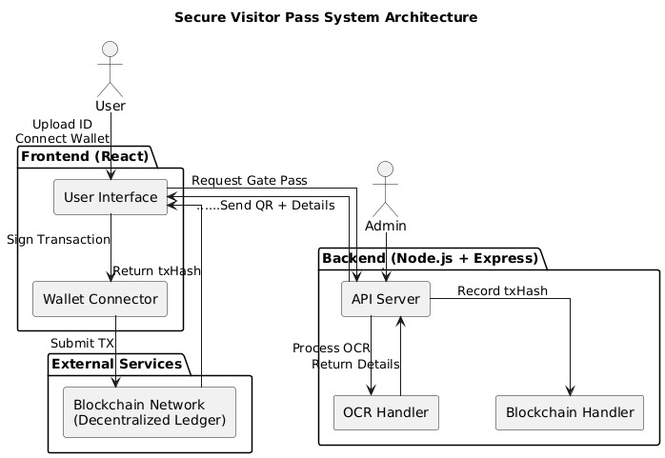

Fig: 4.1.1 Architecture Diagram
4.2 UML Diagrams
UML Diagrams are classified into different types such as :
- USE CASE DIAGRAM
- CLASS DIAGRAM
- SEQUENCE DIAGRAM
- ACTIVITY DIAGRAM

Class Diagram
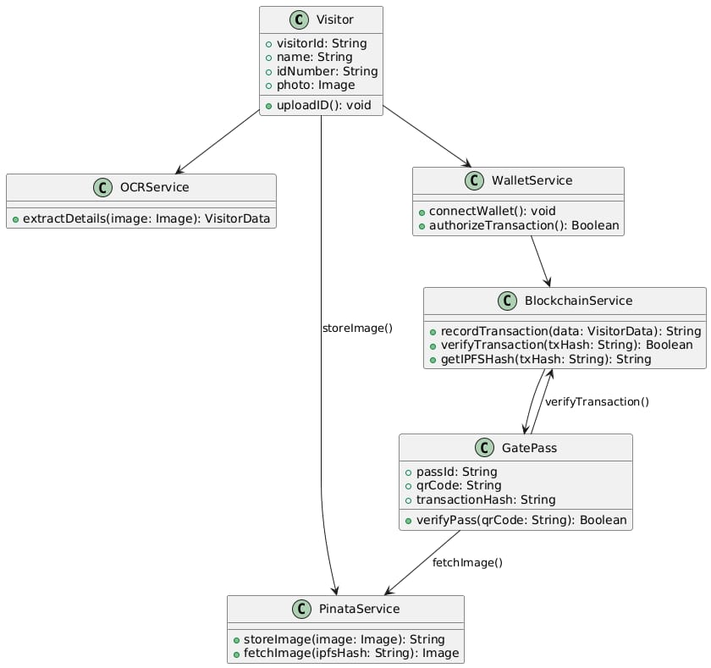
A class diagram is a visual representation used in object-oriented design to illustrate the structure of a system by showing its classes, attributes, methods, and the relationships between them. It helps define the blueprint of objects, specifying their characteristics (attributes) and behaviors (methods), and how they interact with one another through associations like inheritance, composition, or dependency. As part of UML (Unified Modelling Language), class diagrams are essential for modelling complex software systems, providing a clear view of how different components interact, and serving as a guide for developers during implementation.

Fig: 4.2.1 Class Diagram
Use Case Diagram
A use case diagram is a type of behavioral diagram in UML (Unified Modeling Language) that visually represents the interactions between users (actors) and a system to achieve specific goals (use cases). It shows how users engage with the system by outlining the various use cases, which represent different functionalities or services the system provides. Actors, who can be users or external systems, are connected to these use cases to indicate their involvement
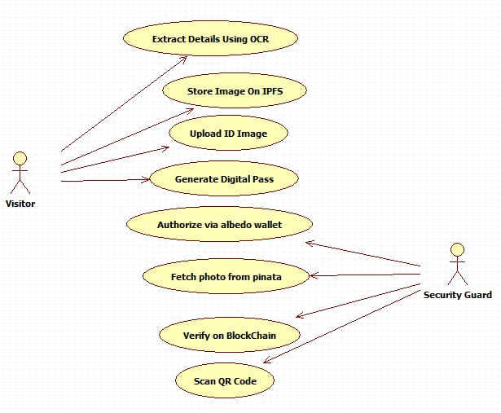

Fig: 4.2.2 Use Case Diagram

Activity Diagram
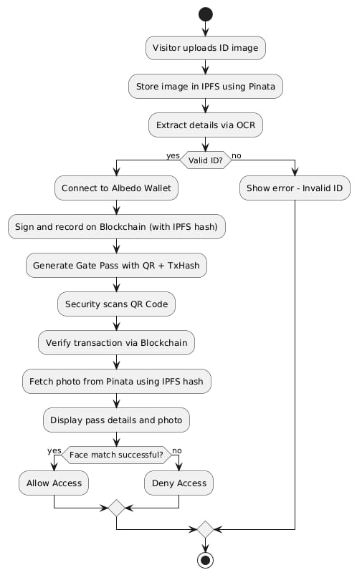
An activity diagram is a type of UML (Unified Modelling Language) diagram that models the dynamic behaviour of a system by illustrating the flow of activities or actions. It focuses on the sequence of steps involved in a process or workflow, representing the flow of control from one activity to another.

Fig: 4.2.3 Activity Diagram
Sequence Diagram
A sequence diagram is a type of UML (Unified Modeling Language) diagram that visualizes the sequential flow of interactions between objects or components in a system. It shows how messages or events are exchanged between participants over time, illustrating the order of operations and relationships.
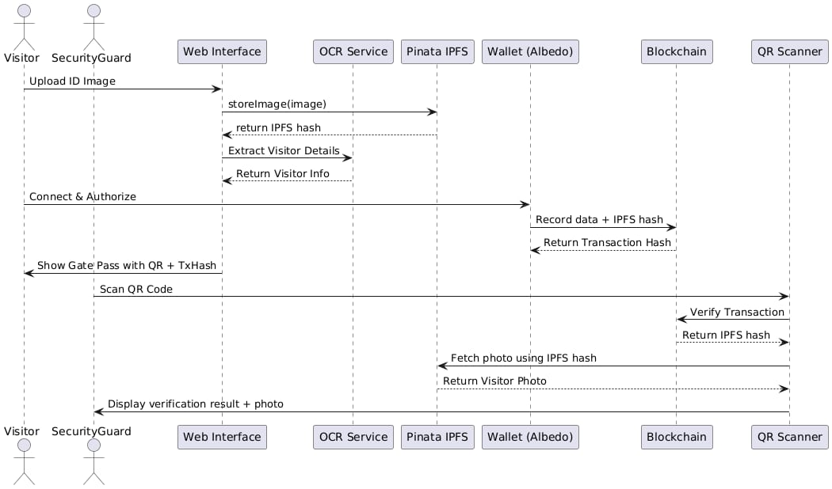

Fig: 4.2.4 Sequence Diagram

Component Diagram
The component diagram represents the major modules of the Secure Visitor Pass Generator. The frontend built with React.js interacts with the backend (Node.js/Express) to handle user requests. The OCR engine extracts details from uploaded ID images, while IPFS/Pinata provides secure decentralized storage. Visitor records are stored in MongoDB, and Stellar Blockchain with Albedo Wallet ensures tamper-proof verification of gate passes.

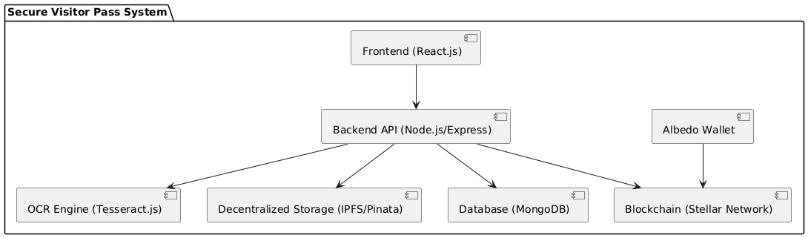

Fig: 4.2.5 Component Diagram

State Chart Diagram
The state chart diagram illustrates the lifecycle of a visitor pass. A pass is first requested when an ID is uploaded, then generated after validation. It becomes active once issued and moves to verified after blockchain confirmation at entry. Finally, the pass either expires after its validity ends or is revoked manually, ensuring controlled and secure access management.
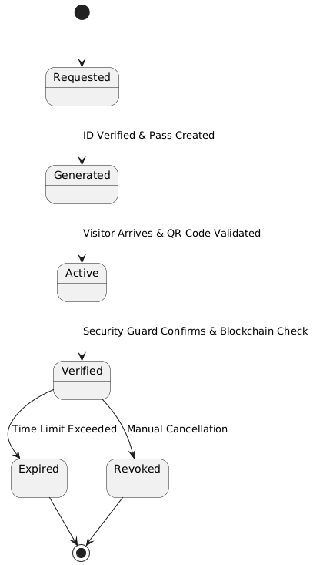

Fig: 4.2.6 State Chart Diagram

Deployment Diagram
The deployment diagram highlights the physical distribution of system components. Visitors and security guards use devices connected via web or mobile interfaces. The application server hosts the backend logic and OCR services, while MongoDB runs on a dedicated database server. Images are stored on decentralized storage (IPFS/Pinata), and blockchain transactions are recorded on the Stellar network, ensuring a secure and scalable deployment.

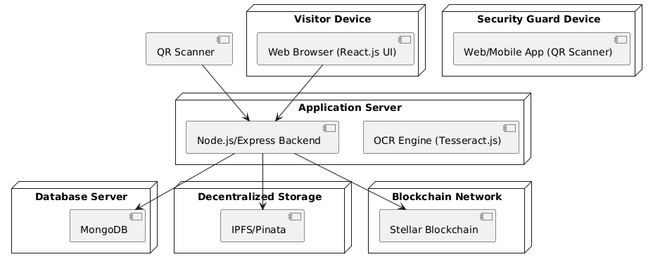
Fig: 4.2.7 Deployment Diagram

CHAPTER 5
METHODOLOGY
5.1 Technologies Used:
1. Python in Secure Visitor Pass Generator
Python is the backbone of this application, chosen for its simplicity, flexibility, and wide range of libraries for blockchain integration, cryptography, and image processing.
- Backend Development: Python handles the business logic, pass generation, and verification workflows.
- Blockchain Interaction: Python SDKs are used to interact with the Stellar blockchain for storing and validating visitor pass data.
- Image Processing: Python integrates with OCR libraries to extract text from uploaded ID cards.
- Scalability: Python’s modularity allows secure, reusable code for visitor management and blockchain transactions.
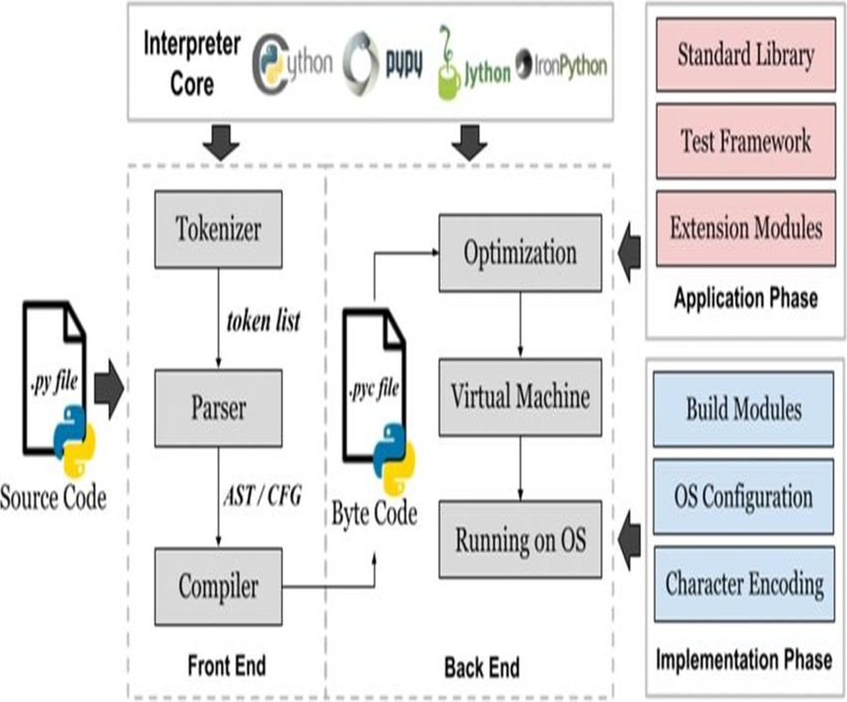
Fig: 5.1.1 Architecture Of Python

2. Blockchain (Stellar Network + Albedo Wallet)
The Stellar blockchain ensures decentralized, tamper-proof storage of visitor pass verification data.
- Transaction Logging: Each pass is recorded as a blockchain transaction, preventing forgery.
- Decentralized Trust: Security guards can verify passes without relying on a central server.
- Albedo Wallet: Enables secure authorization of transactions by visitors and system admins.
- Transparency & Security: Immutable ledger entries ensure reliable and auditable pass management.
3.IPFS/Pinata for Decentralized Storage
IPFS (InterPlanetary File System), integrated via Pinata, stores visitor ID images in a decentralized manner.
- Image Storage: Uploaded ID card photos are stored securely on IPFS.
- Verification: During entry, the visitor’s photo is fetched from IPFS for cross-verification.
- Decentralization: Eliminates risks of centralized server failures or data tampering.

5.2 Module Description
1. Visitor Registration & ID Verification
Description:
Visitors upload their ID card image and personal details. The system extracts data using OCR, validates it, and stores the image securely on IPFS. Blockchain ensures authenticity of records.
Key Features:
- Upload ID card image and details.
- Automatic text extraction using OCR.
- Storage of images on IPFS/Pinata.
- Initial verification before pass generation.
2. Digital Pass Generation
Description:
After verification, the system generates a secure QR-based visitor pass linked with blockchain records.
Key Features:
- QR code generation for each visitor pass.
- Blockchain entry for tamper-proof validation.
- Pass metadata stored in linked to visitor’s photo on IPFS.
3. Gate Pass Verification (by Security Guard)
Description:
At entry, security guards scan the visitor’s QR code. The system verifies the transaction on blockchain and fetches the stored photo from IPFS to confirm authenticity.
Key Features:
- QR code scanning via guard’s device.
- Blockchain verification of pass validity.
- Fetching visitor’s ID photo from IPFS.
- Instant result for pass authenticity.
4. Security & Data Protection
Description:
The application integrates cryptographic methods to ensure user data privacy and tamper-proof operations.
Key Features:
- Blockchain-based immutability for pass records.
- Secure decentralized storage via IPFS.
- Protection against unauthorized access.
- Transparent verification for trust building.

import React, { useState } from 'react';
import { BarChart3, Users, Shield, Activity, Download, Calendar, TrendingUp, AlertTriangle } from 'lucide-react';
interface GatePassRecord {
id: string;
holderName: string;
issueDate: string;
status: 'active' | 'expired' | 'revoked';
lastVerified: string;
blockchainHash: string;
}
const Admin: React.FC = () => {
const [activeTab, setActiveTab] = useState<'dashboard' | 'passes' | 'analytics'>('dashboard');
// Mock data
const stats = {
totalPasses: 1247,
activePasses: 892,
verificationsToday: 156,
blockchainTransactions: 1247
};
const recentPasses: GatePassRecord[] = [
{
id: 'ABC123XYZ',
holderName: 'Rajesh Kumar Singh',
issueDate: '2024-01-15',
status: 'active',
lastVerified: '2024-01-15 14:30',
blockchainHash: '0x7f8a9b2c3d4e5f6a7b8c9d0e1f2a3b4c'
},
{
id: 'DEF456ABC',
holderName: 'Priya Sharma',
issueDate: '2024-01-14',
status: 'active',
lastVerified: '2024-01-15 12:15',
blockchainHash: '0x9a8b7c6d5e4f3a2b1c0d9e8f7a6b5c4d'
},
{
id: 'GHI789DEF',
holderName: 'Amit Patel',
issueDate: '2024-01-13',
status: 'expired',
lastVerified: '2024-01-14 09:45',
blockchainHash: '0x5c4d3e2f1a0b9c8d7e6f5a4b3c2d1e0f'
}
];
const getStatusBadge = (status: string) => {
const statusStyles = {
active: 'bg-green-100 text-green-800',
expired: 'bg-red-100 text-red-800',
revoked: 'bg-gray-100 text-gray-800'
};
return (
<span className={`px-2 py-1 rounded-full text-xs font-medium ${statusStyles[status as keyof typeof statusStyles]}`}>
{status.charAt(0).toUpperCase() + status.slice(1)}
</span>
);
};
const DashboardView = () => (
<div className="space-y-6">
{/* Stats Grid */}
<div className="grid grid-cols-1 md:grid-cols-2 lg:grid-cols-4 gap-6">
<div className="bg-white p-6 rounded-xl shadow-sm border border-gray-100">
<div className="flex items-center justify-between">
<div>
<p className="text-sm text-gray-600">Total Passes</p>
<p className="text-3xl font-bold text-gray-900">{stats.totalPasses.toLocaleString()}</p>
</div>
<Users className="h-8 w-8 text-blue-600" />
</div>
<div className="mt-4 flex items-center">
<TrendingUp className="h-4 w-4 text-green-600 mr-1" />
<span className="text-sm text-green-600">+12% from last month</span>
</div>
</div>
<div className="bg-white p-6 rounded-xl shadow-sm border border-gray-100">
<div className="flex items-center justify-between">
<div>
<p className="text-sm text-gray-600">Active Passes</p>
<p className="text-3xl font-bold text-gray-900">{stats.activePasses.toLocaleString()}</p>
</div>
<Shield className="h-8 w-8 text-green-600" />
</div>
<div className="mt-4 flex items-center">
<TrendingUp className="h-4 w-4 text-green-600 mr-1" />
<span className="text-sm text-green-600">+8% from last month</span>
</div>
</div>
<div className="bg-white p-6 rounded-xl shadow-sm border border-gray-100">
<div className="flex items-center justify-between">
<div>
<p className="text-sm text-gray-600">Verifications Today</p>
<p className="text-3xl font-bold text-gray-900">{stats.verificationsToday}</p>
</div>
<Activity className="h-8 w-8 text-purple-600" />
</div>
<div className="mt-4 flex items-center">
<TrendingUp className="h-4 w-4 text-green-600 mr-1" />
<span className="text-sm text-green-600">+24% from yesterday</span>
</div>
</div>
<div className="bg-white p-6 rounded-xl shadow-sm border border-gray-100">
<div className="flex items-center justify-between">
<div>
<p className="text-sm text-gray-600">Blockchain Txns</p>
<p className="text-3xl font-bold text-gray-900">{stats.blockchainTransactions.toLocaleString()}</p>
</div>
<BarChart3 className="h-8 w-8 text-orange-600" />
</div>
<div className="mt-4 flex items-center">
<TrendingUp className="h-4 w-4 text-green-600 mr-1" />
<span className="text-sm text-green-600">+15% from last month</span>
</div>
</div>
</div>
{/* Recent Activity */}
<div className="bg-white rounded-xl shadow-sm border border-gray-100 p-6">
<h3 className="text-lg font-semibold text-gray-900 mb-4">Recent Gate Passes</h3>
<div className="overflow-x-auto">
<table className="w-full">
<thead>
<tr className="border-b border-gray-200">
<th className="text-left py-3 px-4 font-medium text-gray-600">Pass ID</th>
<th className="text-left py-3 px-4 font-medium text-gray-600">Holder Name</th>
<th className="text-left py-3 px-4 font-medium text-gray-600">Issue Date</th>
<th className="text-left py-3 px-4 font-medium text-gray-600">Status</th>
<th className="text-left py-3 px-4 font-medium text-gray-600">Last Verified</th>
</tr>
</thead>
<tbody>
{recentPasses.map((pass) => (
<tr key={pass.id} className="border-b border-gray-100 hover:bg-gray-50">
<td className="py-3 px-4 font-mono text-sm">{pass.id}</td>
<td className="py-3 px-4">{pass.holderName}</td>
<td className="py-3 px-4">{pass.issueDate}</td>
<td className="py-3 px-4">{getStatusBadge(pass.status)}</td>
<td className="py-3 px-4 text-sm text-gray-600">{pass.lastVerified}</td>
</tr>
))}
</tbody>
</table>
</div>
</div>
</div>
);
const PassesView = () => (
<div className="space-y-6">
<div className="flex justify-between items-center">
<h2 className="text-2xl font-bold text-gray-900">All Gate Passes</h2>
<button className="bg-blue-600 hover:bg-blue-700 text-white px-4 py-2 rounded-lg font-medium flex items-center space-x-2 transition-colors">
<Download className="h-4 w-4" />
<span>Export CSV</span>
</button>
</div>
<div className="bg-white rounded-xl shadow-sm border border-gray-100 p-6">
<div className="mb-4 flex flex-col sm:flex-row sm:items-center sm:justify-between space-y-2 sm:space-y-0">
<div className="flex space-x-2">
<input
type="text"
placeholder="Search passes..."
className="px-4 py-2 border border-gray-300 rounded-lg focus:ring-2 focus:ring-blue-500 focus:border-blue-500" />
<select className="px-4 py-2 border border-gray-300 rounded-lg focus:ring-2 focus:ring-blue-500 focus:border-blue-500">
<option>All Status</option>
<option>Active</option>
<option>Expired</option>
<option>Revoked</option>
</select>
</div>
</div>
<div className="overflow-x-auto">
<table className="w-full">
<thead>
<tr className="border-b border-gray-200">
<th className="text-left py-3 px-4 font-medium text-gray-600">Pass ID</th>
<th className="text-left py-3 px-4 font-medium text-gray-600">Holder Name</th>
<th className="text-left py-3 px-4 font-medium text-gray-600">Issue Date</th>
<th className="text-left py-3 px-4 font-medium text-gray-600">Status</th>
<th className="text-left py-3 px-4 font-medium text-gray-600">Blockchain Hash</th>
<th className="text-left py-3 px-4 font-medium text-gray-600">Actions</th>
</tr>
</thead>
<tbody>
{recentPasses.map((pass) => (
<tr key={pass.id} className="border-b border-gray-100 hover:bg-gray-50">
<td className="py-3 px-4 font-mono text-sm">{pass.id}</td>
<td className="py-3 px-4">{pass.holderName}</td>
<td className="py-3 px-4">{pass.issueDate}</td>
<td className="py-3 px-4">{getStatusBadge(pass.status)}</td>
<td className="py-3 px-4 font-mono text-xs text-gray-600">
{pass.blockchainHash.substring(0, 16)}...
</td>
<td className="py-3 px-4">
<button className="text-blue-600 hover:text-blue-800 text-sm font-medium">
View Details
</button>
</td>
</tr>
))}
</tbody>
</table>
</div>
</div>
</div>
);

const AnalyticsView = () => (
<div className="space-y-6">
<h2 className="text-2xl font-bold text-gray-900">Analytics & Reports</h2>

<div className="grid grid-cols-1 lg:grid-cols-2 gap-6">
<div className="bg-white rounded-xl shadow-sm border border-gray-100 p-6">
<h3 className="text-lg font-semibold text-gray-900 mb-4">Pass Generation Trends</h3>
<div className="h-64 bg-gray-50 rounded-lg flex items-center justify-center">
<p className="text-gray-500">Chart visualization would go here</p>
</div>
</div>

<div className="bg-white rounded-xl shadow-sm border border-gray-100 p-6">
<h3 className="text-lg font-semibold text-gray-900 mb-4">Verification Patterns</h3>
<div className="h-64 bg-gray-50 rounded-lg flex items-center justify-center">
<p className="text-gray-500">Chart visualization would go here</p>
</div>
</div>
<div className="bg-white rounded-xl shadow-sm border border-gray-100 p-6">
<h3 className="text-lg font-semibold text-gray-900 mb-4">Security Alerts</h3>
<div className="space-y-3">
<div className="flex items-start space-x-3 p-3 bg-yellow-50 rounded-lg">
<AlertTriangle className="h-5 w-5 text-yellow-600 mt-0.5" />
<div>
<p className="text-sm font-medium text-yellow-800">Suspicious Verification Pattern</p>
<p className="text-xs text-yellow-600">Multiple failed verifications from IP 192.168.1.100</p>
</div>
</div>
</div>
</div>

<div className="bg-white rounded-xl shadow-sm border border-gray-100 p-6">
<h3 className="text-lg font-semibold text-gray-900 mb-4">Blockchain Status</h3>
<div className="space-y-4">
<div className="flex items-center justify-between">
<span className="text-gray-600">Network Status</span>
<span className="text-green-600 font-medium">✓ Connected</span>
</div>
<div className="flex items-center justify-between">
<span className="text-gray-600">Last Block</span>
<span className="text-gray-900 font-mono text-sm">#2,847,592</span>
</div>
<div className="flex items-center justify-between">
<span className="text-gray-600">Gas Price</span>
<span className="text-gray-900">0.00001 XLM</span>
</div>
</div>
</div>
</div>
</div>
);

return (
<div className="max-w-7xl mx-auto">
<div className="mb-8">
<h1 className="text-3xl font-bold text-gray-900 mb-2">Admin Dashboard</h1>
<p className="text-gray-600">Manage and monitor the SecurePass system</p>
</div>
{/* Tab Navigation */}
<div className="mb-8">
<nav className="flex space-x-8">
<button
onClick={() => setActiveTab('dashboard')}
className={`py-2 px-1 border-b-2 font-medium text-sm transition-colors ${
activeTab === 'dashboard'
? 'border-blue-500 text-blue-600'
: 'border-transparent text-gray-500 hover:text-gray-700 hover:border-gray-300'
}`}
>
<div className="flex items-center space-x-2">
<BarChart3 className="h-4 w-4" />
<span>Dashboard</span>
</div>
</button>
<button
onClick={() => setActiveTab('passes')}
className={`py-2 px-1 border-b-2 font-medium text-sm transition-colors ${
activeTab === 'passes'
? 'border-blue-500 text-blue-600'
: 'border-transparent text-gray-500 hover:text-gray-700 hover:border-gray-300'
}`}
<div className="flex items-center space-x-2">
<Shield className="h-4 w-4" />
<span>Gate Passes</span>
</div>
</button>
<button
onClick={() => setActiveTab('analytics')}
className={`py-2 px-1 border-b-2 font-medium text-sm transition-colors ${
activeTab === 'analytics'
? 'border-blue-500 text-blue-600'
: 'border-transparent text-gray-500 hover:text-gray-700 hover:border-gray-300'
}`}
>
<div className="flex items-center space-x-2">
<Activity className="h-4 w-4" />
<span>Analytics</span>
</div>
</button>
</nav>
</div>

{/* Tab Content */}
{activeTab === 'dashboard' && <DashboardView />}
{activeTab === 'passes' && <PassesView />}
{activeTab === 'analytics' && <AnalyticsView />}
</div>
);
};

export default Admin;
import React, { useEffect, useRef, useState } from 'react';
import { useParams, useLocation, Link } from 'react-router-dom';
import {
Download,
Share2,
CheckCircle,
QrCode as QrCodeIcon,
Calendar,
Clock,
User
} from 'lucide-react';
import QRCode from 'react-qr-code';
import html2canvas from 'html2canvas';
import jsPDF from 'jspdf';

interface UserData {
name: string;
aadhaarNumber: string;
photoUrl: string;
}

interface LocationState {
userData: UserData;
gatePassId: string;
txHash?: string;
}

const GatePass: React.FC = () => {
const { id } = useParams<{ id: string }>();
const location = useLocation();
const qrRef = useRef<HTMLDivElement>(null);
const passRef = useRef<HTMLDivElement>(null);
const [qrGenerated, setQrGenerated] = useState(false);

const state = location.state as LocationState;
const userData = state?.userData;
const gatePassId = state?.gatePassId || id;
const txHash = state?.txHash || '';

const currentDate = new Date().toLocaleDateString('en-IN');
const validUntil = new Date(Date.now() + 24 * 60 * 60 * 1000).toLocaleDateString('en-IN');

useEffect(() => {
if (txHash) setQrGenerated(true);
}, [txHash]);

const downloadPass = async () => {
if (!passRef.current) return;

const canvas = await html2canvas(passRef.current, {
scale: 2,
useCORS: true
});

const imgData = canvas.toDataURL("image/jpeg", 1.0);
const link = document.createElement("a");
link.href = imgData;
link.download = `GatePass_${gatePassId}.jpg`;
link.click();
};

const sharePass = () => {
if (navigator.share) {
navigator.share({
title: 'SecurePass Gate Pass',
text: `Gate Pass ID: ${gatePassId}`,
url: window.location.href
});
} else {
navigator.clipboard.writeText(window.location.href);
alert('Gate pass link copied to clipboard');
}
};

if (!userData) {
return (
<div className="max-w-2xl mx-auto text-center">
<div className="bg-red-50 border border-red-200 rounded-lg p-6">
<h2 className="text-xl font-semibold text-red-800 mb-2">Gate Pass Not Found</h2>
<p className="text-red-600 mb-4">
The gate pass you're looking for doesn't exist or has expired.
</p>
<Link
to="/upload"
className="bg-blue-600 hover:bg-blue-700 text-white px-6 py-2 rounded-lg font-medium transition-colors"
>
Generate New Pass
</Link>
</div>
</div>
);
}

return (
<div className="max-w-2xl mx-auto">
<div className="bg-green-50 border border-green-200 rounded-lg p-4 mb-6 flex items-center space-x-3">
<CheckCircle className="h-6 w-6 text-green-600" />
<div>
<h3 className="font-semibold text-green-800">Gate Pass Generated Successfully!</h3>
<p className="text-green-600 text-sm">
Your data has been recorded on the Stellar Testnet blockchain.
</p>
</div>
</div>

<div
className="bg-white rounded-xl shadow-lg border border-gray-200 overflow-hidden"
ref={passRef}
>
<div className="bg-gradient-to-r from-blue-600 to-blue-700 text-white p-6">
<div className="flex items-center justify-between">
<div>
<h1 className="text-2xl font-bold">DIGITAL GATE PASS</h1>
<p className="text-blue-100">SecurePass System</p>
</div>
<QrCodeIcon className="h-12 w-12 text-blue-200" />
</div>
</div>

<div className="p-6">
<div className="grid md:grid-cols-3 gap-6 mb-6">
<div className="text-center">
<div className="w-32 h-32 mx-auto mb-3 bg-gray-100 rounded-lg overflow-hidden border-2 border-gray-200">
<img
src={userData.photoUrl}
alt="User"
className="w-full h-full object-cover"
/>
</div>
<p className="text-sm text-gray-600">Verified Photo</p>
</div>

<div className="md:col-span-2 space-y-4">
<div className="flex items-center space-x-3">
<User className="h-5 w-5 text-gray-500" />
<div>
<p className="text-sm text-gray-600">Full Name</p>
<p className="font-semibold text-gray-900">{userData.name}</p>
</div>
</div>
<div className="flex items-center space-x-3">
<Calendar className="h-5 w-5 text-gray-500" />
<div>
<p className="text-sm text-gray-600">Issue Date</p>
<p className="font-semibold text-gray-900">{currentDate}</p>
</div>
</div>
<div className="flex items-center space-x-3">
<Clock className="h-5 w-5 text-gray-500" />
<div>
<p className="text-sm text-gray-600">Valid Until</p>
<p className="font-semibold text-gray-900">{validUntil}</p>
</div>
</div>
</div>
</div>

<div className="border-t border-gray-200 pt-6">
<div className="flex flex-col md:flex-row md:items-center md:justify-between space-y-4 md:space-y-0">
<div className="text-center md:text-left">
<h3 className="text-lg font-semibold text-gray-900 mb-2">QR Code</h3>
<p className="text-sm text-gray-600 mb-2">
Scan this code for instant verification
</p>
<p className="text-xs text-gray-500">
Pass ID: <span className="font-mono">{gatePassId}</span>
</p>
</div>
<div className="flex justify-center">
<div ref={qrRef} className="bg-white p-4 rounded-lg border-2 border-gray-200">
<QRCode
value={JSON.stringify({
name: userData.name,
aadhaar: userData.aadhaarNumber,
tx: txHash
})}
size={150}
/>
</div>
</div>
</div>
</div>

{txHash && (
<div className="border-t border-gray-200 pt-6 mt-6">
<div className="bg-blue-50 rounded-lg p-4">
<div className="flex items-center space-x-3 mb-2">
<CheckCircle className="h-5 w-5 text-blue-600" />
<h4 className="font-semibold text-blue-900">Blockchain Verified</h4>
</div>
<p className="text-sm text-blue-700">
This gate pass is recorded on the Stellar Testnet. You can verify the details using the transaction hash.
</p>
<a
href={`https://stellar.expert/explorer/testnet/tx/${txHash}`}
target="_blank"
rel="noreferrer"
className="text-xs text-blue-600 mt-2 font-mono underline block"
>
TX Hash: {txHash}
</a>
</div>
</div>
)}
</div>
</div>

<div className="flex space-x-4 mt-6">
<button
onClick={downloadPass}
className="flex-1 bg-blue-600 hover:bg-blue-700 text-white px-6 py-3 rounded-lg font-semibold flex items-center justify-center space-x-2 transition-colors"
>
<Download className="h-5 w-5" />
<span>Download Pass</span>
</button>
<button
onClick={sharePass}
className="px-6 py-3 border border-gray-300 text-gray-700 rounded-lg font-semibold hover:bg-gray-50 transition-colors flex items-center space-x-2"
>
<Share2 className="h-5 w-5" />
<span>Share</span>
</button>
</div>
</div>
);
};

6.2 Output Screens:
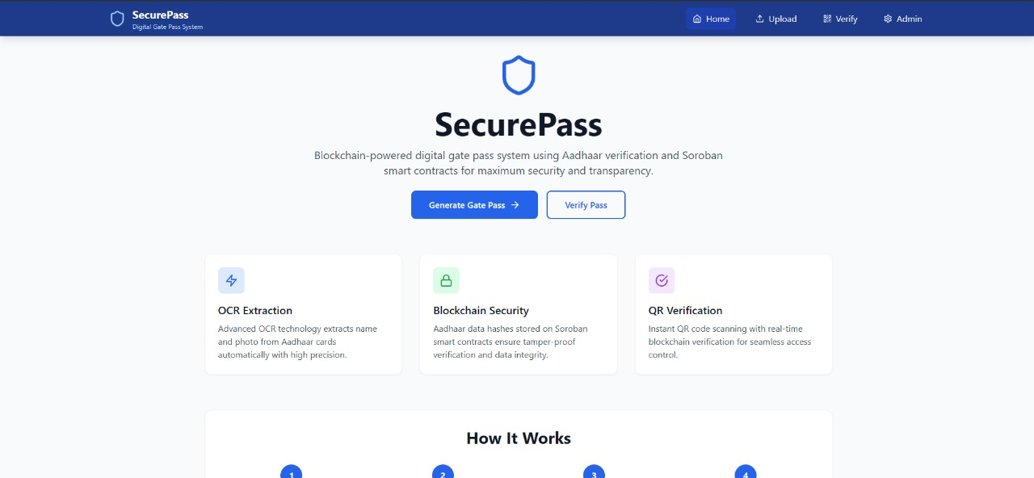
Fig: 6.2.1 Home Screen

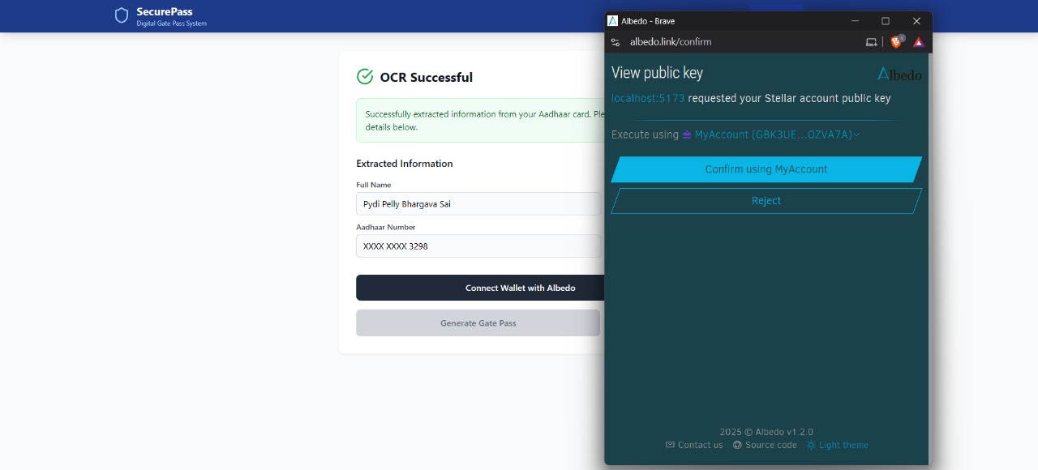
Fig: 6.2.2 Wallet Connection
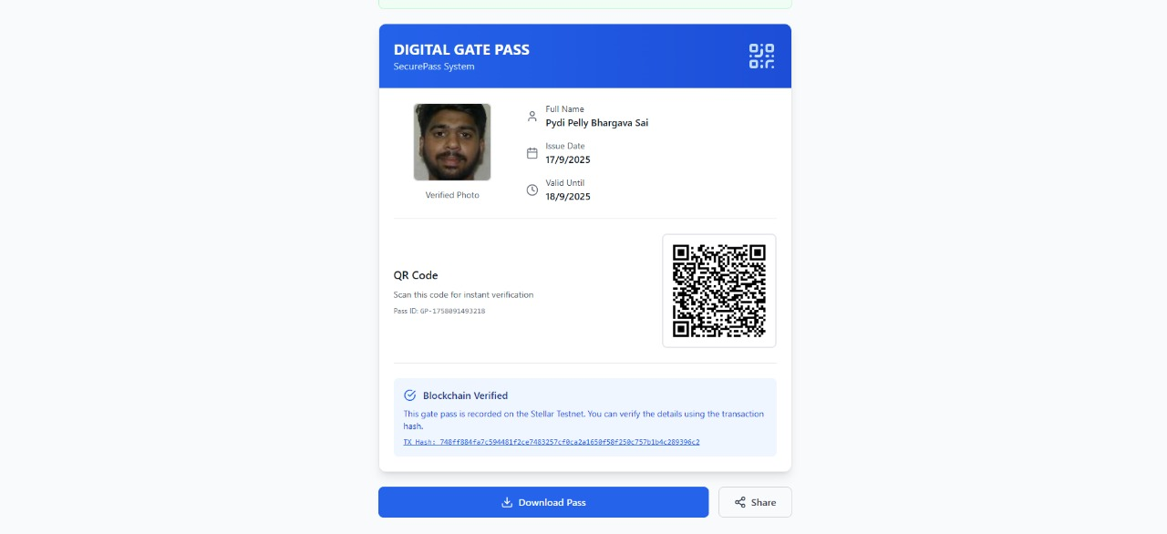
Fig: 6.2.3 Gate Pass

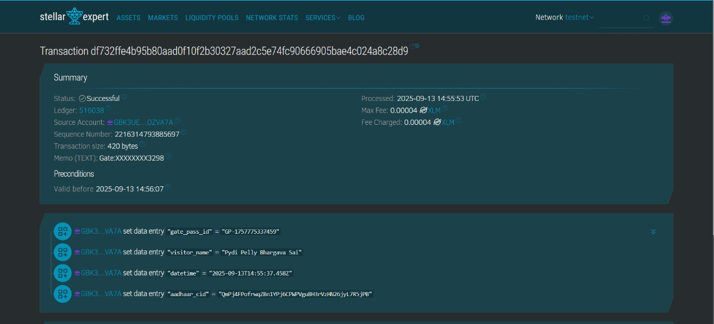
Fig: 6.2.4 Stellar Network

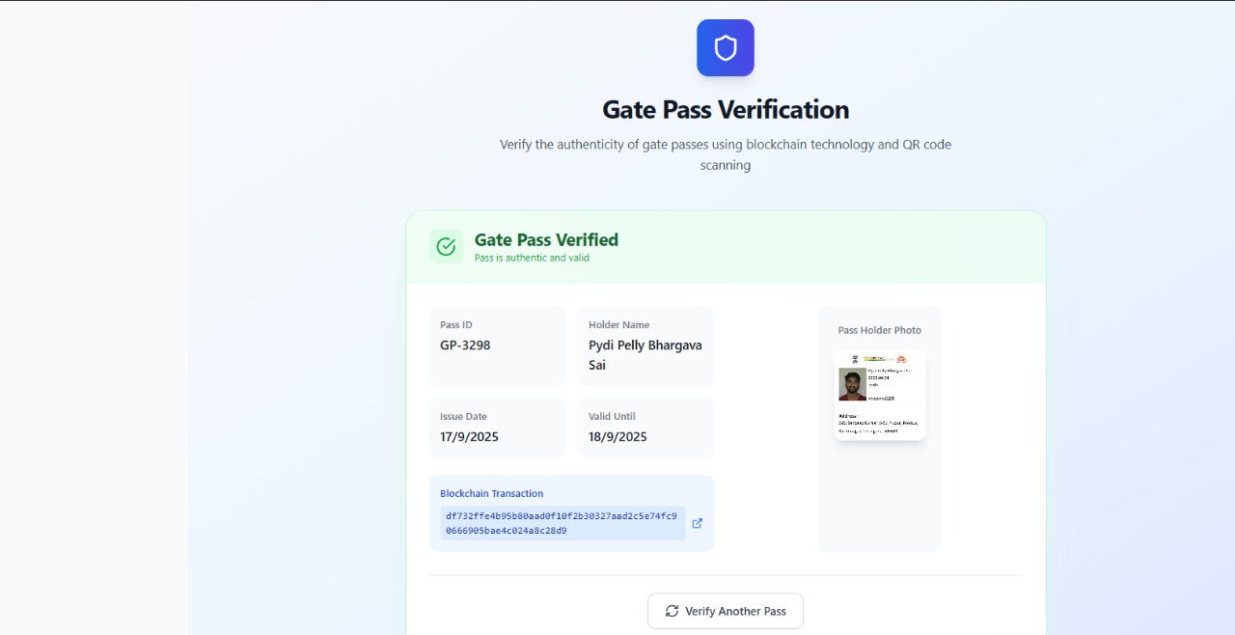
Fig: 6.2.5 Verification Screen

CHAPTER 7
CONCLUSION & FUTURE SCOPE
Conclusion
The Secure Visitor Pass Generator using Blockchain provides a modern and reliable approach to visitor management. By integrating blockchain technology, decentralized storage, and QR-based authentication, the system ensures tamper-proof, transparent, and efficient visitor pass generation. The use of Stellar blockchain with Albedo wallet guarantees secure transaction logging, while IPFS/Pinata ensures decentralized storage of visitor ID images, eliminating the risks of centralized failures. With OCR-based ID detail extraction and real-time QR code verification, the system enhances security, reduces manual errors, and streamlines entry processes. Overall, the solution demonstrates how blockchain can be leveraged to improve transparency, trust, and security in organizational access control systems.

Future Scope
- Biometric Integration: Incorporating facial recognition and fingerprint authentication for stronger verification.
- Multi-Organization Support: Extending the system for use across multiple campuses, offices, or institutions.
- Mobile App Development: Providing a dedicated Android/iOS app for visitors and security guards for faster access.
- AI-Powered Analytics: Using AI to analyze visitor data for security insights and predictive analysis.
- IOT Integration: Linking with smart gates and access control devices for automated entry.
- Scalability: Expanding the blockchain network to support large-scale enterprise visitor management.

CHAPTER 8
BIBLIOGRAPHY
[1] S. K. Sharma, A. Roy, et al., “Application of blockchain technology in access control systems,” International Journal of Computer Applications, vol. 178, no. 24, pp. 15–20, 2019.
[2] M. N. Patil, V. J. Mahajan, et al., “Digital replacement of traditional visitor logbooks using secure web applications,” Journal of Information Systems and Technology, vol. 12, no. 3, pp. 88–94, 2020.
[3] R. R. Kulkarni, S. S. Deshmukh, et al., “Automation of identity verification using OCR and document scanning technologies,” Procedia Computer Science, vol. 152, pp. 375–381, 2019.
[4] T. K. Sinha, D. K. Rajput, et al., “QR code-based authentication model for physical access systems,” International Conference on Smart Technologies (ICST), pp. 142–147, 2021.
[5] A. A. Khan, P. L. Mehta, et al., “Decentralized file storage using IPFS and Pinata,” IEEE Transactions on Cloud Computing, vol. 9, no. 4, pp. 1103–1112, 2021.
[6] N. M. Karthik, S. V. Rao, et al., “Digital wallet authorization for blockchain transactions,” International Journal of Blockchain Applications, vol. 7, no. 2, pp. 45–52, 2020.
[7] P. Dasgupta, V. Iyer, et al., “Evaluation of modular visitor pass systems with scalable architectures,” Journal of Network and Computer Applications, vol. 166, pp. 102734, 2020.
[8] S. N. Reddy, A. Banerjee, et al., “Real-time QR code verification mechanisms in smart building access systems,” Proceedings of the IEEE International Conference on Smart Infrastructure (ICSI), pp. 201–206, 2022.
[9] H. L. Chouhan, Y. J. Park, et al., “Gamification in smart infrastructure for improved engagement,” Journal of Smart Cities and Society, vol. 5, no. 1, pp. 33–41, 2021.
[10] R. K. Gupta, P. S. D. S. Menon, et al., “Privacy and data protection in decentralized applications,” IEEE Access, vol. 8, pp. 147892–147901, 2020.

