HOSPITAL MANAGEMENT SYSTEM
A DBMS Capstone Project Report submitted in partial fulfillment of the requirements for the award of the degree of
BACHELOR OF TECHNOLOGY
in
ARTIFICIAL INTELLIGENCE AND MACHINE LEARNING

Submitted By
G. YUVA CHANDU –25B11AI310
M. SRIHARI – 25B11AI668
Y. ASHOKNANDA – 25B11AID07
K. PADMAKARA CHOWDARY –25B11AI489

Under the esteemed guidance of

Mr. T.Srinivasulu M.Tech, (Ph.D.) Assistant Professor


DEPARTMENT OF ARTIFICIAL INTELLIGENCE AND MACHINE LEARNING ADITYA UNIVERSITY
(Formerly Aditya Engineering College (A))
Aditya Nagar, ADB Road, Surampalem, Andhra Pradesh, India

2026 – 2027


Aditya Nagar, ADB Road, Surampalem, Andhra Pradesh, India
DEPARTMENT OF ARTIFICIAL INTELLIGENCE AND MACHINE LEARNING

CERTIFICATE

This is to certify that the DBMS Capstone Project report entitled “HOSPITAL MANAGEMENT SYSTEM” is being submitted by G. YUVA CHANDU (Roll No. 25B11AI310), M. SRIHARI (Roll No. 25B11AI668), Y. ASHOKNANDA (Roll No.

25B11AID07) and K. PADMAKARA CHOWDARY (Roll No. 25B11AI489) in partial
fulfillment of the requirements for the award of the B.Tech. degree in Artificial Intelligence and Machine Learning.The work documented in this report was carried out as part of the Capstone Project for the course Database Management Systems (2501IT05) during the academic year 2026–2027, and records the database design, implementation, testing and documentation undertaken by the team.

Project Guide Head of the Department
Mr. T. Srinivasulu, M. Tech, (Ph.D.) Dr. K. Naga Bhargavi, M. Tech, Assistant Professor Associate Professor & HOD

External Examiner

DECLARATION

We hereby declare that the DBMS Capstone Project entitled “HOSPITAL MANAGEMENT SYSTEM” is a genuine work carried out by us. The database design, SQL implementation, queries and documentation presented in this report are our own work, completed under the guidance of Mr. T. Srinivasulu, Department of Artificial Intelligence and Machine Learning, Aditya University, Surampalem.
We further declare that this work has not been submitted, in full or in part, for the award of any degree of this or any other educational institution.

Project Associates
G. YUVA CHANDU – 25B11AI310
M. SRIHARI – 25B11AI 668
Y. ASHOKNANDA – 25B11AID07
K. PADMAKARA CHOWDARY – 25B11AI489

Date: Place: Surampalem

ACKNOWLEDGEMENT

It is with immense pleasure that we express our indebted gratitude to our project guide Mr.T.Srinivasulu , Department of ARTIFICIAL INTELLIGENCE AND MACHINE LEARNING who guided us throughout the capstone project. We are thankful for the constant encouragement and valuable suggestions received at every review stage.
We are grateful to Dr. K. Naga Bhargavi, Head of the Department, for inspiring us and for arranging the facilities and resources needed for this project.
We extend our sincere thanks to the Management, Dr. M. Sreenivasa Reddy, Deputy Pro-Chancellor, Dr. M. B. Srinivas, Vice-Chancellor, and Dr. A. Ramesh, Pro Vice-Chancellor (Engineering & Sciences), for providing an excellent academic environment.
Not to forget, we thank the Teaching and Non-Teaching Staff, our parents and our friends, who have directly or indirectly supported us in completing this project on time.

Project Associates
G. YUVA CHANDU - 25B11AI310
M. SRIHARI – 25B11AI668
Y. ASHOKNANDA – 25B11AID07
K. PADMAKARA CHOWDARY– 25B11AI489

DATABASE MANAGEMENT SYSTEMS
CAPSTONE PROJECT DOCUMENTATION

HOSPITAL MANAGEMENT SYSTEM

Project Title: | Hospital Management System
Domain: | Healthcare / Hospital Database Management
DBMS: | MySQL
Course: | Database Management Systems (DBMS)
Department: | Artificial Intelligence & Machine Learning
Academic Year: | 2026-27
Course Code: | 2501IT05
Faculty Coordinator: | Mr. T.Srinivasulu M.Tech, (Ph.D.)
Date of Submission:
GitHub Repository: | https://github.com/yuvachandu233-stack/hospital-management-system


TEAM MEMBERS
G. YUVA CHANDU –25B11AI310
M. SRIHARI – 25B11AI668
Y. ASHOKNANDA – 25B11AID07
K. PADMAKARA CHOWDARY –25B11AI489

INDEX

Chapter | Title | Page No.
 | Certificate | i
 | Declaration | ii
 | Acknowledgement | iii
 | Abstract | iv
 | List of Figures | v
 | List of Tables | vi
1 | Introduction | 1
1.1 | Introduction to the Domain | 1
1.2 | Problem Statement | 1
1.3 | Motivation and Need for a Database | 2
1.4 | Objectives of the Project | 2
1.5 | Scope of the Project | 3
1.6 | Organization of the Report | 3
2 | System Study and Tools | 4
2.1 | Existing System and Its Limitations | 4
2.2 | Proposed Database System | 4
2.3 | Tools and Technologies Used | 5
2.4 | Software and Hardware Requirements | 5
3 | Database Design (Review – I) | 6
3.1 | Identified Entities | 6
3.2 | Entity Attributes and Attribute Types | 7
3.3 | ER Diagram | 8
3.4 | Relationships and Cardinality | 9
3.5 | Relational Database Schema | 10
3.6 | Primary Keys and Foreign Keys | 11
3.7 | Normalization up to 3NF | 12
4 | Database Implementation (Review – II) | 13
4.1 | Database and Table Creation – DDL | 13

4.2 | Sample Data Insertion – DML | 15
4.3 | Constraints and Data Integrity | 17
4.4 | Data Validation Rules | 18
5 | SQL Operations and Queries | 19
5.1 | DQL – Basic Retrieval Queries | 19
5.2 | Join Operations | 20
5.3 | Aggregate Functions, GROUP BY and HAVING | 22
5.4 | Nested and Correlated Subqueries | 23
5.5 | Views and Relational Set Operations | 24
5.6 | DCL and TCL Operations | 25
6 | Modules and Functionalities | 26
7 | Results – Sample Outputs and Screenshots | 29
8 | Testing and Data Validation | 32
9 | GitHub Repository and Team Contribution | 35
10 | Conclusion and Future Enhancements | 38
 | References | 40
 | Appendix A – Complete SQL Script | 41

LIST OF FIGURES

Figure No. | Title of the Figure
Fig. 3.1 | ER Diagram of the Hospital Management System
Fig. 3.2 | Relational Schema Diagram of the Hospital Management System
Fig. 4.1 | Successful Creation of Hospital Management System Tables
Fig. 4.2 | Sample Data Inserted into the Tables
Fig. 7.1 | Patient Table – Sample Output
Fig. 7.2 | Doctor Table – Sample Output
Fig. 7.3 | Appointment and Doctor JOIN Output
Fig. 7.4 | Treatment and Prescription Output
Fig. 7.5 | Billing Query Output

Fig. 7.6 | Aggregate Query Output
Fig. 7.7 | View Output
Fig. 7.8 | GitHub Repository
Fig. 7.9 | SQL Execution / Database Demonstration

LIST OF TABLES

Table No. | Title of the Table
Table 2.1 | Tools and Technologies Used
Table 2.2 | Software and Hardware Requirements
Table 3.1 | Entities Identified for the Hospital Management System
Table 3.2 | Attributes of Each Entity
Table 3.3 | Relationships and Cardinality
Table 3.4 | Relational Database Schema
Table 3.5 | Primary Key and Foreign Key Definitions
Table 3.6 | Normalization Steps
Table 4.1 | Sample Data Summary
Table 4.2 | Constraints and Data Integrity Rules
Table 4.3 | Data Validation Rules
Table 6.1 | Hospital Management System Modules and Their Functionalities
Table 8.1 | Test Cases and Results
Table 9.1 | Team Responsibilities
Table 9.2 | Review-wise Progress Record

ABSTRACT
The Hospital Management System is a relational database project developed to organize and manage essential hospital information in a centralized and structured manner. Hospitals handle large volumes of patient, doctor, appointment, treatment, ward and billing data, making efficient data management essential for reliable operations. The proposed system stores information about patients, doctors, departments, wards, appointments, treatments, prescriptions and bills using interconnected relational tables.
The database is designed using primary keys, foreign keys and normalization techniques to reduce redundancy and maintain relationships between records. Constraints such as NOT NULL, UNIQUE, CHECK and DEFAULT are used to improve data integrity and validation. SQL operations including DDL, DML, DQL, CRUD, joins, aggregate functions, GROUP BY, HAVING, subqueries and views are used to manage and retrieve meaningful information.
The system provides an organized approach to hospital record management and demonstrates the practical application of database management concepts. The implementation improves data consistency, simplifies information retrieval and supports efficient reporting of hospital activities.

INTRODUCTION

BACKGROUND
Hospitals manage large amounts of interconnected information every day. Patient details, doctors, departments, wards, appointments, treatments and billing records need to be stored and accessed accurately. In traditional systems, much of this information is maintained manually or in isolated files, which leads to data duplication, inconsistency and difficulty in retrieval when the volume of records grows.
A relational database provides a structured way to store this information using multiple related tables. Relationships, keys and constraints help maintain consistency and reduce duplication. By organizing data into well-defined entities and linking them through foreign keys, a relational database ensures that each piece of information is stored exactly once and can be accessed efficiently through SQL queries.
The Hospital Management System applies core DBMS concepts to create an organized and efficient hospital information database. It models real-world hospital operations — patient registration, doctor assignments, appointment scheduling, treatment recording, prescription management and billing — as a set of normalized relational tables connected through meaningful relationships.

PURPOSE OF THE DATABASE
The purpose of the database is to provide centralized storage and efficient retrieval of hospital records. By consolidating all hospital data into a single relational database, the system eliminates redundant storage, enforces data integrity through constraints and enables fast, structured retrieval of information using SQL queries.
The primary users and stakeholders of the system include:
    - Hospital administrators — for overall data management and reporting.
    - Doctors — for accessing patient appointments, diagnoses and treatment records.
    - Reception and appointment staff — for scheduling and managing patient appointments.
    - Billing staff — for generating and tracking patient bills and payment status.
    - Authorized hospital personnel — for accessing relevant records as permitted.
The database manages the following categories of information:

    - Patient records — personal and demographic details.
    - Doctor information — specialization, experience and department association.
    - Department information — department names, heads and floor locations.
    - Ward information — ward capacity, available beds and department association.
    - Appointments — scheduling between patients and doctors.
    - Treatments — diagnosis, treatment dates and ward assignments.
    - Prescriptions — medicines prescribed for each treatment.
    - Bills — consultation, medicine and bed charges with payment status.

PROBLEM STATEMENT
Managing hospital information through manual records or disconnected systems can result in duplicate data, inconsistent information, difficulty in tracking appointments and treatments, and delays in retrieving billing and patient records. There is a need for a centralized relational database that can organize hospital information, establish relationships between records and provide reliable data retrieval.
The proposed Hospital Management System addresses these issues by maintaining interconnected tables for patients, doctors, departments, wards, appointments, treatments, prescriptions and bills. Database constraints, normalization and validation rules are used to maintain accuracy, consistency and referential integrity.

OBJECTIVES
The following are the specific objectives of the Hospital Management System project:
- To design a relational database for managing hospital information.
- To maintain accurate patient, doctor, department and ward records.
- To manage appointments, treatments, prescriptions and billing information.
- To implement SQL operations, CRUD, joins, aggregate functions and views.
- To ensure data integrity and consistency using keys, constraints and validation.

5. TOOLS & TECHNOLOGIES USED
The following tools and technologies were used in the development of the Hospital Management System:

Category | Tool / Technology
Database Server | MySQL
Query / Admin Tool | MySQL Workbench
Front-end | Not implemented / Database-focused project [ENTER FRONT-END TECHNOLOGY IF USED]
Operating System | sqldeveloper
Version Control | GitHub
Programming / Query Language | SQL

DATABASE DESIGN

IDENTIFIED ENTITIES
The following entities were identified during the analysis of hospital management operations. Each entity represents a key data object in the system:

Entity | Description
Patient | Stores personal and demographic information of patients.
Patient_Contact | Stores one or more contact numbers associated with patients.
Doctor | Stores doctor details, specialization and department association.
Department | Stores hospital department information.
Ward | Stores ward capacity, bed information and department association.
Appointment | Stores appointment details connecting patients and doctors.
Treatment | Stores diagnosis, treatment date and ward information.
Prescription | Stores medicines prescribed for a treatment.
Bill | Stores consultation, medicine and bed charges and payment status.

ENTITY ATTRIBUTES
The following table lists all entities with their attributes, data types, key constraints and attribute types:

Entity | Attribute | Data Type | Key | Attribute Type
PATIENT | patient_id | INT | PK | Simple
PATIENT | first_name | VARCHAR(50) | — | Simple
PATIENT | last_name | VARCHAR(50) | — | Simple
PATIENT | DOB | DATE | — | Simple
PATIENT | age | INT | — | Derived
PATIENT | blood_group | VARCHAR(5) | — | Simple

PATIENT | address | VARCHAR(200) | — | Simple
PATIENT | gender | VARCHAR(10) | — | Simple
PATIENT_CONTACT | contact_id | INT | PK | Simple
PATIENT_CONTACT | patient_id | INT | FK | Simple
PATIENT_CONTACT | contact_number | VARCHAR(15) | — | Simple
DOCTOR | doctor_id | INT | PK | Simple
DOCTOR | first_name | VARCHAR(50) | — | Simple
DOCTOR | last_name | VARCHAR(50) | — | Simple
DOCTOR | specialization | VARCHAR(100) | — | Simple
DOCTOR | experience_years | INT | — | Simple
DOCTOR | email | VARCHAR(100) | UNIQUE | Simple
DOCTOR | dept_id | INT | FK | Simple
DEPARTMENT | dept_id | INT | PK | Simple
DEPARTMENT | dept_name | VARCHAR(100) | — | Simple
DEPARTMENT | hod_doctor_id | INT | FK | Simple
DEPARTMENT | floor_no | INT | — | Simple
WARD | ward_id | INT | PK | Simple
WARD | ward_name | VARCHAR(100) | — | Simple
WARD | capacity | INT | — | Simple
WARD | available_beds | INT | — | Derived
WARD | dept_id | INT | FK | Simple
APPOINTMENT | appt_id | INT | PK | Simple
APPOINTMENT | patient_id | INT | FK | Simple
APPOINTMENT | doctor_id | INT | FK | Simple
APPOINTMENT | appointment_date | DATE | — | Simple
APPOINTMENT | appointment_time | TIME | — | Simple
APPOINTMENT | status | VARCHAR(20) | — | Simple

TREATMENT | treatment_id | INT | PK | Simple
TREATMENT | appt_id | INT | FK | Simple
TREATMENT | diagnosis | VARCHAR(255) | — | Simple
TREATMENT | treatment_date | DATE | — | Simple
TREATMENT | ward_id | INT | FK | Simple
PRESCRIPTION | prescription_id | INT | PK | Simple
PRESCRIPTION | treatment_id | INT | FK | Simple
PRESCRIPTION | medicine_name | VARCHAR(100) | — | Simple
PRESCRIPTION | dosage | VARCHAR(50) | — | Simple
PRESCRIPTION | duration | VARCHAR(50) | — | Simple
BILL | bill_id | INT | PK | Simple
BILL | patient_id | INT | FK | Simple
BILL | treatment_id | INT | FK | Simple
BILL | consultation_fee | DECIMAL(10,2) | — | Simple
BILL | medicine_charges | DECIMAL(10,2) | — | Simple
BILL | bed_charges | DECIMAL(10,2) | — | Simple
BILL | total_amount | DECIMAL(10,2) | — | Derived
BILL | payment_status | VARCHAR(20) | — | Simple
BILL | bill_date | DATE | — | Simple

ER DIAGRAM
The Entity-Relationship (ER) diagram for the Hospital Management System represents all implemented entities, their important attributes, primary keys, foreign keys, relationships and cardinalities. The diagram provides a visual overview of the database structure.

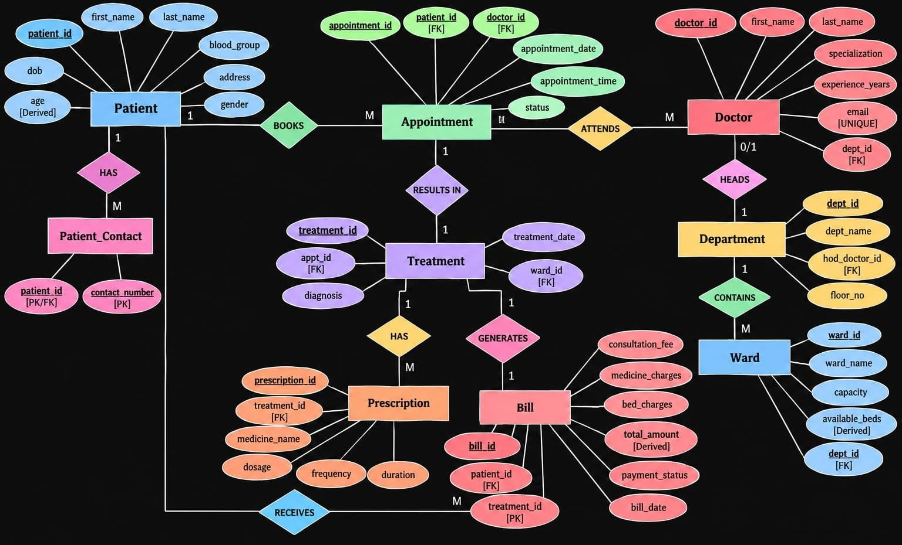

    - All implemented entities (Patient, Patient_Contact, Doctor, Department, Ward, Appointment, Treatment, Prescription, Bill)
    - Important attributes for each entity
    - Primary keys and foreign keys
    - Relationships between entities with cardinalities

RELATIONSHIPS & CARDINALITY
The following table describes the relationships and cardinalities between the entities in the Hospital Management System:

Entity 1 | Relationship | Entity 2 | Cardinality
Doctor | belongs to | Department | N:1
Department | contains | Ward | 1:N
Patient | has | Appointment | 1:N
Doctor | attends | Appointment | 1:N
Appointment | generates | Treatment | 1:1
Patient | has | Bill | 1:N
Treatment | generates | Bill | 1:1

Patient | has | Patient_Contact | 1:N
Treatment | has | Prescription | 1:N

RELATIONAL DATABASE SCHEMA
The following table presents the complete relational schema for all implemented tables in the Hospital Management System:

Table | Column | Data Type | Constraints
PATIENT | patient_id | INT | PRIMARY KEY
PATIENT | first_name | VARCHAR(50) | NOT NULL
PATIENT | last_name | VARCHAR(50) | NOT NULL
PATIENT | DOB | DATE | —
PATIENT | age | INT | —
PATIENT | blood_group | VARCHAR(5) | —
PATIENT | address | VARCHAR(200) | —
PATIENT | gender | VARCHAR(10) | —
PATIENT_CONTACT | contact_id | INT | PRIMARY KEY
PATIENT_CONTACT | patient_id | INT | FOREIGN KEY
PATIENT_CONTACT | contact_number | VARCHAR(15) | NOT NULL
DOCTOR | doctor_id | INT | PRIMARY KEY
DOCTOR | first_name | VARCHAR(50) | NOT NULL
DOCTOR | last_name | VARCHAR(50) | NOT NULL
DOCTOR | specialization | VARCHAR(100) | NOT NULL
DOCTOR | experience_years | INT | —
DOCTOR | email | VARCHAR(100) | UNIQUE
DOCTOR | dept_id | INT | FOREIGN KEY
DEPARTMENT | dept_id | INT | PRIMARY KEY
DEPARTMENT | dept_name | VARCHAR(100) | NOT NULL

DEPARTMENT | hod_doctor_id | INT | —
DEPARTMENT | floor_no | INT | —
WARD | ward_id | INT | PRIMARY KEY
WARD | ward_name | VARCHAR(100) | NOT NULL
WARD | capacity | INT | —
WARD | available_beds | INT | —
WARD | dept_id | INT | FOREIGN KEY
APPOINTMENT | appt_id | INT | PRIMARY KEY
APPOINTMENT | patient_id | INT | FOREIGN KEY
APPOINTMENT | doctor_id | INT | FOREIGN KEY
APPOINTMENT | appointment_date | DATE | —
APPOINTMENT | appointment_time | TIME | —
APPOINTMENT | status | VARCHAR(20) | —
TREATMENT | treatment_id | INT | PRIMARY KEY
TREATMENT | appt_id | INT | FOREIGN KEY
TREATMENT | diagnosis | VARCHAR(255) | —
TREATMENT | treatment_date | DATE | —
TREATMENT | ward_id | INT | FOREIGN KEY
PRESCRIPTION | prescription_id | INT | PRIMARY KEY
PRESCRIPTION | treatment_id | INT | FOREIGN KEY
PRESCRIPTION | medicine_name | VARCHAR(100) | —
PRESCRIPTION | dosage | VARCHAR(50) | —
PRESCRIPTION | duration | VARCHAR(50) | —
BILL | bill_id | INT | PRIMARY KEY
BILL | patient_id | INT | FOREIGN KEY
BILL | treatment_id | INT | FOREIGN KEY
BILL | consultation_fee | DECIMAL(10,2) | —

BILL | medicine_charges | DECIMAL(10,2) | —
BILL | bed_charges | DECIMAL(10,2) | —
BILL | total_amount | DECIMAL(10,2) | —
BILL | payment_status | VARCHAR(20) | —
BILL | bill_date | DATE | —

NORMALIZATION
Normalization is the process of organizing data to reduce redundancy and improve data integrity. The Hospital Management System database is normalized up to Third Normal Form (3NF).

Unnormalized Form (UNF):
In the initial design, patient information may contain multiple contact numbers in a single field, and treatment records may contain multiple medicines in a single field. These multi-valued attributes violate the rules of normalization and lead to redundancy and inconsistency.

First Normal Form (1NF):
To satisfy 1NF, all multi-valued attributes are separated so that each field contains only atomic values. The Patient_Contact table is created to store multiple patient contact numbers as individual rows, each linked to a patient through a foreign key. Similarly, the Prescription table is created to store multiple medicines associated with a treatment as separate rows.

Second Normal Form (2NF):
To satisfy 2NF, all non-key attributes are ensured to depend on the complete primary key. Since all tables use single-column primary keys, partial dependencies are inherently avoided. Independent information is separated into appropriate tables — for example, doctor details are stored separately from department details, and billing information is stored separately from treatment information.

Third Normal Form (3NF):
To satisfy 3NF, transitive dependencies are removed by storing department, doctor, ward, appointment, treatment and billing information in separate related tables. No non-key attribute depends on another non-key attribute. For example, department information is stored

in the Department table and referenced through dept_id in the Doctor and Ward tables, rather than being duplicated.
Conclusion: The database is normalized up to 3NF where applicable, reducing redundancy and preventing insertion, update and deletion anomalies.

DATABASE IMPLEMENTATION

DDL — DATABASE AND TABLE CREATION
The following Data Definition Language (DDL) statements are used to create the database and all tables in the Hospital Management System. The statements demonstrate the use of PRIMARY KEY, FOREIGN KEY, NOT NULL, UNIQUE, CHECK and DEFAULT
constraints.
CREATE DATABASE hospital_management; USE hospital_management;

CREATE TABLE statements for all implemented tables:
CREATE TABLE Patient ( patient_id INT PRIMARY KEY,
first_name VARCHAR(50) NOT NULL, last_name VARCHAR(50) NOT NULL, DOB DATE,
age INT,
blood_group VARCHAR(5), address VARCHAR(200), gender VARCHAR(10)
);
CREATE TABLE Patient_Contact ( contact_id INT PRIMARY KEY, patient_id INT,
contact_number VARCHAR(15) NOT NULL,
FOREIGN KEY (patient_id) REFERENCES Patient(patient_id)
);
CREATE TABLE Department ( dept_id INT PRIMARY KEY,
dept_name VARCHAR(100) NOT NULL, hod_doctor_id INT,
floor_no INT
);
CREATE TABLE Doctor (
doctor_id INT PRIMARY KEY, first_name VARCHAR(50) NOT NULL, last_name VARCHAR(50) NOT NULL,
specialization VARCHAR(100) NOT NULL,

experience_years INT, email VARCHAR(100) UNIQUE,
dept_id INT,
FOREIGN KEY (dept_id) REFERENCES Department(dept_id)
);
CREATE TABLE Ward (
ward_id INT PRIMARY KEY, ward_name VARCHAR(100) NOT NULL, capacity INT,
available_beds INT, dept_id INT,
FOREIGN KEY (dept_id) REFERENCES Department(dept_id)
);
CREATE TABLE Appointment ( appt_id INT PRIMARY KEY, patient_id INT, doctor_id INT, appointment_date DATE, appointment_time TIME,
status VARCHAR(20) DEFAULT 'Scheduled',
FOREIGN KEY (patient_id) REFERENCES Patient(patient_id), FOREIGN KEY (doctor_id) REFERENCES Doctor(doctor_id)
);
CREATE TABLE Treatment ( treatment_id INT PRIMARY KEY, appt_id INT,
diagnosis VARCHAR(255), treatment_date DATE, ward_id INT,
FOREIGN KEY (appt_id) REFERENCES Appointment(appt_id), FOREIGN KEY (ward_id) REFERENCES Ward(ward_id)
);
CREATE TABLE Prescription ( prescription_id INT PRIMARY KEY, treatment_id INT,
medicine_name VARCHAR(100), dosage VARCHAR(50), duration VARCHAR(50),
FOREIGN KEY (treatment_id) REFERENCES Treatment(treatment_id)
);

CREATE TABLE Bill (
bill_id INT PRIMARY KEY, patient_id INT, treatment_id INT,
consultation_fee DECIMAL(10,2), medicine_charges DECIMAL(10,2), bed_charges DECIMAL(10,2), total_amount DECIMAL(10,2),
payment_status VARCHAR(20) DEFAULT 'Pending', bill_date DATE,
FOREIGN KEY (patient_id) REFERENCES Patient(patient_id), FOREIGN KEY (treatment_id) REFERENCES Treatment(treatment_id)
);
Constraints demonstrated in the DDL statements:
- PRIMARY KEY — Applied on all major tables (e.g., patient_id, doctor_id, dept_id).
- FOREIGN KEY — Applied on related tables to maintain referential integrity (e.g., patient_id in Patient_Contact).
- NOT NULL — Applied on mandatory attributes (e.g., first_name, last_name in Patient).
- UNIQUE — Applied on doctor email to prevent duplicate values.
- DEFAULT — Applied on payment_status ('Pending') and appointment status ('Scheduled').
- CHECK — Applied on fields with restricted valid values where supported by the actual implementation.

SAMPLE DATA — DML
The following Data Manipulation Language (DML) statements demonstrate the insertion, update and deletion of sample records in the Hospital Management System database. Representative examples are shown below for each operation type.

INSERT — Adding hospital records:

-- Department records
INSERT INTO Department (dept_id, dept_name, hod_doctor_id, floor_no) VALUES (1, 'Cardiology', 1, 2);
INSERT INTO Department (dept_id, dept_name, hod_doctor_id, floor_no) VALUES (2, 'Neurology', 2, 3);
INSERT INTO Department (dept_id, dept_name, hod_doctor_id, floor_no) VALUES (3, 'Orthopedics', 3, 1);
INSERT INTO Department (dept_id, dept_name, hod_doctor_id, floor_no) VALUES (4, 'Pediatrics', 4, 4);
INSERT INTO Department (dept_id, dept_name, hod_doctor_id, floor_no) VALUES (5, 'General Medicine', 5, 1);
-- Doctor records
INSERT INTO Doctor (doctor_id, first_name, last_name, specialization, experience_years, email, dept_id)
VALUES (1, 'Rajesh', 'Kumar', 'Cardiologist', 12,
'rajesh.kumar@hospital.com', 1);
INSERT INTO Doctor (doctor_id, first_name, last_name, specialization, experience_years, email, dept_id)
VALUES (2, 'Anita', 'Sharma', 'Neurologist', 10,
'anita.sharma@hospital.com', 2);
INSERT INTO Doctor (doctor_id, first_name, last_name, specialization, experience_years, email, dept_id)
VALUES (3, 'Vikram', 'Singh', 'Orthopedic Surgeon', 8, 'vikram.singh@hospital.com', 3);
-- Patient records
INSERT INTO Patient (patient_id, first_name, last_name, DOB, age, blood_group, address, gender)
VALUES (1, 'John', 'Doe', '1990-05-15', 34, 'O+', '123 Main Street, City A', 'Male');
INSERT INTO Patient (patient_id, first_name, last_name, DOB, age, blood_group, address, gender)
VALUES (2, 'Mary', 'Wilson', '1985-08-22', 39, 'A+', '456 Oak Avenue, City
B', 'Female');

INSERT INTO Patient (patient_id, first_name, last_name, DOB, age, blood_group, address, gender)
VALUES (3, 'Robert', 'Brown', '1978-03-10', 46, 'B+', '789 Pine Road, City C', 'Male');
-- Patient_Contact records
INSERT INTO Patient_Contact (contact_id, patient_id, contact_number) VALUES (1, 1, '9876543210');
INSERT INTO Patient_Contact (contact_id, patient_id, contact_number) VALUES (2, 1, '9876543211');
INSERT INTO Patient_Contact (contact_id, patient_id, contact_number) VALUES (3, 2, '9123456780');
-- Ward records
INSERT INTO Ward (ward_id, ward_name, capacity, available_beds, dept_id) VALUES (1, 'Cardiac Ward', 20, 8, 1);
INSERT INTO Ward (ward_id, ward_name, capacity, available_beds, dept_id) VALUES (2, 'Neuro Ward', 15, 5, 2);
INSERT INTO Ward (ward_id, ward_name, capacity, available_beds, dept_id) VALUES (3, 'Ortho Ward', 18, 10, 3);
-- Appointment records
INSERT INTO Appointment (appt_id, patient_id, doctor_id, appointment_date, appointment_time, status)
VALUES (1, 1, 1, '2025-01-15', '09:30:00', 'Scheduled');
INSERT INTO Appointment (appt_id, patient_id, doctor_id, appointment_date, appointment_time, status)
VALUES (2, 2, 2, '2025-01-16', '10:00:00', 'Completed');
INSERT INTO Appointment (appt_id, patient_id, doctor_id, appointment_date, appointment_time, status)
VALUES (3, 3, 3, '2025-01-17', '11:00:00', 'Scheduled');
-- Treatment records
INSERT INTO Treatment (treatment_id, appt_id, diagnosis, treatment_date, ward_id)
VALUES (1, 2, 'Migraine', '2025-01-16', 2);
INSERT INTO Treatment (treatment_id, appt_id, diagnosis, treatment_date, ward_id)
VALUES (2, 1, 'Hypertension', '2025-01-15', 1);
-- Prescription records
INSERT INTO Prescription (prescription_id, treatment_id, medicine_name, dosage, duration)
VALUES (1, 1, 'Paracetamol', '500mg twice daily', '5 days');
INSERT INTO Prescription (prescription_id, treatment_id, medicine_name,

dosage, duration)
VALUES (2, 1, 'Ibuprofen', '400mg thrice daily', '3 days');
INSERT INTO Prescription (prescription_id, treatment_id, medicine_name, dosage, duration)
VALUES (3, 2, 'Amlodipine', '5mg once daily', '30 days');
-- Bill records
INSERT INTO Bill (bill_id, patient_id, treatment_id, consultation_fee, medicine_charges, bed_charges, total_amount, payment_status, bill_date) VALUES (1, 1, 2, 500.00, 300.00, 200.00, 1000.00, 'Paid', '2025-01-15');
INSERT INTO Bill (bill_id, patient_id, treatment_id, consultation_fee, medicine_charges, bed_charges, total_amount, payment_status, bill_date) VALUES (2, 2, 1, 600.00, 150.00, 350.00, 1100.00, 'Pending', '2025-01-16');

UPDATE — Modifying existing records:
UPDATE Patient
SET address = '456 New Address, Updated City' WHERE patient_id = 1;

DELETE — Removing records:
DELETE FROM Patient WHERE patient_id = 10;
Note: The above statements are representative examples. Do not claim these were executed unless actual execution results or screenshots are available.

CONSTRAINTS & DATA INTEGRITY
The following table documents all constraints applied in the Hospital Management System database and their purposes:

Constraint | Where Applied | Purpose | Validation Behavior | Evidence
PRIMARY KEY | All major tables (patient_id, doctor_id, dept_id, etc.) | Uniquely identifies records and prevents duplicate IDs. | Duplicate ID → Rejected | [INSERT ACTUAL SCREENSHOT HERE]
FOREIGN KEY | Related tables (Patient_Contact, Doctor, Ward, Appointment, Treatment, Prescription, Bill) | Maintains referential integrity between tables. | Invalid FK → Rejected | [INSERT ACTUAL SCREENSHOT HERE]
NOT NULL | Mandatory attributes (first_name, last_name, specialization, contact_number) | Prevents missing required information. | Missing mandatory value  → Rejected | [INSERT ACTUAL SCREENSHOT HERE]
UNIQUE | Doctor email field | Prevents duplicate email values. | Duplicate unique value → Rejected | [INSERT ACTUAL SCREENSHOT HERE]
CHECK | Fields with restricted valid values (gender, status, payment_status) | Prevents invalid data entry. | Invalid CHECK value → Rejected | [INSERT ACTUAL SCREENSHOT HERE]
DEFAULT | payment_status ('Pending'), appointment status ('Scheduled') | Provides a default value when no value is supplied. | No value supplied → Default applied | [INSERT ACTUAL SCREENSHOT HERE]

SQL OPERATIONS & QUERIES
The following table presents representative SQL queries demonstrating various database operations used in the Hospital Management System:

# | Category | Purpose | SQL Example
1 | CREATE DATABASE | Create the hospital database. | CREATE DATABASE hospital_management;
2 | CREATE TABLE | Define relational tables. | CREATE TABLE Patient (patient_id INT PRIMARY KEY, first_name VARCHAR(50) NOT NULL, ...);
3 | INSERT | Add hospital records. | INSERT INTO Patient (patient_id, first_name, last_name) VALUES (1, 'John', 'Doe');
4 | UPDATE | Modify existing records. | UPDATE Patient SET address = 'New Address' WHERE patient_id = 1;
5 | DELETE | Remove records. | DELETE FROM Patient WHERE patient_id = 10;
6 | SELECT | Retrieve records. | SELECT * FROM Patient;
7 | INNER JOIN | Combine patient, appointment and doctor information. | SELECT p.first_name, p.last_name, a.appointment_date, d.first_name AS doctor FROM Patient p INNER JOIN Appointment a ON p.patient_id = a.patient_id INNER JOIN Doctor d ON a.doctor_id = d.doctor_id;
8 | LEFT JOIN | Display all records from one table with matching related records. | SELECT p.first_name, a.appt_id FROM Patient p LEFT JOIN Appointment a ON p.patient_id = a.patient_id;
9 | COUNT() | Count appointments/records. | SELECT d.first_name, COUNT(a.appt_id) AS total_appointments FROM Doctor d JOIN Appointment a ON d.doctor_id = a.doctor_id GROUP BY d.doctor_id;
10 | SUM() | Calculate total billing amounts. | SELECT patient_id, SUM(total_amount) AS total_billed FROM Bill GROUP BY patient_id;
11 | AVG() | Calculate average | SELECT AVG(total_amount) AS avg_bill FROM

 |  | values. | Bill;
12 | GROUP BY / HAVING | Generate grouped reports and filter aggregated results. | SELECT d.specialization, COUNT(a.appt_id) AS appt_count FROM Doctor d JOIN Appointment a ON d.doctor_id = a.doctor_id GROUP BY d.specialization HAVING COUNT(a.appt_id) > 2;
13 | SUBQUERY | Retrieve records based on another query. | SELECT * FROM Patient WHERE patient_id IN (SELECT patient_id FROM Bill WHERE total_amount > 1000);
14 | VIEW | Create reusable reports. | CREATE VIEW DoctorAppointments AS SELECT d.first_name, d.last_name, a.appointment_date, p.first_name AS patient FROM Doctor d JOIN Appointment a ON d.doctor_id = a.doctor_id JOIN Patient p ON a.patient_id = p.patient_id;

SAMPLE OUTPUTS / SCREENSHOTS
The following sections present screenshots of important database operations and query outputs. Each figure shows both the SQL query and its result where possible.
Figure 1: Database and Table Creation
https://dbfiddle.dev/postgres?checkpoint=1790499877

Figure 2: Sample Patient / Doctor / Appointment Records (SELECT * FROM Patient;)
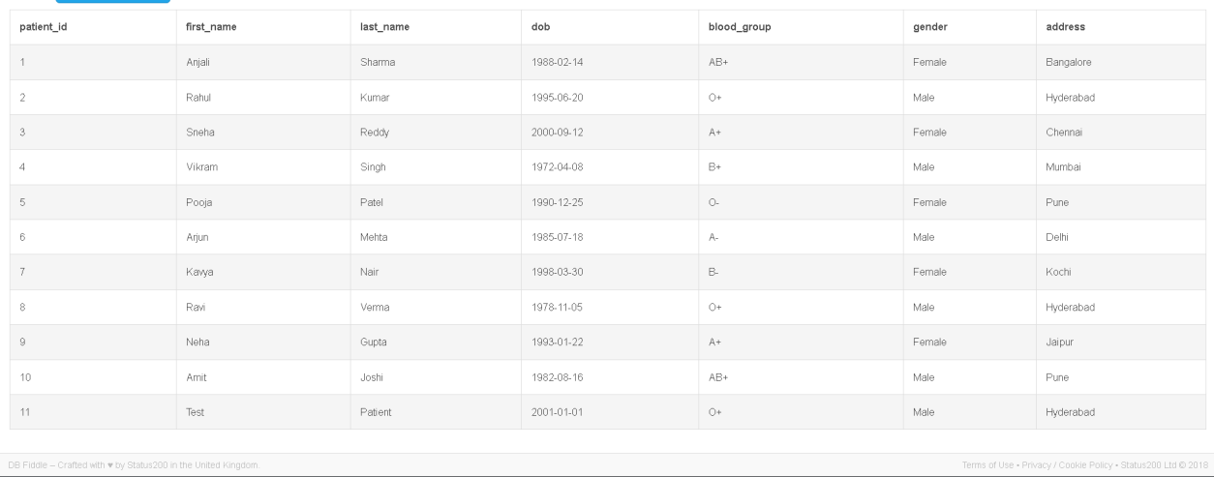

Figure 3: JOIN / Aggregate Query Output
(SELECT p.first_name || ' ' || p.last_name AS patient_name, d.first_name || ' ' || d.last_name AS doctor_name,a.appointment_date, a.status FROM Appointment a
JOIN Patient p ON a.patient_id = p.patient_id JOIN Doctor d ON a.doctor_id = d.doctor_id;
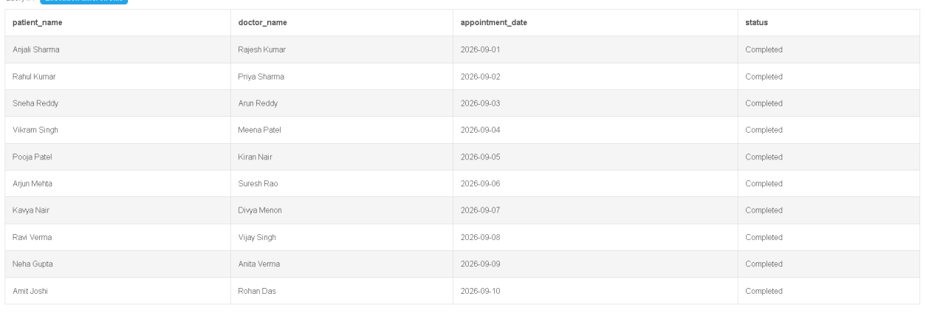
Figure 4: View / Validation Output
(SELECT * FROM Patient_Appointment_View;)

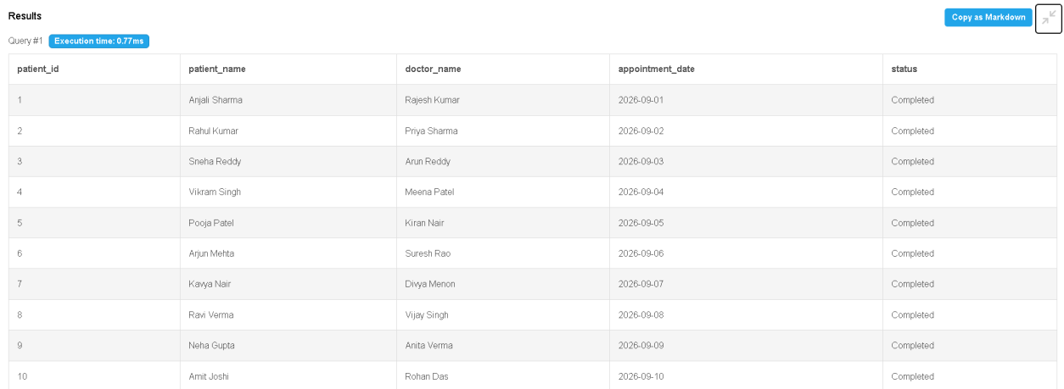
.

MODULES & FUNCTIONALITIES
The Hospital Management System is organized into the following functional modules, each responsible for a specific area of hospital data management:

Module | Functionality
Patient Management | Add, update, view and manage patient information including personal and demographic details.
Doctor Management | Maintain doctor details, specialization, experience and department association.
Department Management | Manage hospital departments, department heads and floor information.
Ward Management | Maintain ward capacity, available beds and department association.
Appointment Management | Schedule and track appointments between patients and doctors with status tracking.
Treatment Management | Store diagnosis, treatment dates and ward assignment for patient treatments.
Prescription Management | Maintain prescribed medicines, dosage and duration associated with treatments.
Billing Management | Maintain consultation, medicine and bed charges with payment status tracking.

GITHUB REPOSITORY & TEAM RESPONSIBILITIES

REPOSITORY LINK
The complete source code and SQL scripts for the Hospital Management System are maintained in a GitHub repository:
https://github.com/yuvachandu233-stack/hospital-management-system

TEAM RESPONSIBILITIES
The following table describes the responsibilities assigned to each team member:

Role | Responsibilities
G.YUVACHANDU | Database design, project coordination, integration and presentation.
M. SRIHARI | Patient and Doctor modules — table creation, sample data and queries.
ASHOKNANDA | Appointment and Treatment modules — table creation, sample data and queries.
K. PADMAKARA CHOWDARY | Billing, testing and documentation — bill table, constraint validation and report.

ENHANCEMENTS & FUTURE IMPROVEMENTS
The following enhancements and future improvements can be considered to extend the functionality and scope of the Hospital Management System:
- Online appointment booking — allowing patients to schedule appointments through a web interface.
- Patient and doctor login — implementing authentication for secure access to records.
- Role-based access control — restricting data access based on user roles (admin, doctor, receptionist, billing).
- Digital prescription management — enabling electronic generation and tracking of prescriptions.
- Automated bill and invoice generation — calculating total amounts automatically from individual charges.
- Hospital analytics dashboard — providing visual summaries of patient flow, revenue and department activity.
- Advanced reporting — generating periodic reports for hospital administration and departments.
- Cloud database deployment — hosting the database on a cloud platform for remote access and scalability.
- Mobile application integration — developing a mobile interface for doctors and patients.
- Backup and recovery mechanisms — implementing automated backup and disaster recovery procedures.

CONCLUSION
The Hospital Management System successfully demonstrates the practical implementation of a relational database for managing hospital information. The system organizes patient, doctor, department, ward, appointment, treatment, prescription and billing data into related tables. Primary keys and foreign keys establish relationships, while NOT NULL, UNIQUE, CHECK and DEFAULT constraints improve data integrity.
The project demonstrates important DBMS concepts including ER modeling, relational schema design, normalization up to 3NF, DDL, DML, DQL, CRUD operations, joins, aggregate functions, GROUP BY, HAVING, subqueries and views. The implementation provides efficient data organization and retrieval while reducing redundancy and maintaining consistency.
Through this project, the team gained practical knowledge of database design, SQL implementation, data validation and collaborative project development.

REFERENCES
- MySQL Documentation — SQL Statements and Database Management. https://dev.mysql.com/doc/
- Silberschatz, A., Korth, H. F., & Sudarshan, S. — Database System Concepts. McGraw-Hill Education.
- Elmasri, R., & Navathe, S. B. — Fundamentals of Database Systems. Pearson.
- Course materials and laboratory notes for Database Management Systems, Department of Artificial Intelligence & Machine Learning.
- GitHub repository of the project — [https://github.com/yuvachandu233-stack/hospital-management-system].

Appendix A. COMPLETE SQL SCRIPT
The following is the complete SQL script used for the Hospital Management System project. It includes database creation, table creation, data insertion, updates, deletions, select queries, joins, aggregate functions, subqueries and views.
-- ============================================================
-- HOSPITAL MANAGEMENT SYSTEM — COMPLETE SQL SCRIPT
-- ============================================================

-- Database Creation
CREATE DATABASE hospital_management; USE hospital_management;

-- ============================================================
-- TABLE CREATION (DDL)
-- ============================================================

CREATE TABLE Patient ( patient_id INT PRIMARY KEY,
first_name VARCHAR(50) NOT NULL, last_name VARCHAR(50) NOT NULL, DOB DATE,
age INT,
blood_group VARCHAR(5), address VARCHAR(200), gender VARCHAR(10)
);

CREATE TABLE Patient_Contact ( contact_id INT PRIMARY KEY, patient_id INT,
contact_number VARCHAR(15) NOT NULL,
FOREIGN KEY (patient_id) REFERENCES Patient(patient_id)
);

CREATE TABLE Department ( dept_id INT PRIMARY KEY,
dept_name VARCHAR(100) NOT NULL, hod_doctor_id INT,
floor_no INT

);

CREATE TABLE Doctor (
doctor_id INT PRIMARY KEY, first_name VARCHAR(50) NOT NULL, last_name VARCHAR(50) NOT NULL, specialization VARCHAR(100) NOT NULL, experience_years INT,
email VARCHAR(100) UNIQUE,
dept_id INT,
FOREIGN KEY (dept_id) REFERENCES Department(dept_id)
);

CREATE TABLE Ward (
ward_id INT PRIMARY KEY, ward_name VARCHAR(100) NOT NULL, capacity INT,
available_beds INT, dept_id INT,
FOREIGN KEY (dept_id) REFERENCES Department(dept_id)
);

CREATE TABLE Appointment ( appt_id INT PRIMARY KEY, patient_id INT, doctor_id INT, appointment_date DATE, appointment_time TIME,
status VARCHAR(20) DEFAULT 'Scheduled',
FOREIGN KEY (patient_id) REFERENCES Patient(patient_id), FOREIGN KEY (doctor_id) REFERENCES Doctor(doctor_id)
);

CREATE TABLE Treatment ( treatment_id INT PRIMARY KEY, appt_id INT,
diagnosis VARCHAR(255), treatment_date DATE, ward_id INT,
FOREIGN KEY (appt_id) REFERENCES Appointment(appt_id), FOREIGN KEY (ward_id) REFERENCES Ward(ward_id)

);

CREATE TABLE Prescription ( prescription_id INT PRIMARY KEY, treatment_id INT,
medicine_name VARCHAR(100), dosage VARCHAR(50), duration VARCHAR(50),
FOREIGN KEY (treatment_id) REFERENCES Treatment(treatment_id)
);

CREATE TABLE Bill (
bill_id INT PRIMARY KEY, patient_id INT, treatment_id INT,
consultation_fee DECIMAL(10,2), medicine_charges DECIMAL(10,2), bed_charges DECIMAL(10,2), total_amount DECIMAL(10,2),
payment_status VARCHAR(20) DEFAULT 'Pending', bill_date DATE,
FOREIGN KEY (patient_id) REFERENCES Patient(patient_id), FOREIGN KEY (treatment_id) REFERENCES Treatment(treatment_id)
);

-- ============================================================
-- DATA INSERTION (DML)
-- ============================================================

-- Departments
INSERT INTO Department VALUES (1, 'Cardiology', 1, 2);
INSERT INTO Department VALUES (2, 'Neurology', 2, 3);
INSERT INTO Department VALUES (3, 'Orthopedics', 3, 1);
INSERT INTO Department VALUES (4, 'Pediatrics', 4, 4);
INSERT INTO Department VALUES (5, 'General Medicine', 5, 1);

-- Doctors
INSERT INTO Doctor VALUES (1, 'Rajesh', 'Kumar', 'Cardiologist', 12, 'rajesh.kumar@hospital.com', 1);
INSERT INTO Doctor VALUES (2, 'Anita', 'Sharma', 'Neurologist', 10, 'anita.sharma@hospital.com', 2);

INSERT INTO Doctor VALUES (3, 'Vikram', 'Singh', 'Orthopedic Surgeon', 8, 'vikram.singh@hospital.com', 3);
INSERT INTO Doctor VALUES (4, 'Priya', 'Patel', 'Pediatrician', 6, 'priya.patel@hospital.com', 4);
INSERT INTO Doctor VALUES (5, 'Sanjay', 'Gupta', 'General Physician', 15, 'sanjay.gupta@hospital.com', 5);

-- Patients
INSERT INTO Patient VALUES (1, 'John', 'Doe', '1990-05-15', 34, 'O+', '123
Main Street, City A', 'Male');
INSERT INTO Patient VALUES (2, 'Mary', 'Wilson', '1985-08-22', 39, 'A+',
'456 Oak Avenue, City B', 'Female');
INSERT INTO Patient VALUES (3, 'Robert', 'Brown', '1978-03-10', 46, 'B+',
'789 Pine Road, City C', 'Male');
INSERT INTO Patient VALUES (4, 'Sarah', 'Davis', '1992-11-05', 32, 'AB+',
'321 Elm Street, City D', 'Female');
INSERT INTO Patient VALUES (5, 'Michael', 'Clark', '1980-07-18', 44, 'O-',
'654 Maple Lane, City E', 'Male');

-- Patient Contacts
INSERT INTO Patient_Contact VALUES (1, 1, '9876543210');
INSERT INTO Patient_Contact VALUES (2, 1, '9876543211');
INSERT INTO Patient_Contact VALUES (3, 2, '9123456780');
INSERT INTO Patient_Contact VALUES (4, 3, '9988776655');
INSERT INTO Patient_Contact VALUES (5, 4, '9001234567');

-- Wards
INSERT INTO Ward VALUES (1, 'Cardiac Ward', 20, 8, 1);
INSERT INTO Ward VALUES (2, 'Neuro Ward', 15, 5, 2);
INSERT INTO Ward VALUES (3, 'Ortho Ward', 18, 10, 3);
INSERT INTO Ward VALUES (4, 'Pediatric Ward', 12, 6, 4);
INSERT INTO Ward VALUES (5, 'General Ward', 25, 15, 5);

-- Appointments
INSERT INTO Appointment | VALUES | (1, | 1, | 1, | '2025-01-15', | '09:30:00',
'Scheduled');
INSERT INTO Appointment | VALUES | (2, | 2, | 2, | '2025-01-16', | '10:00:00',
'Completed');
INSERT INTO Appointment | VALUES | (3, | 3, | 3, | '2025-01-17', | '11:00:00',
'Scheduled');
INSERT INTO Appointment VALUES (4, 4, 4, '2025-01-18', '14:00:00',

'Completed');
INSERT INTO Appointment VALUES (5, 5, 5, '2025-01-19', '09:00:00',
'Cancelled');

-- Treatments
INSERT INTO Treatment VALUES (1, 2, 'Migraine', '2025-01-16', 2);
INSERT INTO Treatment VALUES (2, 1, 'Hypertension', '2025-01-15', 1);
INSERT INTO Treatment VALUES (3, 4, 'Viral Fever', '2025-01-18', 4);

-- Prescriptions
INSERT INTO Prescription VALUES (1, 1, 'Paracetamol', '500mg twice daily', '5 days');
INSERT INTO Prescription VALUES (2, 1, 'Ibuprofen', '400mg thrice daily', '3 days');
INSERT INTO Prescription VALUES (3, 2, 'Amlodipine', '5mg once daily', '30 days');
INSERT INTO Prescription VALUES (4, 3, 'Amoxicillin', '250mg thrice daily', '7 days');

-- Bills
INSERT INTO Bill VALUES (1, '2025-01-15');
1, | 2, | 500.00, | 300.00, | 200.00, 1000.00, 'Paid',
2, | 1, | 600.00, | 150.00, | 350.00, 1100.00,
4, | 3, | 400.00, | 200.00, | 0.00, 600.00, 'Paid',

INSERT INTO Bill VALUES (2, 'Pending', '2025-01-16'); INSERT INTO Bill VALUES (3, '2025-01-18');

-- ============================================================
-- UPDATE AND DELETE (DML)
-- ============================================================

UPDATE Patient SET address = '456 Updated Address, New City' WHERE patient_id = 1;
DELETE FROM Patient WHERE patient_id = 10;

-- ============================================================
-- SELECT QUERIES (DQL)
-- ============================================================

SELECT * FROM Patient;
SELECT * FROM Doctor WHERE specialization = 'Cardiologist';

SELECT first_name, last_name, blood_group FROM Patient WHERE gender = 'Male';

-- ============================================================
-- JOIN QUERIES
-- ============================================================

-- INNER JOIN: Patient + Appointment + Doctor
SELECT p.first_name, p.last_name, a.appointment_date, d.first_name AS doctor_name
FROM Patient p
INNER JOIN Appointment a ON p.patient_id = a.patient_id INNER JOIN Doctor d ON a.doctor_id = d.doctor_id;

-- LEFT JOIN: All patients with their appointments
SELECT p.first_name, p.last_name, a.appt_id, a.appointment_date FROM Patient p
LEFT JOIN Appointment a ON p.patient_id = a.patient_id;

-- ============================================================
-- AGGREGATE FUNCTIONS
-- ============================================================

-- COUNT
SELECT d.first_name, COUNT(a.appt_id) AS total_appointments FROM Doctor d
JOIN Appointment a ON d.doctor_id = a.doctor_id GROUP BY d.doctor_id;

-- SUM
SELECT patient_id, SUM(total_amount) AS total_billed FROM Bill
GROUP BY patient_id;

-- AVG
SELECT AVG(total_amount) AS average_bill_amount FROM Bill;

-- ============================================================
-- GROUP BY / HAVING
-- ============================================================

SELECT d.specialization, COUNT(a.appt_id) AS appt_count FROM Doctor d
JOIN Appointment a ON d.doctor_id = a.doctor_id GROUP BY d.specialization
HAVING COUNT(a.appt_id) > 1;

-- ============================================================
-- SUBQUERIES
-- ============================================================

SELECT * FROM Patient
WHERE patient_id IN (SELECT patient_id FROM Bill WHERE total_amount > 1000);

SELECT first_name, last_name FROM Doctor
WHERE dept_id = (SELECT dept_id FROM Department WHERE dept_name = 'Cardiology');

-- ============================================================
-- VIEWS
-- ============================================================

CREATE VIEW DoctorAppointments AS
SELECT d.first_name AS doctor_first, d.last_name AS doctor_last, p.first_name AS patient_first, a.appointment_date, a.status
FROM Doctor d
JOIN Appointment a ON d.doctor_id = a.doctor_id JOIN Patient p ON a.patient_id = p.patient_id;

SELECT * FROM DoctorAppointments;

-- ============================================================
-- END OF SCRIPT
-- ============================================================
Note: The SQL script above must match the actual project implementation. If the final database differs from this script, replace it with the actual executed SQL script.

Appendix B. ADDITIONAL SCREENSHOTS / OUTPUTS
The following section contains additional screenshots of database operations and query outputs. Each figure should show the SQL command and its result.
Figure 5: Patient Table Structure (DESC Patient)
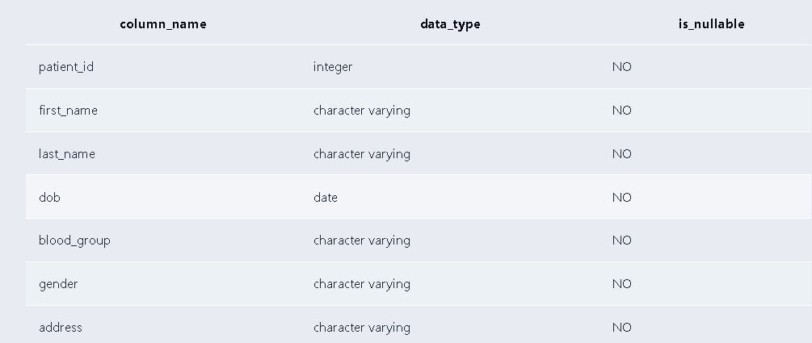
Figure 6: Appointment Records (SELECT * FROM Appointment)
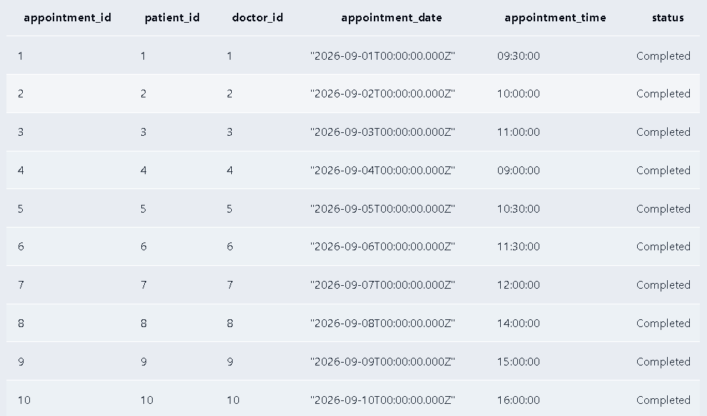

Figure 7: Doctor-Appointment JOIN Result
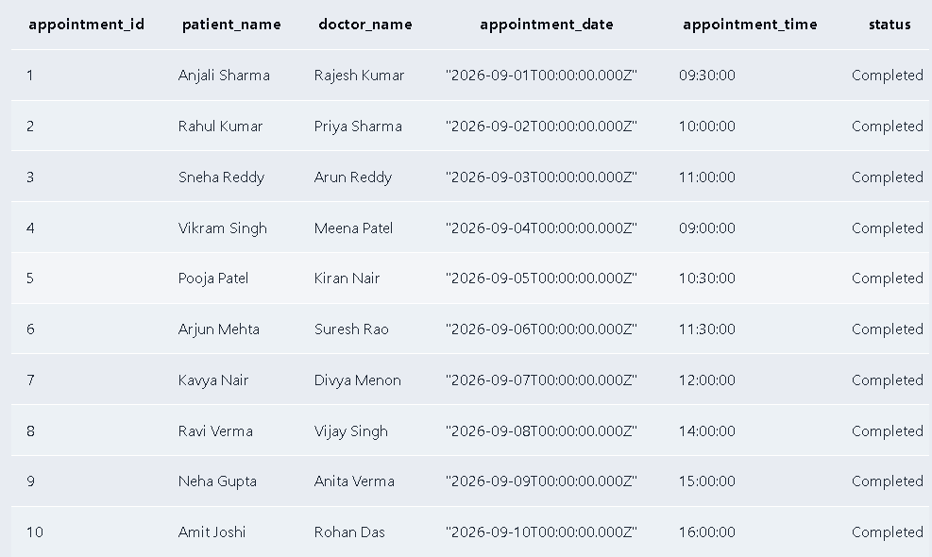
Figure 8: Billing Aggregate Query Result (SUM by Patient)
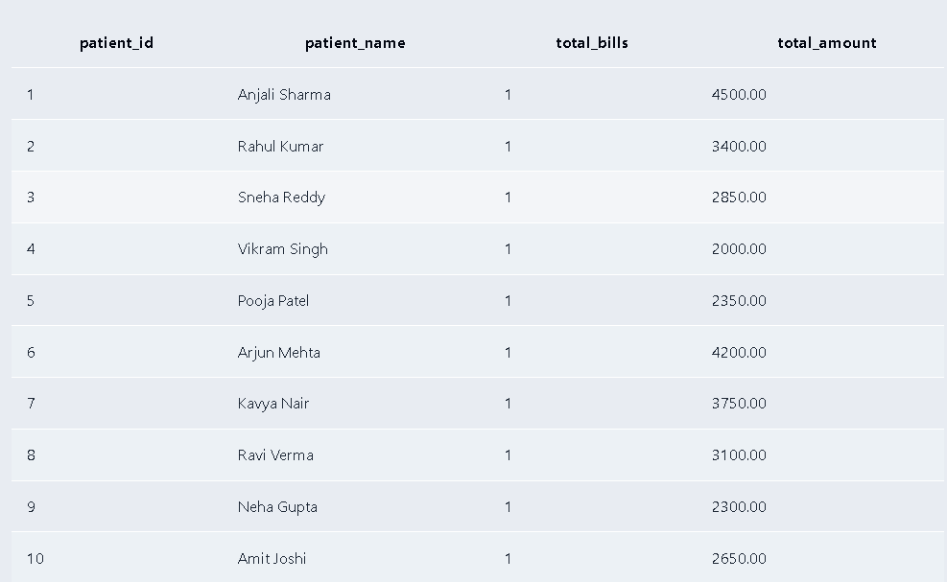

Figure 9: GROUP BY / HAVING Query Result
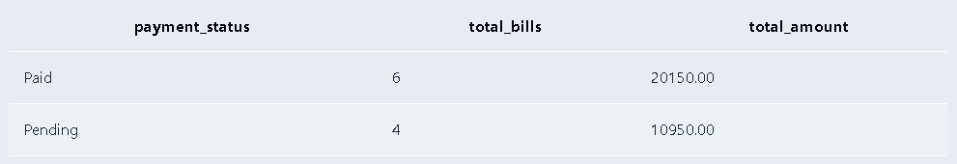
Figure 10: View Output (SELECT * FROM DoctorAppointments)
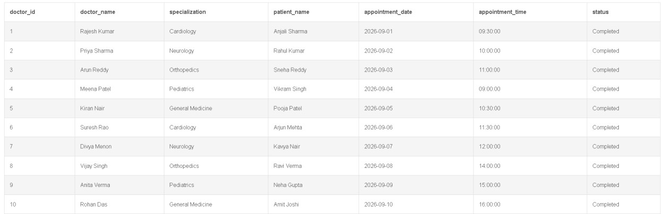
Figure 11: Constraint Validation — Duplicate Primary Key Rejected

Figure 12: Constraint Validation — Foreign Key Error Rejected

