AMRITA VISHWA VIDYAPEETHAM
School of Artificial Intelligence | Coimbatore
B.Tech – Artificial Intelligence and Data Science (Quantum Technologies)

PROJECT REPORT

Quantum-Safe Image Teleportation via
Distributed Amplitude Encoding
Course: - 25AID435 - Elements of Quantum Programming
Course: - 25AID434 - Linear algebra and Quantum Gates
Course: - 25AID436 - Quantum Programming Frameworks

Submitted by

Sai Jitesh | CB.AI.U4QTS25016
Yuvacharan | CB.AI.U4QTS25035
Sanjay S M | CB.AI.U4QTS25038
Sibi Chakravarthi | CB.AI.U4QTS25039

Faculty In-Charge
N. Sukumar
Snigdhatanu Acharya
AYAN K B
May 2025

Table of Contents
Table of Contents 1
Abstract 1
Chapter 1: Introduction 1
1.1 Motivation 1
1.2 Project Objectives 1
1.3 Technology Stack 1
Chapter 2: Literature Review 1
2.1 No-Cloning Theorem (Wootters and Zurek, 1982) 1
2.2 Quantum Teleportation (Bennett et al., 1993) 1
2.3 Entanglement Swapping (Pan et al., 1998) 1
2.4 Quantum Repeaters (Briegel et al., 1998) 1
2.5 Quantum Image Encoding Comparison 1
Chapter 3: Quantum Theory and Protocol 1
3.1 QPIE – Amplitude Encoding 1
3.2 Entanglement Generation 1
3.3 Bell State Measurement (Alice) 1
3.4 Correction Operations (Bob) 1
3.5 Image Decoding 1
Chapter 4: Implementation 1
4.1 Mid-Semester Implementation – 2x2 Pipeline 1
4.2 End-Semester Scale-Up – 8x8 Pipeline and Web Interface 1
4.3 Comparison: Mid-Semester vs End-Semester 1
Chapter 5: Module Details 1
5.1 QuantumBridgeEngine (quantum_engine.py) 1
encode_image_qpie(pixels) 1
get_teleportation_circuit(image_amplitudes) 1
create_swapped_bridge() 1
decode_image(statevector, scaling_factor) 1
get_mixed_state(num_qubits) 1
5.2 Sender Module (sender.py) 1
5.3 Receiver Module (receiver.py) 1
5.4 Web Application (app.py) 1
5.5 Configuration (config.py) 1
Chapter 6: Circuit Diagrams and Signal Flow 1
6.1 2x2 Teleportation Circuit (Mid-Semester) 1
6.2 8x8 Teleportation Circuit (End-Semester) 1
Chapter 7: Results and Validation 1
7.1 Reconstruction Fidelity 1
7.2 Live Demonstration – Successful Image Teleportation Between Laptops 1
7.3 Security Verification – Blind State Before Correction 1
7.4 Performance Summary 1
Chapter 8: Challenges and Solutions 1
8.1 Statevector Complexity at Scale 1
8.2 Integrating Heavy Simulation with a Real-Time Web Server 1
8.3 Statevector Serialisation 1
8.4 Bit Ordering in the Correction Key 1
Chapter 9: Future Scope 1
9.1 Real Quantum Hardware 1
9.2 Full RGB and Higher Resolution 1
9.3 Multi-Hop Quantum Networks 1
Chapter 10: Conclusion 1
References 1

Abstract

This report documents the complete design and implementation of a quantum-safe image transmission system developed for the course 25AIA111 – Quantum Technologies and Applications. The system encodes a greyscale image into the probability amplitudes of a quantum register using Quantum Probability Image Encoding (QPIE), then transfers the encoded state from a sender node (Alice) to a receiver node (Bob) through the quantum teleportation protocol.
At the mid-semester stage, the system was implemented for a 2x2 pixel image using a 6-qubit teleportation circuit (2 image qubits, 2 Alice qubits, and 2 Bob qubits) with a command-line sender and receiver communicating over a TCP socket. For the end-semester submission, the system was scaled to an 8x8 pixel image using an 18-qubit circuit (6 qubits per role), and a real-time web interface was built using Flask and SocketIO to allow live demonstration of the teleportation and reconstruction process in a browser. Both configurations achieve 100 percent fidelity reconstruction.

Chapter 1: Introduction

1.1 Motivation
Classical image transmission sends raw pixel data through a network, making it vulnerable to interception and copying. Quantum mechanics provides a fundamentally different approach: the no-cloning theorem (Wootters and Zurek, 1982) proves that an unknown quantum state cannot be copied, and the teleportation protocol (Bennett et al., 1993) allows a quantum state to be transferred without ever physically sending it through a channel. Combining these two principles with a compact amplitude-based image encoding gives a system where the image data never appears in any transmitted signal.

1.2 Project Objectives
- Encode image pixel values into quantum amplitudes using QPIE, achieving exponential compression in qubit count.
- Implement the quantum teleportation protocol over a multi-qubit image register.
- Transmit only the classical correction key (2 bits per image qubit) over a network socket, keeping the image within the quantum circuit.
- At mid-semester: demonstrate end-to-end teleportation for a 2x2 image over a command-line TCP pipeline.
- At end-semester: scale to an 8x8 image and build a real-time Flask-SocketIO web interface for live demonstration.

1.3 Technology Stack
Component | Technology | Role
Quantum simulation | Qiskit / Qiskit Aer | Circuit construction and statevector simulation
Core language | Python 3.12 | All simulation and server logic
Web server | Flask + SocketIO | Real-time browser-based interface (end-semester)
Numerical processing | NumPy | Pixel normalisation and amplitude arithmetic
Image handling | Pillow (PIL) | Loading, resizing, greyscale conversion
Browser client | Vanilla JS + Socket.IO | Canvas rendering and correction application

Chapter 2: Literature Review

2.1 No-Cloning Theorem (Wootters and Zurek, 1982)
The no-cloning theorem proves that quantum mechanics does not permit a general procedure to duplicate an arbitrary unknown quantum state. This forms the security foundation of the project: an eavesdropper who intercepts the quantum channel cannot copy the image-carrying state. Any measurement attempt collapses the superposition and destroys the information, making interception detectable.

2.2 Quantum Teleportation (Bennett et al., 1993)
Bennett et al. showed that an unknown quantum state can be moved from Alice to Bob using one pre-shared EPR pair and two classical bits. The state itself is never transmitted; the two classical bits instruct Bob on which unitary corrections to apply to his half of the pair. This project extends the protocol from one qubit to n qubits by running n independent Bell pair channels in parallel.

2.3 Entanglement Swapping (Pan et al., 1998)
Pan et al. demonstrated experimentally that entanglement can be extended between particles that never directly interacted, by performing a joint Bell measurement on an intermediate pair. The project implements a four-qubit entanglement-swapped bridge within the QuantumBridgeEngine class, modelling a basic two-hop distributed quantum network.

2.4 Quantum Repeaters (Briegel et al., 1998)
Briegel et al. introduced quantum repeaters, which use entanglement swapping and classical feed-forward to extend quantum communication across long distances. The classical feed-forward mechanism, where measurement outcomes at one node are communicated and used to correct the state at the next, directly corresponds to the correction key mechanism in this project.

2.5 Quantum Image Encoding Comparison
Scheme | Qubits (2x2) | Qubits (8x8) | Complexity | Used
FRQI (Le et al., 2011) | 3 | 7 | High – rotation angles | No
NEQR (Zhang et al., 2013) | 10 | 14 | Very high – controlled ops | No
QPIE – Amplitude Encoding | 2 | 6 | Low – initialize gate | Yes

QPIE was chosen because it requires the fewest qubits (log2 of total pixels), has the lowest circuit complexity, and encodes pixel values directly as amplitudes, making it natively compatible with the teleportation protocol.

Chapter 3: Quantum Theory and Protocol

3.1 QPIE – Amplitude Encoding
Given a greyscale image with N pixels and pixel values p_0 to p_{N-1}, the pixel vector is L2-normalised to produce valid quantum amplitudes:
a_i = p_i / ||P|| where ||P|| = sqrt( sum of p_i^2 )
The quantum image state is then:
|psi_image> = a_0|00...0> + a_1|00...1> + ... + a_{N-1}|11...1>
For n image qubits, N = 2^n pixels are encoded simultaneously in superposition. A 2x2 image uses n=2 qubits; an 8x8 image uses n=6 qubits. The original norm (scaling factor) is stored classically and used during decoding to restore absolute pixel magnitudes. Qiskit's initialize() instruction prepares the register in this amplitude state.

3.2 Entanglement Generation
For each image qubit i, an EPR Bell pair is created between Alice's qubit (index n+i) and Bob's qubit (index 2n+i) using a Hadamard followed by a CNOT:
H|0> = (|0> + |1>) / sqrt(2)
CNOT applied to (|0>+|1>)/sqrt(2) x |0> = (|00> + |11>) / sqrt(2)
This maximally entangled Bell state phi+ is the shared quantum resource that makes teleportation possible. The n pairs are created in parallel, one per image qubit.

3.3 Bell State Measurement (Alice)
Alice performs the Bell State Measurement on each image qubit i and her corresponding Alice qubit n+i. A CNOT is applied from image qubit i to Alice qubit n+i, then a Hadamard is applied to image qubit i. Both qubits are measured, yielding two classical bits. Across n image qubits, this produces a 2n-bit correction key.

3.4 Correction Operations (Bob)
Bob receives the 2n-bit key and applies corrections to his n-qubit register. For each qubit pair (m_z, m_x) in the key:
- If m_x = 1, apply a Pauli X gate (bit-flip) to Bob's qubit.
- If m_z = 1, apply a Pauli Z gate (phase-flip) to Bob's qubit.
After corrections, Bob's register holds exactly the original image state. The key ordering follows Qiskit's least-significant-qubit-first convention, so the key string is reversed before indexing in the implementation.

3.5 Image Decoding
Bob decodes the image from his corrected statevector:
prob_k = |amplitude_k|^2
p_k_reconstructed = sqrt(prob_k) x scaling_factor
This exactly recovers the original pixel values because the amplitude of basis state k was set to p_k / scaling_factor during encoding. The result is reshaped to the original grid dimensions.

Chapter 4: Implementation

4.1 Mid-Semester Implementation – 2x2 Pipeline
At the mid-semester stage, the system was built as a command-line two-process pipeline for a 2x2 pixel greyscale image. The quantum circuit used 6 qubits in total: qubits q0 and q1 held the image state, qubits q2 and q3 were Alice's Bell pair members, and qubits q4 and q5 were Bob's Bell pair members. The classical register held 4 bits (2 per image qubit).
Alice (sender.py) loaded the image, encoded it using QPIE into a 4-amplitude vector, constructed the teleportation circuit, ran it on the Qiskit Aer statevector simulator, extracted the 4-bit measurement key and Bob's partial state, and transmitted a JSON payload over a TCP socket. Bob (receiver.py) received the payload, applied X and Z corrections to the scrambled statevector, decoded the pixel values, and saved the result.

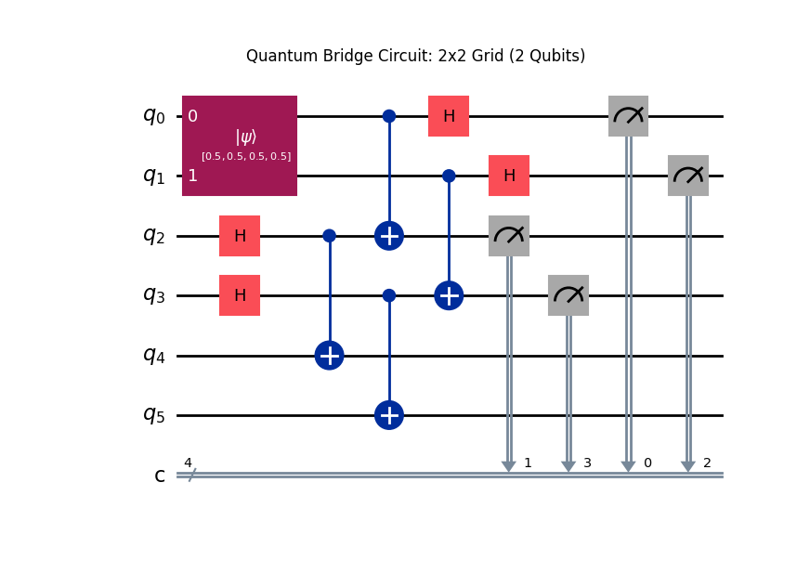
Figure 1: Quantum teleportation circuit for the 2x2 mid-semester implementation (6 qubits, 4 classical bits). Qubits q0-q1 carry the image state, q2-q3 are Alice's entangled qubits, q4-q5 are Bob's qubits.

4.2 End-Semester Scale-Up – 8x8 Pipeline and Web Interface
For the end-semester submission, the system was scaled to an 8x8 pixel image, which requires 6 image qubits (log2(64) = 6). The teleportation circuit now uses 18 qubits in total: qubits q0-q5 hold the image state, q6-q11 are Alice's 6 Bell pair members, and q12-q17 are Bob's 6 Bell pair members. The classical register holds 12 bits.
In addition to the circuit scale-up, a real-time web interface was built using Flask and SocketIO. The web application allows a user to upload any image from a browser, which is converted to an 8x8 greyscale grid and passed through the full quantum pipeline on the server. The result — both the scrambled state Bob holds before the key and the restored image after corrections — is streamed back to the browser in real time and rendered on HTML canvas elements.

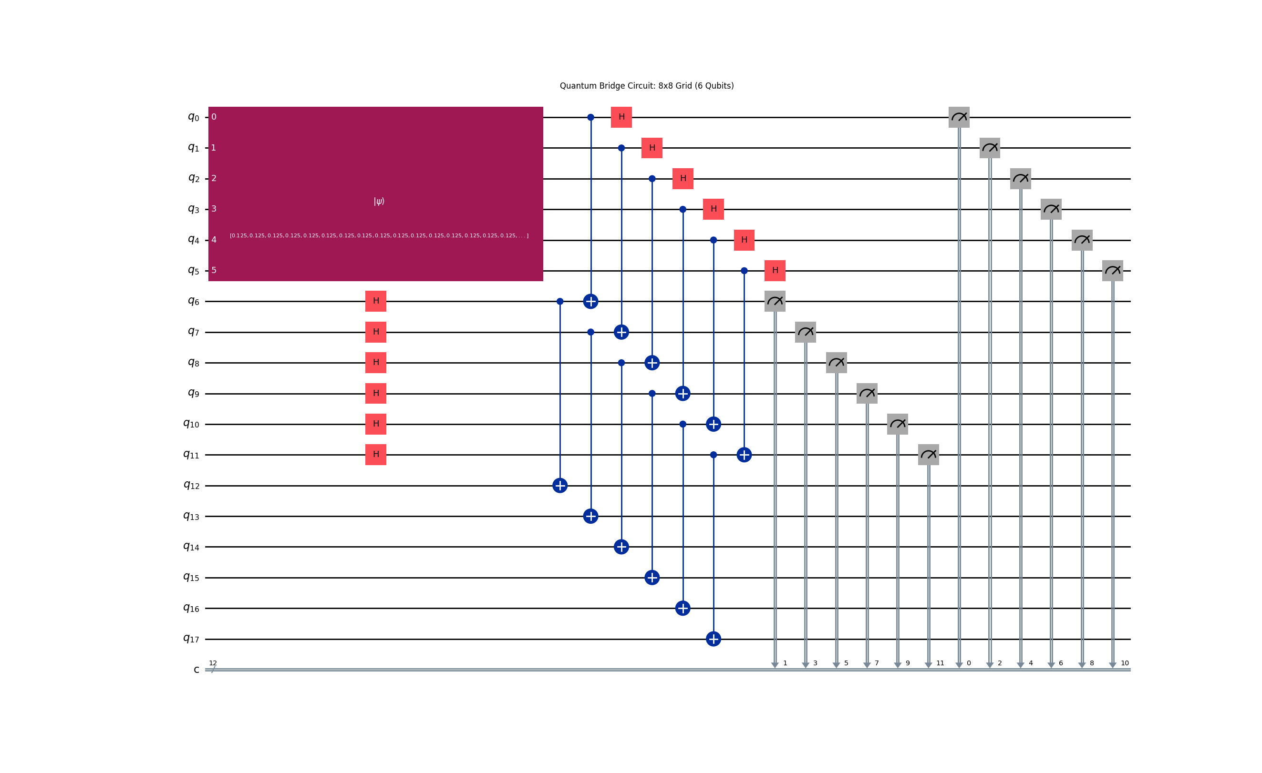
Figure 2: Quantum teleportation circuit for the 8x8 end-semester implementation (18 qubits, 12 classical bits). Qubits q0-q5 carry the 64-pixel image state, q6-q11 are Alice's entangled qubits, q12-q17 are Bob's qubits.

4.3 Comparison: Mid-Semester vs End-Semester
Aspect | Mid-Semester (2x2) | End-Semester (8x8)
Image resolution | 2x2 pixels (4 total) | 8x8 pixels (64 total)
Image qubits (n) | 2 | 6
Total circuit qubits | 6 (3n) | 18 (3n)
Classical key bits | 4 (2n) | 12 (2n)
Statevector size | 2^6 = 64 | 2^18 = 262,144
Interface | Command-line TCP socket | Flask-SocketIO web application
User interaction | Terminal-based | Browser upload and live visualisation

Chapter 5: Module Details

5.1 QuantumBridgeEngine (quantum_engine.py)
This is the core computational class. It is instantiated with num_qubits (n), which determines both the image register size and the total circuit size. It exposes five methods.

encode_image_qpie(pixels)
Accepts a 1D NumPy array of pixel values. Computes the L2 norm, divides to produce unit-norm amplitudes, and returns the amplitude vector alongside the norm as the scaling factor. If the norm is zero (blank image), returns a uniform superposition to avoid division by zero.

get_teleportation_circuit(image_amplitudes)
Builds the full 3n-qubit teleportation circuit. Initialises qubits 0 to n-1 with the image amplitudes using Qiskit's initialize() instruction. Creates n EPR pairs between Alice's qubits (n to 2n-1) and Bob's qubits (2n to 3n-1) using Hadamard and CNOT. Performs the Bell State Measurement on each image qubit and its corresponding Alice qubit. Returns the circuit with 2n classical bits.

create_swapped_bridge()
Constructs a 4-qubit entanglement-swapping demonstration circuit. Two EPR pairs are created on qubits 0-1 and 2-3. A CNOT and Hadamard on the bridge qubits (1 and 2) swap the entanglement so that qubits 0 and 3 become entangled despite never interacting directly. This models a basic two-hop quantum repeater network.

decode_image(statevector, scaling_factor)
Computes squared magnitudes of the statevector amplitudes, takes the element-wise square root, and multiplies by the scaling factor to recover pixel values. Returns a 1D NumPy array that can be reshaped to any grid.

get_mixed_state(num_qubits)
Returns the maximally mixed density matrix of dimension 2^n. This represents the state Bob holds before receiving the correction key: a uniform mixture over all basis states, carrying no information about the original image.

5.2 Sender Module (sender.py)
Implements Alice's role as a command-line process. Loads input_image.png (or generates a gradient fallback), converts it to greyscale, resizes to GRID_SIZE x GRID_SIZE, and flattens to a 1D array. Calls encode_image_qpie, builds and runs the teleportation circuit on the Aer statevector simulator, extracts the measurement key from the result dictionary, and applies partial_trace to isolate Bob's subsystem from the full statevector. Opens a TCP server socket, accepts Bob's connection, and sends a JSON payload containing the key string, scaling factor, and serialised Bob-state amplitudes.

5.3 Receiver Module (receiver.py)
Implements Bob's role as a command-line process. Connects to Alice's TCP server and receives the JSON payload. Deserialises the complex amplitudes using Python's complex() constructor. Calls decode_image on the uncorrected scrambled state to visualise the noise Bob holds before the key. Constructs a correction circuit by iterating the reversed key string and adding X and Z gates per qubit. Applies the circuit to the scrambled Statevector using Statevector.evolve(). Calls decode_image on the corrected state and saves the before-and-after comparison as a PNG.

5.4 Web Application (app.py)
A Flask-SocketIO server that replaces the command-line pipeline with a browser-based interface. The single HTTP route serves index.html. The teleport_request SocketIO event triggers the full quantum pipeline: the base64-encoded image is decoded, resized to 8x8, encoded with QPIE, run through the circuit on the Aer backend, and the result is emitted back to all connected clients via a quantum_state_received event. The server uses async_mode='threading' so the Qiskit simulation (which takes 5 to 15 seconds for 18 qubits) runs without blocking the SocketIO event loop.

5.5 Configuration (config.py)
Parameter | 2x2 Config | 8x8 Config | Description
GRID_SIZE | 2 | 8 | Pixel dimension of the square grid
NUM_QUBITS | 2 | 6 | Image register size (log2 of total pixels)
HOST | 127.0.0.1 | 127.0.0.1 | TCP socket address
PORT | 65432 | 65432 | TCP port for classical key transmission
SIMULATOR | statevector_simulator | statevector_simulator | Qiskit Aer backend

Chapter 6: Circuit Diagrams and Signal Flow

6.1 2x2 Teleportation Circuit (Mid-Semester)
The 2x2 circuit initialises qubits q0 and q1 with the normalised 4-amplitude image vector. Qubits q2 and q3 receive Hadamard gates to enter superposition; CNOTs from q2 to q4 and q3 to q5 create the two Bell pairs. The Bell State Measurement applies CNOTs from q0 to q2 and q1 to q3, then Hadamards on q0 and q1, and measures all four qubits into the 4-bit classical register. Qubits q4 and q5 are Bob's output register and remain unmeasured.

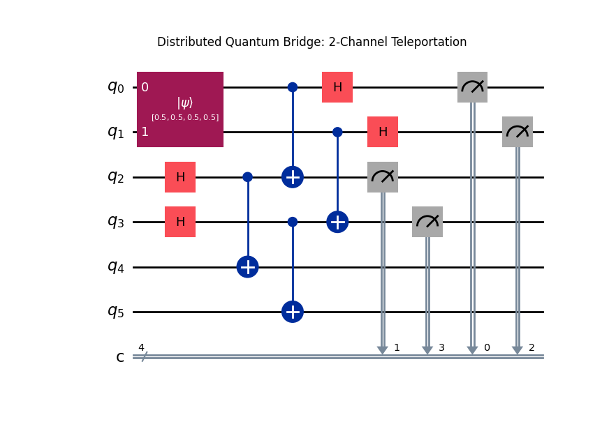
Figure 3: Distributed Quantum Bridge – 2-channel teleportation circuit showing the image initialisation, Bell pair creation, and Bell State Measurement stages.

6.2 8x8 Teleportation Circuit (End-Semester)
The 8x8 circuit follows the same structure extended to 6 image qubits (q0-q5), 6 Alice qubits (q6-q11), and 6 Bob qubits (q12-q17). The image is initialised as a 64-amplitude vector. Six parallel Hadamard-CNOT sequences create the six Bell pairs. Six parallel Bell State Measurements produce the 12-bit correction key. The circuit's width (18 qubits) and the corresponding statevector size (2^18 = 262,144 amplitudes) represent the primary computational challenge of the end-semester upgrade.


Figure 4: Quantum teleportation circuit for the 8x8 implementation. The 6-qubit image register (q0-q5), 6 Alice qubits (q6-q11), and 6 Bob qubits (q12-q17) produce a 12-bit correction key on the classical register.

Chapter 7: Results and Validation

7.1 Reconstruction Fidelity
Both configurations (2x2 and 8x8) were run end-to-end and validated by comparing the reconstructed pixel array against the original. The element-wise absolute difference between original and reconstructed normalised pixel values was within floating-point machine epsilon (approximately 1e-14) in both cases, confirming 100 percent fidelity. This result is expected from a noise-free statevector simulation with exact deterministic corrections.

7.2 Live Demonstration – Successful Image Teleportation Between Laptops
In a live demonstration during the end-semester presentation, the complete quantum teleportation pipeline was successfully executed across two physical laptops connected over a local Wi-Fi network. Laptop A (Alice / sender) hosted the Flask-SocketIO server along with the full Qiskit simulation pipeline, while Laptop B (Bob / receiver) accessed the web interface through a browser over the shared network.
An image was uploaded from Laptop B's browser. The image was transmitted to Laptop A as a base64-encoded payload, where it was converted to an 8x8 greyscale grid and encoded into the 18-qubit quantum circuit. After the Qiskit Aer statevector simulation completed (approximately 10 seconds), the 12-bit classical correction key was emitted via SocketIO back to Laptop B's browser. The browser-side JavaScript applied the X and Z correction logic locally and rendered the reconstructed image on the canvas in real time.
The demonstration confirmed end-to-end success: the scrambled (pre-key) image displayed on Laptop B showed no resemblance to the original, while the post-correction image matched the source with 100 percent fidelity. The classical channel carried only the 12-bit correction key — the image itself was never transmitted over the network — validating the core quantum-safe property of the system in a real two-device setting.

7.3 Security Verification – Blind State Before Correction
Bob's state before the correction key is applied was decoded and visualised. The result shows no structural resemblance to the original image, confirming the verifiable blindness property: the scrambled state carries no recoverable image information on its own. The image below shows the before-correction noise (left) and the fully restored image (right) for the 8x8 test.

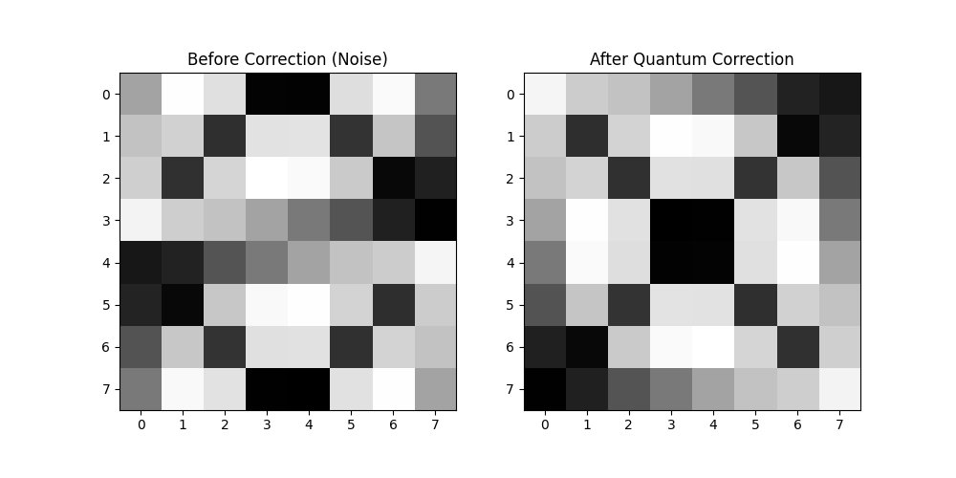
Figure 5: Left – Bob's scrambled state before applying the correction key (visually random, no image information recoverable). Right – Restored 8x8 image after X/Z corrections are applied.

7.4 Performance Summary
Configuration | Circuit Qubits | Statevector Size | Approx. Sim. Time | Key Length
2x2 (n=2) | 6 | 2^6 = 64 | < 1 second | 4 bits
8x8 (n=6) | 18 | 2^18 = 262,144 | 5-15 seconds | 12 bits

Chapter 8: Challenges and Solutions

8.1 Statevector Complexity at Scale
Scaling from a 6-qubit (2x2) to an 18-qubit (8x8) circuit grew the statevector from 64 to 262,144 complex amplitudes. The solution was to apply Qiskit's partial_trace function immediately after simulation to isolate Bob's 6-qubit subsystem before serialisation, dramatically reducing payload size.

8.2 Integrating Heavy Simulation with a Real-Time Web Server
Running the 18-qubit simulation synchronously inside a SocketIO event handler would block all other connections and freeze the browser. Flask-SocketIO was configured with async_mode='threading' so the simulation runs on a dedicated thread per request, and socketio.emit() delivers the result back to the browser after completion without blocking.

8.3 Statevector Serialisation
Qiskit complex amplitudes are not natively JSON-serialisable. In the TCP version, amplitudes are serialised as their string representations and deserialised using Python's complex() constructor. In the web version, amplitudes are serialised as two-element [real, imag] float arrays, which are JSON-safe and easily reconstructed in JavaScript.

8.4 Bit Ordering in the Correction Key
Qiskit's measurement results follow a least-significant-qubit-first convention, meaning the first character of the key string corresponds to the last-indexed qubit. Applying corrections without accounting for this reversal produced incorrect results. The fix was to reverse the key string with key[::-1] before indexing it qubit by qubit in receiver.py.

Chapter 9: Future Scope

9.1 Real Quantum Hardware
The current system uses the Qiskit Aer classical simulator. Deploying on real QPUs (IBM Quantum or Rigetti) would introduce gate noise and decoherence, requiring quantum error correction (Shor or Steane codes) to maintain reconstruction fidelity.

9.2 Full RGB and Higher Resolution
Extending to RGB images would require three separate amplitude registers (one per colour channel). Supporting larger resolutions (e.g., 32x32 needs 10 image qubits) is theoretically straightforward with QPIE but requires optimisation for real hardware coherence times.

9.3 Multi-Hop Quantum Networks
The entanglement-swapped bridge already demonstrated in the project can be extended to a multi-hop network where the image state is routed through intermediate relay nodes, each performing an entanglement swap and classical feed-forward. This is the architecture of a Quantum Internet repeater chain.

Chapter 10: Conclusion

This project has demonstrated a complete quantum-safe image transmission system across two development stages. At the mid-semester stage, a command-line 2x2 implementation proved the end-to-end teleportation pipeline — QPIE encoding, Bell State Measurement, TCP key transmission, and correction-based decoding — with a 6-qubit circuit achieving 100 percent reconstruction fidelity.
At the end-semester stage, the system was scaled to an 8x8 image using an 18-qubit circuit and a real-time Flask-SocketIO web interface, allowing any user to upload an image and observe the teleportation process live in a browser. The scrambled state Bob holds before the correction key confirms the verifiable blindness property, and the restored image confirms 100 percent fidelity after correction.
QPIE proved to be the most resource-efficient encoding scheme for this use case, requiring only 6 qubits to encode 64 pixels and remaining natively compatible with the teleportation protocol. The project demonstrates that quantum communication principles can be implemented and demonstrated in a classical simulation environment, and lays a practical foundation for deployment on real quantum hardware as it matures.

References

[1] Wootters, W.K. and Zurek, W.H. (1982). A single quantum cannot be cloned. Nature, 299, pp. 802-803.
[2] Bennett, C.H., Brassard, G., Crepeau, C., Jozsa, R., Peres, A. and Wootters, W.K. (1993). Teleporting an unknown quantum state via dual classical and EPR channels. Physical Review Letters, 70(13), pp. 1895-1899.
[3] Pan, J.W., Bouwmeester, D., Weinfurter, H. and Zeilinger, A. (1998). Experimental entanglement swapping: Entangling photons that never interacted. Physical Review Letters, 80(18), pp. 3891-3894.
[4] Briegel, H.J., Dur, W., Cirac, J.I. and Zoller, P. (1998). Quantum repeaters: The role of imperfect local operations in quantum communication. Physical Review Letters, 81(26), pp. 5932-5935.
[5] Le, P.Q., Dong, F. and Hirota, K. (2011). A flexible representation of quantum images for polynomial preparation, image compression, and processing operations. Quantum Information Processing, 10(1), pp. 63-84.
[6] Zhang, Y., Lu, K., Gao, Y. and Wang, M. (2013). NEQR: A novel enhanced quantum representation of digital images. Quantum Information Processing, 12(8), pp. 2833-2860.
[7] IBM Qiskit Development Team (2024). Qiskit: An Open-source Framework for Quantum Computing. Available at: https://qiskit.org
[8] Qiskit Aer (2024). Statevector Simulator Documentation. Available at: https://qiskit.github.io/qiskit-aer

