WEEK–2 PROJECT REPORT
WALMART DATA ANALYSIS AND FORECASTING
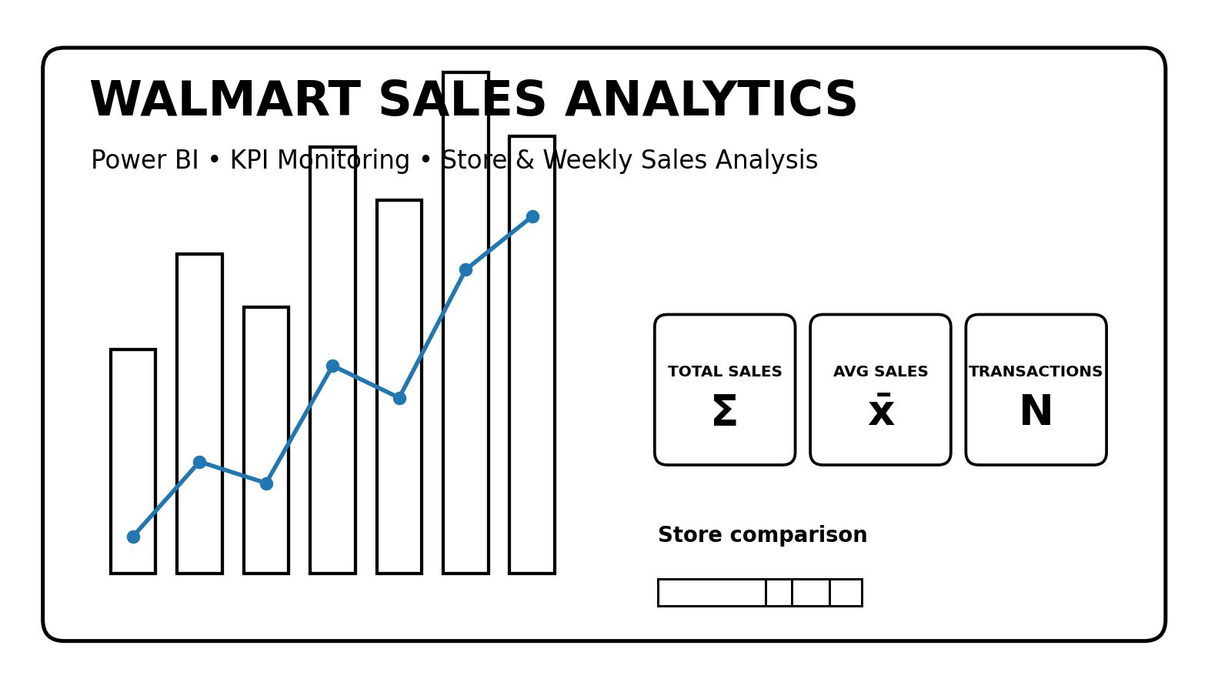
Submitted by
G. YUVADHARSHINI
Roll No: E25FA051
Power BI Dashboard Analysis

1. Executive Summary
This report documents the Week-2 Power BI project titled “Walmart Data Analysis and Forecasting.” The uploaded PBIX project contains four report pages: KPI CARDS, Financial Visualization tool-1, Financial Visualization tool-2, and Financial Dashboard. Together, these pages provide a structured view of Walmart sales performance through KPI cards, store comparisons, weekly sales analysis, cumulative trend monitoring, store ranking, sales-share analysis, relationship analysis, and interactive filters.
The dashboard is designed to convert transactional sales data into decision-support visuals. Instead of relying only on detailed tables, the report uses cards and charts to make performance patterns easier to compare across stores and time. The dashboard also provides slicers for Store, Date, and Holiday Status, allowing users to narrow the analysis to a specific business context.

2. Project Objectives
- Develop an interactive Power BI dashboard for Walmart sales analysis.
- Monitor important sales KPIs such as total sales, average sales, and transaction count.
- Compare sales performance across stores and weekly periods.
- Study cumulative sales trends and changes over time.
- Examine store ranking and sales contribution using multiple visual perspectives.
- Provide interactive filtering through store, date, and holiday-status slicers.

3. Dataset and Analytical Context
The Power BI model is built around a table named “Walmart Data Analysis and Forca” in the uploaded project. The report visuals reference fields such as Store, Date, Weekly Sales, and Holiday_Flag, along with measures including TOTALS SALES, AVERAGE SALES, and TRANSACTION COUNT. The dashboard therefore focuses on store-level and time-based sales performance rather than customer-level profiling.
The analytical context is suitable for retail performance monitoring: store managers can compare locations, analysts can examine weekly movement, and decision-makers can use filters to investigate particular dates or holiday conditions.

4. Dashboard Architecture
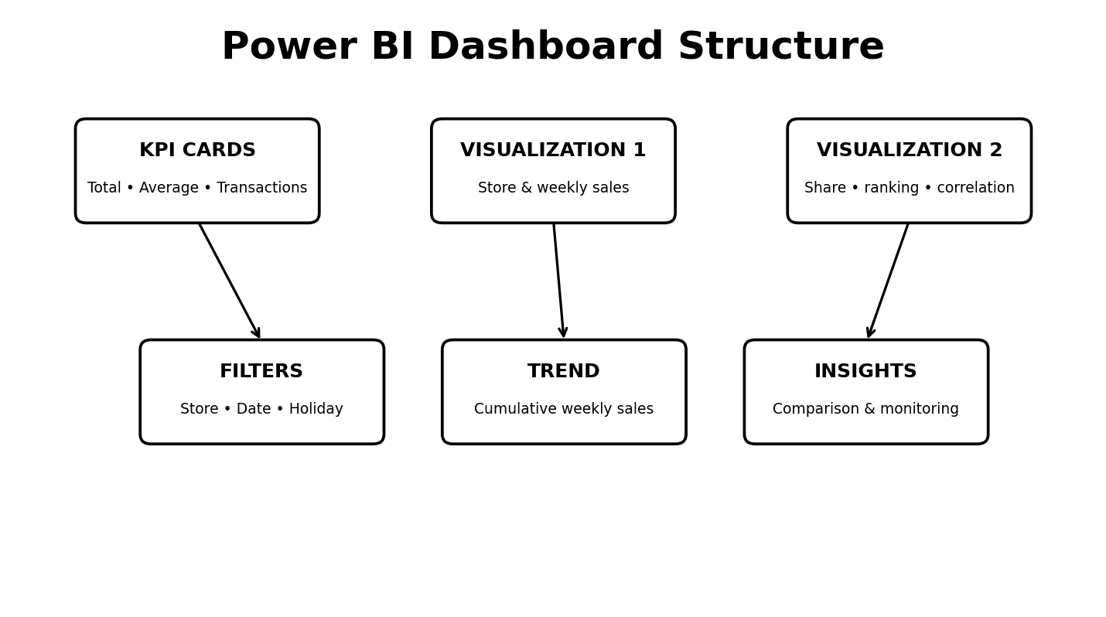
The dashboard is organized into four complementary layers. KPI cards provide an immediate summary; visualization pages support comparison and exploration; the Financial Dashboard combines KPIs, charts, and slicers into a single analytical workspace; and the trend/ranking views help users interpret changes over time.

5. KPI Analysis
KPI | Purpose | Interpretation
Total Sales | Measures overall sales generated in the selected context. | Useful for assessing overall revenue scale and comparing filtered periods/stores.
Average Sales | Shows the average sales level used by the dashboard. | Useful for understanding typical sales performance rather than only totals.
Transaction Count | Tracks the number of sales records/transactions represented. | Useful for monitoring activity volume and supporting comparisons between sales value and transaction activity.

6. Visualization Analysis
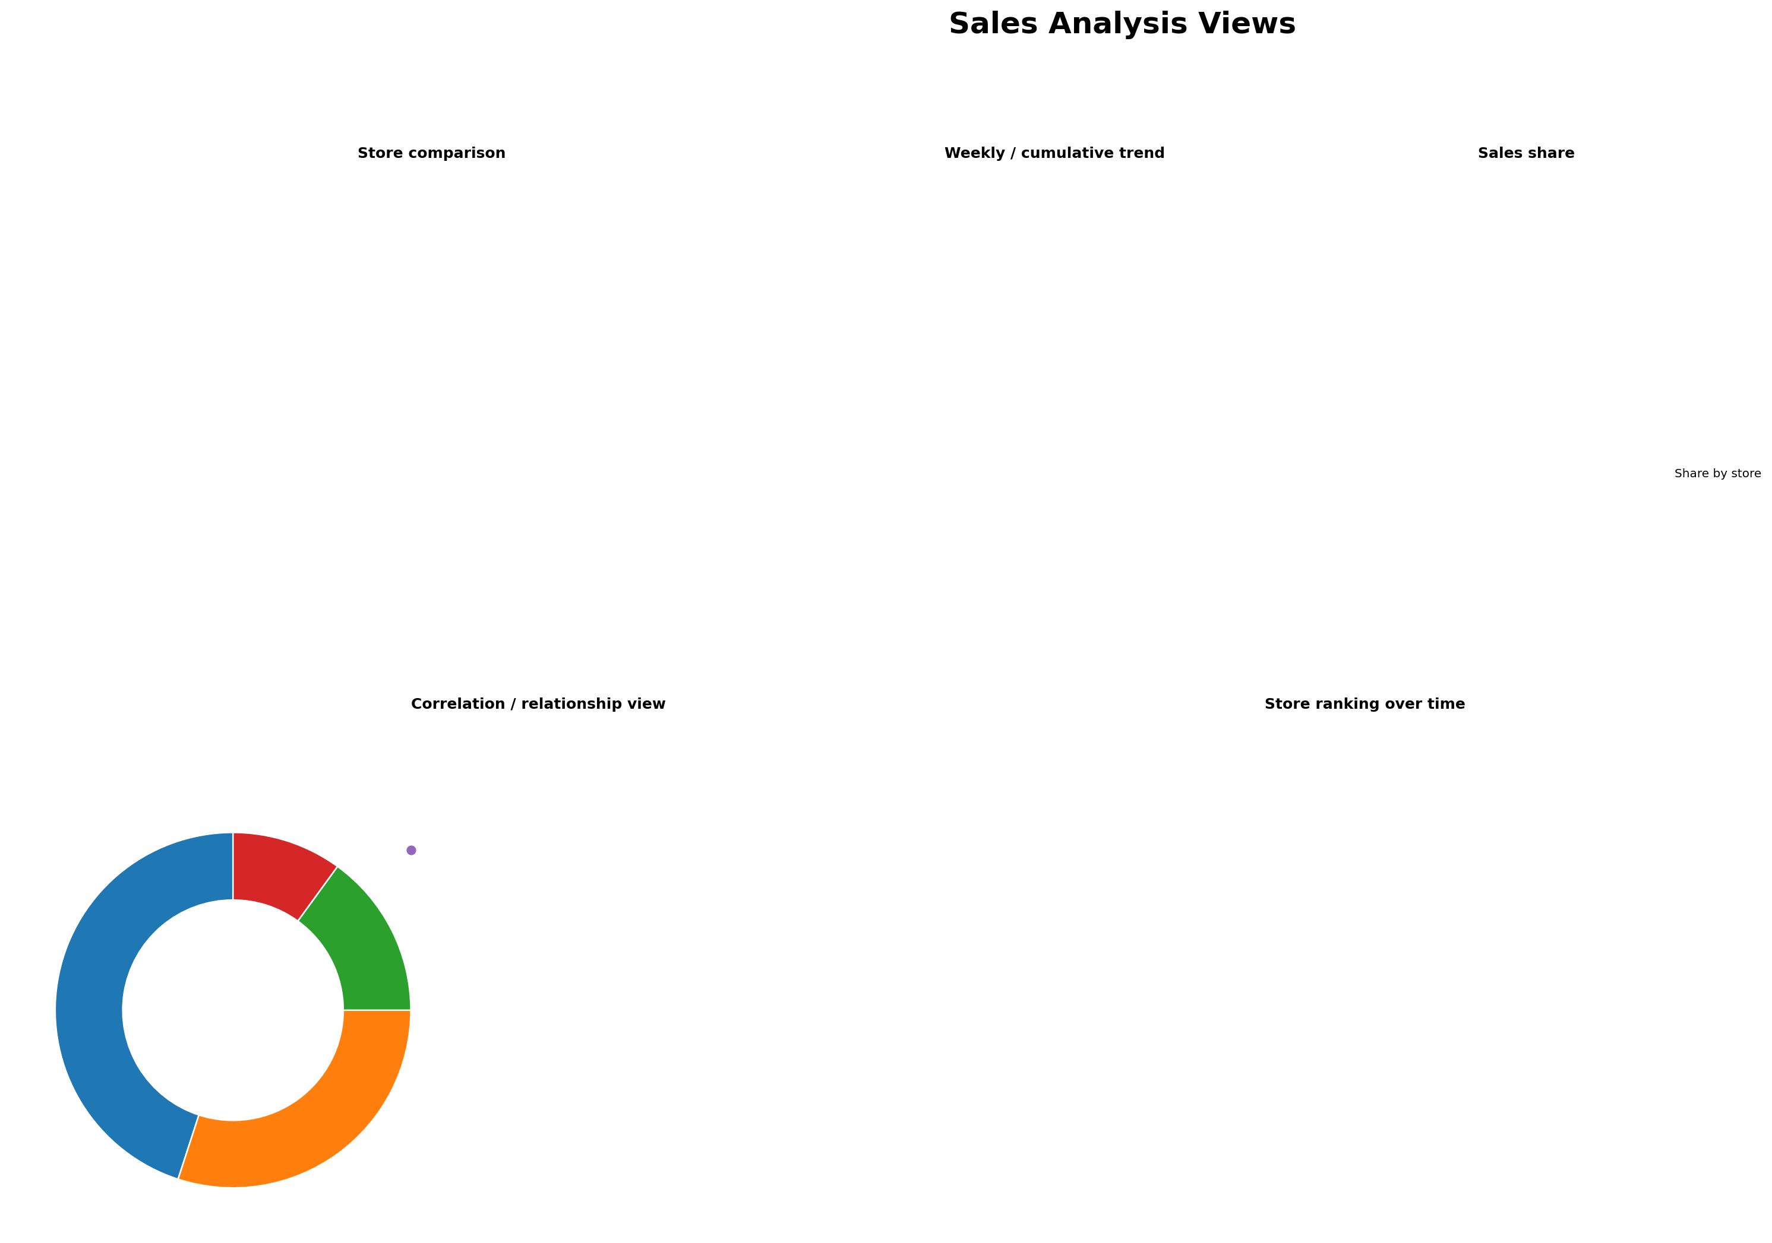

6.1 Store-wise and Weekly Sales
The clustered column visual titled “STORY WISE TOTAL WEEKLY SALES” is designed to compare sales across stores and weekly observations. This makes it possible to identify differences in sales scale and observe how performance varies between locations.

6.2 Average Sales Comparison
The clustered bar visual supports direct comparison of average sales across stores or selected categories. Horizontal bars are particularly useful when many store categories must be compared in a compact space.

6.3 Cumulative Weekly Sales Trend
The line chart titled “CUMULATIVE WEEKLY SALES TRDEND” provides a time-series perspective. A cumulative view helps users understand how sales build across the reporting period and whether the trajectory changes over time.

6.4 Sales Share
The donut chart represents the contribution of stores to total sales. This view is useful for understanding concentration of sales across locations, while recognizing that a share chart is complementary to absolute-sales comparisons.

6.5 Relationship Analysis
The scatter chart provides a relationship-oriented view of sales-related variables. Such a visual is useful for identifying clusters, unusual observations, and possible relationships that may warrant deeper statistical analysis.

6.6 Store Ranking Over Time
The ribbon chart titled “STORE RANKING OVER TIME” is designed to show how store positions change across time. It is particularly useful for identifying stores whose relative performance rises or falls during the selected period.

7. Interactive Filters
The Financial Dashboard includes three important slicers: STORE, DATE, and HOLIDAY STATUS. These controls allow the user to move from a high-level dashboard view to a focused analysis. For example, a user can select a particular store, restrict the date range, and then compare results under different holiday conditions. This interactive approach improves usability because the same dashboard can answer multiple business questions without creating separate static reports.

8. Key Findings from the Dashboard Design
- The project emphasizes store-level sales performance and weekly time-based analysis.
- The dashboard combines summary KPIs with detailed visual exploration, creating a clear progression from overview to analysis.
- Time-based visuals are central to the project, with both weekly and cumulative sales perspectives.
- Store ranking and sales-share views provide complementary measures of relative store performance.
- Holiday Status is treated as an analytical filter, enabling comparison of sales under different calendar conditions.
- Interactive slicers make the dashboard suitable for exploratory analysis rather than one fixed presentation.

9. Business Use Cases
Use Case | Application
Store Performance Monitoring | Managers can compare store performance and identify locations requiring closer review.
Weekly Sales Tracking | Analysts can monitor changes across weeks and use cumulative trends to understand overall movement.
Performance Ranking | Management can review how store positions change over time instead of relying on a single-period ranking.
Holiday Analysis | Users can isolate holiday and non-holiday periods to study differences in sales behavior.
Management Reporting | KPI cards and summary charts provide a concise format for routine performance discussions.

10. Strengths of the Dashboard
- Multiple visual types are used for different analytical questions.
- KPI cards provide quick access to core performance indicators.
- Store, date, and holiday filters support focused analysis.
- Trend and ranking visuals add a time dimension to the report.
- The layout supports both executive-level scanning and deeper exploration.

11. Suggested Improvements
- Add explicit target or benchmark lines so users can compare actual sales with planned performance.
- Include year-over-year or week-over-week variance measures for faster performance diagnosis.
- Add tooltips containing additional store metrics to reduce visual clutter.
- Provide a dedicated forecasting visual with confidence intervals if forecast outputs are available.
- Document the data refresh date and data-quality checks on the dashboard.

12. Conclusion
The Week-2 Walmart Data Analysis and Forecasting project demonstrates how Power BI can transform retail sales data into an interactive analytical report. The uploaded dashboard combines KPI cards, store comparisons, weekly and cumulative trends, sales-share analysis, relationship analysis, store ranking, and slicers for Store, Date, and Holiday Status. These components provide a practical framework for monitoring sales performance and exploring differences across stores and time.
Overall, the project establishes a strong foundation for further retail analytics. Future extensions can add targets, variance analysis, forecasting, and more advanced diagnostic measures while retaining the dashboard's interactive structure.

13. References
1. Uploaded Power BI project: Week-2 (4).pbix.zip — Walmart Data Analysis and Forecasting.
2. Microsoft Power BI — dashboard and data-visualization concepts.
3. Project report interpretation based on the visual configuration and fields contained in the uploaded PBIX project.

