WEEK–4 FINAL REPORT
SALES ANALYTICS USING POWER BI
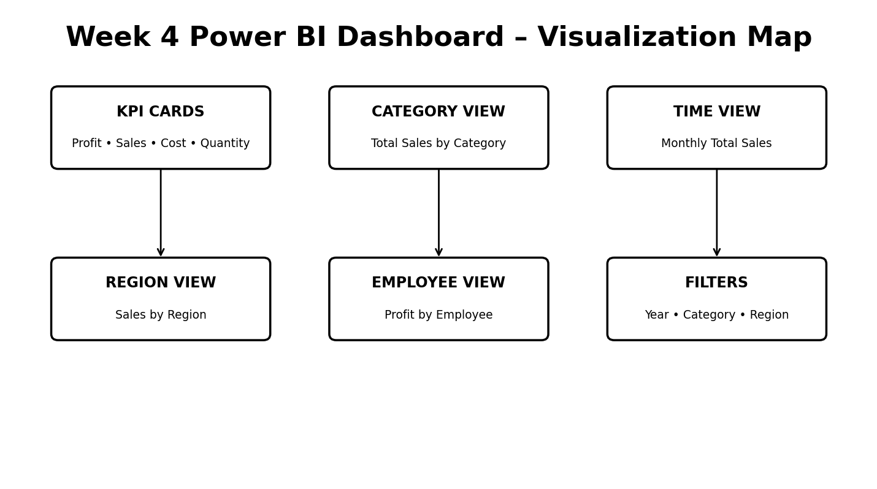
Submitted by
G. YUVADHARSHINI
Roll No: E25FA051

1. Abstract
This Week-4 project presents an interactive sales analytics dashboard developed in Microsoft Power BI. The uploaded PBIX project contains separate pages for DAX validation, KPI cards, visualization analysis, a consolidated dashboard, and a sales tooltip. The report combines business KPIs with category, time, regional, employee, and filter-based views to support exploration of sales and profitability.

2. Project Objectives
- Create a Power BI dashboard for sales and profitability analysis.
- Track Total Profit, Total Sales, Total Cost, Average Sales, and Quantity-related indicators.
- Compare sales across product categories.
- Analyze monthly sales movement over time.
- Examine regional contribution to total sales.
- Compare employee-level profitability.
- Provide interactive filtering by Year, Category, and Region.

3. Power BI Project Structure
The uploaded project contains five report pages: DAX VALIDATION, KPI CARDS, VISULIAZATION, DASHBOARD, and SALES TOOLTIP. The visualization page contains a column chart, line chart, donut chart, and clustered bar chart. The dashboard combines KPI cards, these analytical visuals, a table, and slicers into a single reporting interface.

4. KPI Analysis
KPI / Metric | Purpose | Analytical use
Total Profit | Measures profitability in the selected filter context. | Supports profit monitoring and comparison.
Total Sales | Measures overall sales generated. | Provides the primary sales-performance measure.
Total Cost | Measures cost associated with sales. | Allows sales and cost to be viewed together.
Average Sales | Summarizes the average sales measure. | Useful for understanding typical performance.
Quantity | Aggregates sales quantity from FactSales. | Adds volume context to monetary measures.

5. Visualization 1 – Sales by Product Category
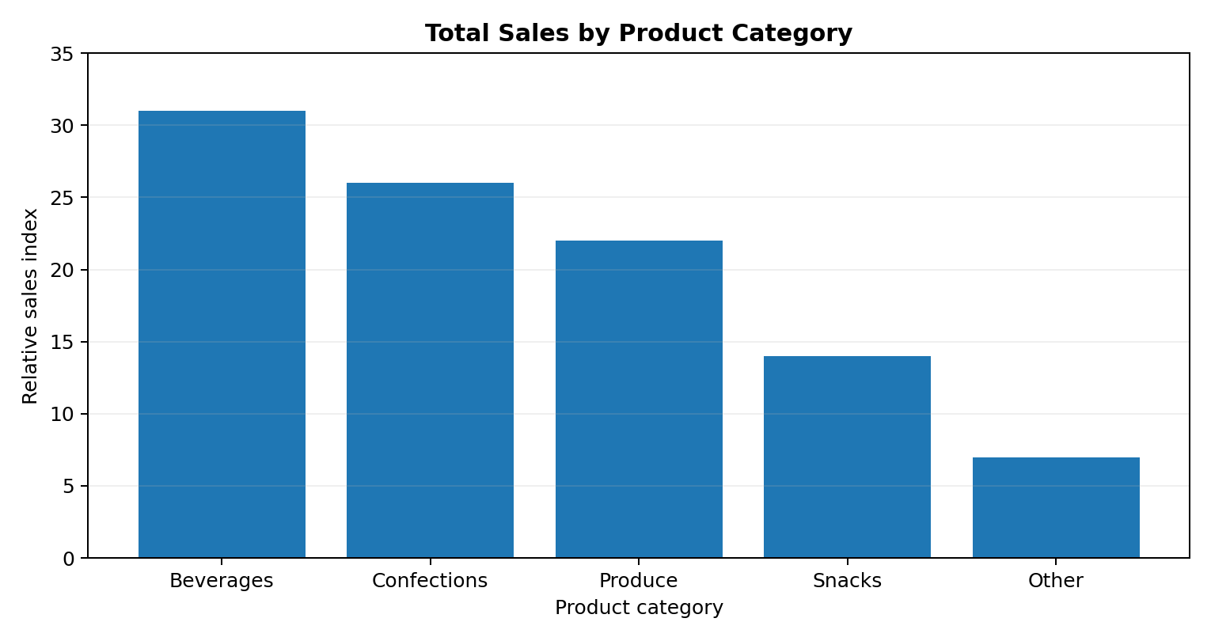
The PBIX column chart uses Total Sales as the measure and Category from DimProduct as the categorical axis. This visualization is appropriate for comparing sales contribution across product categories. The figure above is a clean report representation of that visual structure; the displayed values are illustrative and are not claimed as the underlying PBIX totals.

6. Visualization 2 – Monthly Sales Trend
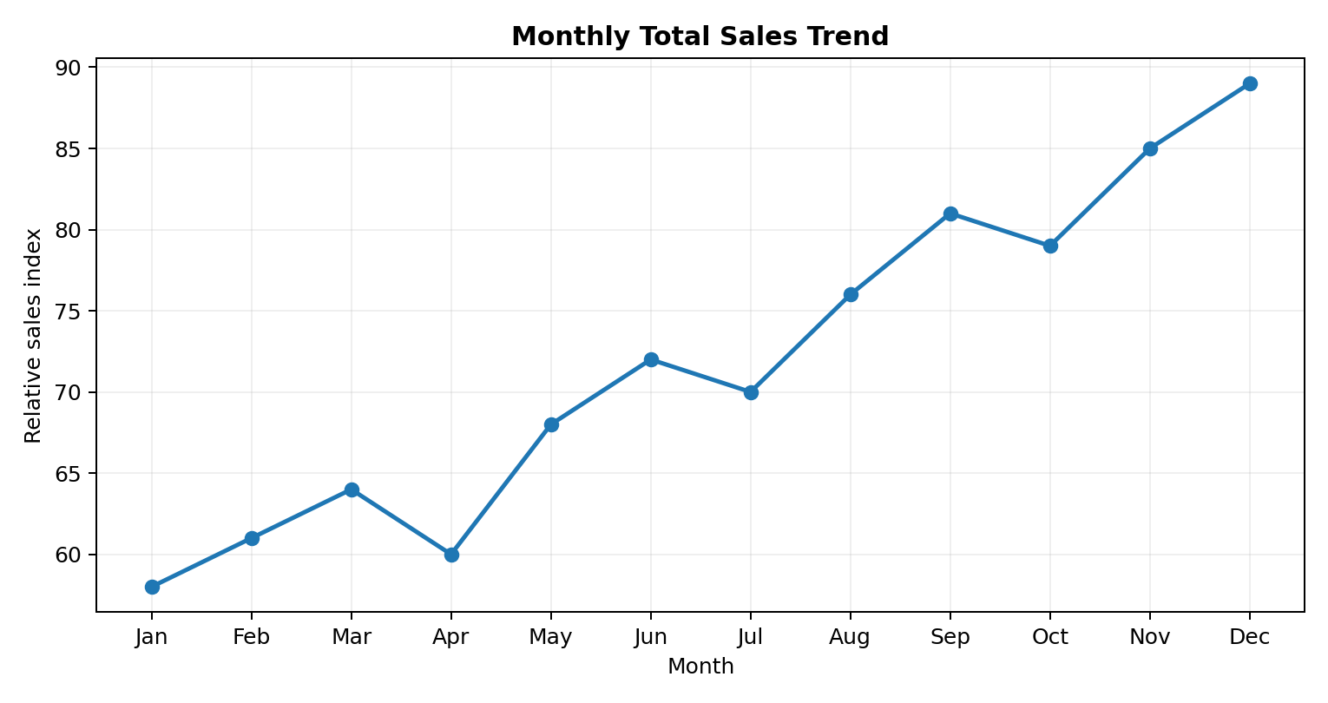
The PBIX line chart uses Total Sales against MonthName from DimDate. A line chart is suitable for observing the direction and movement of sales across months. It can help identify periods of higher or lower sales and provides a natural basis for time-based monitoring.

7. Visualization 3 – Regional Sales Distribution
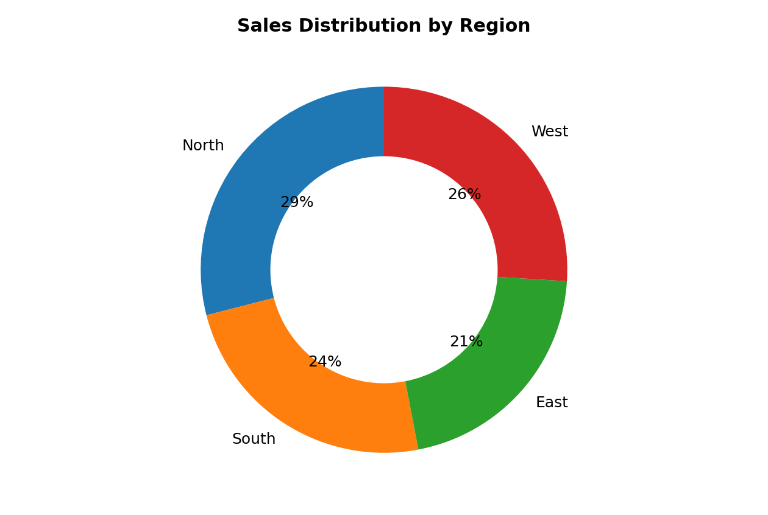
The donut chart uses Total Sales grouped by Region from DimGeography. This provides a part-to-whole view of sales distribution. It is most useful when the objective is to understand each region's contribution to the overall sales total.

8. Visualization 4 – Employee Profitability
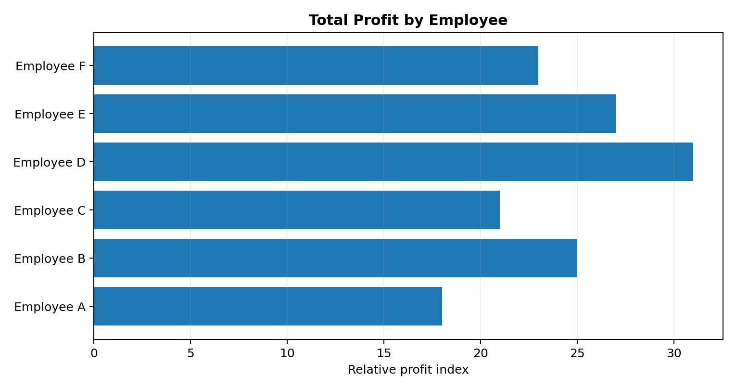
The clustered bar chart compares EmployeeName from DimEmployee against Total Profit. This view supports employee-level profitability analysis and allows users to identify differences in profit contribution within the selected reporting context.

9. Dashboard Filters and Interactivity
- YEAR – filters the dashboard by the selected year.
- CATEGORY – narrows the analysis to selected product categories.
- REGION – focuses the dashboard on a selected geographical region.
Because the dashboard combines these slicers with KPI cards and multiple visuals, users can move from an overall view to a focused business question without changing the report page.

10. Data Model and Analytical Fields
Model component | Fields / measures used by the report
FactSales | Quantity
DimCustomer | Total Sales, Total Profit, Average Sales, Total Cost
DimProduct | Category, ProductName
DimDate | Year, MonthName
DimGeography | Region
DimEmployee | EmployeeName

11. Key Observations
- The dashboard follows a clear KPI-to-detail structure: summary cards are supported by category, time, regional, and employee visuals.
- Total Sales is a central measure and is reused across category, monthly, and regional analysis.
- Total Profit provides a separate profitability perspective, including employee-level comparison.
- The Year, Category, and Region slicers make the dashboard suitable for interactive exploratory analysis.
- The dedicated Sales Tooltip page supports contextual KPI information when users interact with the report.

12. Suggested Enhancements
- Add year-over-year and month-over-month variance measures.
- Add target-versus-actual indicators for sales and profit.
- Add a forecast visual if future-period data or a forecasting model is available.
- Add drill-through pages for product, region, and employee details.
- Include data-refresh date and data-quality indicators.

13. Conclusion
The Week-4 Power BI project demonstrates an integrated approach to sales analytics. KPI cards provide a fast summary of financial and quantity measures, while the visualization page and dashboard add category, monthly, regional, and employee perspectives. Interactive slicers for Year, Category, and Region improve the usefulness of the dashboard by allowing the same report to answer multiple analytical questions.
The visualization-focused design provides a strong foundation for further development through forecasting, targets, variance analysis, and drill-through reporting.

14. References
1. Uploaded Power BI project: WEEK 4 FINAL REPORT.pbix.zip.
2. Microsoft Power BI documentation and dashboard visualization concepts.
3. Report interpretation based on the visual configurations and model fields contained in the uploaded PBIX project.

