**BlackBox1 – Solution**

1. Create an empty .json file named **“config.json”** so the server will be able to be executed.

You can create one by entering: echo > config.json

1. Execute **“server.exe”** and afterwards **“secret.exe”** files on separated **cmd** interfaces.
2. Enter any appropriate input to the **secret.exe** execution, for example:

Enter your username: abcd

Enter your password: 1234

1. 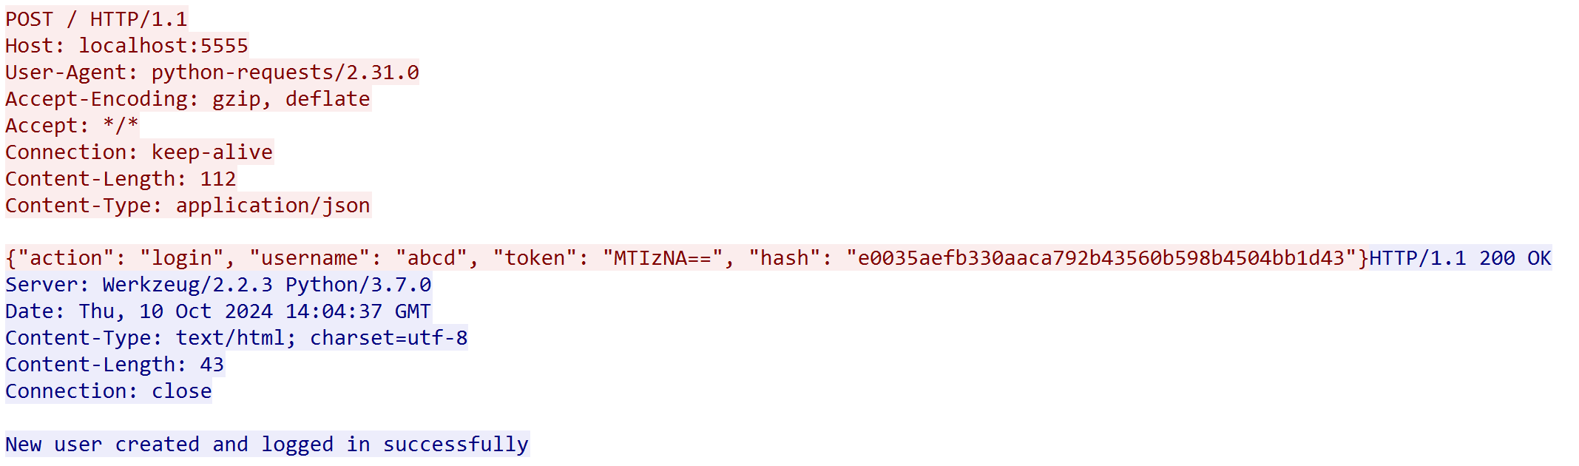Afterwards a packet will be sent to the server, so to track it open **Wireshark** and sniff the packet:

From here we can understand that the client (in red) sends a json format messages to the server with the **“username”** flag that given and some other flags like: **“action”, “token”** and **“hash”**. In addition, to the **config.json** file this data was added:

{"users": [ {"username": "abcd", "token": "MTIzNA=="}]}

Which means that the config file saves users’ details.

1. After writing this script in python:

import base64

def decrypt(encrypted_text):

    # The function gets a string.

    # The function returns the given string after decrypting it.

    return base64.b64decode(encrypted_text).decode()

print(decrypt("MTIzNA=="))

I found that the value “**MTIzNA==**“ which was found on **config.json** and the packet itself under the flag “**token**” is equals “**1234**” which is the password I entered on secret.txt(look at section number 2), so from this it can be concluded that the flag **token** saves passwords.