**Lookup_Documentation**

1. At the beginning, I scan the target’s open tcp top 1000 open ports using Nmap:

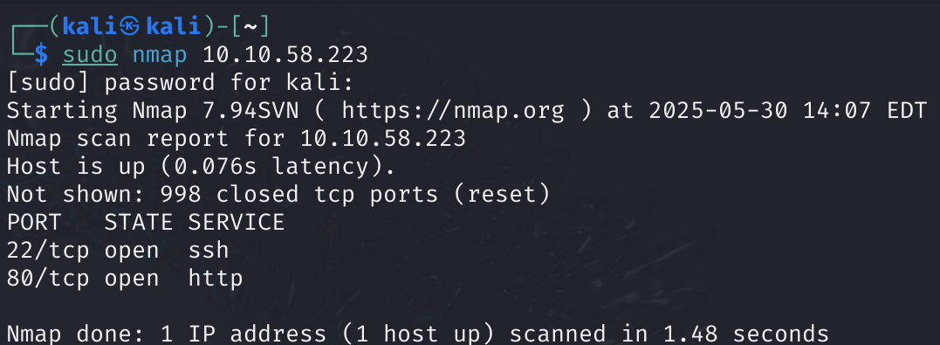

1. I realized that this target has an http open port, so I tried to enter the website. The problem was the domain lookup.thm wasn’t matched to the target’s IP. Therefore, I manually added to my machine’s hosts file the domain with the IP of the target by entering these commands:

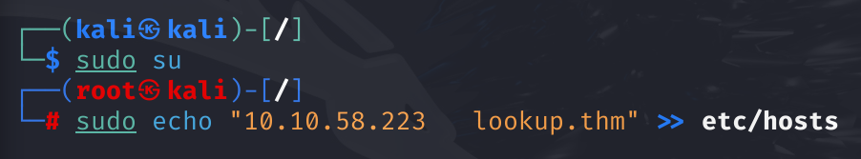

1. After doing that, I opened that website again and this is the main page: