**Neighbour_Documentation**

**Written by: Yuval Quina**

1. So, I began with scanning the target for open ports:

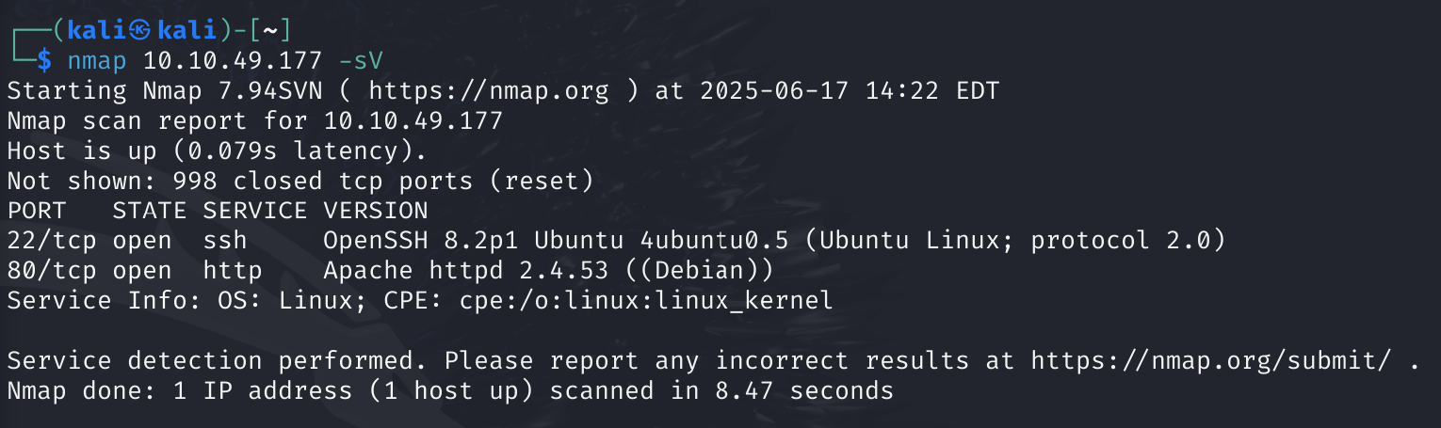

1. I open the website, and this is how it looks like:

תמונה שמכילה טקסט, צילום מסך, גופן, מספר

תוכן בינה מלאכותית גנרטיבית עשוי להיות שגוי.

1. I tried to enter some common credentials (for example: admin, admin) but none of them worked
2. I read the bottom text and clicked Ctrl+u. This shortcut opened the backend code of this page and this is how it looks like:

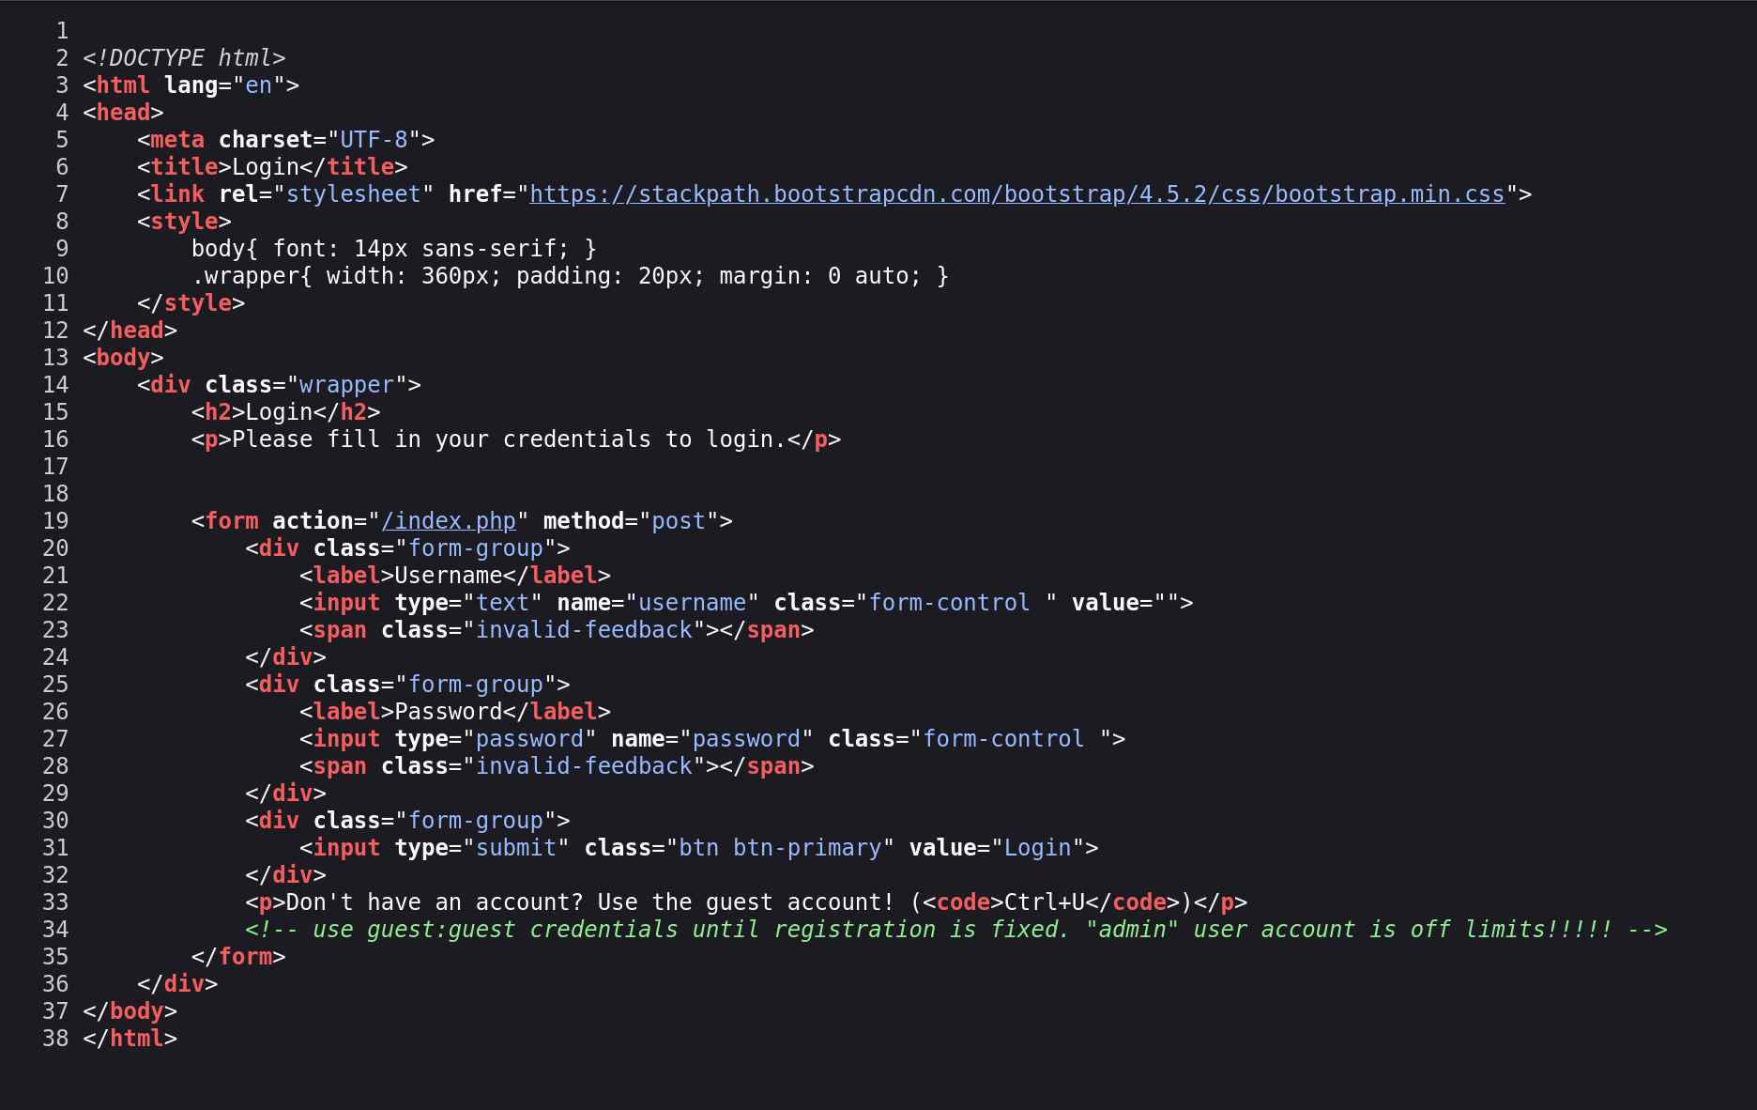

1. I pass over the code and found this note:



1. So, I entered the guest, guest username and password over the login page and this led me to this page:

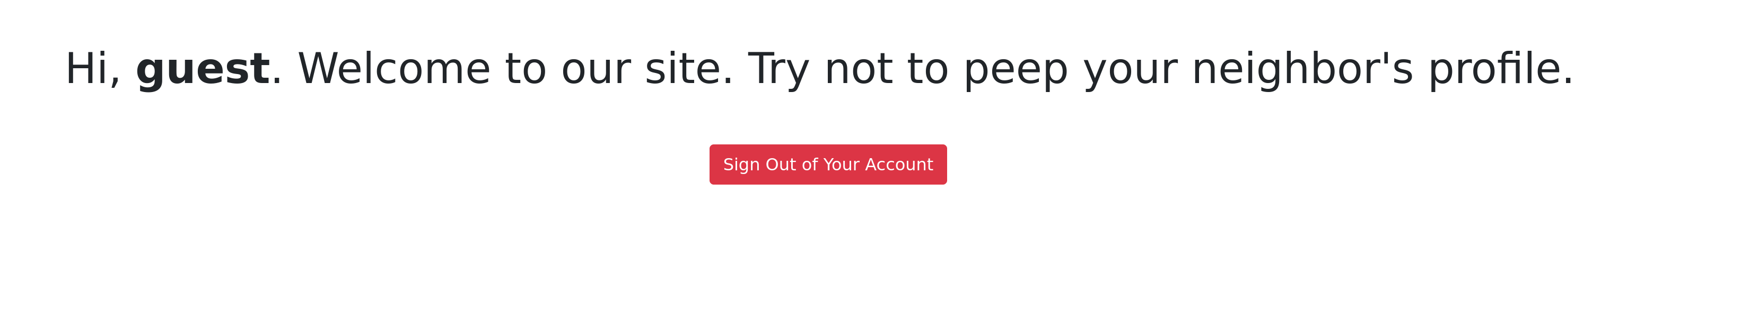

I looked a little at this page and noticed the url:



I tried to replace the user value from “guest” to “admin” and I found the flag!

