**TakeOver_Solution_Documentation**

1. So, I began this CTF by inserting the domain “https://futurevera.thm” to the /etc/hosts file with the IP of the machine target in order to access the website:

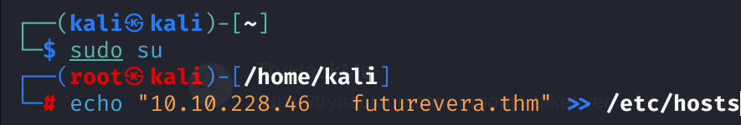

1. Afterwards, I used the gobuster tool in order to enumerate subdomains of this domain using this command: