Wonderland_Solution_Documentation
Written By:
I started this challenge by scanning open ports and services using Nmap:
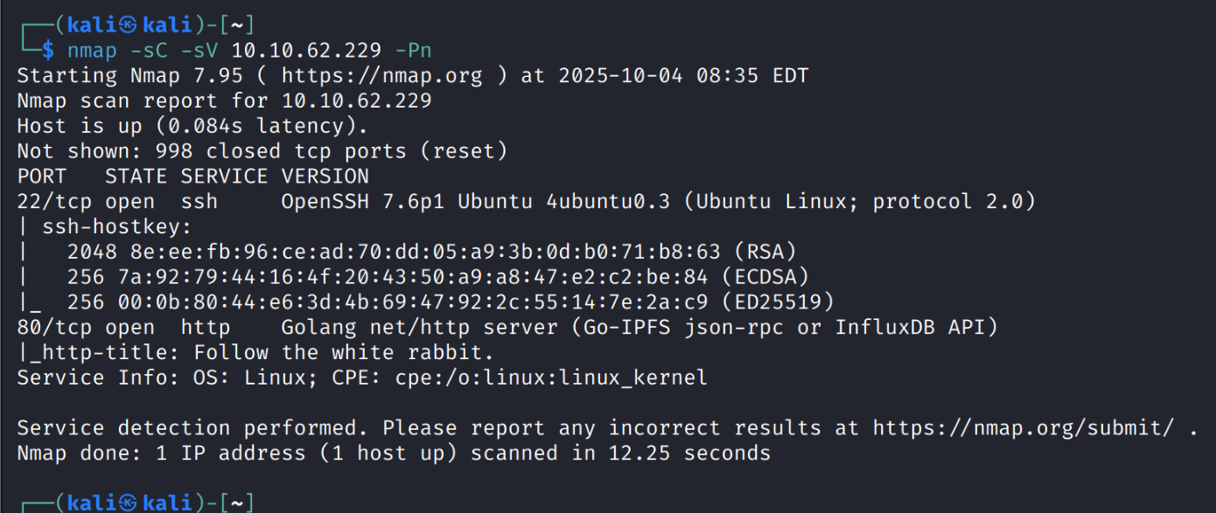
Immediately after I noticed the open 80 port, I executed a directory enumeration attack over the target website using “Gobuster” tool:
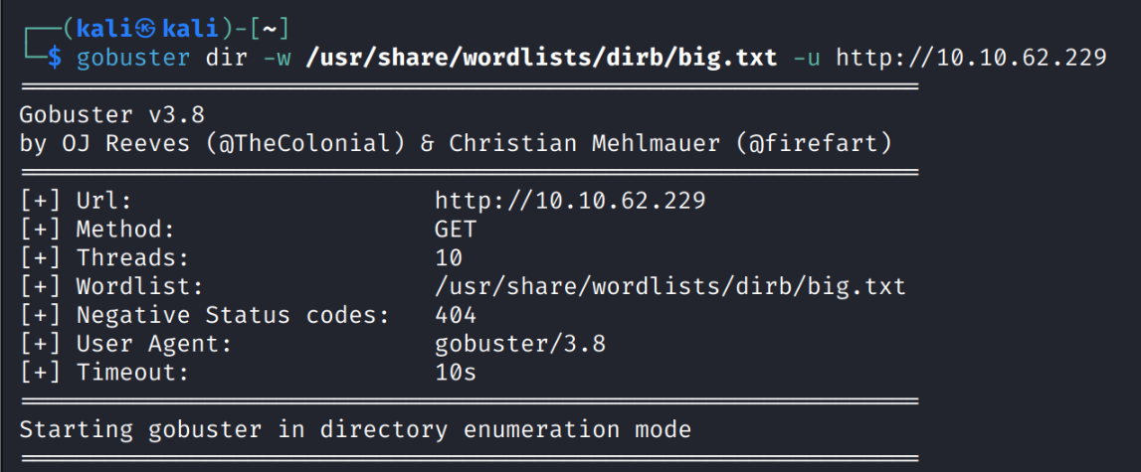
Afterwards, I entered the website itself:
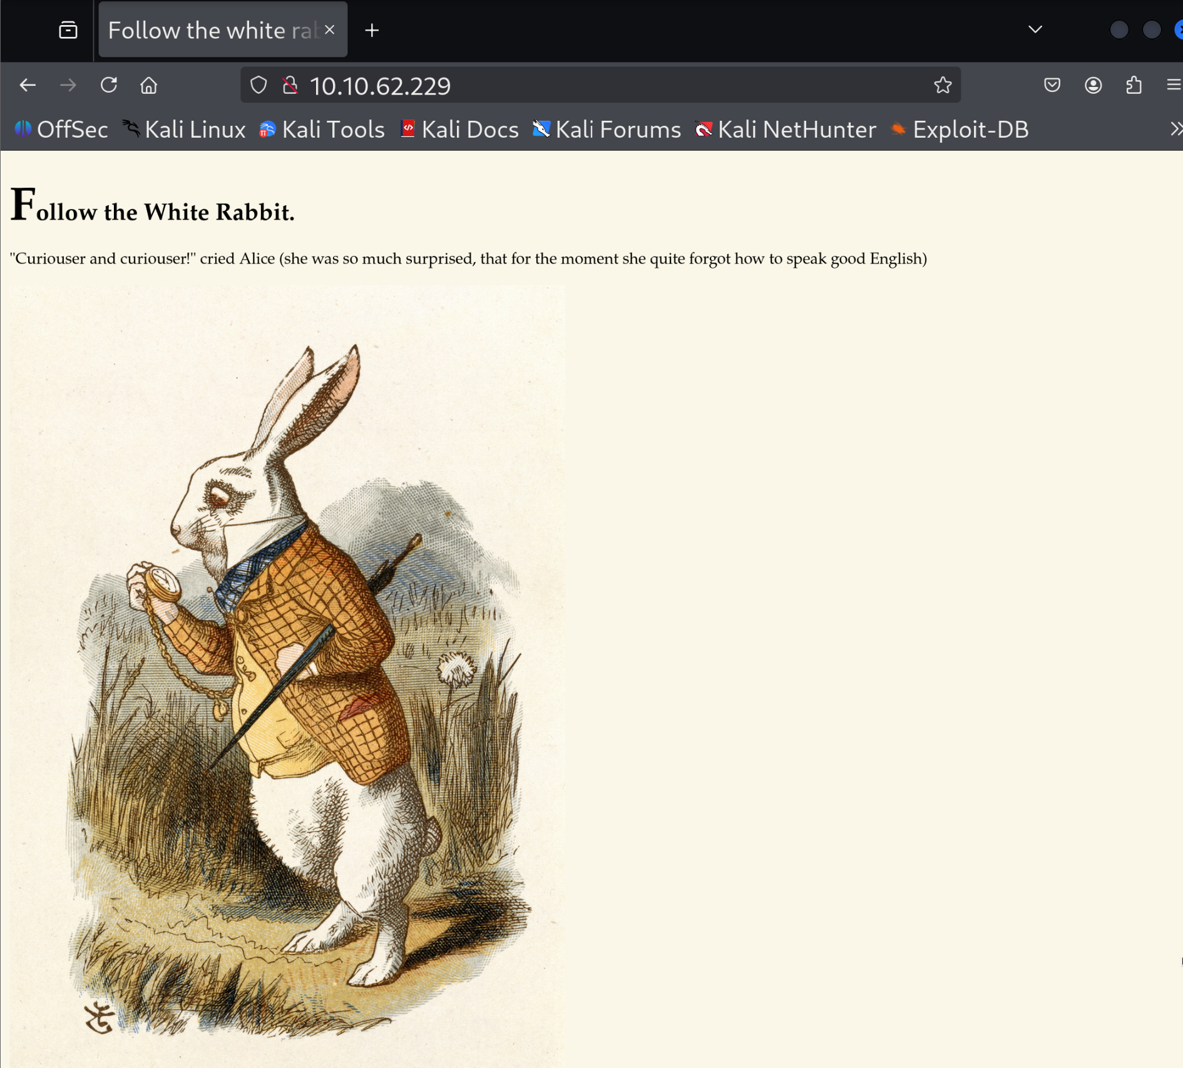
I tried to open the inspector, and I found that the image on this page is stored on a directory “/img” as well as the gobuster detected. I tried to open it and there I found 3 images:
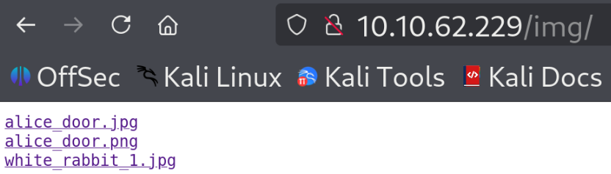
I opened these 3 images, but nothing seems to be suspicious.
At this point, I tried also other directories that gobuster found:
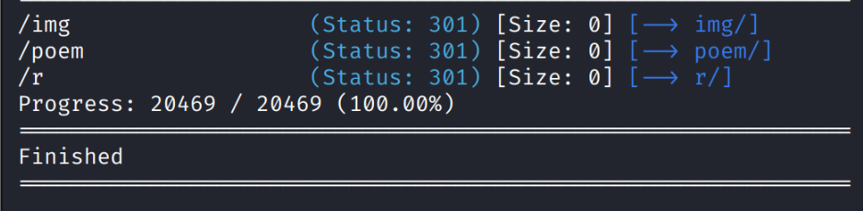
/poem:
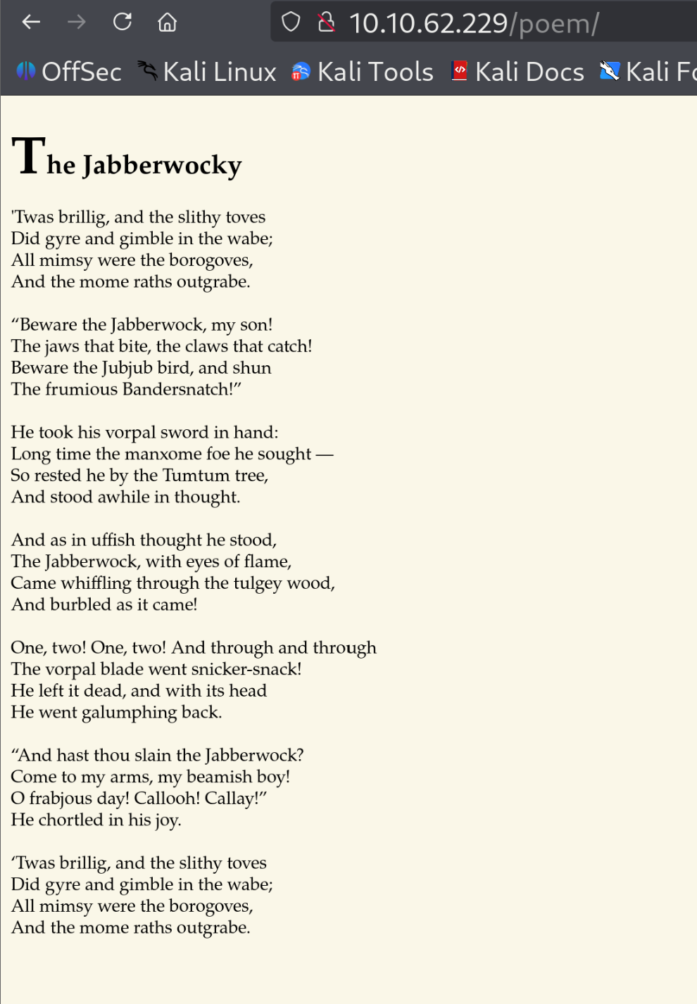
On this page I found nothing.
/r:
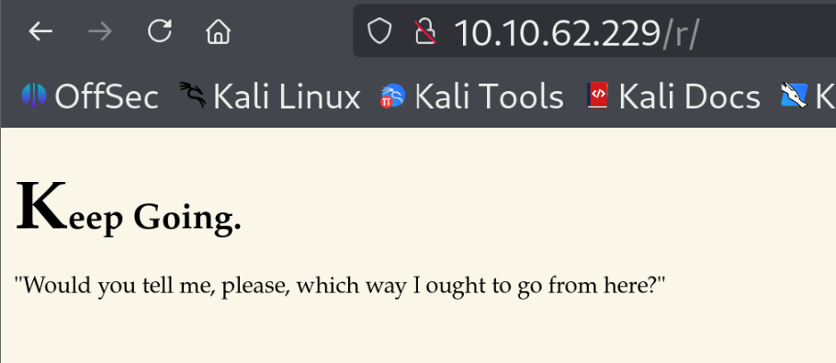
Here I found on the tab’s name the statement “Follow the white rabbit.” This led me to return to the images of the white rabbit. I downloaded them using wget:
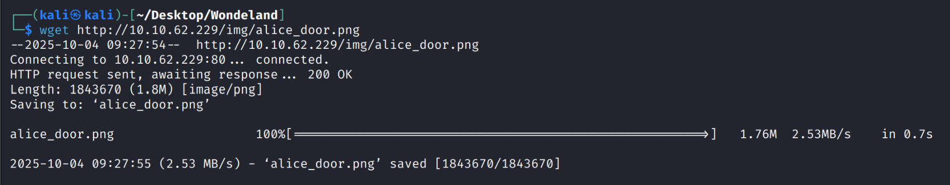
And I saved them on a directory named “Wonderland”.
When I opened the images, I immediately thought that probably one of the images is hiding a secret message using steganography. So, I used the tool “steghide” to find the secret message over the images (despite the fact that I don’t have any passphrase):
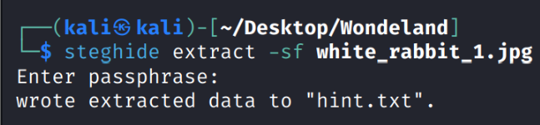
I found that the “white_rabbit_1.jpg” file contained the secret message “wrote extracted data to hint.txt” so I opened this file and found this message:
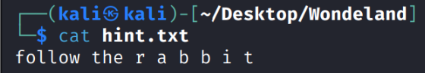
Here I got to a sort of end point because I didn’t know how to continue from this stage.
It took me several minute to discover that the “/r” directory is only the letter “r” in its name so maybe there are sub-directories inside /r with other letters which complete the sequence to “rabbit”. This theory actually fit the clue from the hint.txt where the word “r a b b i t” was split with spaces between each character. So, I added the “/r” directory the “/a” subdirectory and suddenly a new message was raised:
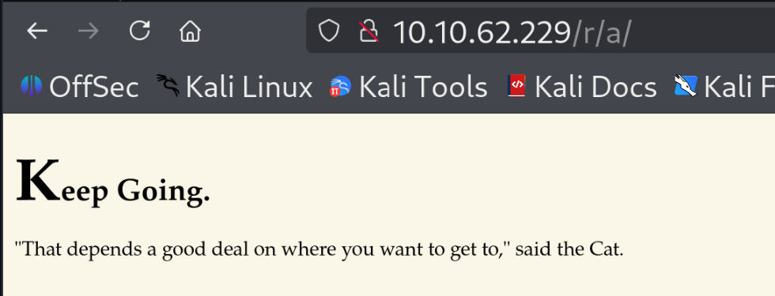
Then I kept adding the other letters:
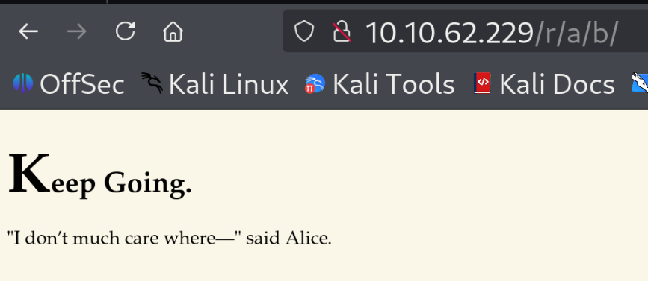
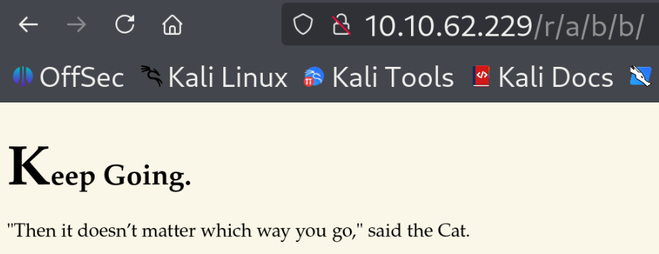
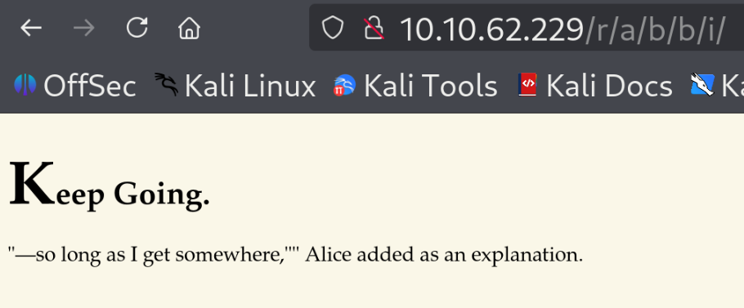
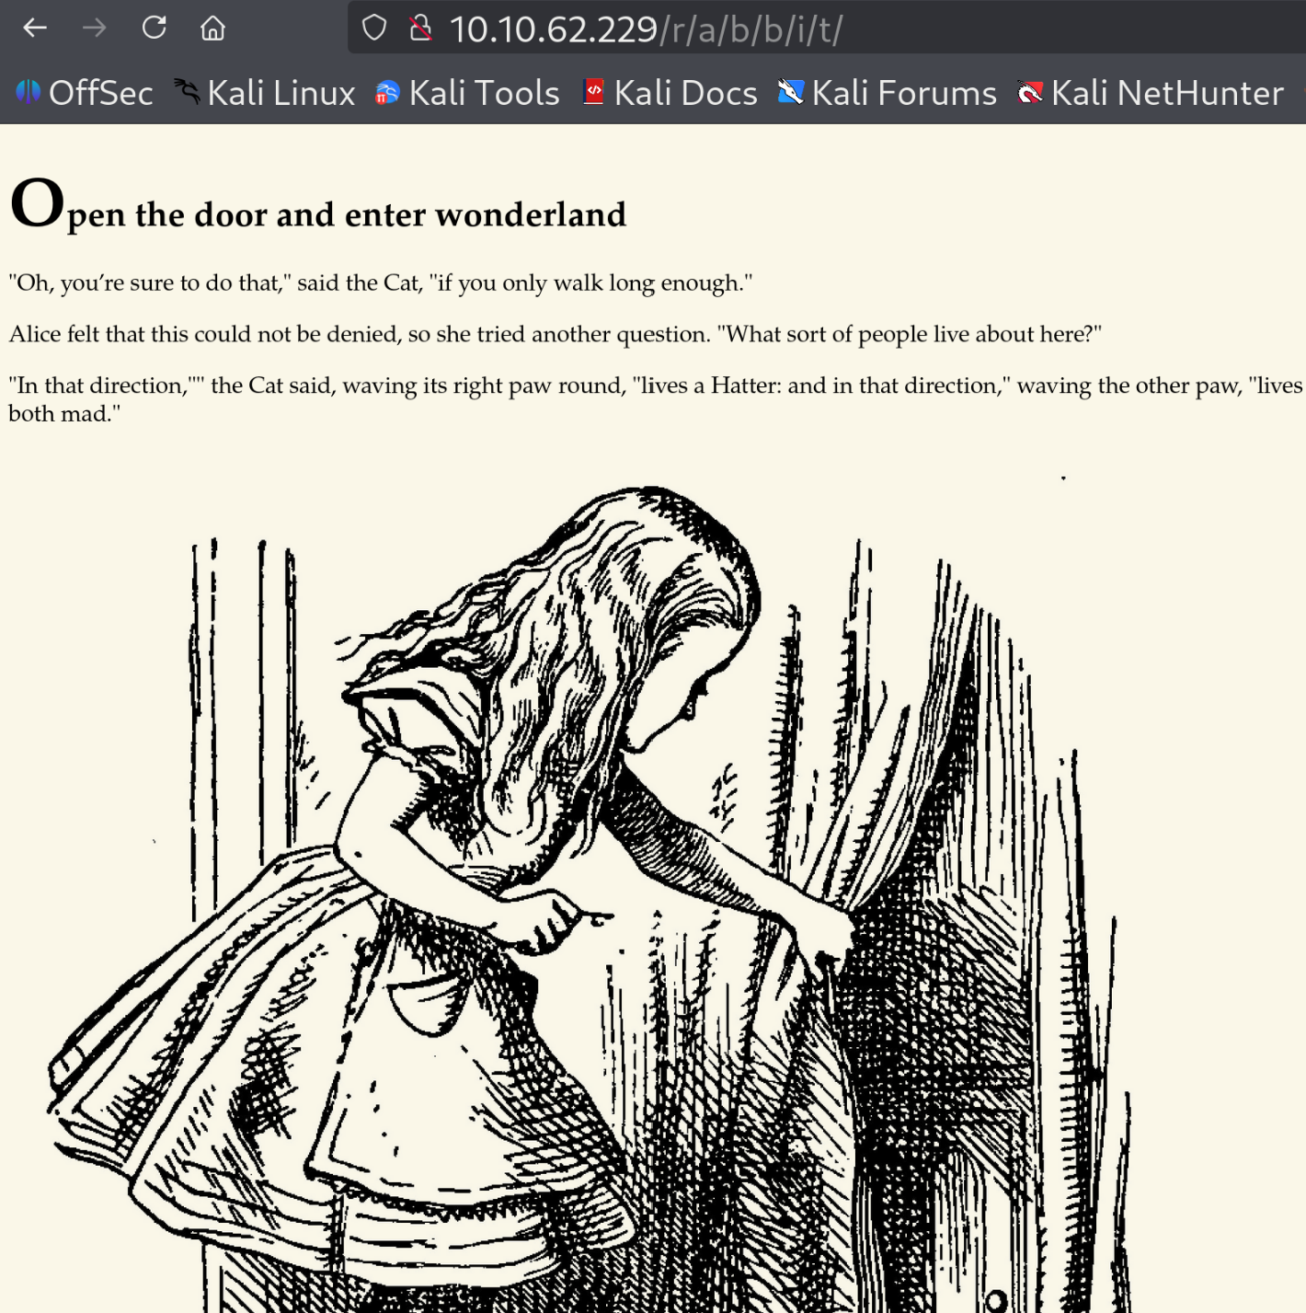
Here I read the text and opened the inspector, and I found this message:
