Byp4ss3d_solution_documentation
Written by: Yuval Quina
I began this challenge by opening the target’s website:
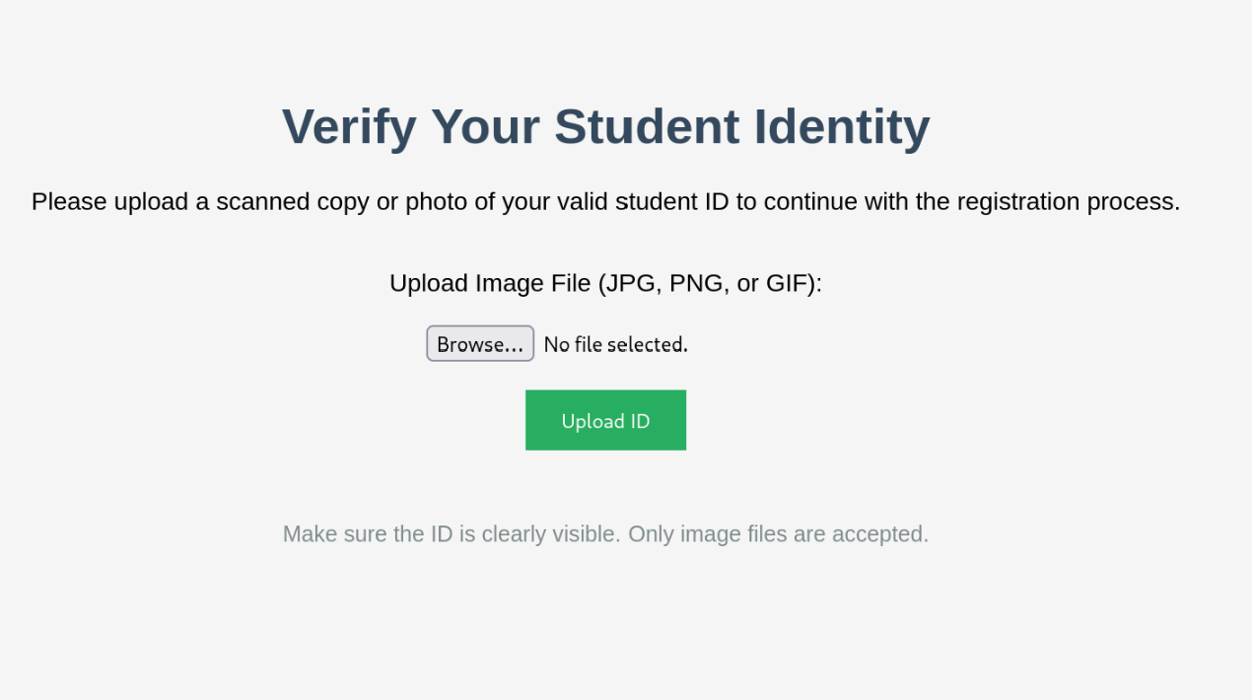
Here I noticed this student id image uploader. I thought to myself that probably there is a way to get a rev shell over the target machine.
I started by examining the results of uploading regular image:

Then, I moved to uploading an unsupported file format:
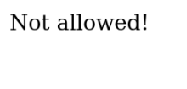
Afterwards, I scan for other directories on this website using Gobuster:
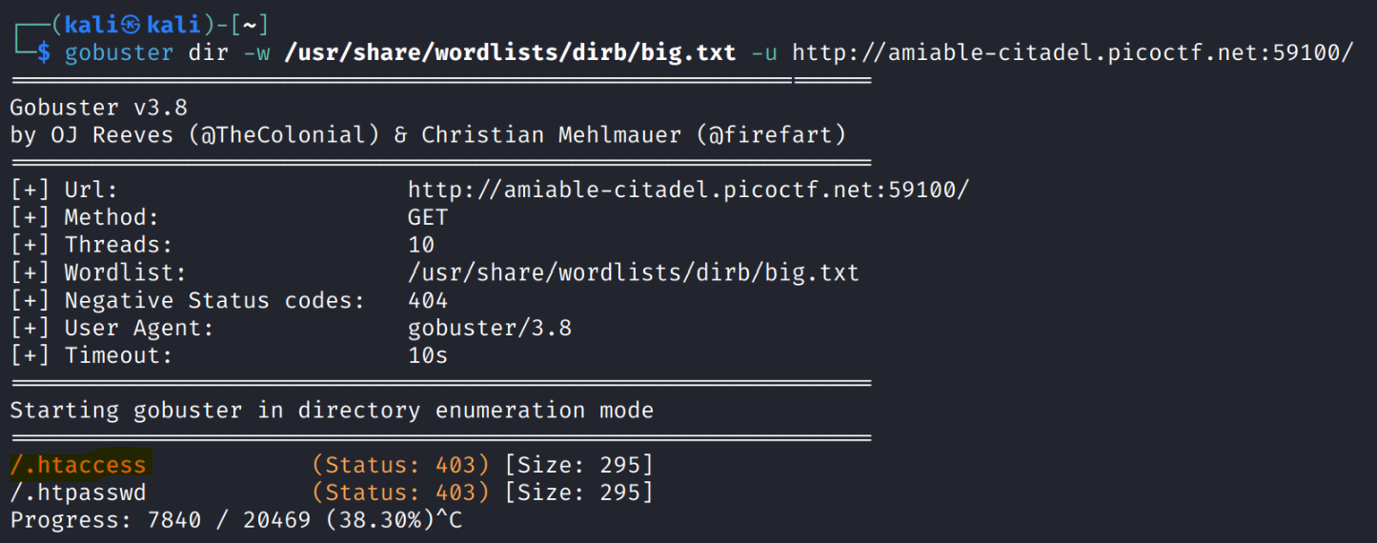
Here, I found this the “/.htaccess” directory, which belong to Apache servers. The first hint noticed me that with this file can execute non php files as php ones.

So, I created a fake .htaccess file that will treat .png files as .php files:
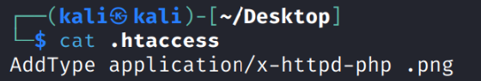
Then, I created this php reverse shell covered file:
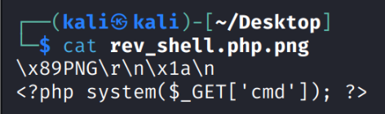
Afterwards, I uploaded both and run command at the rev shell via the “cmd” flag in the url:
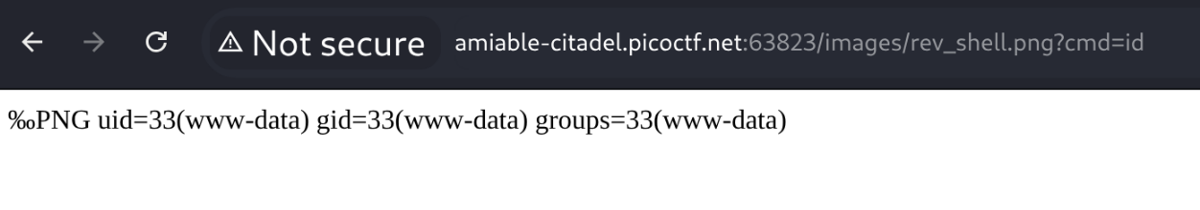
Then I searched for the flag file and I found it on “/var/www”:
