Retro Solution Documentation
Written By: Yuval Quina
I started this challenge be performing a Nmap scan over the target:
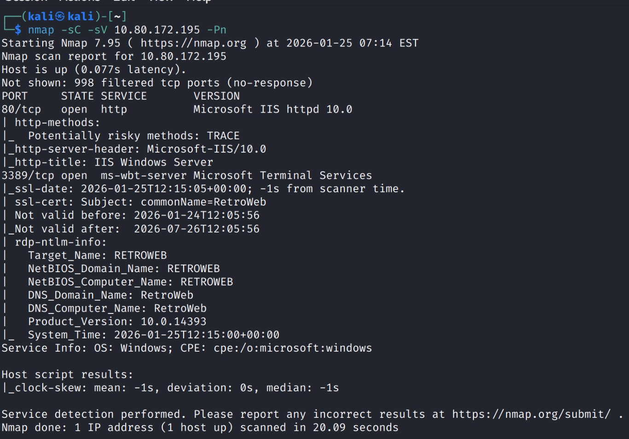
While reading the results, I found the open ports 80 and 3389.
The next step was to conduct a Gobuster directories enumeration over the Website on port 80:
I found the directory “/retro” and I opened it on my browser:
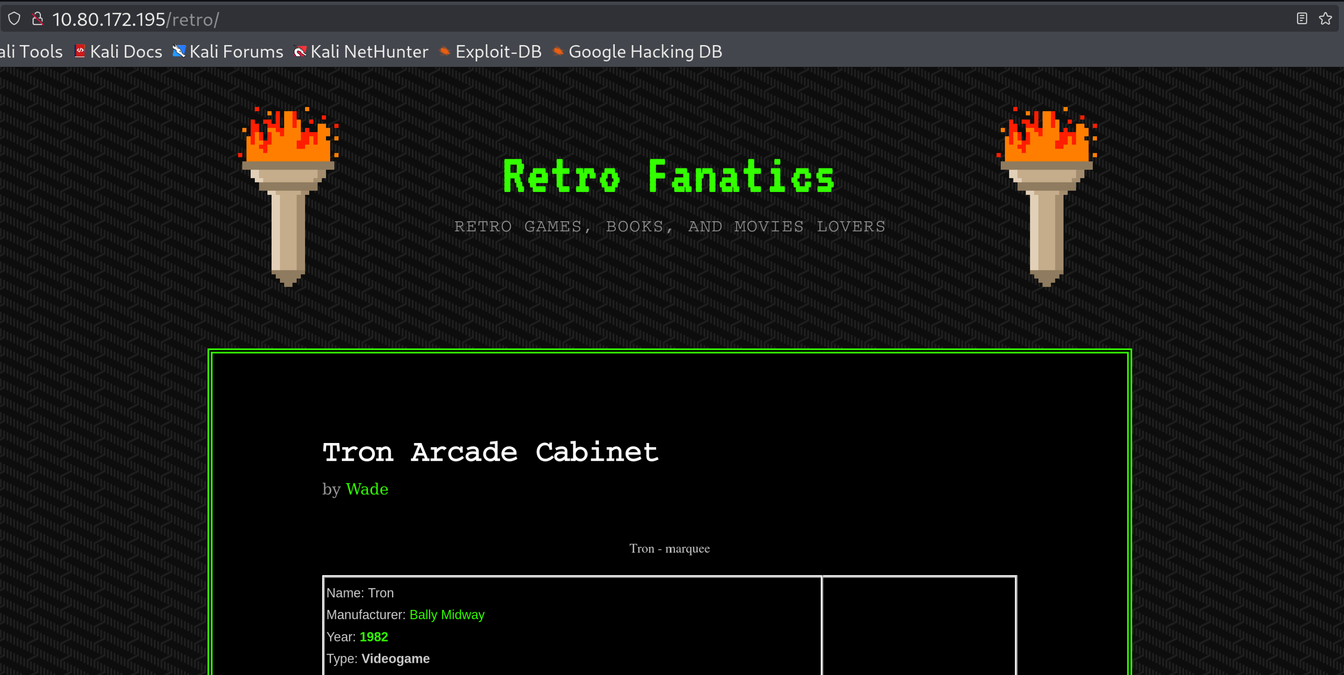
I read a bit the posts that were shown on this page in order to find some clues. I found that all the posts were written by the same user named “Wade”

