Pyrat Solution Documentation
Written by: Yuval Quina
I started this CTF by performing a Nmap scanning over the target:
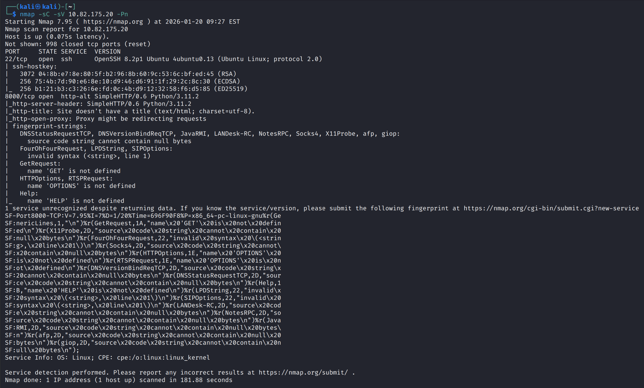
I noticed here that port 8000 is open, so I tried to connect to it via my browser, and I faced with this message:
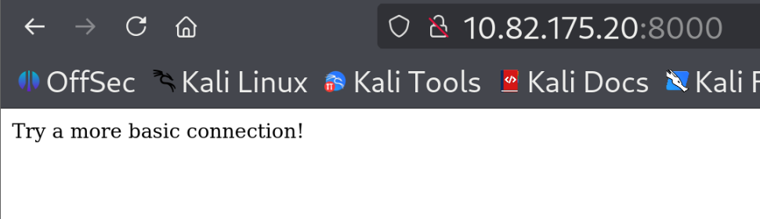
At this moment, I shifted to another way of connection. I looked again at the Nmap results and found that the target has a Python SimpleHTTP module version is 0.6. This version is vulnerable to the vulnerable to CVE-2022-35411. This allows us to exploit Remote Code Execution using pickle.

I found on GitHub this exploit to the vulnerability: https://github.com/fuzzlove/CVE-2022-35411/blob/main/rpc-exploit.py

