RootMe_Solution_Documentation
Written by: Yuval Quina

I started this ctf by performing an Nmap scan:
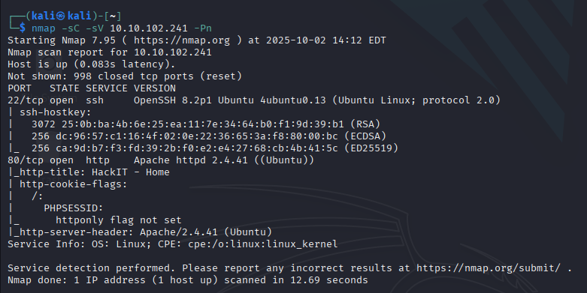
Then, I entered the target’s website:
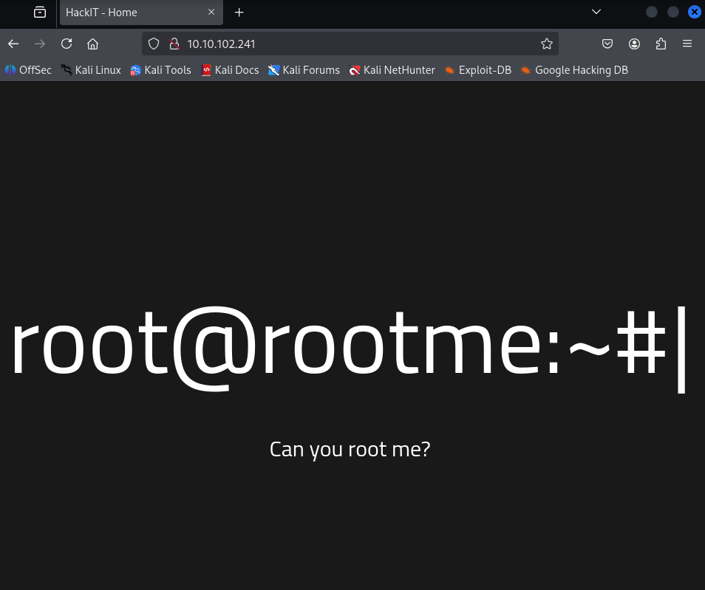
I opened the inspector and found nothing. Then, I enumerated directories using gobuster:
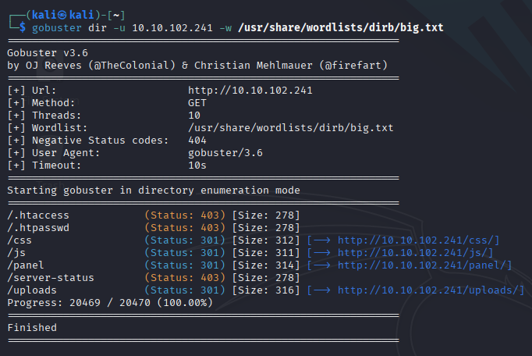
I tried the /panel:
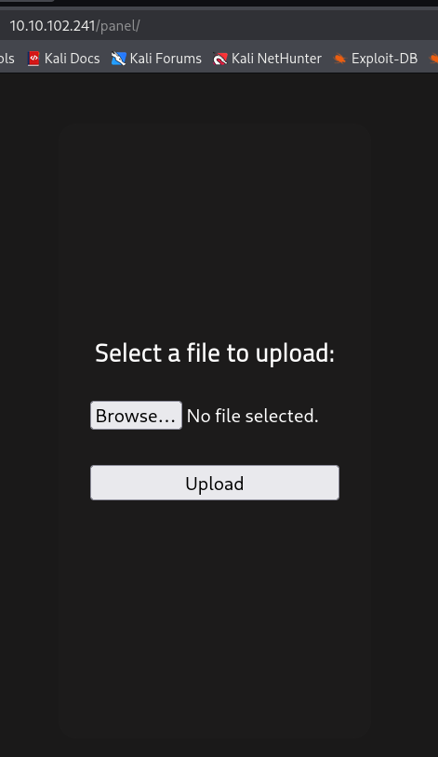
I saw here an upload page. I concluded that it probably possible to upload some malicious files here that can allow me to get a rev shell over the target. I wrote this .php file and tried to upload it:
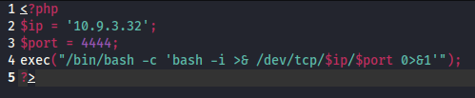
But I faced with this error message:
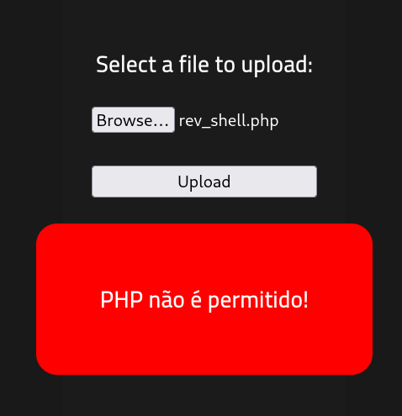
At this point, I started investigating ways to upload this file despite the forbidden extension.
I thought to maybe change the extension from .php to .php5. This solution actually worked the and the file successfully uploaded:
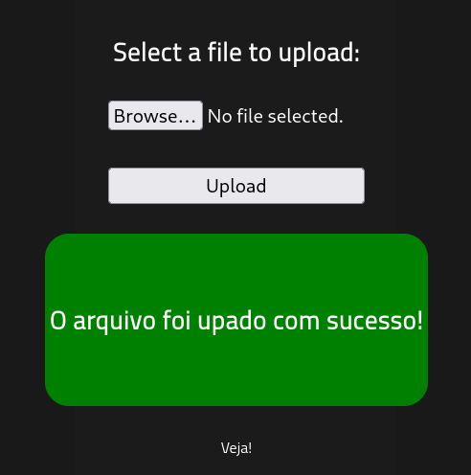
In order to run the file I entered the /uploads directory and clicked on the file:
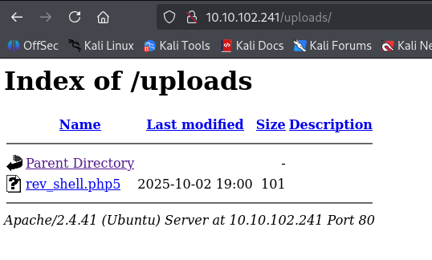
And fortunately, I got reverse shell over the target:
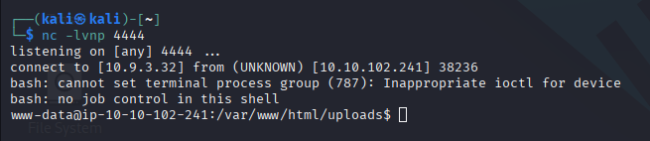
* Notice: I run the command “nc -lvnp 4444” before running the rev_shell.php5 file so my machine will listen to the reverse shell request.”

