Corridor Solution Documentation
Written By: Yuval Quina
I started this challenge by executing a Nmap scan:
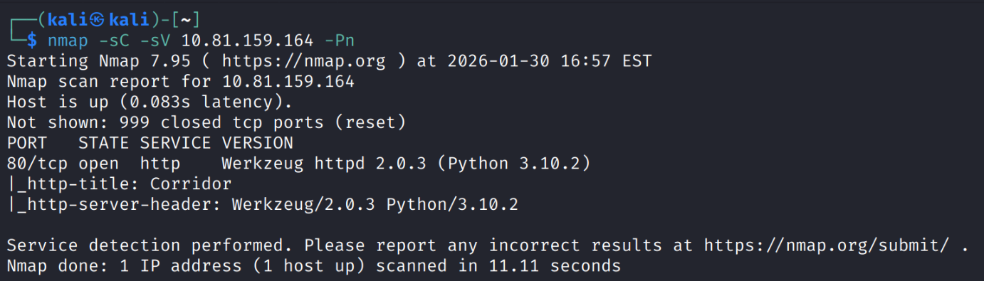
I found port 80 as open, so I connected to the target’s website:
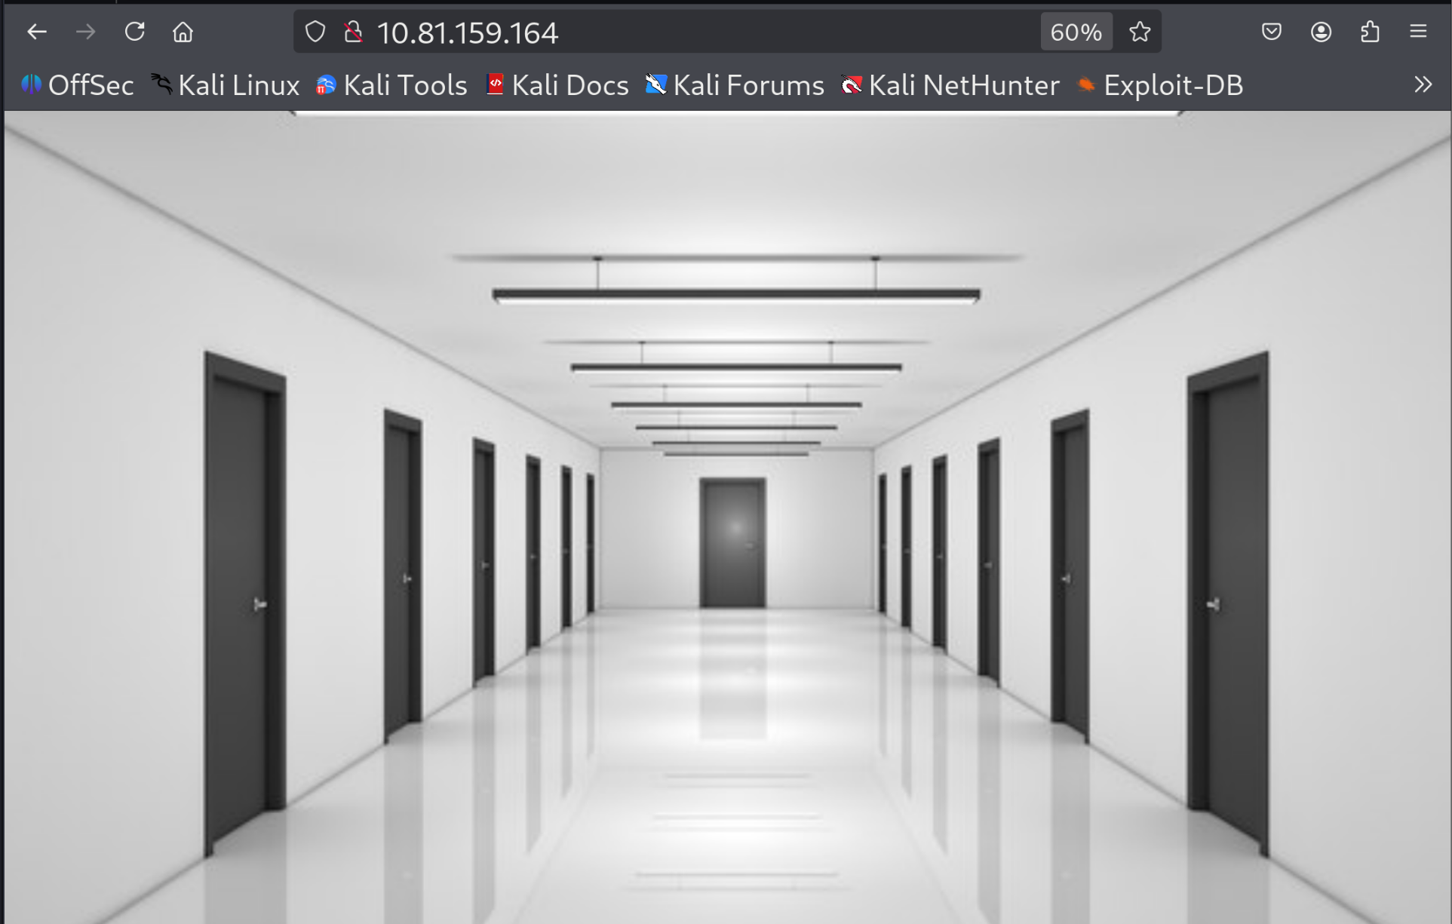
I saw nothing else than this image of a corridor. At this point I started investigating several other ways to continue.
I checked the inspector and found there a map object with multiple areas which each area represents a door in the image and that each door leads to a different link:
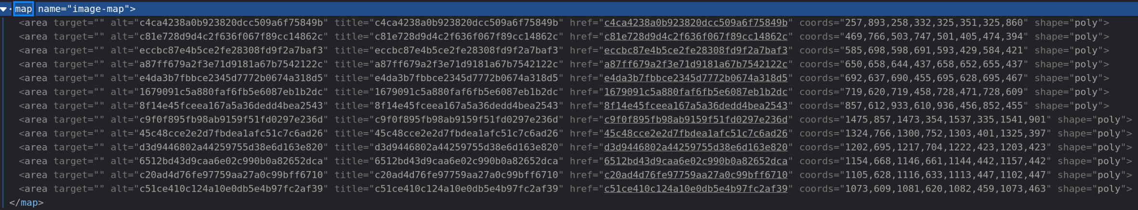
Therefore, I entered each door and found just an image of an empty room:

I felt a little stuck after discovering that each door leads to this image, so I thought to maybe check if these values have an existing common decryption in a database of hashes decryptions values. I used this website for this task https://crackstation.net/
And the results where that all these values have a decryption in MD5 to 1 – 13 in ascending order:

c4ca4238a0b923820dcc509a6f75849b -> 1
c81e728d9d4c2f636f067f89cc14862c -> 2
eccbc87e4b5ce2fe28308fd9f2a7baf3 -> 3
a87ff679a2f3e71d9181a67b7542122c -> 4
e4da3b7fbbce2345d7772b0674a318d5 -> 5
1679091c5a880faf6fb5e6087eb1b2dc -> 6
8f14e45fceea167a5a36dedd4bea2543 -> 7
c9f0f895fb98ab9159f51fd0297e236d -> 8
45c48cce2e2d7fbdea1afc51c7c6ad26 -> 9
d3d9446802a44259755d38e6d163e820 -> 10
6512bd43d9caa6e02c990b0a82652dca -> 11
c20ad4d76fe97759aa27a0c99bff6710 -> 12
c51ce410c124a10e0db5e4b97fc2af39 -> 13

I thought a little bit more what to do with this information and I consider maybe checking if md5 hash of “0” or “14” can lead me to an existing endpoint that is not in the map.
I tried to hash “0” with MD5 and the result is “cfcd208495d565ef66e7dff9f98764da” and when I tried this endpoint it actually worked! not only that, but I also found the CTF’s flag in this endpoint!
