Smol Solution Documentation
Written By: Yuval Quina
I started this CTF by performing an Nmap scanning:
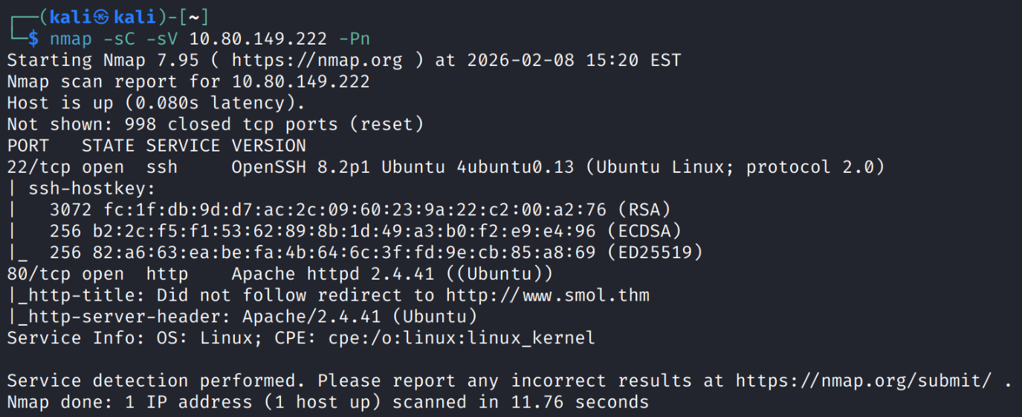
I notice that ports 22 (ssh) and 80 (http) are open, which means the target runs a website and that I can afterward get a ssh shell over the target’s machine.
In addition, I found the domain of the target “smol.thm” from the description of the Nmap scan results, so I added it to the hosts file of my machine:
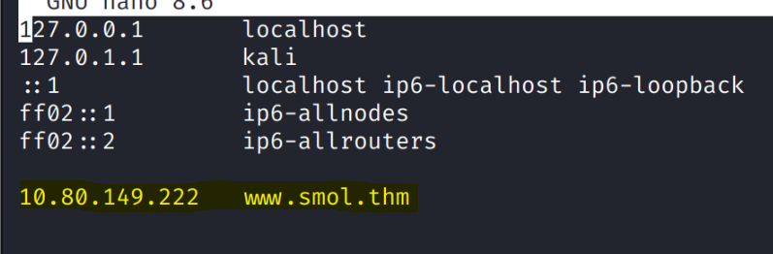
Then, I accessed the website:
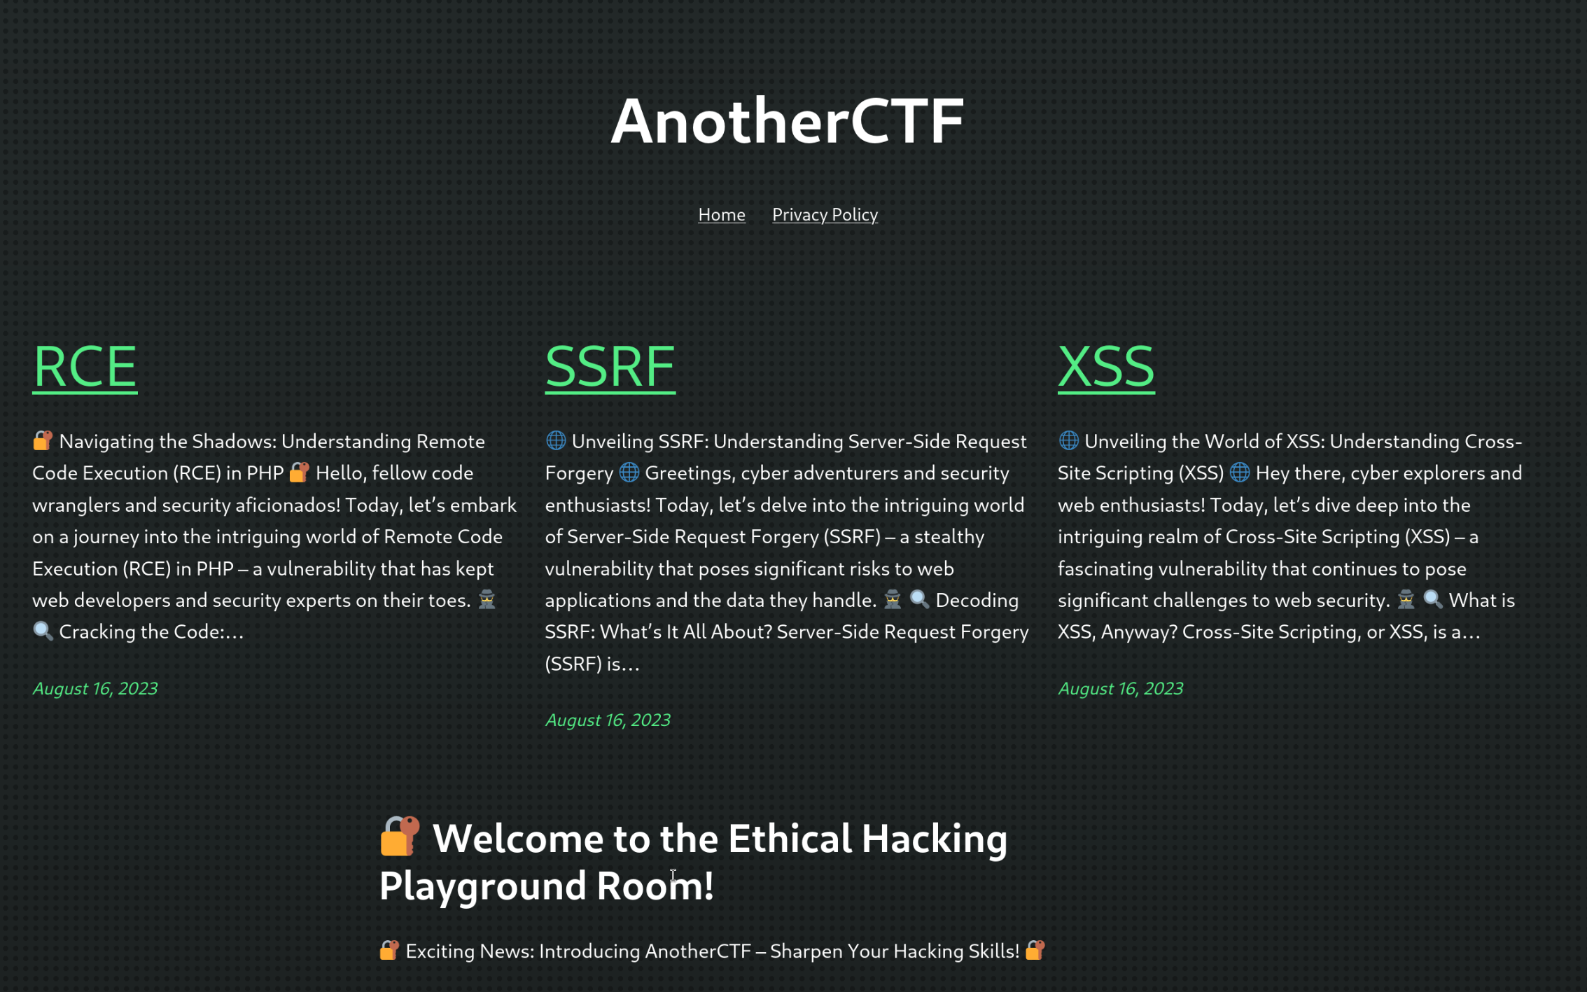
I briefly looked through the website and clicked on the “Privacy Policy” link. This took me to the privacy policy page (with the endpoint “/index.php/privacy-policy/”):
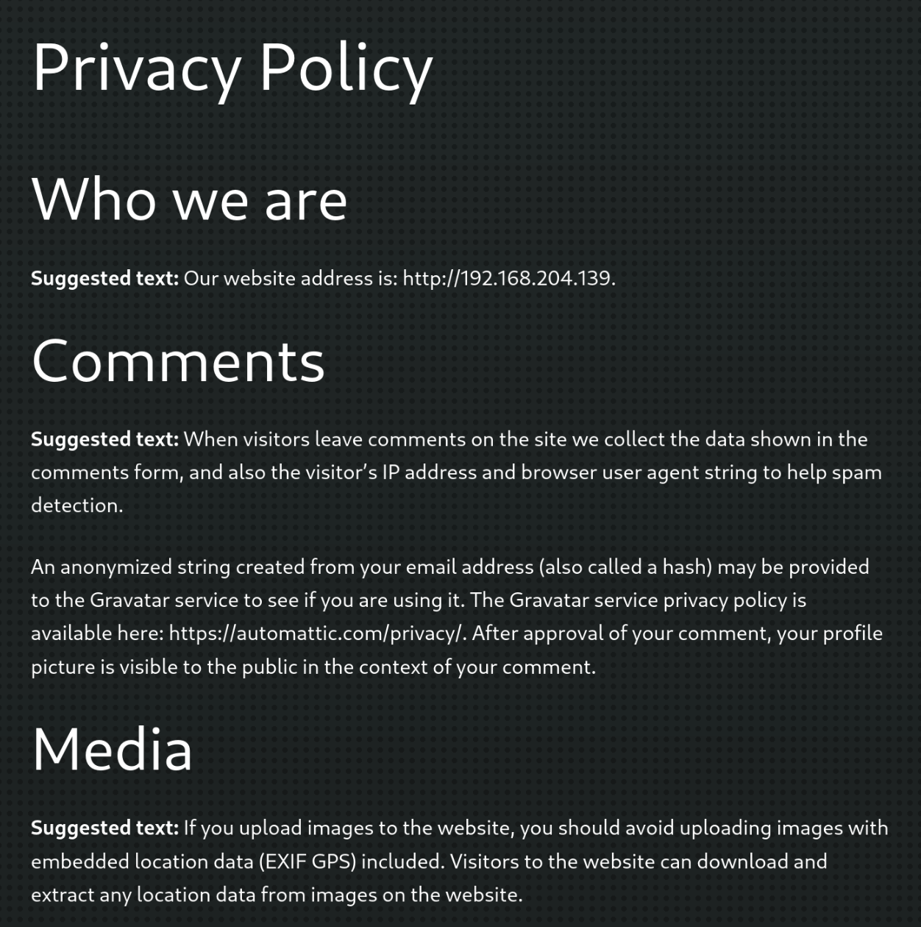
I read a bit the paragraphs and notice several suspicious clues here:
First of all, I saw that the writer leads me to a website that runs on “192.168.204.139”.
Second, in the “Comments” section, it was written that there is a string of a hash which is being provided to the “Gravatar” service which can be vulnerable.
In addition, in the “Media” section, the writer mentioned that we ,as users, “should avoid uploading images with embedded location data (EXIF GPS) included” due to the reason that other users can download the images. This warning actually raised a red flag to me because it describes a situation where I can try to execute an RCE attack over other users.
At this point, I clicked on the “RCE” post and scrolled to the bottom in order to see the comments:
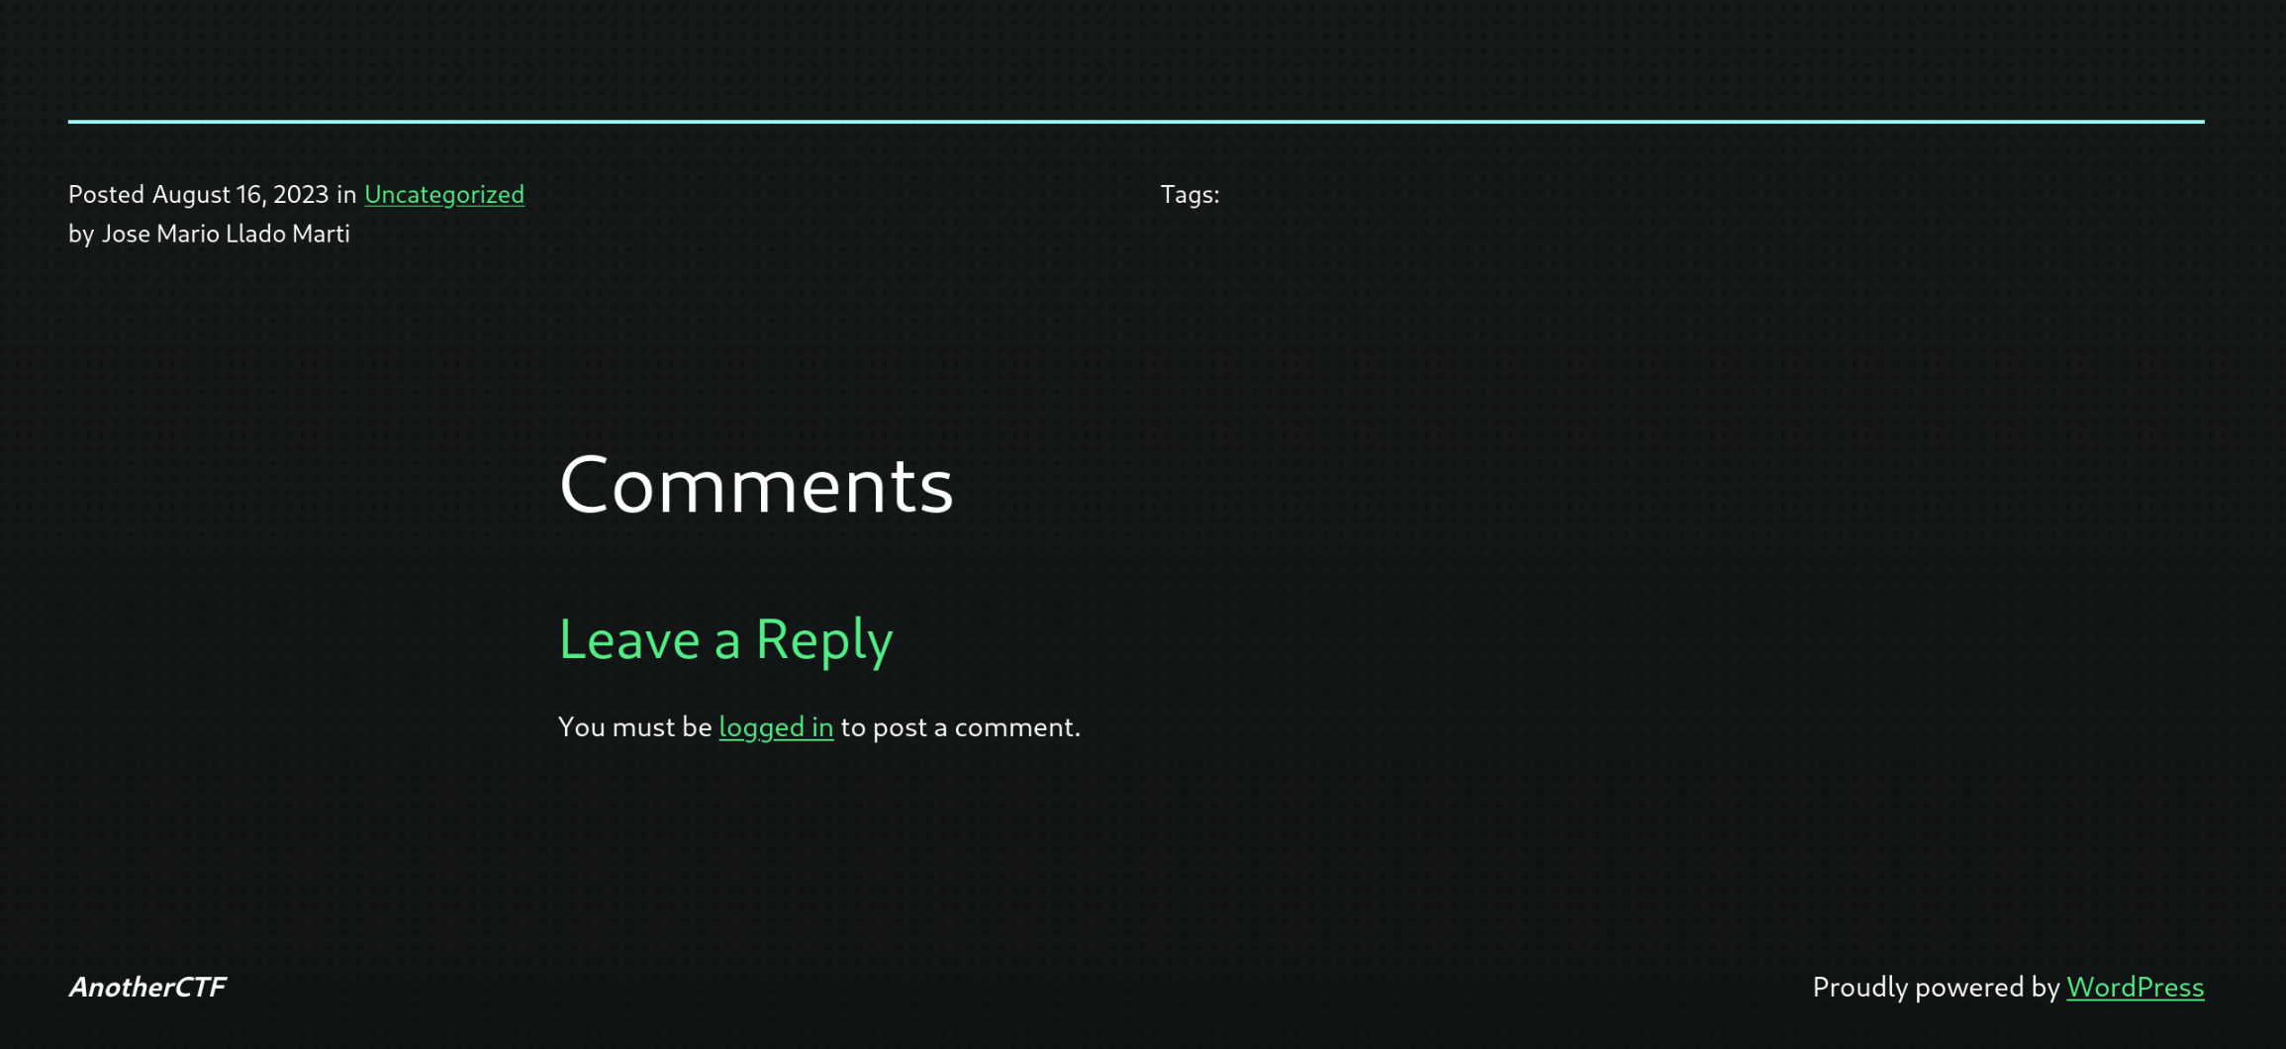
I saw here a “logged in” link and I clicked on it:
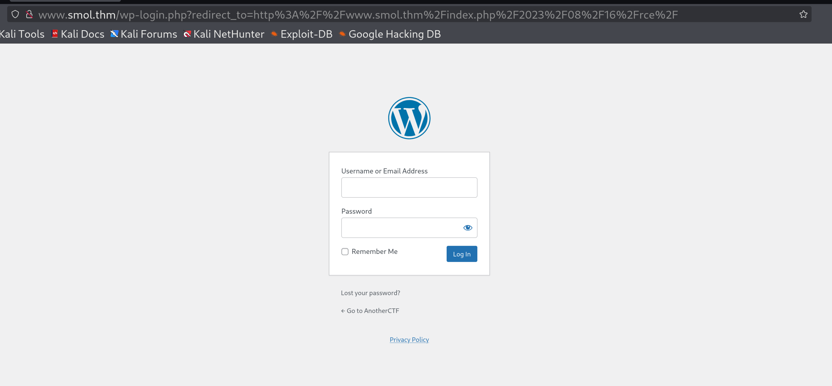
And I was faced with a WordPress login page. I tried to enter fake credentials “test”, “test” to examine the login reaction and I got this error message:
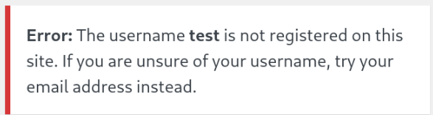
According to this reaction, I understood that the server first of all check if the user exists or not before checking the password so I can use it to perform a username bruteforce using this python script that I wrote:

