Fortress_Solution_Documentation
Written by: Yuval Quina
I began this challenge by adding to my hosts file the ip of the target’s machine and the domains which are associated with it:
I checked that it worked by pinging these domains:
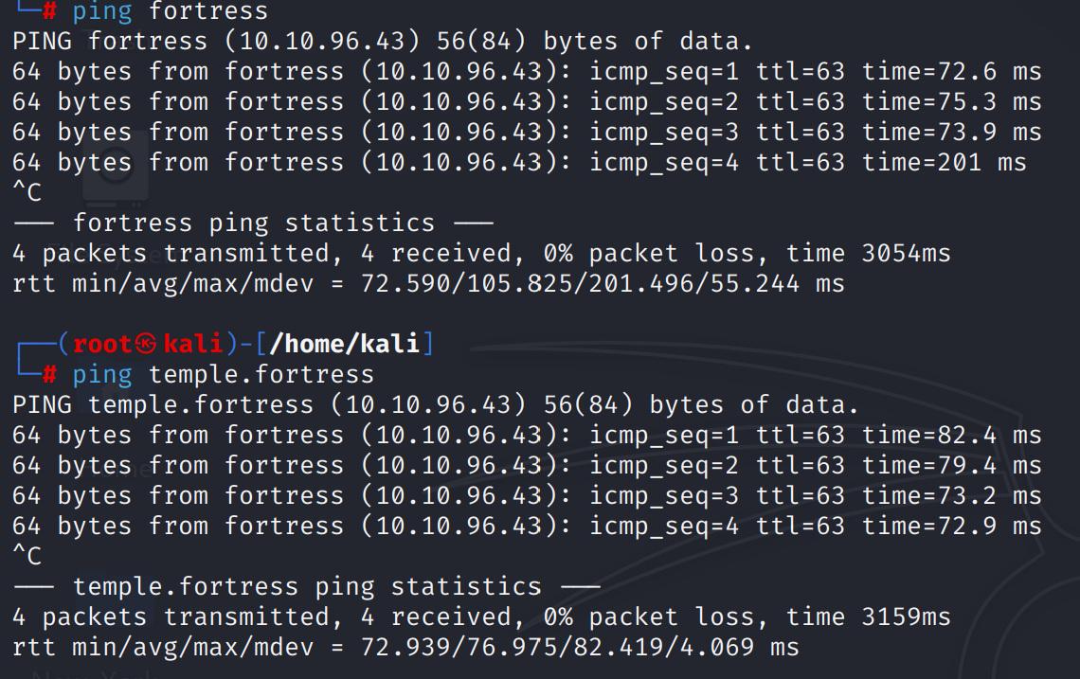
Now, I performed a ports and services scan using Nmap (Note: this scan took me a lot of time because I run it over all the tcp ports):
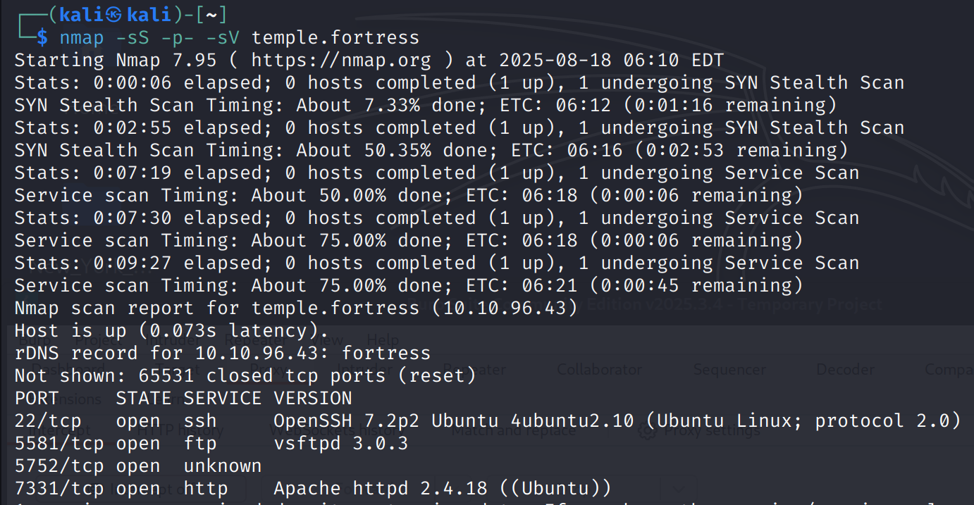
I noticed that the service of “vsftpd” (which is basically ftp with some additional things) running of port 5581. I tried to connect to it using ftp utility in linux but I didn’t have the credentials:
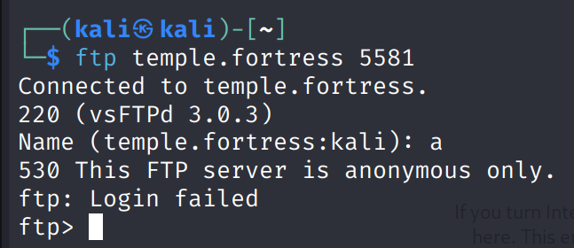
Then, I read the message that appeared “This FTP server is anonymous only.” I realized that probably the username and password should be “anonymous” because I remembered the instructions that was written in the challenge’s page.
Now, when I tried it, it worked!
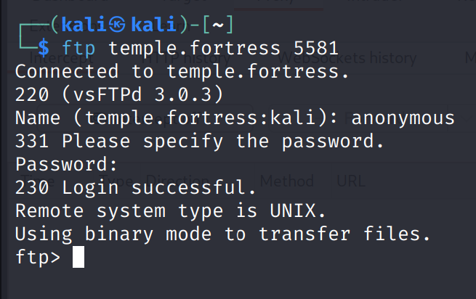
At this point, I searched for interesting files that I can download to my machine from the server. After entering the famous “ls” command, I found a txt file named “marked.txt” that look suspicious:
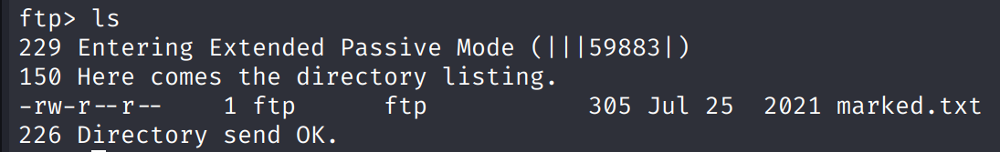
I transferred it to my machine:
And this is its content:
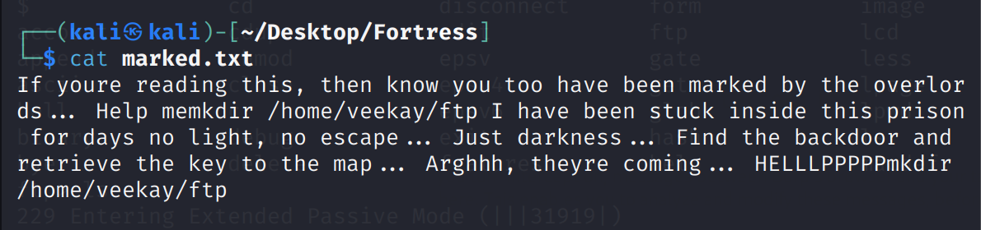
I read it and tried to enter the requested command “mkdir /home/veekay/ftp” in order to create a new folder in the ftp server.
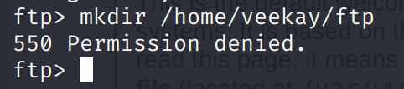
I weren’t managed to do that because I got now permission to create folders in my current state. This led me to find a way to escalate my privileges. The Nmap scan gave me the version of the vsftpd which is “3.0.3” so I check for vulnerabilities in this version.
I found that it vulnerable to a remote denial of service attack (CVE-2021-30047).
In that instant, I downloaded the exploit of this vulnerability:
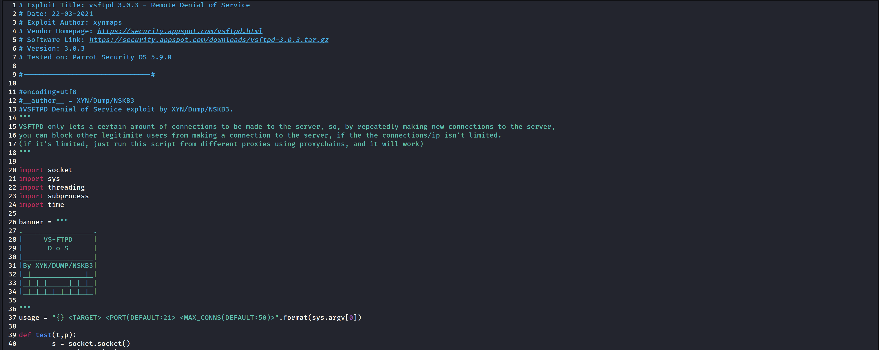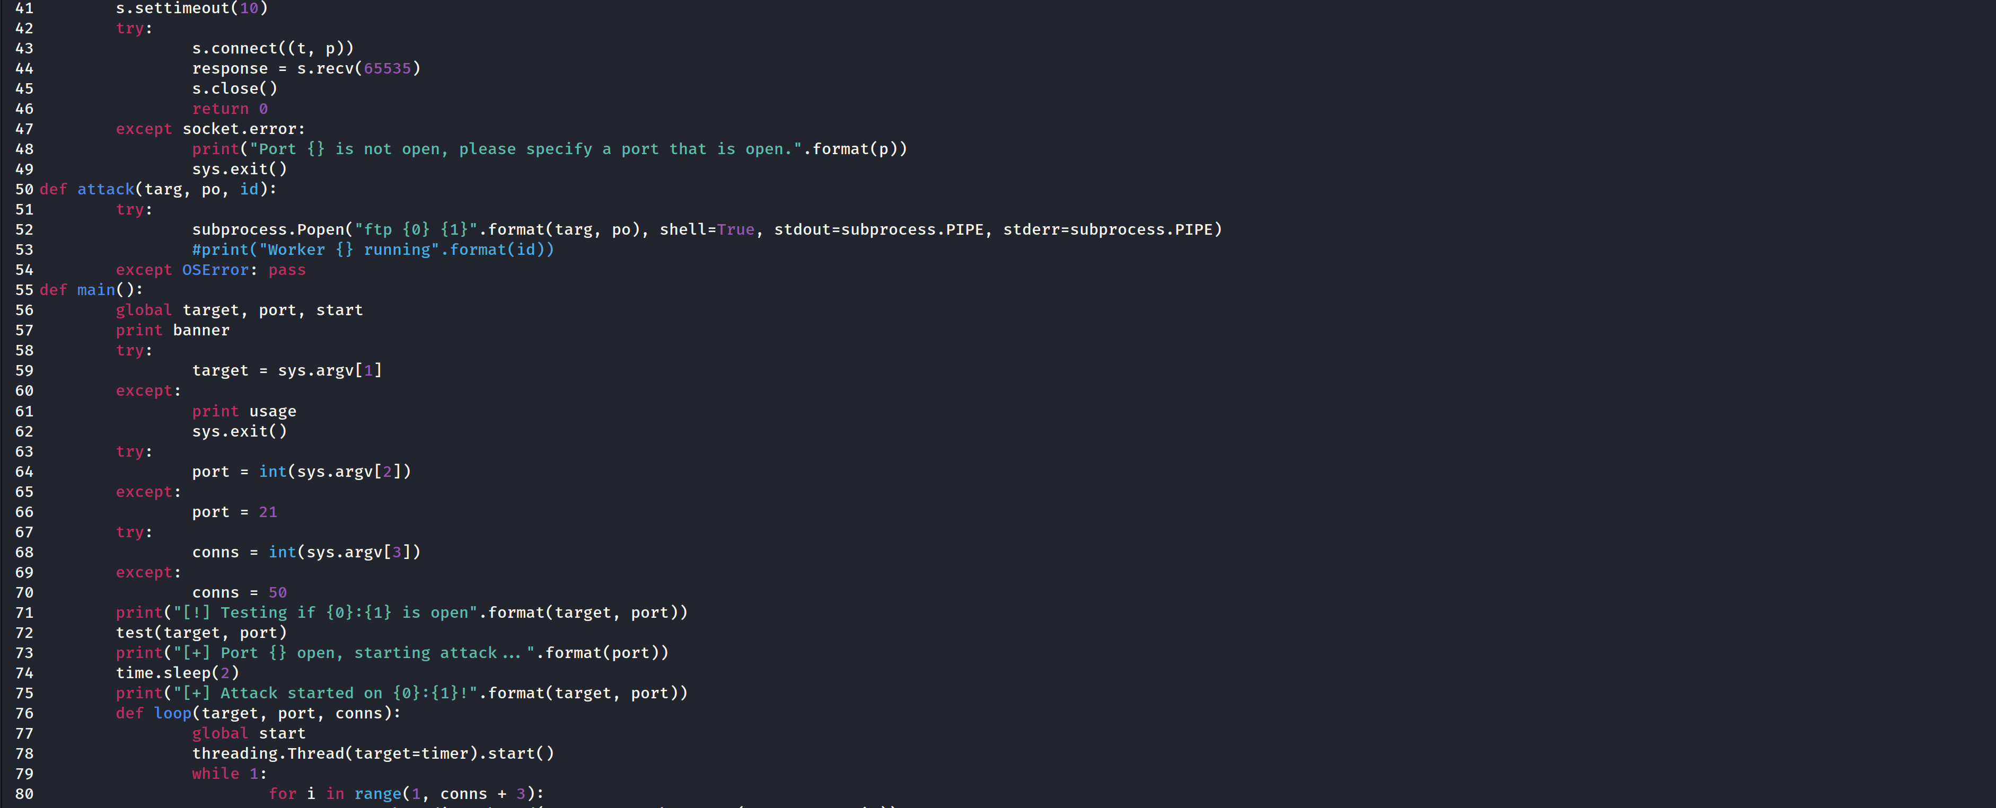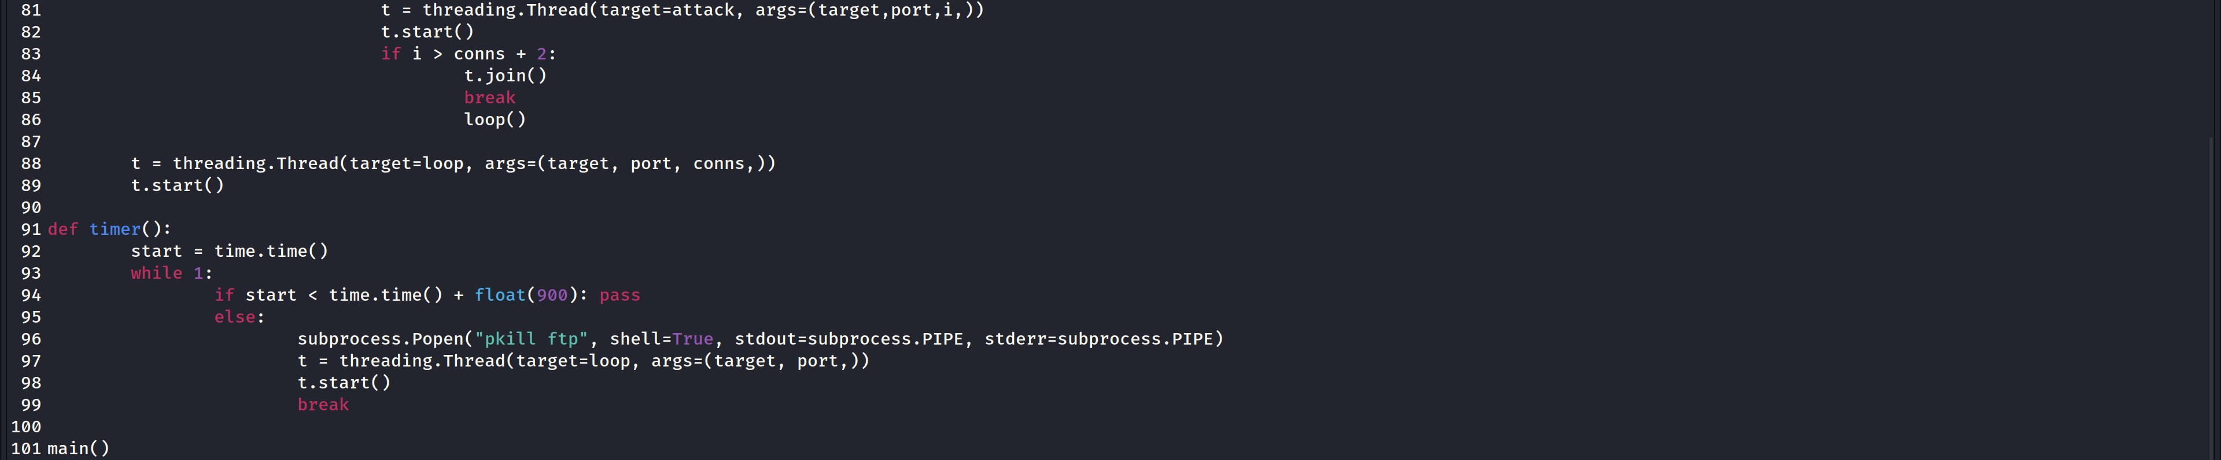
At this point, all that left was to understand how the attack’s behavior and execute it.

