OhSINT Solution Documentation
Written By: Yuval Quina
I started this challenge by downloading the task file. This file was an image file named “WindowsXP_1551719014755.jpg”:

As soon as I saw this image, I recognized it as the Windows XP wallpaper.
After couple of failure tries of using the tools xxd and strings, I moved to try a new tool (for me it was first time of using it) named “exiftool”. I opened its online documentation to learn more about it https://exiftool.org/. And now it was time to use it:
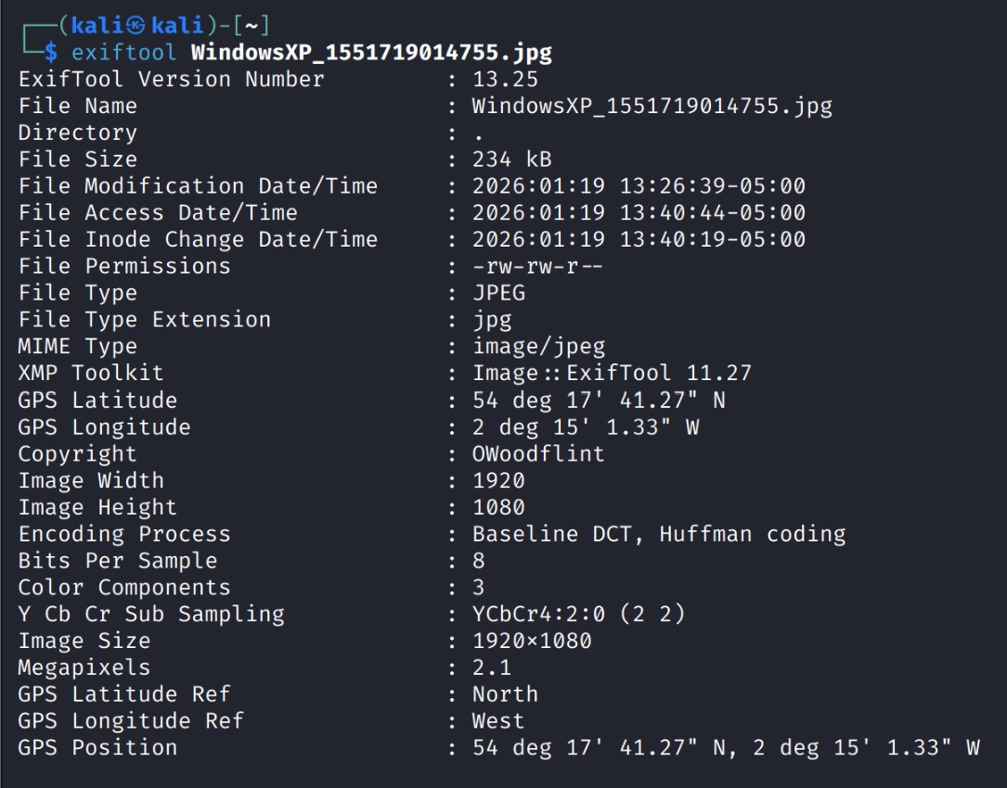
Here I found the Copyright owner of this image who is “OWoodflint”.
After short googling, I found his X account:
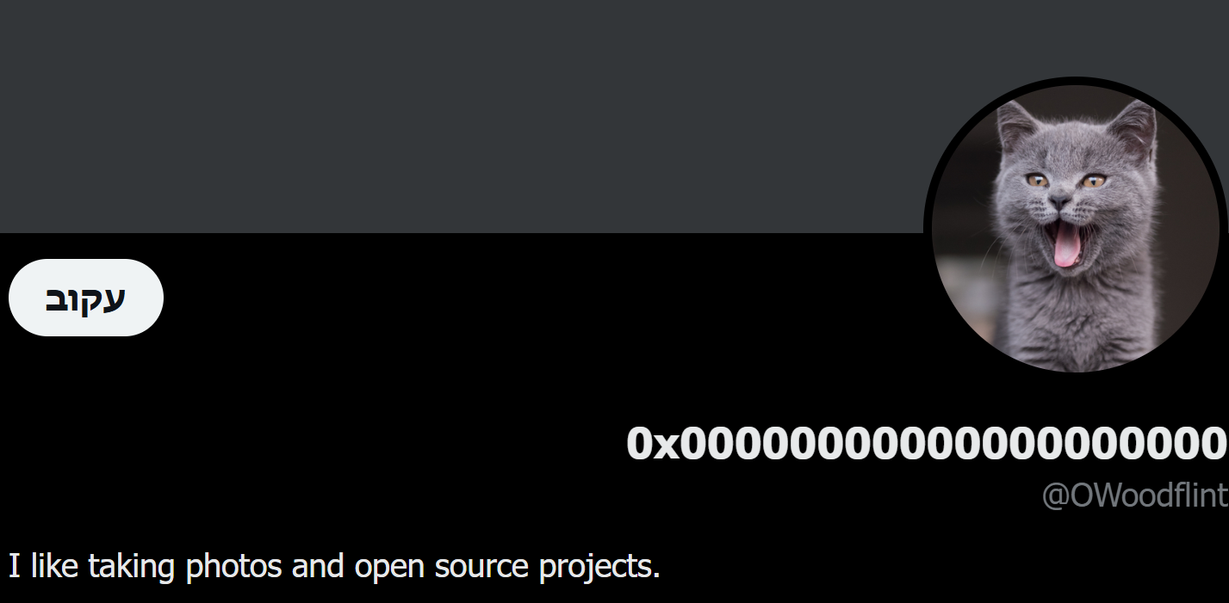
And these are his posts:
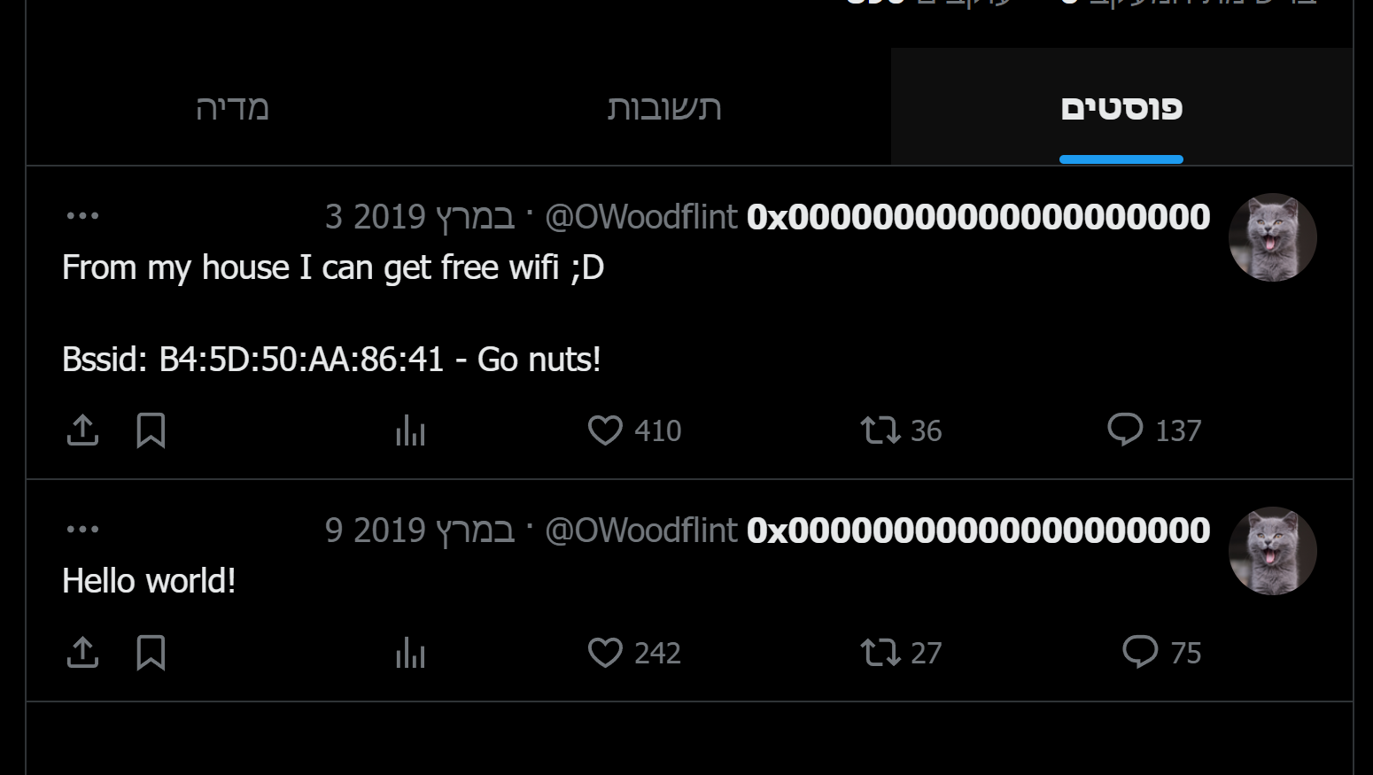
I saw here, that he published his BSSID(which is a MAC address of wireless access points) address which is “B4:5D:50:AA:86:41”.
This person also has a GitHub profile with a repository named “people_finder”: https://github.com/OWoodfl1nt/people_finder.
This repository contains only this README file:
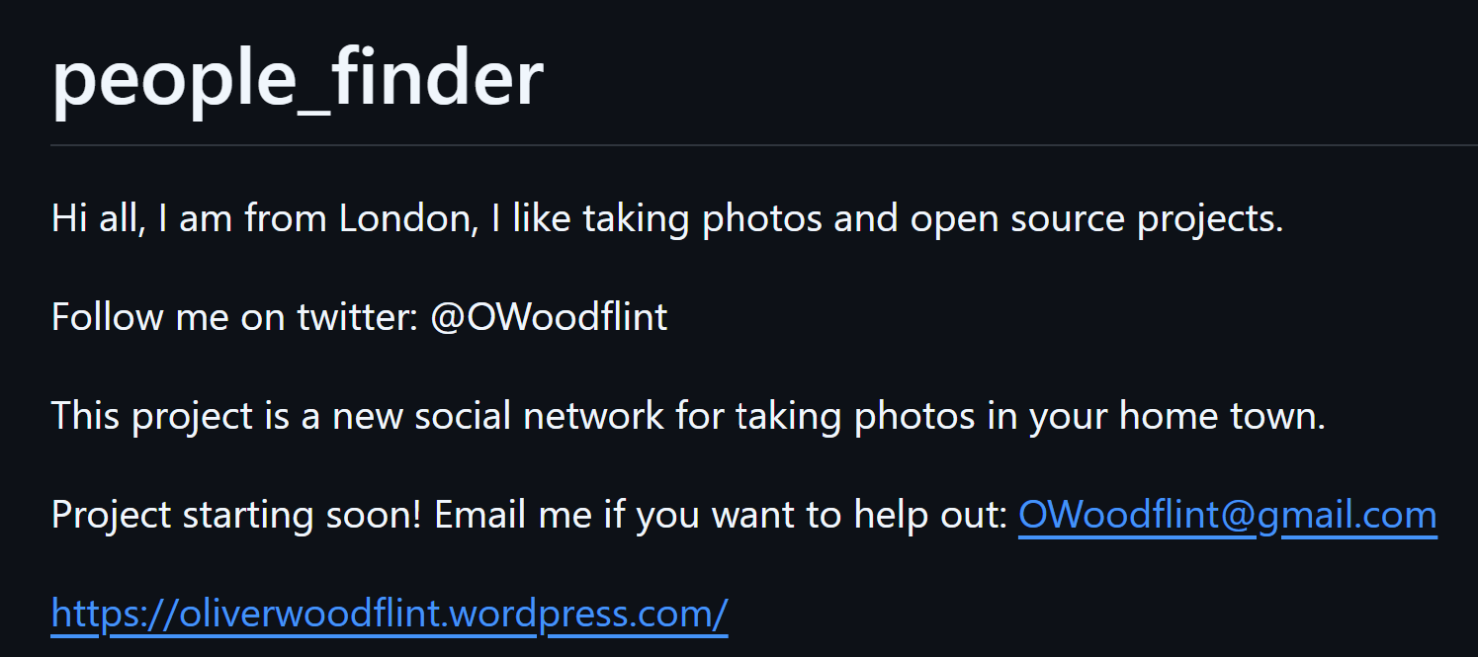
From this message, I could find out that he is in London.
Thereafter, I discovered that his WIFI’s SSID using

