UltraTech_solution_documentation
Written by: Yuval Quina
I started this challenge with a Nmap scanning:
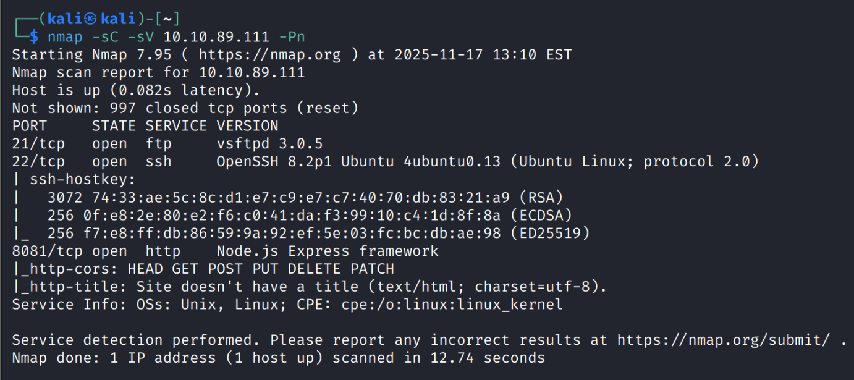
I noticed here a website that runs on port 8081 and based on Node.js Express framework. I decided to open it with my browser, and I saw this message:
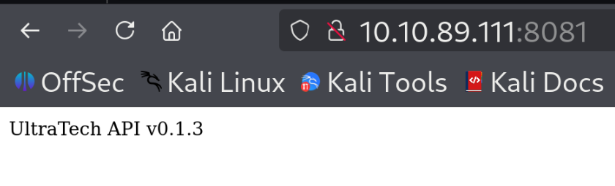
I understood that this website got have an api which its version was “v0.1.3”.
I performed a directories enumeration with Gobuster:
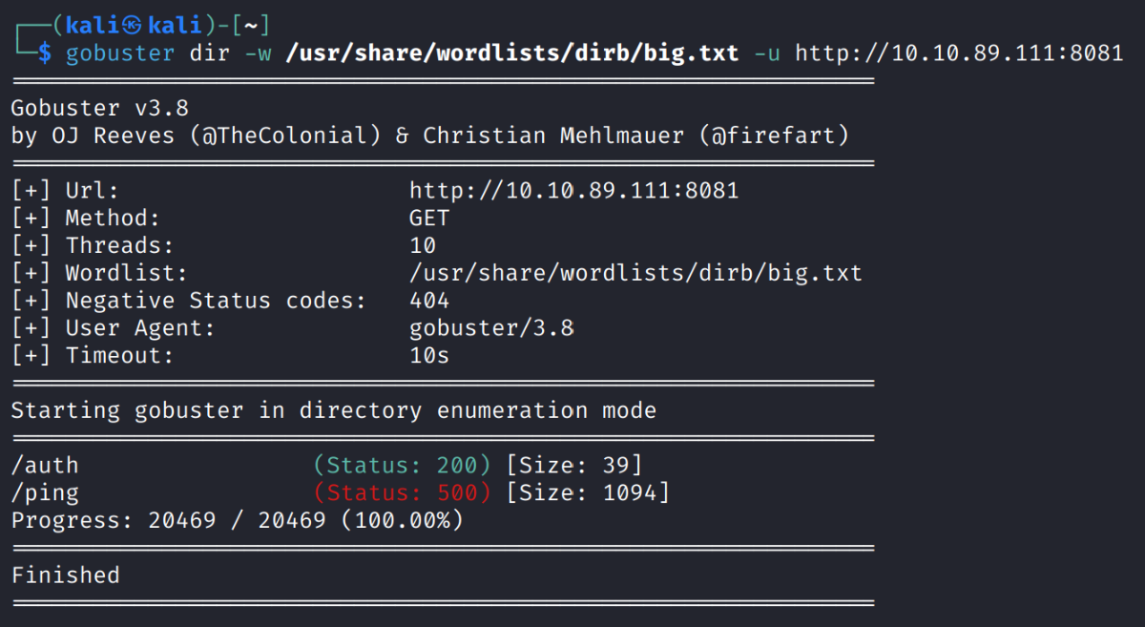
Here, I found 2 directories, the “/auth” returned me this message:
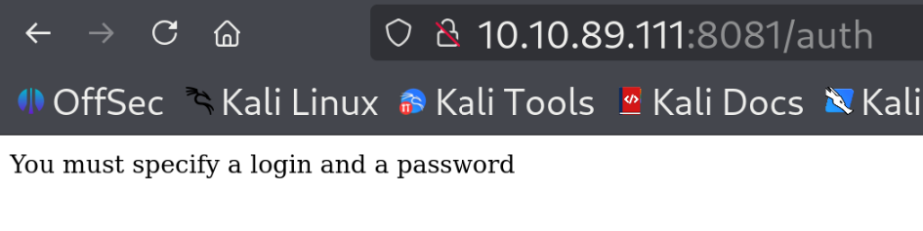
I didn’t understand which login and password I should specify, so I left it to the next steps.
Then, I tried the “/ping” page which got a server internal problem:
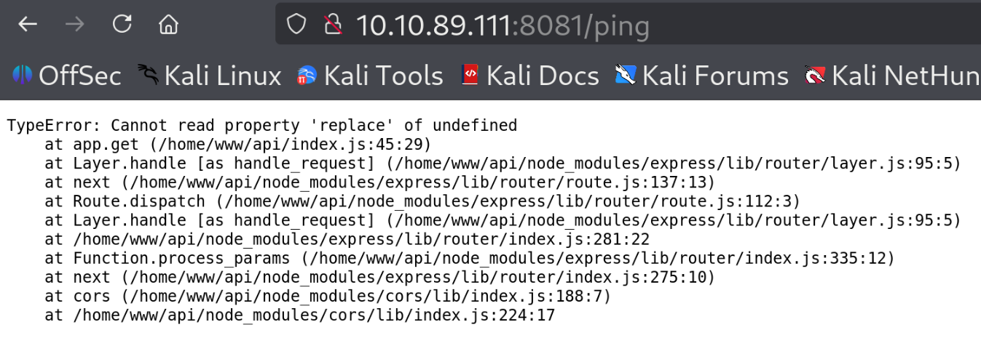
After couple of seconds of reading this error message I found that this error appeared due to

