Anonymous_Solution_Documentation
Written By: Yuval Quina

I started this challenge by performing a Nmap scan:
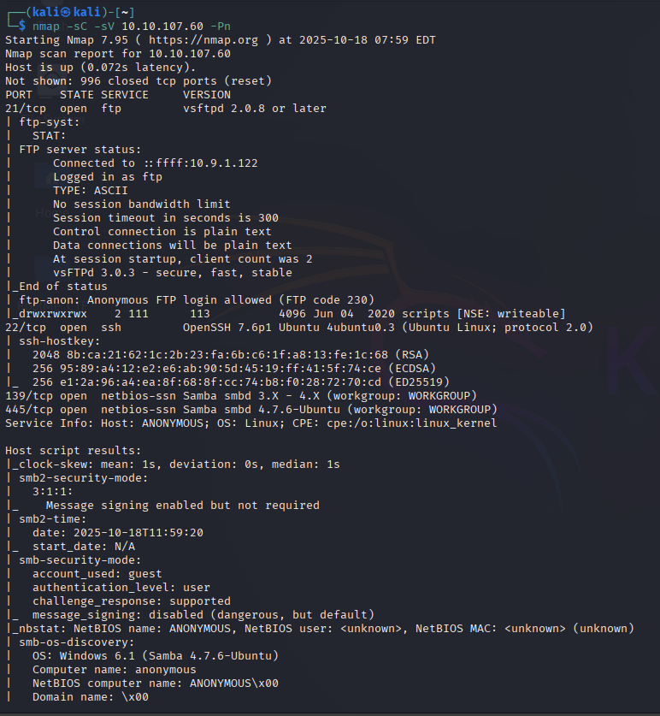
While examining the scan results, I noticed the open SMB ports of 139 and 445. This led me to enumerate the shares of the target’s machine:
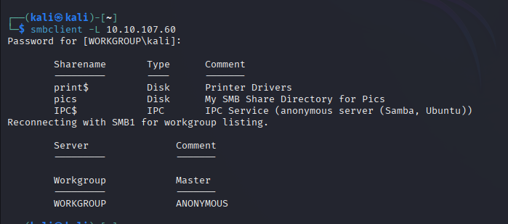
Here I found the “pics” share (which seems to be quite unusual shared folder).
Then, I successfully logged-in to the FTP service using the username “anonymous” with no password:
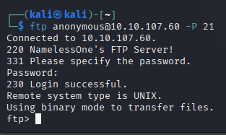
After getting connected, I listed all the available files and folders:
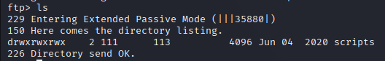
And I noticed the folder “scripts” which contain these files:
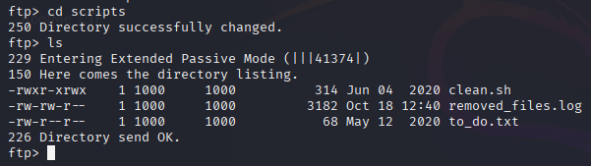
I downloaded them to my own machine and I opened each one:
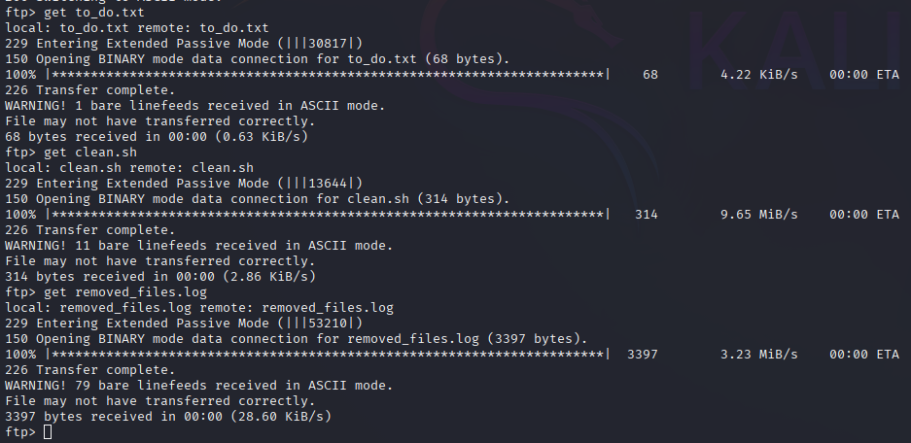
to_do.txt:
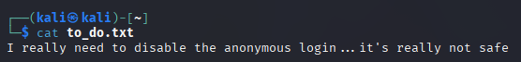
clean.sh:
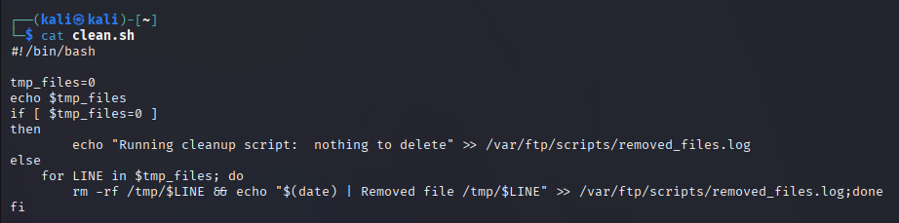

Removed_files.log:

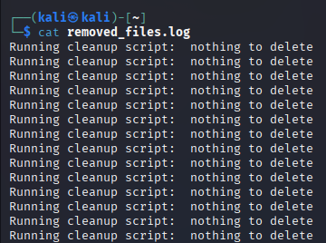

I read the files’ content and understood that the clean.sh script suppose to clean up tmp files from the “/tmp” folder, but it won’t do so, because its value of “tmp_files” never changing from its initial value (0).
At this point,

