mKingdom_Solution_Documentation
written by: Yuval Quina
- Info gathering:
I started this challenge with a basic Nmap ports & services scanning:
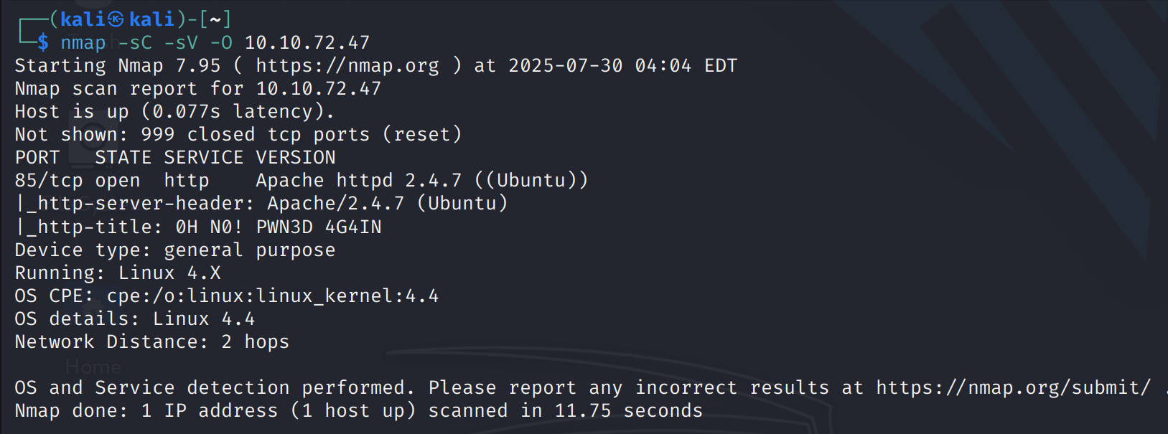
I only found that the http port has changed to 85, so I moved to the target’s website using this port:
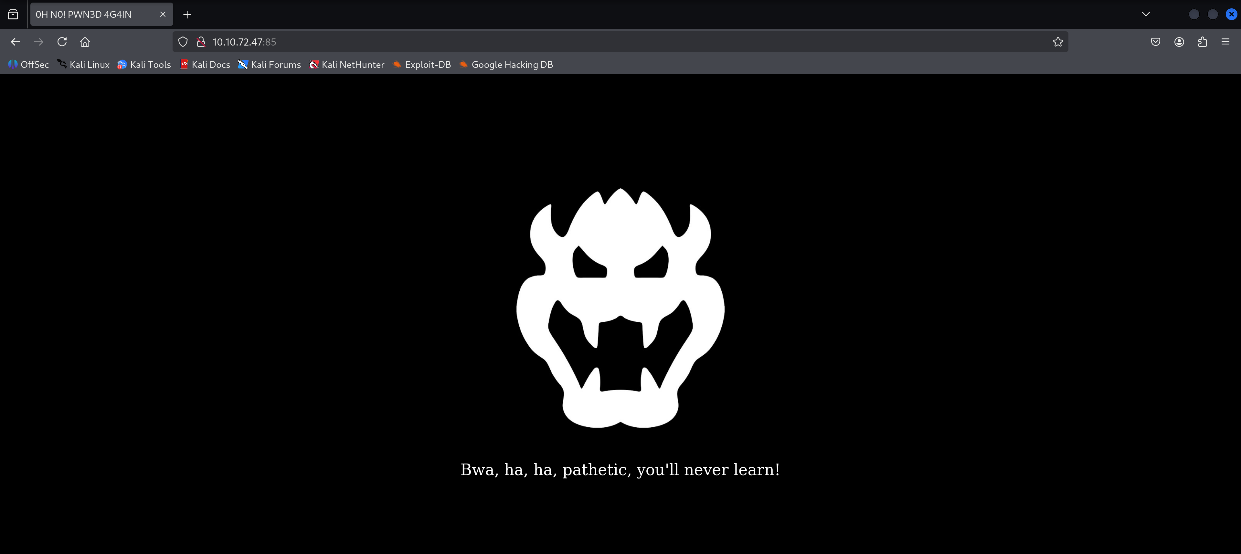
After seeing and examining the inspector I found nothing. From that point I thought to myself that I should probably enumerate directories over the website using gobuster:
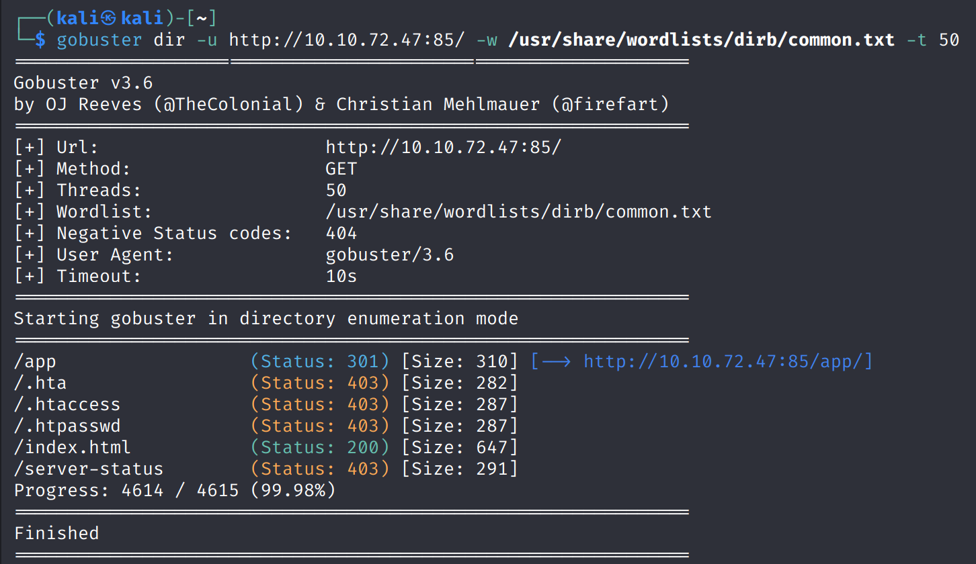
I found the secret page “/app” and this is how it looks like:
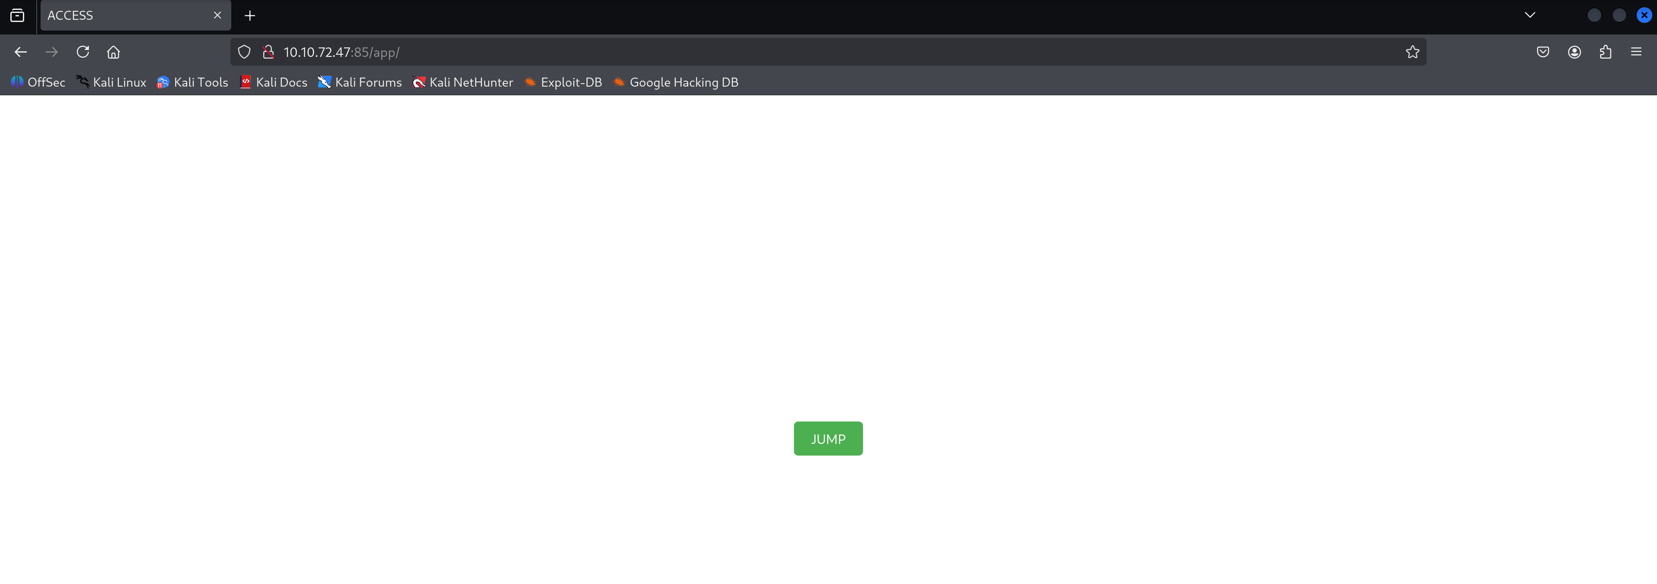
I tried to click on the “JUMP” button and this message popped up:
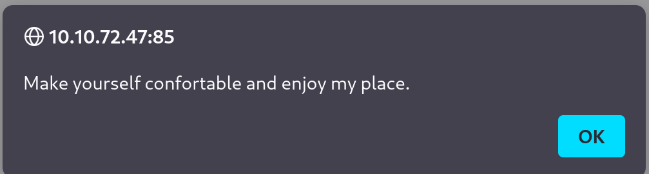
After clicking “OK” I was moved to this page:
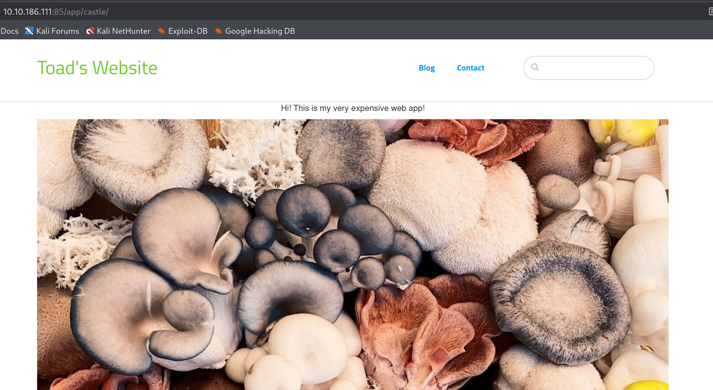

- Vulnerability detection:
I scrolled down to the bottom of this page, and I found that this website was built using “concrete5 CMS” platform.
I wanted to find the Concrete CMS version of the website, so I immediately opened the inspector and found it:
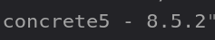
After little googling I found that Concrete CMS version 8.5.2 is vulnerable to “CVE-2020-24986”. This vulenrability about Unrestricted Upload of File with Dangerous Type, specifically the ability to upload PHP files through the File Manager. This makes it possible to modify site configuration to upload the PHP file and execute arbitrary commands.

- Attacking:
I searched a little bit more and I found that in order to exploit this vulnerability I have to get admin permission because only then I can have access to a feature name “Allow File types” that I can modify to allow it to receive PHP files and by doing so performing RCE attack. This led me to enter this login page that I found at the bottom of the main page:

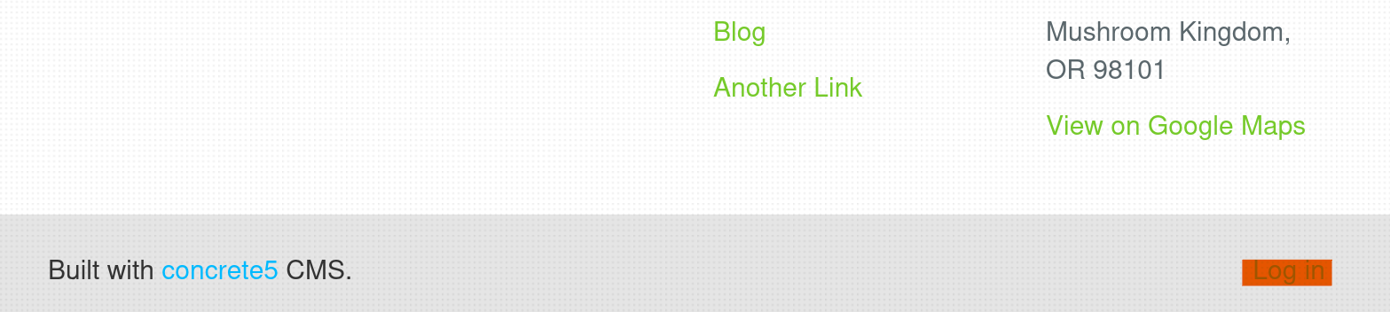
The login page:
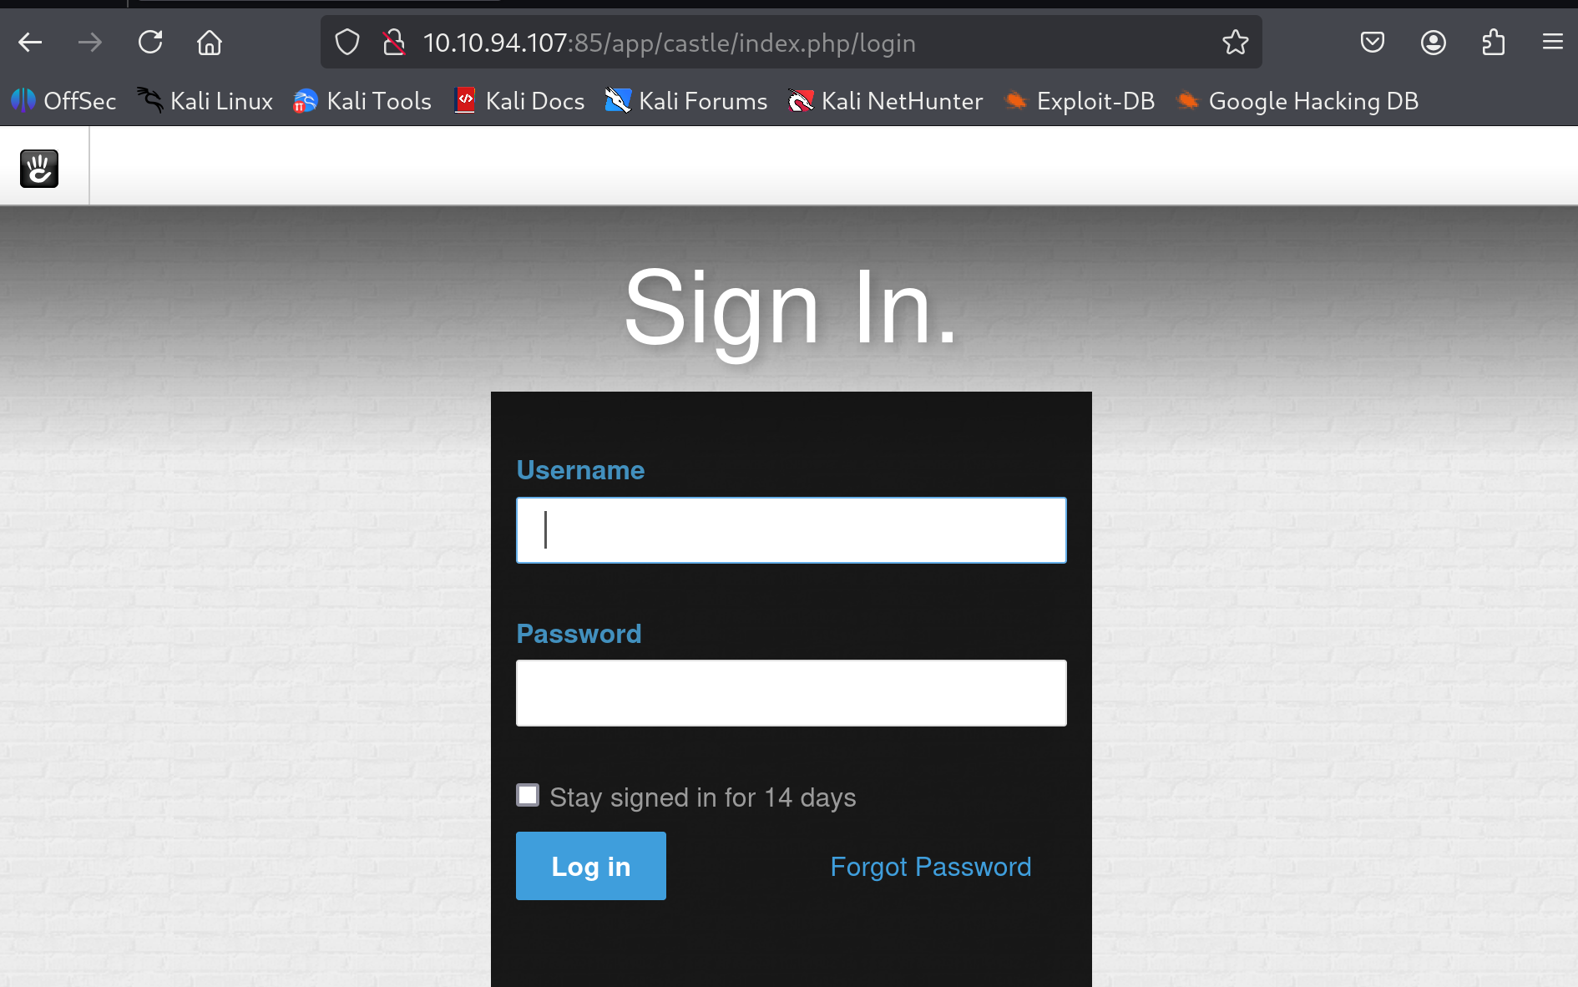

I tried to enter some common default credentials and found the user “admin” with the password “password”.
I was automatically moved to this page:
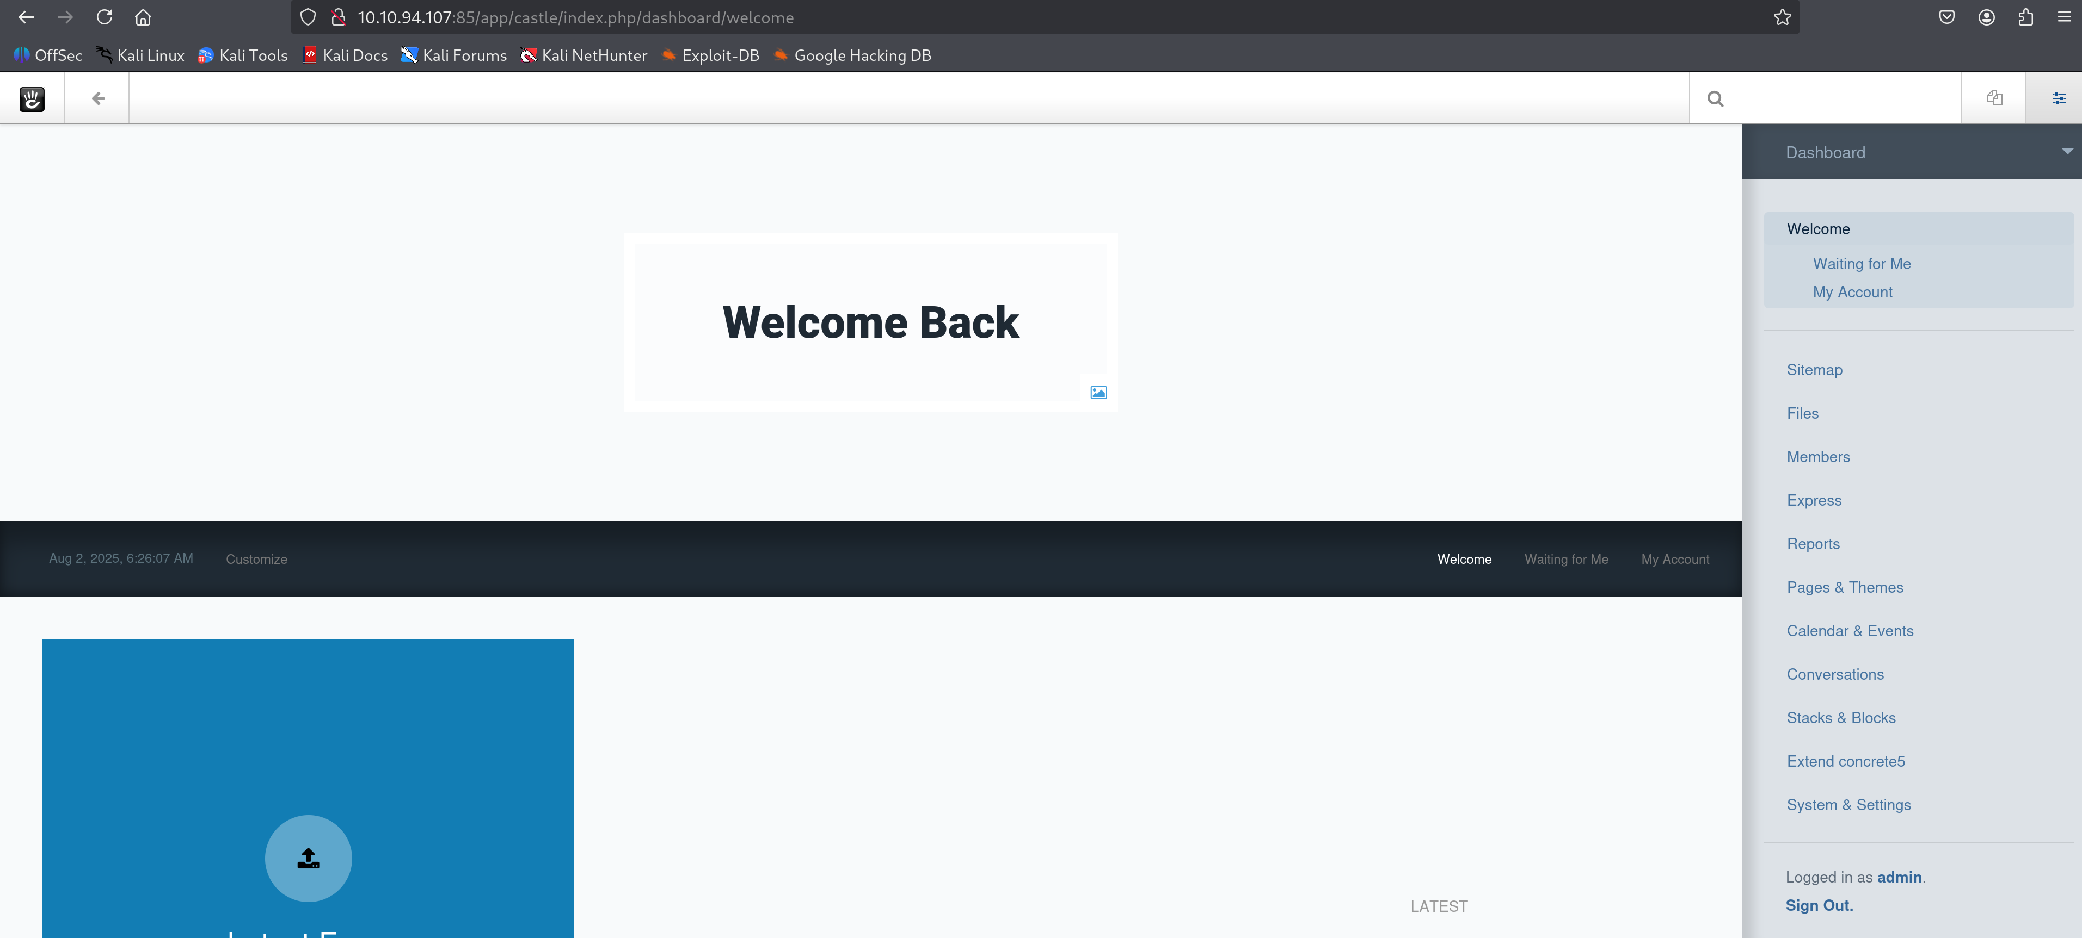

I noticed the link “Files” in the right Dashboard tab, and it moved me to the file manager of the website:
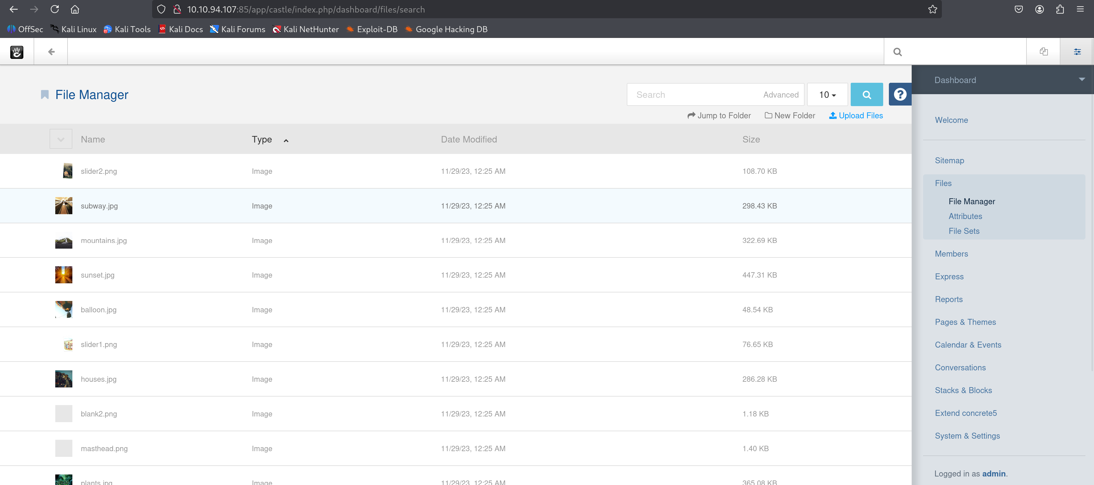
I clicked on the “Upload Files” button and this upload panel was shown up:
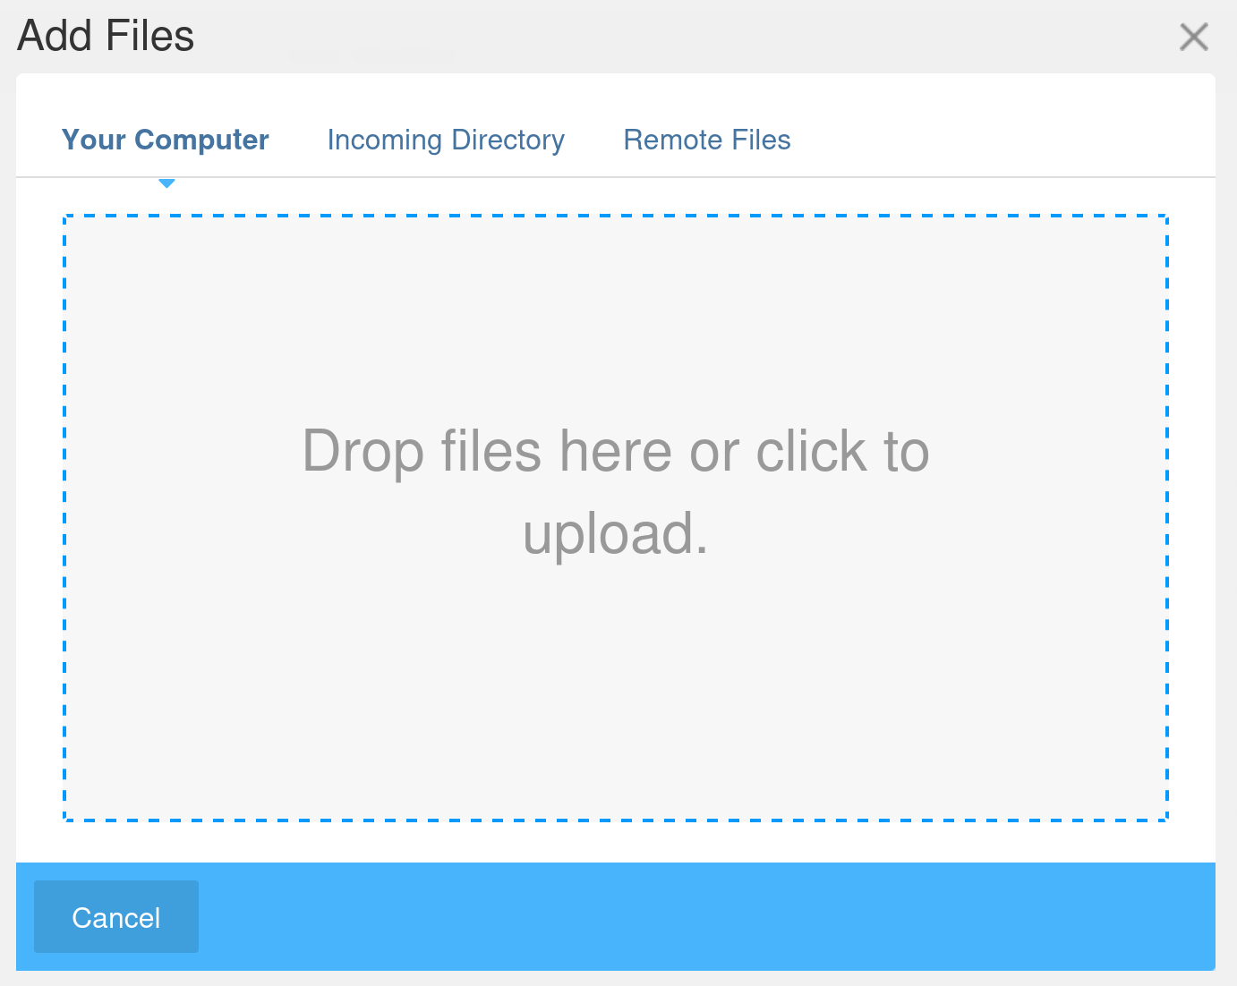
I tried of course to upload the following PHP reverse shell file:
But it failed because on default the concrets5’s file system doesn’t allow to upload .php files. This led me to open the “System & Settings” page from the Dashboard and change the allowed file types:
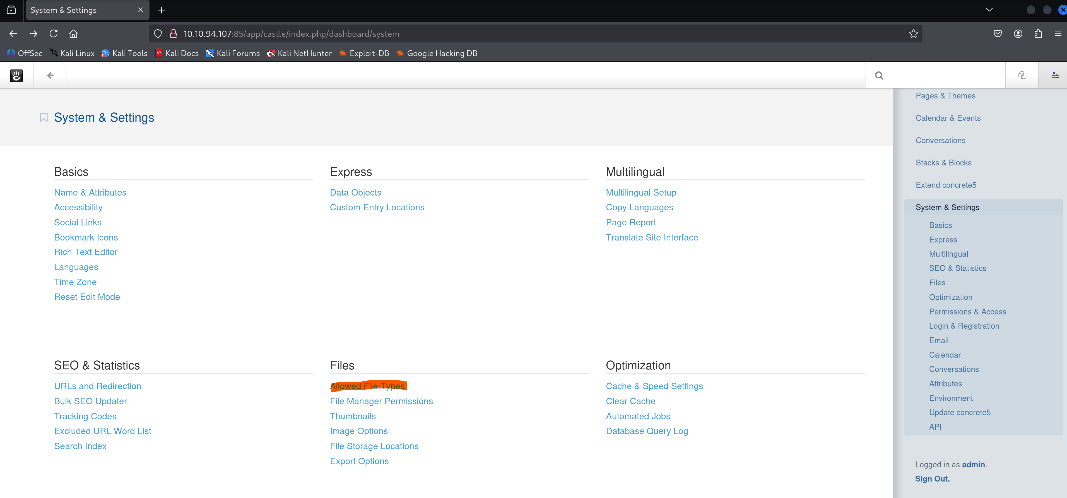
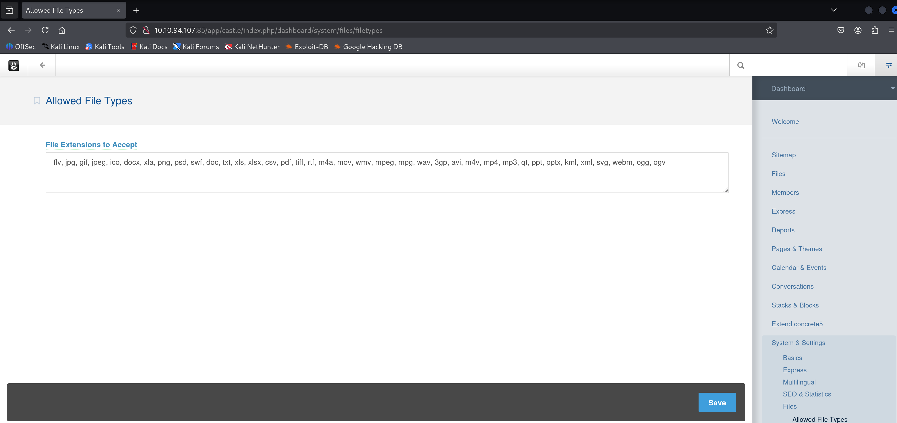
And here I just added “, php” to the file extensions.
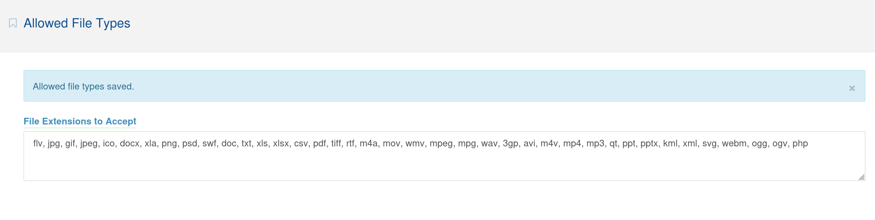

And now I was able to upload the php rev shell file and after uploading it this message was popped up in order to confirm that the file was successfully uploaded:
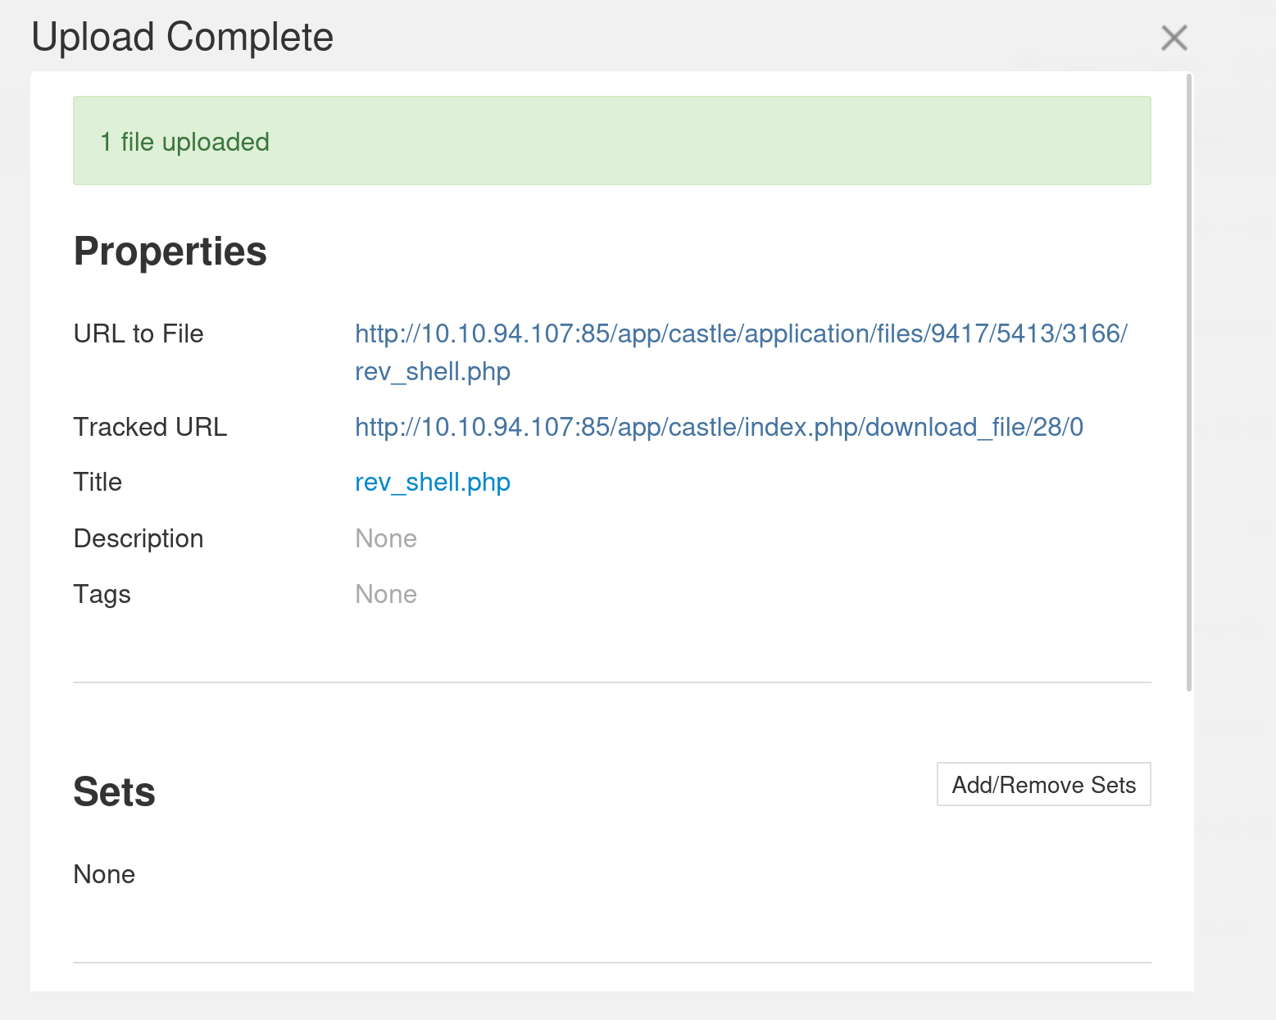
And I noticed that this message contained the url to the file so I clicked on it:
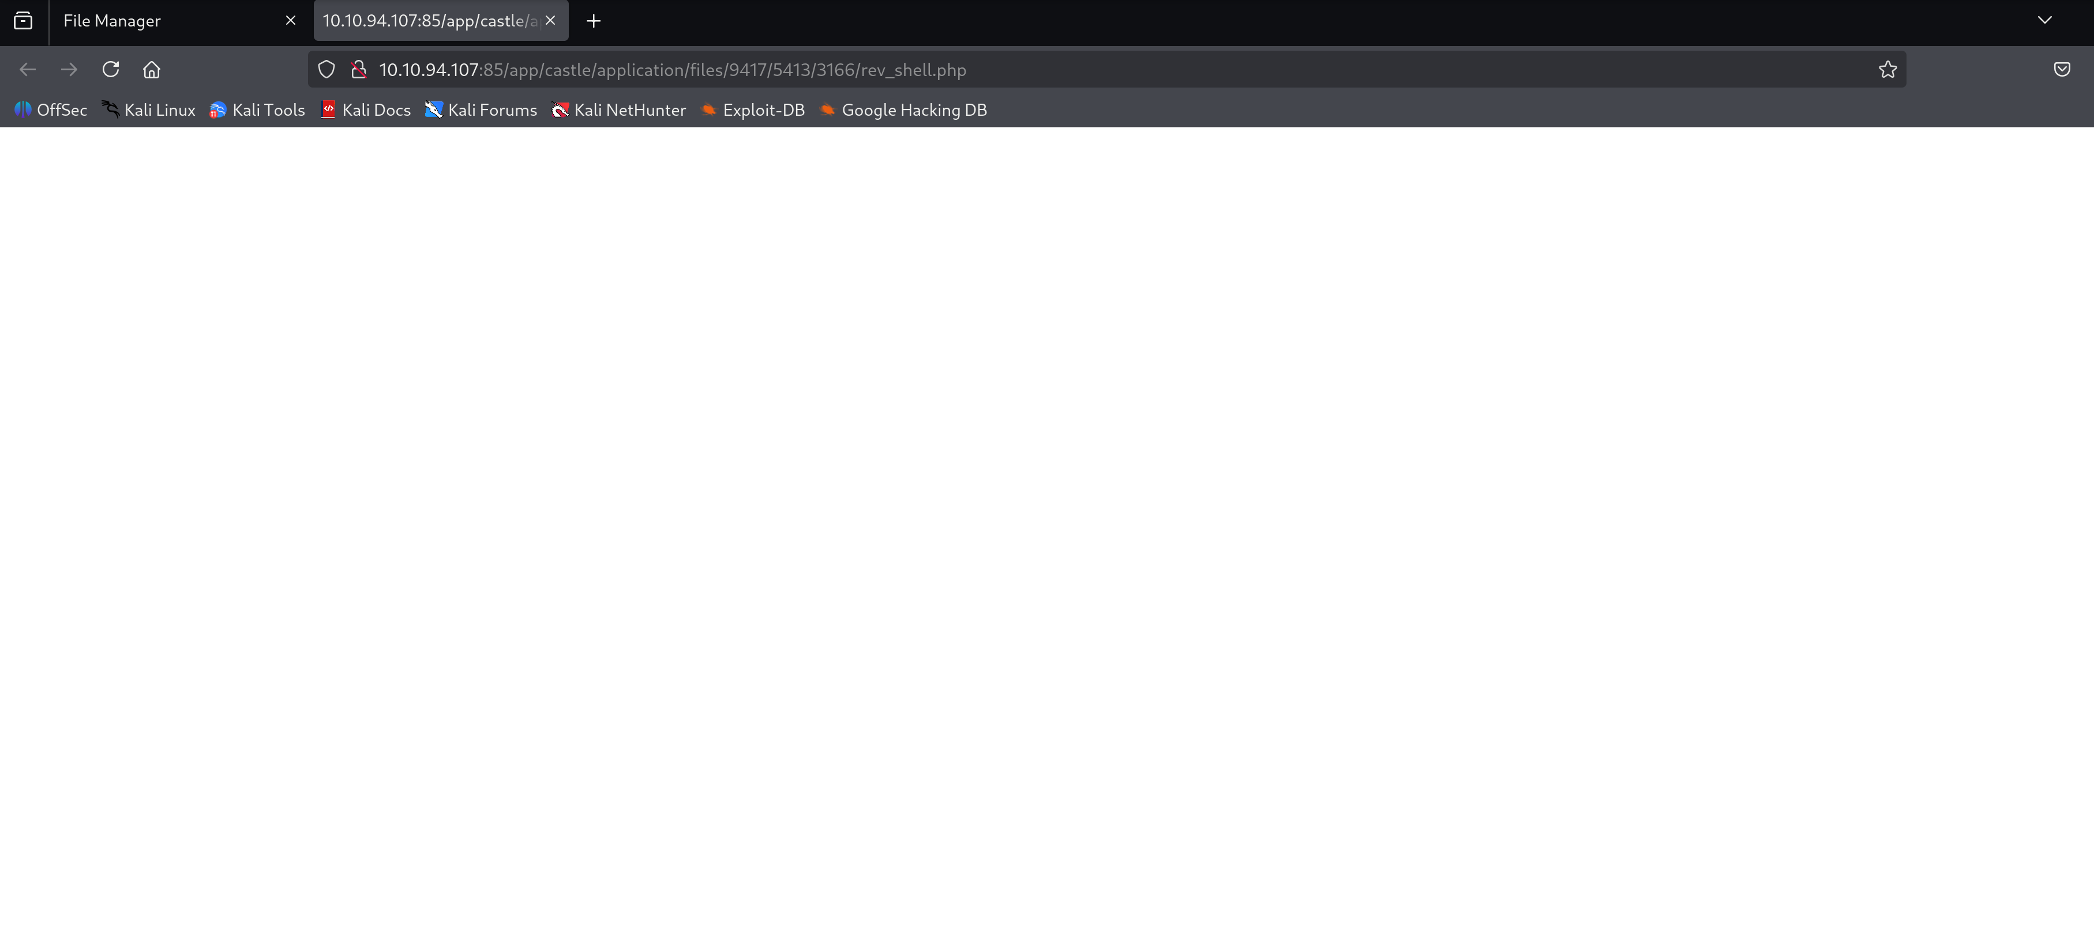
Now I just added the “cmd” flag to the php so I can execute shell commands over the website’s server:
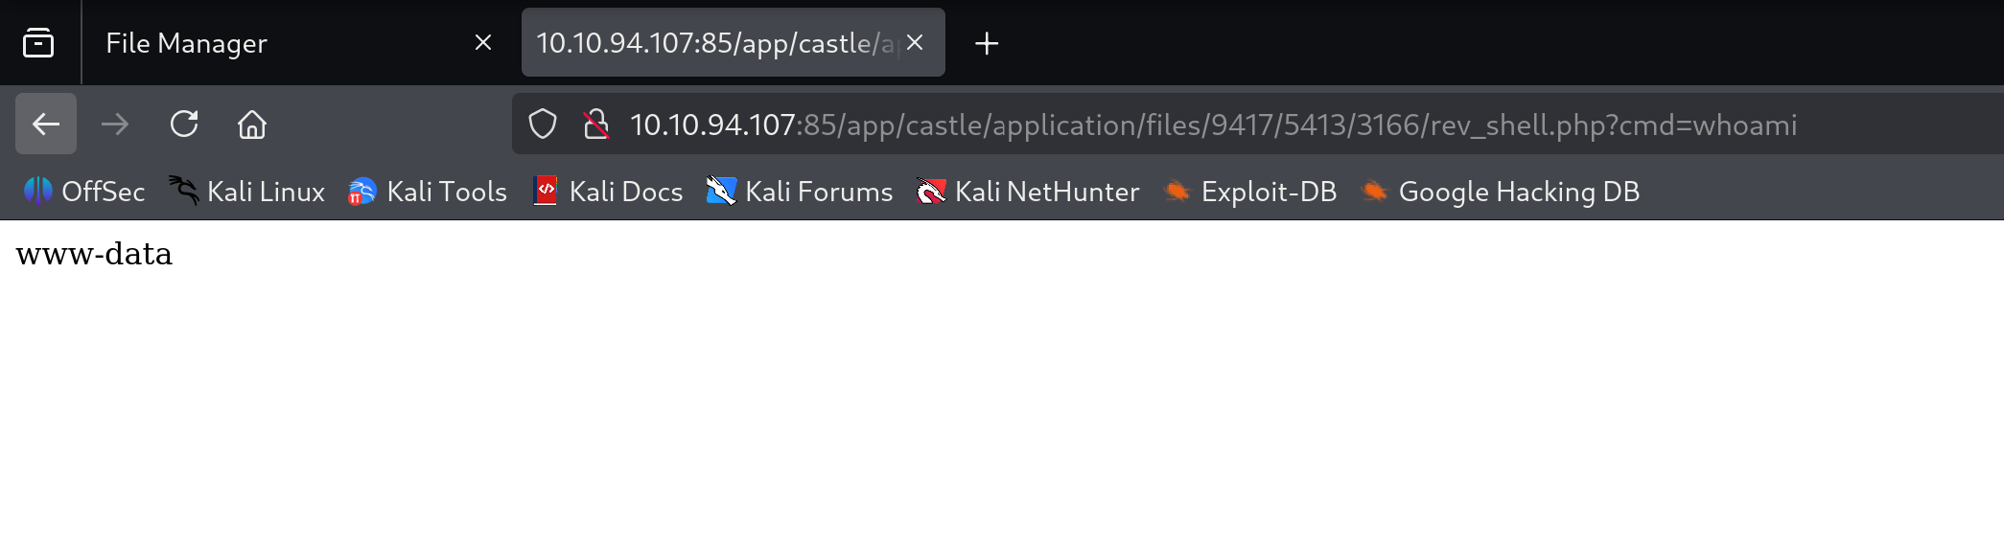
I tried the “whoami” command to ensure that it works and of course it works!
Now I searched for the “user.txt” file that contains the flag
- Privilege escalation:

