



|  |
| --- |
| Smart and amusing Parking System  Software Design Document |
|  |
| Authors**:**  Yuval Berghaus 313247116 |
| **‏‏18/06/2021** |

Table of Contents

1. Introduction 2

1.1. System Overview 2

1.2. Problem Description 2

1.3. Goals 2

1.4. Scope 2

1.5. Glossary 2

2. System Architecture – System Context Diagram 3

3. Design 4

3.1. Data Design 4

3.2. Structural Design 4

3.3. Interaction Design 5

4. Software Architecture 7

5. Verification and Validation 8

# Introduction

The avenging and amusing system

* 1. **System Overview**

Project Oops!e was created to address every person / company with private parking through our smart system. The system will provide a variety of information and options to solve the problem.

* 1. Problem Description

• People park in other people's private parking lots without the consent of the owner (of the parking lot).

• The solutions offered today are ineffective because they do not cause sufficient deterrence.

* 1. **Goals**

Provide information to the main user (the owner of the private parking lot) and provide a creative, deterrent, and entertaining solution against the intruders of the private parking lots.

* 1. **Scope**

Private Parking lots

* 1. **Glossary**

**Throw objects** - Throwing eggs, balloon with liquid glue, balloon with a mixture of water and flour. (The sky is the limit)

**Action request** – Throw eggs / Tow / Identify / Pancture

# System Architecture – System Context Diagram

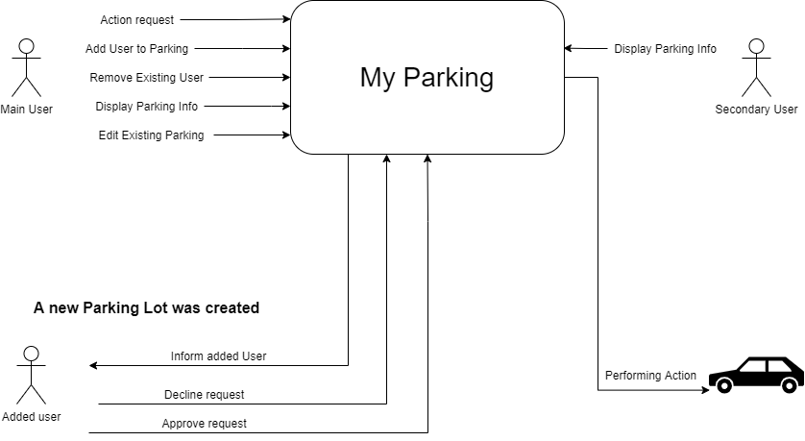The following diagram represents my system architecture

# Design

* 1. 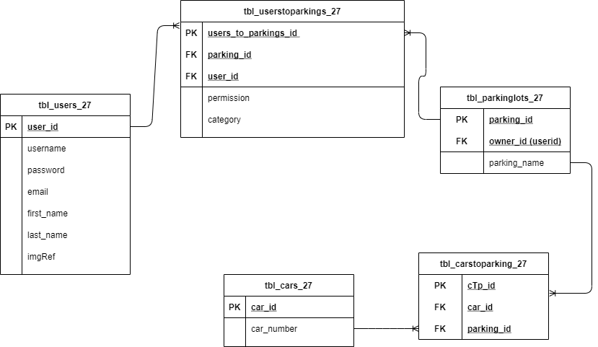Data Design DB

JSON carlist cars.json (Only one report out of the list to display its structure)

  {

    "logo": "https://www.car-logos.org/wp-content/uploads/2011/09/abarth1.png",

    "name": "Abarth"

  }

* 1. Structural Design

Class Diagram

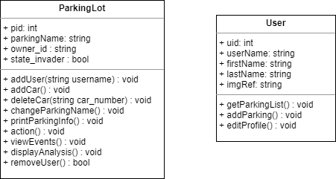

* 1. Interaction Design

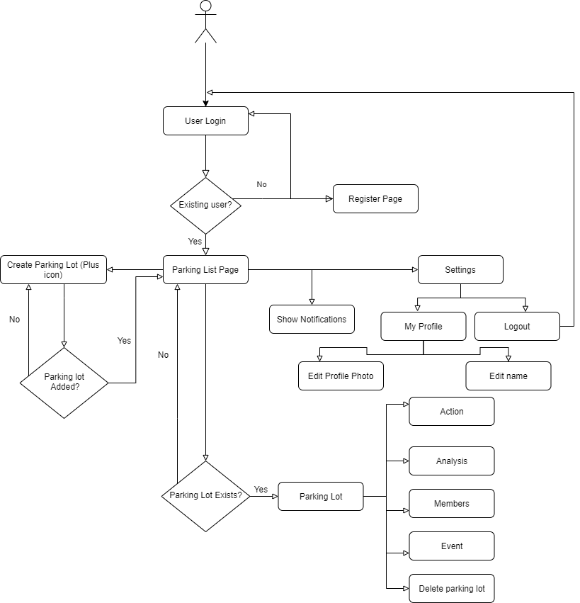

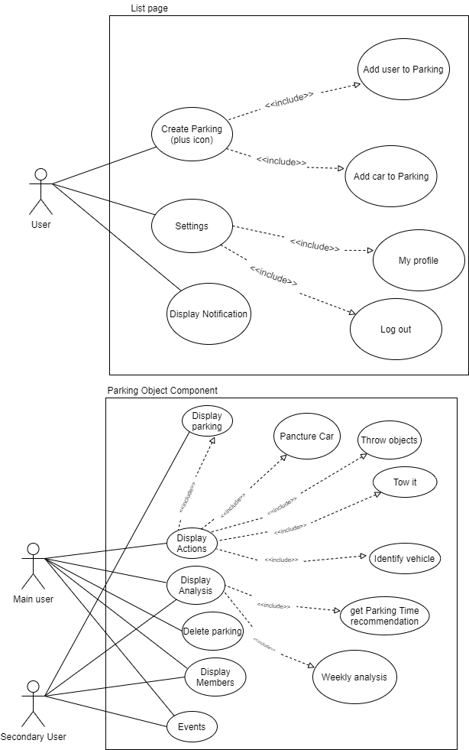Use Case

# Software Architecture

The following diagram represents my Software Architecture which explains the interaction between the user, the server and the Database

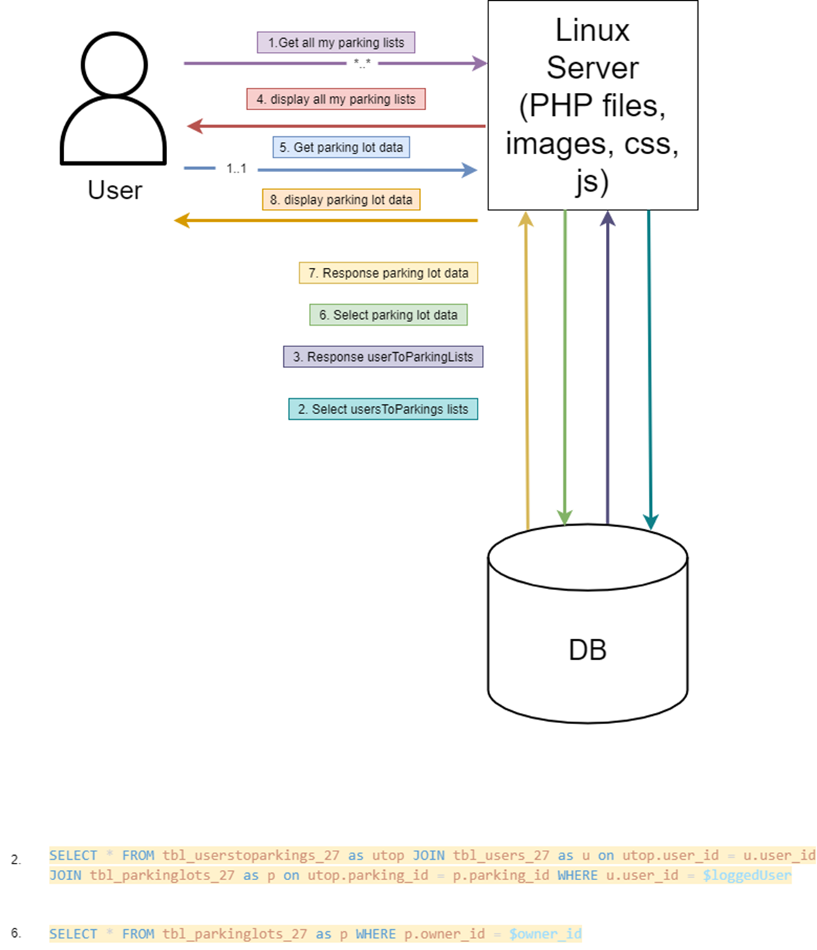

# Verification and Validation

The following lists are the system validation tests

* Check that a user was not entered to the list of permissions of a specific parking more than once.
* Check that no non-user enters the list of users on the form page
* Check that the search box will find me the specific parking I want
* Check When you click the "submit parking" button, the system will send an alert to all users who have been added to the parking lot and ask them to confirm joining the parking lot.