LOGIC design COURSE

NAME: Yuval Elbahar and Michael sidorove
ID: 205523038, 319600698
E-mail: Yuvalelb@post.bgu.ac.il sidorov@post.bgu.ac.il

1 Revision History
Version | DATE | BY | BRIEF DESCRIPTION OF CHANGES
Rev 0 | 1/13/18 | Yuval Elbahar and Michael Sidorov | Initial Draft

Protocol
UART – Universal Asynchronous Receiver Transmitter
Full duplex Communication device with the baud rate of and packet size of 8 bits of data + 3 bits of overhead, with Xon/Xoff implementation and an even parity.
The UART also resends the data received and display it on an LCD, while errors are displayed on the LEDs.

Top module

Overview
Both the control, rx and tx.

Block diagram
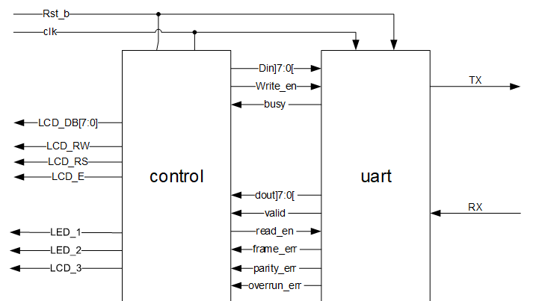

Pin in/out
(put pin out in table)

Pin name | Size in bit | In /out | Description
TX | 1 | Out | Transmitting end
RX | 1 | In | Receiving end
LCD | 8 | Out | LCD sign
LCD_RW | 1 | Out | LCD Indicate writing
LCD_RS | 1 | Out | Not sure
LCD_E | 1 | Out | LCD enable
LED | 3 | Out | Various error indicators
Clk | 1 | In | System clock
Rst_b | 1 | In | Reset

Sub block’s:

TX

Overview:
Transmitting side of the UART

Block diagram / method
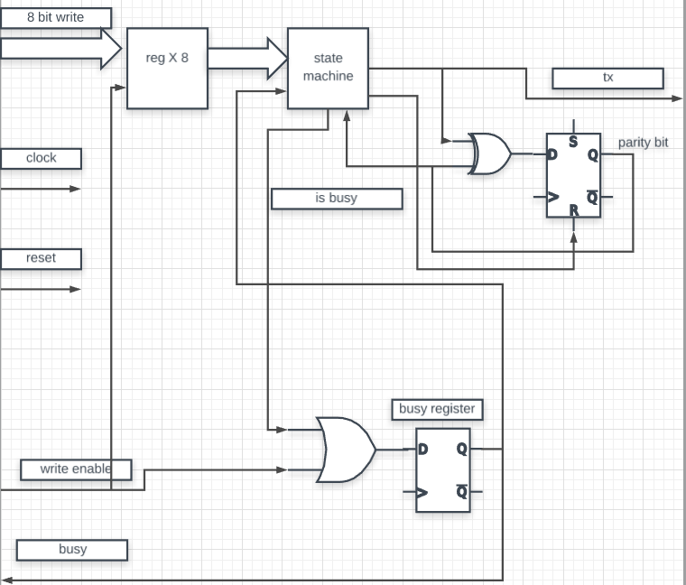

With the state machine of these specifications:
Prity reset | Next state | Is busy | tx | state\output
1 | @busy register 0001  Else 0000 | 0 | 1 | 0000 (idle)
0 | 0010 | 1 | 0 | 0001
0 | 0011 | 1 | Data[0] | 0010
0 | 0100 | 1 | Data[1] | 0011
0 | 0101 | 1 | Data[2] | 0100
0 | 0110 | 1 | Data[3] | 0101
0 | 0111 | 1 | Data[4] | 0110
0 | 1000 | 1 | Data[5] | 0111
0 | 1001 | 1 | Data[6] | 1000
0 | 1010 | 1 | Data[7] | 1001
0 | 1011 | 1 | Parity bit | 1010
1 | 0000 | 0 | 1 | 1011

Pin in/out
(Put pin out in table)

Pin name | Size in bit | In /out | Connect to | Description
Tx | 1 | Out | Outside the device | Transmitting end of the UART
Busy | 1 | Out | Control | Indicates the device is not yet ready to send
Write | 8 | In | Control | Parallel data to be transmitted serially
Write enable | 1 | In | Control | Indicates data is good and is ready to be sent
Clock | 1 | In | Oscillator | System clock
Reset | 1 | In | Control | reset

RX

Overview:
The receiving end of the UART

Block diagram / method
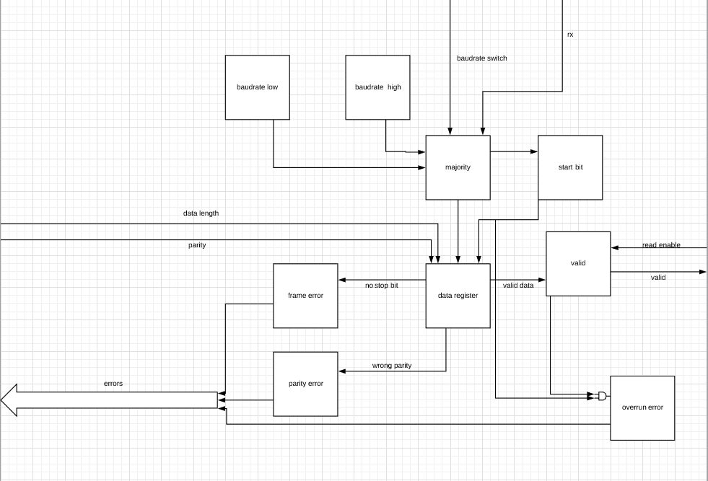
with a state machine of these specifications:
State | Data | Parity reset | Valid | Frame Error | Parity error | Overrun error
0000 | - | 1 | - | - | - | -
0001 | - | 0 | 0 | 0 | 0 | valid
0010 | Data[0] | 0 | 0 | 0 | 0 | -
0011 | Data[1] | 0 | 0 | 0 | 0 | -
0100 | Data[2] | 0 | 0 | 0 | 0 | -
0101 | Data[3] | 0 | 0 | 0 | 0 | -
0110 | Data[4] | 0 | 0 | 0 | 0 | -
0111 | Data[5] | 0 | 0 | 0 | 0 | -
1000 | Data[6] | 0 | 0 | 0 | 0 | -
1001 | Data[7] | 0 | 0 | 0 | 0 | -
1010 | - | 1 | 0 | 0 | parity calc == rx | -
1011 | - | 1 | Frame error ~| parity error | Rx==1 | - | -
1100 | - | 1 | 0 | 0 | 0 | 0

state | Next state
0000 (idle) | @ start bit 0001  Else 0000
0001 | 0010
0010 | 0011
0011 | 0100
0100 | 0101
0101 | 0110
0110 | 0111
0111 | 1000
1000 | 1001
1001 | 1010
1010 | 1011
1011 | @ start bit 0001  @ read enable 1100  Else 1011
1100 | @ start bit 0001  Else 0000

Pin in/out

Pin name | Size in bit | In /out | Connect to | Description
RX | 1 | in | Outside of the device | The receiving end of the UART
Reset | 1 | In | Control | Reset
Clock | 1 | In | oscillator | System clock
Read enable | 1 | In | Control | Indicates the data has been read and errors have been observed
RX data | 8 | Out | Control | 8 bit parallel data received
Valid | 1 | Out | Control | Indicates data is valid
Error | 3 | Out | Control | Indicates the nature of the error
Data length | 1 | In | Control | Data length
Baud rate | 1 | In | Control | Baudrate
Parity | 1 | In | Control | parity

Control

Overview:
The control unit in charge of reading the data and writing it to the LCD and the TX

Block diagram / method
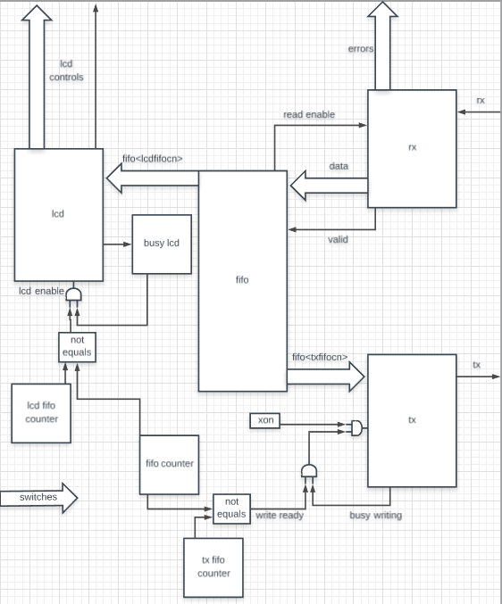
* clk and reset מוזנים לכל הרכיבים, switches מוזנים לtx ולrx

Pin in/out
(Put pin out in table)

Pin name | Size in bit | In /out | Connect to | Description
LCD controls | 10 | Out | LCD controller | The letter to be displayed  By the LCD controller
LCD enable | 1 | Out | LCD controller | Indicates the data on the LCD is valid
TX data | 8 | Out | TX | The data to write
Write enable | 1 | Out | TX | Indicates the Data is ready to be sent
Busy writing | 1 | In | TX | Indicates that the TX is busy sending a packet
errors | 3 | Out | LEDs | Error to be displayed on the LEDs
RX data | 8 | In | RX | The data received
Valid | 1 | In | RX | Indicates the data from RX is valid
Read enable | 1 | Out | RX | Notifies RX that the data has been read.
Busy lcd | 1 | In | Lcd | Notifies that lcd is busy
Switches | 3 | In | Mechanical swiches | Parity on/off, baud rate and data length

