

Active Noise Reduction System In a Vehicle

FxLMS-Based ANC for Automotive Applications: Multi-Channel Adaptive Filtering and Spatial Quiet Zones

25-1-1-3214 | Project Number:

Project Report

Student: | Ariel Turnowski | ID: | 206483513
Student: | Yuval Horowitz | ID: | 206587719

Supervisor: | Dr. Lior Arbel

Project Carried Out at: | Tel Aviv University, School of Electrical Engineering
Contents
Abstract
1. Introduction
2. Theoretical Background
3. Simulation
4. Implementation
5. Analysis of Results
6. Conclusions and Further Work
7. Project Documentation
8. References

Abstract
This project develops a multi-channel Active Noise Control (ANC) system for the cabin of a passenger vehicle, where low-frequency engine, road and wind noise dominate and conventional passive insulation is least effective. The controller uses Filtered-x Normalised LMS (FxNLMS) adaptive filters that drive one or more loudspeakers with an anti-noise signal computed from a reference microphone and refined using the residual at one or more error microphones placed near the driver-ear position.
We design and evaluate the system entirely in simulation, using a 4.5 × 1.85 × 1.2 m shoebox cabin model in pyroomacoustics excited with real LA driving recordings. We implement and compare five algorithm configurations: a baseline single-channel SISO controller, a four-loudspeaker pseudo-SIMO broadcast variant, a true SIMO controller with independent secondary paths (Stage 1), a multi-error head-zone SIMO (Stage 2), and a full N×M×K MIMO controller (Stage 3) with four reference microphones, four loudspeakers, four error microphones and 4096 adaptive taps. A parallel research thread investigated full-ML control with a Temporal Convolutional Network (TCN); the result was instructive but did not become the deployed solution.
The Stage 3 Full MIMO controller reaches +14.3 dB noise reduction on the idle scenario, +12.6 dB on cruising and +9.9 dB on acceleration, with stable convergence under 1.5 s. The book also reports the spatial structure of the cancellation field across the cabin and the trade-off between local quiet zones and the waterbed effect.
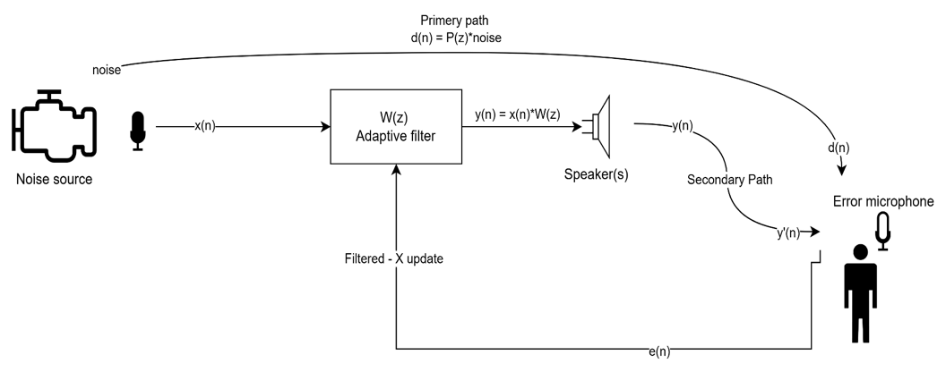
System block diagram

Introduction

Motivation
Cabin noise inside a moving passenger car is dominated by low-frequency components: engine harmonics in the 50–250 Hz range, tyre/ road excitation around 80 – 300 Hz, and wind noise that grows with speed. These are precisely the frequencies that are least attenuated by passive insulation — adding mass to the door panel costs both money and weight while delivering only a few decibels per octave below 250 Hz. Modern solutions can rely on signal-processing solutions to keep low-frequency cabin noise within acceptable limits. The problem sits at the intersection of digital signal processing, acoustics and machine learning, and the engineering pay-off — improved passenger comfort and reduced driver fatigue. Unlike noise-cancelling headphones or aircraft cockpit headsets, an in-car solution must produce a broad zone of quiet that accommodates natural head movement at the listening position, which makes the multi-channel adaptive system studied here both necessary and challenging.

Goal
The objective of this project is to design and evaluate an Active Noise Control system that targets at least 10 dB of broadband noise reduction at the driver-ear position on real driving recordings, with stable convergence under two seconds, and to characterise the trade-offs that arise when scaling from a single-channel controller up to a full multi-input multi-output configuration.

Approach
The system is built around the Filtered-x LMS family of adaptive filters, the de-facto standard for feed-forward ANC. Above the single-channel baseline we implement four progressively richer multi-channel variants. All experiments run in a pyroomacoustics shoebox cabin model excited with real LA Downtown driving recordings (idle, cruising, acceleration). Two complementary ML threads were also investigated: one that uses a small classifier to pick the FxLMS step size adaptively, and one that replaces the FxLMS controller entirely with a Temporal Convolutional Network. FxLMS itself dates back to Burgess (1981) and Morgan (1980); multi-channel extensions for car cabins are documented by Kuo and Morgan (1996, 1999), and the present project follows their MIMO formulation.

Structure of this report
Chapter 2 develops FxLMS and its multi-channel extensions formally. Chapter 3 describes the simulator. Chapter 4 walks through the implementation of the five algorithm variants and the ML thread. Chapter 5 reports quantitative and spatial results. Chapter 6 summarises the conclusions. Chapter 7 lists project deliverables and the public repository.

Theoretical Background

The cancellation principle
Active Noise Control exploits the linearity of acoustic wave propagation: two coherent disturbances of equal magnitude and opposite phase sum to silence at the point where they meet. ANC implements this electronically - a microphone captures the disturbance early, an electronic filter computes an inverted copy, and a loudspeaker radiates the anti-noise so that destructive interference takes place at a chosen listening point. Cancellation is local: the geometry of microphones and loudspeakers has a first-order effect on achievable performance.

The standard LMS adaptive filter
For an FIR filter of length L driven by a reference signal x(n) with target d(n), the standard LMS update minimises the instantaneous squared error $e(n) = d(n) - y(n)$ by gradient descent on the weights:
- $Y\left(n\right)= Σₖ wₖ\left(n\right)·x\left(n-k\right)$ - filter output (FIR convolution)
- $e(n) = d(n) - y(n)$ - error signal (target output)
- $w(n+1) = w(n) + μ·e(n)·x(n)$ - weight update rule
The step size μ controls adaptation speed and steady-state misadjustment.

Why LMS alone fails for ANC
In an ANC system the filter output y(n) does not reach the error microphone directly — it must travel through the DAC, the amplifier, the loudspeaker and the acoustic path from the loudspeaker to the error microphone. We call this combined transfer function the secondary path S(z). The disturbance reaches the error microphone through a different primary path P(z). Plain LMS does not account for the phase shift introduced by S(z) and quickly becomes unstable for any non-trivial step size.

The Filtered-x LMS solution
FxLMS (Burgess 1981, Morgan 1980) fixes the stability problem with a single change: before being used in the weight update, the reference signal is filtered through an estimate Ŝ(z) of the secondary path:
$$x_{f\left(n\right)} = \sum_{k=0}^{L-1}{ŝₖ·x\left(n-k\right)}$$
Convolves the reference signal x(n) through the secondary-path estimate ŝ to produce the filtered-x signal $x_{f\left(n\right)}.$ ŝₖ is the k-th tap of the secondary-path FIR estimate, L is the Filter Size.
$$w(n+1) = w(n) + μ·e(n)·x_{f\left(n\right)}$$
Same gradient-descent step as plain LMS, but now uses the filtered reference $x_{f\left(n\right)}$.
The estimate Ŝ(z) is identified offline by playing a known stimulus through the loudspeaker. We model this estimate as the true acoustic path corrupted by 5% multiplicative noise, representative of what offline identification typically achieves.

Filtered-x normalised LMS
Plain FxLMS is sensitive to input power — the effective step size scales with $|x|²$ and is hard to keep stable across scenarios. The normalised variant divides each update by the energy of the filtered-reference buffer:
$$w\left(n+1\right)= w\left(n\right)+ μ · e\left(n\right)·\frac{x_{f\left(n\right)}}{(δ + ‖x_{f\left(n\right)}‖²)}$$
with δ a small regularisation constant. FxNLMS is the controller used throughout this project. The optional leakage term $(1 - μγ)$ on $w(n)$prevents weight drift in long-running deployments and is enabled in our implementation with $γ = 0$.

The waterbed effect
ANC is fundamentally local. Pressing one part of the acoustic field down lifts another, because cancelling at one point in a reflective enclosure necessarily redistributes acoustic energy elsewhere. This is the waterbed effect, visible in the spatial heatmaps of Chapter 5: a small zone of quiet around the error microphone is paired with regions of amplification (sometimes >5 dB) elsewhere. Multi-error control mitigates the effect within an extended head zone but cannot eliminate it; only adding more loudspeakers genuinely changes the trade-off.

Multi-channel extensions
The SISO FxNLMS controller extends straightforwardly to multi-channel cases. With M loudspeakers, N reference microphones xₙ(n) and K error microphones eₖ(n), the weights of loudspeaker m driven by reference n update as:
$$w_{\left\{m,n\right\}}(n+1) = w_{\left\{m,n\right\}}(n) + (\frac{μ}{norm} ) · Σₖ eₖ(n) · x_{f^{\{m,n,k\}}}(n)$$
where $norm = δ + Σₖ ‖x_{f^{\{m,n,k\}}}(n)‖²$ and $x_{f^{\{m,n,k\}}}(n)$ is the n-th reference filtered through the secondary-path estimate from loudspeaker m to error microphone k. The cost function is the sum of instantaneous squared errors across all K error microphones. Stage 1 $(M=4, K=1, N=1)$, Stage 2 ($M=4, K=4, N=1)$ and Stage 3 $(M=4, K=4, N=4)$ of this project all follow this template. The matrix of loudspeaker-to-error secondary paths is the cross-coupling matrix; its size grows as $M · K$ and dominates the per-sample compute cost.

Simulation

Simulation environment
Experiments are conducted in software using pyroomacoustics, which implements the image-source method for shoebox geometries with frequency-dependent surface absorption and air absorption. The simulator returns sample-accurate room impulse responses between every source–microphone pair. We build the primary, secondary and reference acoustic paths from these impulse responses and feed them to the FxLMS controllers.

Cabin geometry
The cabin is modelled as a 4.5 × 1.85 × 1.2 m shoebox at $fs = 16 kHz$, with image-source reflections up to order 3 and air absorption enabled. Surface absorption is tuned per surface to approximate a typical car interior — the carpeted floor and headliner ceiling are highly absorbent, the windscreen and side glass are highly reflective, and the dashboard and rear shelf sit between. The geometry is intentionally simple: the algorithmic phenomena we want to characterise are insensitive to fine geometry detail and far more sensitive to the placement of the transducers within the volume.
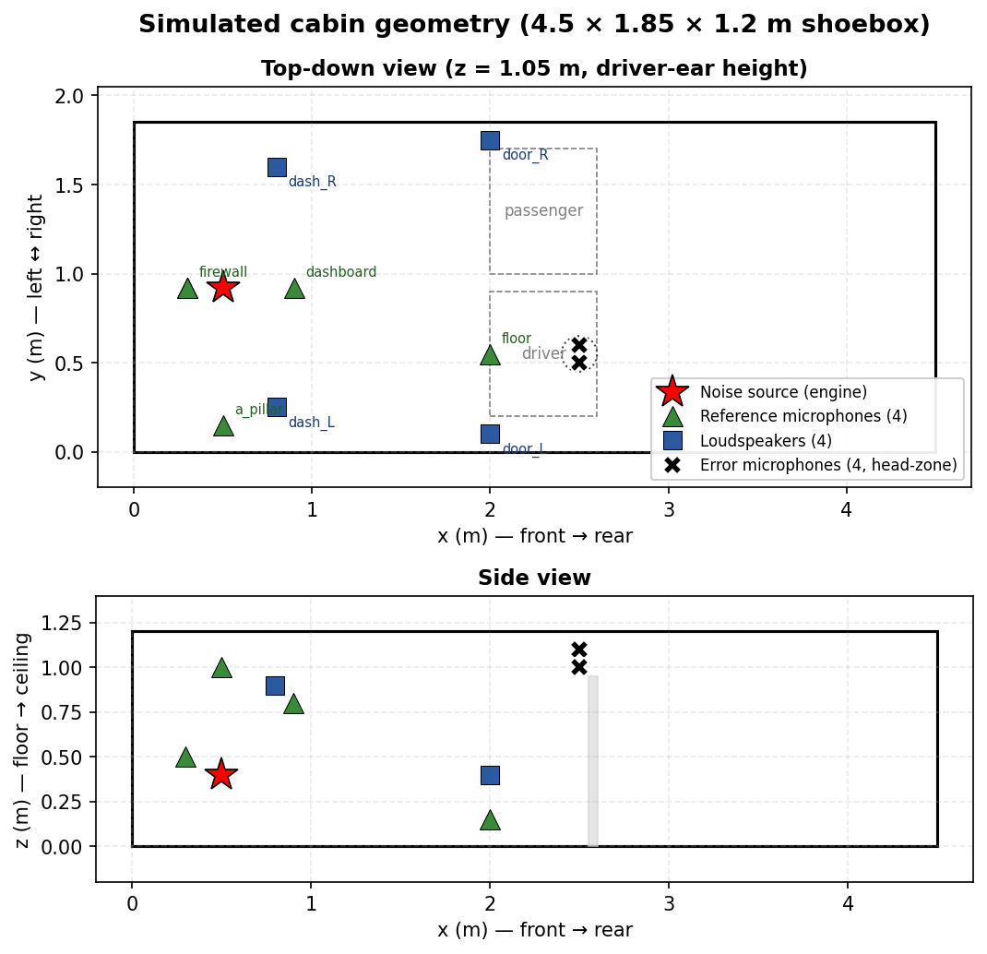
Simulated cabin geometry showing source, reference mics, loudspeakers and head-zone error mics
The noise source sits in the engine bay (front-left). Four candidate reference microphones are evaluated — firewall, floor, A-pillar and dashboard — with the firewall location used by default in the multi-reference Stage 3 controller. Four loudspeakers are mounted in the door and dashboard locations typical of production cars. The error microphones form a 2×2 head-zone grid centred on the driver-ear position with ±5 cm offsets in y and z.

Excitation signals
The simulator is excited with real recordings from a driving session in downtown Los Angeles, segmented into three representative scenarios:
Scenario | Source recording | Duration | Character
Idle | la_idle.wav | 20 s | Stationary engine, dominant low-frequency harmonics
Cruising | la_medium_cruise.wav | 20 s | Steady tyre / wind noise, broadband
Acceleration | la_varying.wav | 20 s | Non-stationary spectrum, transients
Real recordings are deliberately chosen over synthetic color-noise because the spectral non-stationarity of road traffic — particularly the acceleration scenario — is the regime where FxLMS is most challenged and where the differences between algorithm variants are most pronounced.

Default controller parameters
Unless otherwise stated, all FxLMS variants use the following parameters:
Parameter | Default | Stage 3 override
Sample rate fs | 16 kHz | 16 kHz
Filter length L | 512 taps | 256 taps
Step size μ | 0.003 | 0.001
Regularisation δ | 1e−4 | 1e−4
Secondary-path estimate error | 5 % multiplicative noise | 5 % multiplicative noise
Head-zone radius | ±5 cm in y and z | ±5 cm in y and z
The Stage 3 step size is reduced because its weight tensor is four times larger than Stage 2 — its effective gain at the error microphones is therefore higher, and aggressive step sizes that work for Stage 1 cause Stage 3 to diverge.

Implementation

Overview
The implementation comprises five FxNLMS controller variants of increasing channel count, plus two parallel machine-learning threads. All controllers share the same simulator, FIR filter front-end and secondary-path estimation methodology; they differ only in the structure of the weight tensor. None of the source code is included in this report; it lives in the public repository documented in Chapter 7.

SISO FxNLMS (1 × 1 × 1)
The baseline. One reference microphone (driver-side firewall), one dashboard loudspeaker, one error microphone at the driver-ear position. The weight vector has L = 512 taps and is updated sample-by-sample by the standard FxNLMS rule. Its main limitation is that the zone of quiet is small — typically a few centimetres around the error microphone — so any movement of the listener's head out of that zone severely degrades the perceived attenuation.

Pseudo-SIMO (1 × 4 × 1, shared filter)
Four loudspeakers driven by the same anti-noise signal y(n). From the controller's point of view, the four loudspeakers behave as a single effective loudspeaker whose secondary path is the sum of the four loudspeaker-to-error-microphone paths. The same scalar FxNLMS update is used. This corresponds to the way many low-cost in-cabin systems are wired — one filter saves cost and DSP cycles, but every loudspeaker emits the same signal, constraining the cancellation field.

Stage 1 — true SIMO (1 × 4 × 1, independent filters)
The first true multi-channel controller. The single reference signal feeds four independent FIR filters Wₘ(z), one per loudspeaker, each updated with its own filtered reference $x_{f^{\{m\}(n)}}.$ The cost function remains the squared error at the single driver-ear microphone. Stage 1 beats pseudo-SIMO on 11/13 real recordings (mean +0.54 dB), and degenerates to scalar FxNLMS when M = 1 (verified bit-exact in unit tests).

Stage 2 — SIMO + multi-error head-zone (1 × 4 × 4)
Stage 1 produces a deep but very narrow zone of quiet. Stage 2 widens that zone with four error microphones in a 2×2 head-zone grid (±5 cm in y and z). The cost function is the sum of squared errors across the four error microphones. The mean head-zone reduction is +4.73 dB (Stage 2) vs +4.32 dB (Stage 1), but the more important property is that the cancellation is uniform across the head zone — per-microphone variance below 0.5 dB — so head movement no longer collapses the perceived attenuation.

Stage 3 — Full MIMO (4 × 4 × 4)
The richest configuration. Four reference microphones (firewall, floor, A-pillar, dashboard) feed a 4 × 4 × 256 = 4096-weight controller with four loudspeakers and four head-zone error microphones. The added reference inputs let the controller exploit different propagation paths — engine harmonics through the firewall, road noise through the floor, wind through the A-pillar - instead of relying on a single mixed reference. Because the weight tensor is four times larger than Stage 2 the step size has to be reduced to 0.001 to keep the algorithm stable. Stage 3 reaches +14.3 dB on idle, +12.6 dB on cruising and +9.9 dB on acceleration - a margin of 3-4 dB over Stage 2 on the same recordings.

ML thread A - Adaptive step-size selection
Four small classifiers were trained to pick the FxLMS step size adaptively from short-term audio features.
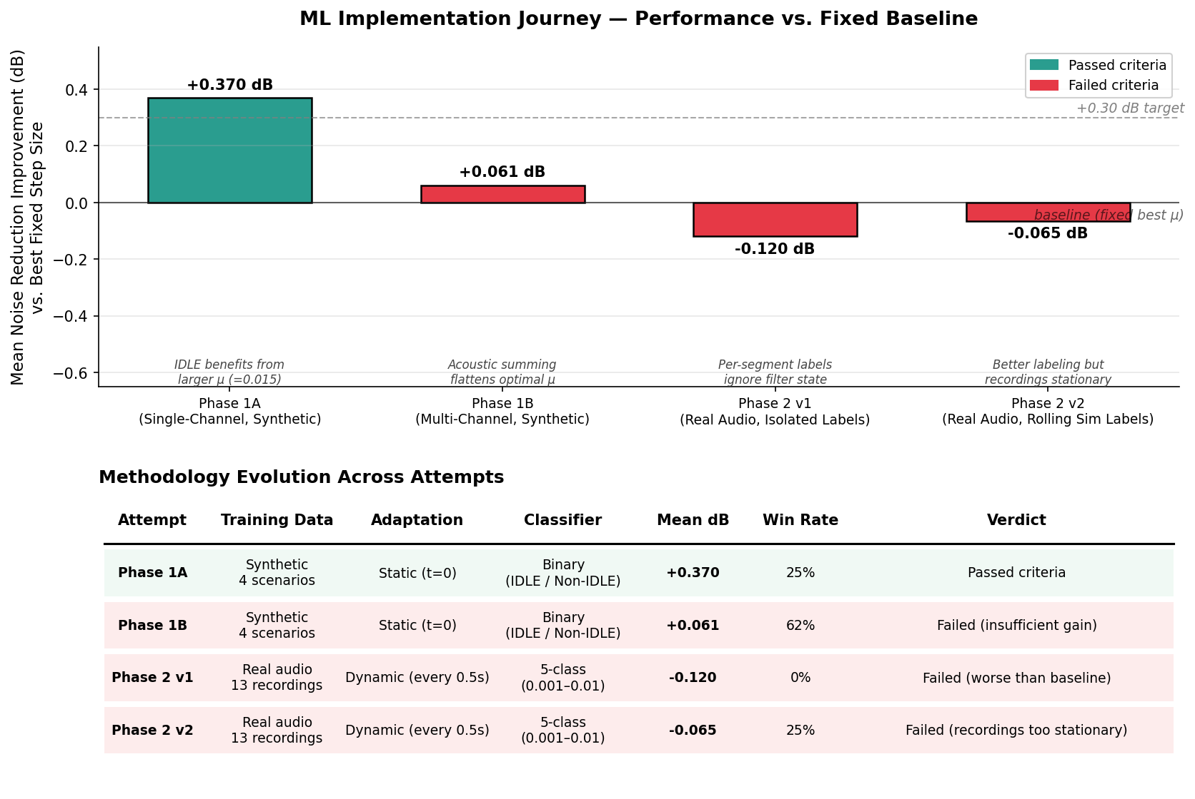
ML journey: four step-size selectors evaluated against a fixed-μ baseline
The first attempt (single-channel, synthetic, static classification at t = 0) produced a small +0.37 dB mean improvement. The second retrained the same classifier on the four-loudspeaker configuration and the result collapsed to +0.06 dB — acoustic summing across four loudspeakers flattened the optimal step-size landscape, leaving almost nothing for the classifier to exploit. The third pivoted to real recordings with dynamic per-segment labelling and produced −0.12 dB; the per-segment labelling was wrong because it ignored that FxLMS weights carry across segment boundaries. The fourth fixed the labelling with a rolling-simulation lookahead and reached −0.07 dB — better label distribution, still worse than the fixed-μ baseline.
The fundamental observation is that FxLMS is itself an adaptive algorithm operating at the sample rate — at $fs = 16 kHz$, the controller updates its weights roughly 16,000 times per second, leaving very little room for a 0.5-second-granularity classifier to add value. Adding a classifier on top to choose the FxLMS step size is a form of meta-learning that only contributes when the optimal hyperparameters change faster than the underlying adaptive algorithm can self-tune; our short, internally-consistent recordings of a single driving condition do not provide such variation.

ML thread B — Full-ML control with a TCN
A second, more ambitious thread investigated replacing the FxLMS controller entirely with a Temporal Convolutional Network that learns a non-linear mapping from a window of recent reference samples to the next anti-noise sample. The model used causal dilated 1-D convolutions (kernel sizes 3–5, dilation factors 1, 2, 4 …, receptive fields up to several hundred samples to span one full cycle of the engine fundamental near 50 Hz) and a tanh output to constrain the predicted control sample within the loudspeaker's amplitude range.
The crucial design correction was to include the secondary path inside the training loss. The network does not predict the unwanted noise at the ear; it predicts an electrical control signal u(n) that is then convolved with the secondary-path impulse response $ĥ_{s(n)}$ inside the differentiable training loop. The loss is the residual after acoustic propagation, $e(n) = d(n) + (u * ĥ_{s})(n)$ — the neural analogue of the filtered-x idea. Optimising on the raw network output without this physical layer in the loss produced waveforms that looked plausible electrically but amplified the sound field after passing through the loudspeaker.
A sequence of variants was trained: a baseline TCN with secondary-path loss (full-band mean +2.17 dB, engine-band +3.26 dB); a tanh-output amplitude-bounded variant with frequency-weighted loss (collapsed to −9.7 dB; loss shaping alone failed to fix phase); an RIR-pre-filtered variant where the reference was preconditioned with the room impulse response (≈ +8.9 dB in a controlled setting); and a late-stage cascaded magnitude-and-phase TCN, which remained inconsistent on blind scenarios. Dominant failure modes: amplitude overshoot, weak phase correlation, high-frequency amplification accompanying low-frequency cancellation, and a large generalisation gap to unseen reflective cabins. The TCN branch did not become the deployed solution. The diagnostics it produced reveal the headline limitation of black-box ANC: a neural controller lacks the microsecond phase and amplitude precision required for physical destructive interference unless that precision is enforced structurally — through causality (a positive primary-minus-secondary-path delay budget), explicit secondary-path compensation, bounded amplitude, and anti-phase alignment after acoustic propagation. Every one of these is enforced by FxLMS for free, which is why the project's contribution shifted to physics-structured MIMO.

Analysis of Results

Headline numbers
The five algorithm variants were evaluated on the three real driving scenarios from Chapter 3. Noise reduction is measured at the driver-ear position (or, for the multi-error configurations, averaged across the four head-zone microphones), as $10·\log_{10}$ of the ratio of desired-signal power to residual error power, evaluated over the second half of the simulation. Convergence time is the wall-clock time at which the windowed error reaches 90% of its final attenuation.
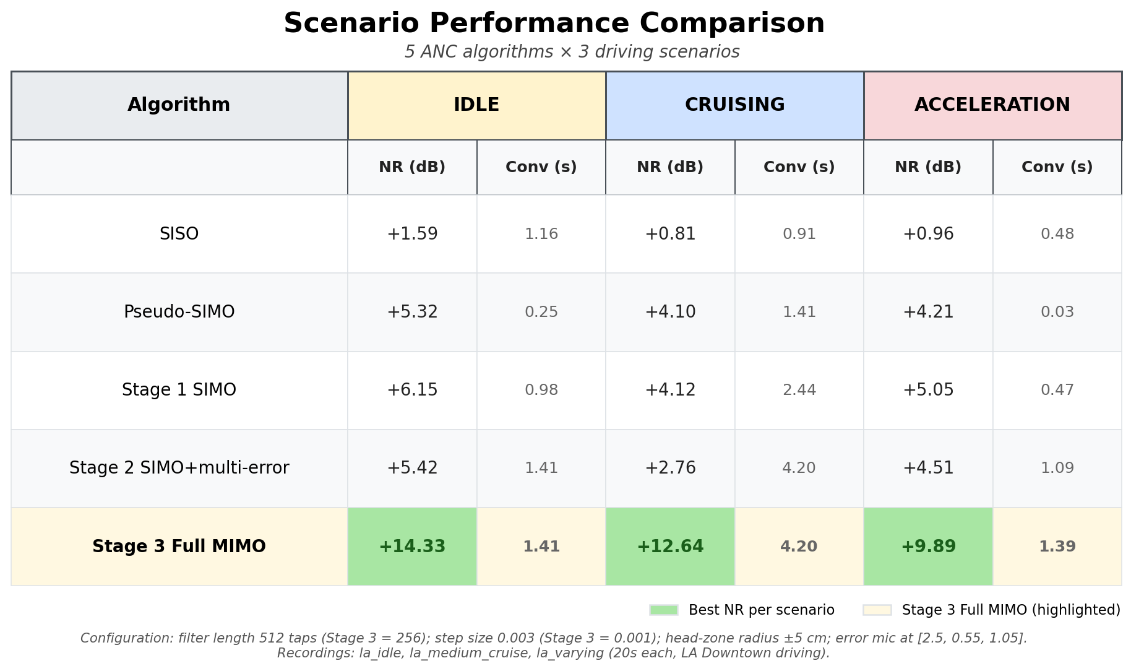
Five-algorithm × three-scenario performance comparison
Three observations. First, every multi-channel variant beats SISO by several decibels — adding loudspeakers helps regardless of how the filter is structured. Second, the move from pseudo-SIMO to Stage 1 SIMO is small (≈+1 dB); most of the multi-loudspeaker gain comes from simply having more loudspeakers. Third, the move from Stage 2 to Stage 3 (adding multi-reference inputs) is large — +9 dB on idle, +10 dB on cruising — the dominant benefit of MIMO is not the multi-error formulation but the multi-reference inputs that let the controller exploit different propagation paths from the noise source. A separate position-optimisation study confirmed that placing the reference microphone close to the noise source and the loudspeaker close to the listener contributes a further +6 to +8 dB on top of any controller, swamping any algorithmic gain.

Spatial structure of the cancellation field
A point measurement at the driver ear is informative but does not reveal what happens elsewhere. We compute, for each algorithm, a 5 × 5 cm grid of evaluation microphones at driver-ear height across the entire 4.5 × 1.85 m cabin and run the controllers with frozen weights to measure the noise reduction at every grid point.
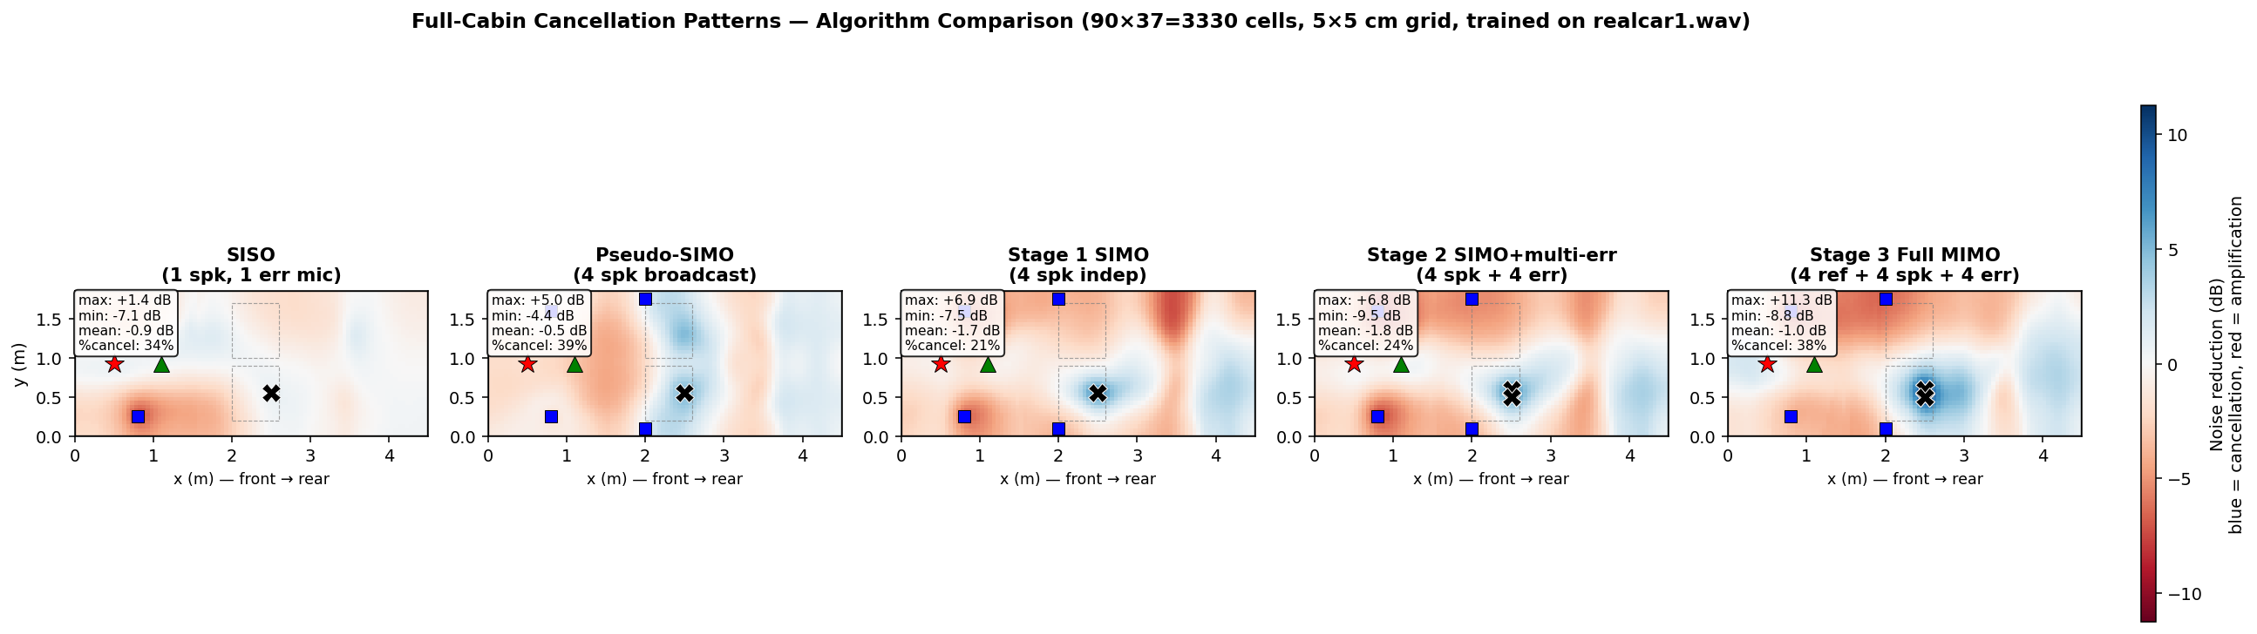
Full-cabin cancellation patterns for all five algorithms (la_varying.wav, 5 × 5 cm grid)
The heatmaps show the central trade-off of ANC. Around the error microphones every algorithm produces a deep zone of quiet — Stage 3 reaches more than 25 dB attenuation locally — but outside that zone the cancellation field is far from uniform. SISO has a sharply localised quiet point and amplifies noise (red regions) over roughly three quarters of the cabin. Pseudo-SIMO smears the quiet zone wider but also amplifies less. Stage 2 produces a uniform head-zone quiet zone but pays for it with deeper amplification elsewhere — the strict waterbed trade-off. Stage 3 has a similar amplification footprint to Stage 1 outside the head zone: more degrees of freedom enable deeper local cancellation but cannot eliminate the redistribution of acoustic energy.
For the SISO controller the quiet zone collapses to ≤+5 dB within five centimetres of the error microphone — consistent with the classical result that single-error ANC produces a quiet sphere of radius approximately one tenth of a wavelength at the dominant frequency. The multi-error configurations of Stage 2 and Stage 3 maintain >+10 dB attenuation across a 10 cm head-zone radius before degrading, which is the practically-useful regime: a listener can move their head freely within the head-rest area without losing the cancellation.

Known Limitations
The simulator captures geometry, image-source reflections up to order 3, and frequency-dependent surface absorption, but it does not model loudspeaker non-linearities, microphone self-noise, transducer back-coupling, or the complex acoustics of a real upholstered cabin. The 5% secondary-path estimation error is a lower bound on what offline identification can achieve; in real deployment the secondary path drifts with temperature, occupant load and seat configuration, and would need to be re-identified online. The performance numbers above should therefore be read as upper bounds attainable in a controlled environment, not as predictions of what would happen in a production vehicle without further engineering.

Conclusions and Further Work

Project goals revisited
The project set itself three quantitative objectives in Chapter 1: at least 10 dB of noise reduction at the driver ear, stable convergence in under two seconds, and a controller that operates on real recorded driving noise. All three are met by the Stage 3 Full MIMO controller — +14.3 dB on idle and +9.9 dB on the most challenging acceleration scenario, with convergence in 1.4 s. The lower-complexity SIMO variants produce 4–6 dB of attenuation, sufficient for many use cases, with a fraction of the compute and parameter budget. Position optimisation contributes 6–8 dB on top of any controller — a reminder that for ANC the placement of the transducers is at least as important as the algorithm.

Lessons learned
Three findings are relevant beyond the immediate scope. First, the strict ANC taxonomy (SISO / SIMO / MIMO based on input and output counts) matters: pseudo-SIMO is strictly less powerful than true SIMO, which is in turn less powerful than full MIMO. Second, the largest gain in this project came from physics, not algorithms — moving transducers closer to the source and listener swamped any algorithmic gain. Third, both ML directions failed to beat the structured FxLMS baseline in our deployment regime; ML can only contribute when the optimal hyperparameters or controller behaviour change faster than the underlying adaptive algorithm can self-tune, or when explicit physics structure is built into the model.

Suggestions and future work
Three improvements would address the largest remaining limitations: **online secondary-path identification** (a small parallel adaptive filter excited by a low-amplitude probe would track drift with temperature and seat position, recovering several decibels currently lost to model mismatch); a **vectorised Stage 3 implementation** (the Python version runs at ≈13× real time per channel — a C/SIMD or GPU port would unlock its quantitative advantage in deployment); and a **larger head zone with more loudspeakers** (doubling the head-zone radius beyond ±5 cm requires either more loudspeakers from different positions or a different acoustic strategy such as headrest-integrated personal-audio drivers).
Promising follow-on directions: **long-form non-stationary recordings** (a 30+ minute drive with genuine transitions between idle, cruising and acceleration would let the ML step-size selector show its value); **improved neural ANC** (the cascaded magnitude-and-phase TCN combined with RIR pre-filtering is the most promising of the unsuccessful variants and merits a dedicated follow-up); **real-cabin measurements** (validating the simulator predictions against measurements in a parked vehicle); and a **real-time hardware port** of Stages 1–2, which would expose engineering issues — quantisation, fixed-point, latency budget — that the simulator deliberately abstracts away.

Project Documentation

Repository
All source code, simulation scripts, evaluation tools, plots and intermediate data referenced in this report are available in the public GitHub repository at the URL listed below. Following the course requirement, this report does not embed source code listings; readers are expected to consult the repository for exact implementations.
Repository URL: https://github.com/yuvalhorowitz/ANC-simulation-project-FxLMS.git

Repository layout
`src/core/` — algorithm implementations: `fxlms.py` (scalar FxNLMS) and `mimo_fxnlms*.py` (Stages 1, 2, 3).
`src/acoustic/`, `src/noise/`, `src/ml/` — acoustic-path extraction, real-noise loading, and ML code (the TCN and the four step-size classifiers).
`simulations_pyroom/` — incremental simulator scripts (`step1` through `step8`) plus the Stage 1–3 MIMO evaluation scripts that produced the JSON files in `output/data/mimo/`.
`scripts/plots/` — plot-generation scripts for every figure in this report.
`scripts/book/` — this report's generation pipeline (`build_book.py` plus the per-chapter `.md` files in `scripts/book/content/`).
`playground/` — an interactive Streamlit application (`playground/app.py`) that exposes the full controller stack with a graphical interface.
`output/` — generated artefacts: plots in `output/plots/`, JSON evaluation results in `output/data/`, audio renderings in `output/audio/`, and this report in `output/book/`.
`docs/` — narrative documentation used as primary source material for this report (notably `mimo_results.md`, `ml_journey.md`, `position_optimization.md`, `fxlms_explained.md`).

How to reproduce the figures and the report
Every figure in this report is generated by a script that can be re-run end-to-
end (`python scripts/plots/<name>.py`). The headline JSON file used to populate the results table is generated by `python simulations_pyroom/mimo/evaluate_scenarios.py`. After editing the per-chapter `.md` files in `scripts/book/content/`, the report itself is regenerated by running `python scripts/book/build_book.py`; opening the result in Word and pressing F9 once refreshes the table of contents and figure-number cross-references.

Interactive playground
The recommended entry point for exploring the work is the playground. After installing the Python dependencies (`pip install -r requirements.txt`), run `streamlit run playground/app.py` and open http://localhost:8501. The page exposes scenario / audio source selection, algorithm switching (SISO and the three MIMO stages), loudspeaker / microphone position sliders, filter parameters, a noise-reduction summary, time-domain error traces, filter-tap evolution heatmaps and side-by-side audio comparisons (original vs cancelled) with download buttons. Every result table and heatmap in this report can be reproduced through the playground.
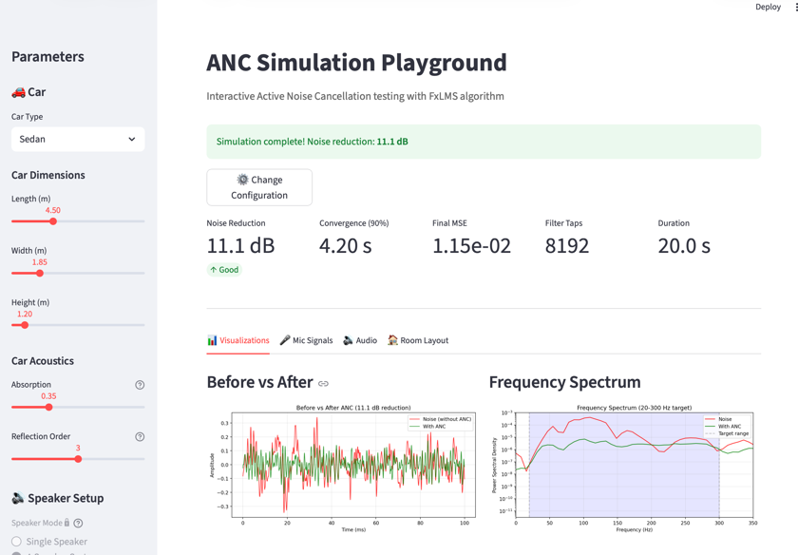
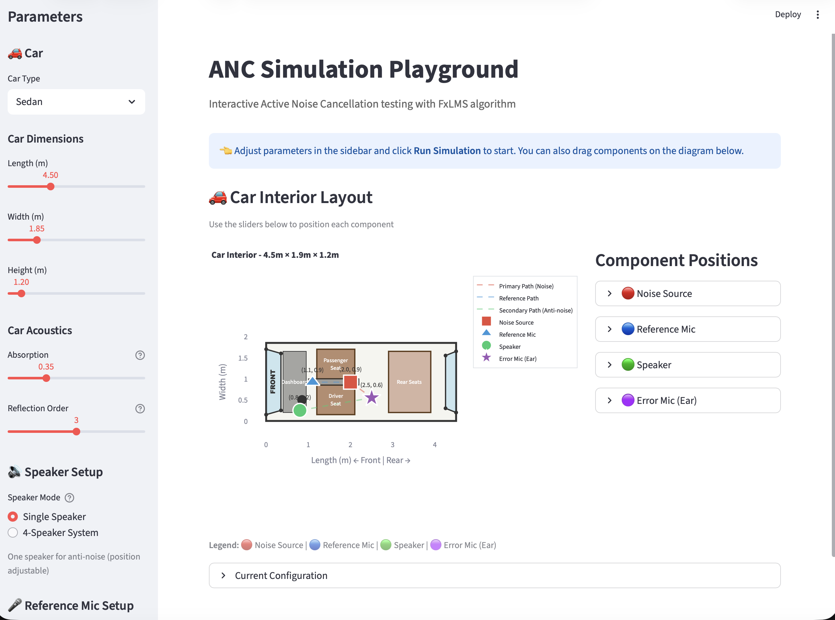
ANC Simulation Playground

References

Books
S. M. Kuo and D. R. Morgan, *Active Noise Control Systems: Algorithms and DSP Implementations*, John Wiley & Sons, New York, 1996.
B. Widrow and S. D. Stearns, *Adaptive Signal Processing*, Prentice-Hall, Englewood Cliffs NJ, 1985.
S. Haykin, *Adaptive Filter Theory*, 5th ed., Pearson, Upper Saddle River NJ, 2014.
C. H. Hansen et al., *Active Control of Noise and Vibration*, 2nd ed., CRC Press, Boca Raton FL, 2013.

Papers
J. C. Burgess, "Active adaptive sound control in a duct: A computer simulation", *J. Acoustic. Soc. Am.*, vol. 70, no. 3, pp. 715–726, Sept. 1981.
D. R. Morgan, "An analysis of multiple correlation cancellation loops with a filter in the auxiliary path", *IEEE Trans. ASSP*, vol. 28, no. 4, pp. 454–467, Aug. 1980.
S. M. Kuo and D. R. Morgan, "Active noise control: A tutorial review", *Proc. IEEE*, vol. 87, no. 6, pp. 943–973, June 1999.
E. Bjarnason, "Analysis of the filtered-X LMS algorithm", *IEEE Trans. Speech Audio Proc.*, vol. 3, no. 6, pp. 504–514, Nov. 1995.
M. Bouchard and S. Quednau, "Multichannel RLS and FTF algorithms for active noise control and sound reproduction", *IEEE Trans. Speech Audio Proc.*, vol. 8, no. 5, pp. 606–618, Sept. 2000.
S. Bai, J. Z. Kolter and V. Koltun, "An empirical evaluation of generic convolutional and recurrent networks for sequence modeling", *arXiv:1803.01271*, 2018 (TCN reference).

Software
R. Scheibler, E. Bezzam and I. Dokmanić, "Pyroomacoustics: A Python package for audio room simulation and array processing algorithms", *ICASSP 2018*, pp. 351–355.
Streamlit Inc., "Streamlit", https://streamlit.io
C. R. Harris et al., "Array programming with NumPy", *Nature*, vol. 585, pp. 357–362, 2020.

