Python
Objects and numbers
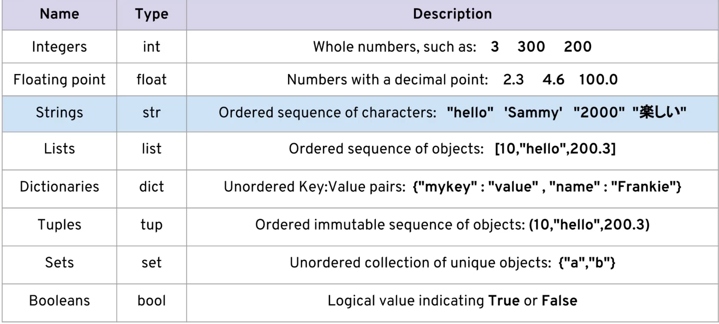

Division / - allows us to divide numbers, python uses true division so it can return float and integers example 1/2 = 0.5
%/ modulo = allows you to see what remains after a number split example: 48%5 = 3
Data type – in python it is possible to assign a different type of data to the same name example: dog = mika, then later write dog = 15
Indexing: its good to note that it isn’t possible to change a single letter in a string using index
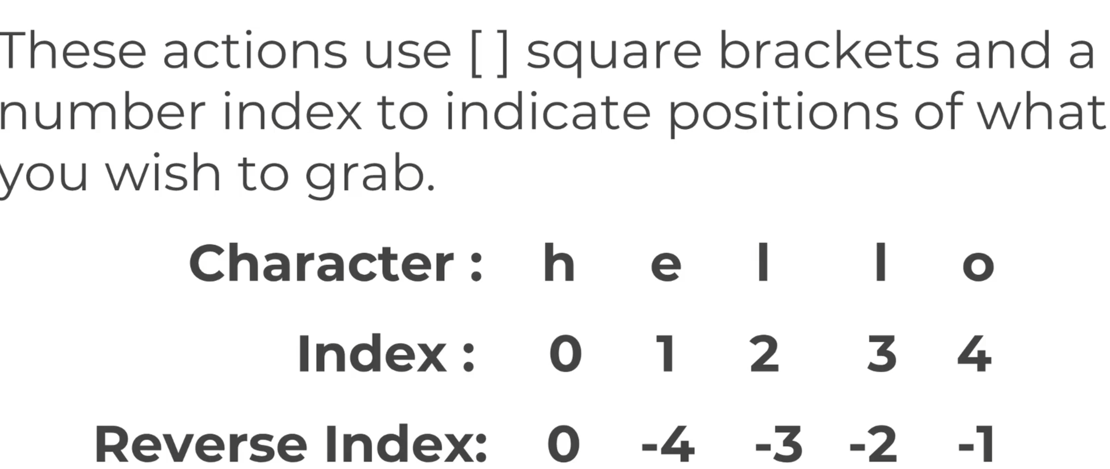
String interposition – in python if you want to print a variable inside your string it is possible to use print(f"{name} hello world") name is our variable and we use the f at the start to let print know that we are giving it a variable to add to the string

