Proximity model train detection system

# Introduction

This document describes the protocol used to interface with the proximity model train detection system. The system is based on the ST Electronics VL6180X time of flight sensor. This sensor can measure the distance between the sensor and an object in range of up to 15cm. Sensors are placed between the tracks and thus can detect if there is a car or a locomotive standing above it (see illustration):

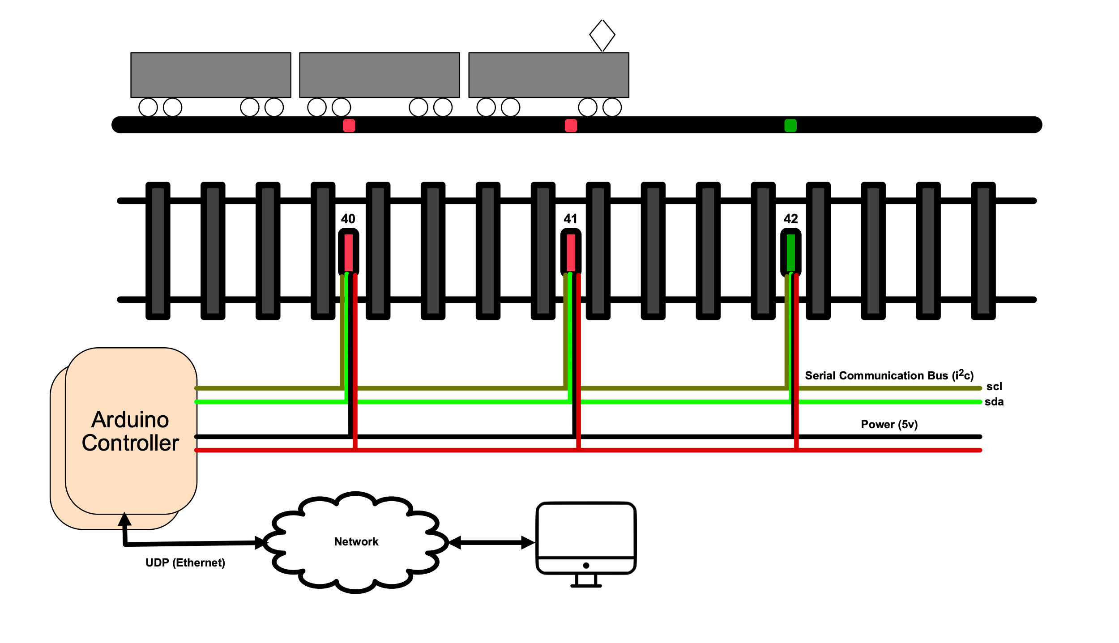

The sensors are daisy chained via a serial bus (i2c). Each sensor has a unique address. The chain is managed via a controller (probably Arduino board)

# Configuration

The configuration protocol is used to allow over the network configuration of the parameters (IP address, netmask, default gateway) needed for UDP communication.

## Identify

The identify command is sent via broadcast. Each controller answers with its unique Mac address, current IP parameters, firmware version and an optional name.

## Configure

The configure packet is broadcasted. It contains the unique Mac address of the controller to be configured. It also contains the controller’s new IP configuration and a descriptive name. The controller replies with a configuration-done packet.

## Blink

The blink packet is broadcasted. It contains the controller unique Mac address. The controller with this address visually identifies itself (for example by blinking its on-board led).

## Unblink

The unblink packet is broadcasted. It contains the controller unique Mac address. The controller with this address stops to visually identifies itself.

# Operational Protocol

## Application originated messages

Each message contains a sequence number which should be included in reply packet. If a reply packet with the sequence number is not received within a timeout, the message is sent again. If reply is not received after a set number of retries, the controller is not responsive.

### Get current state

The get current state packet asks the controller to return the current state of the attached sensors. The returned packet contains:

* The sequence number of the request packet
* The number of attached sensors. For each attached sensor the following data is included:
  + Sensor number (its i2c bus address)
  + ON/OFF (ON if something is above the sensor, OFF is nothing is above the sensor)
  + Actual reading in mm.
  + Changed flag (always TRUE)

### Subscribe

The controller will start sending state changed packets to originator of this message. The controller will reply with a Subscribe accepted message containing the subscribe message’s sequence number.

### Unsubscribe

The controller will stop sending state changed packets to originator of this message. The controller will reply with a Unsubscribe accepted message containing the unsubscribe message’s sequence number.

# Controller Notifications

When a ON/OFF state of an attached sensor is changed, the controller will send a notification to its subscribers. The notification contains:

* Generated sequence number
* The number of attached sensors. For each attached sensor the following data is included:
  + Sensor number (its i2c bus address)
  + ON/OFF (ON if something is above the sensor, OFF is nothing is above the sensor)
  + Actual reading in mm.
  + Changed flag (TRUE if ON/OFF state changed)

Upon reception, the subscriber sends a “notification acknowledged” message with the sequence number it received in the notification message.

If a notification acknowledged message is not received within a timeout from a given subscriber, the notification message is sent again. If after set number of retries a notification acknowledged message is not received, the subscriber is unsubscribed.

Upon receiving of a notification acknowledged message from all subscribers, a Changed flag for all the attached sensors is set to FALSE.

This notification process described above starts whenever an attached sensor ON/OFF state is changed. This could mean that a new notification process can be started again (with a new sequence number) before a notification acknowledged message was received from all subscribers. In this case, the notification acknowledged message with the previous sequence number is ignored.