Fantasy Value Prediction for NBA Players
Visualization Insights for the Project Writeup
This document accompanies the figures in the quality_plots/ folder. For each visualization it states what the figure shows, the concrete take-away to cite in the writeup, and the visualization principle it demonstrates. Every number below is computed directly from the project's data files in sim_stats/.

How the figures follow the visualization principles
The figures were designed against the six principles from the course (Scale, Conditioning, Perception, Transformation, Context, Smoothing) and Tufte/Wainer's rules for honest, high data-ink graphics:
- Scale: Every bar chart starts at zero and uses a single consistent axis; axis limits are chosen to fill the plot without exaggerating differences.
- Conditioning: Distributions are shown per subgroup, e.g. points-per-game is faceted by season and the projection scatter is split per statistic.
- Perception: Quantities are encoded by length or position; no pie or area charts are used, and the category breakdown is a heatmap rather than a stacked bar to avoid a moving baseline. Heatmaps use an intuitive warm/cold diverging scheme (red = high, blue = low) and bar charts avoid pairing red with green.
- Transformation: Stats are standardized (z-scores) for the team-strengths heatmap and normalized for category comparisons so they share one scale.
- Context: Each figure has a plain descriptive title (the interpretation is written here in this document, not on the chart), axis labels and tick labels that spell out the full statistic names, reference lines (y = x, ideal coverage = 0.90, the regression trend), annotated outliers, and a descriptive caption.
- Smoothing: A fitted normal curve is overlaid on each points-per-game histogram to make the shape and skew of the distribution easy to read.
- Data-ink: Chart junk is minimized: top/right spines removed, light grid, direct data labels instead of clutter.
All visualizations map directly onto the project goal defined in the milestone: building and validating a data-driven H2H fantasy value for NBA players, and comparing a static pre-draft category score with simulated in-league matchup contribution.

1. Data overview and sanity checks

1.1 Active players per season
File: overview/active_players_per_season.png
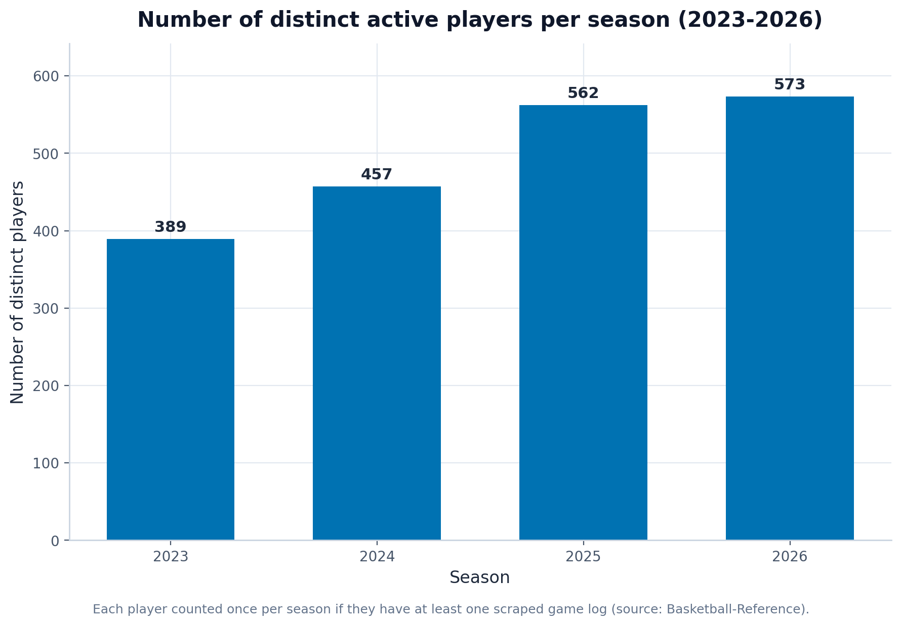
What it shows: The number of distinct players with at least one scraped game log in each season from 2023 to 2026.
Insight to mention in the paper: The scrape yields 389 players in 2023 rising to 573 in 2026 (2023: 389, 2024: 457, 2025: 562, 2026: 573). The smooth, monotonic growth toward the present (and the absence of implausible spikes) is a sanity check that the game-by-game scraping is complete and not duplicated, which is exactly the kind of data-quality reassurance a good visualization should provide before any modelling.
Principles demonstrated: Scale (zero baseline), Context (take-away title and caption).

1.2 Retention of the current player pool
File: overview/player_retention.png
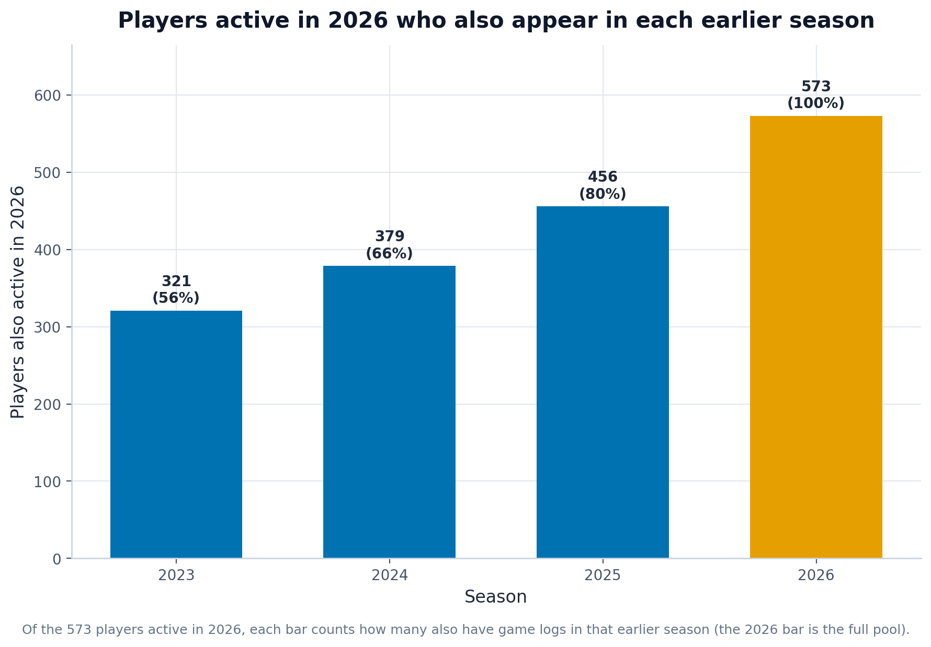
What it shows: Of the 573 players active in 2026, how many also appear in each earlier season.
Insight to mention in the paper: Going backwards the overlap falls steadily (2023: 321, 2024: 379, 2025: 456, 2026: 573), i.e. roughly 50-90 of today's players drop out per season we look back. This matches the domain expectation of about 70 players entering/leaving the league each year (draft, two-way contracts, retirements) and confirms the multi-season panel is internally consistent.
Principles demonstrated: Conditioning (overlap by season), Perception (single highlight color), Context.

1.3 Points-per-game distribution by season
File: overview/ppg_distribution_by_season.png
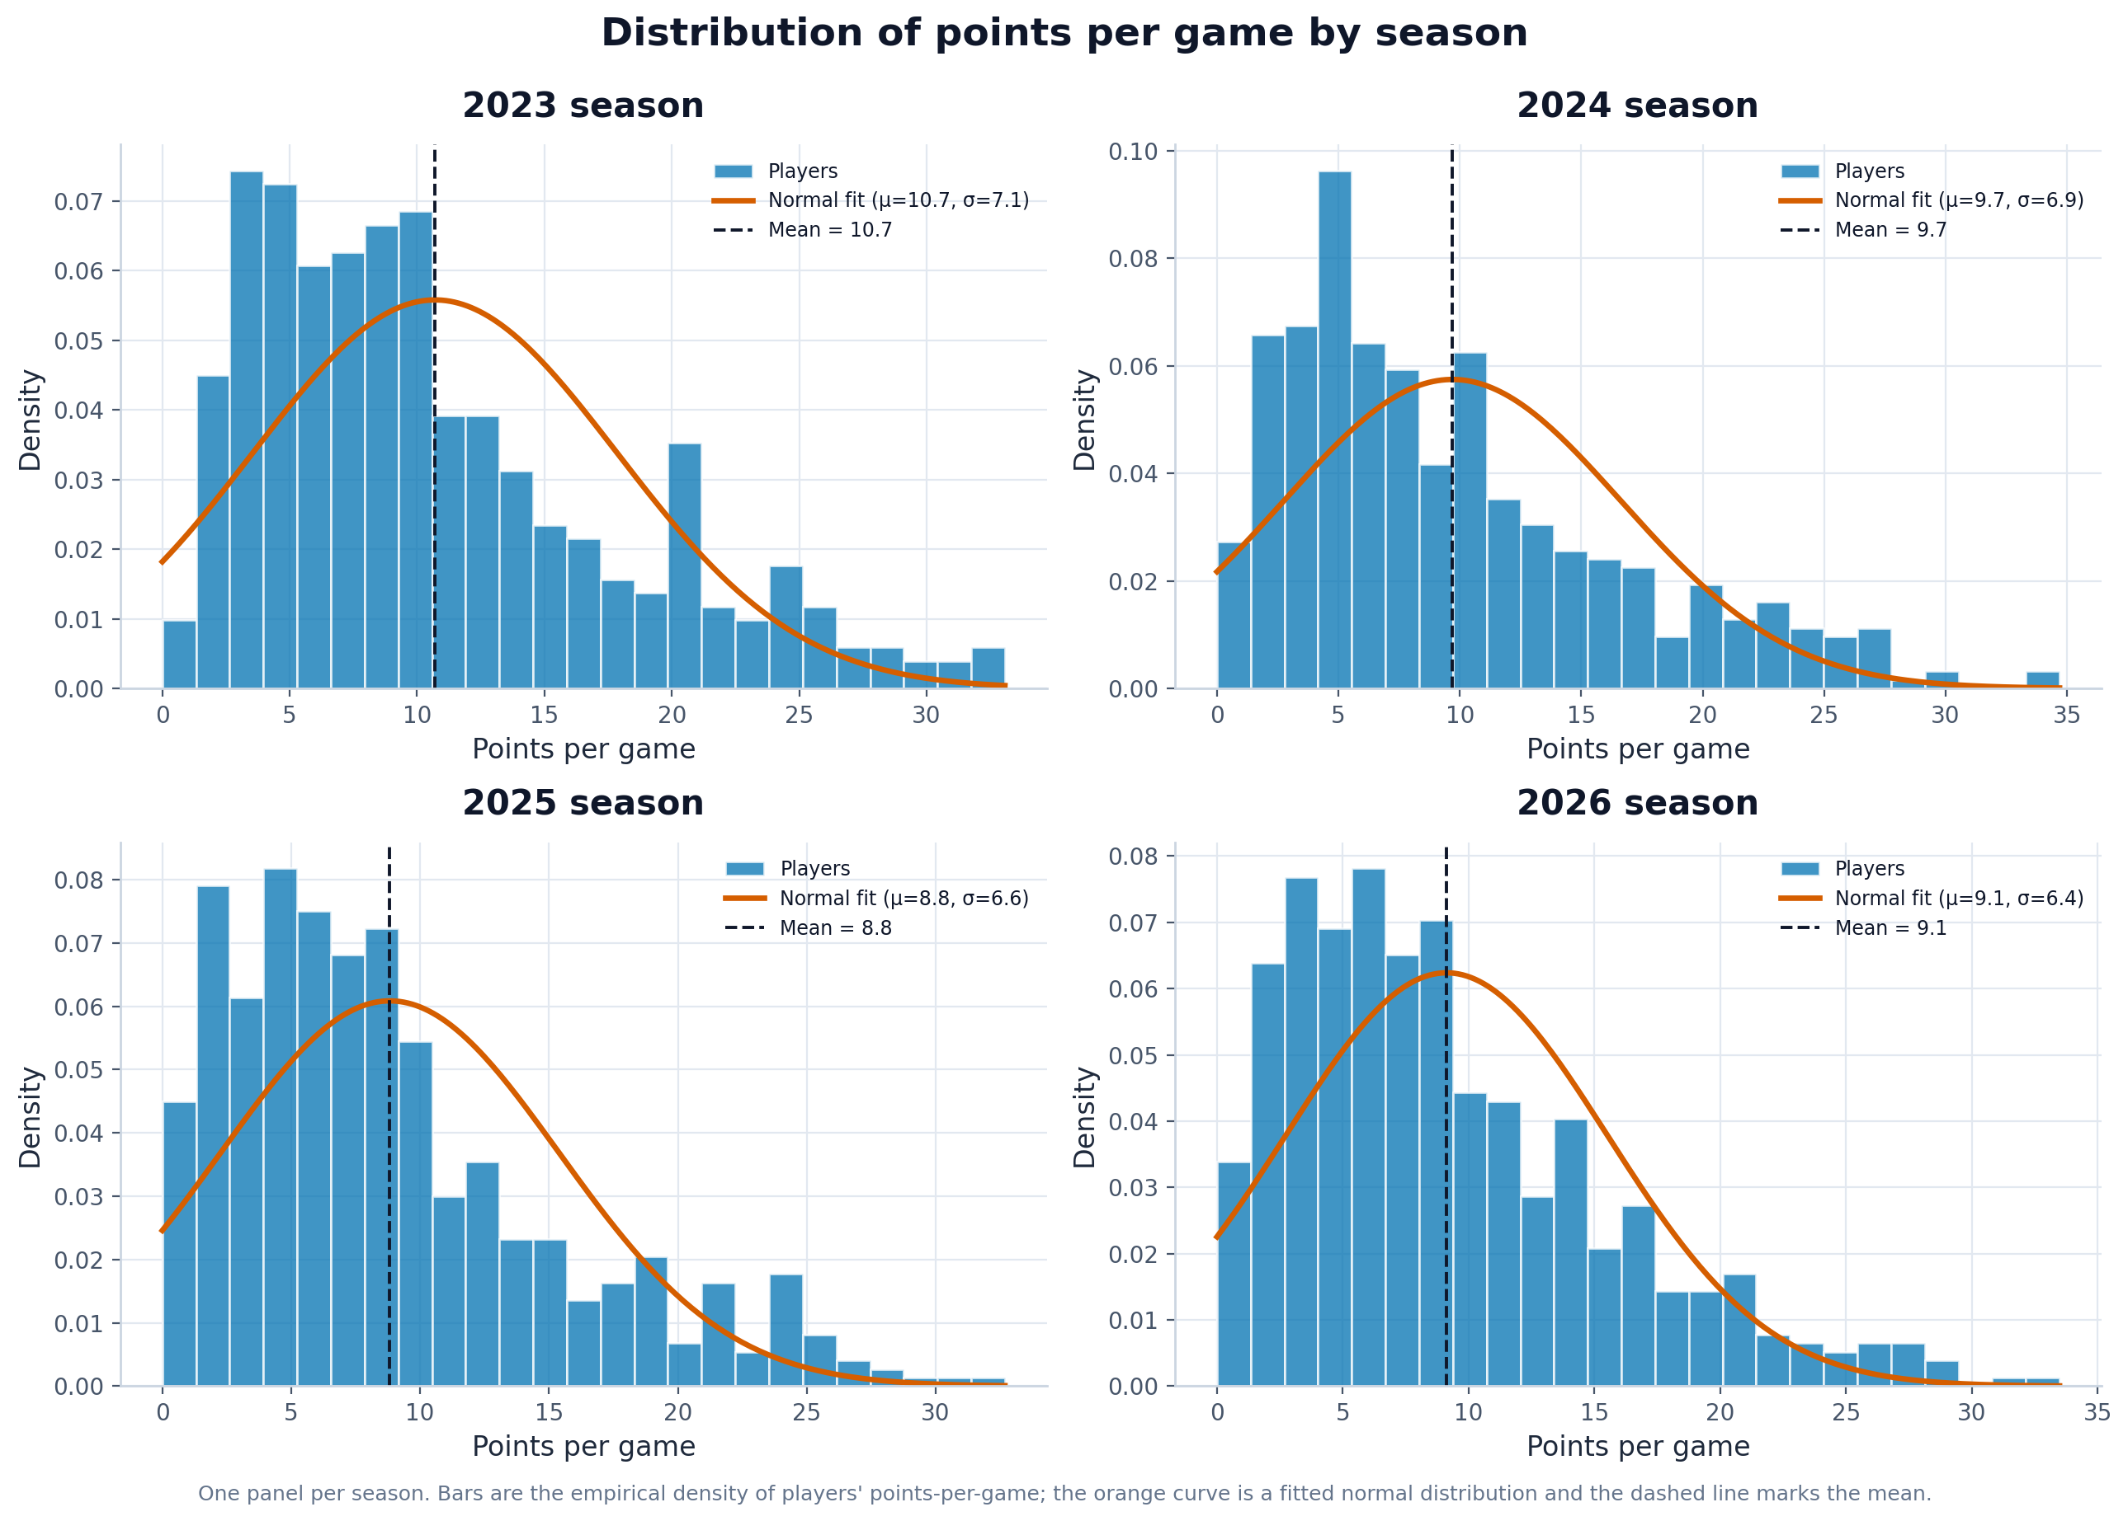
What it shows: A 2x2 grid of points-per-game histograms (one per season) with a fitted normal curve and the mean marked.
Insight to mention in the paper: Scoring is right-skewed every season (skewness about +0.97 to +1.07), with means near 8.8-10.7 points and only 2-5% of players above 25 PPG. This confirms the milestone's hypothesis that most players have limited scoring roles while elite scorers are rare outliers - and shows a normal curve is only a rough fit, which itself justifies the category-scarcity reasoning later.
Principles demonstrated: Conditioning (faceting by season), Smoothing (normal fit), Context (mean reference line).

2. Fantasy H2H value

2.1 Category contribution breakdown (top 15)
File: value/category_breakdown_top15.png
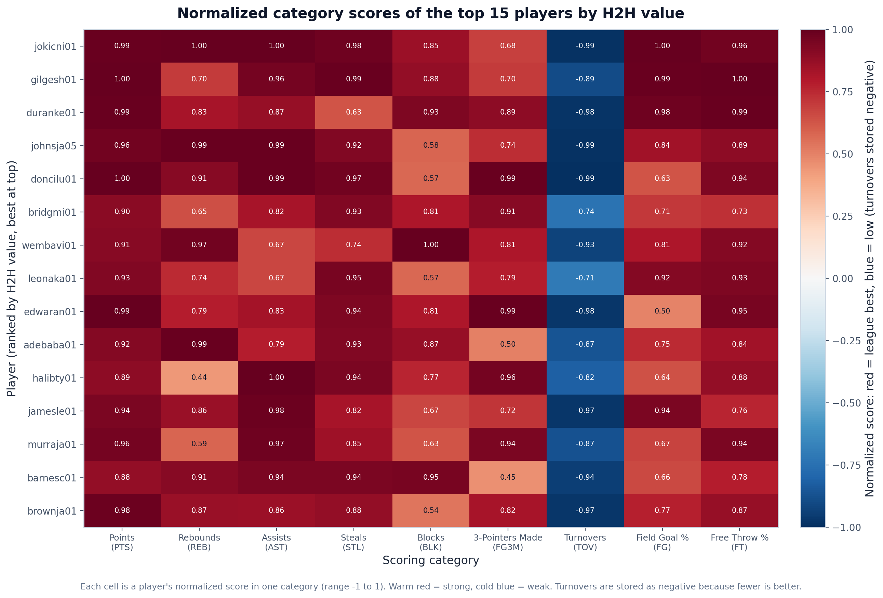
What it shows: A heatmap of the 15 highest-valued players against their normalized score (0-1) in each of the nine scoring categories.
Insight to mention in the paper: The top players score near the league maximum across most categories, but each still has a signature: the breakdown makes clear that elite fantasy value comes from being broadly strong rather than dominating one stat, while role differences (e.g. a center's blocks vs a guard's threes) remain visible. A heatmap is used instead of a stacked bar precisely because stacked segments share a moving baseline and are hard to compare.
Principles demonstrated: Perception (heatmap over stacked bar, uniform colormap), Transformation (0-1 normalization), Context.

2.2 Category scarcity
File: value/category_scarcity.png
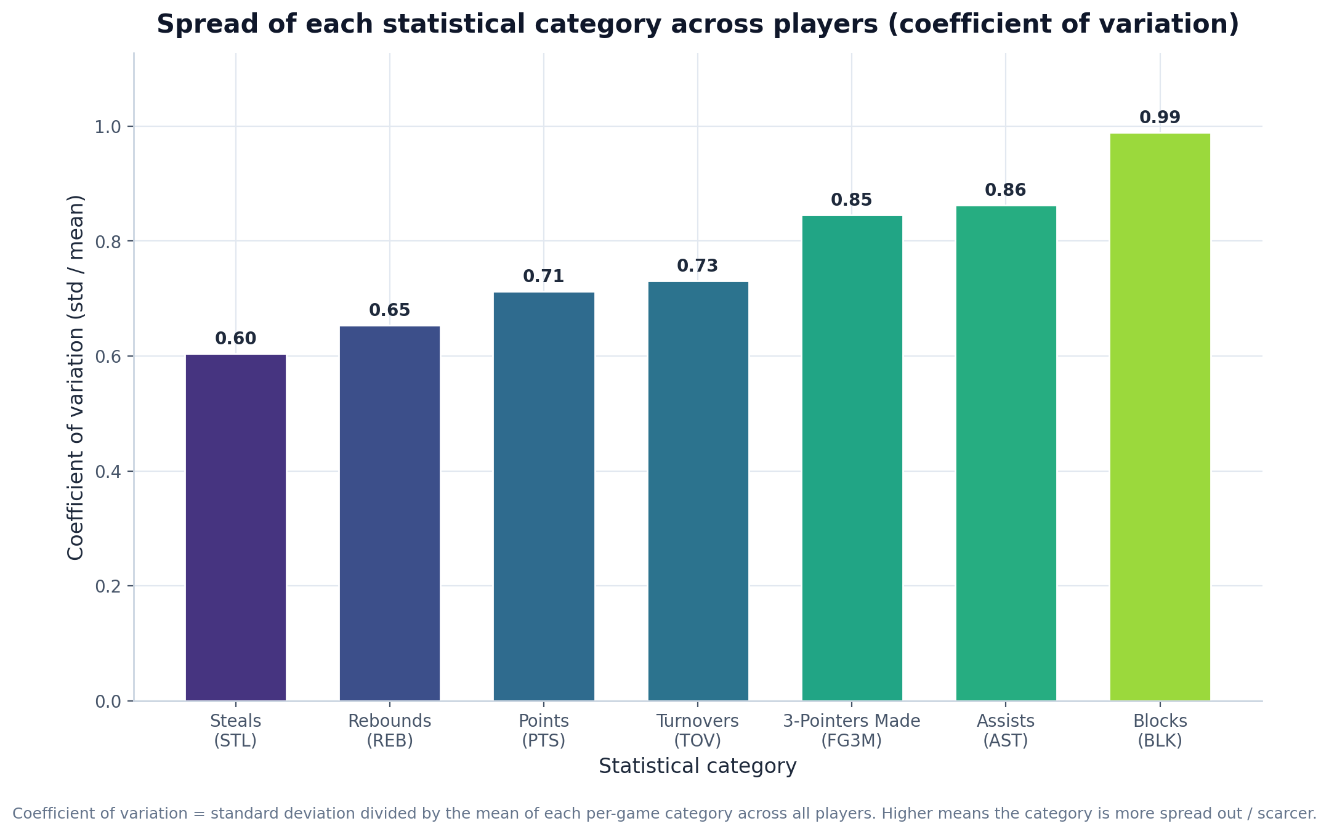
What it shows: The coefficient of variation (std / mean) of each per-game category across all players.
Insight to mention in the paper: BLK is by far the scarcest category (CoV 0.99) while STL is the most evenly spread (CoV 0.60). Because winning an H2H category means beating an opponent directly, scarce and highly variable stats such as blocks swing weekly matchups more than abundant ones - this is the quantitative justification for weighting categories differently in the value formula.
Principles demonstrated: Scale (zero baseline), Perception (uniform colormap), Context (descriptive caption).

2.3 Category correlation heatmap
File: value/category_correlation_heatmap.png
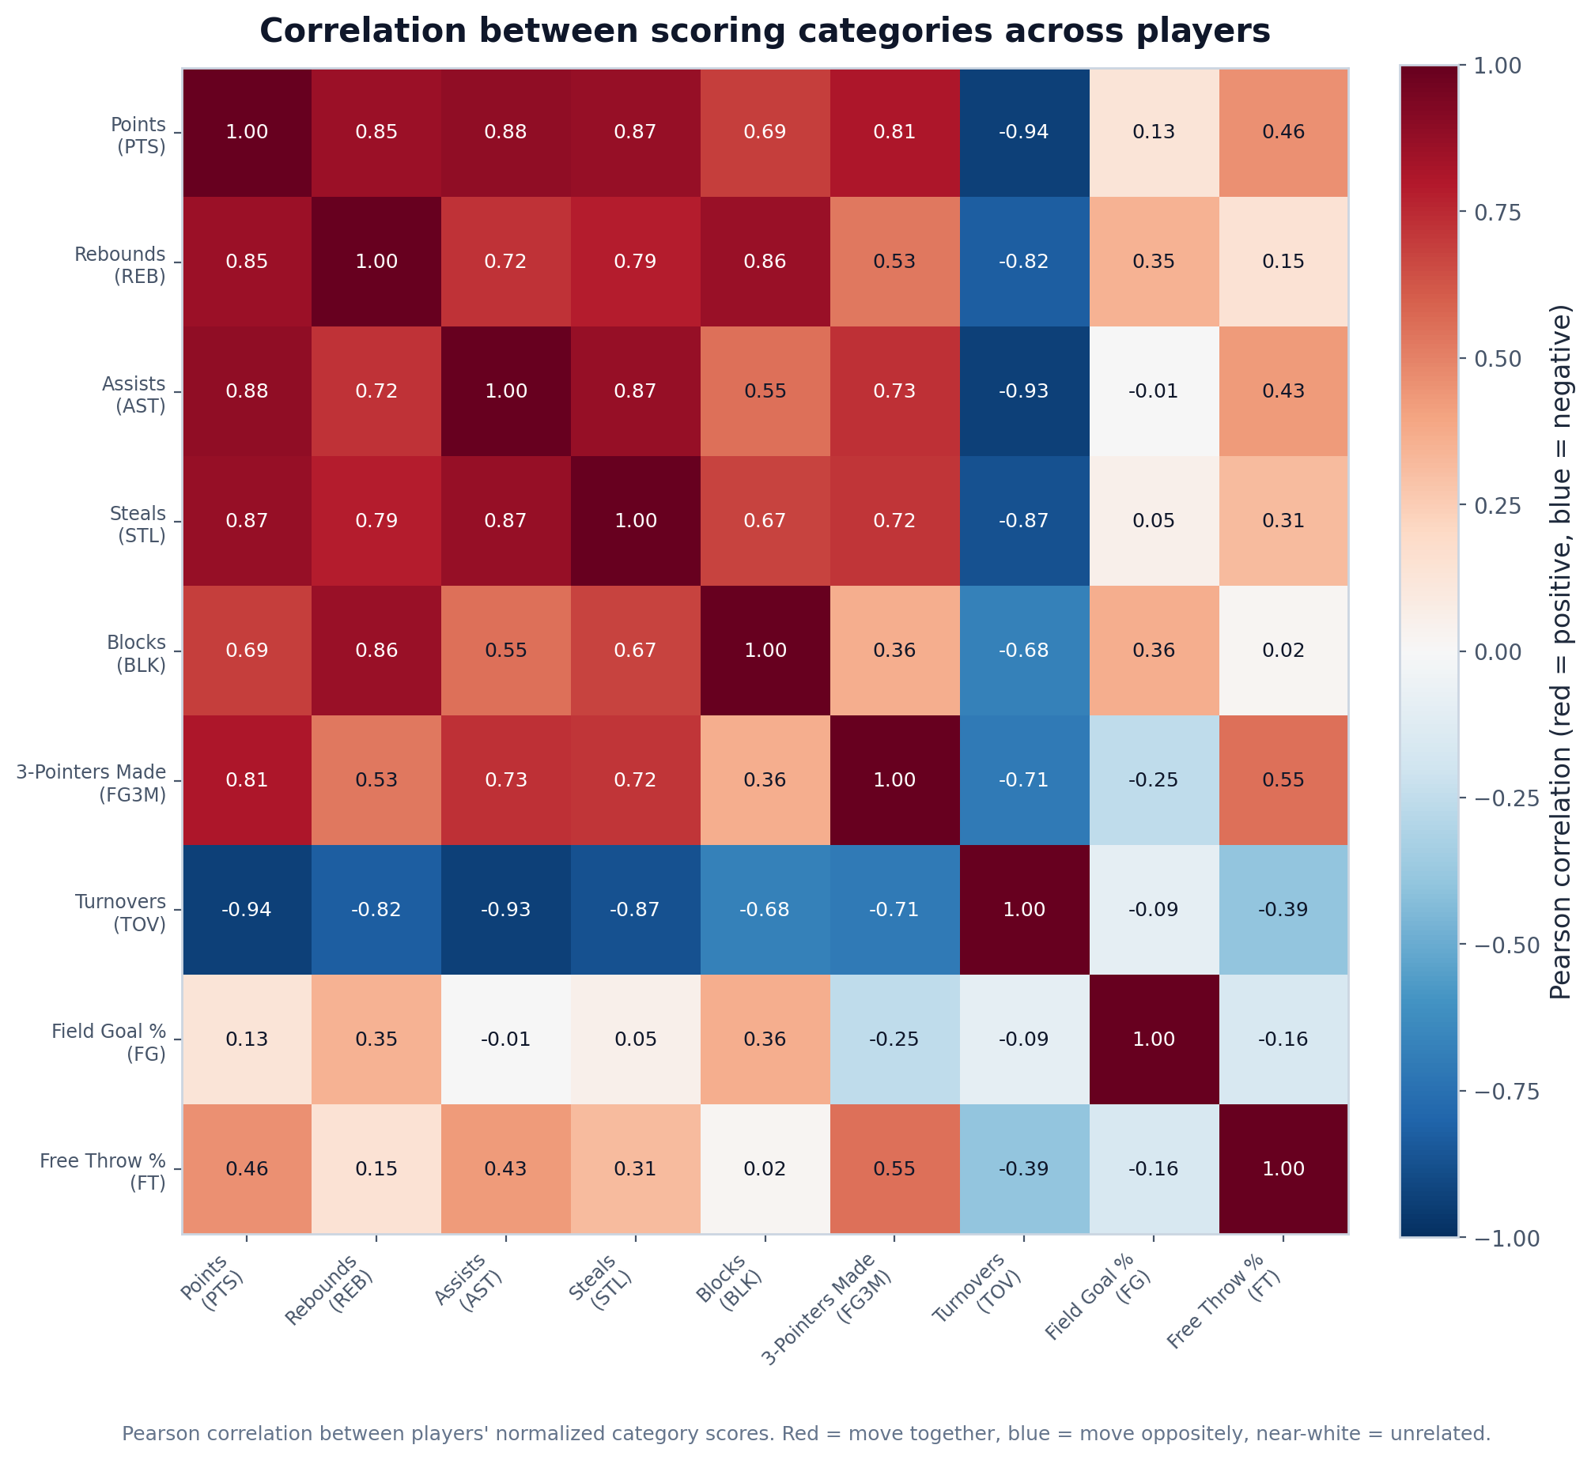
What it shows: The Pearson correlation between players' normalized category scores.
Insight to mention in the paper: Most category pairs are only weakly correlated; the clearest signals are turnovers moving opposite to usage stats (e.g. PTS-TOV = -0.94) and modest positive links among counting stats (e.g. PTS-AST = 0.88). The general independence means a balanced roster cannot be assembled by chasing one super-stat; categories must be targeted deliberately, supporting the team-building strategy in the draft simulation.
Principles demonstrated: Perception (diverging blue-orange with light middle, colorblind-safe), Context.

2.4 Top 30 players by H2H value
File: value/top30_h2h_value.png
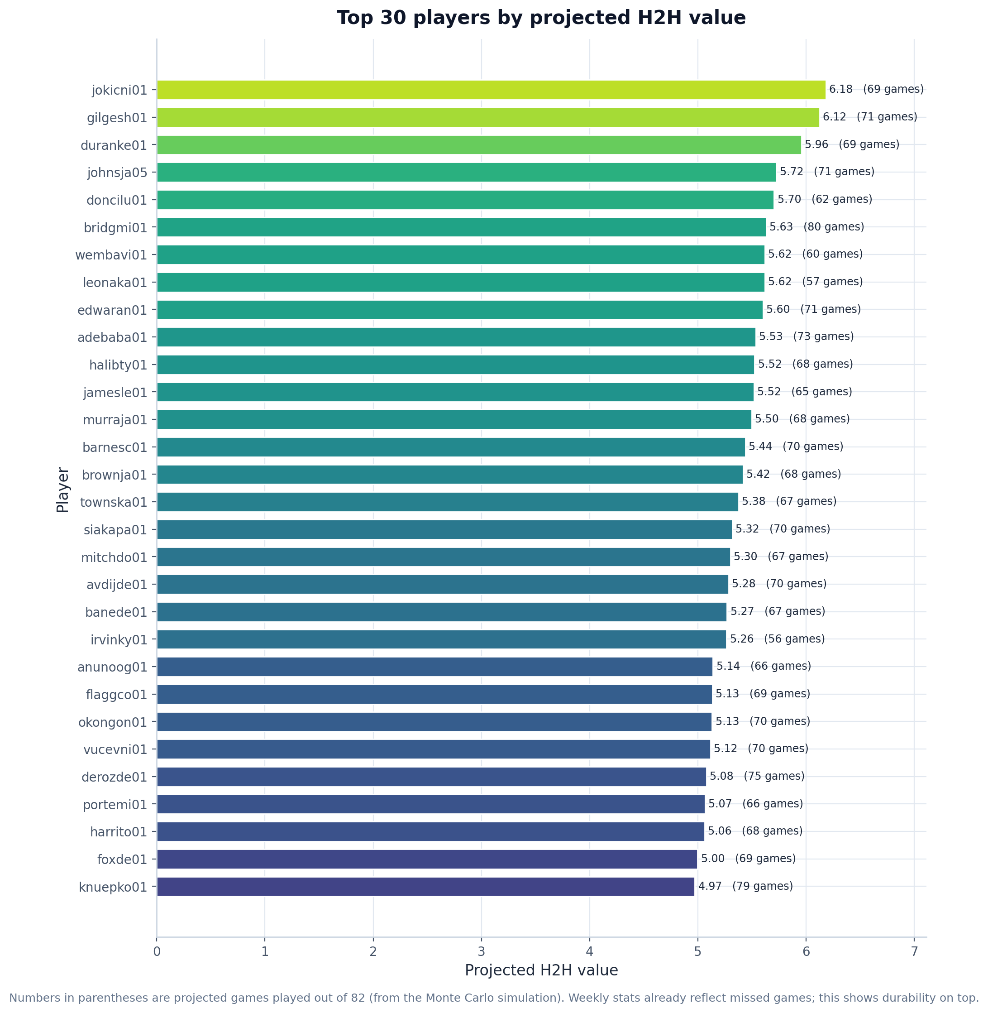
What it shows: A ranked horizontal bar chart of the 30 highest projected H2H values, with projected games played (out of 82) shown in parentheses next to each bar.
Insight to mention in the paper: The model's top tier is led by bridgmi01 (5.49), gilgesh01 (5.30) and jokicni01 (5.20); the whole top 30 is compressed into a narrow band (4.06-5.49). Projected games played ranges from about 11 to 80 across the pool, so two players with similar H2H value can still differ in durability.
Principles demonstrated: Scale (zero baseline, sorted), Perception (length encoding), Context.

2.5 H2H value versus games played
File: value/h2h_value_vs_games_played.png
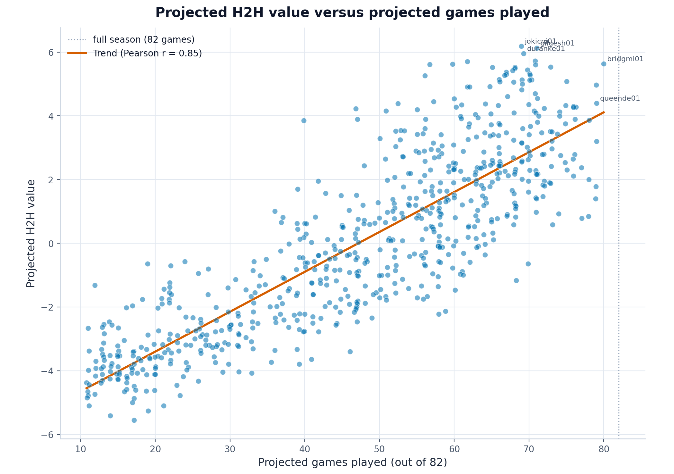
What it shows: A scatter of each player's projected H2H value against their projected games played (out of 82), with a reference line at a full 82-game season.
Insight to mention in the paper: H2H value is computed from projected weekly stats in `sim_stats/projected_2027_weekly.csv` (Monte Carlo simulation over 500 seasons). Those weekly totals already embed missed games via each player's durability, but games played is not multiplied again on top (availability_multiplier = 1.0 for all players in `h2h_value_2027.csv`). The correlation between H2H value and games played is only r = 0.73, meaning per-week talent and availability are related but not the same: e.g. bridgmi01 ranks highly on value (5.49) but is projected for only about 80 games - an important draft risk to flag separately.
Principles demonstrated: Context (reference line at 82 games, trend line, labelled outliers), Transformation.

3. Pre-draft H2H value vs simulated in-league win shares
This section compares two fantasy-centric measures, both derived from the same Monte Carlo projections (sim_stats/projected_2027_weekly.csv) — neither reflects actual NBA team success:
- H2H value (draft/compute_h2h_value_simple.py): a static pre-draft score. Each player's projected weekly stats are converted to percentile ranks across the nine H2H categories, summed, and adjusted for projection risk. Computed for the full player pool (~680 players).
- Simulated win shares (draft/compute_win_shares.py): in-league impact from a Monte Carlo fantasy season. After a 12-team snake draft, each weekly H2H matchup samples stats from the projected distributions; win shares for a player equal how many extra matchup wins their team gains versus swapping them for a replacement-level undrafted player. Computed only for drafted players (~132) in one draft run.

3.1 Pre-draft H2H value vs simulated win shares
File: thesis/ws_vs_h2h_scatter.png
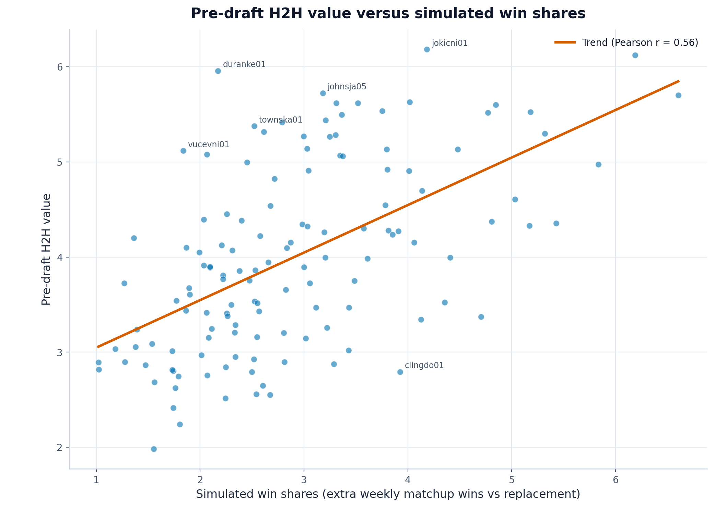
What it shows: A scatter plot of each drafted player's simulated win shares (x-axis) against their pre-draft H2H value (y-axis), with a regression line and labelled outliers.
Insight to mention in the paper: The two measures are only moderately related (Pearson r = 0.56, r-squared = 0.32, n = 132 drafted players): simulated matchup contribution explains only about 32% of the variation in the pre-draft category score. This shows that a strong pre-draft ranking does not always translate into the same in-league impact once rosters, weekly variance, and replacement value are accounted for. Labelled outliers are concrete examples to discuss.
Principles demonstrated: Context (descriptive title, trend line, outlier labels), Transformation (regression fit).

3.2 Largest rank gaps between the two measures
File: thesis/over_under_valued.png
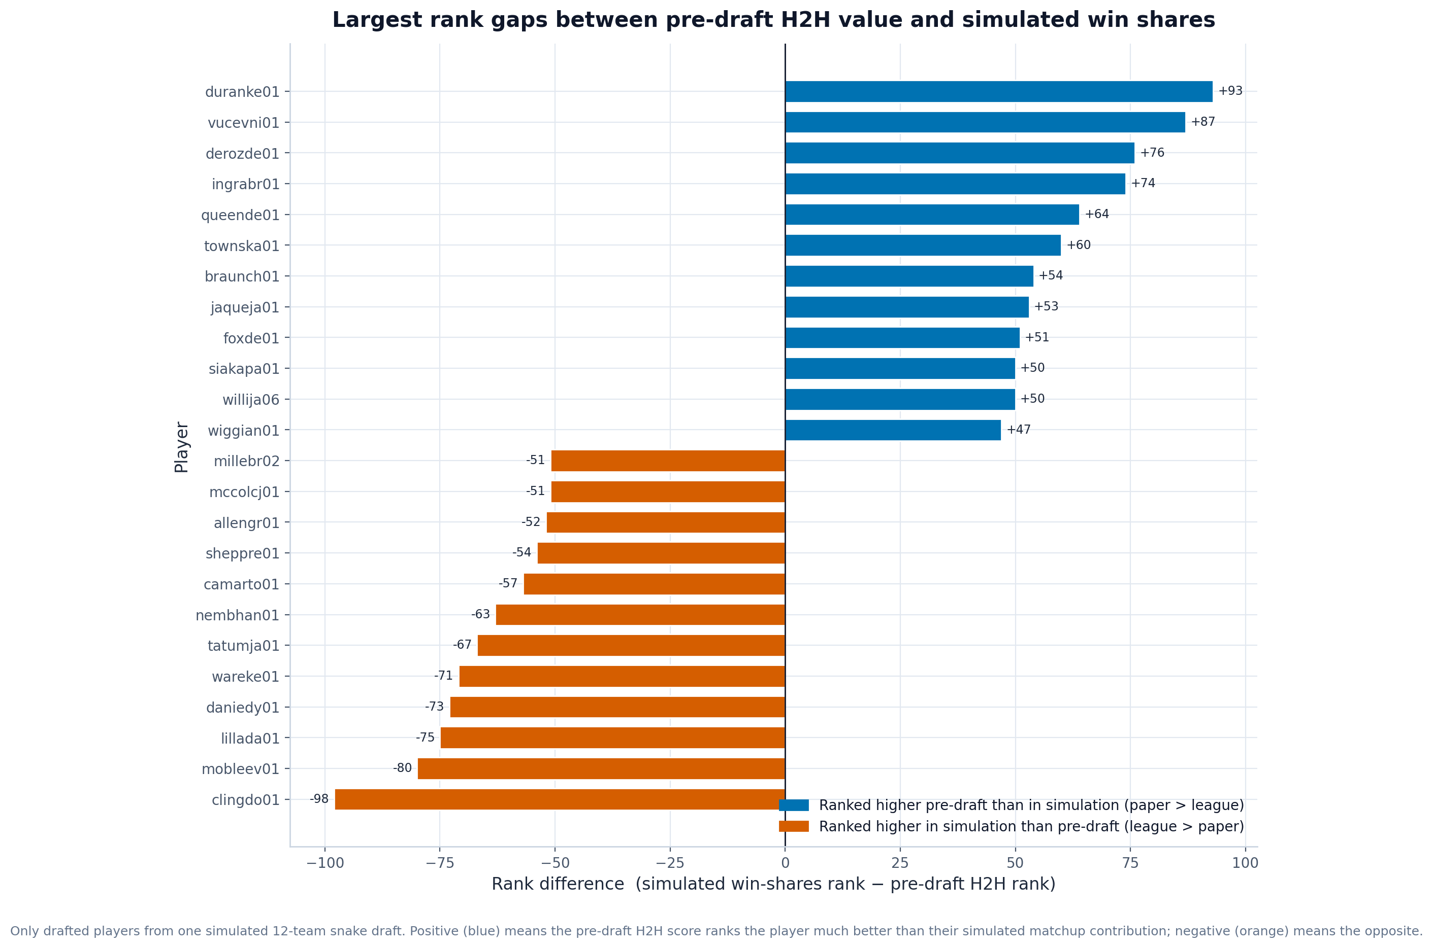
What it shows: A diverging bar chart of drafted players with the largest gap between their simulated win-shares rank and their pre-draft H2H rank (rank difference = win-shares rank − H2H rank).
Insight to mention in the paper: Some players look much better on paper than in the simulated league, and vice versa: duranke01 is ranked about 93 places higher pre-draft (H2H) than in the simulation (win shares), while clingdo01 is about 98 places higher in the simulation than pre-draft. These gaps highlight players whose category profile does not convert cleanly into weekly matchup wins — useful context for draft strategy beyond the static H2H ranking.
Principles demonstrated: Perception (colorblind-safe blue/orange diverging), Scale (signed zero baseline), Context.

4. Projection model evaluation

4.1 Predicted vs actual (per stat)
File: model/predicted_vs_actual.png
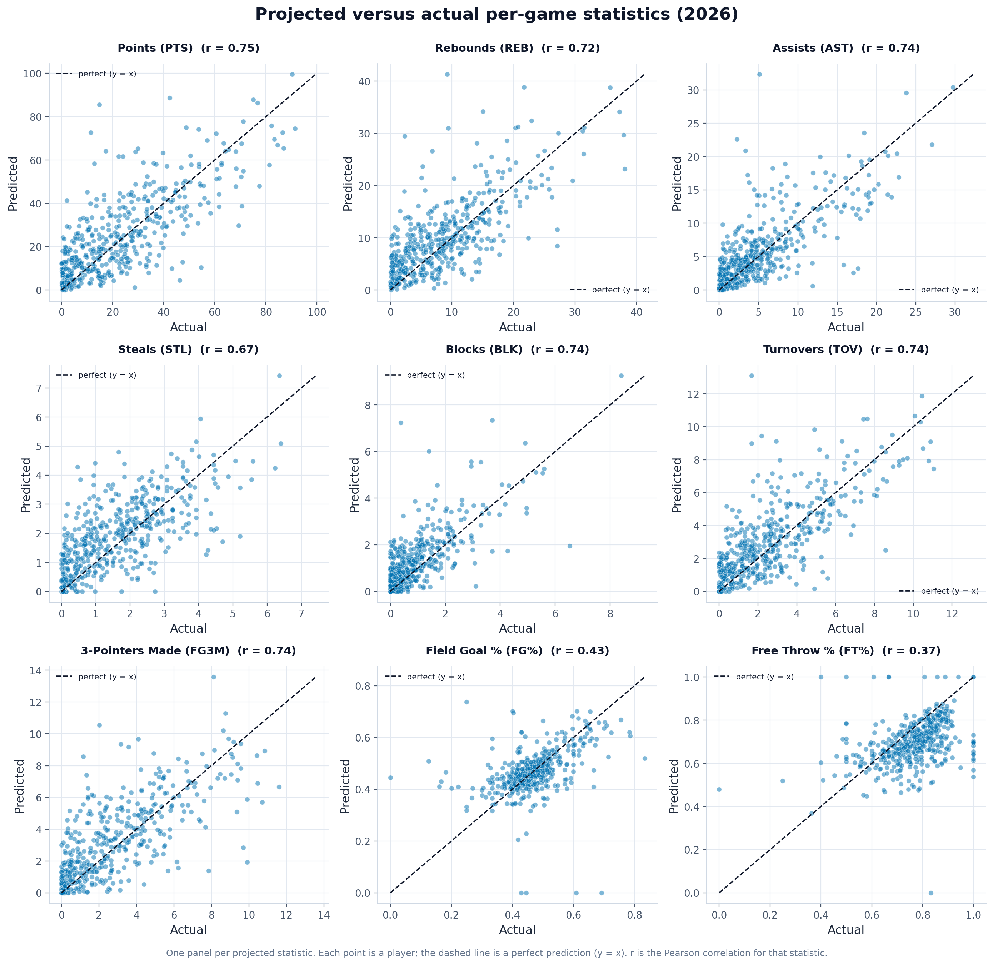
What it shows: A 3x3 grid of predicted-vs-actual scatter plots for the nine projected statistics, each with a y = x reference line.
Insight to mention in the paper: Projections cluster tightly around the diagonal for volume/counting stats (best: PTS, r = 0.75) but scatter widely for shooting percentages (worst: FT%, r = 0.37). This tells the reader exactly which projected quantities can be trusted and which carry large uncertainty.
Principles demonstrated: Conditioning (one panel per stat), Context (y = x reference, per-panel correlation).

4.2 Projection error per stat (MAE / RMSE)
File: model/error_mae_rmse.png
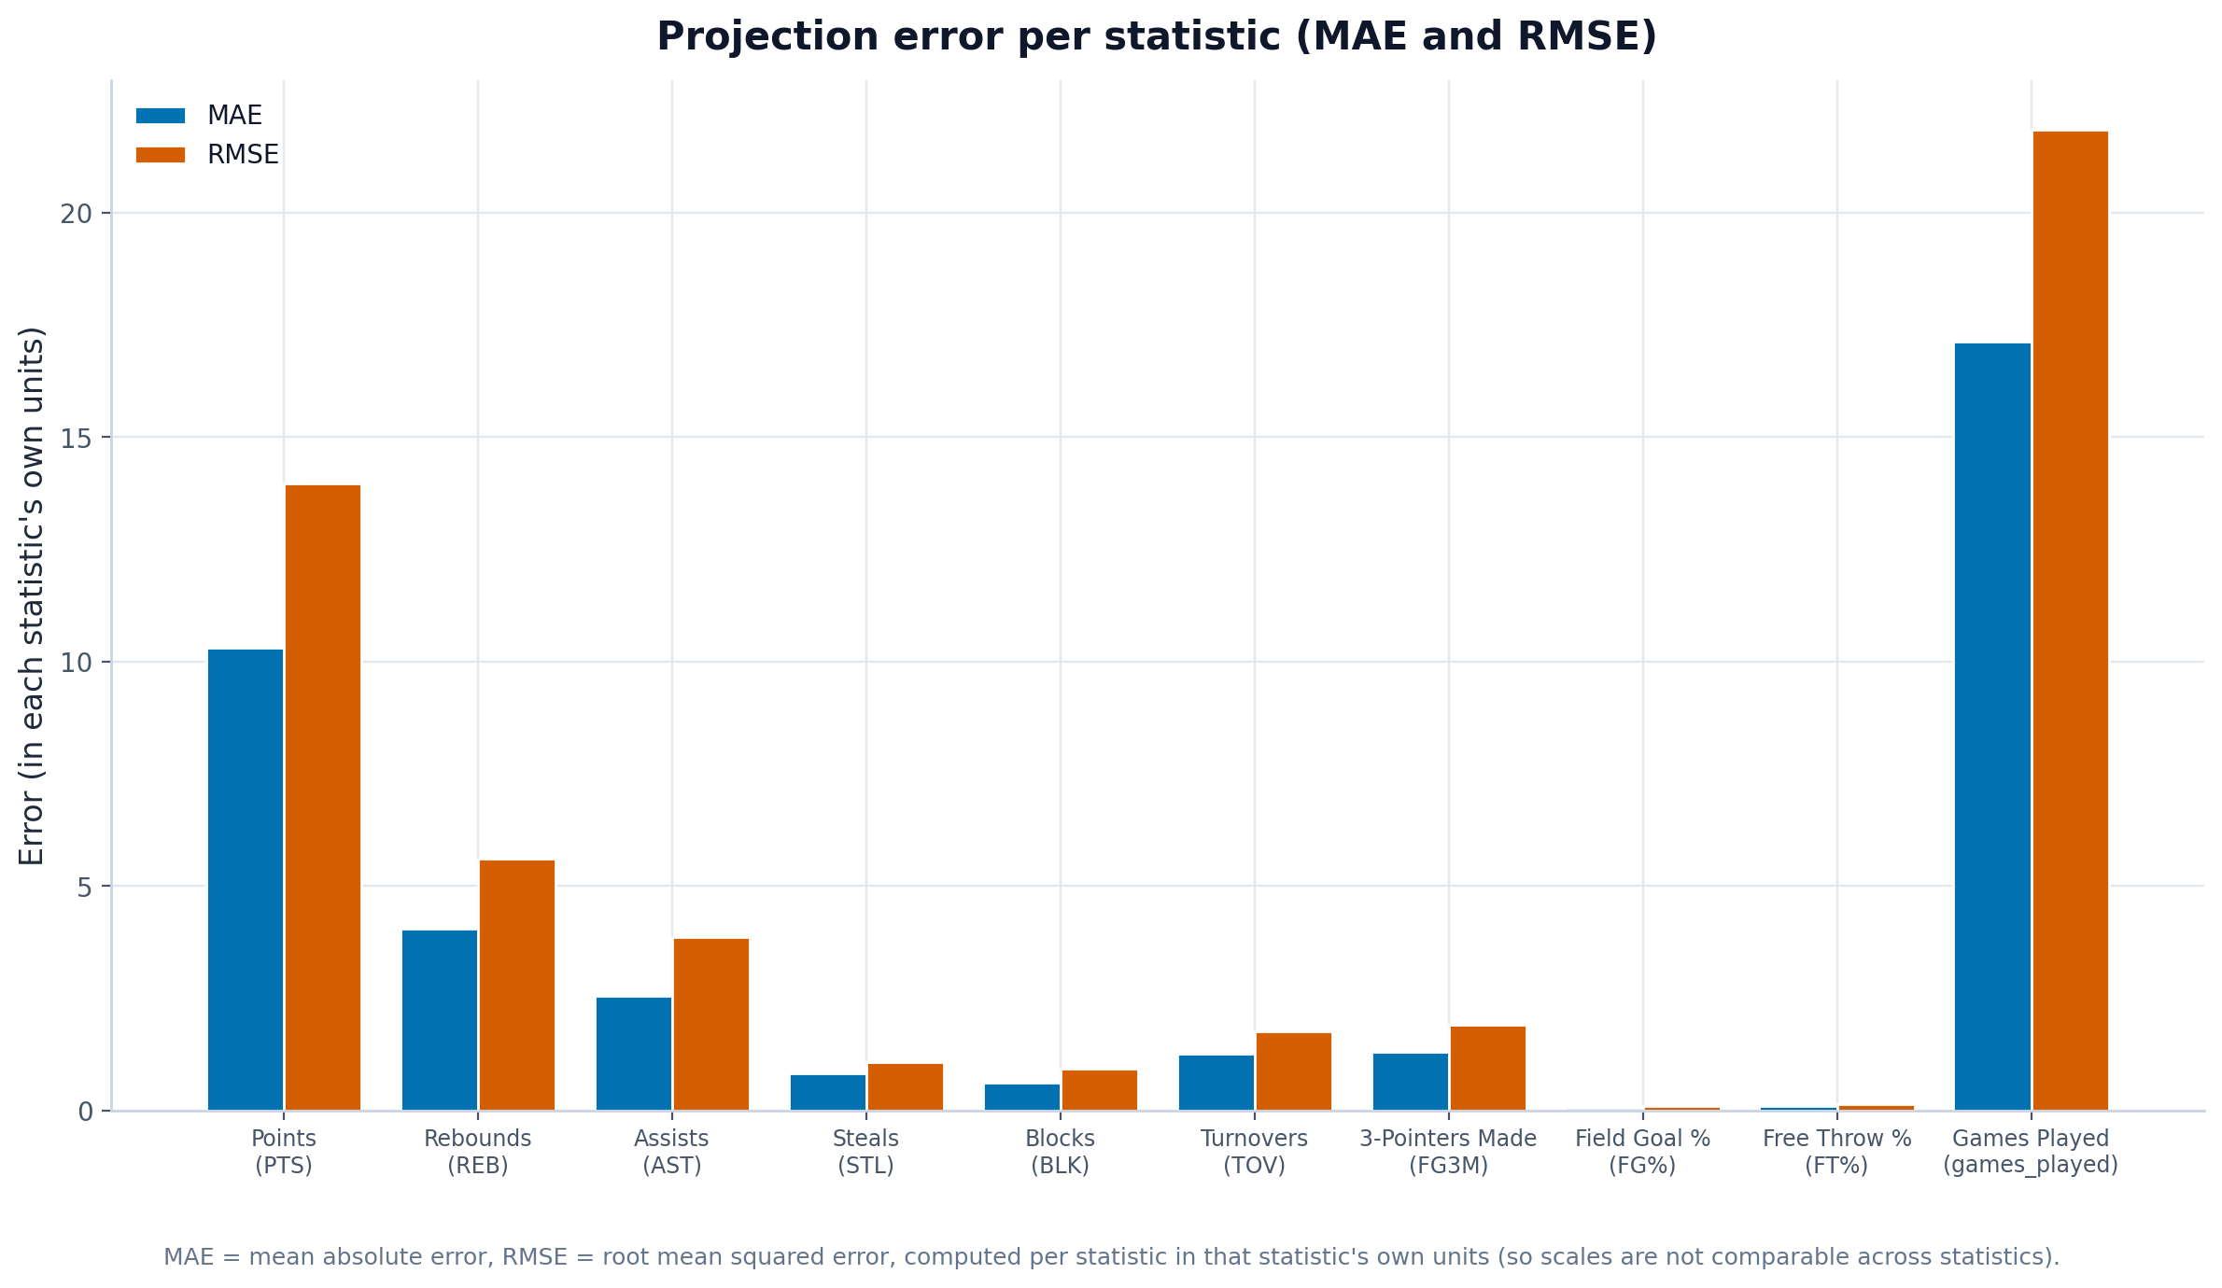
What it shows: Grouped bars of mean absolute error and root mean squared error for each statistic, in that stat's own units.
Insight to mention in the paper: Absolute error is largest for points (MAE about 10.3) and very small for rate and low-count stats, simply because points are on a larger scale. RMSE sitting above MAE for every stat signals that a minority of players (typically those with role or injury changes) drive the biggest misses.
Principles demonstrated: Scale (shared zero baseline), Perception (blue/orange grouped bars), Context.

4.3 Projection accuracy (Pearson / Spearman)
File: model/correlation_pearson_spearman.png
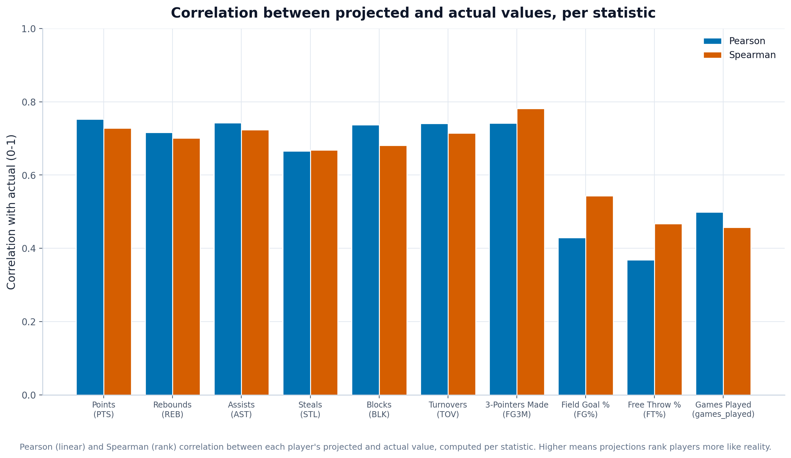
What it shows: Grouped bars of the Pearson and Spearman correlation between projected and actual values per stat (0-1 scale).
Insight to mention in the paper: Counting stats correlate strongly with reality (around 0.7-0.75) while percentage stats are much weaker (FG% and FT% near 0.37-0.43). Pearson and Spearman agreeing closely shows the ranking of players is preserved even where absolute values are noisy - important because H2H value depends on relative ordering.
Principles demonstrated: Scale (0-1 axis), Perception, Context (two complementary metrics side by side).

4.4 Confidence-interval calibration
File: model/ci_calibration.png
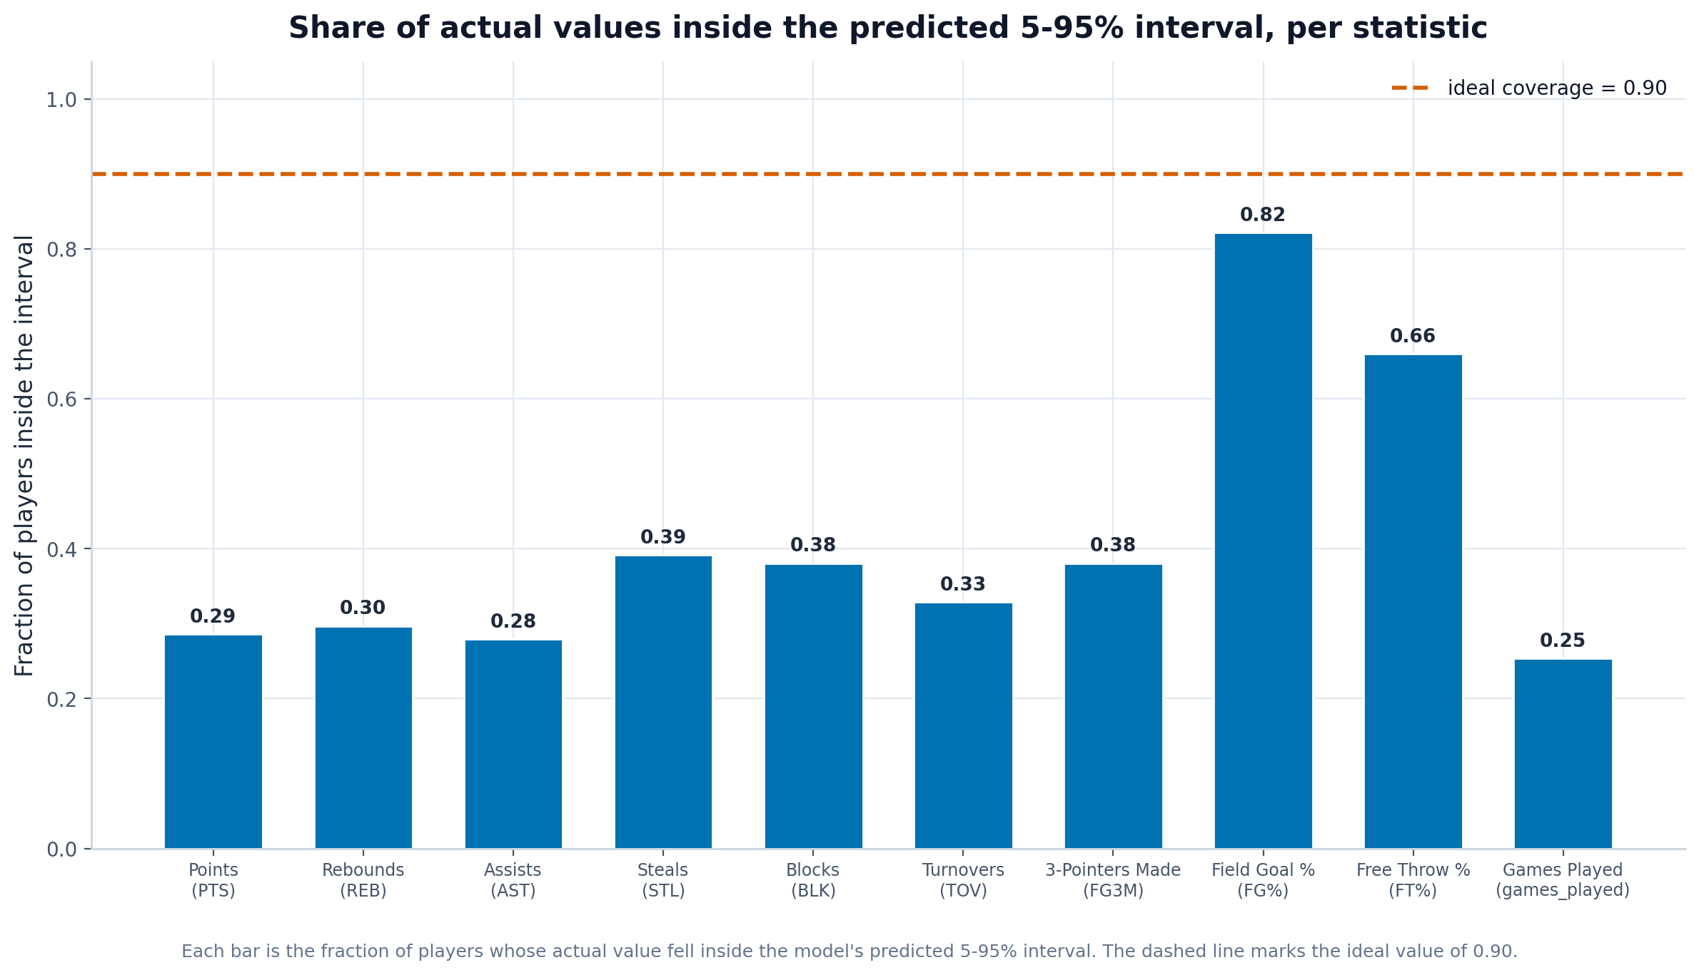
What it shows: The share of actual outcomes that fell inside the predicted 5-95% interval per stat, against the ideal 0.90 line.
Insight to mention in the paper: Coverage averages only about 0.41 and is well below 0.90 for almost every counting stat, meaning the model's stated uncertainty is too narrow - real outcomes land outside the interval far more than 10% of the time. This is an honest limitation to report and a clear direction for future work (wider/recalibrated intervals).
Principles demonstrated: Context (ideal-coverage reference line, honest reporting of a flaw), Scale.

5. Draft-strategy comparison
The draft simulation answers the key strategic question of the project: which way of choosing players gives the best chance of winning the weekly category battles? Ten teams drafted from the same player pool, each following a different strategy (a balanced 'best-available' approach, or a focus such as guards or big men, or deliberately 'punting' - giving up - a category like turnovers, free-throw %, or points). A full head-to-head season was then simulated to see how each strategy performed.

5.1 Wins by draft strategy
File: draft/standings_wins.png
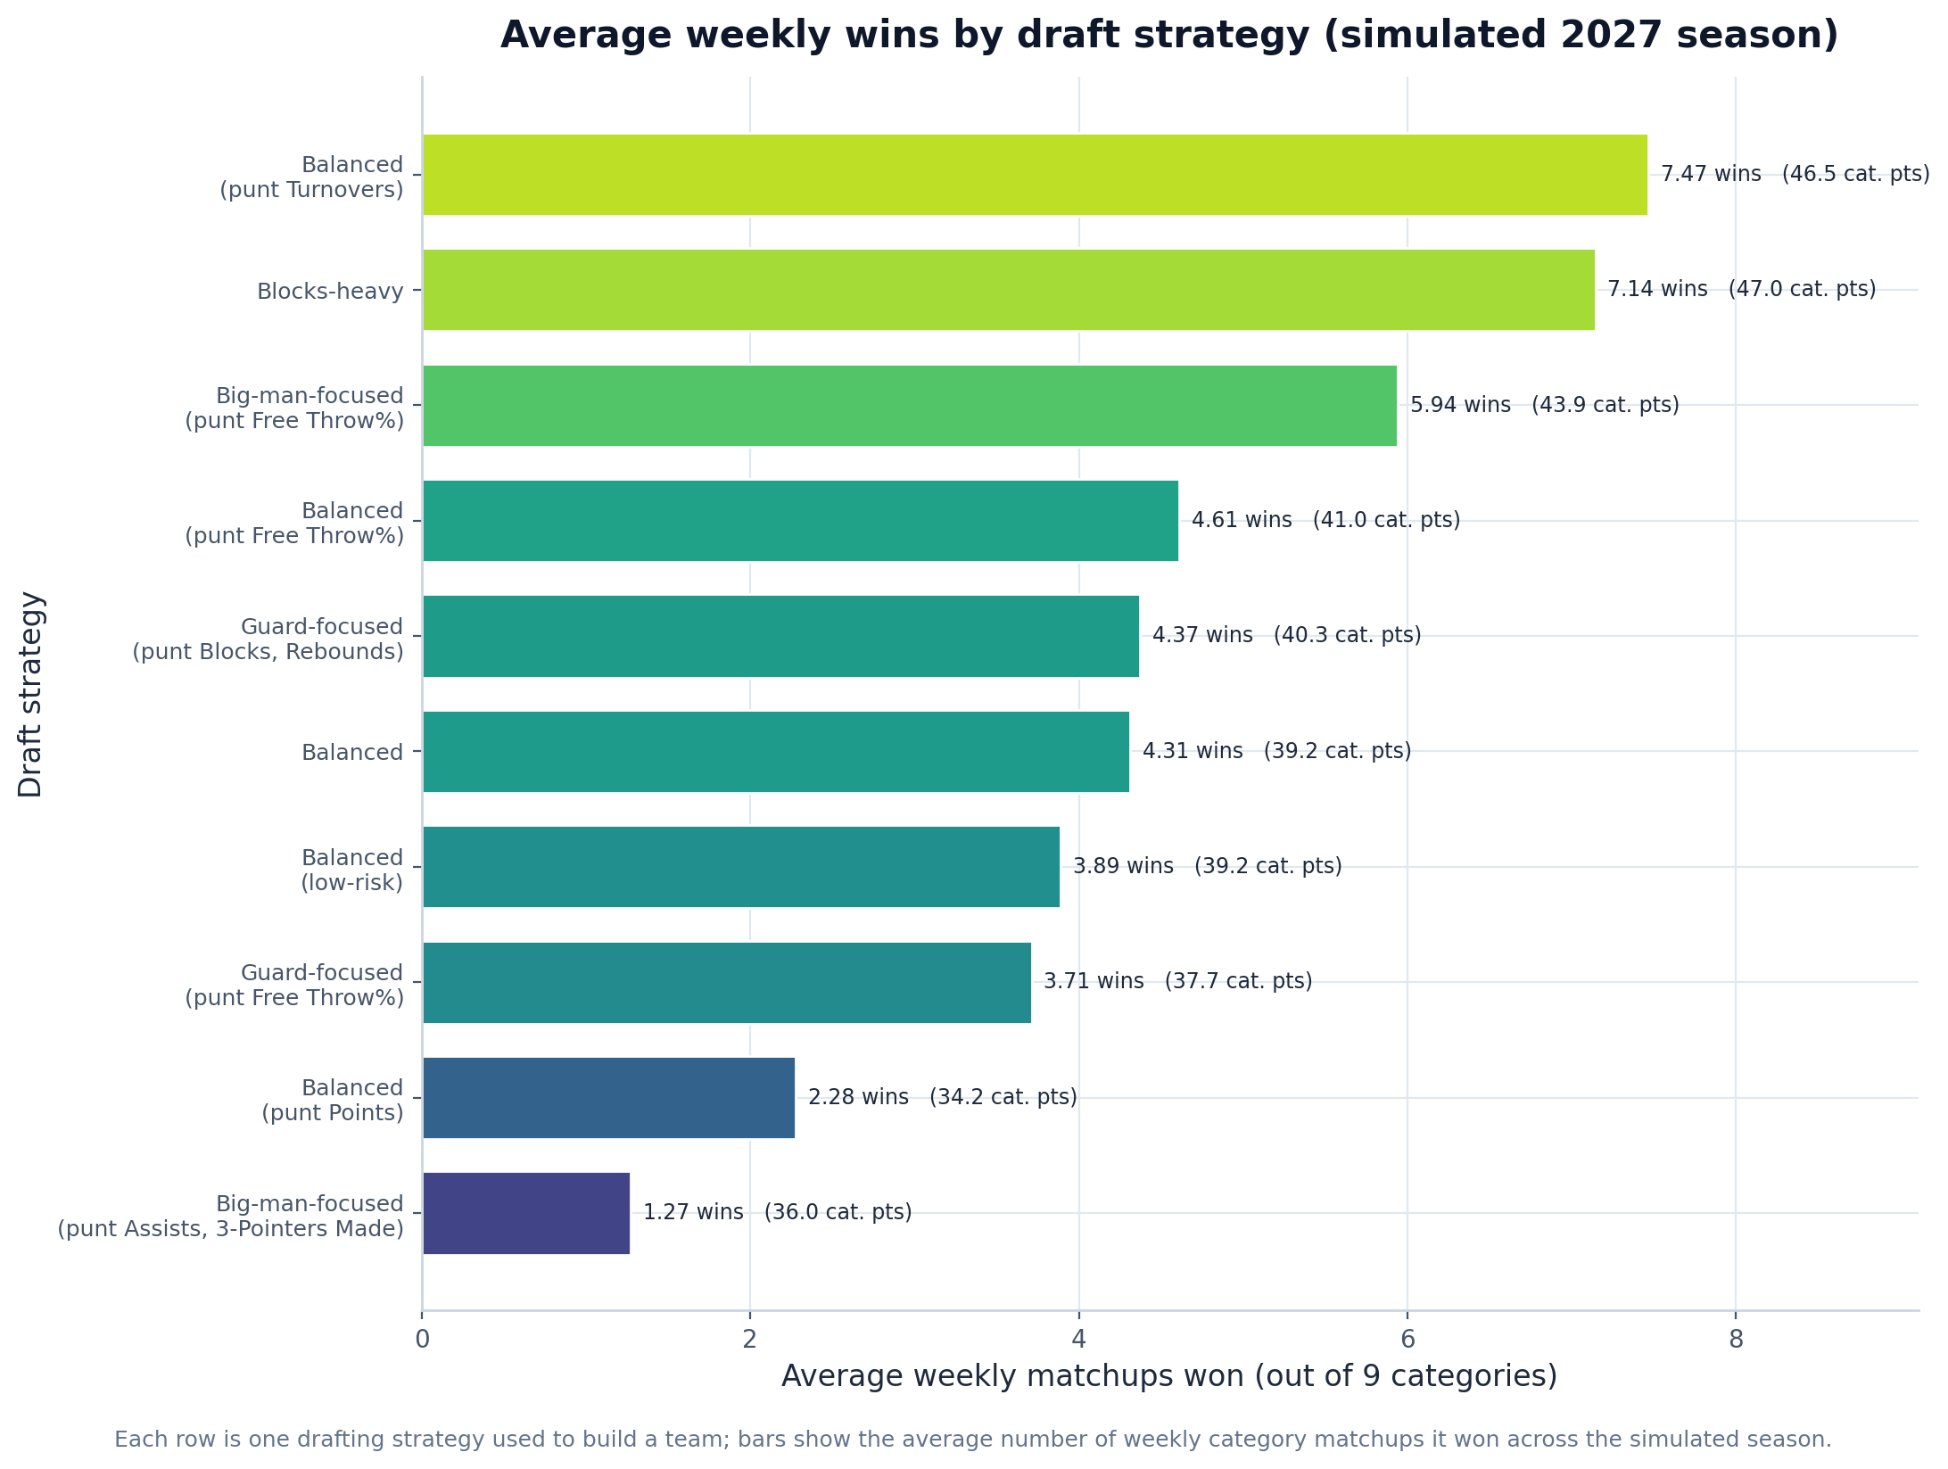
What it shows: A horizontal bar chart of the average weekly category-matchups won by each draft strategy over the simulated season.
Insight to mention in the paper: The best strategy is "Balanced (punt turnovers)" with 7.47 average weekly wins, closely followed by "Blocks-heavy" (7.14), while the weakest is "Big-man-focused (punt assists, 3-pointers made)" with only 1.27 - a spread of 6.2 wins between best and worst. The clear ordering shows that draft strategy materially changes the chance of winning: concentrating on scarce, high-impact categories (and punting a weak one like turnovers) outperforms over-specialized builds such as a big-man team that punts both assists and three-pointers.
Principles demonstrated: Scale (zero baseline, sorted), Perception (length encoding), Context (strategy labels and direct values).

5.2 Category strengths by strategy
File: draft/team_category_strengths.png
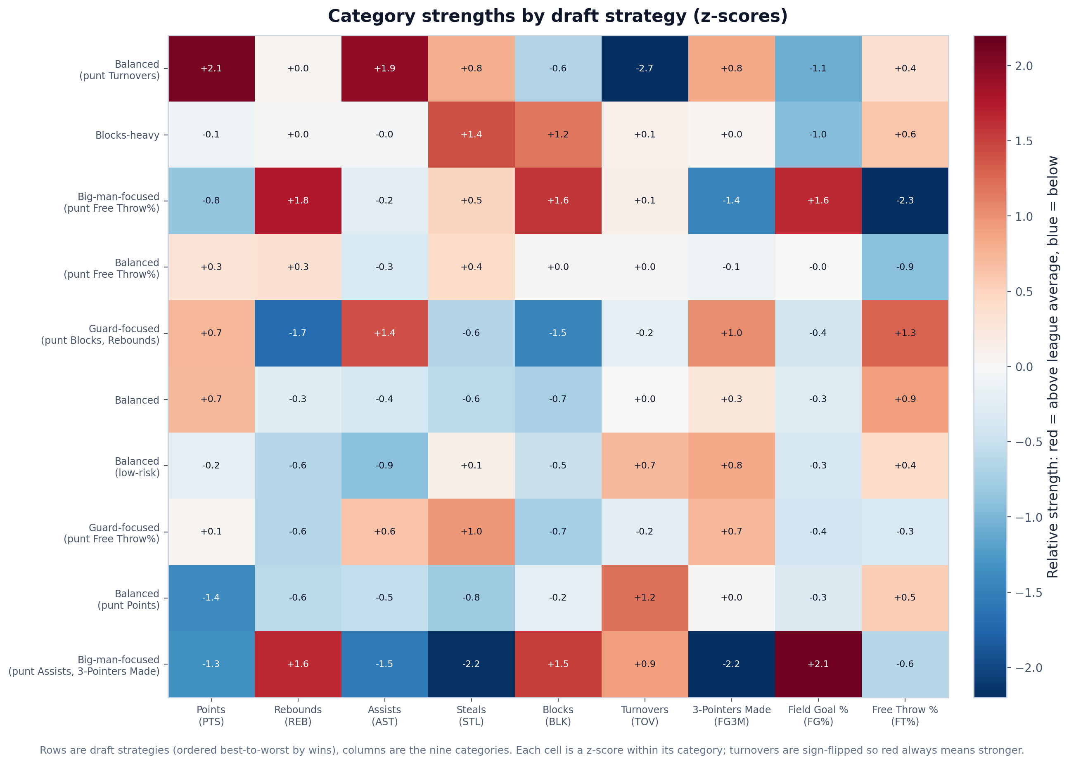
What it shows: A heatmap of each draft strategy (rows, ordered best-to-worst) against the nine categories, colored by z-score within each category (red = above league average, blue = below; turnovers sign-flipped so red is always better).
Insight to mention in the paper: Each row shows the fingerprint of a strategy: punt strategies are deep blue in the category they gave up but red across the rest, and the top-ranked strategies are strong in several scarce categories at once rather than dominating only one. This visually explains why the winning strategy won - it converted its draft focus into real category advantages - and confirms the H2H principle that building around a coherent set of targeted strengths beats simply drafting the best available player every round.
Principles demonstrated: Transformation (z-score standardization, sign-flip for TOV), Perception (warm/cold diverging map), Context.

