HOME ASSIGNMENT

OVERVIEW

* Congratulations on making it to the home assignment stage.
* This assignment is meant to test your thinking, learning and code writing skills.
* The assignment solutions will be reviewed during your scheduled interview.
* The assignment will be evaluated by:
  + Code correctness
  + Code readability
  + Code structure
  + Usage of framework features
* In the end of the document, we have added some reading material to help you with your tasks
* **NOTE***:* It is OK if you do not finish all the assignment parts, but we encourage you to try them all.

REQUIREMENT & CONSTRAINTS

* OS Required: **Windows** (for Mac and Linux users please contact your instructor)
* The assignment must be written in python 3.X using **pytest** framework.

TASKS

SETUP

* The assignment folder contains 3 files:
  + exercise_v1.exe
  + test.js
  + Assignment Document
* To start the assignment, run the **‘exercise_v1.exe’** file.
* 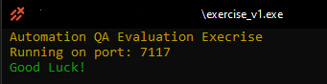If started correctly, you should be able to to see this output (keep it running thourghout your whole work session):

INTRODUCTION

* Your job is to write automated tests using simple http requests to evalutate the API correctness.
* The assigment comes with a lighweight API running on port 7117 on your localhost machine.
* Every section will list the needed test function and the some constraints
* Sections are sorted by most easy to hardest

PART I – Get a key

* Like every respected API, we do keep unwanted guests out of our API, although we chose a more simplistic way to tackle the key problem.
* **TASK 1:** Please write an automated test that will test that if you make a **GET** request to **localhost:7117/** route you will recive back a **401** status code with the error message **‘unauthorized, please provide a valid key’**
* **TASK 2:** Please write an automated test that will test that if you make a **POST** request to **localhost:7117/key,** the api will return an key (30 long string).
* **TASK 3:** Write a test similair to **TASK 1**, only this time with a ‘key’ property at the request headers, make sure you get back **200** status code with the message **‘Got a key!’**
* **NOTE:** You **MUST** provide a key in the session headers throught all your next part tasks
* **NOTE#2:** Making a post request to the key route again, will construct a new key

PART II – Confused Developer

* One of our (very) confused developers has written one our tests in javascript instead of python, can you please re-write the **test.js** file in python and make sure its working?

*P.S. we didn’t add all the modules implementation, but I think you will be able to understand from the context*

* **NOTE:** Don’t forget to add the key to your request headers.

PART III – Connections, connections, connections…

* In earnix we sometime have to test some really complex data structres, in this part we will test our **person connection** **tree** generator.
* The tree generator will generate a connection tree according to the given **depth** you specify in the request **query-params**. For example: making a **GET** request to the **/tree?depth=3** will predouce a tree of connection of depth 3.

Example of a 2 depth tree:

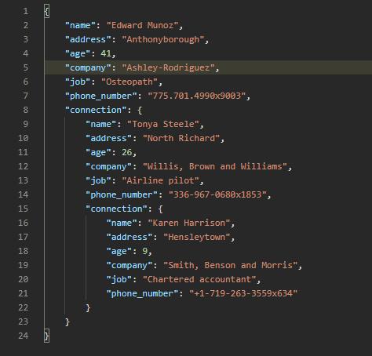

*As you may see, every person has only one connection, the tree ends where there are not more connections.*

* Another feature of this person connection tree generator, is to limit the connections max age, this can be done by providing an **age** query param. For example: making a **GET** request to the route **/tree?&depth=6&age=20** will predouce a connection tree with a depth of 6 where all the persons in the tree maximum 20 year old (via the **‘age’** JSON property)
* **TASK 1:** Write an automated test to make sure you cannot produce a tree larger than 50 and lower than 1
* **TASK 2:** Write an autometed test to make sure the tree depth is as requested, use a recursive function and a non-recursive function.
* **TASK 3:** Write an automated test to make sure that the age constraint works as expected.

PART IV – Tipsy Fibonacci

* At earnix we run some really complex calculations, in this simple API we developed an Fibonacci series generator
* We have not tested it yet, but we will accpect this generator if it only mistaken by 1. For example if the ***Nth*** Fibonacci number should be ***X***, we will accpect it if its also ***X-1, X or X+1***
* To generate a series, provide a json with **‘number_one’**, **‘number_two’** and **‘size’** to the **/tipsy,** make POST request. For example:

*A request with the body as:*

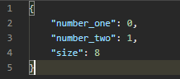

*Will return:*

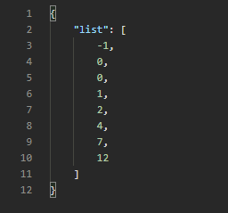

* **TASK 1:** Write an autometed test to check that the fibbonaci series size is as requested
* **TASK 2:** Write an autometed test to check that each number in the fibbonaci series generated is correct, meaning each Nth number in the series mistaken at most by 1.

BONUS: PART V – Bonuses

* **BONUS: PART I** – Use pytest fixture feature to provide the session headers
* **BONUS: PART III – Task 2:** add ‘&hard=True` and try ro assert the tree depth again, (in this tree, one person can have multiple connections, but the tree max depth stays the same)
* **BONUS: PART IV – Task 2:** Use *pandas* to test fibbonachi series

READING MATERIAL

These guides will help you solve the above tasks

AUTOMATION QA:

* <https://www.guru99.com/automation-testing.html>

REST API:

* <https://www.restapitutorial.com/lessons/whatisrest.html>
* <https://www.freecodecamp.org/news/rest-api-tutorial-rest-client-rest-service-and-api-calls-explained-with-code-examples/>

PYTHON:

* <https://www.w3schools.com/python/>

PYTEST:

* <http://library.sadjad.ac.ir/opac/temp/18467.pdf>
* <https://docs.pytest.org/en/stable/talks.html>

PANDAS:

* <https://pandas.pydata.org/pandas-docs/stable/getting_started/tutorials.html>

**Please send your code via email (zip file) to** [**yuvals@earnix.com**](mailto:yuvals@earnix.com)

**Good luck!!!**