Devops: To deliver application very speedly (main theme)

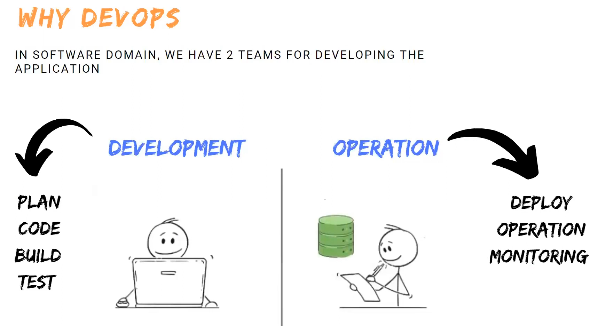

Deployment: Process of installing application in server.

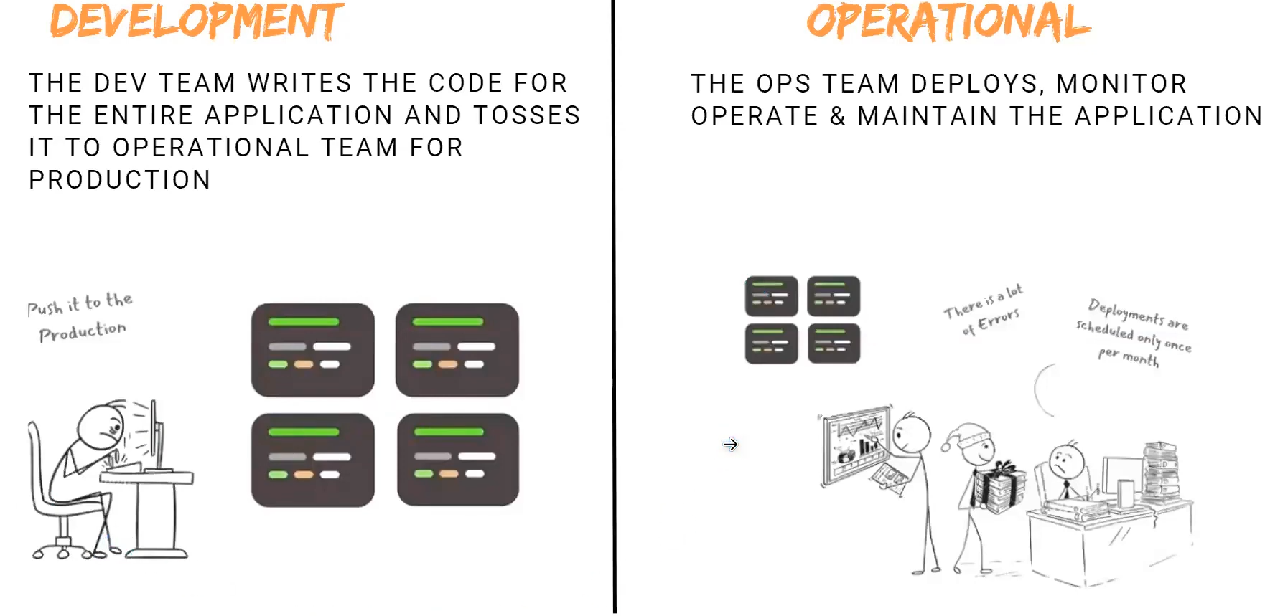

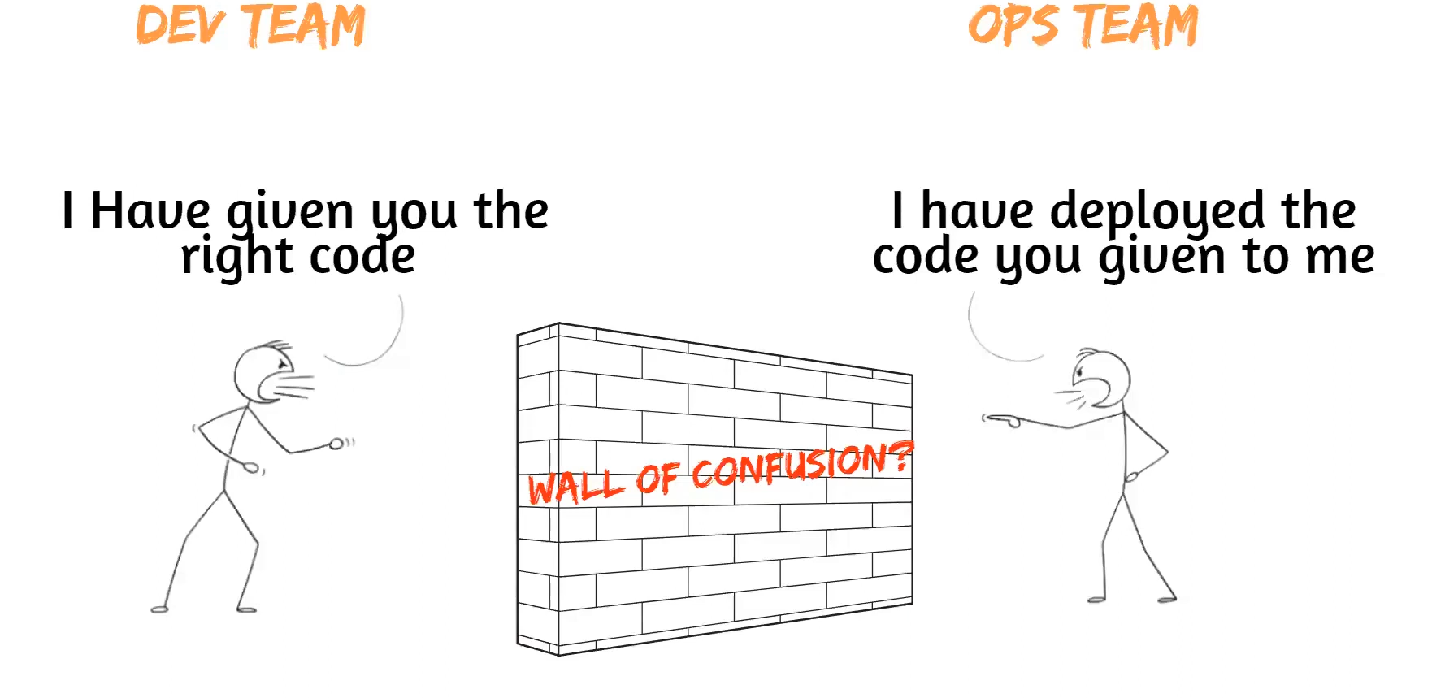

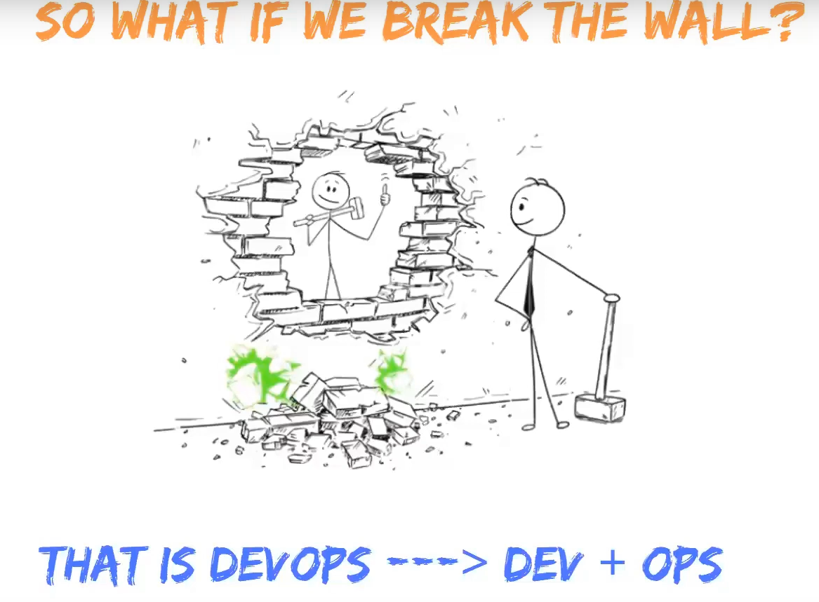

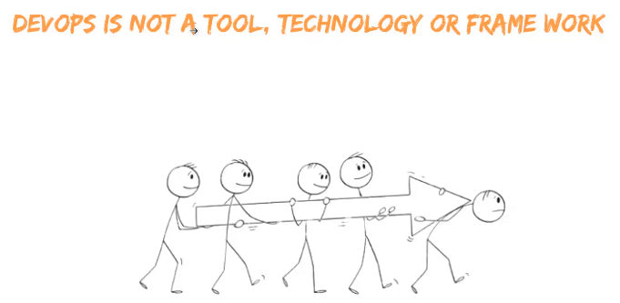

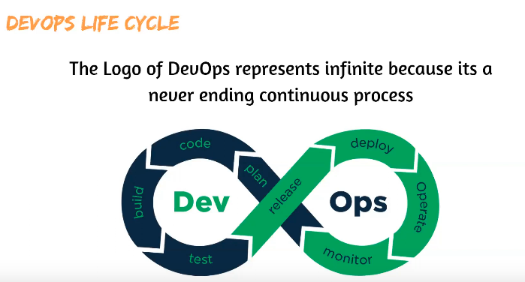

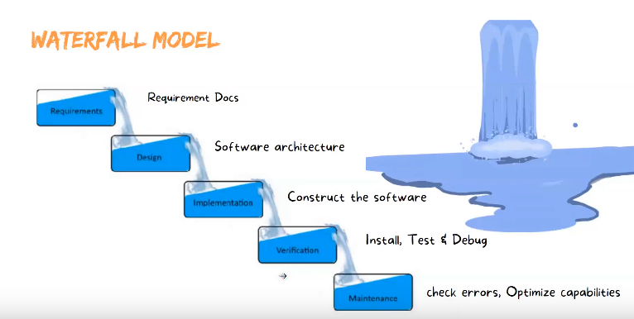

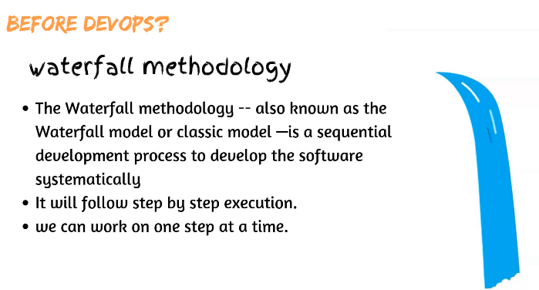

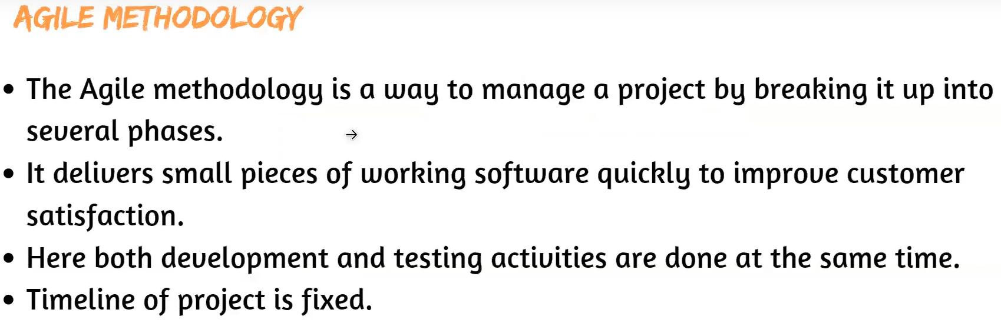

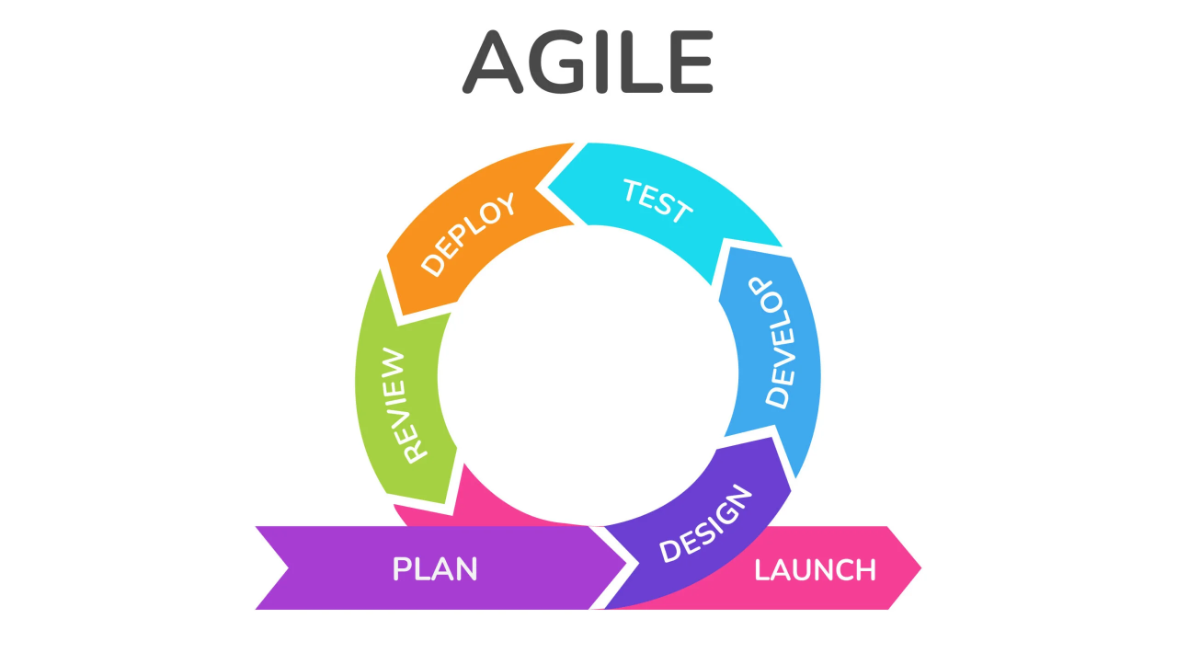

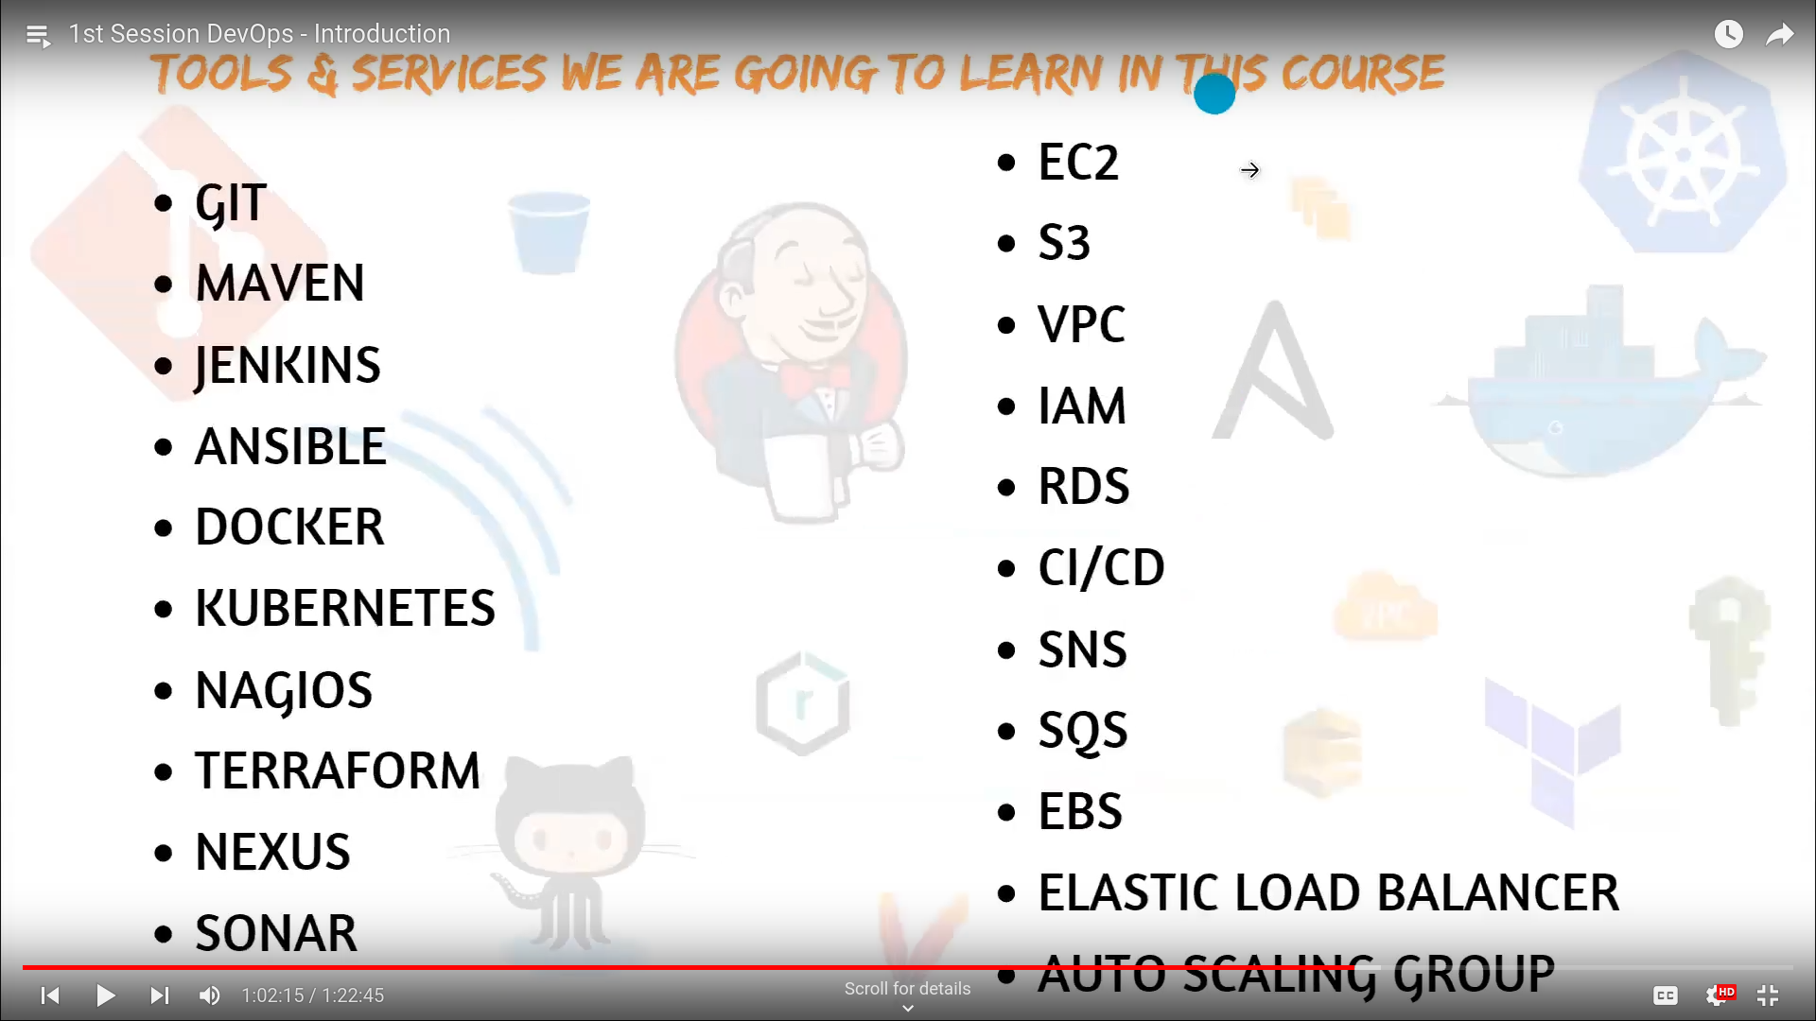

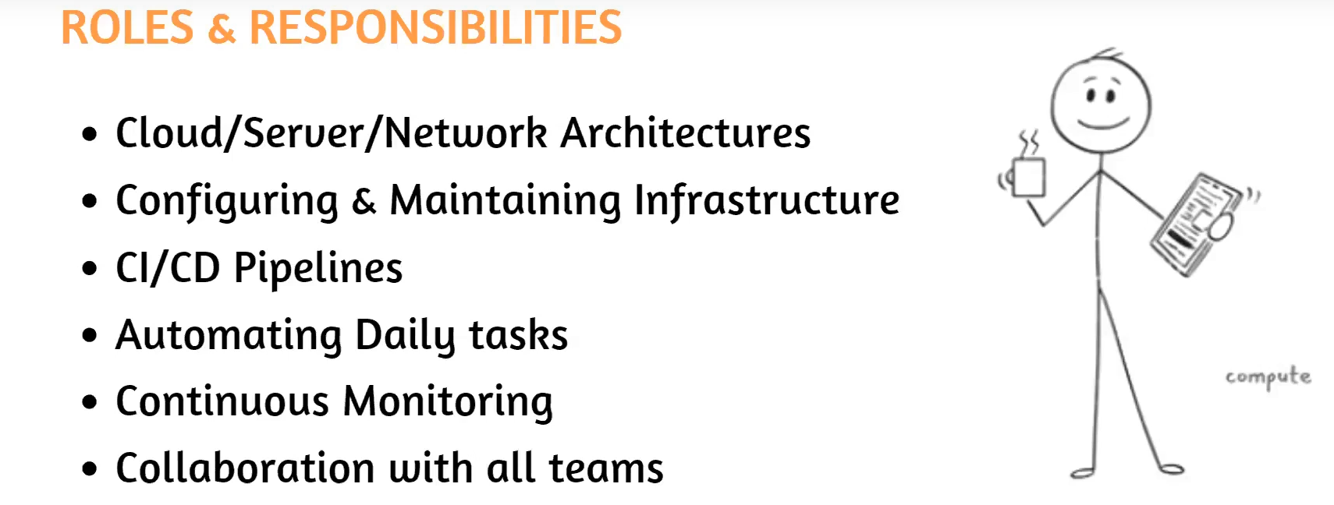

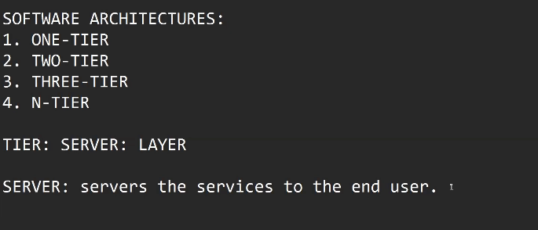
Server: servers the services to the end user.

1. Web server
2. App server
3. Db server

WEB SERVER:

-->I t is also called as the presentation layer.
--> To show the Application.
--> who works: UI/UX Developers.
--> what they use: Web technologies
ex: HTML,CSS,JAVASCRIPT

APP SERVER:

--> To use the application also called as the logic layer.
--> who works: Backend Developers.
--> what they use: programming
ex: java, python,c,c++,.net,go -----

DB SERVER :(Data Base server)

--> It also called as Db layer.
--> To store & retrieve data.
--> who works: Db admins
--> what they use: Db languages
ex: sql,oracle,postgress,arango -----
