PicoRV32 with UART Bootloader
Implementation on the Real Digital Boolean Board (Vivado)
Build, Program, and Upload Manual (Windows 10 + WSL)
Prepared: 27 September 2026

1. Overview
This manual documents the procedure to build and run a PicoRV32 RISC-V core, fitted with a resident UART bootloader, on the Real Digital Boolean board (Xilinx Spartan-7 XC7S50-CSGA324-1) via Vivado. Unlike the earlier NEORV32 setup, PicoRV32 ships as a bare CPU core with no board support package, so the surrounding SoC (memory, UART, bootloader, address decode) was designed and built from scratch.
The key idea behind the bootloader is to mirror the Arduino upload experience: compile firmware, send it over a serial connection, and have it start running immediately — without re-running Vivado synthesis for every firmware change. A small, fixed bootloader program is the only thing baked into the bitstream; the actual application is transferred afterwards, at runtime, over UART.

1.1 Component Summary
Component | Purpose | Where it lives
picorv32.v | The RISC-V CPU core itself (from YosysHQ/picorv32) | Copied manually into the project folder
top.v | Wrapper: CPU + boot ROM + app RAM + UART + LEDs | Project folder
bootloader/ | Resident bootloader firmware (baked into bitstream) | Compiled to bootloader.hex
app/ | Your actual application firmware | Compiled to app.bin, sent over UART
host/upload.py | Python script that sends app.bin over serial | Run from Windows PowerShell
boolean_bootloader.xdc | Pin constraints for clock, reset, LEDs, UART | Project folder
build.tcl | Vivado automation: create project, synthesize, write bitstream | Project folder

1.2 Address Map
Address | Region | Size
0x0000_0000 - 0x0000_07FF | Boot ROM (resident bootloader) | 512 x 32-bit = 2 KB
0x1000_0000 - 0x1000_1FFF | Application RAM (written over UART at runtime) | 2048 x 32-bit = 8 KB
0x2000_0000 | UART DATA register (read = RX byte, write = TX byte) | 32-bit
0x2000_0004 | UART STATUS register (bit0 = tx_busy, bit1 = rx_valid) | 32-bit
0x3000_0000 | LED register (16-bit) | 32-bit

2. Workflow at a Glance
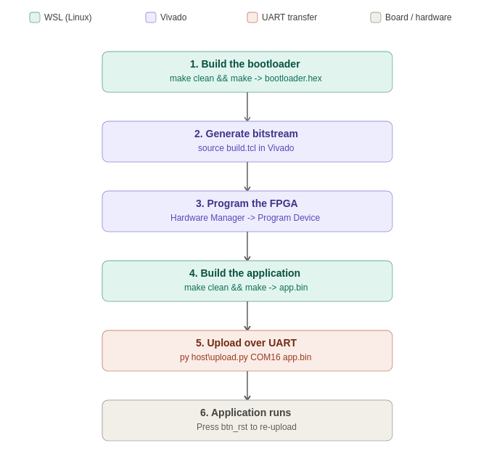

3. Part A — Obtain PicoRV32 and Prepare the Project Folder
This step was implicit in the working session but is required before build.tcl can run, so it is recorded explicitly here.
- Download or clone the PicoRV32 repository: https://github.com/YosysHQ/picorv32
- Locate picorv32.v inside the downloaded repository.
- Copy picorv32.v into the project folder (D:\RISCV_FPGA\picorv32_bootloader), alongside top.v. build.tcl's add_files step requires both files to be in the same folder.

Note: This copy step is easy to miss and was the cause of the first 'File or Directory does not exist' error encountered during this build (see the Troubleshooting appendix).

4. Part B — Build the Bootloader Firmware (WSL)
The bootloader is a small, fixed program that gets baked into the bitstream via $readmemh. It runs on every reset, waits for an application to arrive over UART, writes it into Application RAM, and jumps to it.
cd /mnt/d/RISCV_FPGA/picorv32_bootloader/bootloader
make clean
make

ls -la bootloader.hex
Copy the result up one folder, next to top.v, so $readmemh("bootloader.hex", bootrom) in top.v can find it:
cp bootloader.hex /mnt/d/RISCV_FPGA/picorv32_bootloader/bootloader.hex
Note: If riscv-none-elf-gcc is not found, run 'source ~/.bashrc' first — the toolchain PATH set up during the NEORV32 build is reused here.

5. Part C — Generate the Bitstream and Program the FPGA (Vivado)
- Open Vivado and open the Tcl Console.
- Navigate to the project folder and confirm the required files are present:
cd {D:/RISCV_FPGA/picorv32_bootloader}
pwd
glob *
Confirm the listing includes at minimum: top.v, picorv32.v, bootloader.hex, boolean_bootloader.xdc, and build.tcl.
- Run the build script:
source build.tcl
This creates the project, runs synthesis and implementation, and writes the bitstream.
- Open Hardware Manager -> Open Target -> Auto Connect.
- Program the device with the generated .bit file (under picorv32_bootloader_proj/picorv32_bootloader_proj.runs/impl_1/).

Note: Immediately after programming, the 16 LEDs should show binary 0000000000000001 (only led[0] lit). This is the bootloader signalling that it is waiting for an upload — it stays in this state indefinitely until an application is sent.

6. Part D — Build the Application (WSL)
With the bootloader running on the board, the application is compiled separately and sent afterward — no further Vivado steps are needed for this or future application changes.
cd /mnt/d/RISCV_FPGA/picorv32_bootloader/app
make clean
make

ls -la app.bin
This produces app.bin — a raw binary image, linked to start at address 0x1000_0000 (Application RAM), not converted to a hex file, since it is transferred over UART rather than baked into the bitstream.

7. Part E — Upload the Application (Windows PowerShell)
Run the Python upload script, giving it the board's COM port and the path to the compiled application:
py D:\RISCV_FPGA\picorv32_bootloader\host\upload.py COM16 D:\RISCV_FPGA\picorv32_bootloader\app\app.bin
Note: This must be run from a folder PowerShell can resolve, or with full paths as shown above — a bare 'host\upload.py' only works if PowerShell's current directory is already the project folder (cd D:\RISCV_FPGA\picorv32_bootloader first).
The script sends a 4-byte length header followed by the raw application bytes, then waits for a single 'K' acknowledgement byte from the board. On success it prints:
Upload confirmed -- application should now be running.

7.1 What to Expect on the LEDs During Upload
LED Pattern | Meaning
0x0001 (led[0] only) | Bootloader waiting for an upload
0x0003 (led[0], led[1]) | Bootloader receiving bytes over UART
0xFFFF (all 16 LEDs) | Transfer complete, about to jump to the application
Single LED walking 0 -> 15, repeating | Application is now running (LED-walk demo)

8. Part F — Resetting and Re-uploading
Pressing the physical reset button (btn_rst) halts the CPU and forces it to re-boot into the bootloader, since PROGADDR_RESET always points at the boot ROM. The LEDs will return to 0x0001 (waiting), and a new application can be uploaded immediately by repeating Part E — no re-synthesis required.
- A full power cycle behaves the same way as pressing reset, since Application RAM is volatile block RAM.
- There is no 'run automatically' fallback: because nothing persists in flash, the bootloader always waits for a fresh upload after every reset or power-up.

9. Why PuTTY Was Not Used Here
Unlike the NEORV32 bootloader, this bootloader is fully automatic and non-interactive: it does not print a menu, and it does not wait for typed commands such as 'u' or 'e'. It moves straight from waiting, to receiving, to jumping into the application, entirely on its own. upload.py plays the role PuTTY plus manual keystrokes played for NEORV32.
PuTTY can still be used here if desired, on the same COM port at 115200 baud (not 19200, which was specific to the NEORV32 bootloader). Doing so would only show a single 'K' character appear at the moment an upload finishes, since nothing else in this bootloader or application prints readable text. Adding further uart_putc() calls inside the application would let PuTTY function as a debug console going forward, similar to the Arduino Serial Monitor.

10. Troubleshooting Appendix
Issues actually encountered while bringing this design up, and their resolutions, are recorded here for reference.

10.1 "File or Directory 'top.v' does not exist"
Cause: Vivado's Tcl Console current directory was not the project folder (a fresh Tcl Console session resets to Vivado's default location and does not remember an earlier cd).
Fix: Re-run cd {D:/RISCV_FPGA/picorv32_bootloader} followed by pwd and glob * to confirm the location before re-running add_files or build.tcl. Use forward slashes inside the curly braces.

10.2 "File or Directory 'firmware.hex' / 'bootloader.hex' does not exist"
Cause: build.tcl reached the add_files step for the hex file before that file had been built in WSL and copied into the project folder.
Fix: Run make in the relevant firmware/bootloader folder first, confirm the .hex file was produced with ls -la, copy it into the project folder next to top.v, then re-run build.tcl.

10.3 "The object 'file' does not have a property 'used_in_synthesis'"
Cause: an earlier draft of build.tcl attempted to set used_in_synthesis / used_in_implementation properties on the hex file; this Vivado version does not support setting that property this way for this file type.
Fix: Remove (or comment out) the two set_property used_in_synthesis / used_in_implementation lines from build.tcl entirely — $readmemh reads the file directly at synthesis time regardless of these properties.

10.4 "no files matched glob pattern '...impl_1/*.bit'"
Cause: this only affects the final diagnostic line in build.tcl, not the build itself. It fires when the implementation run has not completed successfully yet, or completed with a different status than expected.
Fix: Check get_property STATUS [get_runs impl_1] and get_property PROGRESS [get_runs impl_1]. If STATUS shows 'write_bitstream Complete!', the bitstream exists and can be located manually with glob -nocomplain ./picorv32_bootloader_proj/picorv32_bootloader_proj.runs/impl_1/*.

10.5 Python script "can't open file '...host\\upload.py'"
Cause: PowerShell's current directory was not the project folder, so the relative path host\upload.py did not resolve.
Fix: Either cd D:\RISCV_FPGA\picorv32_bootloader first, or call the script using its full path, as shown in Part E above.

11. End-to-End Command Summary
Stage | Environment | Key Commands
Prepare project folder | Windows (File Explorer) | Copy picorv32.v alongside top.v
Build bootloader | WSL (Ubuntu) | make clean / make -> bootloader.hex
Generate bitstream | Windows (Vivado Tcl Console) | cd {...}; source build.tcl
Program FPGA | Windows (Vivado) | Hardware Manager -> Program Device
Build application | WSL (Ubuntu) | make clean / make -> app.bin
Upload application | Windows (PowerShell) | py host\upload.py COM16 app\app.bin
Re-upload after changes | WSL + PowerShell | Repeat the two steps above only
Reset / re-run bootloader | Board (hardware) | Press btn_rst

12. Notes and Recommendations
- Keep a copy of the exact picorv32.v commit/version used, since the core's parameter list and port names have changed across releases.
- Verify the on-board oscillator is genuinely 100 MHz before relying on the CLKS_PER_BIT = 868 UART timing constant in top.v; a different clock frequency requires recalculating this value for 115200 baud.
- Because Application RAM is volatile, budget time for a fresh upload after every FPGA power cycle during development and demonstrations.
- Consider adding uart_putc()-based debug printing to the application firmware to make PuTTY useful as a runtime debug console, now that the UART hardware and protocol already exist.

