**727721euit186**

**Yuvan.s**

**Q1:**

package porm.exam.ca1;

import org.openqa.selenium.By; import org.openqa.selenium.JavascriptExecutor; import org.openqa.selenium.WebDriver; import org.openqa.selenium.WebElement; import org.openqa.selenium.chrome.ChromeDriver; import org.openqa.selenium.chrome.ChromeOptions;

import io.github.bonigarcia.wdm.WebDriverManager;

/**

* Hello world!
* */

public class App

{

public static void main( String[] args ) throws InterruptedException

{

ChromeOptions co=new ChromeOptions(); co.addArguments("--remote-allow-origins=*");

WebDriverManager.chromedriver().setup();

WebDriver d=new ChromeDriver(co);

// TODO Auto-generated method stub

ChromeOptions co1=new ChromeOptions(); co1.addArguments ("--remote-allow-origins=*"); WebDriverManager.chromedriver().setup (); WebDriver driver=new ChromeDriver(co1);

driver.get ("https://www.amazon.in/Fire-Boltt-Bluetooth-Calling-AssistanceResolution/dp/B0BF57RN3K/ref=sr_1_1?pd_rd_r=409b3030-7867-4121-a31da60d9451d0ca&pd_rd_w=lvK72&pd_rd_wg=vpblK&pf_rd_p=3a59b28c-4626-48f9-b66f114571ee563d&pf_rd_r=722H7NPQ0Q655R1NJNXP&qid=1681290834&sr=8-1"); driver.manage().window().maximize() ; String currentTitle=driver.getTitle();

System.out.println(currentTitle);

String expectedTitle="Fire-Boltt Ninja Call Pro Plus 1.83\" Smart Watch with

Bluetooth Calling, AI Voice Assistance, 100 Sports Modes IP67 Rating, 240 * 280 Pixel High

Resolution (Black) - Amazon.in";

if(currentTitle.equals(expectedTitle)) {

System.out.println("Title Matched");

}

else {

System.out.println("Title not Matched");

}

driver.findElement(By.xpath("//*[@id=\"add-to-cart-button\"]")).click(); driver.findElement(By.xpath("//*[@id=\"nav-cart\"]")).click();

driver.findElement(By.xpath("//*[@id=\"a-autoid-0-announce\"]")).click(); driver.findElement(By.xpath("//*[@id=\"quantity_4\"]")).click();

driver.findElement(By.xpath("//*[@id=\"sc-buy-box-ptcbutton\"]/span/input")).click();

|  |  |  |
| --- | --- | --- |
|  |  | WebElement txtBoxl=driver.findElement(By.xpath("//*[@id=\"ap_email\"]")); |
|  |  | txtBoxl.sendKeys("7502840773"); |
|  |  | WebElement txtBox2=driver.findElement(By.xpath("//*[@id=\"ap_email\"]")); |
|  |  | txtBox2.sendKeys("7502840773"); |
|  |  |  |
| // |  | driver.navigate().back(); |
|  |  | Thread.sleep(5000); |
| // |  | driver.findElement(By.xpath("//*[@id=\"Mod112\"]/div/div/ul/li[1]/h4/a")).click(); |

}}

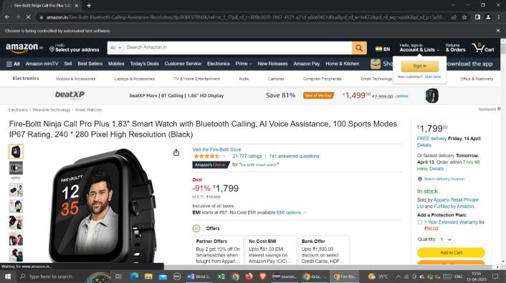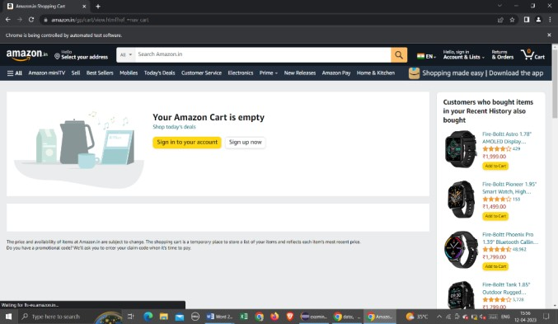

**Q2:**

package porm.exam.ca1;

import org.openqa.selenium.By; import org.openqa.selenium.WebDriver; import org.openqa.selenium.WebElement; import org.openqa.selenium.chrome.ChromeDriver; import org.openqa.selenium.chrome.ChromeOptions;

import io.github.bonigarcia.wdm.WebDriverManager;

public class Ca1q2 {

public static void main(String[] args) {

// TODO Auto-generated method stub ChromeOptions co=new ChromeOptions(); co.addArguments ("--remote-allow-origins=*"); WebDriverManager.chromedriver().setup (); WebDriver driver=new ChromeDriver(co); driver.get ("https://www.amazon.in/"); driver.manage().window().maximize() ;

String currentTitle=driver.getTitle();

System.out.println(currentTitle);

String expectedTitle="Online Shopping site in India: Shop Online for Mobiles,

Books, Watches, Shoes and More - Amazon.in"; if(currentTitle.equals(expectedTitle)) {

System.out.println("Title Matched");

}

else {

System.out.println("Title not Matched");

}

WebElement

txtBoxl=driver.findElement(By.xpath("//*[@id=\"twotabsearchtextbox\"]"));

txtBoxl.sendKeys("macbook"); driver.findElement(By.xpath("//*[@id=\"nav-search-submitbutton\"]")).click();

//displaying 5 products

String

txt1=driver.findElement(By.xpath("//*[@id=\"search\"]/div[1]/div[1]/div/span[1]/div[1]/div[ 3]/div/div/div/div/div/div/div/div[2]/div/div/div[1]/h2/a/span")).getText();

System.out.println(txt1);

String

txt2=driver.findElement(By.xpath("//*[@id=\"search\"]/div[1]/div[1]/div/span[1]/div[1]/div[ 4]/div/div/div/div/div/div/div/div[2]/div/div/div[1]/h2/a/span")).getText();

System.out.println(txt2);

String

txt3=driver.findElement(By.xpath("//*[@id=\"search\"]/div[1]/div[1]/div/span[1]/div[1]/div[ 5]/div/div/div/div/div/div[2]/div/div/div[1]/h2/a/span")).getText();

System.out.println(txt3);

String

txt4=driver.findElement(By.xpath("//*[@id=\"search\"]/div[1]/div[1]/div/span[1]/div[1]/div[ 6]/div/div/div/div/div/div[2]/div/div/div[1]/h2/a/span")).getText();

System.out.println(txt4);

String

txt5=driver.findElement(By.xpath("//*[@id=\"search\"]/div[1]/div[1]/div/span[1]/div[1]/div[ 7]/div/div/div/div/div/div[2]/div/div/div[1]/h2/a/span")).getText();

System.out.println(txt5);

//filter

driver.findElement(By.xpath("//*[@id=\"p_36/7252032031\"]/span/a/span")).click()

;

driver.findElement(By.xpath("//*[@id=\"p_n_pattern_browse-

bin/1464446031\"]/span/a/span")).click();

}}

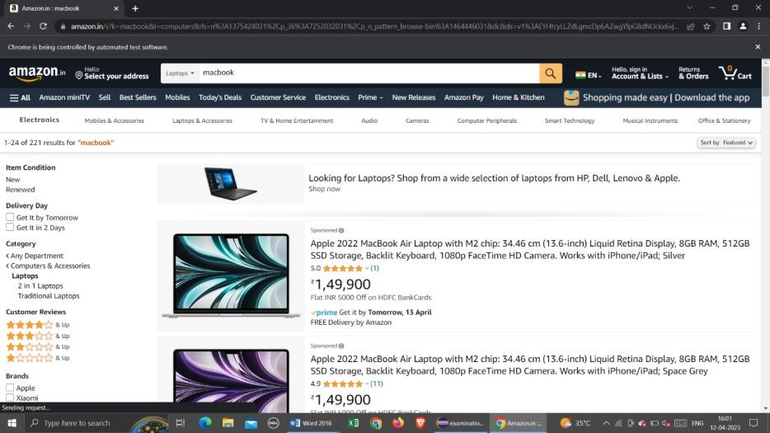

**Q3:**

package porm.test.demo;

import org.openqa.selenium.By; import org.openqa.selenium.WebDriver; import org.openqa.selenium.WebElement; import org.openqa.selenium.chrome.ChromeDriver; import org.openqa.selenium.chrome.ChromeOptions;

import io.github.bonigarcia.wdm.WebDriverManager;

public class CA1Q3 {

public static void main(String[] args) {

// TODO Auto-generated method stub ChromeOptions co=new ChromeOptions(); co.addArguments ("--remote-allow-origins=*"); WebDriverManager.chromedriver().setup (); WebDriver driver=new ChromeDriver(co);

driver.get ("https://www.amazon.in/"); driver.manage().window().maximize() ;

String currentTitle=driver.getTitle();

System.out.println(currentTitle);

String expectedTitle="Online Shopping site in India: Shop Online for Mobiles,

Books, Watches, Shoes and More - Amazon.in"; if(currentTitle.equals(expectedTitle)) {

System.out.println("Title Matched");

}

else {

System.out.println("Title not Matched");

}

driver.findElement(By.xpath("//*[@id=\"nav-link-accountList\"]")).click();

WebElement

txtBoxl=driver.findElement(By.xpath("//*[@id=\"ap_email\"]")); txtBoxl.sendKeys("9345611608");

driver.findElement(By.xpath("//*[@id=\"continue\"]")).click();

WebElement

txtBox2=driver.findElement(By.xpath("//*[@id=\"ap_password\"]"));

txtBox2.sendKeys("kamalesh0617");

driver.findElement(By.xpath("//*[@id=\"signInSubmit\"]")).click();

driver.findElement(By.xpath("//*[@id=\"nav-link-accountList\"]")).click();

driver.findElement(By.xpath("//*[@id=\"a-

page\"]/div[2]/div/div[2]/div[1]/a/div/div")).click();

driver.findElement(By.xpath("//*[@id=\"a-autoid-2-announce\"]")).click();

driver.findElement(By.xpath("//*[@id=\"ordersInPackagecontainer\"]/div/div/a[1]")).click();

}}

