**Requirements**:

- Create Database in MySQL

- Connect Database in python through IntelliJ

- Create a table with parameters and insert data

- read the data and print it

- update the data for given parameters

- delete the data for given parameters

**Link to git repository (userInfo branch):** <https://github.com/yuvanadarsh/Python-MySQL.git>

**MySQL statements**

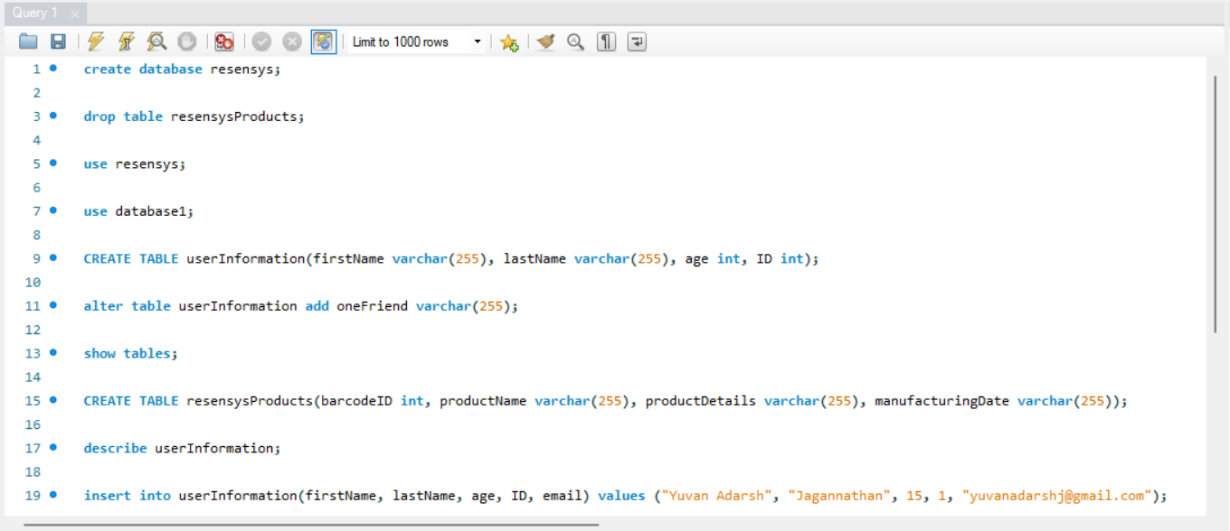

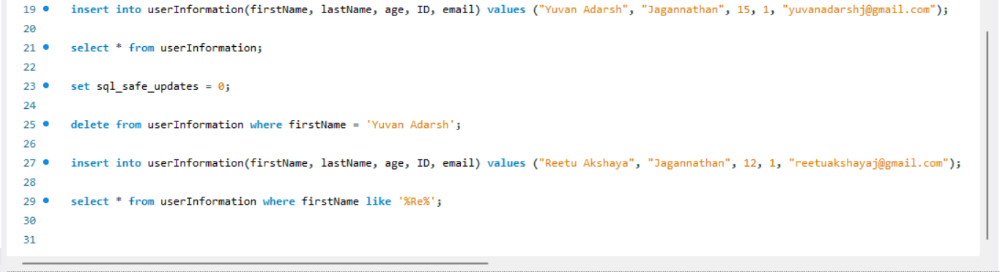

**Python Code**

