// Functions

// count()

SELECT COUNT(amount)
FROM transactions;
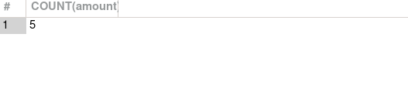

// now we named the function with the name count
SELECT COUNT(amount) AS Count
FROM transactions;
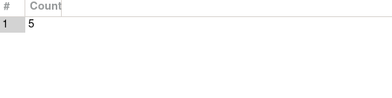

SELECT COUNT(amount) AS "Today's transaction"
FROM transactions;

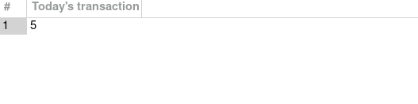
// MAX()

SELECT MAX(amount) AS "Maximum sale"
FROM transactions;
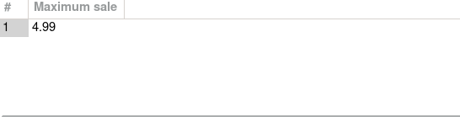

// MIN()
SELECT MIN(amount) AS "Miniumum sale"
FROM transactions;
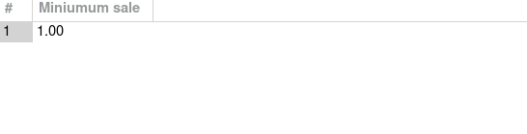
// Average()
SELECT AVG(amount) AS "Average"
FROM transactions;
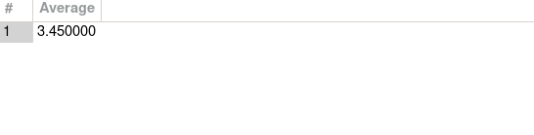

// SUM()
SELECT SUM(amount) AS "Total Sale"
FROM transactions;
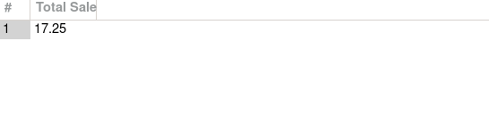
// CONCAT()

SELECT first_name, last_name
FROM employees;
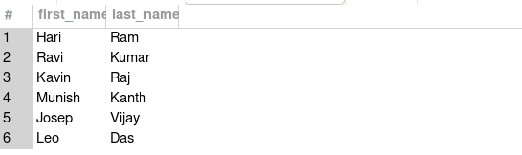

SELECT CONCAT(first_name, last_name) as Full_Name
FROM employees;
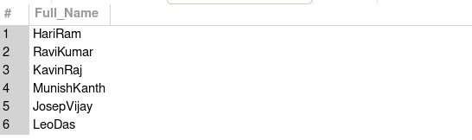
SELECT CONCAT(first_name, " ", last_name) as Full_Name
FROM employees;
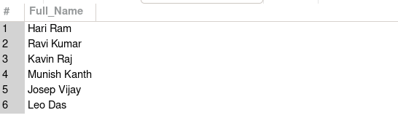

// OPERATORS

lets add a column job to employees table

ALTER TABLE employees
ADD COLUMN job VARCHAR(25) AFTER hourly_pay;

SELECT * FROM employees;
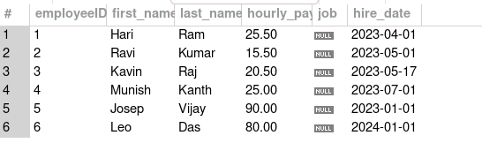
// UPDATE the job details

UPDATE employees
SET job = "cashier"
WHERE employeeID = 1;

SELECT * FROM employees;

--> this will throw an error that you are using sql in safe mode so you cant update, to over came this we use this below command

// SET SQL_SAFE_UPDATES = 0;

// now update the values
UPDATE employees
SET job = "cashier"
WHERE employeeID = 1;

SELECT * FROM employees;

--> value updated successful

// After updating all details
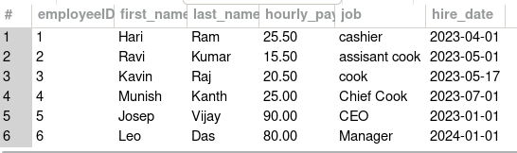

// AND OPERATOR

// select the cooks whose hire date date is befor 2023-05-01
SELECT *
FROM employees
WHERE hire_date < "2023-05-01" AND job = "cook";
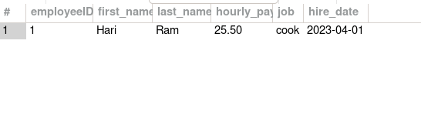

SELECT CONCAT(first_name, last_name) AS Full_Name
FROM employees
WHERE hire_date < "2023-05-01" AND job = "cook";
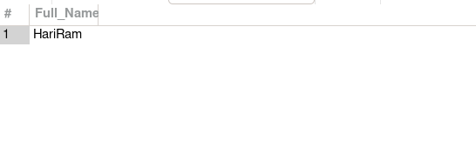
// NOT OPERATOR

// select the persons who are not at the managerial level

SELECT *
FROM employees
WHERE NOT job = "manager" AND NOT job = "ceo";
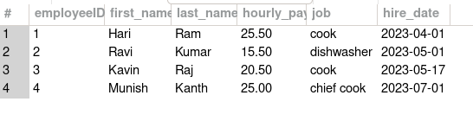

// BETWEEN OPERATOR

SELECT *
FROM employees
WHERE hire_date BETWEEN "2023-01-01" AND "2023-07-01";
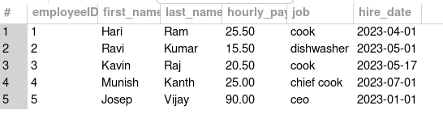

// IN OPERATOR

SELECT *
FROM employees
WHERE job IN ("cook", "dishwasher", "chief cook");

// OR OPERATOR
SELECT *
FROM employees
WHERE job = "cook" OR job = "dishwasher";
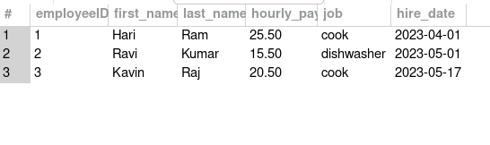

// WILD CARD CHARACTERS ( %,_) using LIKE

// This is used to match the contents present in the table

// eg., if you want to view all the jobs whose name starts with ‘c’

SELECT *
FROM employees
WHERE job LIKE "c%";
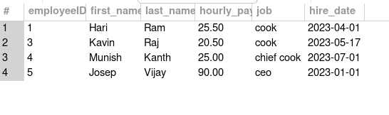

// % is used to match the contents that starts or ends with

// while ‘_’ is used to match the exact pattern
// eg., to find the jobs with has the patter a random character followed by ook
// _ook --> cook

SELECT *
FROM employees
WHERE job LIKE "_ook";
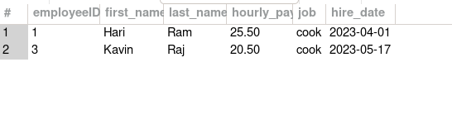
// what if “_ook_” this will check for 5 letter words whose 1st and last position of random characters and middle one with “ook”.

// this will perform the task of persons who where hired on the 1st of the month
SELECT *
FROM employees
WHERE hire_date LIKE "____-__-01";

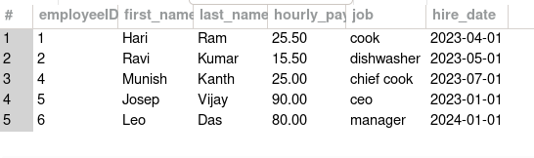

// select all the cooks

SELECT *
FROM employees
WHERE job LIKE "%_ook";

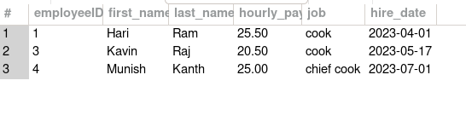

// ORDER BY CLAUSE --> This will give the table in format of asc r des order of the given column

// ASC / DES

// By Default the Order By will give you in asc order

//

SELECT *
FROM employees
ORDER BY first_name ASC;
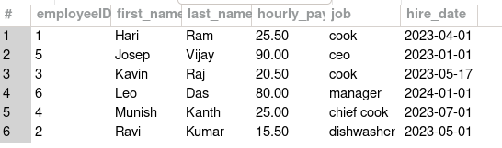
SELECT *
FROM employees
ORDER BY first_name DESC;
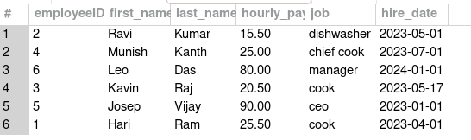
SELECT *
FROM employees
ORDER BY hire_date ASC;
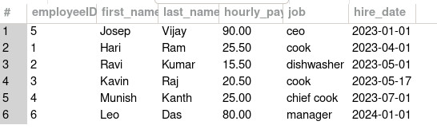

SELECT *
FROM transactions
ORDER BY amount ASC;
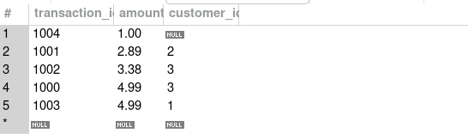

// Incase if you order by based on 2 columns then you can do it
// this will work based on the if 2 or more rows having same amount, it will check for the 2nd columns asc or des order

eg

SELECT *
FROM transactions
ORDER BY amount, customer_id ASC;
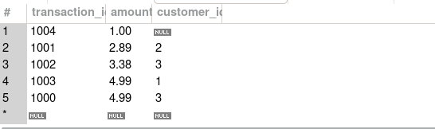
SELECT *
FROM transactions
ORDER BY amount ASC, customer_id DESC;

// LIMIT CLAUSE

