
(An Autonomous Institution, Affiliated to Anna University, Chennai)
Weather Analysis and Climate Insights
Using Power BI
AD23632 – FRAMEWORK FOR DATA AND VISUAL ANALYTICS
Submitted by
Name: YUVAN PRASANTH R
Register Number: 241501255
Department: Artificial Intelligence and Machine Learning
Submitted to
Ms. AKSHAYA V
Academic Year: 2026–2027
TABLE OF CONTENTS
Abstract 3
Chapter 1: Introduction 4
Chapter 2: Tools and Technologies Used 5
Chapter 3: Dataset Description 6
Chapter 4: Methodology 7
Chapter 5: Power BI Dashboard and Visualizations 8
Chapter 6: Results and Discussion 10
Chapter 7: Advantages, Limitations and Future Enhancements 11
Chapter 8: Dashboard Output and Conclusion 12
ABSTRACT
The Weather Analysis project examines a large weather observations dataset using Microsoft Power BI. The dataset contains 533,312 records and eight numeric attributes: atmospheric pressure, global radiation, mean, minimum and maximum temperature (in °C), wind speed, wind bearing, and a normalized label with four classes (0 to 3).
The Power BI report contains three pages. The first page is an overview with four visuals: a pie chart of pressure, label, temperature and wind fields; a donut chart of temperature and global radiation totals; a column chart of wind speed and temperatures; and a bar chart comparing six measures. The second page compares the totals of six measures in a clustered column chart. The third page shows the share of temperature totals and the label in a donut chart. The project demonstrates how visual analytics can help users compare temperature, wind, radiation, and pressure measurements in a large dataset.
CHAPTER 1: INTRODUCTION
1.1 Introduction
Weather analytics applies data analysis and visualization to meteorological observations such as temperature, wind, pressure, and radiation. Understanding these measurements supports planning in agriculture, energy, transport, and public safety. This project uses a weather observations dataset and a Power BI report to summarize and compare the main weather variables.
1.2 Problem Statement
Weather datasets contain hundreds of thousands of rows and several numeric attributes. Reviewing them manually makes it difficult to compare variables and spot patterns. A visual analytics solution helps summarize the records and present comparisons clearly.
1.3 Objectives
- Explore the weather dataset and its attributes.
- Compare minimum, mean, and maximum temperature totals.
- Compare wind speed, global radiation, and pressure measurements.
- Examine the share of each measure in combined totals.
- Understand the normalized label field and its distribution.
- Build a multi-page Power BI report.
1.4 Scope of the Project
The analysis covers 533,312 records and 8 attributes as represented in the supplied dataset. The data does not include date or location columns, so the report does not analyze trends over time or by place. Results describe this dataset and are not a live weather feed.
CHAPTER 2: TOOLS AND TECHNOLOGIES USED
2.1 Microsoft Power BI
Power BI is used to create interactive report pages and visualizations. The supplied PBIX file includes a pie chart, two donut charts, a clustered column chart, a clustered bar chart, and a text box title.
2.2 Tabular Dataset
The data is held in a single table named Combined12 (2), imported into the Power BI data model. Such tabular data can also be stored as CSV and inspected using spreadsheet software, Python libraries, and Power BI.
2.3 Python and Pandas
Python and Pandas can be used to inspect the dataset, check data types, detect missing or duplicate rows, and calculate summary statistics.
2.4 Technologies Summary
Technology | Purpose
Tabular dataset (CSV) | Stores weather observations in rows and columns.
Microsoft Power BI | Creates charts and report pages.
Python | Supports data inspection and preprocessing.
Pandas | Loads and summarizes the dataset.
CHAPTER 3: DATASET DESCRIPTION
3.1 Dataset Overview
The Power BI data model contains one table, Combined12 (2), with 533,312 rows and 8 columns. All columns are numeric. The dataset includes atmospheric, radiation, temperature, and wind measurements together with a normalized label.
3.2 Important Attributes
Attribute | Description | Range (mean)
Pressure | Atmospheric pressure reading. | 971.5 to 1015.0 (1011.44)
global_radiation | Global radiation reading. | 0.03 to 3.60 (1.31)
temp_mean(c) | Mean temperature in °C. | -11.1 to 28.6 (12.65)
temp_min(c) | Minimum temperature in °C. | -16.0 to 22.0 (8.65)
temp_max(c) | Maximum temperature in °C. | -8.5 to 37.0 (16.87)
Wind_Speed | Wind speed reading. | 0.00 to 47.53 (11.89)
Wind_Bearing | Wind direction in degrees. | 0 to 359 (192.50)
normalized_label | Label with four classes: 0, 1, 2, 3. | 0 to 3 (0.91)
The normalized_label field has 239,241 records in class 0 (44.9%), 155,709 in class 1 (29.2%), 87,533 in class 2 (16.4%), and 50,829 in class 3 (9.5%). Its meaning is not documented in the file. Records in classes 2 and 3 have a much higher average wind speed (about 22) than classes 0 and 1 (about 8), and classes 1 and 3 have higher average temperature and radiation.
3.3 Dataset Quality Checks
Basic inspection found 0 missing cells. It also found 16,264 fully duplicated rows (3.05% of the data), which were not removed in the report. In addition, 3,809 rows (0.71%) have a mean temperature greater than the maximum temperature, which suggests some inconsistent values. These checks do not guarantee that every value is semantically valid.
CHAPTER 4: METHODOLOGY
4.1 Project Workflow
Dataset → Data Inspection → Data Preparation → Power BI Import → Visualizations → Interpretation
4.2 Data Inspection and Preparation
- Load the dataset and inspect rows and columns.
- Check column names, data types, missing values, and duplicate records.
- Confirm the temperature, wind, radiation, pressure, and label fields.
- Aggregate the numeric fields as sums for the visuals.
- Build report visuals in Power BI.
4.3 Dashboard Development
The supplied PBIX file contains three report pages. Every visual uses the sum of numeric fields (such as temperature, wind speed, global radiation, pressure, wind bearing, and the normalized label). The report does not group the data by category, so each visual compares overall totals of the selected fields.
4.4 Interpretation
The visuals compare the share of each field within the combined total, and the relative size of temperature, wind, radiation, and label totals.
CHAPTER 5: POWER BI DASHBOARD AND VISUALIZATIONS
Dashboard Overview
The report contains three pages. The screenshots below show each page of the dashboard.
5.1 Page 1: Weather Overview
The first page carries the title “weather analysis” and four visuals. The pie chart combines pressure, normalized label, mean and minimum temperature, wind bearing, and wind speed; pressure takes 81.7% of this total because its values are around 1,000 per record, and wind bearing takes 15.55%. The donut chart compares total minimum temperature (4.61M, 21.91%), mean temperature (6.74M, 32.03%), maximum temperature (9.00M, 42.74%), and global radiation (0.70M, 3.32%). The column and bar charts compare wind speed with the three temperature measures, and global radiation and the normalized label are added in the bar chart.
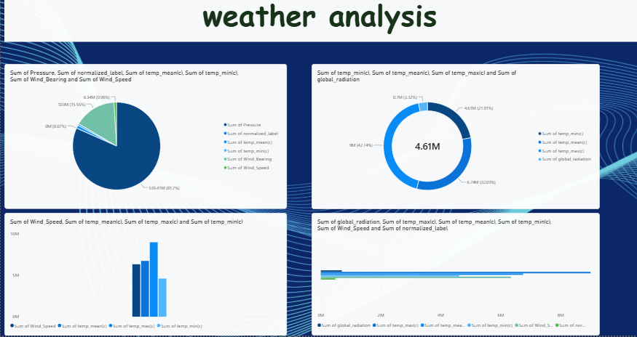
Figure 5.1: Page 1 – Weather Overview
5.2 Page 2: Comparison of Measures
The second page is a clustered column chart of six totals. Maximum temperature has the largest total (9.00M), followed by mean temperature (6.74M), wind speed (6.34M), and minimum temperature (4.61M). Global radiation (0.70M) and the normalized label (0.48M) are much smaller.
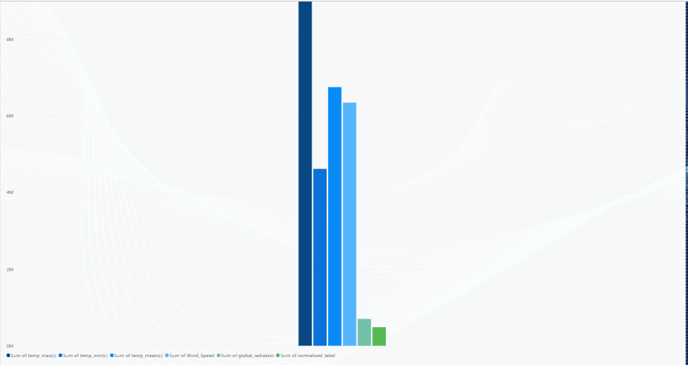
Figure 5.2: Page 2 – Totals of Six Measures
5.3 Page 3: Temperature Share
The third page is a donut chart of the totals of maximum temperature, mean temperature, minimum temperature, and the normalized label. Maximum temperature holds 43.18% of the combined total (9.00M, shown in the centre of the chart), mean temperature 32.37% (6.74M), minimum temperature 22.13% (4.61M), and the normalized label 2.32%.
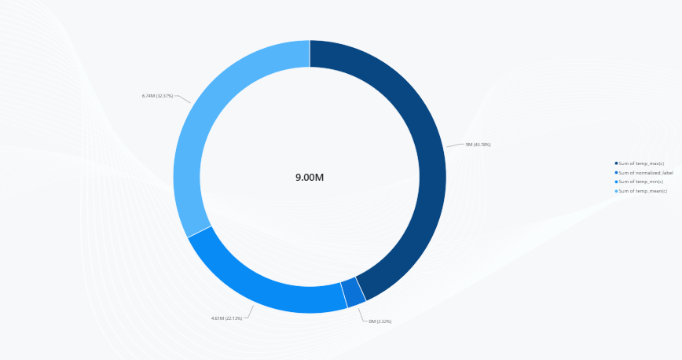
Figure 5.3: Page 3 – Temperature and Label Share
CHAPTER 6: RESULTS AND DISCUSSION
6.1 Results
- The dataset contains 533,312 records and 8 numeric attributes.
- Average temperatures are 8.65 °C (minimum), 12.65 °C (mean), and 16.87 °C (maximum).
- Mean temperature ranges from -11.1 °C to 28.6 °C; maximum temperature reaches 37.0 °C.
- Maximum temperature has the largest total (9.00M), followed by mean temperature (6.74M) and wind speed (6.34M).
- Global radiation (0.70M) and the normalized label (0.48M) have the smallest totals.
- Pressure takes 81.7% of the combined pie chart total because of its large values.
- Wind speed averages 11.89 and is much higher in label classes 2 and 3 (about 22) than in classes 0 and 1 (about 8).
- 16,264 rows are duplicates and 3,809 rows have mean temperature above maximum temperature.
6.2 Discussion
The dashboard compares totals of weather fields. These findings are descriptive. Summing different fields such as pressure, wind bearing, and temperature does not give physically meaningful totals, and fields with large values (like pressure) dominate the charts. Averages, distributions, or grouping by date or location would give more meaningful comparisons. The findings do not establish relationships between variables.
CHAPTER 7: ADVANTAGES, LIMITATIONS & FUTURE ENHANCEMENTS
7.1 Advantages
- Summarizes a large dataset (over 533,000 records) visually.
- Makes comparison of temperature measures easier.
- Shows the relative size of wind, radiation, and temperature totals.
- Provides a multi-page report in Power BI.
7.2 Limitations
- Results depend on the supplied dataset’s correctness.
- The dataset has no date or location column, so trends over time or by place cannot be shown.
- Visuals use sums of different fields, which are not meaningful as totals; averages would be more suitable.
- Fields with large values, such as pressure, dominate combined charts.
- The normalized label is not documented, and 16,264 duplicate rows and 3,809 inconsistent temperature rows remain in the data.
- The dashboard is not live unless connected to an updating source.
7.3 Future Enhancements
- Use averages, minimum, and maximum instead of sums.
- Add date and location fields to analyze trends over time and by place.
- Add slicers for the normalized label and temperature ranges.
- Analyze the relationship between temperature, radiation, and wind speed.
- Remove duplicate rows and correct inconsistent temperature values.
- Document the meaning of the normalized label.
CHAPTER 8: DASHBOARD OUTPUT AND CONCLUSION
8.1 Dashboard Output
Figure 8.1: Power BI dashboard output (Page 1)
8.2 Conclusion
The Weather Analysis project demonstrates how a large weather dataset can be explored and summarized using Microsoft Power BI. The report presents temperature, wind speed, global radiation, pressure, and label totals through pie, donut, column, and bar visualizations.
The project provides practical experience in dataset inspection, aggregation, visual analytics, and dashboard presentation. Findings remain limited to the records and fields available in the supplied dataset.

