A PROJECT REPORT ON
AIML TRANSACTIONS & FRAUD ANALYSIS
Transaction Monitoring, Fraud Detection and Alert Analysis using Microsoft Power BI
Submitted by
S. YUVANRAJ
Course: B.Com Fintech with AI
October 2026

Contents
1. Introduction
2. Objectives
3. Tools and Technologies
4. Data Source and Data Model
5. Dashboard Structure
6. Page 1: KPI
7. Page 2: Interactive Dashboard
8. Page 3: Tooltip
9. Key Insights
10. Role of AI and Machine Learning
11. Recommendations
12. Limitations and Future Scope
13. Conclusion

1. Introduction
Digital payments have made financial services faster and more convenient, but they have also made fraud and money laundering harder to detect. Banks and fintech companies process millions of transactions, and only a very small fraction of them are suspicious. Finding these few transactions among millions is one of the most important problems in modern financial analytics.
This project presents the AIML Transactions & Fraud Analysis dashboard, a three-page Power BI report built on a dataset of accounts, alerts and transactions. The dashboard summarises transaction volume and value, shows how many transactions are flagged as fraudulent, breaks down the alerts raised by type, and lets the user filter the analysis by fraud status and alert type.
The report documents the purpose, data model, design and findings of every dashboard page, together with charts and tables, and discusses how AI and machine learning can build on this analysis.

2. Objectives
- To build a Power BI dashboard that gives a clear view of transaction activity and fraud in one place.
- To measure key indicators such as total transactions, transaction value, fraudulent transactions, accounts and initial balances.
- To compare legitimate and fraudulent transactions and measure the fraud rate.
- To analyse the alerts raised by the system by alert type (cycle and fan_in).
- To provide interactive slicers for IS_FRAUD and ALERT_TYPE so that users can explore the data.
- To add a tooltip page that shows summary figures on hover.
- To link the findings to AI and machine learning approaches for fraud detection.

3. Tools and Technologies
Tool / Feature | Purpose in this project
Microsoft Power BI Desktop | Data modelling, measure creation and report design
Data model (3 tables) | accounts, alerts and transactions tables linked for combined analysis
DAX measures | Total Transactions, Fraudulent Transactions, Total Transaction Amount, Average Transaction Amount, Total Accounts, Total Initial Balance
Visualizations | Cards, bar charts, donut chart, column chart and line chart
Slicers | IS_FRAUD checkbox slicer and ALERT_TYPE tile slicer
Tooltip page | Report-page tooltip with fraud and transaction totals

4. Data Source and Data Model
The Data pane of the report shows three tables. Together they describe the customers' accounts, the transactions made between them and the alerts raised on suspicious activity.
Table 1: Tables in the data model
Table | Description
accounts | Account records, including the initial balance of each account (10K accounts in total)
transactions | Individual transactions with amount, timestamp and an IS_FRAUD flag (True or False)
alerts | Alerts raised on suspicious activity, identified by ALERT_ID and classified by ALERT_TYPE (cycle or fan_in)

Two alert types appear in the dashboard. A cycle pattern is where money moves through a loop of accounts and returns to its starting point, and a fan_in pattern is where many accounts send money into a single account. Both are well-known patterns used to identify money laundering. The structure of the data suggests it comes from a simulated anti-money-laundering (AML) dataset used for learning and testing.

5. Dashboard Structure
The report has three pages. All pages use a deep-blue background with a flowing wave graphic and white rounded cards, so that numbers and charts are easy to read.
Table 2: Pages of the dashboard
Page | Name | Purpose
1 | KPI | Six headline KPI cards and four charts on alerts, fraud share and transaction trend
2 | Interactive dashboard | Titled page with the same KPIs and charts, plus IS_FRAUD and ALERT_TYPE slicers
3 | Tooltip | Hover page showing Fraudulent Transactions, Total Transaction Amount and Total Transactions

6. Page 1: KPI
The KPI page is the summary view of the project. Six cards on the left show the key numbers, while four charts on the right show alerts by type, the fraud split and the transaction trend over time.
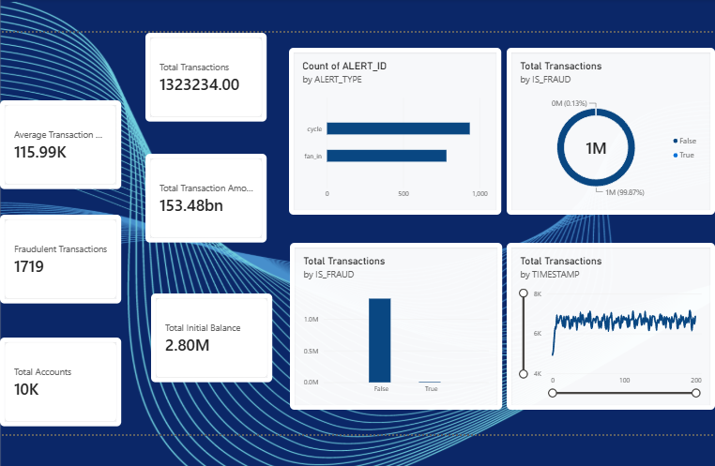
Figure 1: KPI page of the dashboard

6.1 Key Performance Indicators
Table 3: KPI cards
KPI | Value | What it tells us
Total Transactions | 1,323,234 | Number of transactions recorded
Total Transaction Amount | 153.48 bn | Total value of all transactions
Average Transaction Amount | 115.99K | Average value of one transaction
Fraudulent Transactions | 1,719 | Transactions flagged IS_FRAUD = True
Total Accounts | 10K | Number of accounts in the data
Total Initial Balance | 2.80M | Sum of opening balances of all accounts

6.2 Count of ALERT_ID by ALERT_TYPE
The bar chart counts alerts for each alert type. Cycle alerts are the more frequent type at roughly 940, while fan_in alerts are roughly 780. Together they come close to the 1,719 fraudulent transactions, which suggests that the alerts line up closely with the fraud cases.
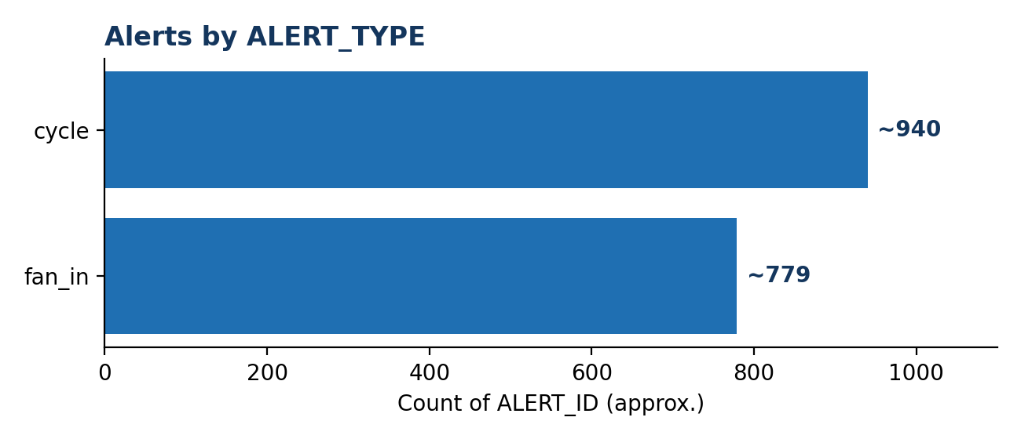
Figure 2: Alerts by ALERT_TYPE (approximate values read from the dashboard chart)

6.3 Total Transactions by IS_FRAUD
The donut chart shows that 99.87% of transactions are legitimate (False) and only 0.13% are fraudulent (True). The column chart shows the same split in absolute numbers, where the True bar is too small to see. This is the main point of the dashboard: fraud is rare, but it must still be found.
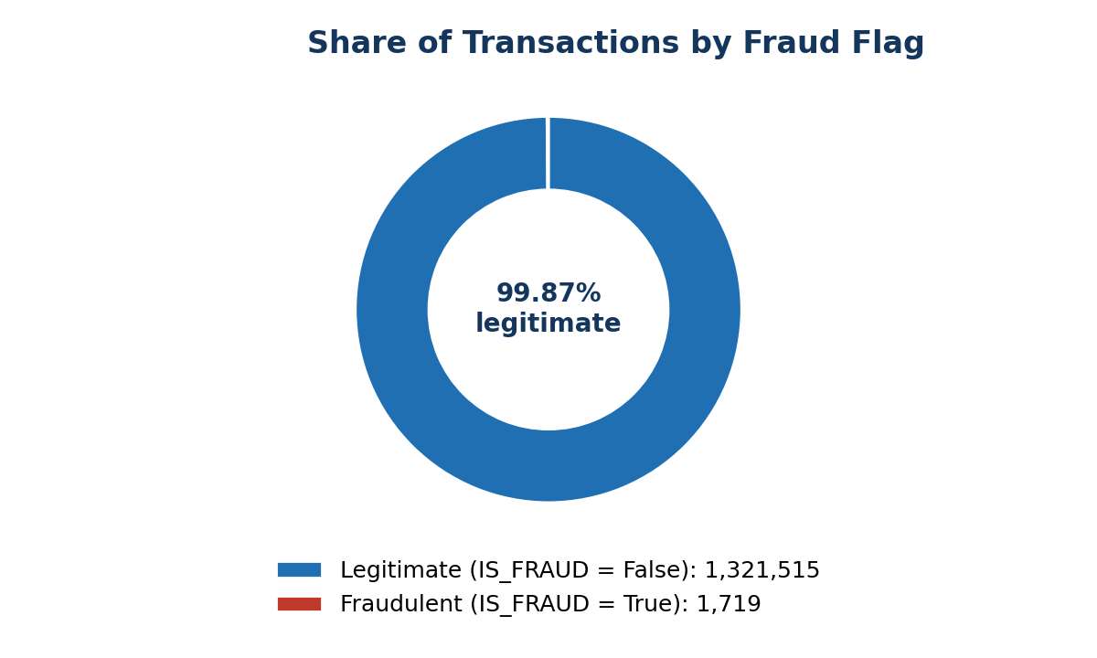
Figure 3: Share of legitimate and fraudulent transactions
Table 4: Legitimate vs fraudulent transactions
IS_FRAUD | Transactions | Share
False (legitimate) | 1,321,515 | 99.87%
True (fraudulent) | 1,719 | 0.13%
Total | 1,323,234 | 100%

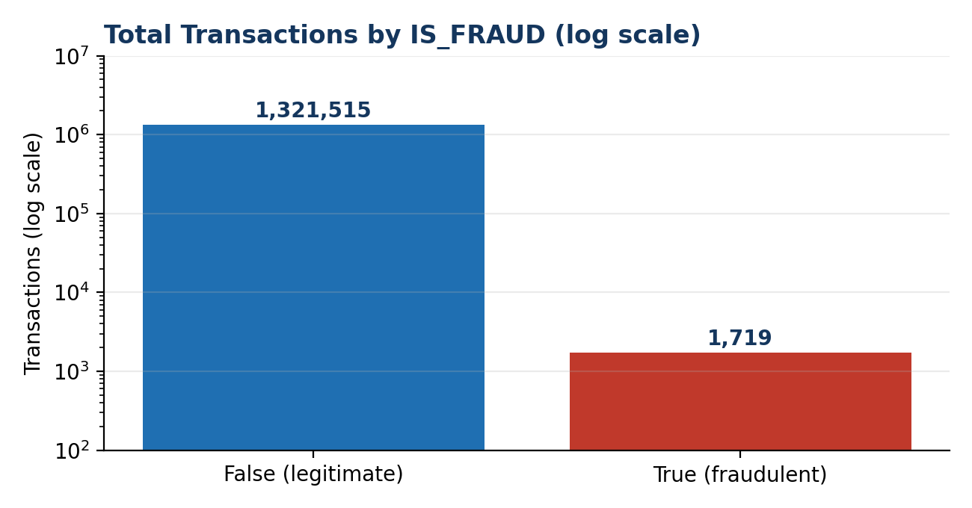
Figure 4: Transactions by IS_FRAUD on a logarithmic scale, which makes the small fraud bar visible

6.4 Total Transactions by Timestamp
The line chart tracks the number of transactions across timestamps. After a sharp rise at the very start, transactions stay in a stable band of roughly 6,000 to 7,000 per timestamp until the end of the period, with regular small fluctuations. There is no sudden collapse or spike, so the volume is steady. The chart also has sliders on both axes, which let the user zoom into a range.
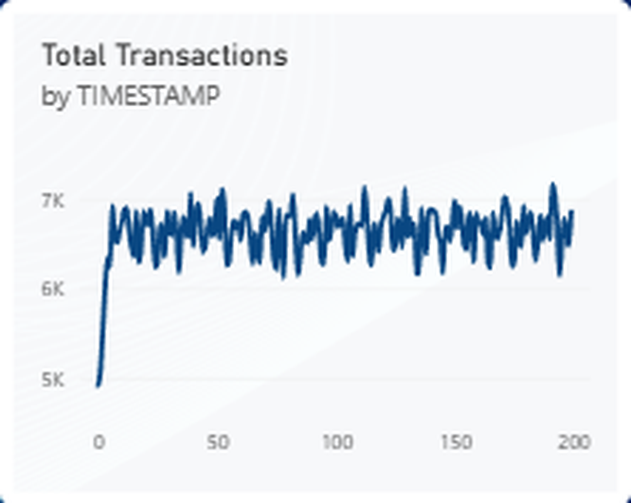
Figure 5: Total Transactions by TIMESTAMP (taken from the dashboard)

7. Page 2: Interactive Dashboard
The second page carries the title AIML TRANSACTIONS & FRAUD ANALYSIS and repeats the KPI cards and charts of the first page. In addition it provides two slicers at the bottom left, so the user can filter every visual on the page.
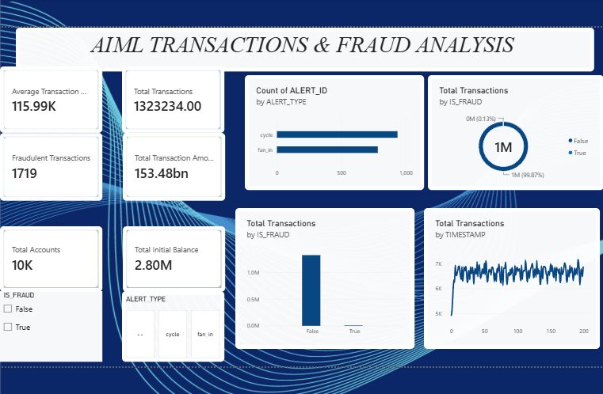
Figure 6: Interactive dashboard page with slicers
Table 5: Slicers on the interactive page
Slicer | Type | Effect on the dashboard
IS_FRAUD | Checkbox list (False, True) | Show only legitimate or only fraudulent transactions, with all KPIs and charts updating
ALERT_TYPE | Tile buttons (cycle, fan_in and a blank option) | Show results for one alert type

7.1 How the interactivity works
- Ticking True in the IS_FRAUD slicer isolates the 1,719 fraudulent transactions, so the cards show their count, amount and pattern over time.
- Ticking False shows the legitimate transactions, which allows a comparison of normal behaviour with fraud.
- Clicking cycle or fan_in in the ALERT_TYPE slicer shows only the transactions linked with that alert pattern.
- The slicers can be combined, for example fraudulent transactions with cycle alerts.
- Cards, charts and the line chart all respond at the same time, which makes the page useful for investigation.

8. Page 3: Tooltip
The third page is a custom tooltip page. It is not used on its own: it appears as a small pop-up when the user hovers over a visual on the other pages. It contains three cards: Fraudulent Transactions (1719), Total Transaction Amount (153.48 bn) and Total Transactions (1323234). With Keep all filters switched on, the tooltip shows figures that match whatever filters or hover context the user has selected. In the design view some card labels are cut off, so the card width can be increased to show the full labels.
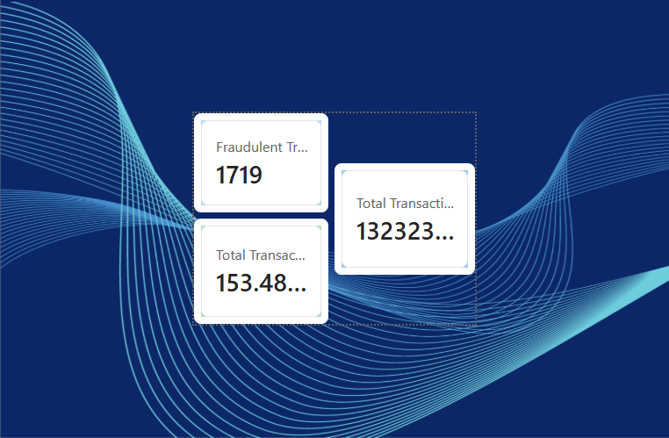
Figure 7: Tooltip page
Table 6: Tooltip card values (no filter applied)
Measure | Value
Fraudulent Transactions | 1,719
Total Transaction Amount | 153.48 bn
Total Transactions | 1,323,234

9. Key Insights
A few extra metrics can be calculated from the dashboard figures.
Table 7: Derived metrics
Metric | Value | Calculation
Fraud rate | 0.13% | 1,719 ÷ 1,323,234
Legitimate transactions | 1,321,515 | Total − Fraudulent
Transactions per fraud case | about 770 | 1,323,234 ÷ 1,719
Average transactions per account | about 132 | 1,323,234 ÷ 10K accounts
Average initial balance per account | about 280 | 2.80M ÷ 10K accounts
Total amount per account | about 15.3M | 153.48 bn ÷ 10K accounts
Average amount per transaction | about 115,987 | 153.48 bn ÷ 1,323,234

- Fraud is extremely rare: only about 1 in 770 transactions is fraudulent, so it cannot be spotted by looking at totals alone.
- Alerts match fraud: the combined cycle and fan_in alerts are close to the number of fraudulent transactions, so the alerting rules appear to capture the fraud cases.
- Cycle is the larger pattern: cycle alerts are somewhat more common than fan_in alerts (about 55% against 45%).
- Steady activity: transaction counts stay in a stable band across the time axis, so any unusual burst would stand out.
- Large value per transaction: the average transaction is about 115,987 while the average initial balance per account is only about 280. This gap is very large and suggests the data is simulated rather than taken from a real bank.

10. Role of AI and Machine Learning
The dashboard describes what has happened. AI and machine learning can predict which new transactions are likely to be fraudulent. Key ideas for this dataset are below.
Table 8: How AI/ML connects to the dashboard
Topic | Relevance
Class imbalance | With only 0.13% fraud, a model that predicts "not fraud" every time would be 99.87% accurate but useless. Precision, recall and F1-score should be used instead of accuracy.
Supervised learning | The IS_FRAUD flag is a ready label, so models such as logistic regression, random forest or gradient boosting can be trained to classify transactions.
Anomaly detection | Unsupervised methods can find unusual transactions where labels are missing.
Graph analysis | Cycle and fan_in alerts describe patterns in a network of accounts, so graph-based features and graph neural networks suit this data.
Explainability | Banks need to explain why a transaction was flagged, so interpretable models and feature importance are important.

11. Recommendations
- Monitor the fraud rate (0.13%) as a standing KPI and set an alert threshold if it rises.
- Prioritise investigation of cycle alerts first because they are the larger group, while keeping fan_in rules active.
- Use the IS_FRAUD and ALERT_TYPE slicers to review fraud cases by pattern before closing alerts.
- Build a machine learning model with imbalance handling (class weights or resampling) and evaluate it with precision and recall.
- Add account-level and time-based features so that suspicious accounts can be ranked for review.

12. Limitations and Future Scope
Limitations
- The data appears to be simulated, so findings illustrate the method rather than real-world fraud levels.
- The dashboard shows counts and totals but does not yet show fraud amounts, fraud by account, or detection accuracy.
Future scope
- Add fraud amount, fraud by account and by time period.
- Integrate a trained ML model and show predicted fraud scores in the dashboard.
- Add a network view of accounts to visualise cycle and fan_in patterns.

13. Conclusion
The AIML Transactions & Fraud Analysis dashboard turns a large transaction dataset into a clear and interactive view of risk. With 1,323,234 transactions worth 153.48 bn across 10K accounts, only 1,719 transactions (0.13%) are fraudulent, and the alerts are split between cycle and fan_in patterns. The KPI page gives the overall picture, the interactive page lets users filter by fraud status and alert type, and the tooltip page gives quick figures on hover.
The project also shows why AI and machine learning matter in fintech: when fraud is this rare, simple totals are not enough and well-evaluated models are needed. With fraud amounts, account-level views and predictive scores added, the dashboard can grow into a complete monitoring tool.

