MINI PROJECT REPORT

GLOBAL SALES AND FINANCIAL
PERFORMANCE ANALYSIS
Using Power BI, DAX and a Star-Schema Data Model
Submitted by | S Yuvanraj
Course | B.Com Fintech with AI
Dataset | Global Sales and Financial Performance Dataset
Tool Used | Microsoft Power BI Desktop
Date | 29 September 2026

1. Introduction
Sales and financial performance data is the backbone of every commercial decision, from what to stock and where to sell, to how much cost the business can absorb. In a global business, this data is spread across products, customers, employees, dates and geographies, so raw tables alone do not tell the story. Business intelligence tools turn those tables into measures, visuals and interactive dashboards that decision-makers can read at a glance.
This report presents an end-to-end analysis of the Global Sales and Financial Performance Dataset using Microsoft Power BI. The work covers building a star-schema data model, writing and validating DAX measures, designing a sales performance analysis page, and publishing an interactive dashboard with slicers for year, category and region.

1.1 Objectives
- Build a clean, relational data model with one fact table and five dimension tables.
- Create DAX measures for Total Sales, Total Profit, Total Quantity, Total Cost, Order Count and Average Sales.
- Validate the DAX results by reconciling a product-level table against the headline KPI cards.
- Analyse sales by product category, month, employee and region.
- Deliver an interactive dashboard that lets a user filter the whole report by year, category and region.

1.2 Scope of the Study
The analysis covers the complete sales dataset of 300,006 units sold, generating total sales of 70.64 million. It is descriptive in nature: it explains what happened and where, and it identifies patterns that a business or a finance team would want to investigate further.

2. Dataset and Data Model
The Power BI file (YUVANRAJ_POWERBI_DATASET_2) is organised as a star schema. A single fact table stores every sales transaction, and five dimension tables describe the who, what, when and where of each transaction. This design keeps the model fast, avoids duplicated data and makes DAX measures simple to write.
Table | Type | Purpose
FactSales | Fact | Transaction-level sales, quantity, cost and profit values
DimCustomer | Dimension | Customer attributes used to analyse who is buying
DimDate | Dimension | Calendar attributes such as year and month name for time analysis
DimEmployee | Dimension | Sales employees, used for employee-wise profit analysis
DimGeography | Dimension | Region and location details for geographic analysis
DimProduct | Dimension | Product name, product code and category
Table 1: Tables in the Power BI data model

2.1 Why a Star Schema
- Performance: filters flow from small dimension tables to the large fact table, so visuals refresh quickly.
- Clarity: each business question maps to one dimension, for example region questions use DimGeography.
- Reusability: the same measures work across every visual, slicer and page without rewriting.

2.2 Key Measures
Measure | What it shows | Value (full dataset)
Total Sales | Sum of sales revenue | 70.64M
Total Cost | Sum of cost of goods sold | 45.52M
Total Profit | Sales minus cost | 25.12M
Total Quantity | Units sold | 300K (300,006)
Order Count | Number of distinct orders | Shown on the interactive page
Average Sales | Average sales value per order | Shown on the interactive page
Table 2: Measures created in the model

3. DAX Validation
Before building any charts, the measures were validated on the first report page, named DAX VALIDATION. A table visual lists every product code with its Total Sales, Total Quantity and Total Profit, and its grand total row was compared with the KPI cards on the analysis page. The totals match exactly: 70.64M sales, 300K units and 25.12M profit. This confirms the measures are aggregating the fact table correctly and that no rows are lost or duplicated by the relationships.
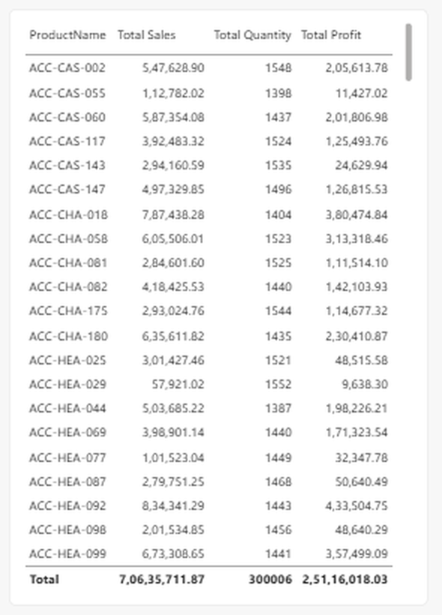
Figure 1: DAX Validation page, product-level table with grand totals
The table below reproduces the first 21 product codes from that validation table. A profit margin column has been added to show how much variation exists between products, even within the same product family.
Product Code | Total Sales | Quantity | Total Profit | Margin
ACC-CAS-002 | 5,47,628.90 | 1548 | 2,05,613.78 | 37.5%
ACC-CAS-055 | 1,12,782.02 | 1398 | 11,427.02 | 10.1%
ACC-CAS-060 | 5,87,354.08 | 1437 | 2,01,806.98 | 34.4%
ACC-CAS-117 | 3,92,483.32 | 1524 | 1,25,493.76 | 32.0%
ACC-CAS-143 | 2,94,160.59 | 1535 | 24,629.94 | 8.4%
ACC-CAS-147 | 4,97,329.85 | 1496 | 1,26,815.53 | 25.5%
ACC-CHA-018 | 7,87,438.28 | 1404 | 3,80,474.84 | 48.3%
ACC-CHA-058 | 6,05,506.01 | 1523 | 3,13,318.46 | 51.7%
ACC-CHA-081 | 2,84,601.60 | 1525 | 1,11,514.10 | 39.2%
ACC-CHA-082 | 4,18,425.53 | 1440 | 1,42,103.93 | 34.0%
ACC-CHA-175 | 2,93,024.76 | 1544 | 1,14,677.32 | 39.1%
ACC-CHA-180 | 6,35,611.82 | 1435 | 2,30,410.87 | 36.3%
ACC-HEA-025 | 3,01,427.46 | 1521 | 48,515.58 | 16.1%
ACC-HEA-029 | 57,921.02 | 1552 | 9,638.30 | 16.6%
ACC-HEA-044 | 5,03,685.22 | 1387 | 1,98,226.21 | 39.4%
ACC-HEA-069 | 3,98,901.14 | 1440 | 1,71,323.54 | 42.9%
ACC-HEA-077 | 1,01,523.04 | 1449 | 32,347.78 | 31.9%
ACC-HEA-087 | 2,79,751.25 | 1468 | 50,640.49 | 18.1%
ACC-HEA-092 | 8,34,341.29 | 1443 | 4,33,504.75 | 52.0%
ACC-HEA-098 | 2,01,534.85 | 1456 | 48,640.29 | 24.1%
ACC-HEA-099 | 6,73,308.65 | 1441 | 3,57,499.09 | 53.1%
Total (all products) | 7,06,35,711.87 | 300006 | 2,51,16,018.03 | 35.6%
Table 3: Product-level sales, quantity and profit (first 21 products and grand total)

3.1 Observations from the Validation Table
- Quantities are very even. every product listed sold between roughly 1,390 and 1,550 units, so differences in sales come mainly from price and mix, not volume.
- Best performer in the list: ACC-HEA-092 has the highest sales (8,34,341.29) and the highest profit (4,33,504.75), a margin of about 52%.
- Weakest performer in the list: ACC-HEA-029 has the lowest sales (57,921.02) and profit of only 9,638.30, a margin of about 17%.
- Margin spread is wide. ACC-CAS-055 sold 1,398 units but earned a margin of just 10.1%, while ACC-CHA-018 earned about 48.3% on similar volume. This points to pricing and cost differences rather than demand.

4. Sales Performance Analysis
The second report page, SALES PERFORMANCE ANALYSIS, brings the validated measures together in a single view. Four KPI cards sit at the top, followed by charts for category, month, employee and region.
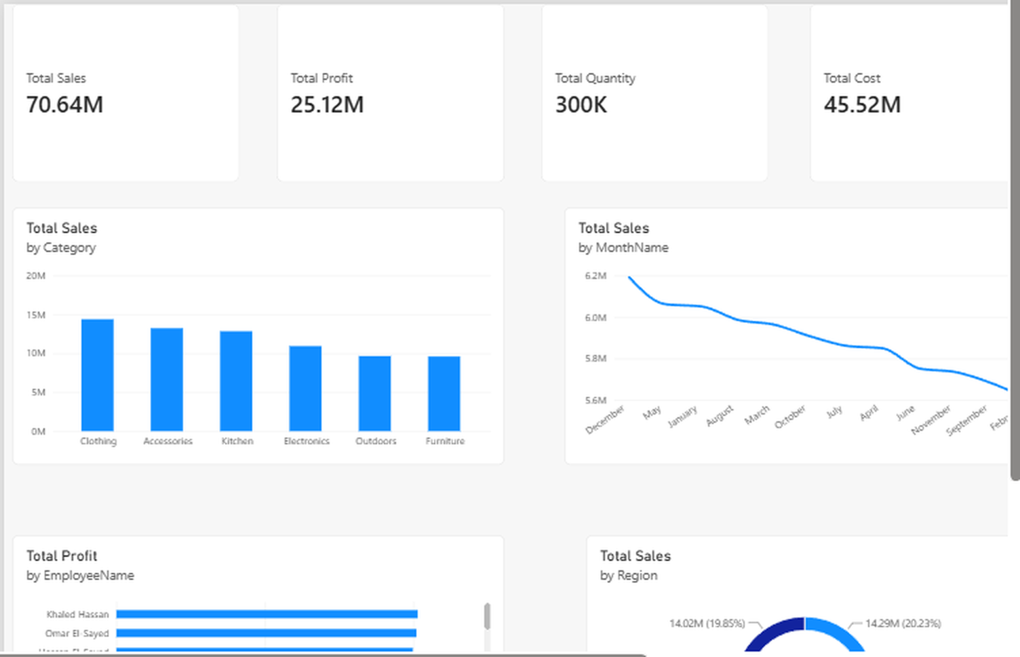
Figure 2: Sales Performance Analysis page in Power BI

4.1 Headline KPIs
KPI | Value | Reading
Total Sales | 70.64M | Total revenue generated across the dataset
Total Cost | 45.52M | About 64.4% of sales is consumed by cost
Total Profit | 25.12M | About 35.6% of sales is retained as profit
Total Quantity | 300K | Average of about 235.5 in sales per unit sold
Table 4: Headline KPIs and what they indicate
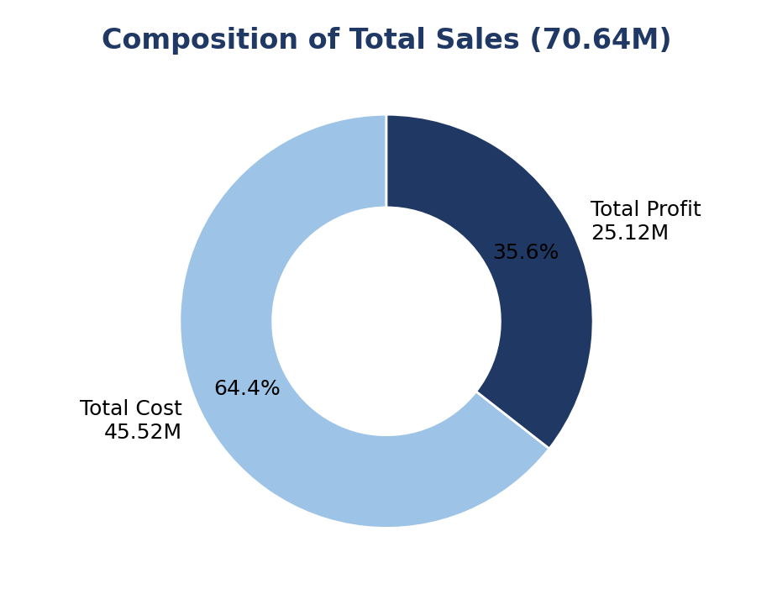
Figure 3: Split of total sales into cost and profit
Of every 100 units of sales revenue, roughly 64 go to cost and about 36 remain as profit. Profit per unit sold works out to about 83.7 (25.12M divided by 300K units). Because the financial health of a sales business depends on this margin, it is the single most important ratio on the page.

4.2 Sales by Product Category
Six product categories contribute to sales. Clothing leads, followed closely by Accessories and Kitchen, while Outdoors and Furniture trail at the bottom of the ranking.
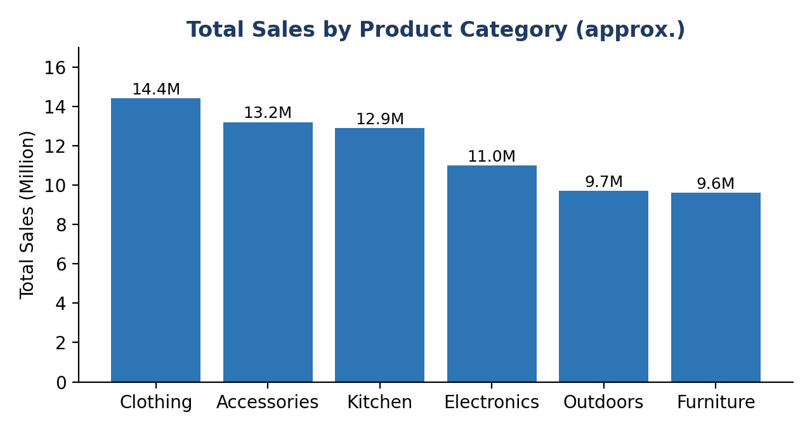
Figure 4: Total sales by category (values read from the dashboard bar chart, approximate)
Rank | Category | Total Sales (approx.) | Share of Sales
1 | Clothing | 14.4M | 20.3%
2 | Accessories | 13.2M | 18.6%
3 | Kitchen | 12.9M | 18.2%
4 | Electronics | 11.0M | 15.5%
5 | Outdoors | 9.7M | 13.7%
6 | Furniture | 9.6M | 13.6%
Table 5: Category ranking by sales (approximate values from chart)
The top three categories together produce roughly 57% of sales, which shows moderate concentration. Clothing, at around one fifth of sales, is the anchor category for the business.

4.3 Sales by Month
The line chart ranks months from the highest sales to the lowest. December is the strongest month at about 6.2M, and February is the weakest at about 5.65M, so the gap between the best and worst month is only about 9%. This narrow range suggests demand is fairly stable through the year with a mild lift around the year-end period.
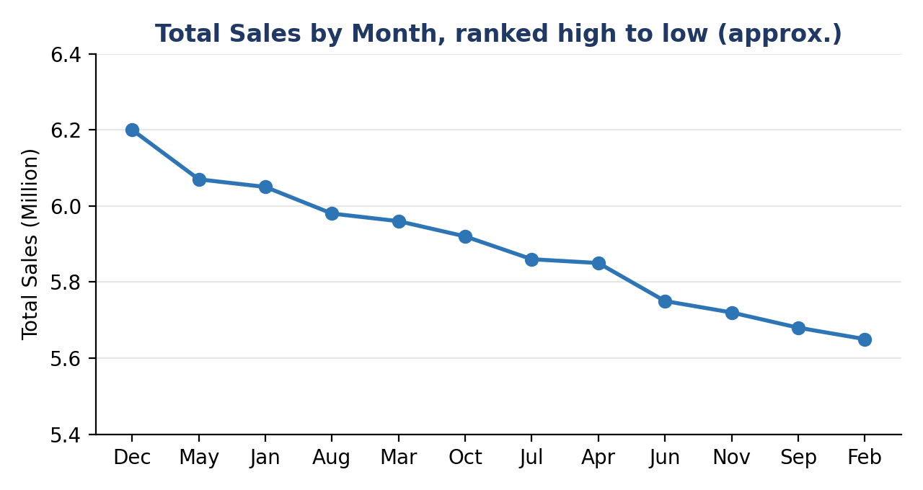
Figure 5: Monthly sales ranked from highest to lowest (approximate)

4.4 Profit by Employee and Sales by Region
The employee bar chart ranks sales staff by Total Profit, with Khaled Hassan, Omar El Sayed and other team members at the top. It allows management to see which sales people generate the most profit rather than only the most revenue, and it is useful for incentive design and performance reviews.
The regional donut chart shows a balanced spread of sales across five regions. The two regions labelled on the chart hold 14.02M (19.85%) and 14.29M (20.23%) of sales, and the remaining three regions share the balance of about 60%. No single region dominates, which reduces geographic concentration risk.

5. Interactive Sales Dashboard
The third page, INTERACTIVE SALES DASHBOARD, titled Global Sales and Financial Performance, is the finished product for end users. It adds two more KPIs, Order Count and Average Sales, and three slicers that filter every visual on the page at the same time.
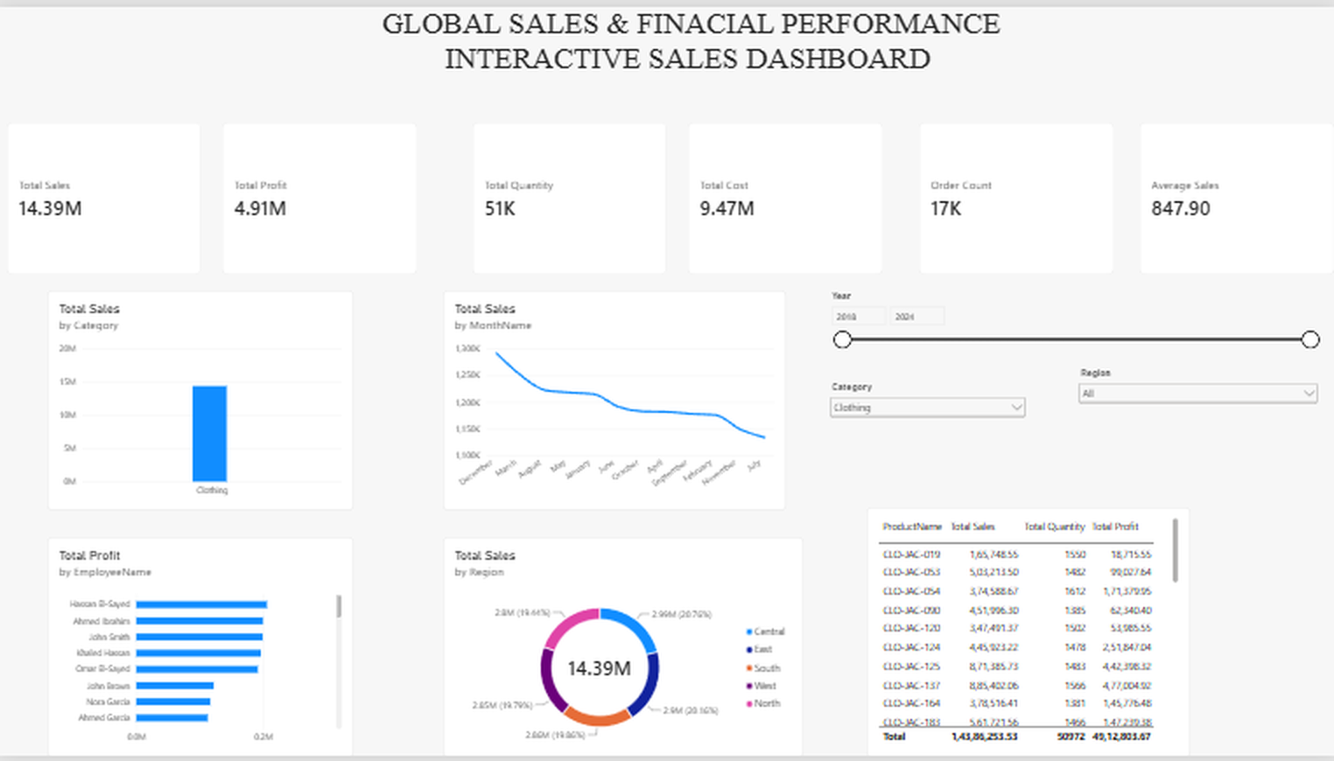
Figure 6: Interactive Sales Dashboard with Year, Category and Region slicers

5.1 Slicers Provided
- Year: a range slider that restricts the analysis to selected years.
- Category: a dropdown to focus on one product category, for example Clothing.
- Region: a dropdown to focus on one region or view all of them.

5.2 Example: Filtering to Clothing
In the screenshot, the Category slicer is set to Clothing. Every card and chart recalculates instantly, showing how Clothing alone performs compared with the whole business.
Metric | Full dataset | Clothing view
Total Sales | 70.64M | 14.39M
Total Profit | 25.12M | 4.91M
Total Quantity | 300K | 51K
Total Cost | 45.52M | 9.47M
Profit margin | 35.6% | 34.1%
Order Count | n/a | 17K
Average Sales | n/a | 847.90
Table 6: Overall performance compared with the Clothing filter
Clothing contributes about 20% of total sales (14.39M of 70.64M) with a margin of 34.1%, slightly below the company average of 35.6%. This means the category wins on volume rather than on profitability, and a small improvement in Clothing margin would have an outsized effect on overall profit. Note that the Year slicer on this page may also restrict the period, so the figures reflect the filters selected at the time of the screenshot.

6. Key Findings
# | Finding | Business Meaning
1 | Profit margin is about 35.6% on 70.64M of sales | A healthy overall margin, with cost at 64.4% of revenue
2 | Clothing, Accessories and Kitchen lead category sales | These three categories deserve priority in stock and marketing
3 | Monthly sales vary by only about 9% from best to worst month | Demand is stable, so planning risk from seasonality is low
4 | Sales are spread almost evenly across five regions | Low geographic concentration risk
5 | Product margins range from about 10% to over 50% | Pricing and cost control are the biggest profit levers
6 | Units sold per product are nearly identical | Revenue differences come from price and mix, not volume
Table 7: Summary of key findings

7. Relevance to Fintech and AI
This project connects directly to the B.Com Fintech with AI programme. Fintech is built on trusted, well-modelled financial data, and the practices used here, such as a star schema, reconciled measures and slicer-driven dashboards, are the same foundation used in banking analytics, payments monitoring and investment reporting.
- Forecasting: the monthly sales series can feed a time-series model to forecast future revenue and cash flow.
- Margin anomaly detection: machine learning can flag products whose margin falls outside its normal range, such as those below 15%.
- Customer analytics: the customer dimension can support segmentation, churn prediction and lifetime value scoring.
- Natural-language insights: AI assistants such as Copilot in Power BI can answer questions about the model in plain language, which is why the model was kept clean and well named.

8. Recommendations
- Review low-margin products. investigate items such as ACC-CAS-055 and ACC-HEA-029 for price increases or cost reduction.
- Defend and grow the leaders. protect stock levels of Clothing, Accessories and Kitchen and test promotions around December.
- Lift Furniture and Outdoors. use bundles or cross-selling with stronger categories to raise their contribution.
- Add a margin visual. extend the dashboard with margin percentage by category and region so profitability, not just sales, is visible.
- Reward on profit. use the employee profit chart as a basis for incentives that reward profitable selling rather than only revenue.

9. Limitations
- Category and month values in this report were read from chart visuals, so they are approximate. Exact figures are available in the Power BI model.
- The analysis is descriptive. It does not test causes or forecast future values.
- Currency units and the exact date range are not shown on the report pages and should be confirmed with the data source.

10. Conclusion
The Global Sales and Financial Performance dashboard shows a business with 70.64M in sales, 25.12M in profit and a healthy margin of about 35.6%. A properly modelled star schema, validated DAX measures and interactive slicers turn 300,006 units of transaction data into clear answers about categories, months, employees and regions. The main opportunities lie in improving low-margin products and strengthening the weaker categories, while the balanced regional and monthly patterns point to a stable base. The project also shows how business intelligence forms the foundation on which fintech and AI techniques, such as forecasting and anomaly detection, can be added next.

