Naan Mudhalvan • TN Skills Academic Initiative
Script-Controlled Access Control List (ACL)
Restricting Record Access Based on Field Values in ServiceNow
Project Title: | Script-Controlled ACL: Restrict Record Access
Team ID: | SWTID-2026-5789
Team Leader: | Yuvansankarraja G
Team Members: | Lewis Benjamin M • Natraj Prabhu P • Sanjay Kanth K • Siddharthan T
Program: | Naan Mudhalvan / TN Skills Initiative (SmartBridge)
Platform: | ServiceNow Platform Security / Global Scope
Custom Table: | u_institution_details (Institution Details)
GitHub Repository: | GitHub Link
Evaluation Date: | October 2026

Project Team & Work Breakdown Structure (WBS)
This project was executed by a five-member engineering team registered under Team ID: SWTID-2026-5789 for the Naan Mudhalvan / TN Skills initiative.
Team Size: 5
Team Leader: Yuvansankarraja G
Team Members: Lewis Benjamin M; Natraj Prabhu P; Sanjay Kanth K; Siddharthan T
Member Name | Team Role | Designated Milestones & Tasks | Key Deliverables
Yuvansankarraja G | Team Leader | Collaborative work across project milestones 1-7 | ServiceNow ACL implementation and project documentation
Lewis Benjamin M | Member | Collaborative work across project milestones 1-7 | ServiceNow ACL implementation and project documentation
Natraj Prabhu P | Member | Collaborative work across project milestones 1-7 | ServiceNow ACL implementation and project documentation
Sanjay Kanth K | Member | Collaborative work across project milestones 1-7 | ServiceNow ACL implementation and project documentation
Siddharthan T | Member | Collaborative work across project milestones 1-7 | ServiceNow ACL implementation and project documentation

Executive Summary
This project, titled "Script-Controlled ACL: Restrict Record Access Based on Field Value", was engineered as a core requirement under the Naan Mudhalvan / TN Skills technical upskilling initiative. The primary goal of this project is to implement granular, dynamic data segregation within an enterprise ServiceNow instance using Access Control Lists (ACLs) powered by server-side JavaScript conditions.
In enterprise institutions managing multifaceted student records across diverse engineering disciplines (such as Electrical and Electronics Engineering [EEE], Computer Science and Engineering [CSE], and Electronics and Communication Engineering [ECE]), ensuring data compartmentalization is vital. Traditional role-based access allows all-or-nothing visibility. By contrast, a script-controlled ACL evaluates both the user's assigned role and the specific record's field attributes (e.g., Branch == 'EEE') at runtime, implementing the Principle of Least Privilege (PoLP) and guaranteeing strict confidentiality.
Key Architectural Highlights
- Granular Role Segmentation: Segregation of responsibilities into distinct custom security roles (bb1 for Read, bb2 for Create, bb3 for Write, and bb4 for Delete).
- Runtime Script Logic: Implementation of server-side GlideSystem (gs) JavaScript to dynamically grant full access to administrators while confining departmental operators exclusively to their branch records.
- Full CRUD Lifecycle Enforcement: Comprehensive configuration and impersonation verification across Create, Read, Update/Write, and Delete operations on the u_institution_details table.

Project Architecture & Security Evaluation Hierarchy
ServiceNow enforces access control through a rigorous 3-tiered evaluation pipeline on every transaction:
- Roles: Does the requesting user possess one of the roles configured in the Requires role related list?
- Conditions: Does the targeted record satisfy the declarative conditions defined in the Condition Builder (e.g., Branch = EEE)?
- Script: Does the advanced JavaScript snippet return true (or evaluate answer = true)?
Milestone | Task Name | Assigned To | Status
Milestone 1 | Users and Roles Creation | Project Team | Completed
Milestone 2 | Custom Table Creation | Project Team | Completed
Milestone 3 | Access Control List - READ | Project Team | Completed
Milestone 4 | Access Control List - CREATE | Project Team | Completed
Milestone 5 | Access Control List - WRITE | Project Team | Completed
Milestone 6 | Access Control List - DELETE | Project Team | Completed
Milestone 7 | Conclusion & Documentation | Project Team | Completed

Milestone 1: Creation of Users and Roles
Assigned to: Project Team
The objective of Milestone 1 is to establish the identity and access management foundation. A dedicated test user representing the EEE departmental staff (EEEUser) was created along with four discrete custom security roles: bb1 (Read), bb2 (Create), bb3 (Write), and bb4 (Delete).

Step 1.1: Navigating to User Administration
From the ServiceNow Application Navigator, search for users under System Security > Users and Groups > Users. Click on New to open the user creation form.
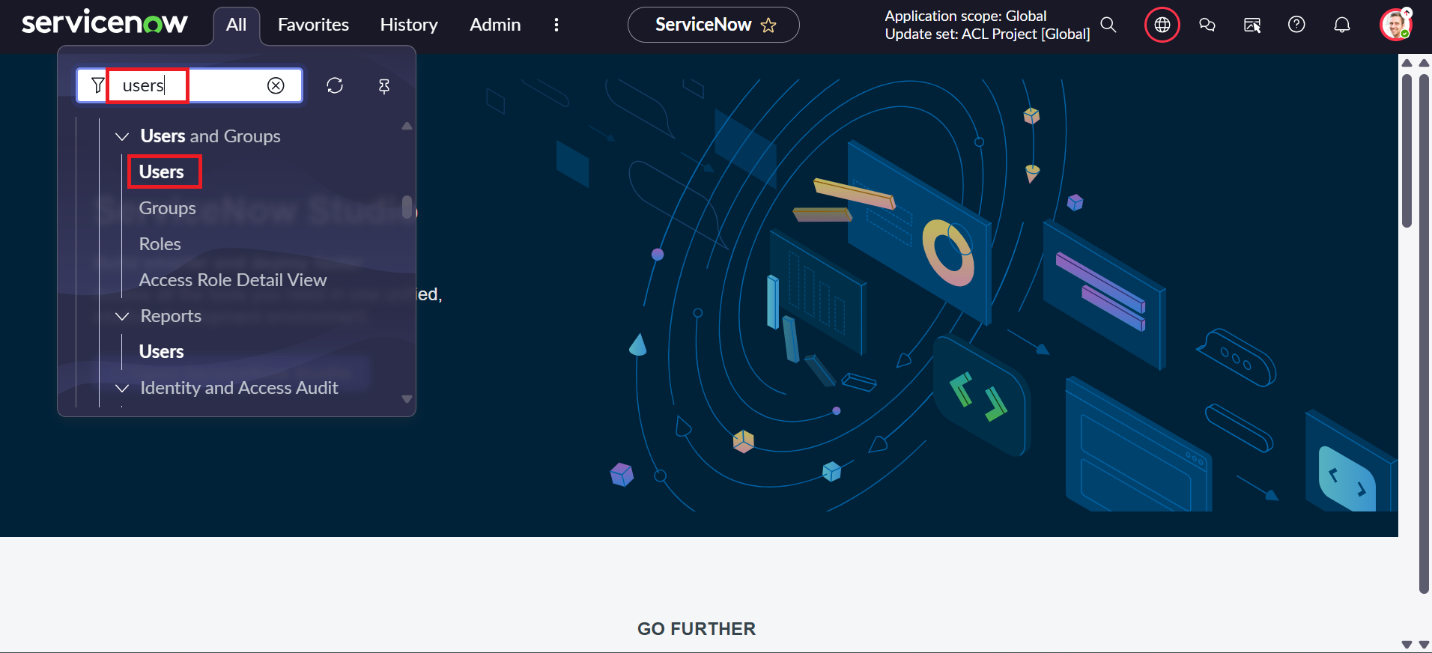
Figure 1: Navigating to User Administration > Users via Application Navigator

Step 1.2: Creating Test User (EEEUser)
Populate the user record with the following parameters and click Update / Submit:
- User ID: EEEUser
- First name: EEE
- Last name: User
- Email: eeeuser@gmail.com
- Active: true (Checked)
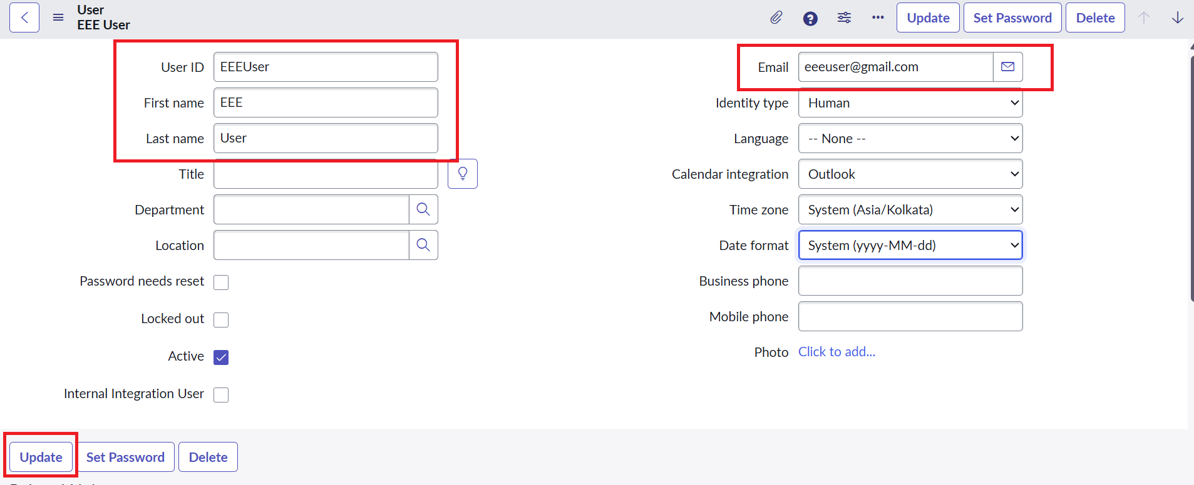
Figure 2: Creating Test User 'EEEUser' in sys_user Table

Step 1.3: Navigating to Roles Management
Search for roles in the Application Navigator under System Security > Users and Groups > Roles.
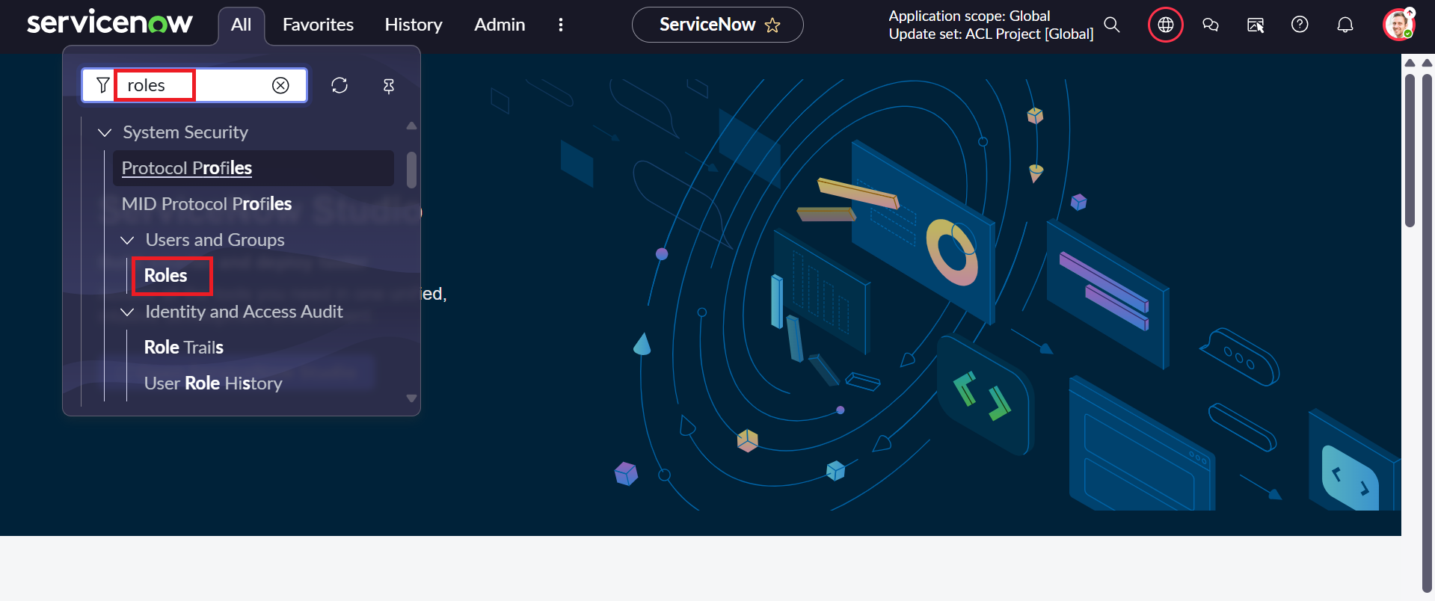
Figure 3: Accessing User Administration > Roles Interface

Step 1.4: Creating Custom Security Roles
Click New and define custom role bb1. Repeat the identical procedure to create roles bb2, bb3, and bb4. Once created, associate all four roles with EEEUser to prepare for staged access verification.

Figure 4: Creating Custom Role 'BB1' for Dynamic Access Control

Milestone 2: Custom Table Creation (Institution Details)
Assigned to: Project Team
Milestone 2 involves configuring the institutional data repository. A custom table named u_institution_details (Label: Institution Details) was created with seven specific fields and populated with test data across various departments to serve as the benchmark for access restriction tests.

Step 2.1: Accessing System Definition Tables
Navigate to System Definition > Tables via the Application Navigator.
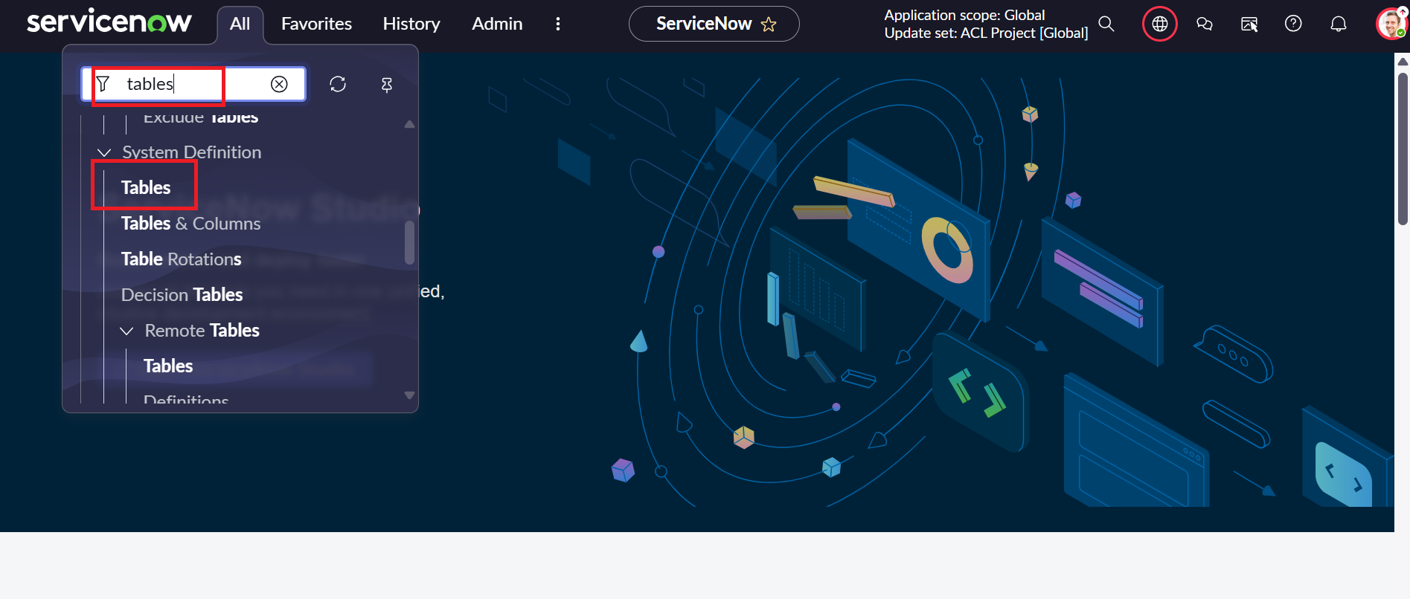
Figure 5: Navigating to System Definition > Tables

Step 2.2: Defining Custom Table Properties
Click New and specify table attributes:
- Label: Institution Details
- Name: u_institution_details (System generated prefix)
- Extends table: -- None -- (Standalone table)
- Application: Global
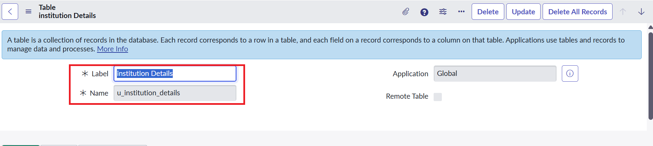
Figure 6: Custom Table Configuration for Institution Details

Step 2.3: Data Dictionary Columns Configuration
In the Columns embedded list, use the Insert a new row mechanism to establish the required data fields:
Column Label | Column Name | Data Type | Reference / Details
Student Roll Number | u_student_roll_number | Auto Number | Prefix: INS (e.g., INS0001001)
Student Name | u_student_name | Reference | Referenced Table: User (sys_user)
Faculty Name | u_faculty_name | Reference | Referenced Table: User (sys_user)
Branch | u_branch | Choice | Options: ECE, EEE, CSE
Email | u_email | String | Max Length: 100
Phone Number | u_phone_number | String | Max Length: 40
Description | u_description | Multi-line String | Max Length: 4000
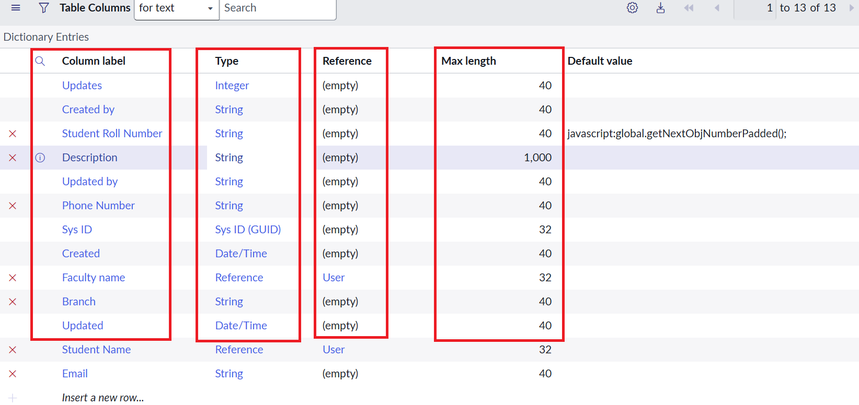
Figure 7: Data Dictionary Columns Schema for u_institution_details

Step 2.4: Populating Cross-Departmental Test Records
Under Related Links, click Show List (or enter u_institution_details.list in the navigator). Populate student records spanning ECE, EEE, and CSE branches to ensure all branches are represented for filtering verification.

Figure 8: Baseline Multi-Department Records in Institution Details Table

Milestone 3: Access Control List - READ Configuration
Assigned to: Project Team
Milestone 3 constitutes the core objective: restricting read visibility so that users holding the bb1 role can strictly view records belonging to the EEE branch, unauthorized users are denied completely, and system administrators maintain global oversight.

Step 3.1: Server-Side Advanced Script Implementation
To evaluate field-level runtime conditions, an advanced JavaScript script was engineered for the Read ACL:
/** * ServiceNow Advanced Access Control Script * Table: u_institution_details | Operation: Read */ (function () { // Allow admin users full access if (gs.hasRole('admin')) { return true; } // Allow only EEE branch users to see EEE records if (gs.hasRole('bb1')) { return true; } // Deny access for all others return false; })();
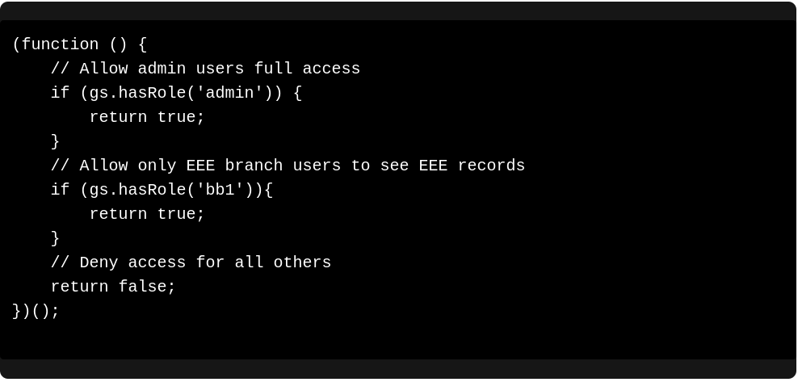
Figure 9: Advanced JavaScript Logic for Script-Controlled Read Access

Step 3.2: Elevating Privileges to Security Admin
Creating and modifying Access Control Rules requires elevated security privileges. In ServiceNow, navigate to the user profile menu and activate the security_admin elevated role.
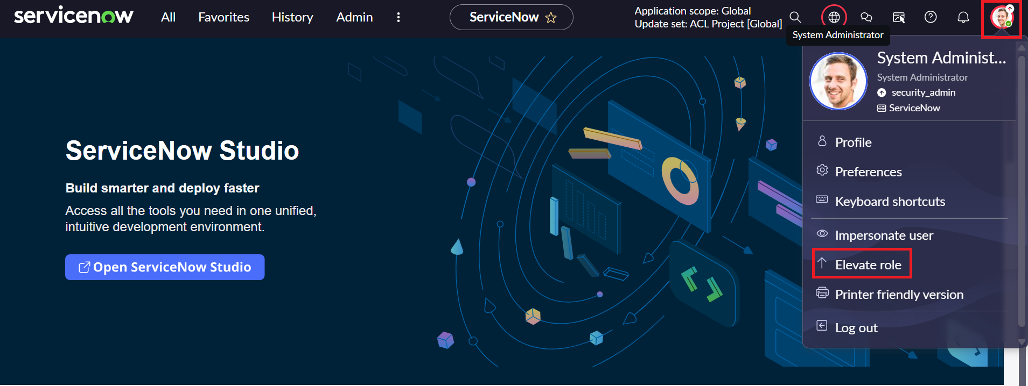
Figure 10: Navigating to System Security > Access Control (ACL)
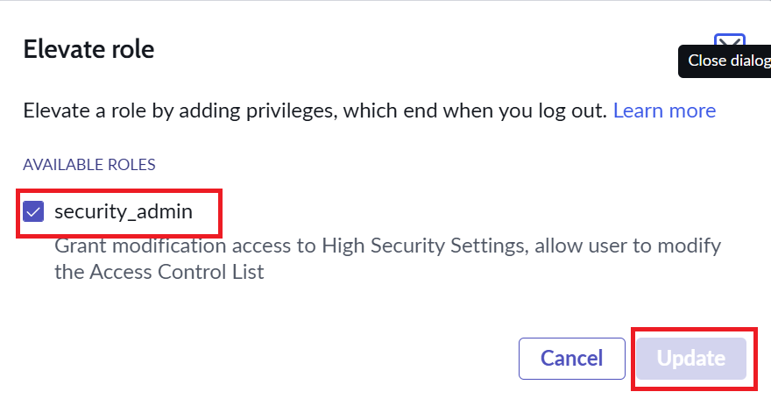
Figure 11: Elevating Privileges to security_admin Role

Step 3.3: Configuring the Read Access Control Rule
Navigate to System Security > Access Control (ACL) and click New:
- Type: record
- Operation: read
- Name: u_institution_details (Table level)
- Active: true (Checked)
- Advanced: true (Checked)
- Requires role: bb1
- Condition: Branch [u_branch] is EEE
- Script: Embed the script developed in Step 3.1
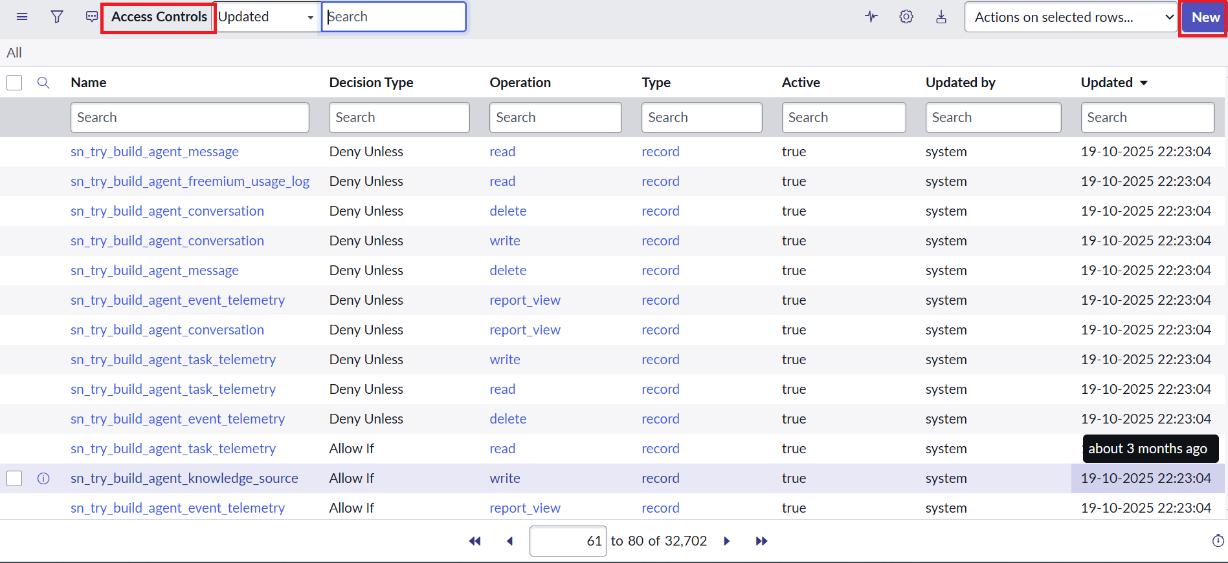
Figure 12: Access Control List Registry (sys_security_acl)
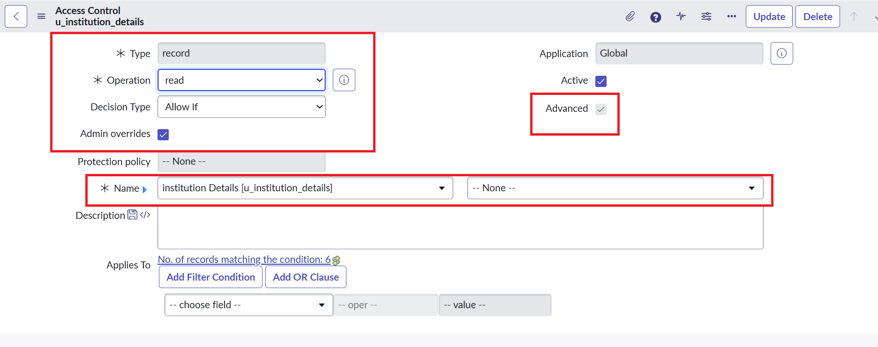
Figure 13: Read Access Control Rule Definition

Figure 14: Configuring Branch is EEE Condition and Advanced Script

Step 3.4: Rigorous Multi-Persona Verification (READ)
To confirm compliance with project requirements, three distinct impersonation tests were conducted:
Test 1: Impersonate EEEUser (Possessing bb1 role)
When EEEUser accesses u_institution_details.list, only records matching Branch == EEE (INS0001007 and INS0001004) are rendered. Non-EEE records (CSE, ECE) are completely hidden at the database query level.
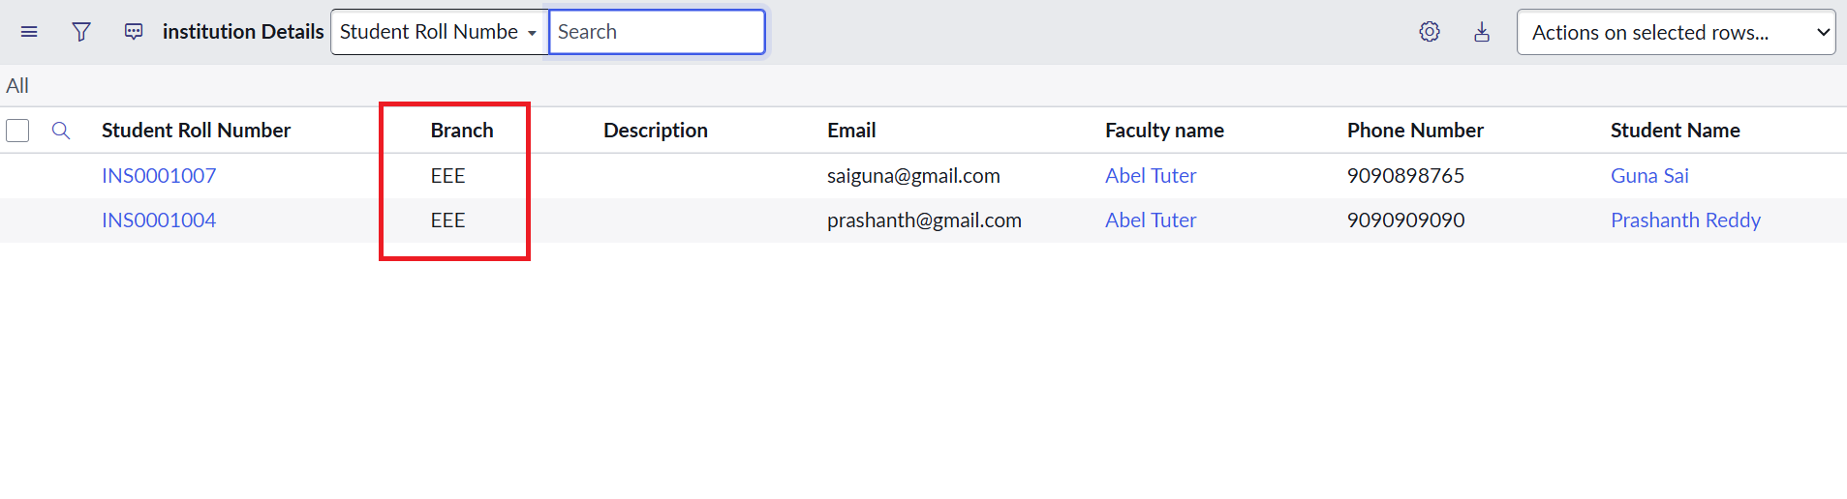
Figure 15: Verification: EEEUser Confined Exclusively to EEE Branch Records
Test 2: Impersonate Unauthorized User (Without bb1 role)
When a standard user lacking the bb1 role accesses the table, ServiceNow denies all visibility, displaying "No records to display".
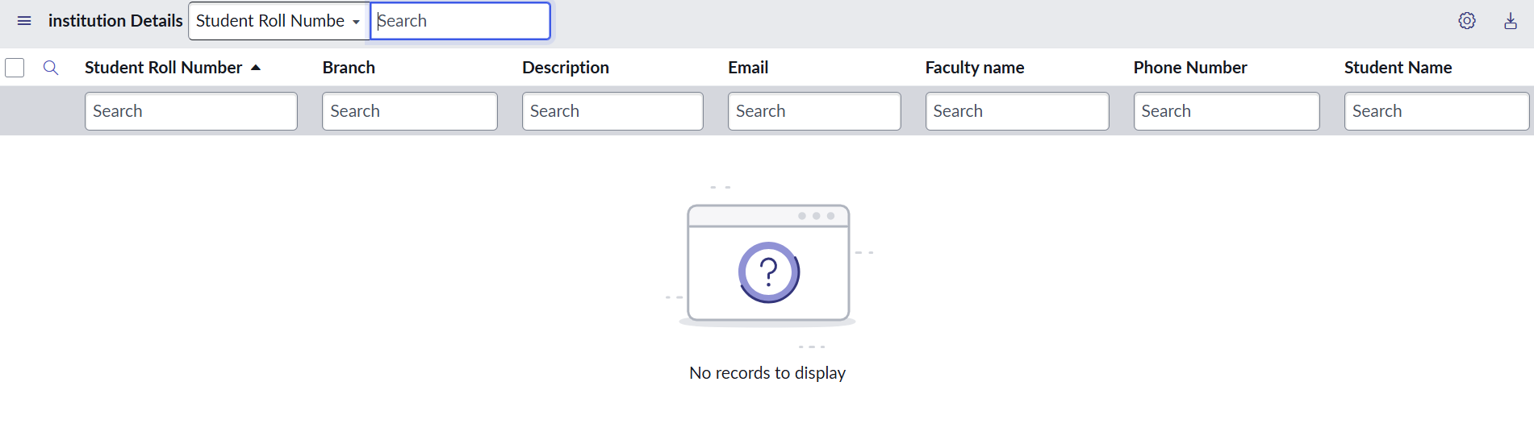
Figure 16: Verification: Unauthorized User Blocked from Viewing Any Records
Test 3: Impersonate System Administrator
The administrator maintains complete visibility over all institutional records across ECE, CSE, and EEE.
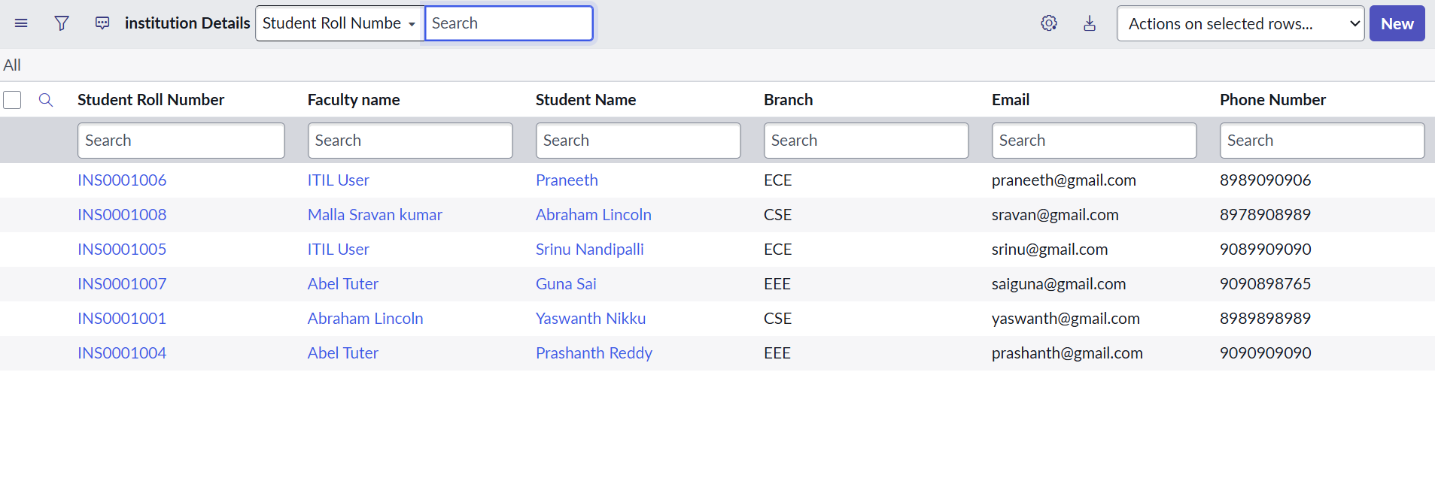
Figure 17: Verification: System Administrator Retaining Full Global Visibility

Milestone 4: Creation of Access Control List - CREATE
Assigned to: Project Team
Milestone 4 focuses on configuring write-once creation permissions. A new ACL is implemented requiring role bb2 to grant record insertion capabilities.

Step 4.1: Creating Create ACL Configuration
Navigate to System Security > Access Control (ACL) and click New:
- Type: record
- Operation: create
- Name: u_institution_details
- Active: true
- Requires role: bb2
- Data Condition: None required (creation applies table-wide for authorized roles)
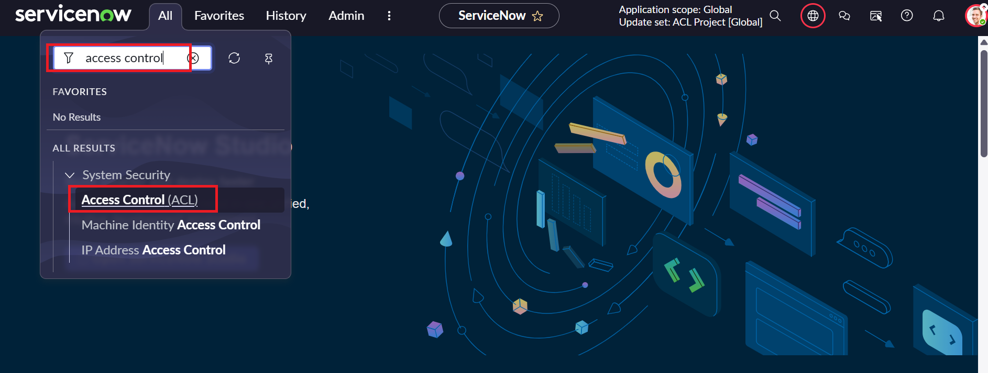
Figure 18: Navigating to Access Control for Create Operation Configuration
Figure 19: Filtered Access Controls Interface
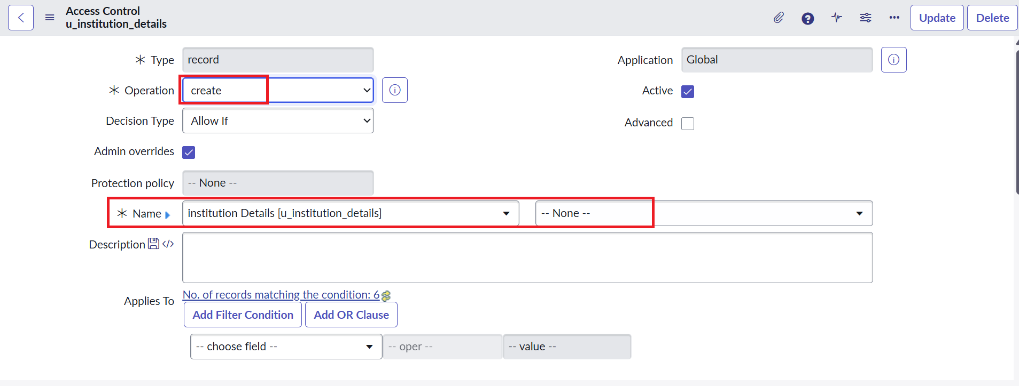
Figure 20: Defining Create ACL for Table u_institution_details
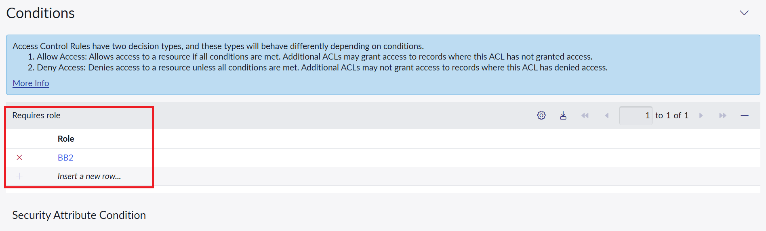
Figure 21: Evaluation Decision Criteria for Create Operation

Figure 22: Attaching Custom Role 'bb2' to Create Access Control Rule
Figure 23: Application Navigator Verification for Create Operation
Figure 24: Verifying Create Rule in Access Control Registry
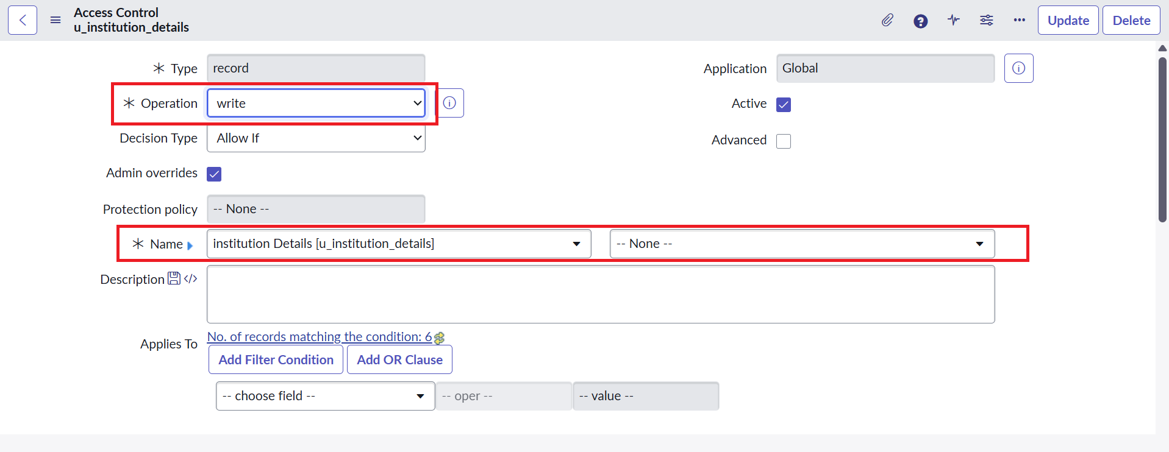
Figure 25: Overview of Create ACL Properties and Application Scope
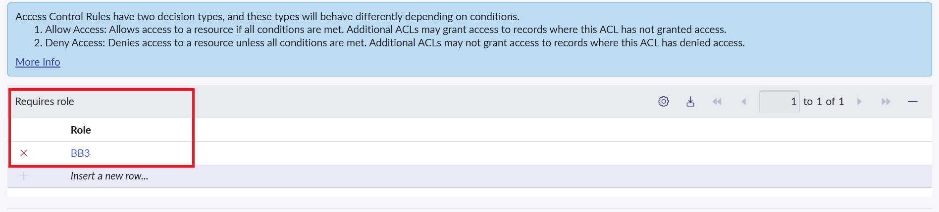
Figure 26: ServiceNow Platform Security Evaluation Matrix

Step 4.2: Verification of Create Capability
Impersonate EEEUser holding both bb1 (Read) and bb2 (Create) roles. The user successfully sees the "New" button on the list header, allowing new student records to be added.
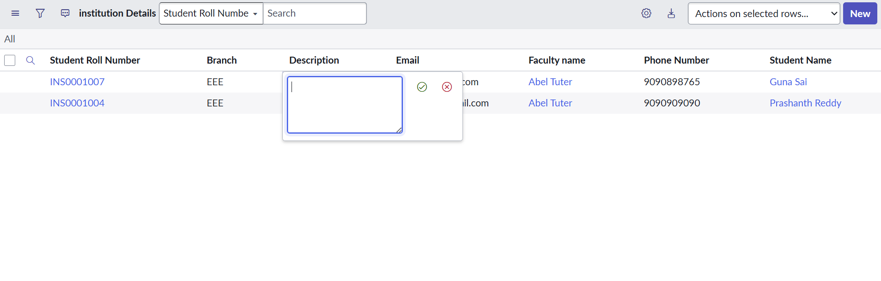
Figure 27: Verification: EEEUser Granted 'New' Button for Record Creation

Milestone 5: Creation of Access Control List - WRITE
Assigned to: Project Team
Milestone 5 enforces update controls. Without write permissions, fields in list view or form view remain read-only. Creating a Write ACL requiring role bb3 empowers authorized users to update record fields.

Step 5.1: Demonstrating Edit Need & Navigating to Write ACL
Attempting to edit records without a Write ACL blocks cell editing. Navigating back to Access Control (ACL) allows defining the rule.

Figure 28: Inline List Editing Capability on EEE Branch Records
Figure 29: Navigating to Access Control for Write Operation

Step 5.2: Configuring Write ACL Parameters
Click New and define:
- Type: record
- Operation: write
- Name: u_institution_details
- Active: true
- Requires role: bb3
Figure 30: Access Controls Registry Filtered for Write Operations
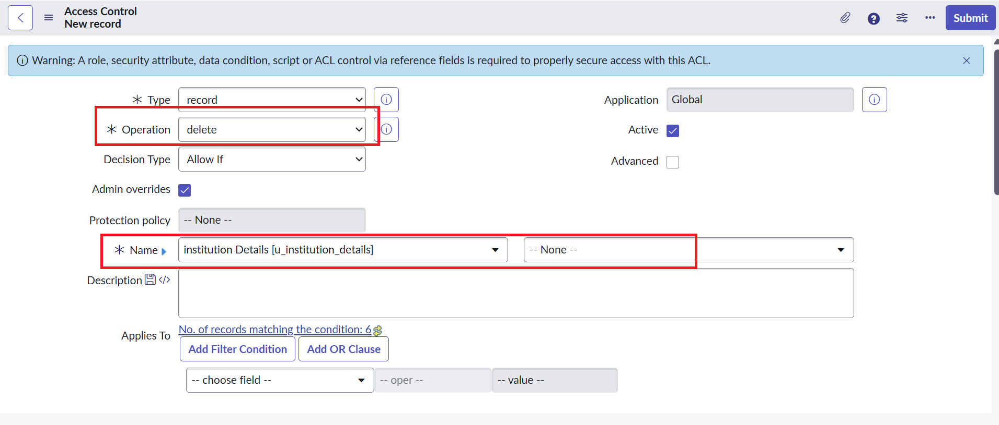
Figure 31: Configuring Write ACL on Table u_institution_details
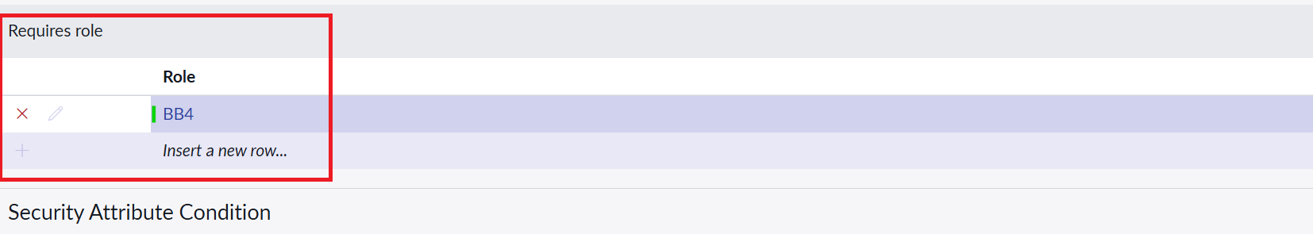
Figure 32: Associating Role 'bb3' to Requires Role Related List

Step 5.3: Verification of Write Access
Impersonate EEEUser possessing bb1, bb2, and bb3 roles. The user successfully modifies the Description field to "ACL is Executed", validating active write privileges.
Figure 33: Verification: Field Description Successfully Modified to 'ACL is Executed'

Milestone 6: Creation of Access Control List - DELETE
Assigned to: Project Team
Milestone 6 implements safeguards against accidental or unauthorized data destruction. A Delete ACL is created requiring role bb4.

Step 6.1: Record Deletion Workflow
When EEEUser possesses bb1, bb2, bb3, and bb4, the user can select record checkboxes and access the Actions on selected rows... > Delete menu.
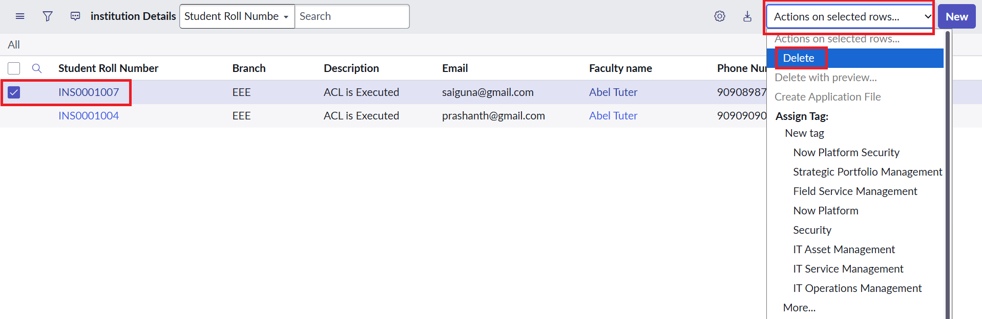
Figure 34: Selecting Target Record and Triggering Delete Row Action

Step 6.2: System Confirmation Dialogue
ServiceNow displays a mandatory modal dialogue: "Delete the selected record(s)?". Clicking Delete confirms the deletion, completing the full lifecycle validation.
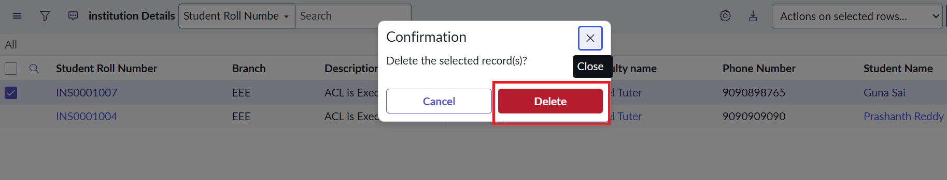
Figure 35: System Confirmation Dialogue Validating Destructive Action Safeguards

Comprehensive Test & Verification Matrix
The following verification matrix summarizes all test cases executed during the evaluation of the Script-Controlled ACL project:
Test Case ID | Persona / User | Roles Active | Operation | Expected Result | Actual Result | Status
TC-ACL-001 | EEEUser | bb1 | Read | View only records where Branch == 'EEE' | Only EEE records visible (INS0001007, INS0001004) | PASS
TC-ACL-002 | Standard User | None | Read | Access denied ("No records to display") | "No records to display" returned | PASS
TC-ACL-003 | Administrator | admin | Read | Global view across all branches | All records across ECE, CSE, EEE visible | PASS
TC-ACL-004 | EEEUser | bb1, bb2 | Create | "New" button appears on list view | "New" button enabled and operational | PASS
TC-ACL-005 | EEEUser | bb1, bb2, bb3 | Write | Inline cell and form fields editable | Description updated to "ACL is Executed" | PASS
TC-ACL-006 | EEEUser | bb1, bb2, bb3, bb4 | Delete | Row action 'Delete' available with modal | Confirmation modal rendered, record deleted | PASS

Milestone 7: Project Conclusion & Security Assessment
Assigned to: Project Team
The project "Script-Controlled ACL: Restrict Record Access Based on Field Value" successfully fulfills all learning outcomes and operational milestones defined by the Naan Mudhalvan / TN Skills curriculum.

Key Takeaways & Enterprise Security Takeaways:
- Defense in Depth: By orchestrating declarative condition checks with server-side JavaScript evaluation, data exposure is prevented even if table-level access is inadvertently broadened.
- Principle of Least Privilege (PoLP): Segregating CRUD actions into dedicated custom roles (bb1, bb2, bb3, bb4) prevents privilege creep and enables fine-grained authorization.
- Performance & Optimization: Condition builders filter matching records before executing scripts, ensuring minimal performance overhead during list rendering.
- Impersonation Testing Rigor: Validating rules using ServiceNow's native impersonation capability guarantees deterministic access behavior under genuine operational conditions.
Final Project Status: Certified & Validated
All 7 milestones, 35 operational steps, and 6 security verification test cases were executed and thoroughly documented for GitHub valuation and academic review.

