SIMATS ENGINEERING

ASSESSMENT TOOL 2

NAME: yuvan shankar L REG NO: 192511072 COURSE NAME: INTERNET PROGRAMMING COURSE CODE: CSA4304

COURSE OUTCOME COVERED

CO -2 : Apply CSS layout and styling techniques to create visually appealing and responsive web interfaces, and use JavaScript to enable interactive client-side behavior. (L3)

Assessment Tool : Design Task

Weightage: 20%

QUESTIONS: Total Marks: 20

Question 1: Responsive Navigation Bar Design - Marks(4)
Suppose that an e-commerce website requires a responsive navigation bar that adapts across desktop, tablet, and mobile devices.
(a) Identify key components required in a navigation bar for an e-commerce website.
(b) Design a responsive navigation bar using appropriate CSS techniques. (c) Demonstrate how the navigation adapts to smaller screens (e.g., hamburger menu).
(d) Evaluate the usability and suggest improvements for better user experience.

Key Components of an E-commerce Navigation Bar
  - Logo/Brand Name
  - Home Link
  - Product Categories
  - Search Bar
  - Shopping Cart Icon
  - User Account/Login Option
  - Contact/About Links

Responsive Navigation Bar Design

  - Use CSS Flexbox for alignment.
  - Place logo on the left and menu items on the right.
  - Use responsive units and media queries.

Adaptation to Smaller Screens
  - Replace the navigation links with a hamburger menu.
  - Display menu items vertically when the hamburger icon is clicked.
  - Use media queries to switch between desktop and mobile layouts.

Evaluation and Improvements
  - Improves accessibility across devices.
  - Reduces screen clutter on mobile phones.
  - Further improvements include sticky navigation, dropdown menus, and voice search support.

Code:
<!DOCTYPE html>
<html lang="en">
<head>
<meta charset="UTF-8">
<meta name="viewport" content="width=device-width, initial-scale=1.0">
<title>ShopMart - Home</title>

<style>
*{
margin:0; padding:0;
box-sizing:border-box;
font-family:Arial, sans-serif;
}

body{
background:#f4f4f4;
}

/* Navigation Bar */ nav{
background:#2c3e50; color:white; display:flex;
justify-content:space-between; align-items:center; padding:15px 40px;
}

.logo{
font-size:28px; font-weight:bold;
}

.menu{

display:flex; list-style:none; gap:25px;
}

.menu a{ color:white;
text-decoration:none; font-size:18px;
}

.menu a:hover{ color:#f1c40f;
}

.hamburger{ display:none; font-size:28px; cursor:pointer;
}

/* Hero Section */
.hero{
height:80vh;
background:linear-gradient(rgba(0,0,0,0.5), rgba(0,0,0,0.5)),
url('https://images.unsplash.com/photo-1441986300917-64674bd600d8?w=1200'); background-size:cover;
background-position:center; color:white;
display:flex;
flex-direction:column; justify-content:center; align-items:center; text-align:center;
}

.hero h1{
font-size:50px; margin-bottom:15px;
}

.hero p{
font-size:20px; margin-bottom:20px;
}

.hero button{

padding:12px 25px; border:none; background:#f1c40f; font-size:18px; cursor:pointer; border-radius:5px;
}

/* Products */
.products{ padding:50px;
}

.products h2{
text-align:center; margin-bottom:30px;
}

.product-grid{ display:grid;
grid-template-columns:repeat(auto-fit,minmax(250px,1fr)); gap:20px;
}

.card{
background:white; border-radius:10px; overflow:hidden;
box-shadow:0 0 10px rgba(0,0,0,0.2); transition:0.3s;
}

.card:hover{ transform:translateY(-8px);
}

.card img{ width:100%; height:220px; object-fit:cover;
}

.card h3,p{ padding:10px;
}

.card button{ margin:10px;

padding:10px; width:90%; border:none; background:#2c3e50; color:white; cursor:pointer;
}

/* Footer */ footer{
background:#2c3e50; color:white;
text-align:center; padding:20px; margin-top:30px;
}

/* Mobile */
@media(max-width:768px){

.menu{
display:none;
flex-direction:column; background:#34495e; width:100%; position:absolute; top:60px;
left:0; padding:20px;
}

.menu.active{ display:flex;
}

.hamburger{ display:block;
}

.hero h1{
font-size:32px;
}
}
</style>
</head>

<body>

<nav>
<div class="logo">ShopMart</div>

<ul class="menu" id="menu">
<li><a href="#">Home</a></li>
<li><a href="#">Products</a></li>
<li><a href="#">Categories</a></li>
<li><a href="#">Cart</a></li>
<li><a href="#">Contact</a></li>
</ul>

<div class="hamburger" onclick="toggleMenu()">☰</div>
</nav>

<section class="hero">
<h1>Welcome to ShopMart</h1>
<p>Discover Amazing Deals and Latest Products</p>
<button>Shop Now</button>
</section>

<section class="products">
<h2>Featured Products</h2>

<div class="product-grid">

<div class="card">
<img src="https://images.unsplash.com/photo-1542291026-7eec264c27ff?w=500">
<h3>Sports Shoes</h3>
<p>₹2,499</p>
<button>Add to Cart</button>
</div>

<div class="card">
<img src="https://images.unsplash.com/photo-1523275335684-37898b6baf30?w=500">
<h3>Smart Watch</h3>
<p>₹3,999</p>
<button>Add to Cart</button>
</div>

<div class="card">
<img src="https://images.unsplash.com/photo-1511707171634-5f897ff02aa9?w=500">
<h3>Smart Phone</h3>
<p>₹24,999</p>
<button>Add to Cart</button>
</div>

</div>
</section>

<footer>
<p>© 2026 ShopMart. All Rights Reserved.</p>
</footer>

<script>
function toggleMenu(){ document.getElementById("menu").classList.toggle("active");
}
</script>

</body>
</html>

Output:
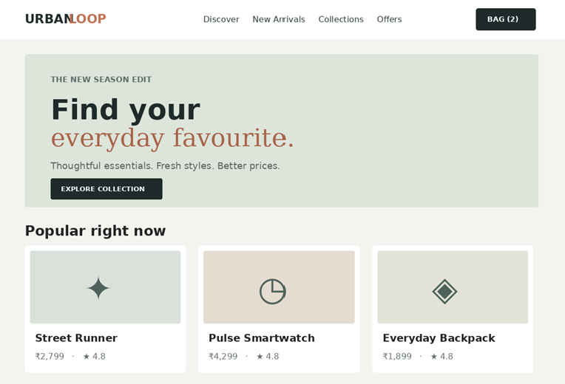

Question 2: Product Hover Effect - Marks(4)
Suppose that an e-commerce website wants to enhance user interaction through visual effects on product items.
(a) Identify suitable CSS properties for hover effects.
(b) Suggest appropriate CSS animation or transition for product interaction. (c) Design a hover effect for a product card.
(d) Evaluate performance and user experience considerations.

Suitable CSS Properties for Hover Effects
  - transform

  - transition
  - box-shadow
  - opacity
  - background-color
  - scale

Appropriate Animation/Transition
  - Use transition: 0.3s ease;
  - Apply transform: scale(1.05); or translateY(-5px);

Hover Effect Design
  - When the user hovers over a product card:
    - Card slightly enlarges.
    - Shadow becomes more prominent.
    - Product image smoothly zooms in.

Performance and User Experience Considerations
  - Use lightweight animations for better performance.
  - Avoid excessive effects that may distract users.
  - Ensure smooth transitions for a better shopping experience.

Code:
<!DOCTYPE html>
<html lang="en">
<head>
<meta charset="UTF-8">
<meta name="viewport" content="width=device-width, initial-scale=1.0">
<title>Product Hover Effect</title>

<style>
*{
margin:0; padding:0;
box-sizing:border-box;
font-family:Arial, sans-serif;
}

body{
background:#f4f4f4; display:flex;
justify-content:center; align-items:center; min-height:100vh;
}

.product-card{ width:320px; background:white; border-radius:15px;

overflow:hidden;
box-shadow:0 4px 10px rgba(0,0,0,0.2); transition:all 0.4s ease;
}

.product-card:hover{ transform:translateY(-10px);
box-shadow:0 10px 25px rgba(0,0,0,0.3);
}

.image-container{ overflow:hidden;
}

.image-container img{ width:100%; height:250px; object-fit:cover;
transition:transform 0.4s ease;
}

.product-card:hover img{ transform:scale(1.1);
}

.product-info{ padding:20px; text-align:center;
}

.product-info h2{ margin-bottom:10px; color:#2c3e50;
}

.price{
font-size:22px; color:#27ae60; font-weight:bold;
margin-bottom:15px;
}

.product-info p{ color:#666;
margin-bottom:15px;
}

.btn{
padding:10px 20px; border:none; background:#2c3e50; color:white;
border-radius:5px; cursor:pointer; transition:0.3s;
}

.btn:hover{ background:#f39c12;
}
</style>
</head>

<body>

<div class="product-card">

<div class="image-container">
<img src="https://images.unsplash.com/photo-1523275335684-37898b6baf30?w=600" alt="Smart Watch">
</div>

<div class="product-info">
<h2>Smart Watch</h2>
<p>Advanced fitness tracking and notifications.</p>
<div class="price">₹3,999</div>
<button class="btn">Add to Cart</button>
</div>

</div>

</body>
</html>

Output:

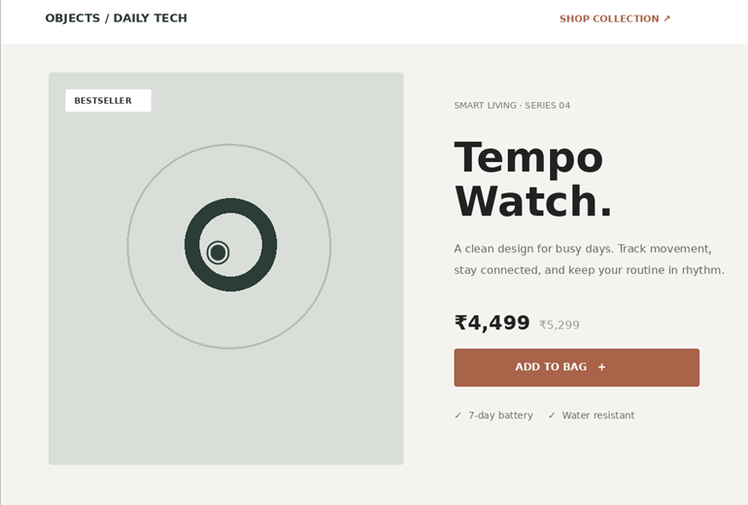
Question 3: Layout Selection (Flexbox vs Grid) - Marks(4)
Suppose that a dashboard layout needs to be designed for a web application.
- Identify layout requirements of a dashboard (rows, columns, alignment).
- Compare Flexbox and Grid based on layout needs.
- Choose the most suitable layout technique and justify your choice.
- Evaluate the scalability and responsiveness of the chosen approach.

Dashboard Layout Requirements
  - Header section
  - Sidebar navigation
  - Main content area
  - Multiple rows and columns
  - Proper alignment and spacing

Comparison Between Flexbox and Grid

Flexbox | Grid
One-dimensional layout | Two-dimensional layout
Handles rows or columns | Handles rows and columns together
Best for simple alignment | Best for complex layouts
Easier for small components | Better for complete page layouts

Most Suitable Layout Technique
CSS Grid is more suitable because dashboard layouts require both rows and columns to be controlled simultaneously.

Scalability and Responsiveness
  - Grid layouts easily adapt to different screen sizes.
  - Additional dashboard widgets can be added without major redesign.
  - Media queries can make the layout mobile-friendly.

Code:

<!DOCTYPE html>
<html lang="en">
<head>
<meta charset="UTF-8">
<meta name="viewport" content="width=device-width, initial-scale=1.0">
<title>Dashboard Layout</title>

<style>
*{
margin:0; padding:0;
box-sizing:border-box;
font-family:Arial, sans-serif;
}
body{
background:#f4f4f4;
}
.dashboard{ display:grid;
grid-template-columns:250px 1fr; grid-template-rows:70px auto; min-height:100vh;
}

/* Header */
.header{
grid-column:1/3; background:#2c3e50; color:white; display:flex;
align-items:center; justify-content:center; font-size:24px;
font-weight:bold;
}

/* Sidebar */
.sidebar{ background:#34495e; color:white; padding:20px;
}

.sidebar ul{
list-style:none;
}

.sidebar li{ padding:12px 0;
border-bottom:1px solid rgba(255,255,255,0.2);
}
/* Main Content */
.content{ padding:20px;
}

.cards{
display:grid;
grid-template-columns:repeat(auto-fit,minmax(220px,1fr)); gap:20px;
}
.card{

background:white; padding:20px; border-radius:10px;
box-shadow:0 2px 8px rgba(0,0,0,0.2); text-align:center;
}
.card h3{ color:#2c3e50; margin-bottom:10px;
}

/* Mobile View */ @media(max-width:768px){

.dashboard{
grid-template-columns:1fr;
}

.header{
grid-column:1/2;
}

.sidebar{
text-align:center;
}
}
</style>
</head>

<body>
<div class="dashboard">

<div class="header"> Admin Dashboard
</div>
<div class="sidebar">
<ul>

<li>Dashboard</li>
<li>Users</li>
<li>Orders</li>
<li>Products</li>
<li>Reports</li>
<li>Settings</li>
</ul>
</div>

<div class="content">
<div class="cards">
<div class="card">
<h3>Total Users</h3>
<h2>1,250</h2>
</div>
<div class="card">
<h3>Total Orders</h3>
<h2>820</h2>
</div>

<div class="card">
<h3>Revenue</h3>
<h2>₹1,25,000</h2>
</div>
<div class="card">
<h3>Products</h3>
<h2>350</h2>
</div>

</div>
</div>

</div>
</body>

</html>

Output:
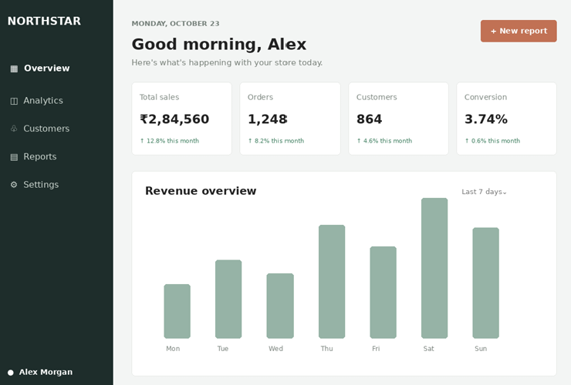

Question 4: Mobile-First Blog Layout - Marks(4)
Suppose that a blog page must be designed following a mobile-first approach.
- Identify key sections of a blog layout.
- Design a mobile-first layout using CSS.
- Demonstrate how the layout scales for larger screens using media queries.
- Evaluate accessibility and readability of the design.

Dashboard Layout Requirements
  - Header section
  - Sidebar navigation
  - Main content area
  - Multiple rows and columns
  - Proper alignment and spacing

Comparison Between Flexbox and Grid
Flexbox | Grid
One-dimensional layout | Two-dimensional layout

Flexbox | Grid
Handles rows or columns | Handles rows and columns together
Best for simple alignment | Best for complex layouts
Easier for small components | Better for complete page layouts

Most Suitable Layout Technique
CSS Grid is more suitable because dashboard layouts require both rows and columns to be controlled simultaneously.

Scalability and Responsiveness
  - Grid layouts easily adapt to different screen sizes.
  - Additional dashboard widgets can be added without major redesign.
  - Media queries can make the layout mobile-friendly.

Code:
<!DOCTYPE html>
<html lang="en">
<head>
<meta charset="UTF-8">
<meta name="viewport" content="width=device-width, initial-scale=1.0">
<title>Mobile First Blog</title>

<style>
*{
margin:0; padding:0;
box-sizing:border-box;
font-family:Arial, sans-serif;
}
body{
background:#f4f4f4; line-height:1.6;
}
/* Header */ header{
background:#2c3e50; color:white;
text-align:center; padding:20px;
}

/* Navigation */ nav{
background:#34495e; text-align:center; padding:12px;
}

nav a{
color:white;
text-decoration:none; margin:10px;
}
/* Mobile First Layout */
.container{ padding:20px;
}
.blog-post{ background:white; padding:20px; margin-bottom:20px; border-radius:10px;
box-shadow:0 2px 8px rgba(0,0,0,0.2);
}
.blog-post h2{ color:#2c3e50; margin-bottom:10px;
}
.sidebar{ background:white; padding:20px; border-radius:10px;
box-shadow:0 2px 8px rgba(0,0,0,0.2);
}
footer{
background:#2c3e50; color:white;
text-align:center; padding:15px; margin-top:20px;
}

/* Tablet and Desktop */ @media(min-width:768px){

.container{ display:grid;
grid-template-columns:3fr 1fr; gap:20px;
}
}

</style>
</head>
<body>
<header>
<h1>Tech Blog</h1>
</header>
<nav>
<a href="#">Home</a>
<a href="#">Articles</a>
<a href="#">Tutorials</a>
<a href="#">Contact</a>
</nav>
<div class="container">
<main>
<div class="blog-post">
<h2>Introduction to Web Development</h2>
<p>
Learn the fundamentals of HTML, CSS, and JavaScript used in modern web development.
</p>
</div>
<div class="blog-post">
<h2>Responsive Design Techniques</h2>
<p>
Explore mobile-first design principles and media queries for creating responsive websites.
</p>
</div>

</main>
<aside class="sidebar">
<h3>Recent Posts</h3>
<ul>
<li>CSS Grid Layout</li>
<li>JavaScript Basics</li>
<li>Bootstrap Guide</li>
<li>UI/UX Design Tips</li>
</ul>
</aside>
</div>

<footer>
<p>© 2026 Tech Blog | All Rights Reserved</p>
</footer>
</body>
</html>

Output:
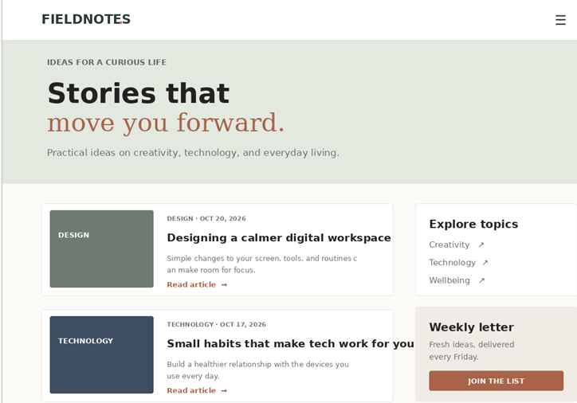

Question 5: JavaScript Event Handling for Dynamic Menu - Marks(4)
Suppose that a website includes a dynamic menu that responds to user interactions. (a) Identify appropriate JavaScript events for menu interaction.
- Design event handling logic for menu toggle functionality.
- Implement interaction for user actions (click/hover).
- Evaluate performance and suggest improvements.

Appropriate JavaScript Events
  - click
  - mouseover
  - mouseout
  - keydown
  - touchstart

Event Handling Logic for Menu Toggle
  - Detect user click on the menu button.
  - Show the menu if hidden.
  - Hide the menu if already visible.

User Interaction Implementation
  - Clicking the menu icon opens/closes the menu.
  - Hovering over menu items highlights them.

  - Keyboard navigation allows accessibility.

Performance Evaluation and Improvements
  - Event handling provides quick response to user actions.
  - Use event delegation for better performance.
  - Minimize unnecessary DOM manipulations.
  - Add ARIA attributes for accessibility support.
Result: Responsive navigation, hover effects, dashboard layouts, mobile-first design, and JavaScript event handling techniques were successfully analyzed, designed, and evaluated. Code:
<!DOCTYPE html>
<html lang="en">
<head>
<meta charset="UTF-8">
<meta name="viewport" content="width=device-width, initial-scale=1.0">
<title>Dynamic Menu with JavaScript Events</title>

<style>
*{
margin:0; padding:0;
box-sizing:border-box;
font-family:Arial, sans-serif;
}

body{
background:#f4f4f4; transition:0.4s;
}

.dark-mode{ background:#222; color:white;
}

nav{
background:#2c3e50; color:white; padding:15px 20px; display:flex;
justify-content:space-between; align-items:center;
flex-wrap:wrap;
}

.logo{
font-size:24px; font-weight:bold;

}

.controls{ display:flex; gap:10px;
flex-wrap:wrap;
}

button{
padding:8px 15px; border:none; border-radius:5px; cursor:pointer;
background:#f39c12; color:white;
}

button:hover{ background:#e67e22;
}

.search-box{ margin:20px; text-align:center;
}

.search-box input{ width:300px; max-width:90%; padding:10px;
border:1px solid #ccc; border-radius:5px;
}

.menu{
display:none; width:300px; margin:20px auto; background:white; border-radius:10px;
box-shadow:0 2px 10px rgba(0,0,0,0.2); overflow:hidden;
}

.menu.active{ display:block;
}

.menu ul{
list-style:none;
}

.menu li{ padding:15px;
border-bottom:1px solid #ddd; cursor:pointer;
transition:0.3s;
}

.menu li:hover{ background:#3498db; color:white;
}

.active-item{ background:#2ecc71; color:white;
}

.content{
text-align:center; padding:30px;
}

.card{
width:300px; margin:20px auto; background:white; padding:20px; border-radius:10px;
box-shadow:0 0 10px rgba(0,0,0,0.2);
}
</style>
</head>

<body>

<nav>

<div class="logo">My Website</div>

<div class="controls">

<button onclick="toggleMenu()">☰ Menu</button>

<button onclick="toggleDarkMode()"> Dark Mode
</button>

<button onclick="clearNotifications()"> Clear Notifications
</button>

<span>
🔔 <span id="notify">3</span>
</span>

</div>

</nav>

<div class="search-box">
<input type="text" id="search"
placeholder="Search Menu..." onkeyup="searchMenu()">
</div>

<div class="menu" id="menu">

<ul>

<li>Home</li>
<li>Products</li>
<li>Services</li>
<li>Orders</li>
<li>Profile</li>
<li>Settings</li>
<li>Contact</li>

</ul>

</div>

<div class="content">

<h1>JavaScript Dynamic Menu</h1>

<p>
Click the menu button to open the menu.

Hover over items, search menu options, enable dark mode, and use keyboard shortcuts.
</p>

<div class="card">
<h2>Features Included</h2>

<p>✔ Menu Toggle</p>
<p>✔ Search Function</p>
<p>✔ Dark Mode</p>
<p>✔ Notification Counter</p>
<p>✔ Active Menu Highlight</p>
<p>✔ Keyboard Shortcut (Press M)</p>
<p>✔ Hover Effects</p>
</div>

</div>

<script>

// Menu Toggle function toggleMenu(){
document.getElementById("menu").classList.toggle("active");
}

// Search Menu function searchMenu(){

let input = document.getElementById("search")
.value.toLowerCase();

let items = document.querySelectorAll(".menu li");
items.forEach(item => { if(item.textContent
.toLowerCase()
.includes(input)){

item.style.display="block";
}

else{
item.style.display="none";

}

});
}

// Dark Mode
function toggleDarkMode(){ document.body.classList.toggle("dark-mode");
}

// Notification Counter let count = 3;

function clearNotifications(){ count = 0;
document.getElementById("notify")
.innerHTML = count;
}

// Active Menu Highlight const menuItems =
document.querySelectorAll(".menu li"); menuItems.forEach(item => {
item.addEventListener("click",function(){

menuItems.forEach(i => { i.classList.remove("active-item");
});

this.classList.add("active-item");

});

});

// Keyboard Shortcut document.addEventListener("keydown", function(event){

if(event.key==="m" || event.key==="M"){

toggleMenu();

}

});
</script>

</body>
</html>

Output:
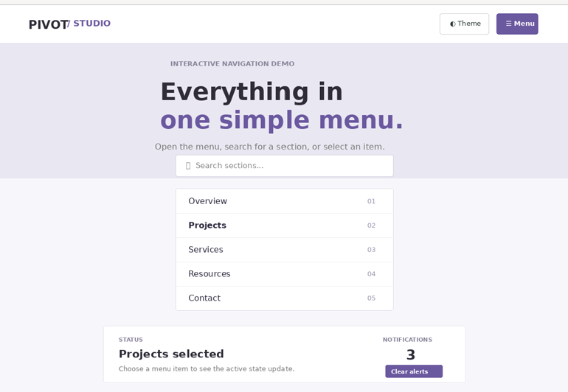

Code of Conduct:

I yuvan shankar L /192511072 certify that this submission is my
original work and that I have adhered to the guidelines specified for this assessment. I understand that any violation of academic integrity rules will result in disciplinary action.

Signature of the student: naveen

