CREDIT PORTFOLIO
ANALYSIS
Data Understanding • Risk Analysis • Machine Learning • Power BI
FINAL PROJECT REPORT
DATASET SIZE  1,048,575 records | INPUT FIELDS  15 original columns
PROCESSED FIELDS  26 columns | OVERALL DEFAULT RATE  19.95%
Prepared from the completed Python, SQL and Power BI analysis outputs
November 2026

Executive Summary
This project examines a loan-granting dataset to describe portfolio composition and observed default patterns, prepare analytical features, build a baseline Logistic Regression model, explore borrower segments with K-Means clustering, query the processed data in MySQL, and present key indicators in a Power BI dashboard.
The processed dataset contains 1,048,575 records and 26 columns. The overall observed default rate is 19.95%. The average loan amount is 14,469.31 and the total loan amount is 15,172,154,075 (approximately 15.17 billion in the dataset currency, which was not specified in the supplied project details).
Descriptive analysis shows variation in default rates across loan purpose, employment length, FICO bands, loan-size bands, income bands and issue year. A baseline Logistic Regression model trained and evaluated on a balanced sample achieved 60.91% accuracy and a ROC-AUC of 0.6542. K-Means clustering on a 100,000-record sample produced four interpretable segments with observed default rates from 9.92% to 26.06%. These are exploratory findings and should not be interpreted as causal effects or as a production credit decision model.
The Power BI report contains four KPI cards, four analytical charts and slicers for issue year, loan purpose, state and employment length. The report is intended as a portfolio analysis and learning project, not as a live lending or underwriting system.

Project Snapshot
Area | Completed work / result
Data | 1,048,575 rows; 15 original fields; 26 processed fields
Cleaning | Date conversion, missing-value handling decisions, outlier flags, removal of high-missing free-text fields
EDA | Default distribution, category comparisons, correlations and numerical summaries
Machine learning | Baseline Logistic Regression; four-cluster K-Means segmentation
SQL | Five aggregate analyses run against the full imported MySQL table
Visualization | Power BI KPI cards, trend and category charts, and interactive slicers

1. Introduction and Objectives
Credit portfolio analysis uses borrower, loan and repayment-status information to describe lending activity and examine patterns associated with default. In this project, the target field is Default, represented as a binary value: 0 for non-default and 1 for default.

1.1 Project Objectives
- Understand the structure, completeness and quality of the supplied loan-granting dataset.
- Clean and prepare the data while retaining unusual observations that cannot be confirmed as errors.
- Explore default patterns across borrower, loan and time-related variables.
- Create derived features that may support analysis and a baseline classification model.
- Evaluate a Logistic Regression baseline and describe borrower segments using K-Means.
- Use SQL to aggregate the full processed dataset and build an interactive Power BI dashboard.

1.2 Project Workflow
The workflow followed was: CSV inspection → data cleaning and EDA in Python/Jupyter → feature engineering → sampled machine-learning experiments → export of the processed CSV → MySQL import and SQL aggregation → Power BI dashboard creation.

2. Dataset Overview
The source file used in the notebook was loans_granting_model_dataset.csv. The notebook loaded 1,048,575 records and 15 original columns. The processed dataset expanded to 26 columns after cleaning and feature engineering.
Field | Description used in the project
id | Loan or record identifier
issue_d | Loan issue date, converted from month-year text to a date
revenue | Borrower revenue / income measure
dti_n | Debt-to-income measure
loan_amnt | Loan amount
fico_n | FICO score measure
experience_c | Binary-coded field; exact business meaning was not established from available documentation
emp_length | Employment-length category, including NI
purpose | Loan purpose category
home_ownership_n | Home ownership category
addr_state | Borrower state abbreviation
zip_code | Masked ZIP prefix
Default | Binary target: 0 or 1
title / desc | Free-text loan title and description; removed from the cleaned analytical table

The project details supplied do not identify the dataset publisher, currency, collection methodology or full field-level data dictionary. The report therefore describes the fields according to their names and the analyses performed, without asserting an external source or a specific currency.

3. Data Cleaning and Preparation

3.1 Missing Values and Text Fields
Field / issue | Observed condition | Project treatment
desc | 997,510 missing (95.13%) | Removed from df_clean because it was very sparse free text
title | 13,369 missing (1.27%); 31,030 unique values | Removed from df_clean due to inconsistent, high-cardinality free text
dti_n | 28 values coded as 999 | Preserved original values in dti_original and changed 999 to missing in dti_n
zip_code | 1 missing value | Filled with Unknown
issue_d | Month-year text values | Converted to datetime using %b-%y; no conversion failures were observed

The cleaned analytical table retained the 28 missing DTI values. For the modeling table only, those DTI values were imputed with the modeling-table median. This keeps the cleaning record separate from the model-ready representation.

3.2 Extreme Values and Outlier Flags
The DTI field contained 365 records above 100 after changing the special value 999 to missing. These observations were retained because extreme values alone did not establish that the source records were invalid. A dti_group flag was created to distinguish Extreme DTI from Normal DTI for investigation.
Revenue had a 99.9th percentile of 595,208.40. A revenue_outlier flag classified values above this threshold as High Revenue. There were 1,049 such records. They were retained rather than deleted; the threshold is an investigation flag, not proof of data error.

3.3 Validation
Validation check | Result
Duplicate rows | 0
Default target | Only 0 and 1; no missing target values
Issue date range | June 2007 to December 2018
Processed dataset shape | 1,048,575 rows × 26 columns
Remaining missing values in df_clean | 28 in dti_n; the modeling table imputed these with its median

The issue-year output contains records for 2007–2011 and 2013–2018; 2012 does not appear in the observed year counts. This is reported as an observed gap and has not been assumed to represent missing or corrupted records.

4. Exploratory Data Analysis

4.1 Default Distribution
Default value | Records | Share
0 - Non-default | 839,415 | 80.05%
1 - Default | 209,160 | 19.95%
Total | 1,048,575 | 100.00%

The dataset is imbalanced, with approximately four non-default records for every default record. This class imbalance was considered when constructing the balanced modeling sample.

4.2 Numerical Relationships with Default
Variable | Correlation with Default | Descriptive reading
FICO score (fico_n) | -0.132 | Higher FICO values are associated with lower default values in this dataset
DTI (dti_n) | 0.087 | Higher DTI values have a small positive association with default
Loan amount | 0.064 | Loan amount has a small positive association with default
Revenue | -0.041 | Revenue has a small negative association with default
Experience code | 0.001 | Near-zero linear association; code meaning not verified

These are pairwise correlations, not causal relationships. The magnitudes are modest. The project also observed that defaulted borrowers had a higher average loan-to-income ratio than non-defaulted borrowers: 0.243 versus 0.203.

4.3 Default Rate by FICO Band
FICO category | Borrowers | Default rate
Fair | 191,663 | 26.1%
Good | 744,157 | 19.9%
Very Good | 100,954 | 9.8%
Excellent | 11,801 | 6.2%
Poor | 0 | Not applicable - no observations

The observed default rate decreases across the populated FICO categories. The Poor category contains no records because the observed FICO values did not fall within that bin.

4.4 Default Rate by Loan and Income Categories
Loan amount category | Borrowers | Default rate
Very Low | 140,957 | 15.5%
Low | 289,116 | 17.1%
Medium | 389,061 | 21.8%
High | 165,254 | 22.8%
Very High | 64,187 | 24.0%

Income category | Borrowers | Default rate
Low | 74,529 | 24.1%
Lower Middle | 395,174 | 22.0%
Middle | 372,950 | 19.2%
High | 182,420 | 16.0%
Very High | 23,502 | 13.8%

The descriptive results show higher default rates in the larger loan categories and lower income categories. These patterns should be interpreted alongside borrower composition, sample definitions and other risk variables.
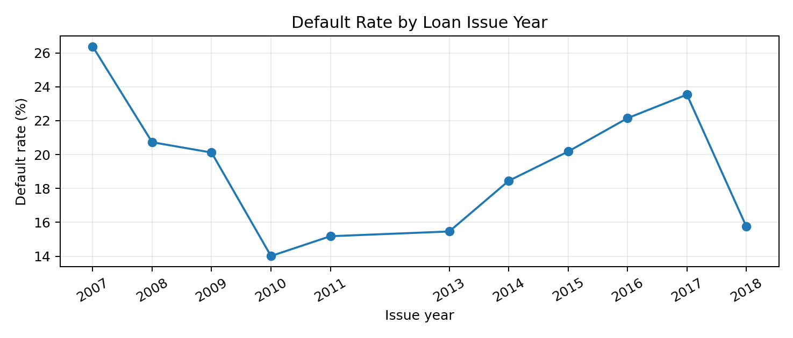
Figure 1. Default rate by issue year, based on the year-wise SQL aggregation.

5. Feature Engineering
The following analytical features were added to support comparisons and modeling:
Feature | Construction / purpose
issue_year | Year extracted from issue_d
issue_month | Numeric month extracted from issue_d
issue_month_name | Month name extracted from issue_d
issue_quarter | Calendar quarter extracted from issue_d
loan_to_income | loan_amnt divided by revenue; used as a model feature
income_to_loan | revenue divided by loan_amnt; inverse ratio retained for descriptive use
loan_category | Binned loan amount into Very Low, Low, Medium, High and Very High
fico_category | Binned FICO into Fair, Good, Very Good and Excellent; Poor had no observations
income_category | Binned revenue into Low, Lower Middle, Middle, High and Very High
dti_group / employment_group | Flags for extreme DTI and unknown employment length
revenue_outlier | Flag for revenue above 595,208.40

The loan_to_income and income_to_loan fields are reciprocal ratios and therefore carry overlapping information. The Logistic Regression input retained loan_to_income and did not include the inverse ratio.

6. Predictive Modeling: Logistic Regression

6.1 Modeling Setup
A model-ready table was assembled using revenue, DTI, loan amount, FICO score, experience_c, loan_to_income, issue_year and issue_month as predictors, with Default as the target. The 28 missing DTI values were imputed using the median of the modeling table.
To create a balanced experiment, 100,000 records were sampled from each target class, giving 200,000 records. The data was split into 80% training and 20% testing using stratification. StandardScaler was fitted on the training predictors and applied to both training and test data. Logistic Regression was fitted with max_iter=1000.

6.2 Evaluation Results
Metric | Result
Accuracy | 0.6091 (60.91%)
Precision | 0.6050 (60.50%)
Recall | 0.6287 (62.87%)
F1-score | 0.6166 (61.66%)
ROC-AUC | 0.6542

6.3 Confusion Matrix
Actual / Predicted | Predicted 0 | Predicted 1
Actual 0 | 11,792 | 8,208
Actual 1 | 7,426 | 12,574

The test set contained 40,000 records: 20,000 in each class. The model correctly classified 11,792 non-default records and 12,574 default records. It misclassified 8,208 non-default records as default and 7,426 default records as non-default.
Interpretation: this is a baseline model with moderate discriminatory performance. Because evaluation was conducted on a balanced test sample, the reported accuracy, precision and recall do not directly represent performance at the original dataset prevalence of 19.95% defaults. Further validation, threshold assessment, calibration and evaluation on a time-based holdout would be needed before any operational use.

7. Borrower Segmentation: K-Means
K-Means clustering was applied to a 100,000-record sample using revenue, DTI, loan amount and FICO score. Revenue was transformed with log1p to reduce the effect of its long right tail. DTI missing values were filled with the sample-preparation median, and the four input variables were standardized before fitting K-Means with four clusters (random_state=42, n_init=10).
Cluster | Borrowers in sample | Avg. revenue | Avg. DTI | Avg. loan | Avg. FICO | Observed default
0 - Moderate income, lower DTI | 33,146 | 69,731.70 | 12.60 | 10,000.86 | 682.19 | 17.71%
1 - Stronger credit score | 14,125 | 76,977.95 | 15.36 | 13,130.53 | 755.79 | 9.92%
2 - Lower income, higher DTI | 28,306 | 47,273.06 | 26.88 | 10,407.35 | 687.80 | 26.06%
3 - Higher income, larger loan | 24,423 | 123,742.46 | 18.36 | 26,032.48 | 696.56 | 22.17%

Cluster 1 had the lowest observed default rate (9.92%) and the highest average FICO score (755.79). Cluster 2 had the highest observed default rate (26.06%), along with the lowest average revenue and highest average DTI. Cluster names are descriptive labels assigned after reviewing their profiles; they are not official credit-risk grades.
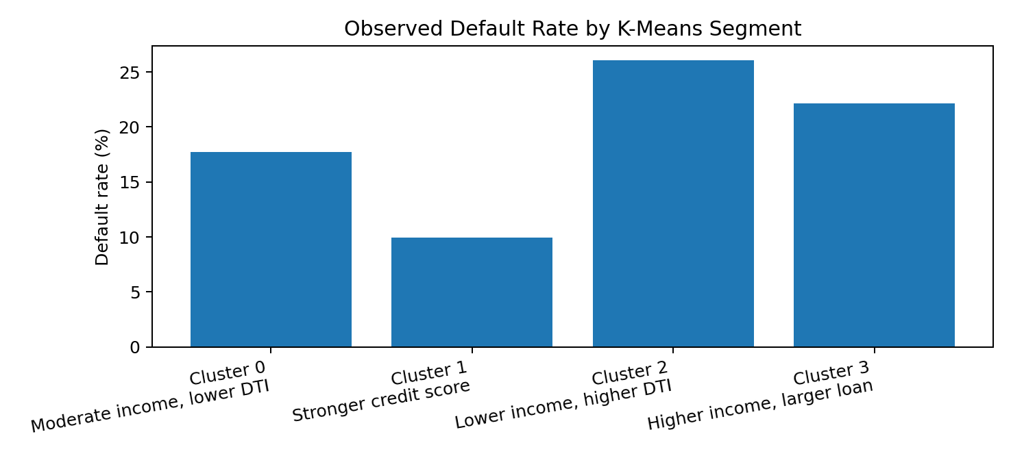
Figure 2. Observed default rate by K-Means segment. Default was not used as a clustering input; it was joined back for descriptive comparison.

8. SQL Portfolio Analysis
The complete processed CSV was imported into MySQL database credit_portfolio_db, table credit_portfolio_cleaned. The final row-count check returned 1,048,575 records. Five aggregate queries were executed successfully.
Query | Key output / interpretation
Overall portfolio | 1,048,575 loans; total loan amount 15,172,154,075; average loan 14,469.31; default rate 19.95%.
Default by purpose | Highest: small business 29.54%; lowest: wedding 10.89%.
Default by employment length | Highest: NI 26.56%; lowest: 10+ years 18.71%.
State-wise analysis | Highest rates shown in the query output: MS 25.65%, NE 25.02%, AR 24.33%, AL 23.77%, OK 23.69%.
Year-wise performance | Highest year-level rate in the output: 2007 at 26.38%; lowest: 2010 at 14.01%. Highest loan count: 2015 with 375,543 loans.

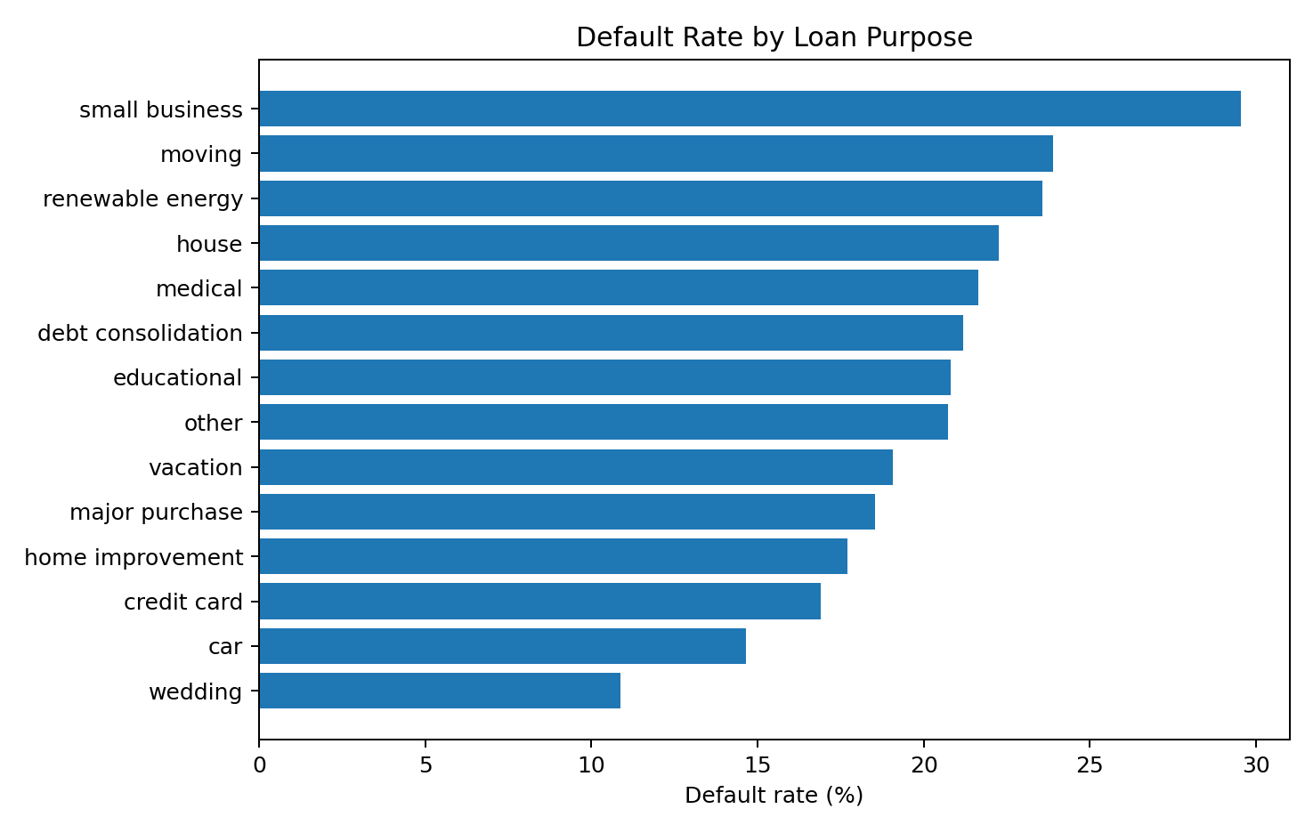
Figure 3. Default rate by loan purpose from the SQL aggregation.
The state and year comparisons are descriptive. State-level rates should be interpreted with their underlying loan counts, and year-level patterns may reflect changes in the portfolio mix or the period represented in the dataset.

9. Power BI Dashboard
A one-page Power BI report was built from the processed CSV. The dashboard includes four KPI cards: Total Loans, Total Amount, Average Loan and Default Rate. The overall unfiltered values shown in the completed screenshot are 1M (rounded display), 15.17bn, 14.47K and 19.95%, respectively.
The page also contains a line chart for year-wise default rate, a bar chart for default rate by purpose, a bar chart for total loan amount by state, and a column chart for default rate by FICO category. Interactive slicers are provided for issue year, purpose, state and employment length.
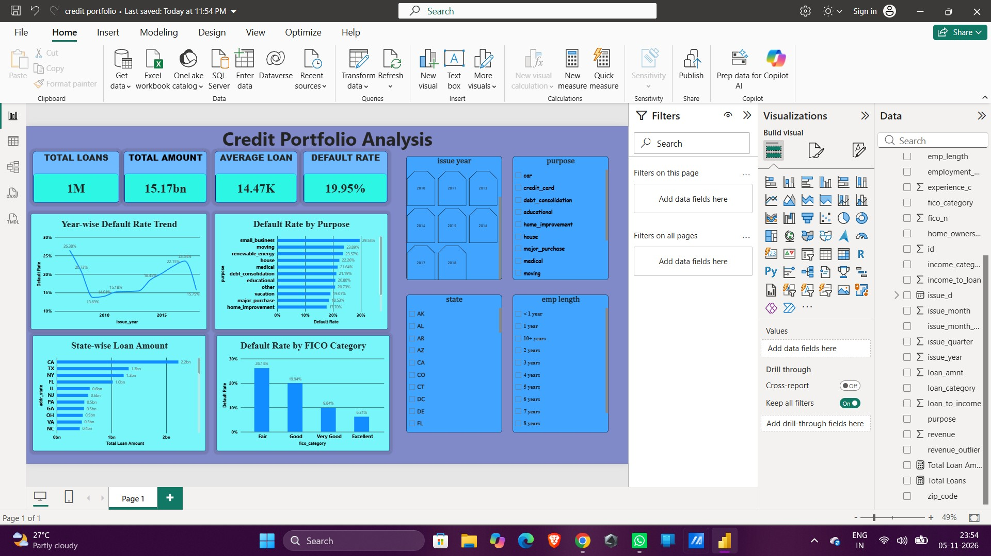
Figure 4. Power BI Credit Portfolio Analysis dashboard supplied in the project screenshots.

9.1 Core DAX Measures
Total Loans = COUNTROWS('credit_portfolio_cleaned')
Total Loan Amount = SUM('credit_portfolio_cleaned'[loan_amnt])
Average Loan Amount = AVERAGE('credit_portfolio_cleaned'[loan_amnt])
Defaulted Loans = SUM('credit_portfolio_cleaned'[Default])
Default Rate = DIVIDE([Defaulted Loans], [Total Loans], 0)
The Default Rate measure should be formatted as a percentage with two decimal places. The cards should show unfiltered portfolio totals when no slicer selections are active.

10. Conclusions, Limitations and Recommendations

10.1 Conclusions
- The processed dataset covers more than one million loan records and has an overall observed default rate of 19.95%.
- Default rates vary across purpose, employment-length, FICO, loan-size, income and issue-year groups.
- FICO score has the strongest absolute pairwise correlation with Default among the five numerical features summarized here (-0.132), though the magnitude is still modest.
- The baseline Logistic Regression model achieved 0.6542 ROC-AUC on a balanced test sample and should be treated as an initial benchmark.
- K-Means produced four descriptive segments, with observed default rates ranging from 9.92% to 26.06%.
- MySQL and Power BI provide an accessible workflow for summarizing and communicating the portfolio findings.

10.2 Limitations
- The available project material does not establish the original dataset publisher, currency, sampling design or full data dictionary.
- The meaning of experience_c and the NI employment-length code was not verified; their labels should not be expanded without documentation.
- Extreme DTI and revenue observations were flagged and retained; they may affect summaries and model behavior.
- The Logistic Regression evaluation used balanced class sampling, so the metrics do not directly estimate performance at the natural default prevalence.
- The modeling work used a random stratified split rather than a chronological holdout; temporal generalization was not assessed.
- K-Means cluster labels are exploratory and depend on feature selection, scaling, sample and chosen k=4.
- Observed group differences and correlations do not establish causation or justify individual credit decisions.

10.3 Recommended Next Steps
- Confirm the dataset dictionary, provenance, currency and the business meanings of coded fields before external submission or deployment.
- Validate the Logistic Regression model with a time-based holdout and compare it with appropriate baseline and tree-based models.
- Evaluate precision, recall, ROC-AUC, PR-AUC, calibration and threshold trade-offs at the natural class prevalence.
- Review subgroup stability and sample sizes before interpreting state- or category-level default rates.
- Save the SQL queries as a reusable .sql file and document the notebook, processed CSV and Power BI file in GitHub.
- Add a README containing the project objective, tools, workflow, key findings, setup instructions and dashboard screenshot.

Appendix A. Key SQL Queries
The following queries reproduce the five summary analyses on the imported MySQL table.

A1. Overall portfolio
SELECT
COUNT(*) AS total_loans,
SUM(loan_amnt) AS total_loan_amount,
ROUND(AVG(loan_amnt), 2) AS average_loan_amount,
ROUND(AVG(`Default`) * 100, 2) AS default_rate
FROM credit_portfolio_cleaned;

A2. Default rate by purpose
SELECT purpose, COUNT(*) AS total_loans,
SUM(`Default`) AS defaulted_loans,
ROUND(AVG(`Default`) * 100, 2) AS default_rate
FROM credit_portfolio_cleaned
GROUP BY purpose ORDER BY default_rate DESC;

A3. Default rate by employment length
SELECT emp_length, COUNT(*) AS total_borrowers,
SUM(`Default`) AS defaulted_borrowers,
ROUND(AVG(`Default`) * 100, 2) AS default_rate
FROM credit_portfolio_cleaned
GROUP BY emp_length ORDER BY default_rate DESC;

A4. State-wise portfolio
SELECT addr_state, COUNT(*) AS total_loans,
SUM(loan_amnt) AS total_loan_amount,
ROUND(AVG(`Default`) * 100, 2) AS default_rate
FROM credit_portfolio_cleaned
GROUP BY addr_state ORDER BY default_rate DESC;

A5. Year-wise performance
SELECT issue_year, COUNT(*) AS total_loans,
SUM(loan_amnt) AS total_loan_amount,
ROUND(AVG(`Default`) * 100, 2) AS default_rate
FROM credit_portfolio_cleaned
GROUP BY issue_year ORDER BY issue_year;

Appendix B. Core DAX Measures
Total Loans = COUNTROWS('credit_portfolio_cleaned')
Total Loan Amount = SUM('credit_portfolio_cleaned'[loan_amnt])
Average Loan Amount = AVERAGE('credit_portfolio_cleaned'[loan_amnt])
Defaulted Loans = SUM('credit_portfolio_cleaned'[Default])
Default Rate = DIVIDE([Defaulted Loans], [Total Loans], 0)

Appendix C. Suggested GitHub Repository Structure
Credit_Portfolio_Analysis/
|-- data/
| |-- raw/ # Original CSV (share only if license permits)
| |-- processed/ # Cleaned CSV (large file; consider Git LFS or omit)
|-- notebooks/
| |-- 01_Data_Understanding.ipynb
|-- sql/
| |-- credit_portfolio_analysis.sql
|-- powerbi/
| |-- Credit_Portfolio_Analysis.pbix
|-- reports/
| |-- Credit_Portfolio_Analysis_Final_Report.docx
|-- images/
| |-- dashboard_screenshot.png
|-- README.md
Repository note: confirm dataset redistribution permissions before uploading either CSV. A dataset with more than one million rows can be too large for ordinary GitHub file storage; consider Git LFS or document the download source and keep the raw/processed data out of the repository if redistribution is not allowed.

