**Product Sales Analysis**

**Problem Statement:**

* The problem statement for a product sales analysis involves examining sales data to identify trends, patterns, and factors affecting product sales.
* This analysis aims to optimize marketing strategies, improve inventory management, and enhance overall business decision-making to increase product sales and profitability.

**Description:**

* Product sales analysis involves a comprehensive examination of sales data and related factors to gain valuable insights into the performance, trends, and dynamics of a company's products. This analysis includes evaluating various aspects such as sales volume, revenue, profit margins, customer behavior, market trends, and competition.
* By leveraging statistical techniques, data visualization, and predictive modeling, businesses can identify patterns, make informed decisions, optimize pricing strategies, plan inventory, devise targeted marketing campaigns, and enhance overall sales performance.
* The ultimate goal is to maximize profitability and ensure the successful positioning and promotion of products in the market.

**Key Features For Product Sales Analysis:**

**1. Sales Data Visualization:**

- Displaying sales data using charts, graphs, and dashboards for easy interpretation and insights.

**2. Product Performance Metrics:**

- Tracking metrics like sales volume, revenue, profit margins, and inventory turnover for each product.

**3. Customer Segmentation:**

- Categorizing customers based on behavior, preferences, demographics, or purchasing patterns to tailor marketing strategies.

**4. Market Trend Analysis:**

- Studying market trends, seasonality, and external factors that influence product sales.

**5. Inventory Management:**

- Monitoring inventory levels and predicting restocking needs to prevent stock outs or overstocking.

**6. Sales Forecasting:**

- Predicting future sales based on historical data and other relevant factors to plan effectively.

**7. Competitor Benchmarking:**

- Comparing sales performance with competitors to identify strengths, weaknesses, and potential areas for improvement.

**8. Promotion and Campaign Evaluation:**

- Assessing the effectiveness of promotions, discounts, and marketing campaigns on sales.

**9. Customer Feedback Analysis:**

- Analyzing customer feedback and reviews to identify areas for product improvement and customer satisfaction enhancement.

**10. Profitability Analysis:**

- Evaluating the profitability of each product, considering production costs, pricing strategies, and associated expenses.

**11. Cross-selling and Upselling Opportunities:**

- Identifying opportunities to recommend related or upgraded products to customers based on their purchasing history.

**12. Sales Channel Analysis:**

- Evaluating sales performance across various channels (e.g., online, offline, partnerships) to optimize channel-specific strategies.

**13. Time Series Analysis:**

- Utilizing time series analysis to understand sales patterns over specific time periods and detect trends or seasonality.

**14. Data Integration and Connectivity:**

- Integrating data from various sources like POS systems, CRM software, and online platforms for comprehensive analysis.

**15. Alerts and Notifications:**

- Setting up alerts for unusual sales patterns or significant deviations from expected performance.

**Here is the CSV file for the above projects:**

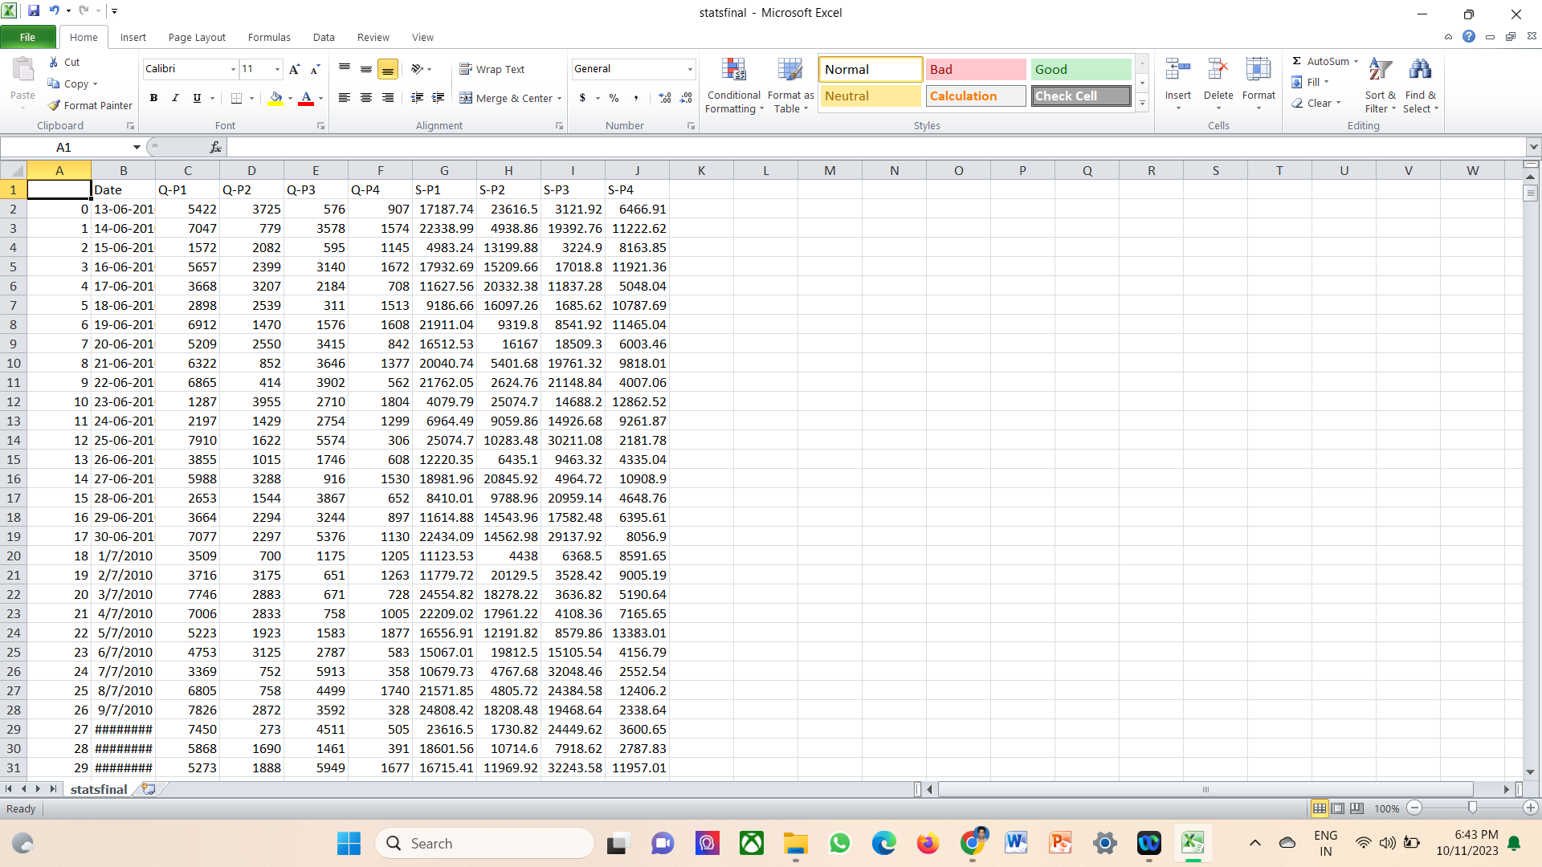

**We need to design this CSV file using the below python code:**

pip install pandas matplotlib

import pandas as pd

import matplotlib.pyplot as plt

# Load the data from the CSV file

csv_file = r'C:\Users\Yuva\Desktop\sci-hub\your_data.csv'

df = pd.read_csv(csv_file)

# Assuming the CSV file has two columns: 'Category' and 'Value'

# You can adjust the column names as needed.

category_column = 'Category'

value_column = 'Value'

# Create a bar chart

plt.figure(figsize=(10, 6)) # Adjust the figure size as needed

plt.bar(df[category_column], df[value_column, color='blue')

plt.xlabel('Categories')

plt.ylabel('Values')

plt.title('Bar Chart from CSV Data')

plt.xticks(rotation=45) # Rotate x-axis labels if necessary

plt.tight_layout() # Ensures the labels fit within the figure area

plt.show()