Price Elasticity Modelling Report
Date: February 18, 2026
This report summarizes the price elasticity analysis performed on the provided sales data, including data cleaning, exploratory analysis, elasticity estimation, and actionable business recommendations.

1. Executive Summary
The analysis estimates price elasticity at the SKU and category level. Most SKUs are inelastic, but some categories and products are highly price-sensitive. Recommendations are provided for pricing strategy optimization.

2. SKU-Level Elasticity Summary
Elasticity statistics across all SKUs:
count 265.000000
mean 0.050325
std 0.600174
min -5.664706
25% -0.021668
50% 0.000000
75% 0.078329
max 4.524553

3. Most and Least Price-Sensitive SKUs
Top 5 Most Price-Sensitive SKUs:
Product Number | Elasticity
1067517 | -5.66
1042983 | -1.43
1064337 | -1.40
1034004 | -0.97
1006655 | -0.89
Top 5 Least Price-Sensitive SKUs:
Product Number | Elasticity
1024280 | 4.52
1067193 | 3.10
1017370 | 2.13
1000430 | 1.96
1064630 | 1.69

4. Category-Level Elasticity
Top 10 Categories by Average Elasticity:
Category | Avg Elasticity | Recommendation
Wire strainers | -3.28 | Highly elastic: Consider price cuts.
Coveralls | -1.43 | Highly elastic: Consider price cuts.
Companion dog | -0.97 | Moderately elastic: Price changes will impact sales.
Wet cat food | -0.28 | Inelastic: Price changes have limited effect.
Drench combination | -0.27 | Inelastic: Price changes have limited effect.
Electrolytes | -0.27 | Inelastic: Price changes have limited effect.
Insulators | -0.25 | Inelastic: Price changes have limited effect.
Y-posts | -0.23 | Inelastic: Price changes have limited effect.
Equestrian, performance and lifestyle | -0.18 | Inelastic: Price changes have limited effect.
Cattle pour-on | -0.14 | Inelastic: Price changes have limited effect.

5. Key Visualizations
The following plots summarize the main findings:
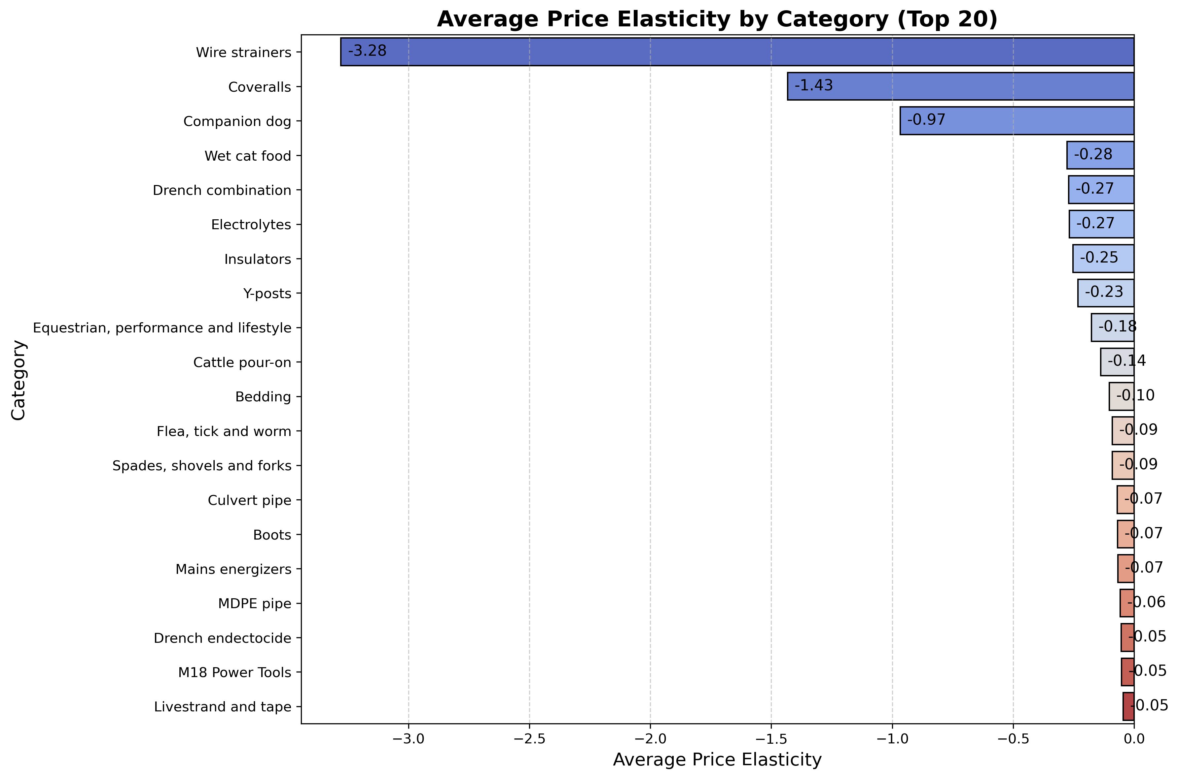
Figure 1: Average Price Elasticity by Category (Top 20)
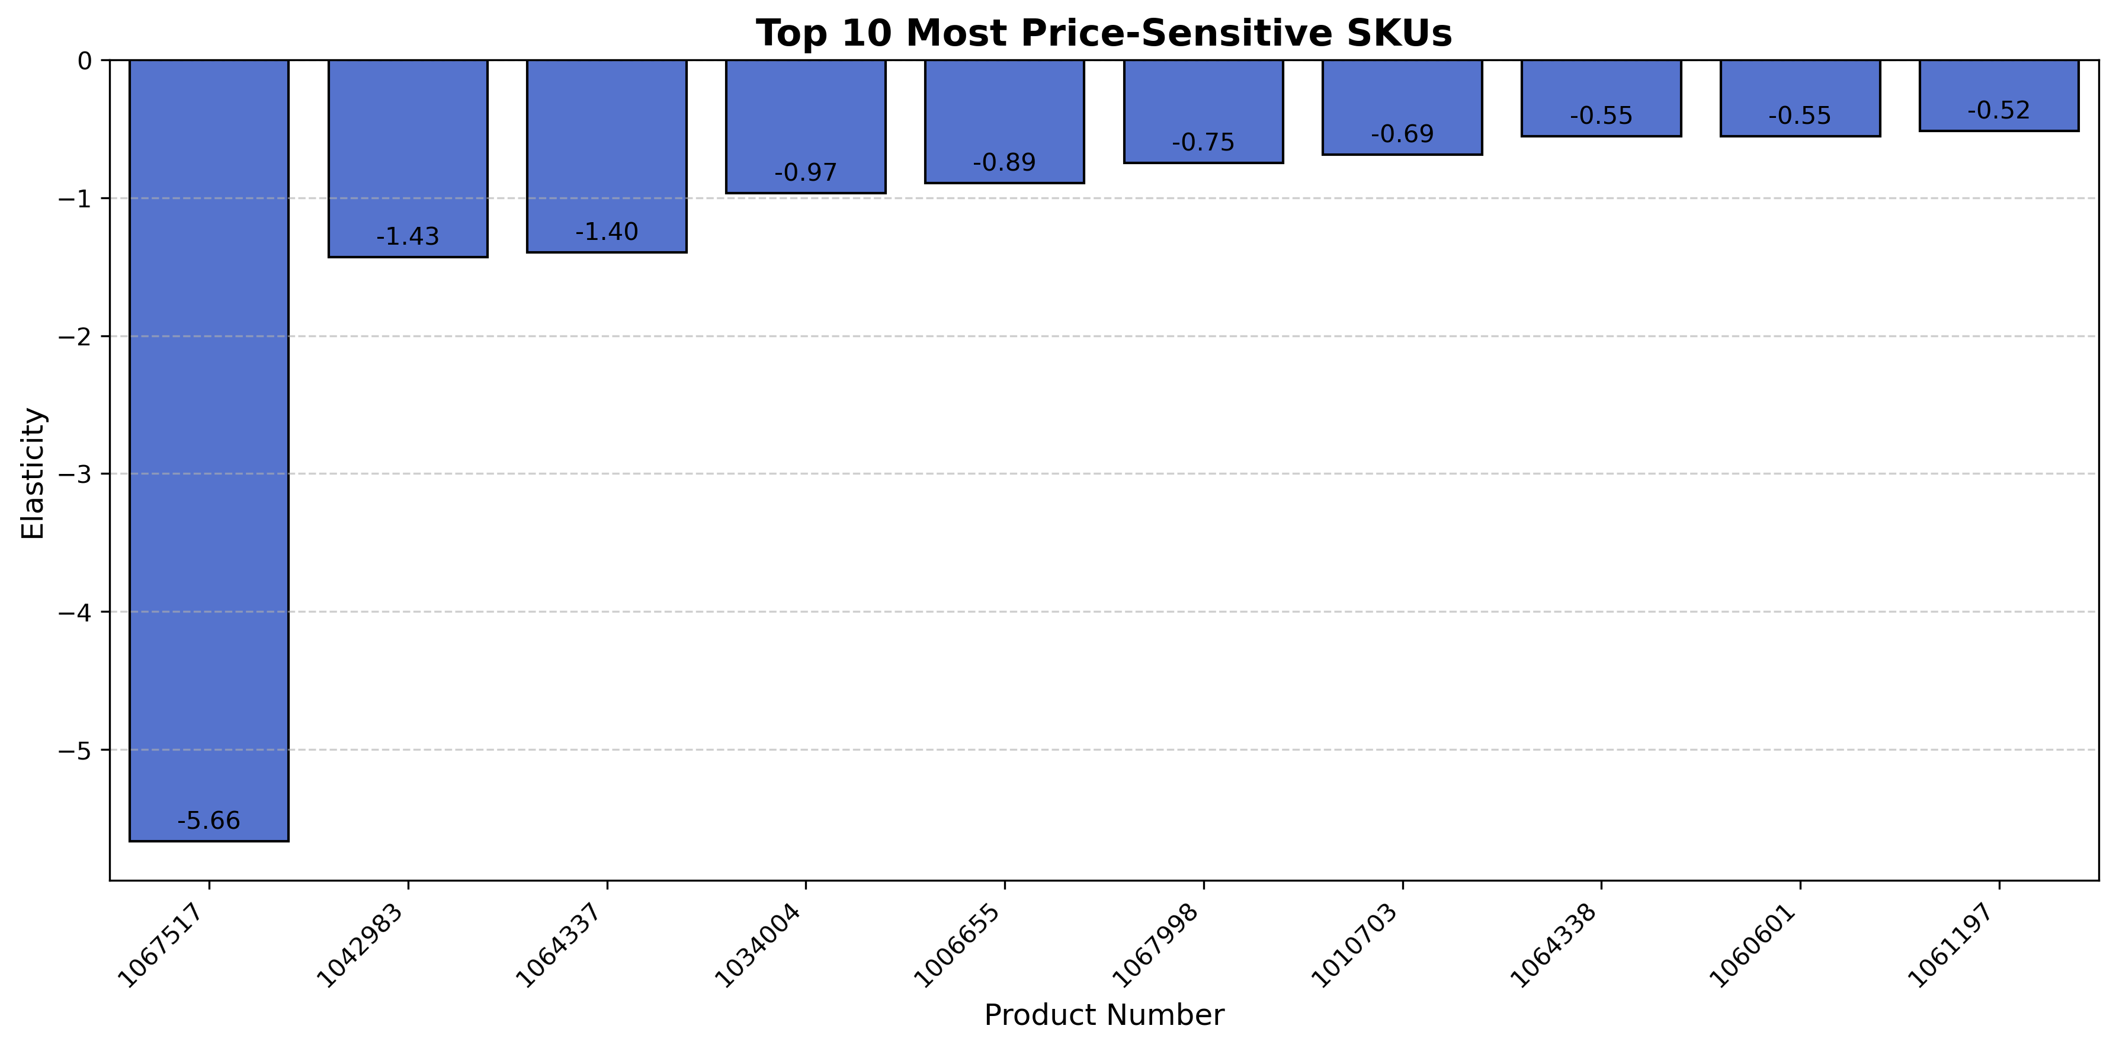
Figure 2: Top 10 Most Price-Sensitive SKUs
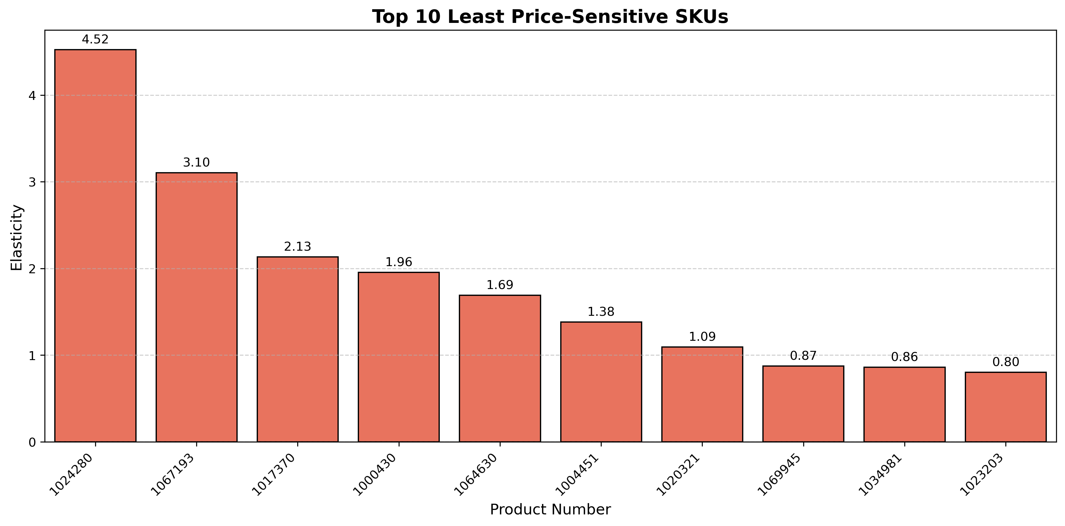
Figure 3: Top 10 Least Price-Sensitive SKUs

6. Conclusions & Recommendations
- Highly elastic SKUs and categories: Consider price reductions to boost sales.
- Inelastic SKUs and categories: Price increases may be possible with minimal sales loss.
- Outliers or positive elasticity: Review for data quality or special business cases.
- Use these insights to inform pricing strategy and promotional planning.
End of Report

