#### **Support Vector Machine**

The objective of the support vector machine algorithm is to find the hyperplane that has the maximum margin in an N-dimensional space(N — the number of features) that distinctly classifies the data points.

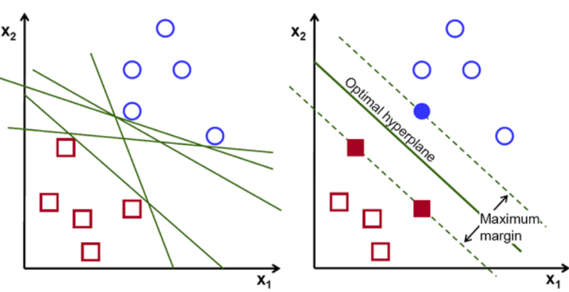

Data points falling on either side of the hyperplane can be attributed to different classes. Also, the dimension of the hyperplane depends upon the number of features. If the number of input features is 2, then the hyperplane is just a line. If the number of input features is 3, then the hyperplane becomes a two-dimensional plane.

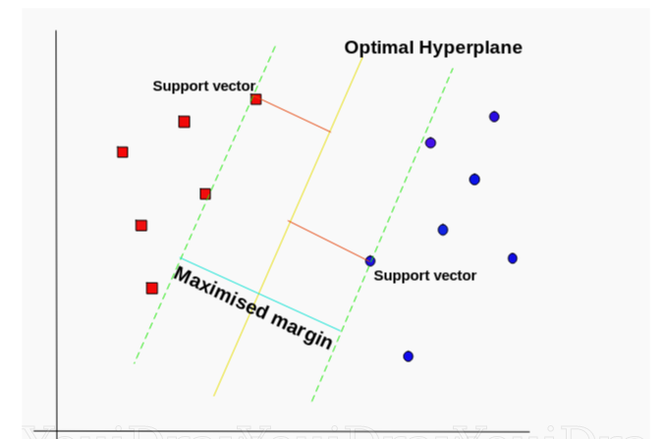

Support vectors are data points that are closer to the hyperplane and influence the position and orientation of the hyperplane. Using these support vectors, we maximize the margin of the classifier. Deleting the support vectors will change the position of the hyperplane. These are the points that help us build our SVM.